ENGLISH PRACTICE 47
I. Circle the word whose underlined part is pronounced differently from that of the others.
1. A. arrow B. loud C. moldy D. poultry
2. A. basilisk B. bison C. basic D. basin
3. A. subtlety B. indebtedness C. bombard D. combing
4. A. benevolent B. content C. molecules D. technique
5. A. conscience B. bronchitis C. shuttle D. chauffeur

II. Choose the word whose syllable is stressed differently from that of the others in each line.
6. A. comic B. clementine C. climax D. thermonuclear
7. A. diligent B. dimension C. action D. innate
8. A. characterize B. absence C. datum D. charcoal
9. A. solicitor B. separately C. spacious D. sequence
10. A. parachute B. armchair C. accent D. accidentally

III. Choose the word or phrase that best completes each sentence.
11. Assembly lines are useful for producing a large _______ of identical products.
A. quality B. quantity C. quandary D. qualification
12. Only the _______ of the building is going to be remodeled.
A. insides B. interior C. indoors D. inner
13. Whether the sports club survives is a matter of complete _______ to me.
A. indifference B. disinterest C. importance D. interest
14. After years of neglect there was a huge _______ program to return the city to its former glory.
A. restoration B. preservation C. conservation D. refurbishment
15. The assistant suggested _______ the next day when the manager would be there.
A. we are coming back B. to come back C. we will come back D. we came back
16. I never get a _______ of sleep after watching a horror film.
A. wink B. blink C. night D. ounce
17. As it was Christmas, the _______ at church was much larger than usual.
A. audience B. convention C. congregation D. grouping
18. The sheep were huddled into a _______ to protect them from overnight frosts.
A. cage B. kennel C. hutch D. pen
19. The jury _______ the defendant “not guilty”.
A. gave B. returned C. subscribed D. found
20. Many _______ crafts such as weaving are now being revived.
A. customary B. habitual C. traditional D. ordinary
21. He managed to finish his thesis under the _______ of his tutor.
A. guidance B. help C. aid D. assistance
22. Mr. Henry was given a medal in _______ of his service to his country.
A. gratitude B. knowledge C. recognition D. response
23. Everyone knows about pollution problems, but not many people have _______ any solutions.
A. thought over B. come up with C. looked into D. got round to
24. You _______ as well seek for a fish in the tree as try to do that.
A. must B. would C. should D. might
25. _______ calculations have shown that the earth’s resources may run out before the end of the next century.
A. Raw B. Rude C. Crude D. Blunt
26. By the time you receive this letter, I _______ for China.
A. will have left B. have left C. would have left D. will leave
27. Prizes are awarded _______ the number of points scored.
A. resulting from B. adding up C. presented to D. according to
28. The needs of gifted children in schools have long been _______ neglected.
A. dolefully B. woefully C. idly D. pathetically
29. I must take this watch to be repaired; it _______ over 20 minutes a day.
A. increases B. gains C. accelerates D. progresses
30. It had been a trying afternoon, _______ at about six o’clock in the television breaking down.
A. culminating B. leading C. arriving D. finalizing

IV. Write the correct FORM of each bracketed (0) has been done as an example. 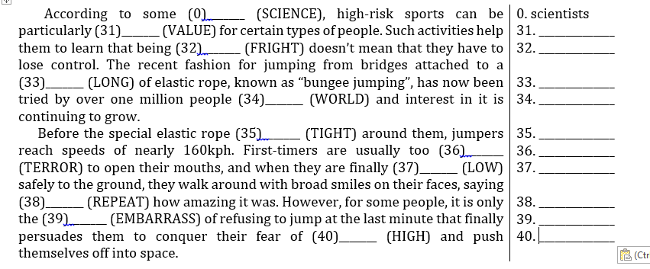
V. The passage below contains 10 mistakes. (0) has been done as an example.
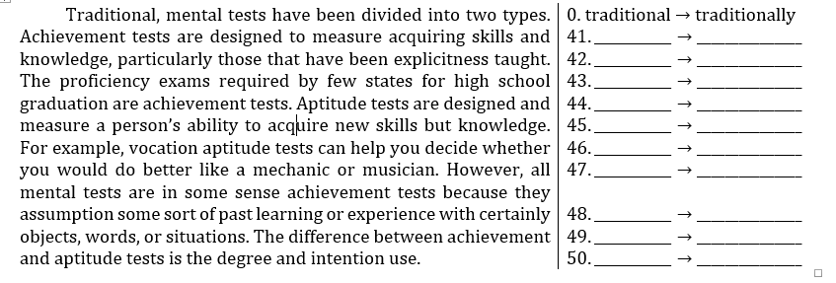
VI. Read the following passage and decide which answer (A, B, C or D) best fits each gap.
The ability to weep is a uniquely human form of emotional response. Some scientists have suggested that human tears are (51)_______ of an aquatic past – but this does not seem very likely. We cry from the moment we enter this world, for a number of reasons. Helpless babies cry to persuade their parents that they are ill, hungry or uncomfortable. As they (52)_______, they will also cry just to attract parental attention and will often stop when they get it.
The idea that having a good cry do you (53)_______ is a very old one and now it has scientific validity since recent research into tears has shown that they (54)_______ a natural painkiller called enkaphalin. By fighting sorrow and pain this chemical helps you feel better. Weeping can increase the quantities of enkaphalin you (55)_______.
Unfortunately, in our society we impose restrictions upon this naturally (56)_______ activity. Because some people still regard it as a (57)_______ of weakness in men, boys in particular are admonished when they cry. This kind of repression can only increase stress, both emotionally and physically.
Tears of emotion also help the body (58)_______ itself of toxic chemical waste, for there is more protein in them than in tears resulting from cold winds or other irritants. Crying comforts, calms and can be very enjoyable – (59)_______ the popularity of highly emotional films which are commonly (60)_______ “weepies”. It seems that people enjoy crying together almost as much as laughing together.
51. A. witness B. evidence C. result D. display
52. A. evolve B. change C. develop D. alter
53. A. better B. fine C. good D. well
54. A. contain B. retain C. hold D. keep
55. A. construct B. achieve C. provide D. produce
56. A. curing B. treating C. healing D. improving
57. A. hint B. symbol C. feature D. sign
58. A. release B. rid C. loosen D. expel
59. A. consider B. remark C. distinguish D. regard
60. A. named B. entitled C. subtitled D. called

VII. Read the following passage and answer the questions.
Legend has it that sometime toward the end of the Civil War (1861-1865) a government train carrying oxen traveling through the northern plains of eastern Wyoming was caught in a snowstorm and had to be abandoned. The driver returned the next spring to see what had become of his cargo. Instead of the skeletons he had expected to find, he saw his oxen, living, fat, and healthy. How had they survived?
The answer lay in a resource that unknowing Americans lands trampled underfoot in their haste to cross the “Great American Desert” to reach lands that sometimes proved barren. In the eastern parts of the United States, the preferred grass for forage was a cultivated plant. It grew well with enough rain, then when cut and stored it would cure and become nourishing hay for winter feed. But in the dry grazing lands of the West that familiar bluejoint grass was often killed by drought. To raise cattle out there seemed risky or even hopeless. Who could imagine a fairy-tale grass that required no rain and somehow made it possible for cattle to feed themselves all winter? But the surprising western wild grasses did just that. They had wonderfully convenient features that made them superior to the cultivated eastern grasses. Variously known as buffalo grass, grama grass, or mesquite grass, not only were they immune to drought; but they were actually preserved by the lack of summer and autumn rains. They were not juicy like the cultivated eastern grasses, but had short, hard stems. And they did not need to be cured in a barn, but dried right where they grew on the ground. When they dried in this way, they remained naturally sweet and nourishing through the winter. Cattle left outdoors to fend for themselves thrived on this hay. And the cattle themselves helped plant the fresh grass year after year for they trampled the natural seeds firmly into the soil to be watered by the melting snows of winter and the occasional rains of spring. The dry summer air cured them much as storing in a barn cured the cultivated grasses.
61. What does the passage mainly discuss?
A. A type of wild vegetation B. Western migration after Civil War
C. The raising of cattle D. The climate of the Western United States
62. What can be inferred by the phrase “Legend has it” in line 1?
A. Most history book include the story of the train.
B. The story of the train is similar to other ones from that time period.
C. The driver of the train invented the story.
D. The story of the train may not be completed factual.
63. The word “they” in line 4 refers to________.
A. plains B. skeletons C. oxen D. Americans
64. What can be inferred about the “Great American Desert” mentioned in line 7?
A. Many had settled there by the 1860’s.
B. It was not originally assumed to be a fertile area.
C. It was a popular place to raise cattle before the Civil War.
D. It was not discovered until the late 1800’s.
65. The word “barren” in line 7 is closed in meaning to________.
A. lonely B. uncomfortable C. infertile D. dangerous
66. The word “preferred” in line 8 is closed in meaning to________.
A. favored B. available C. ordinary D. required
67. Which of the following can be inferred about the cultivated grass mentioned in the second paragraph?
A. Cattle raised in the Western United States refused to eat it.
B. It had to be imported into the United States.
C. It would probably not grow in the western United States.
D. It was difficult for cattle to digest.
68. Which of the following was NOT one of the names given to the western grasses?
A. Mesquite grass B. Bluejoint grass C. Buffalo grass D. Grama grass
69. Which of the following was NOT mentioned as a characteristic of western grasses?
A. They contain little moisture B. They have tough stems
C. They can be grown indoors D. They are not affected by dry weather
70. According to the passage, the cattle help promote the growth of the wild grass by________.
A. eating only small quantities of grass.
B. continually moving from one grazing area to another.
C. naturally fertilizing the soil.
D. stepping on and pressing the seeds into the ground.

VIII. Finish the second sentence in such a way that it means exactly the same as the sentence printed before it
71. Customs officials are stopping more travelers than usual this week.
→ An increased_________________________________________________.
72. I left without saying goodbye as I didn’t want to disturb the meeting.
→ Rather _______________________________________________________.
73. My decision to get up and dance coincided with the band’s decision to stop playing.
→ The moment_________________________________________________.
74. He never suspected that the bicycle had been stolen.
→ At no time ___________________________________________________.
75. How could I help, except to offer to lend her some money?
→ Other ________________________________________________________?

IX. Use the word(s) given in the brackets and make any necessary additions to complete a new sentence in such a way that it is as similar as possible in meaning to the original sentence. Do NOT change the form of the given word(s).
76. To this day no one has equaled his achievements in the field of technology. (unsurpassed)
→ To this day_________________ in the field of technology.
77. Peter grimaced as he swallowed the foul-tasting medicine. (pulled)
→ Peter_________________ the foul-tasting medicine.
78. It’s unfortunately that the construction of the building will not be finished as originally planned.
→ The construction of the building_________________ unfortunate. (longer)
79. What he told me made me very curious to hear the rest of the history. (appetite)
→ What he told me_________________ the story.
80. They chose not to drive because they thought there would be too much snow. (fear)
→ They chose_________________ too much snow.

______________THE END_______________

Keys – practice 47
I. | (5pts) 1 point/correct answer. |  |  |  |  | II. | (5pts) 1 point/correct answer.
 | 1. B | 2. A | 3. C | 4. C | 5. B |  | 6. D | 7. B | 8. A | 9. A | 10. D

III. | (20pts) 1 point/correct answer.
 | 11. B | 12. B | 13. A | 14. A | 15. D | 16. A | 17. C | 18. D | 19. D | 20. C
 | 21. A | 22. C | 23. B | 24. D | 25. C | 26. A | 27. D | 28. B | 29. B | 30. A

IV. | (10pts) 1 point/correct answer.
 | 31. valuable  32. frightened | 33. length  34. worldwide | 35. tightened  36. terrified | 37. lowered  38. repeatedly | 39. embarrassment  40. heights

V. | (10pts) 1 point/correct answer.
 | 41. acquired  42. explicitly | 43. a few  44. to | 45. to  46. vocational | 47. as  48. assume | 49. certain  50. intended

VI. | (10pts) 1 point/correct answer.
 | 51. B | 52. C | 53. C | 54. A | 55. D | 56. C | 57. D | 58. B | 59. A | 60. D

VII. | (20pts) 2 points/correct answer.
 | 61. A | 62. B | 63. C | 64. D | 65. C | 66. A | 67. C | 68. B | 69. D | 70. B

VIII. (20pts) 2 points/correct answer.
IX. | 71.  72.  73.  74.  75.  76.  77.  78.  79.  80. | → An increased number of travelers is being stopped by customs officials this week.  → Rather than disturb the meeting, I left without saying goodbye.  → The moment I decided to get up to dance, the band decided to stop playing.  → At no time did he suspect that the bicycle had been stolen.  → Other than to offer to lend her some money, how could I help?  → To this day his achievements are unsurpassed in the field of technology.  → Peter pulled a face as he swallowed the foul-tasting medicine.  → The construction of the building will take longer than originally planned, which is unfortunate.  → What he told me whetted my appetite for the rest of the story.  → They chose not to drive for fear of too much snow.

