Date of preparing: ………………………………….
Date of teaching: ………………………………….

Period……
UNIT 3: FRIENDS
Lesson 2 - Part 3 (Page 27) – Pronunciation and Speaking

I. OBJECTIVES
By the end of the lesson, Ss will be able to…
1. Knowledge
- use sound changes in the question: “What are you doing?”
- invite a friend out and discuss things to do together.
2. Ability
- improve speaking skills.
3. Quality
- have positive attitude in English language learning so that they actively participate in all classroom activities.
- take part in some useful activities with friends to relax after school time.

II. TEACHING AIDS AND LEARNING MATERIALS
Lesson plan, PPT slides, student’s book, workbook, notebook, personal computer (if any), projector/TV, speakers, DCR & DHA on Eduhome, handouts…

III. PROCEDURES
A. Warm up: (5’)
a) Objective: Introduce the new lesson and set the scene for Ss to acquire new language; get students' attention at the beginning of the class by means of enjoyable and short activities as well as to engage them in the steps that follow.
b) Content: Introduction of some weekend activities.
c) Product: Ss know more interesting weekend activities and have plans for them.
d) Competence: Collaboration, observation
e) Organization of the activity:
Teacher’s Activities | Students’ Activities
- Give greetings  - Check attendance  - Option 1: Weekend activities  - Have Ss close all books  - Show pictures on the screen (or use handouts)  - Have Ss look at the pictures and give the name of the activity in the picture  - Have Ss give answers, call other Ss to give other answers if the first one is incorrect  Lead to the new lesson  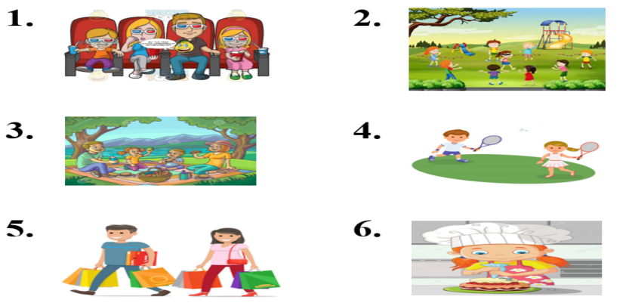  - Option 2:  - Have Ss close all books  - Have Ss work in groups and list things they can do on the weekend (in 1 minute)  - Have Ss write answers on the board  - The group which has most correct answers will be the winner  - Have class give a round applause to the winner  Lead to the new lesson. | - Greet T  - Close books  - Look, name the activities  - Give answers  Answers keys  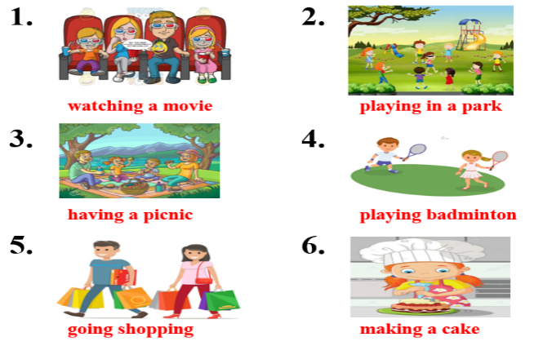  - Close books  - List activities Ss often do on the weekend  - Write answers  - Check answers with the teacher.

B. New lesson (35’)
- Activities 1: Pronunciation (10’)
a) Objective: Ss know how to use sound changes in the question: “What are you doing?”
b) Content:
- Recognizing the sound changes in the question: “What are you doing?”
- Listening and focusing pronunciation feature, find and correct mistakes.
- Practicing the pronunciation as directed.
c) Products: Ss can apply the sound changes when speaking.
d) Competence: Communication, collaboration, listening.
e) Organization of the activity:
Teacher’s Activities | Students’ Activities
a + b. Listen. Notice the sound changes of the underlined words  - Play the recording (CD1, track 36)  - Ask Ss to listen and pay attention to the sound changes  - Call Ss to make their comments on the sound changes of the questions: “What are you doing?”  - Give feedback, explain the pronunciation feature: “What are you doing …?” often sounds like /wɒdəjədu:ɪŋ/  - Play the recording again, have Ss listen and repeat with a focus on the pronunciation feature  c + d. Listen and cross out the one with the wrong sound changes, then read the sentences with the correct sound changes to a partner.  - Play the recording, have Ss listen and cross out the option that doesn’t use the correct sound changes  - Call Ss to give answers  - Play the recording again and check answers as a whole class  - Then have Ss practice saying the sentences with a partner, using the correct sound changes, then encourage Ss to use their own sentences  - Call some Ss to read their sentences in front of the class  -Check and correct Ss’ pronunciation | - Listen  - Comment  - Listen  - Listen again and repeat  - Listen and cross out  - Give answers  - Listen again and check  - Work in pairs  - Present
- Activity 2: Practice (10’)
a) Objective: Ss can ask and answer questions about activities on the weekend.
b) Content: Practicing a conversation by using pictures on the right as a cue
c) Products: Ss can use the language provided successfully in their communication.
d) Competence: Collaboration, communication, creativity, public speaking
e) Organization of the activity:
Teacher’s Activities | Students’ Activities
a. Practice the conversation. Swap the roles and repeat. (controlled practice)  - Option 1:  - Demonstrate the activity by practicing role-play with a student  - Emphasize the structures to give suggestions  Do you want to come?  What about / How about Tuesday?  Would you like to come?  - Have pairs practice the conversation  - Call some pairs to read in front of the class  - Have pairs swap roles and repeat-using the ideas on the right  - Have some pairs demonstrate the activity in front of the class  - Check Ss’ pronunciation  - Option 2: (for class with better students)  - Follow the same steps as option 1  - Then give Ss an extra activity: Practice the conversation in the textbook; however, they try to remember the conversation content  - Have some pairs demonstrate the activity in front of the class, not looking at the textbook; encourage Ss to present as naturally as possible  - Give feedback and evaluation  b. Practice with your own ideas. (Free - practice)  - Have pairs practice the conversation with their own ideas, then swap roles  - Go round, observe Ss’ work and give help if necessary  - Call some pairs to demonstrate the activity in front of the class  - Give feedback and evaluation | - Listen  - Work in pairs  - Act out the conversation  - Listen to the instruction and work in pairs  - Act out the conversation  - Listen  - Work in pairs  - Present
- Activity 3: Speaking (15’)
a) Objective: Ss can invite friend out and discuss things to do together.
b) Content: Asking and answering questions about activities.
c) Products: Ss can apply the target language learnt in the lesson to produce the language successfully.
d) Competence: Collaboration, communication, critical thinking, persuasion.
e) Organization of the activity:
Teacher’s Activities | Students’ Activities
a. You want to invite your friend out. Student A use the information on page 27, choose an activity from his calendar and ask his partner to join. Student B goes to page 125, file 12. Then, swap the roles and repeat  - Demonstrate the activity by practicing role-play with a student  - Remind Ss to use the Present Continuous tense and some structures of making suggestions  - Have student A look at the schedule on the bottom of the page and student B turn to page 125, file 12.  - Have Ss do the role-play for Week 1  - Have Ss find out which days they’re both free and choose an activity to do together  - Have some pairs demonstrate their role-play in front of the class.  b. Complete your calendar for Week 2 with activities. Continue the conversation. Talk about what you and your partner are doing together.  - Have Ss fill in the blanks for Week 2, using their own ideas and continue the conversation  - Ask Ss to demonstrate the role-play on front of the class  - Give feedback and evaluation | - 1 S practices role-play with the teacher  - Listen  - Work in pairs  - Role play  - Work in pairs

C. Consolidation (3’)
* Pronunciation: “What are you doing …?” often sounds like /wɒdəjədu:ɪŋ/
* Weekend activities: Making a cake, going swimming, playing sports, having a barbecue, having a party, going shopping, watching a movie, having a picnic …
* Giving suggestions
How about / What about + V-ing / noun
Why don’t we + V _{bare infinitive}
Let’s + V _{bare infinitive}
Do you want to …? / Would you like to …?

D. Homework (2’)
- Practice using sound changes in the question: “What are you doing?”
- Find more useful activities Ss often do on the weekend.
- Make 2 sentences for each structure of giving suggestions.
- Prepare: Lesson 3: Literature – New Words and Listening (page 28 – SB).

