|  |  |
| --- | --- |
| **Tiếng Anh 8 Friends Plus** | **FP 8 – UNIT 8 - TEST 1**  **Test for Unit**  *-------------------------* |

**I. Pronunciation**

**Question 1.** Which word has the underlined part pronounced differently from that of the others?

**A.** **g**uess  **B.** man**g**a

**C.** **g**enerosity  **D.** **g**ame

**Đáp án đúng**: C

**Question 2.** Which word has the underlined part pronounced differently from that of the others?

**A.** lar**g**est  **B.** **g**ather

**C.** ori**g**inal  **D.** intelli**g**ent

**Đáp án đúng**: B

**Question 3.** Which word has a different stress pattern from that of the others?

**A.** incredible  **B.** comedy

**C.** extraordinary  **D.** award

**Đáp án đúng**: B

**Question 4.** Which word has a different stress pattern from that of the others?

**A.** music  **B.** classic  **C.** release  **D.** fiction

**Đáp án đúng**: C

**II. Choose the answer (A, B, C or D) that best fits the space in each question.**

**Question 5.** I’m a big fan of action films. – “………”

**A.** I will go with you.  **B.** Let’s ask the fans.

**C.** I prefer the comedy.  **D.** Why don’t we decide when we get there?

**Đáp án đúng**: C

**Question 6.** Paul doesn’t fancy **__________** out in the evening because he often practices playing the drums.

**A.** goes  **B.** go  **C.** going  **D.** to go

**Đáp án đúng**: C

**Question 7.** It is **__________** that our team won the match despite lacking players.

**A.** classical  **B.** incredible

**C.** believable  **D.** comedic

**Đáp án đúng**: B

**Question 8.** Students should read the stories that **__________** happiness and hope throughout society.

**A.** share  **B.** communicate

**C.** donate  **D.** collect

**Đáp án đúng**: A

**Question 9.** I like **__________** fast-paced movies such as action, superheroes, and sci-fi ones.

**A.** watches  **B.** watched  **C.** watching  **D.** watch

**Đáp án đúng**: C

**Question 10.** James Cameron was **__________** an Oscar for “Avatar” in 2010.

**A.** awarding  **B.** awards  **C.** awarded  **D.** to award

**Đáp án đúng**: C

**Question 11.** What film is nominated for Oscar this year? – “…….”

**A.** Yes, you should definitely see it.

**B.** I think I will ask my friends to come with.

**C.** That film is extraordinary.

**D.** Avatar 2, I guess.

**Đáp án đúng**: D

**Question 12.** When I was young, I was **__________** to care for others, love myself and overcome obstacles.

**A.** teach  **B.** to teach  **C.** teaching  **D.** taught

**Đáp án đúng**: D

**Question 13.** Sometimes we make **__________** mistakes, but we can always learn from them.

**A.** fantastic  **B.** terrible  **C.** terrific  **D.** awesome

**Đáp án đúng**: B

**Question 14.** It took an **__________** amount of work to build this monument.

**A.** unnormal  **B.** extraordinary

**C.** unremarkable  **D.** usual

**Đáp án đúng**: B

**III. Look at the signs. Choose the best answer (A, B, C or D).**

**Question 15.**

What does this note mean?

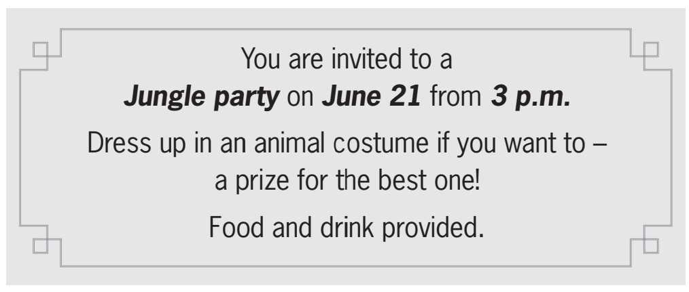

**A.** Guests will have a prize if they bring food and drink.

**B.** Guests must dress up as a type of animal.

**C.** Guests might win something if they wear a costume.

**D.** Guests should bring some food and drink.

**Đáp án đúng**: C

**Question 16.**

Why has Jenna left a note for Marcus?

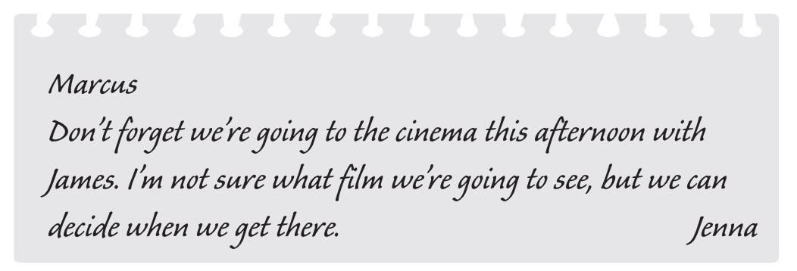

**A.** to remind him about an arrangement  **B.** to suggest a film which they could see

**C.** to choose the cinema  **D.** to invite him to the cinema

**Đáp án đúng**: A

**IV. Read the following passage. Decide if the statements from 17 to 20 are True or False, and choose the correct answers (A, B, C or D) for questions 21 and 22.**

Ho Chi Minh City will host an annual Lunar New Year (Tet) book fair on Le Loi Street, District 1, from 5:00 pm on January 19th to 10:00 pm on January 26th. The opening and closing days are the 28th and 5th of the 12th and first lunar months, respectively.

The book festival, entitled ‘Ho Chi Minh City - Happy and successful new year’ was announced on Thursday by the municipal Department of Information and Communications. The city hosts the “Lunar New Year book festival” to promote reading habits and provide entertainment place for locals and tourists.

The city's most picturesque street, Le Loi Street, will host the book festival this year from Nguyen Hue Pedestrian Street to the Quach Thi Trang Roundabout. Over 20 units will participate in three book street areas. Documents, images, and publications about late State Presidents Ho Chi Minh and Ton Duc Thang, historical events, and valuable books will be displayed on Nguyen Hue Promenade leading to Pasteur Street. Audio books, e-books, and smart libraries will be located from Pasteur Street to Nam Ky Khoi Nghia Street. Readers and tourists can also participate in interactive activities.

From Nam Ky Khoi Nghia Street to the Quach Thi Trang Roundabout, there will be children's books, a playground with creative and team-building activities, and a space for book launches and artistic exhibits.

**Question 17.** The book fair is held every two years.

**A.** False  **B.** True

**Đáp án đúng**: A

**Question 18.** The book fair lasts for 10 days.

**A.** True  **B.** False

**Đáp án đúng**: B

**Question 19.** Promoting reading habits is one of the main purposes of this book festival.

**A.** True  **B.** False

**Đáp án đúng**: A

**Question 20.** Readers and tourists can only read printed books.

**A.** True  **B.** False

**Đáp án đúng**: B

**Question 21.** What is the main idea of the passage?

**A.** The famous streets of book fair.  **B.** The book fair on Tet holidays.

**C.** The activities of people in HCMC.  **D.** The historical events at Tet.

**Đáp án đúng**: B

**Question 22.** What activity is **not mentioned** in the passage?

**A.** It is inconvenient for tourists with children to enjoy this book fair.

**B.** Readers can talk to the authors directly.

**C.** Tourists can see photos of some famous people and historical events.

**D.** Readers can read digital books.

**Đáp án đúng**: B

**V. Choose the word (A, B, C or D) that best fits the blank space in the following passage.**

*A MOVIE REVIEW*

Pirates of the Caribbean 2: Dead Man’s Chest is a pirate adventure **_____23_____** Johnny Depp, Orlando Bloom, and Keira Knightley as the main **____24______**.

The movie is about the adventures of Captain Jack Sparrow, **____25______** by Johnny Depp. We follow the Captain and his friends as they go on a journey full of **_____26_____**. They travel across the sea because they want to find treasure. They have many adventures on the way.

At first, I thought it would be another bad pirate movie, but I **____27______** wrong! The actors were all very talented and the movie was very exciting! For me, Johnny Depp was the funniest actor in the movie! I believe that Johnny Depp is the most **_____28_____** actor working today.

**Question 23.**

**A.** shining  **B.** starring  **C.** showing  **D.** coming

**Đáp án đúng**: B

**Question 24.**

**A.** characters  **B.** human

**C.** mankind  **D.** people

**Đáp án đúng**: A

**Question 25.**

**A.** played  **B.** controlled

**C.** managed  **D.** done

**Đáp án đúng**: A

**Question 26.**

**A.** hopelessness  **B.** surprises

**C.** indifferences  **D.** expectations

**Đáp án đúng**: B

**Question 27.**

**A.** will be  **B.** am  **C.** be  **D.** was

**Đáp án đúng**: D

**Question 28.**

**A.** dim  **B.** talented  **C.** dull  **D.** able

**Đáp án đúng**: B

**VI. Supply the correct form of the word given in each sentence.**

**Question 29.** My interests include anything challenging or ______________. (adventure)

**Đáp án đúng**: adventurous

**Question 30.** This actor has had nine Oscar ______________. (nominate)

**Đáp án đúng**: nominations

**Question 31.** He started out as a stand-up ______________ in Liverpool. (comedy)

**Đáp án đúng**: comedian

**Question 32.** For over 25 years, she has worked as a professional ______________. (musical)

**Đáp án đúng**: musician

**Question 33.** The first edition of this classic novel was ______________ in 1938. (publisher)

**Đáp án đúng**: published

**Question 34.** Some youngsters find it challenging to ______________ to a new school. (adaption)

**Đáp án đúng**: adapt

**VII. Rearrange the groups of words in a correct order to make complete sentences.**

**Question 35.** care for others./ the book is/ like most about/ the way I am/ taught to/ The thing I

The thing I _______________________________________________________________

**Đáp án đúng**: The thing I like most about the book is the way I am taught to care for others.

**Question 36.** This actor/his excellent/performance./first prize for/was awarded the

This actor _______________________________________________________________

**Đáp án đúng**: This actor was awarded the first prize for his excellent performance.

**VIII. Rewrite each of the following sentences in another way so that it means almost the same as the sentence printed before it.**

**Question 37.** Paul started learning Spanish three years ago.

Paul has _______________________________________________________________

**Đáp án đúng**: Paul has learned Spanish for three years.

**Question 38.** We made a project about ancient books in Literature last month.

A project _______________________________________________________________

**Đáp án đúng**: A project about ancient books was made in Literature last month.

**Question 39.** My friend told me, “I always eat healthy food and do morning exercise.”

My friend told me _______________________________________________________

**Đáp án đúng**: My friend told me he always ate healthy food and did morning exercise.

**Question 40.** Maria can help you, but she is busy now.

If Maria _______________________________________________________________

**Đáp án đúng**: If Maria weren’t busy now, she could help you.

**IX. Task 1: Listen and fill in the blanks with one word/ number. Task 2: Listen again and decide whether the statements are true or false.**

**Question 41.** Beyoncé is a great __________ singer.

**Đáp án đúng**: Beyoncé is a great R&B singer.

**Question 42.** She is very popular with __________.

**Đáp án đúng**: She is very popular with teenagers.

**Question 43.** Her band broke up in __________.

**Đáp án đúng**: Her band broke up in

**Question 44.** Her latest album is full of __________ tunes.

**Đáp án đúng**: Her latest album is full of catchy tunes.

**Question 45.** She also acted in some __________.

**Đáp án đúng**: She also acted in some films.

**Question 46.** Beyoncé is always in the top ten of the music charts.

**A.** True  **B.** False

**Đáp án đúng**: A

**Question 47.** A lot of teenagers hardly recognize her.

**A.** True  **B.** False

**Đáp án đúng**: B

**Question 48.** Her first band was called ‘Destiny’s Child’.

**A.** False  **B.** True

**Đáp án đúng**: B

**Question 49.** Her career is limited to singing.

**A.** True  **B.** False

**Đáp án đúng**: B

**Question 50.** She also performed her song with another singer.

**A.** False  **B.** True

**Đáp án đúng**: B

**----HẾT---**