School: ……………………………………….. | Date:……………………………………..
Class: ……………………………..................... | Period: 60

UNIT 4: ALL THINGS HIGH-TECH
Vocabulary 4c (Page 68)

1. Objectives
By the end of this lesson, students will be able to…
1.1. Language knowledge/ skills
- learn and use vocabulary: screen, tower, mouse, router, speakers, keyboard, USB flash drive.
- practise listening for specific information.
- talk about their computers.
- improve listening skills and pronunciation.
1.2. Competences
- improve Ss’ communication, collaboration, analytical and critical thinking skills.
1.3. Attributes
- build their love for high technology.
- become knowledgeable people.
2. Teaching aids and materials
- Teacher’s aids: Student’s book and Teacher’s book, class CDs, IWB – Phần mềm tương tác trực quan, projector/interactive whiteboard /TV (if any), PowerPoint slides.
- Students’ aids: Student’s book, Workbook, Notebook.
3. Assessment evidence
Performance Tasks | Performance Products | Assessment Tools
- Answer the question.  - Match the words with the picture.  - Fill in the blanks.  - Answer the questions.  - Talk about parts of a computer. | - Ss’ answers.  - Ss’ answers.  - Ss’ answers.  - Ss’ answers.  - Ss’ answers/ presentation. | - Observation.  - Observation.  - Observation.  - Observation.  - Observation.

4. Procedures
A. Warm up: 5 minutes
a. Objectives: to brainstorm the topic and introduce some parts of a computer.
b. Content: vocabulary about some parts of a computer.
c. Expected outcomes: Ss can recall vocabulary and think about the topic.
d. Organization
Teacher’s activities | Students’ activities
Answer the question:  Can you tell me some parts of a computer?  - Ask Ss to think about their computer and list the parts of a computer that they know.  - Get Ss to check their answers with their friends.  - Check Ss’ answers. | - List the parts of a computer.  - Do the task individually and then share with their friends.  Suggested answers:  screen, keyboard, mouse, speakers, CPU,…  - Listen to the teacher and take notes.

B. Vocabulary presentation: 10 minutes
a. Objectives: to present new words for computer.
b. Content: task 1.
c. Expected outcomes: Ss can remember vocabulary and do the task correctly.
d. Organization
Teacher’s activities | Students’ activities
Task 1: Match the pictures (1-7) to the words in the list (A-G). Listen and check, then repeat.  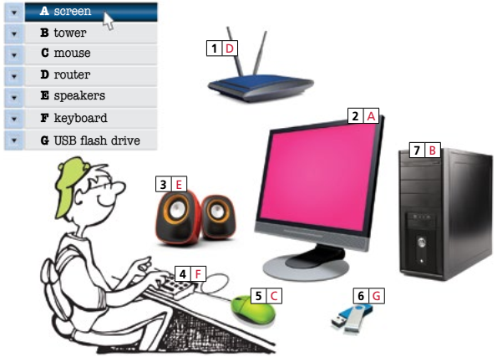  - Ask Ss to look at the pictures and match them to the words in the list.  - Play the recording, using the IWB (if any) for Ss to check their answers.  - Elicit the meanings of the words.  - Then play the recording again, Ss listen and repeat chorally and/or individually | - Match the words with the correct pictures.  - Check answers.  - Take notes and repeat the words.  Answer Keys:  1.D 2.A 3.E 4.F 5.C 6.G 7.B

C. Vocabulary practice: 15 minutes
a. Objectives: to help Ss practise the vocabulary for computer and listen for specific information about the topic.
b. Content: task 2 and task 3.
c. Expected outcomes: Ss can remember and use the words in the context correctly.
d. Organization:
Teacher’s activities | Students’ activities
Task 2: Complete the sentences with the words from Exercise 1.  1. You need a________ to connect to the Internet.  2. To choose an item on the ______ , you must click on it with your_______.  3. Most of the important parts of a computer are in a ______.  4. Please copy the files to my ______.  5. I can’t listen to the song; my ______don’t work.  6. Use your _____to type in your homework.  - Explain the task using IWB. Read through the list of words and explain their meanings again.  - Give Ss time to complete the task and then  check Ss’ answers (using the IWB). | - Listen to teacher’s explanation and complete the sentences.  - Check the answers.  Answer Keys:  1. router 2.screen/mouse 3. tower  4. USB flash drive 5. speakers 6. keyboard
Task 3: What’s wrong with Helen’s computer? Listen and write in your notebook.  - Explain the task using IWB.  - Play the recording, using the IWB (twice if necessary). Ask Ss to listen and complete the task.  - Check Ss’ answers (play the recording with pauses for Ss to check their answers if necessary). | - Listen to the recording and write down the answers.  - Do the task individually and then compare answers with friend.  - Listen again and check answers.  Answer Keys  The computer isn’t working and there’s nothing on the screen. It looks like there is a  problem with the tower.

D. Production: 10 minutes
a. Objectives: to help Ss to use the language and information in the real situation.
b. Content: task 4.
c. Expected outcomes: Ss can make notes on a text, talk about their computer.
d. Organization

Teacher’s activities | Students’ activities
Task 4: Have you got a computer at home? Which of the parts above has it got? Tell your partner.  - Explain the task and give Ss time to complete it in pairs.  - Check Ss’ answers around the class. | - Make notes and tell their friends about their computer.  - Talk to the class about their computer.  Suggested Answer:  I have got a computer at home. It has got a  tower, screen, keyboard, mouse and speakers.  I also have got a USB ﬂash drive and a router.

E. Consolidation and homework assignments: 5 minutes
- Vocabulary: screen, tower, mouse, router, speakers, keyboard, USB flash drive.
- Do the exercises in workbook on page 34.
- Do the vocabulary exercise in TA7 Right On! Notebook page 31.
- Prepare the next lesson: Speaking 4d (page 69).
5. Reflection

a. What I liked most about this lesson today:
…………………………………………………………………………………………
b. What I learned from this lesson today:
…………………………………………………………………………………………
c. What I should improve for this lesson next time:
…………………………………………………………………………………………

