ĐỀ VIP 9+ - ĐỀ SỐ 6

Read the following school announcement and mark the letter A, B, C, or D to indicate the correct option that best fits each of the numbered blanks from 1 to 6.
Are you passionate (1) traditional music? Here’s your chance to (2) your singing skills! We’re (3) to announce our upcoming Folk Singing Competition, and we encourage all students (4) . This event is open to everyone, (5) experience level. By joining, you’ll experience a (6) of artistic expression that will leave you feeling fulfilled and proud. The competition will take place in the school auditorium on Friday, November 24, at 3:00 p.m. To register, sign up at the front office or visit our website by November 20.
Don’t miss this wonderful opportunity to celebrate folk music and share your voice with us!
Question 1. | A. at | B. in | C. about | D. on
Question 2. | A. show off | B. go over | C. take up | D. keep on
Question 3. | A. thrilling | B. thrilled | C. thrill | D. thrillingly
Question 4. | A. participate | B. to participate | C. to participating | D. participating
Question 5. | A. by means of | B. with regard to | C. regardless of | D. in contrast to
Question 6. | A. number | B. handful | C. majority | D. degree
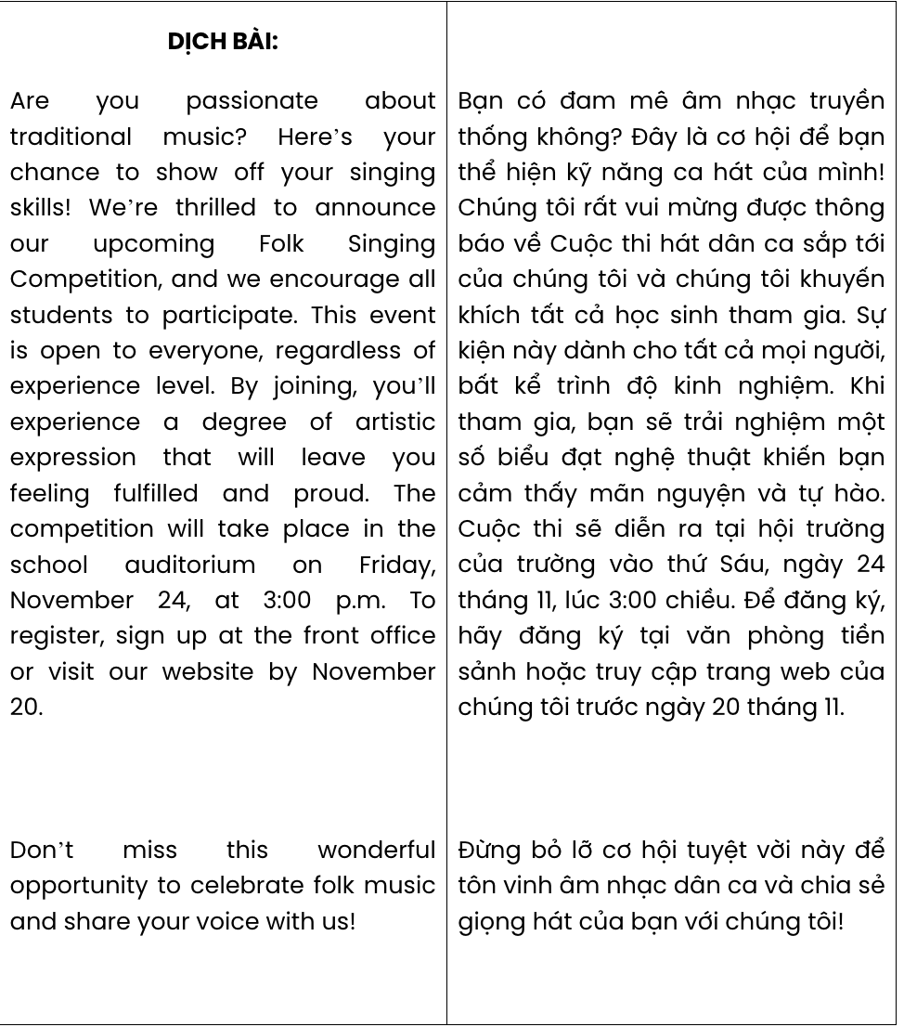
GIẢI CÂU 1:
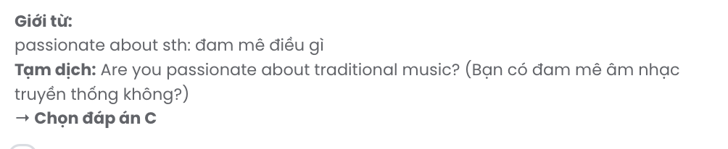
GIẢI CÂU 2: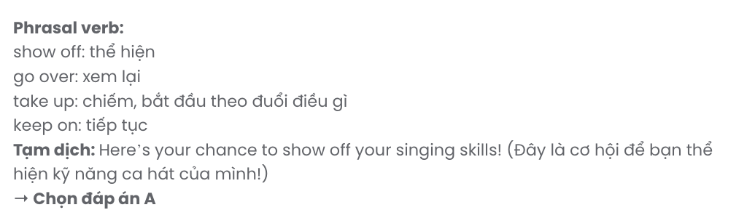
GIẢI CÂU 3:
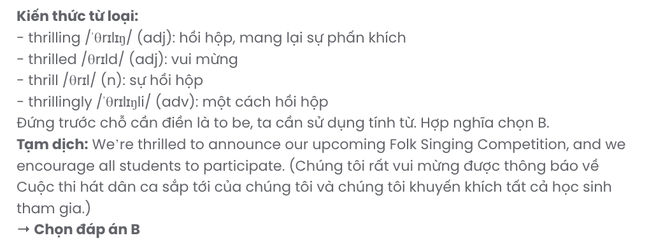
GIẢI CÂU 4:
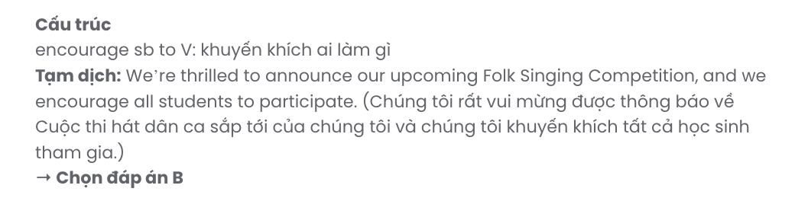
GIẢI CÂU 5:
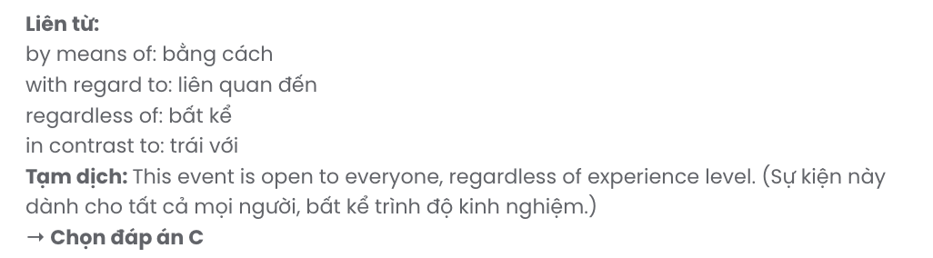
GIẢI CÂU 6:
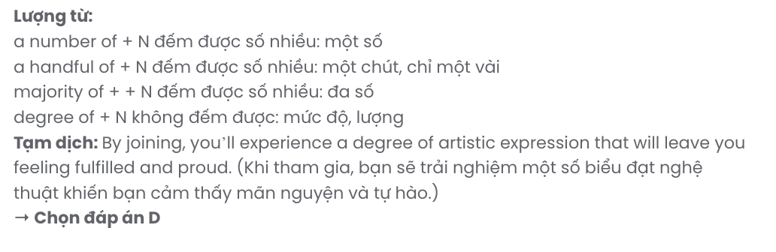
Read the following leaflet and mark the letter A, B, C, or D to indicate the correct option that best fits each of the numbered blanks from 7 to 12.

Join the ASEAN Youth Forum: A Platform for Change
Are you an ASEAN young person eager to discuss current issues with others across the region? Don’t miss the ASEAN Youth Forum, a(n) (7) where you can share your voice and ideas! This forum unites young leaders to exchange views on today’s most pressing topics, from climate action to economic resilience. By participating, you’ll collaborate with (8) bright minds and contribute to solutions that will impact our shared future. The forum creates a dynamic space to encourage open dialogue and strengthen (9) between ASEAN youth. Sessions will cover areas like sustainable development and digital literacy, (10) valuable insights and practical strategies.
Connect with like-minded (11) , gain a deeper understanding of our region's challenges, and
(12) steps toward positive change. Register at www.aseanyouthforum.org by November 30!
Question 7. | A. online engaging platform |  | B. engaging online platform
 | C. platform engaging online |  | D. online platform engaging
Question 8. | A. another | B. the others | C. much | D. other
Question 9. | A. links | B. ties | C. ranks | D. paths
Question 10. | A. which offer | B. offered | C. are offered | D. offering
Question 11. | A. dwellers | B. representatives | C. members | D. peers
Question 12. | A. make | B. get | C. lead | D. take

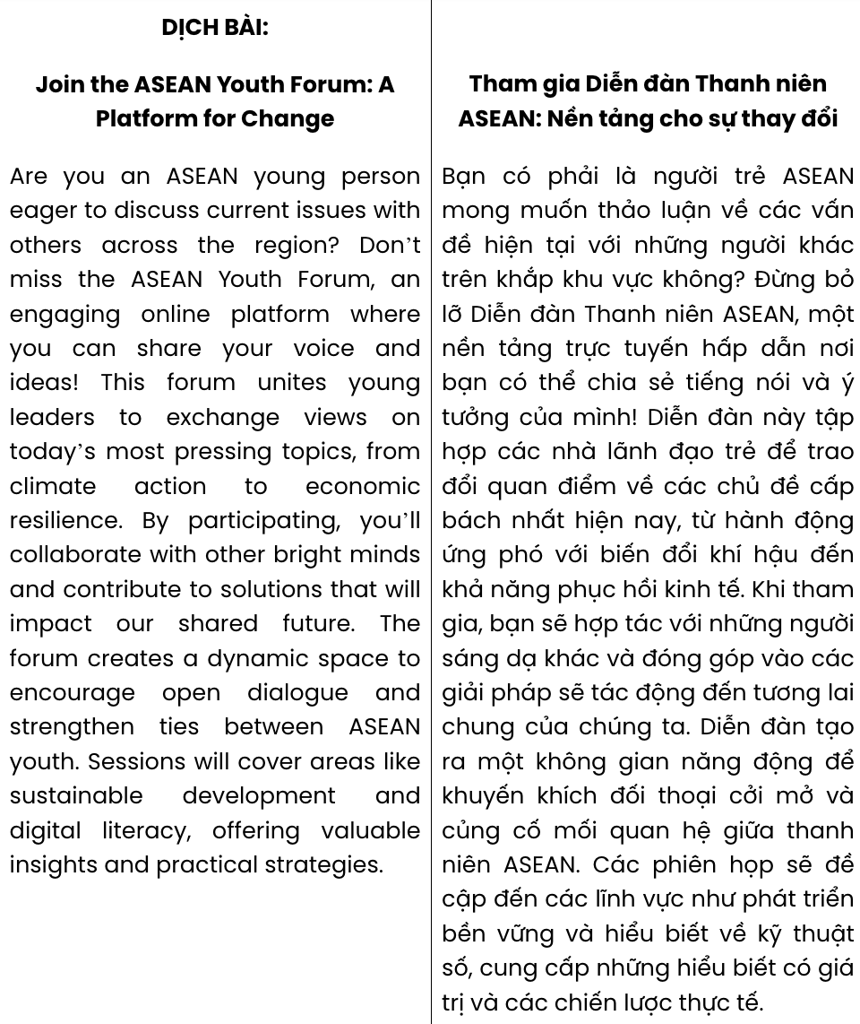
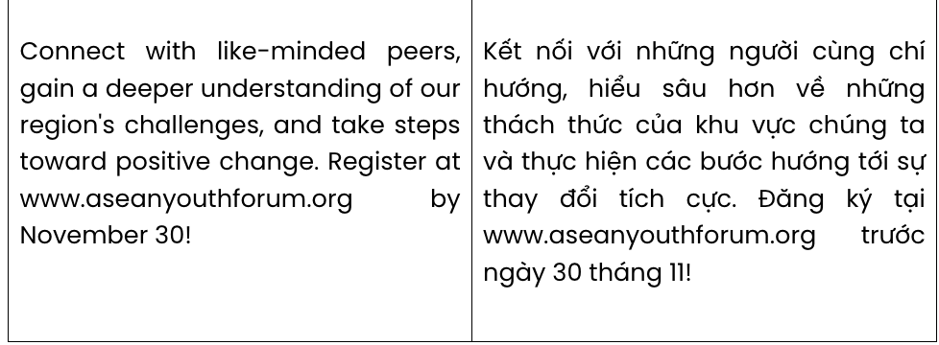
GIẢI CÂU 7:
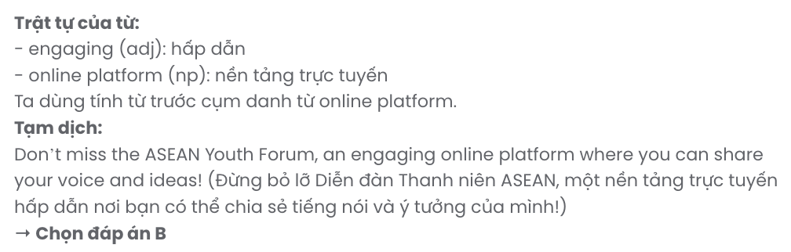
GIẢI CÂU 8:
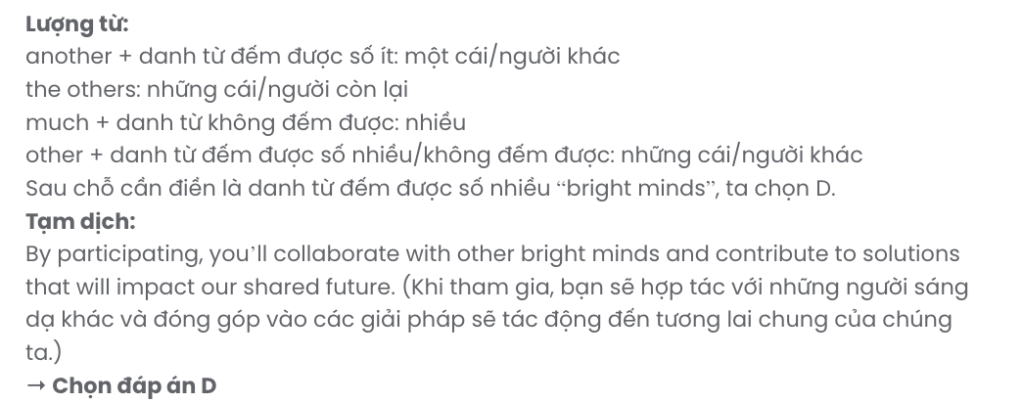
GIẢI CÂU 9:
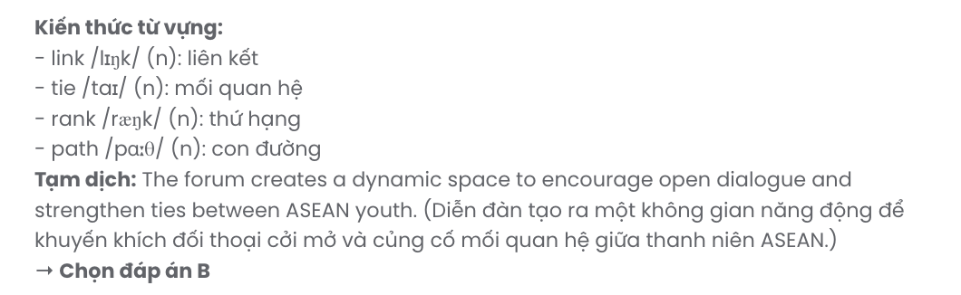
GIẢI CÂU 10:
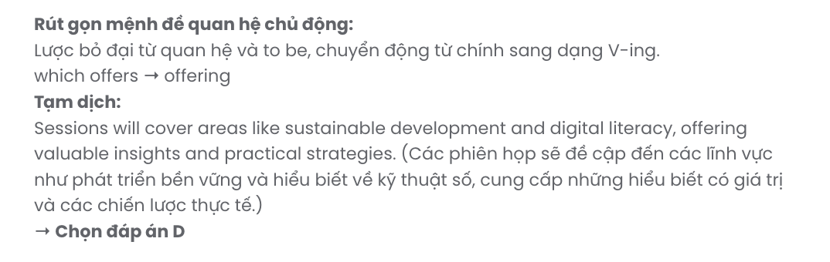
GIẢI CÂU 11:
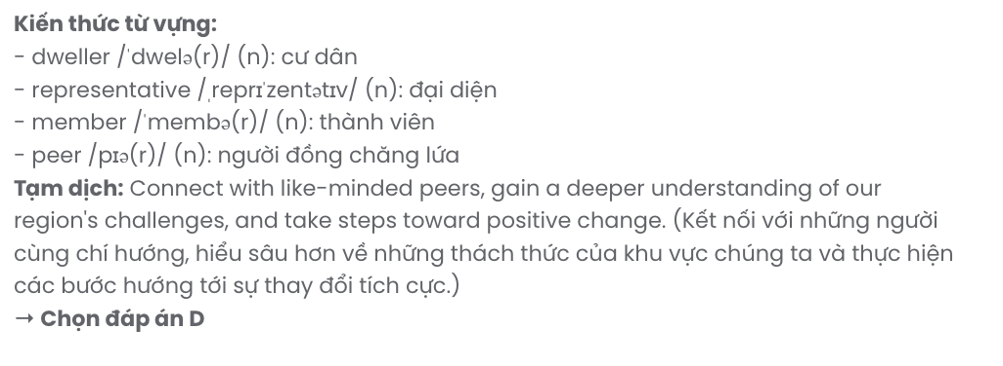
GIẢI CÂU 12:
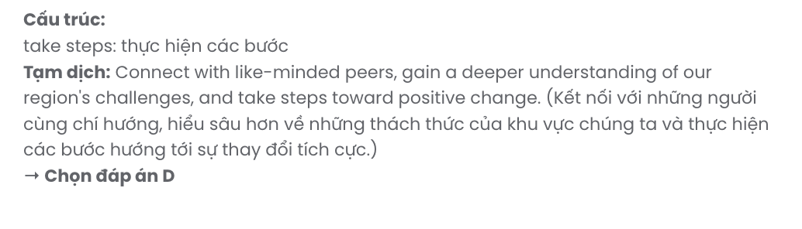
Mark the letter A, B, C or D on your answer sheet to indicate the best arrangement of utterances or sentences to make a meaningful exchange or text in each of the following questions from 13 to 17.

Question 13. GIA SƯTẠIHUẾ (079.3833.272)
- At the orphanage, I spend my days helping children with their studies and organising activities.
- When I decided to take a gap year, I wanted to contribute to my community, and working at a local orphanage seemed like the perfect way to do that.
- Through this experience, I have gained patience, developed leadership skills, and learned how to handle responsibilities that I had never faced before.
- Spending time with these children has not only deepened my understanding of social issues but has also inspired me to consider a future career in social work.
- Reflecting on the past few months, I believe this gap year has been invaluable, as it has equipped me with skills and insights that will benefit me throughout my life.
A. c – a – b – d – e B. a – d – b – c – e C. b – a – d – c – e D. d – c – b – a – e
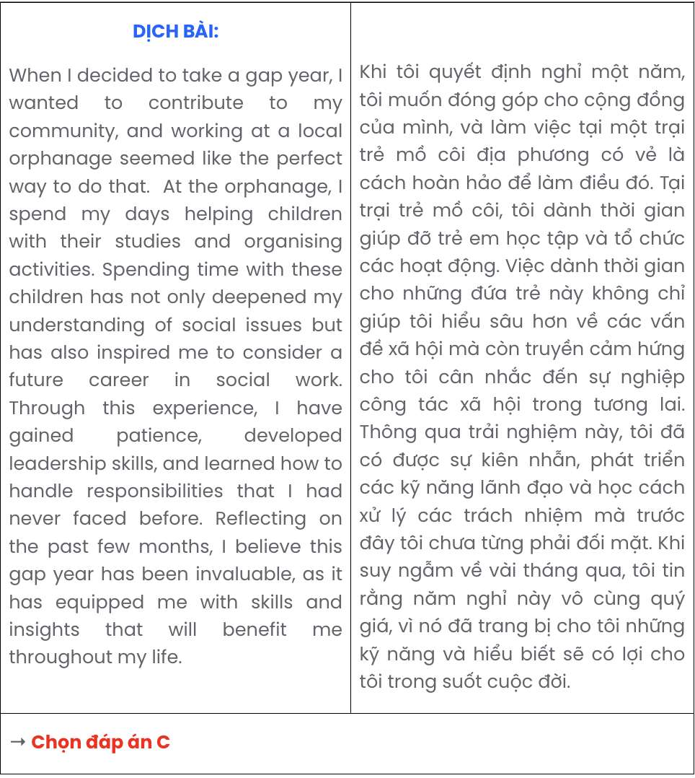

Question 14.
- As the air quality declines, many residents are noticing health issues, especially among the elderly and the children, who are more vulnerable to respiratory problems.
- Despite the recent economic growth, many villagers are concerned about the long-term impact on Oakville’s environment and public health.
- In recent years, the village of Oakville, once known for its pristine surroundings, has been facing a growing challenge with air pollution.
- The increase in trucks transporting goods to and from these factories has also contributed to both air and noise pollution, disturbing the village’s peace.
- The construction of several factories on the outskirts has brought about constant emissions that have tainted the previously fresh air.
A. c – a – d – b – e B. c – e – a – d – b C. c – b – d – e – a D. c – d – a – b – e

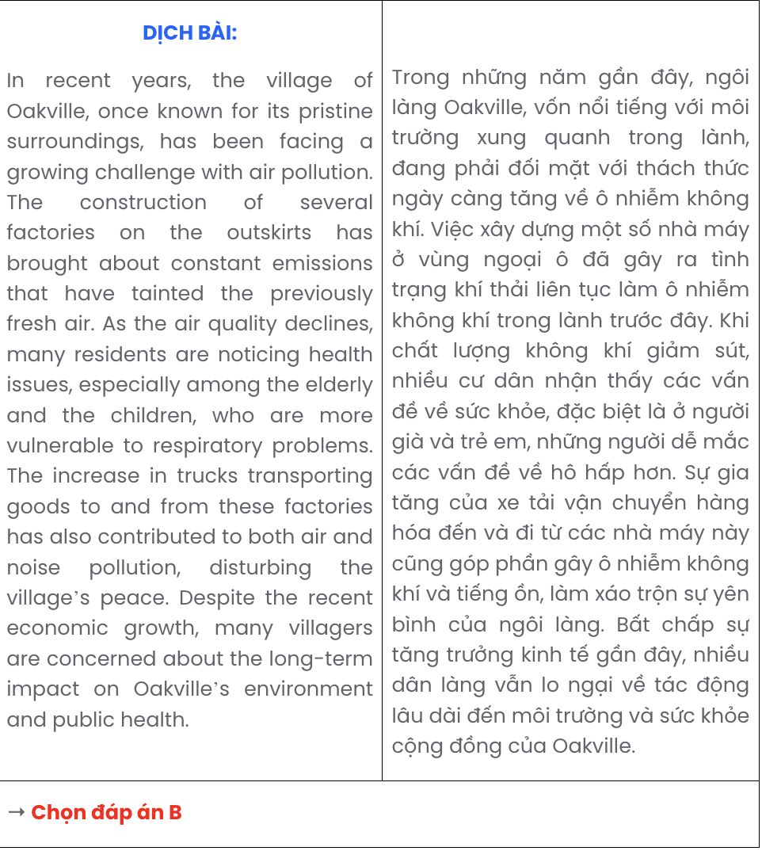

Question 15.
- Tom: Hey, Emma! It’s been so long since we last talked. Have you been travelling lately?
- Tom: Actually, yes! I’m planning to visit Italy next month. I’ve always wanted to see Rome and try authentic Italian cuisine.
- Emma: Hey, Tom! Yes, I just got back from Japan. It was an amazing trip! How about you? Any travel plans?
A. a – c – b B. a – b – c C. b – c – a D. c – a – b


Question 16.
Dear Emma,
- The tips you shared for making homemade pasta have been so helpful. I’ve tried a few recipes, and they turned out really well!
- We should definitely plan a cooking session together sometime. I’d love to learn some of your techniques!
- Thank you for the recipe book you gave me last month; it’s been a fantastic resource.
- Thanks also for suggesting the online cooking tutorials - they’re way more detailed than the ones I used to watch.
- Although I’m focused on perfecting my main dishes for the competition, it’s been fun experimenting with these new pasta recipes.
Looking forward to hearing from you, Lily

A. d – a – e – c – b B. b – d – a – c – e C. e – a – d – c – b D. c – a – e – d – b
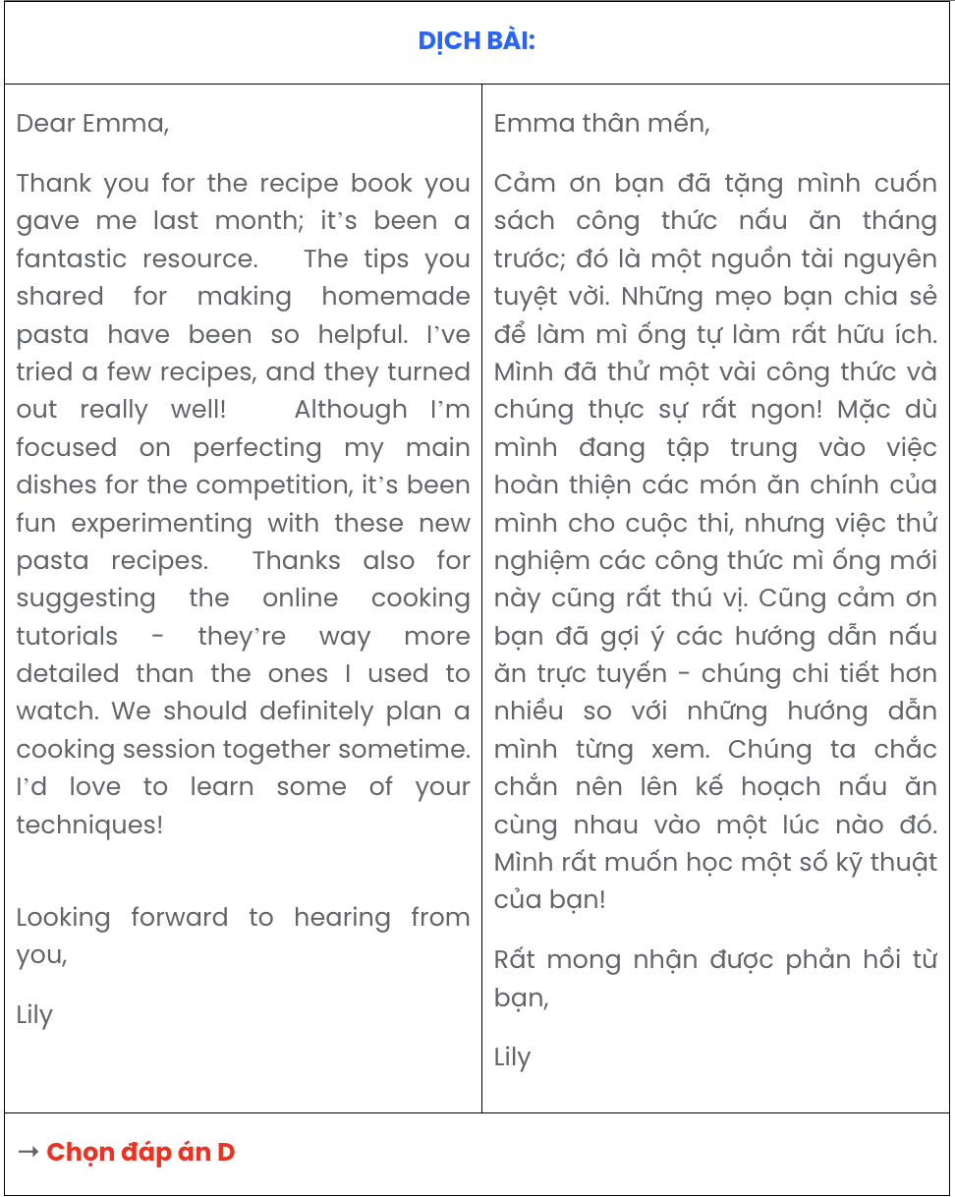

Question 17.
- Mia: I’m considering it. I think it would be a great way to stay active and make new friends.
- Mia: I’m leaning towards the tennis club. They have beginner classes, and it seems like a friendly group.
- Jack: Which club are you interested in?
- Jack: That sounds fun! I’ve heard it’s also a good workout.
- Jack: Are you thinking about joining a sports club this year?
A. c – b – e – d – a B. e – a – c – b – d C. c – a – e – b – d D. e – b – c – a – d
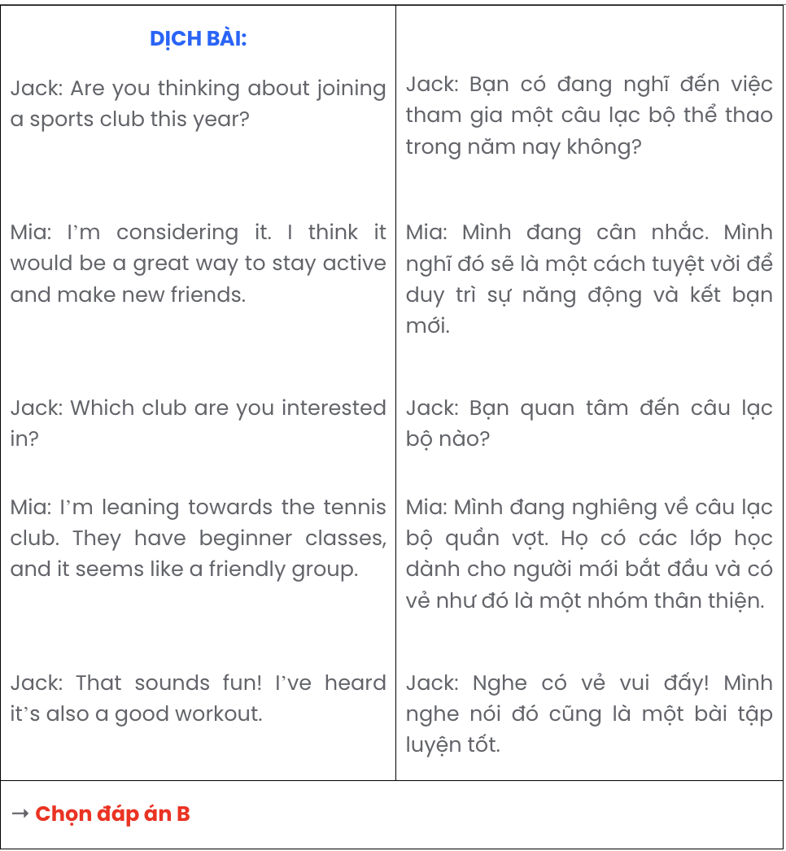

Read the following passage about net-zero movements and cultures and mark the letter A, B, C, or D to indicate the correct option that best fits each of the numbered blanks from 18 to 22.
Net-zero movements, prominent initiatives across the globe to combat climate change, are gaining momentum. The Paris Agreement, for example, (18) . In recent years, several regions have pledged net-zero emissions by 2050, aiming to balance carbon output with removal efforts.
In the corporate world, various companies are driving net-zero innovations whose collaborative approaches in clean energy, waste reduction, and sustainable practices are reshaping industries. Notably, technology giants and energy providers are adopting green energy solutions, such as solar and wind power, to reduce their reliance on fossil fuels. (19) .
Reducing carbon emissions involves strategies from improving energy efficiency to developing alternative fuel sources. Major players in these movements include renewable energy firms and policymakers, (20) . This shift is particularly evident in urban centres where public transportation systems are being revamped to minimise emissions.
Some cities are leading the way in net-zero initiatives with ambitious projects like electrifying public buses and retrofitting buildings with energy-saving systems. San Francisco, for example, has invested in zero-emission goals, setting an example for other urban areas worldwide. (21) .
The collective drive toward net-zero emissions is a response to global climate challenges. Innovative technologies, government policies, and public engagement all play a critical role in reaching net-zero targets. Fuelled by a combination of green innovations and policy frameworks, (22) .
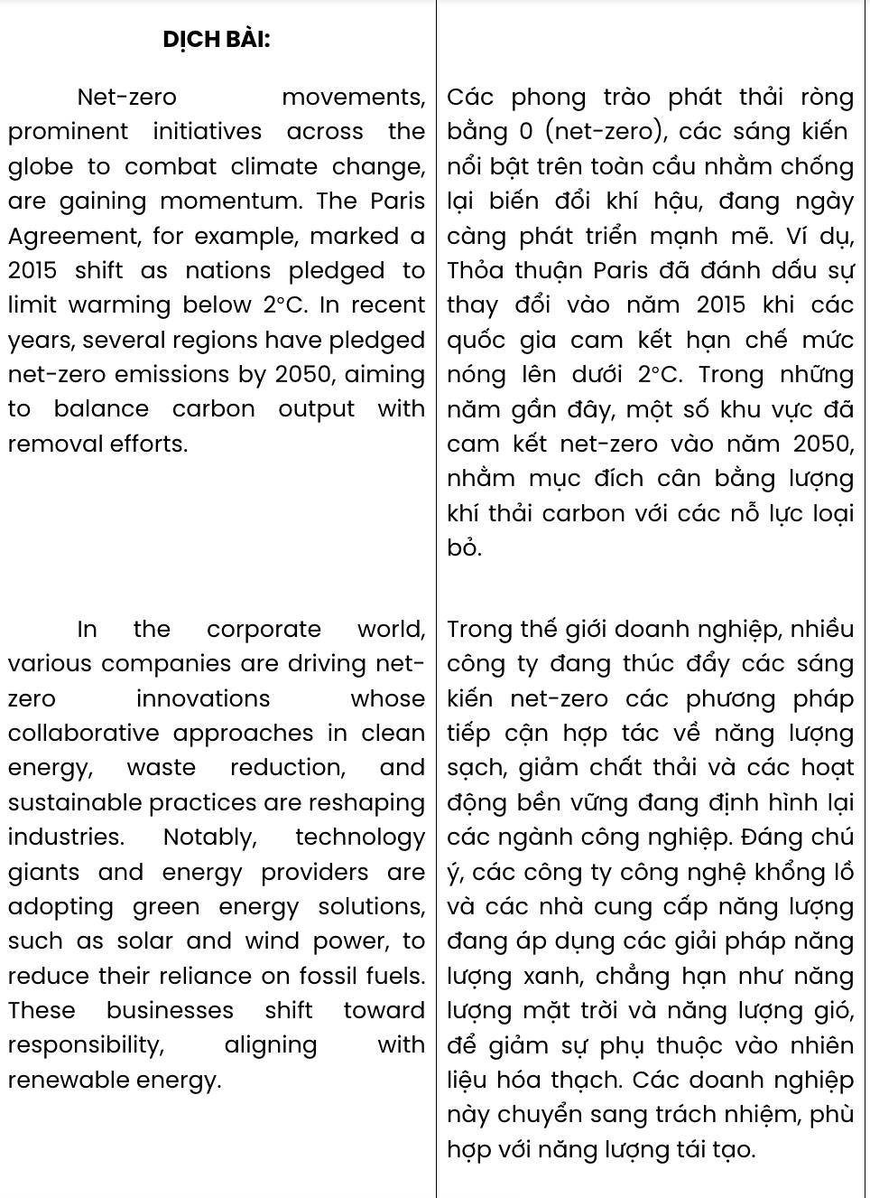
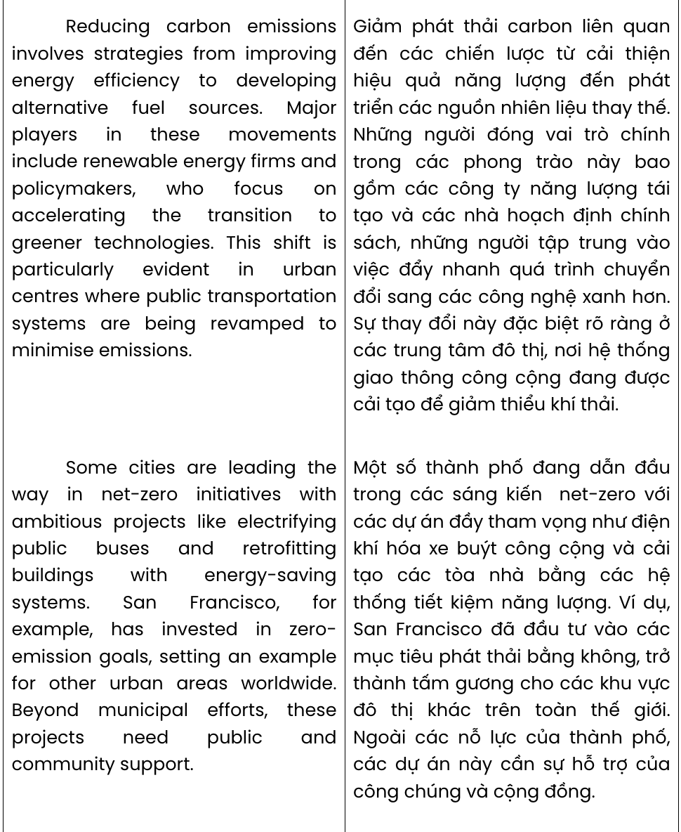
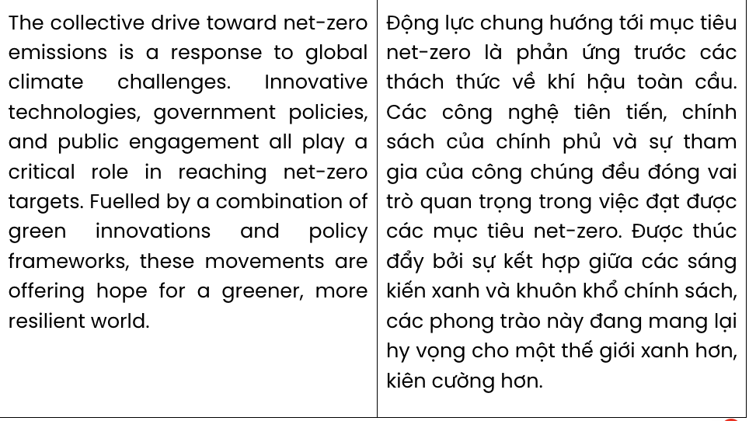

Question 18.
  - marked a 2015 shift as nations pledged to limit warming below 2°C
  - which became a historic moment with nations pledging to keep warming under 2°C
  - that became a landmark in 2015, with nations agreed to limit warming to under 2°C
  - signalling a key 2015 milestone as countries vowed to cap warming below 2°C
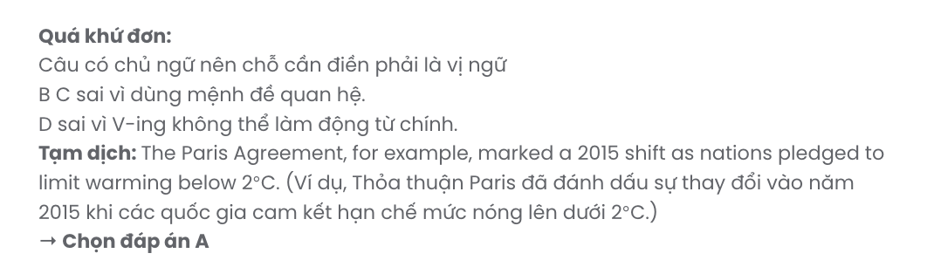

Question 19.
- Aligned with renewable technology, responsible shift is adopted by these businesses
- Without responsibility, these businesses shift towards aligning with renewable energy
- These businesses align with renewable energy so that they shift towards responsibility
- These businesses shift toward responsibility, aligning with renewable energy
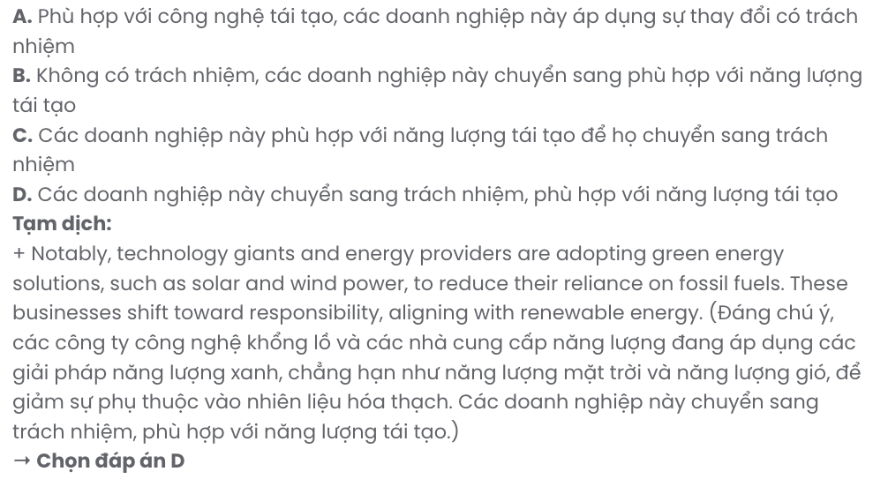

Question 20.
- whose emphasis on fast-tracking the shift to greener technologies
- who focus on accelerating the transition to greener technologies
- have been dedicated to speeding up the shift to greener technologies
- aimed at advancing the transition toward greener technologies

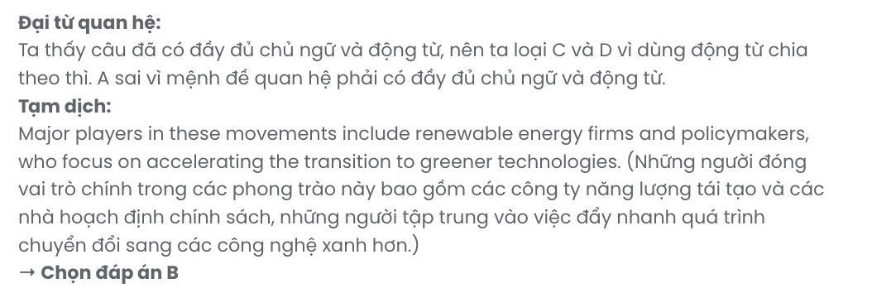

Question 21.
- Beyond municipal efforts, these projects need public and community support
- Calling for public and community support, these projects are beyond municipal efforts
- These projects need municipal efforts rather than public and community support
- Public and community support is vital for these projects regardless of municipal efforts

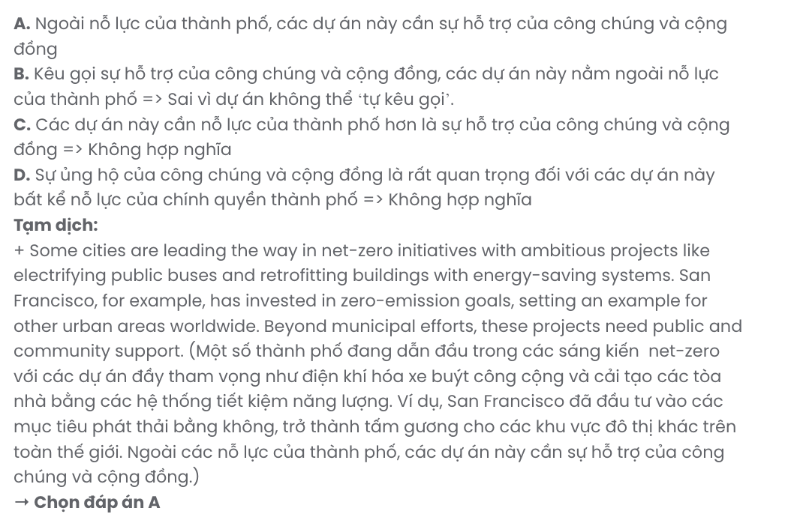

Question 22.
- hope for a green, more resilient world is feasible thanks to these movements
- a greener, more resilient world is ensured through these movements
- these movements are offering hope for a greener, more resilient world
- they bring hope for a greener, more resilient world by these movements
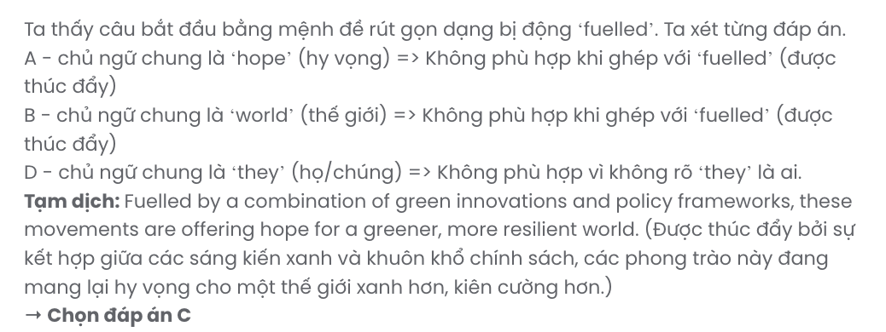

Read the following passage about climate change and growing coffee and mark the letter A, B, C, or D on your answer sheet to indicate the correct answer to each of the questions from 23 to 30.
Around the world, coffee is grown by about 25 million farmworkers on about 27 million acres of land. That's more than seven percent of Earth's surface! Just in Brazil, the world's largest coffee grower, almost 6.2 billion pounds of coffee are grown each year. In Việt Nam, coffee exports reached approximately 1.78 million tonnes in 2022 alone. Every year, people drink more than 500 billion cups. Businesses in the United States spend about $5.5 billion to bring coffee into the country, and make more than $12 billion by selling it. Coffee is big business.
Unfortunately, climate change could be a big threat to this business and the people who depend on it. To grow good coffee, the weather must be just right. If it is too hot or too cold, or if there is too much or too little rain, the plants might die or the coffee beans might be of poor quality. Climate change is making the world hotter and changing where and how much rain falls. Many regions that have perfect weather for growing coffee now will not be good places to grow coffee in the future. In Brazil, for example, more than half of good coffee land will not be usable by the year 2050.
Even worse, an insect called the coffee berry borer beetle, which likes to eat coffee beans, also loves hotter weather. This means that as the climate changes, there will be more of these insects living in more places and more coffee plants will be attacked. In addition, diseases such as coffee rust (a disease that causes the tree to lose its ability to produce berries/beans) become more common when the weather is hotter and wetter.
Coffee is the favourite drink of people all over the world. Human cooperation to stop climate change and protect coffee is essential to keep it part of our future, not just our history.
(Adapted from Explore New Worlds)
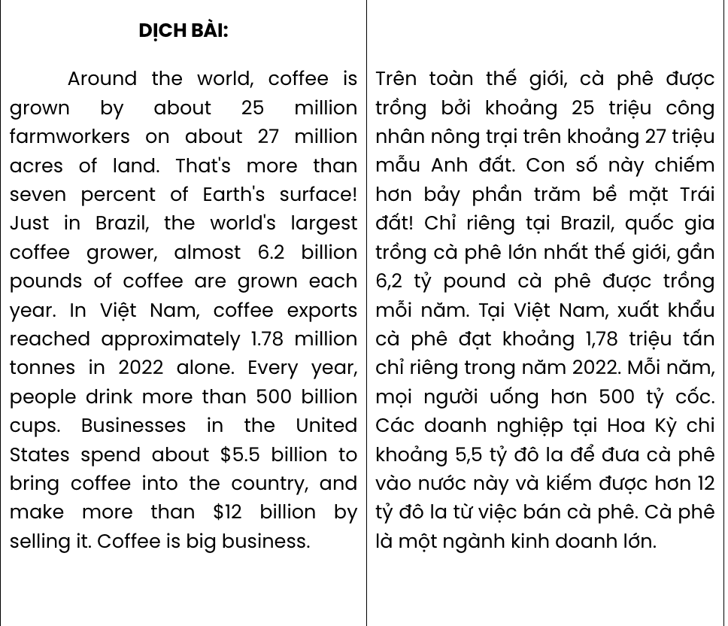
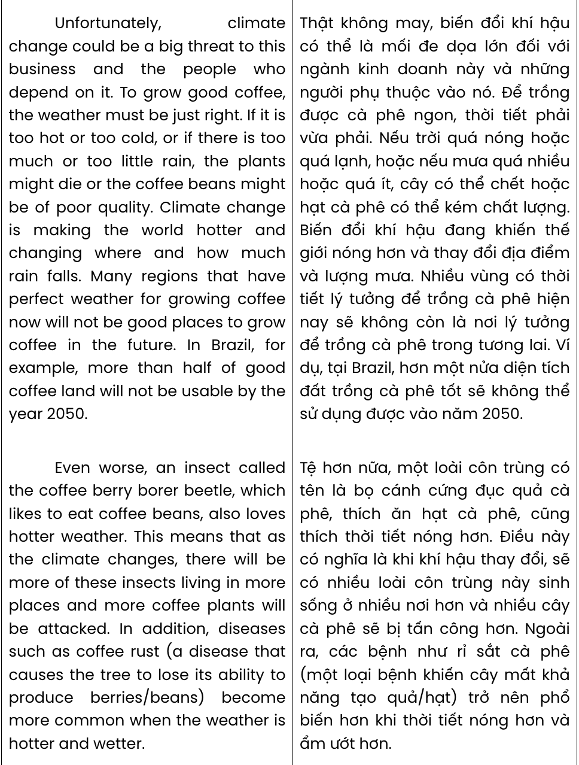
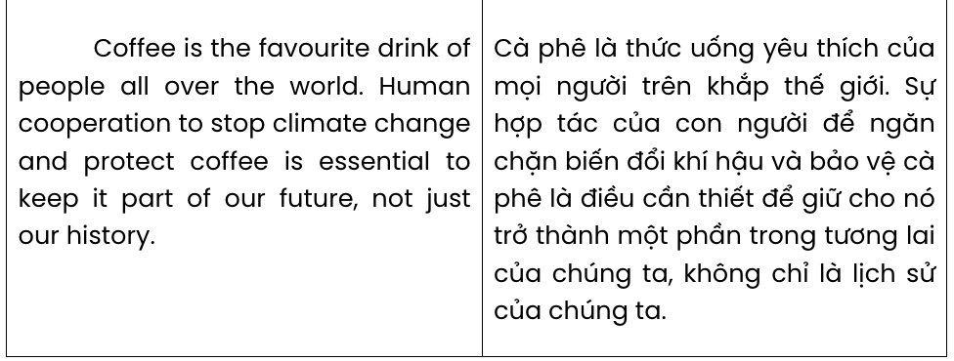
Question 23. What is suggested about Brazil and Vietnam in paragraph 1?
- Their coffee is mainly exported to the United States.
- Both countries are major coffee producers.
- They have witnessed a sharp decline in coffee exports.
- Their major export markets are developed countries.
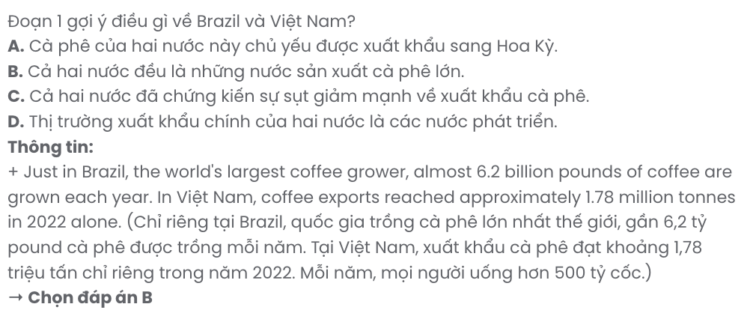
Question 24. The word it in paragraph 1 refers to .
A. business B. the country C. coffee grower D. coffee
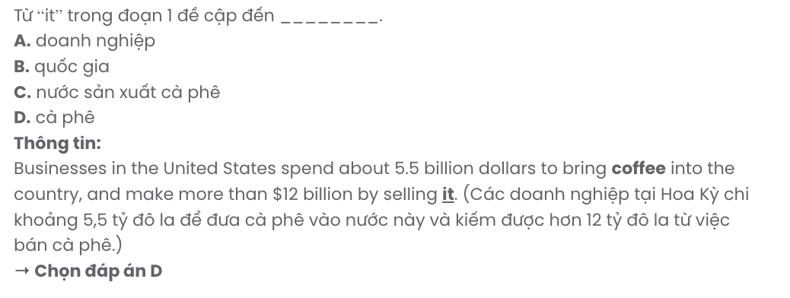
Question 25. The word threat in paragraph 2 is OPPOSITE in meaning to .
A. danger B. change C. recovery D. advantage
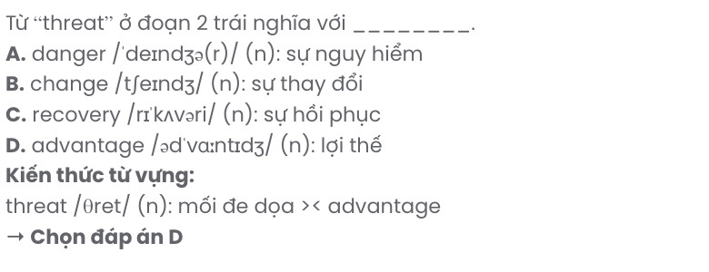

Question 26. Which of the following best paraphrases the underlined sentence in paragraph 2?

Many regions that have perfect weather for growing coffee now will not be good places to grow coffee in the future.
- Regions currently ideal for coffee cultivation may become unsuitable for it in the future.
- Coffee-growing regions will likely expand as climate conditions become more favourable.
- Places perfect for coffee farming now definitely become less ideal in the future.
- Future climate changes are predicted to enhance coffee growth in regions with suitable weather today.
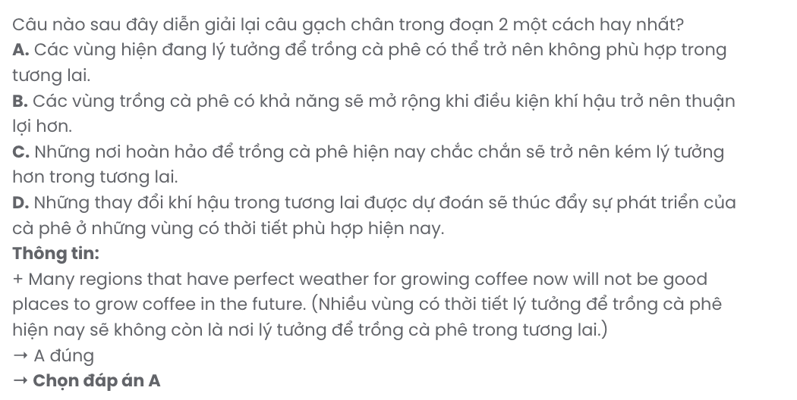
Question 27. The word common in paragraph 3 can be best replaced by .
A. abnormal B. usual C. famous D. tough
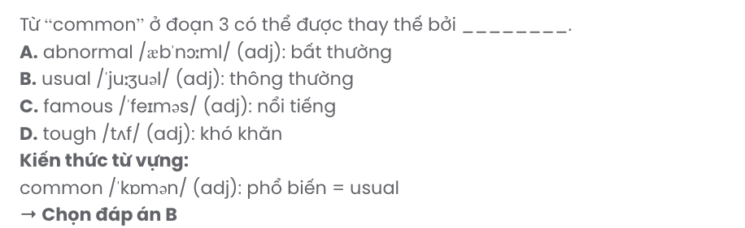
Question 28. Which of the following is TRUE according to the passage?
- Coffee is regarded as the most preferred drink of people all over the world.
- Coffee consumption in the USA is higher than any other countries worldwide.
- A favourable climate plays a vital role in producing high coffee yields.
- Climate change revives some extinct insects, causing harm to coffee plants.
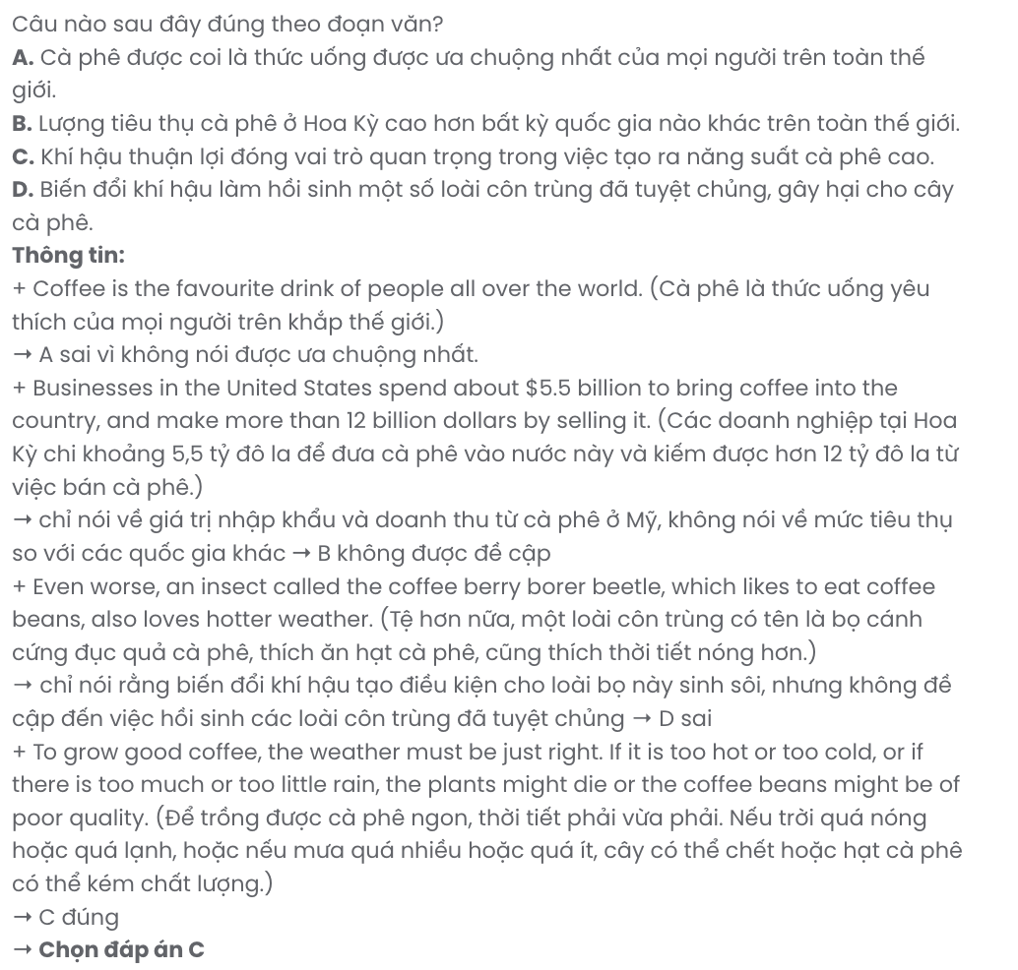
Question 29. In which paragraph does the writer call for action?
A. Paragraph 1 B. Paragraph 2 C. Paragraph 3 D. Paragraph 4
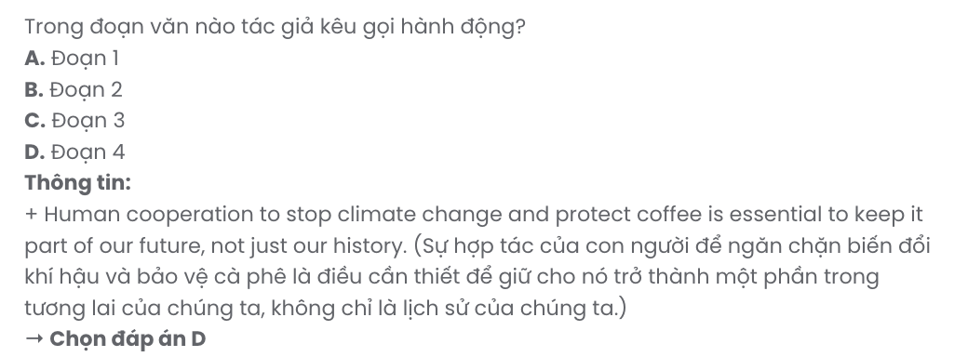
Question 30. In which paragraph does the writer mention a potential menace to coffee plants as a result of climate change?
A. Paragraph 1 B. Paragraph 2 C. Paragraph 3 D. Paragraph 4
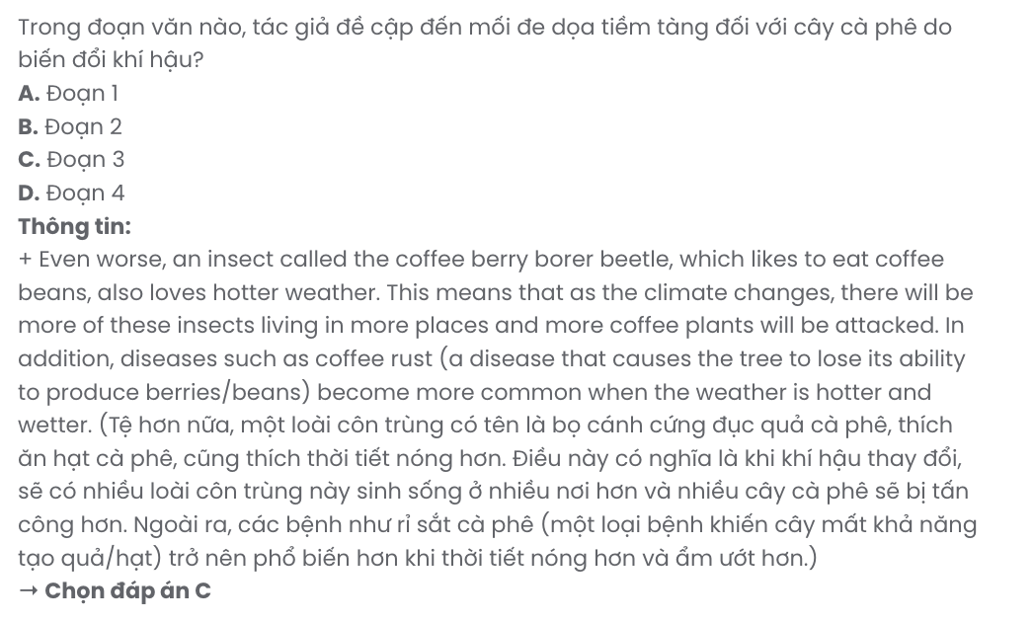

Read the following passage about Steve Irwin and mark the letter A, B, C, or D on your answer sheet to indicate the correct answer to each of the questions from 31 to 40.
Steve Irwin was an Australian television host, wildlife conservationist and zookeeper. Born on 22nd February 1962, in Australia, Steve dedicated his life to the preservation and promotion of wildlife.
Steve's passion for wildlife began at a young age when he helped his parents protect Australia's wild reptiles. They started their business by building Beerwah Reptile Park on 1.6 hectares of land in Queensland. Then, they tried to catch and relocate endangered kinds of reptiles like lizards, snakes and crocodiles to their park; besides, they took care of other injured species like kangaroos and birds. As Steve grew older, his passion for reptiles and other animals deepened, leading him to pursue a career as a nature conservationist.
[I] It was the TV series 'The Crocodile Hunter' that helped Steve become internationally famous. [II] In some scenes, Steve got so close to a venomous snake that he got bitten, but he was well-prepared for that kind of accident and got the antidote instantly. [III] With his strong enthusiasm and close approach to wild animals, he took his job seriously and successfully captured the viewers' attention, raising their awareness of conservation. [IV]
He had hosted other TV shows before he expanded Beerwah Reptile Park and renamed it the Australia Zoo. The zoo became an ideal place for Steve to educate and inspire others about the importance of the natural world. Moreover, he was a passionate supporter of wildlife conservation and helped carry out other conservation projects.
Tragically, on 4th September 2006, Steve was filming a documentary underwater in Australia's Great Barrier Reef when he was stabbed in the heart by a stingray. His untimely death shocked the world's conservation community. However, Steve's legacy of wildlife conservation continued to inspire later generations.
(Adapted from Bright)

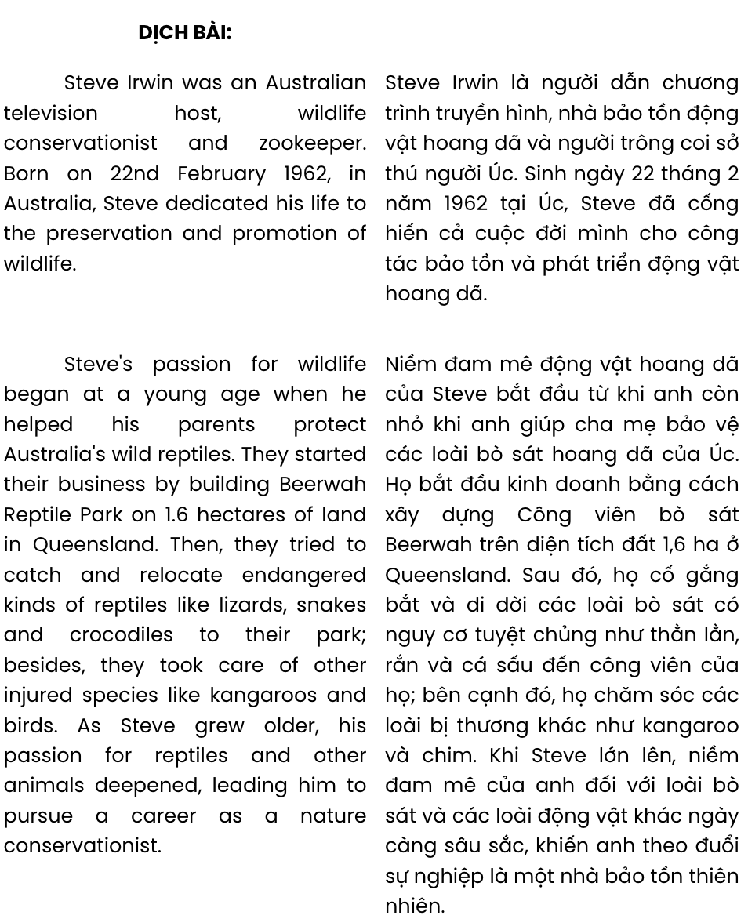

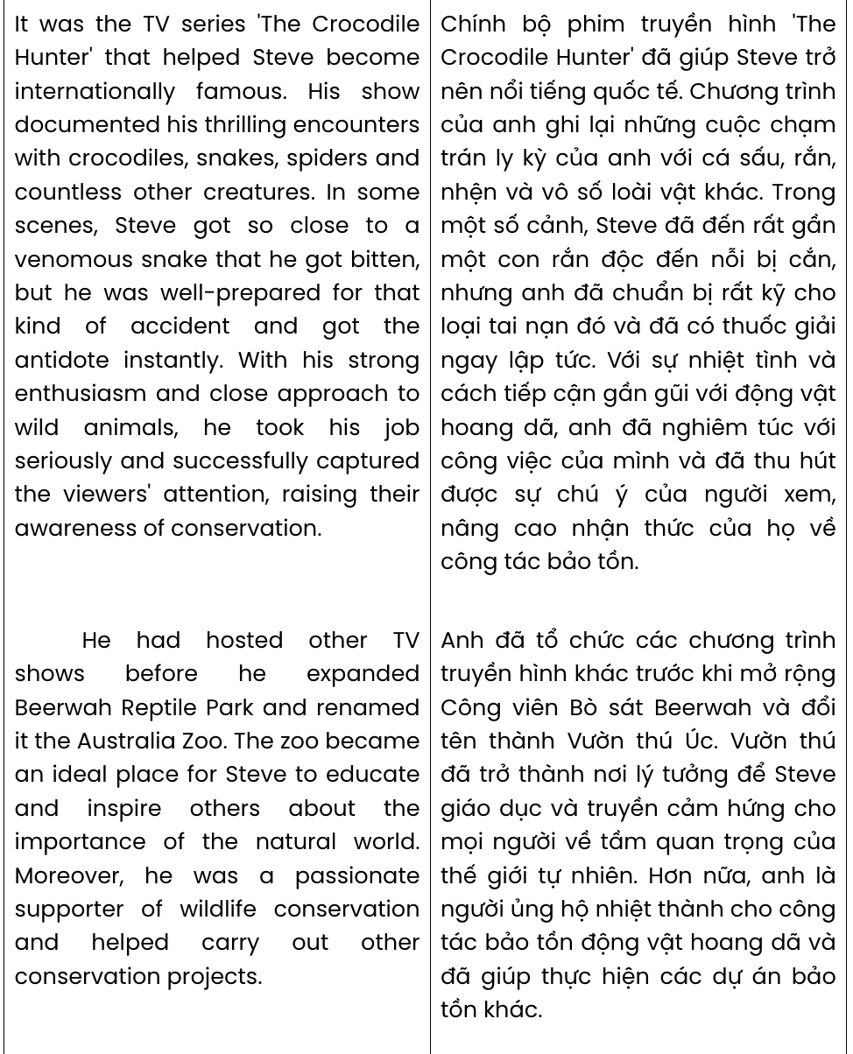

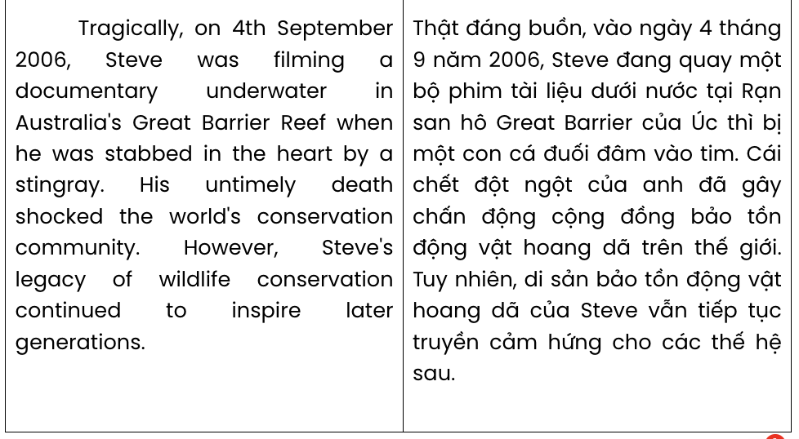
Question 31. Steve's family tried to protect Australia's wild reptiles by doing all of the following EXCEPT
. GIA SƯ TẠI HUẾ (079.3833.272)
A. caring for injured animals B. establishing Beerwah Reptile Park
C. raising awareness through documentaries D. capturing and relocating endangered reptiles
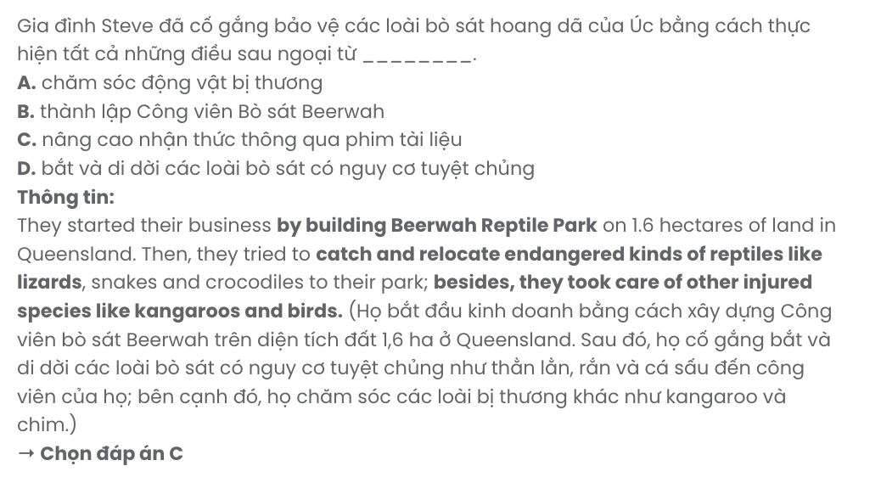
Question 32. The word pursue in paragraph 2 is OPPOSITE in meaning to .
A. attain B. restrict C. abandon D. follow
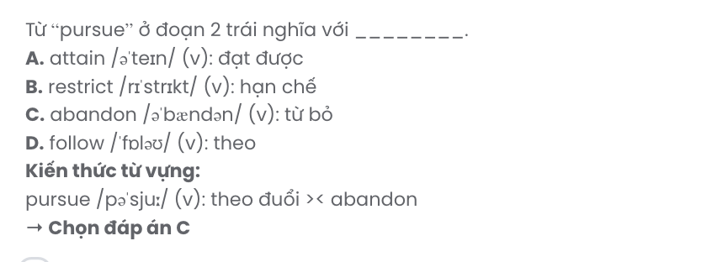
Question 33. Where in paragraph 3 does the following sentence best fit?

His show documented his thrilling encounters with crocodiles, snakes, spiders and countless other creatures.
A. [I] B. [II] C. [III] D. [IV]

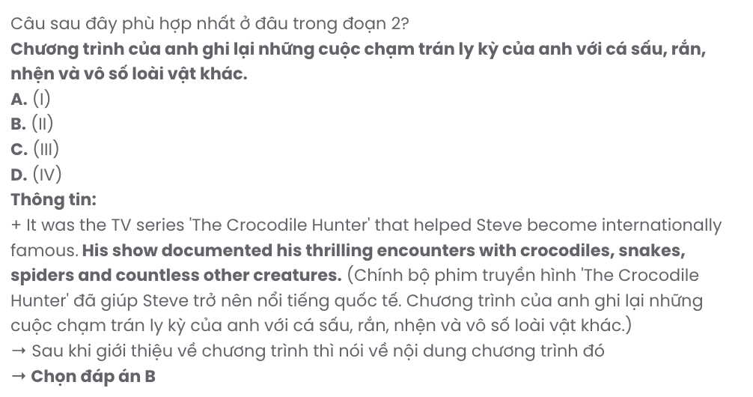
Question 34. The phrase close approach to in paragraph 3 mostly means .
A. full attention to B. hands-on encounters with
C. personal preference for D. unlimited access to
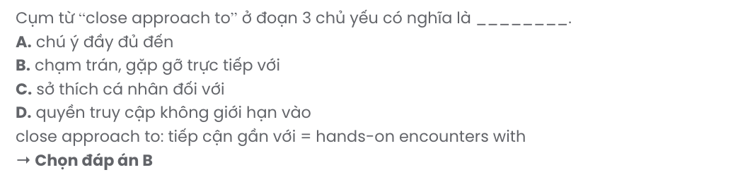
Question 35. The word their in paragraph 3 refers to .
A. animals B. scenes C. the TV series D. the viewers
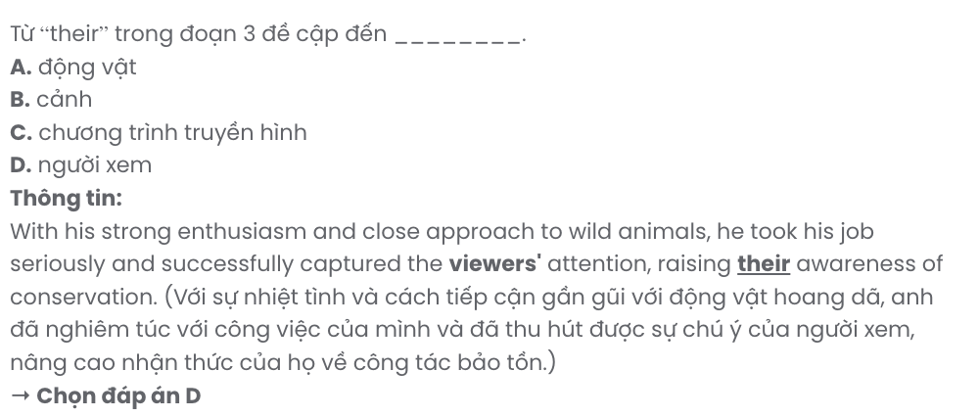
Question 36. Which of the following best summarises paragraph 4?
A. Steve Irwin expanded Beerwah Reptile Park into the Australia Zoo, educating others and supporting conservation efforts.
B. Steve Irwin hosted TV shows to entertain viewers and expanded his zoo to support wildlife tourism.
C. The Australia Zoo became a leading tourist attraction, focused on rare animal exhibits and conservation work.
D. Steve Irwin supported endangered species at his park, which later grew into a national sanctuary.

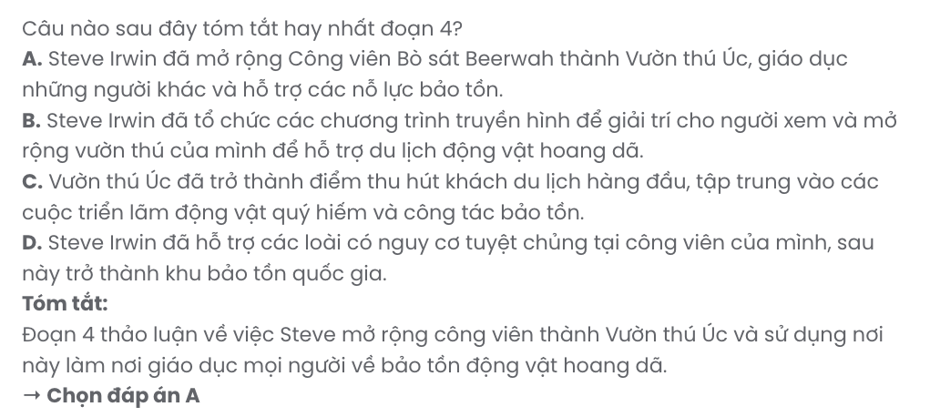
Question 37. Which of the following best paraphrases the underlined part in paragraph 5?

Steve's legacy of wildlife conservation continued to inspire later generations.
A. Steve’s passion for wildlife led later generations to prioritise animal preservation above all else.
B. Steve’s efforts in animal rescue inspired future generations to join the entertainment industry.
C. Steve’s dedication to wildlife conservation remains an inspiration for future generations.
D. Steve’s work in wildlife conservation became popular, making it a trend for future generations.
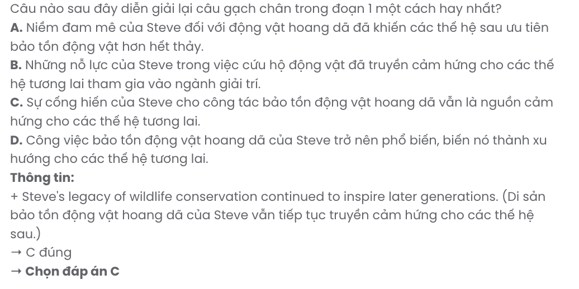
Question 38. Which of the following is NOT mentioned in the passage?
A. Steve’s death while doing his job was astonishing to the world's conservation community.
B. Steve Irwin was deeply committed to wildlife conservation, starting from a young age.
C. Steve used the Australia Zoo for educational purposes, inspiring people to appreciate nature.
D. Being a passionate supporter of conservation, Steve launched awareness campaigns himself.
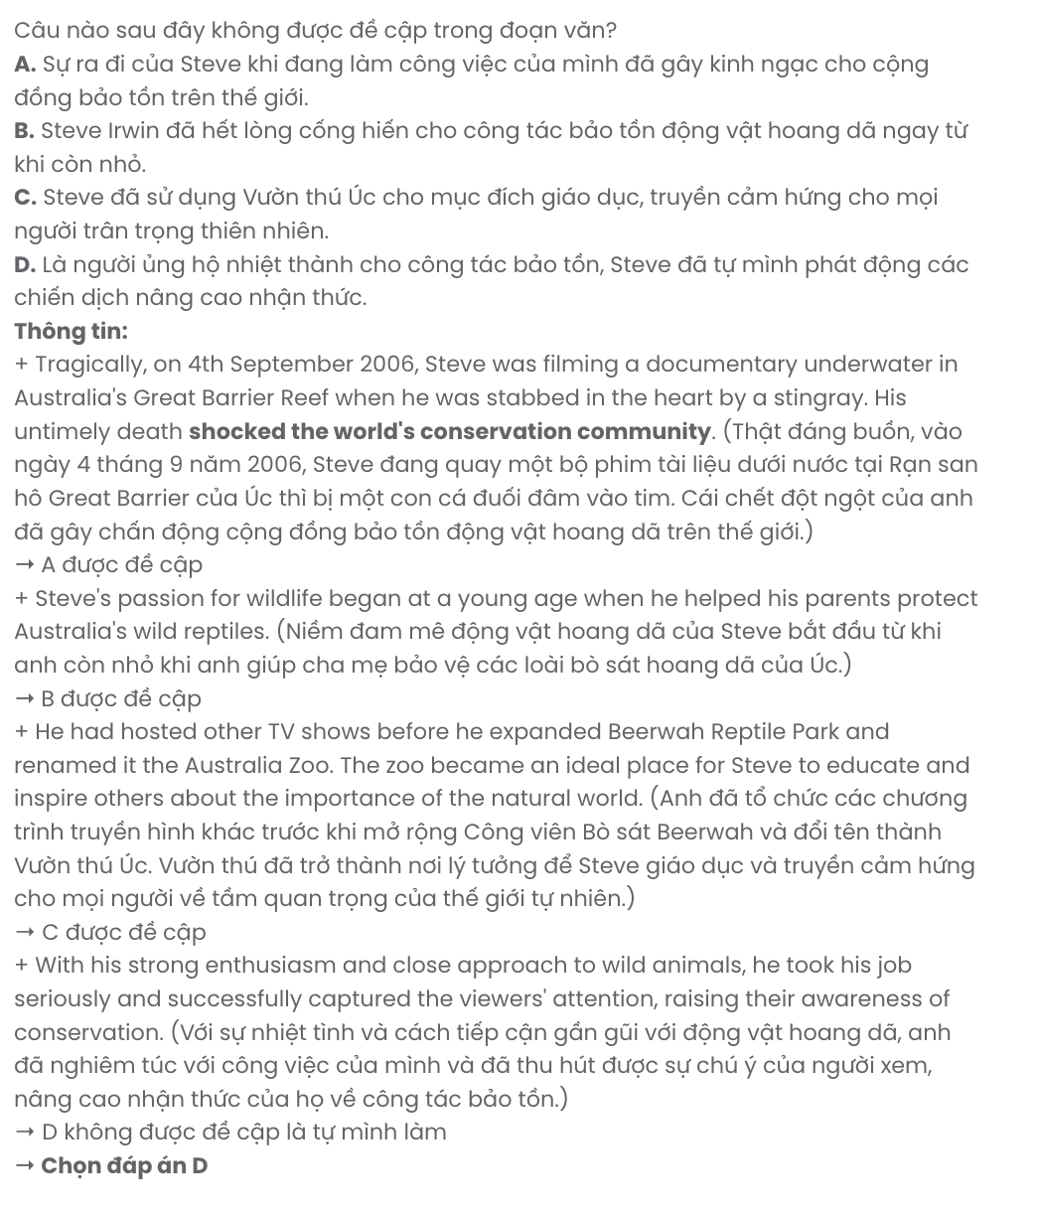
Question 39. Which of the following can be inferred about Steve Irwin from the passage?
A. His methods and dedication to wildlife conservation are unmatched by any other conservationists.
B. His unique approach to wildlife conservation played a significant role in changing public attitudes toward wildlife.
C. His decision to rename Beerwah Reptile Park made it more feasible for him to carry out conservation projects.
D. It was his parents who instilled a lifelong passion for protecting wildlife in him, leading him to gain numerous achievements.
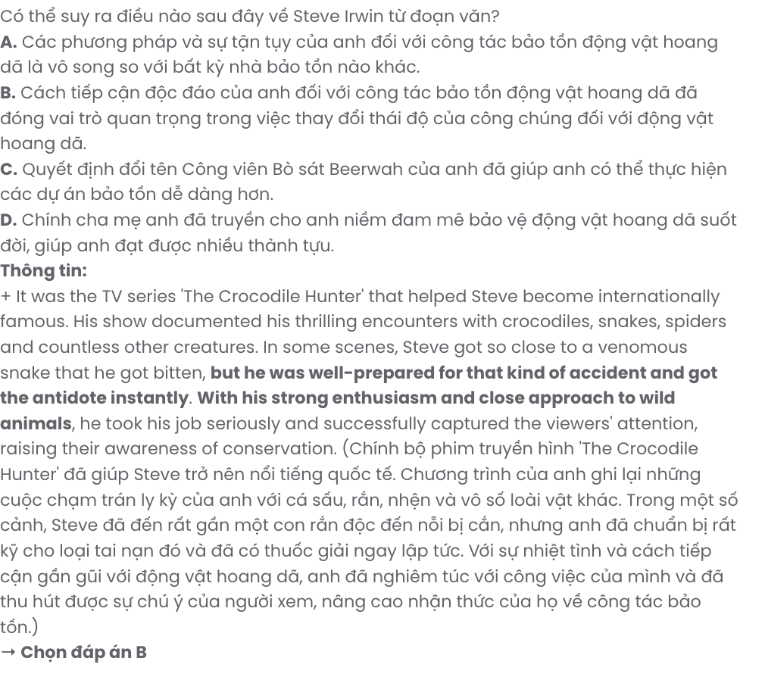

Question 40. Which of the following best summarises the passage?
A. Steve Irwin grew Beerwah Reptile Park into the Australia Zoo, using his passion to focus mainly on native animal rescue and species preservation.
B. Steve Irwin’s career, marked by The Crocodile Hunter, was largely centred around expanding his family’s reptile park, with a focus on attracting international visitors to the Australia Zoo.
C. Steve Irwin became known as a wildlife conservationist whose primary goal was showcasing Australia’s unique animals in the expanded Australia Zoo, where he centred his efforts on education and animal welfare.
D. Steve Irwin, an Australian conservationist and TV host, gained fame through The Crocodile Hunter and expanded Beerwah Reptile Park into the Australia Zoo to promote wildlife conservation and inspire future generations.

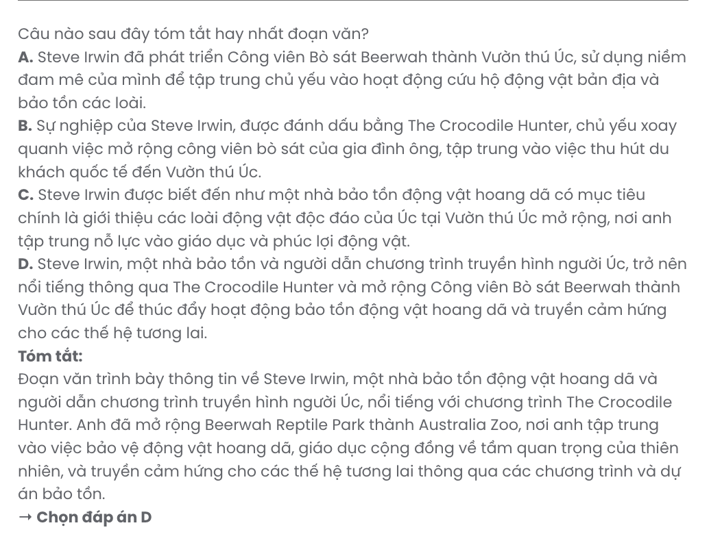

BẢNG TỪ VỰNG
STT | Từ vựng | Từ loại | Phiên âm | Nghĩa
1 | traditional | adj | /trəˈdɪʃənl/ | truyền thống
2 | thrilled | adj | /θrɪld/ | vui mừng
3 | upcoming | adj | /ˈʌpˌkʌmɪŋ/ | sắp tới
4 | participate | v | /pɑːˈtɪsɪpeɪt/ | tham gia
5 | artistic | adj | /ɑːˈtɪstɪk/ | nghệ thuật
6 | expression | n | /ɪkˈspreʃn/ | biểu đạt
7 | fulfilled | adj | /fʊlˈfɪld/ | mãn nguyện
8 | folk music | np | /ˈfəʊk mjuːzɪk/ | dân ca
9 | issue | n | /ˈɪʃuː/ | vấn đề
10 | region | n | /ˈriːdʒən/ | khu vực
11 | forum | n | /ˈfɔːrəm/ | diễn đàn
12 | platform | n | /ˈplætfɔːm/ | nền tảng
13 | exchange | v | /ɪksˈʧeɪnʤ/ | trao đổi
14 | pressing | adj | /ˈpresɪŋ/ | nhức nhối, cấp bách
15 | economic | adj | /ˌiːkəˈnɒmɪk/ | thuộc kinh tế
16 | resilience | n | /rɪˈzɪliəns/ | sự phục hồi
17 | bright | adj | /braɪt/ | sáng dạ
18 | dynamic | adj | /daɪˈnæmɪk/ | năng nổ
19 | dialogue | n | /ˈdaɪəlɒɡ/ | đối thoại
20 | strengthen | v | /ˈstreŋkθn/ | tăng cường
21 | tie | n | /taɪ/ | mối quan hệ
22 | session | n | /ˈseʃn/ | phiên (họp, thảo luận)
23 | sustainable | adj | /səˈsteɪnəbl/ | bền vững
24 | digital | adj | /ˈdɪʤɪtl/ | kỹ thuật số
25 | literacy | n | /ˈlɪtərəsi/ | sự biết chữ
26 | insight | n | /ˈɪnsaɪt/ | cái nhìn sâu sắc
27 | practical | adj | /ˈpræktɪkl/ | thực tế
28 | strategy | n | /ˈstrætəʤi/ | chiến lược
29 | like-minded | adj | /ˌlaɪk ˈmaɪndɪd/ | cùng chí hướng, chung sở thích
30 | dweller | n | /ˈdwelə(r)/ | cư dân
31 | representative | n | /ˌreprɪˈzentətɪv/ | đại diện
32 | peer | n | /pɪə(r)/ | người đồng trang lứa
33 | understanding | n | /ˌʌndəˈstændɪŋ/ | sự hiểu biết
34 | community | n | /kəˈmjuːnəti/ | cộng đồng
35 | orphanage | n | /ˈɔːfənɪdʒ/ | trại trẻ mồ côi

36 | organise/  organize | v | /ˈɔːɡənaɪz/ | tổ chức
37 | patience | n | /ˈpeɪʃns/ | sự kiên nhẫn
38 | leadership | n | /ˈliːdəʃɪp/ | sự lãnh đạo
39 | handle | v | /ˈhændl/ | xử lý
40 | responsibility | n | /rɪˌspɒnsɪˈbɪləti/ | trách nhiệm
41 | reflect | v | /rɪˈflekt/ | suy ngẫm
42 | invaluable | adj | /ɪnˈvæljəbl/ | quý giá
43 | pristine | adj | /ˈprɪstiːn/ | nguyên sơ
44 | surrounding | n | /səˈraʊndɪŋ/ | môi trường xung quanh
45 | outskirts | n | /ˈaʊtskɜːts/ | ngoại ô
46 | constant | adj | /ˈkɒnstənt/ | liên tục
47 | emission | n | /ɪˈmɪʃn/ | khí thải
48 | taint | v | /teɪnt/ | làm ô nhiễm
49 | resident | n | /ˈrezɪdənt/ | cư dân
50 | respiratory | adj | /rəˈspɪrətri/ | về hô hấp
51 | disturb | v | /dɪˈstɜːb/ | làm xáo trộn
52 | long-term | adj | /ˈlɒŋtɜːm/ | lâu dài
53 | authentic | adj | /ɔːˈθentɪk/ | đích thực
54 | cuisine | n | /kwɪˈziːn/ | ẩm thực
55 | recipe | n | /ˈresɪpi/ | công thức
56 | resource | n | /rɪˈzɔːs/ | tài nguyên
57 | homemade | adj | /ˌhəʊmˈmeɪd/ | làm tại nhà
58 | experiment | v | /ɪkˈsperɪmənt/ | thí nghiệm, thử nghiệm
59 | tutorial | n | /tjuːˈtɔːriəl/ | hướng dẫn
60 | technique | n | /tekˈniːk/ | kỹ thuật
61 | workout | n | /ˈwɜːkaʊt/ | bài tập luyện
62 | net-zero | n | /ˌnet ˈzɪərəʊ/ | phát thải ròng bằng 0
63 | movement | n | /ˈmuːvmənt/ | phong trào
64 | prominent | adj | /ˈprɒmɪnənt/ | nổi bật
65 | initiative | n | /ɪˈnɪʃətɪv/ | sáng kiến
66 | climate change | n | /ˈklaɪmət tʃeɪndʒ/ | biến đổi khí hậu
67 | shift | n | /ʃɪft/ | sự thay đổi
68 | pledge | v | /pleʤ/ | cam kết
69 | innovation | n | /ˌɪnəˈveɪʃn/ | sự đổi mới, sáng tạo
70 | collaborative | adj | /kəˈlæbərətɪv/ | mang tính hợp tác
71 | approach | n | /əˈprəʊʧ/ | phương pháp, cách tiếp cận
72 | reshape | v | /ˌriːˈʃeɪp/ | định hình lại
73 | industry | n | /ˈɪndəstri/ | ngành công nghiệp

74 | fossil fuel | n | /ˈfɒsl fjuːəl/ | nhiên liệu hóa thạch
75 | renewable | n | /rɪˈnjuːəbl/ | tái tạo
76 | efficiency | n | /ɪˈfɪʃnsi/ | hiệu quả
77 | alternative | n | /ɒlˈtɜːnətɪv/ | cái thay thế
78 | firm | n | /fɜːm/ | công ty
79 | policymaker | n | /ˈpɒləsɪˌmeɪkə/ | nhà hoạch định chính sách
80 | accelerate | v | /əkˈseləreɪt/ | tăng tốc
81 | transition | n | /trænˈzɪʃn/ | sự chuyển giao
82 | evident | adj | /ˈevɪdənt/ | rõ ràng
83 | revamp | v | /ˌriːˈvæmp/ | cải tạo
84 | minimise/  minimize | v | /ˈmɪnɪmaɪz/ | giảm tối thiểu
85 | ambitious | adj | /æmˈbɪʃəs/ | tham vọng
86 | electrify | v | /ɪˈlektrɪfaɪ/ | điện khí hóa
87 | retrofit | v | /ˈretrəʊfɪt/ | cải tạo
88 | municipal | adj | /mjuːˈnɪsɪpl/ | thuộc thành phố
89 | collective | adj | /kəˈlektɪv/ | tập thể
90 | drive | n | /draɪv/ | động lực
91 | framework | n | /ˈfreɪmwɜːk/ | khuôn khổ
92 | surface | n | /ˈsɜːfɪs/ | bề mặt
93 | export | v | /ɪksˈpɔːt/ | xuất khẩu
94 | approximately | adv | /əˈprɒksɪmətli/ | xấp xỉ
95 | threat | n | /θret/ | mối đe dọa
96 | advantage | n | /ədˈvɑːntɪdʒ/ | lợi thế
97 | usable | adj | /ˈjuːzəbl/ | sử dụng được
98 | insect | n | /ˈɪnsekt/ | côn trùng
99 | beetle | n | /ˈbiːtl/ | bọ cánh cứng
100 | common | adj | /ˈkɒmən/ | thông thường, phổ biến
101 | abnormal | adj | /æbˈnɔːml/ | bất thường
102 | usual | adj | /ˈjuːʒuəl/ | thông thường
103 | cooperation | n | /kəʊˌɒpəˈreɪʃn/ | sự hợp tác
104 | essential | adj | /ɪˈsenʃl/ | thiết yếu
105 | wildlife | n | /ˈwaɪldlaɪf/ | động vật hoang dã
106 | conservationist | n | /ˌkɒnsəˈveɪʃnɪst/ | nhà bảo tồn
107 | zookeeper | n | /ˈzuːˌkiːpə/ | người trông coi sở thú
108 | reptile | n | /ˈreptaɪl/ | loài bò sát
109 | relocate | v | /ˌriːləʊˈkeɪt/ | di dời
110 | endangered | adj | /ɪnˈdeɪnʤəd/ | nguy cấp
111 | lizard | n | /ˈlɪzəd/ | thằn lằn

112 | crocodile | n | /ˈkrɒkədaɪl/ | cá sấu
113 | pursue | v | /pəˈsjuː/ | theo đuổi
114 | attain | v | /əˈteɪn/ | đạt được
115 | restrict | v | /rɪˈstrɪkt/ | hạn chế
116 | abandon | v | /əˈbændən/ | từ bỏ
117 | creature | n | /ˈkriːʧə/ | sinh vật
118 | venomous | adj | /ˈvenəməs/ | (động vật) có độc
119 | well-prepared | adj | /wel prɪˈpeəd/ | chuẩn bị kỹ
120 | antidote | n | /ˈæntidəʊt/ | thuốc giải độc
121 | enthusiasm | n | /ɪnˈθjuːziæzəm/ | sự nhiệt tình
122 | ideal | adj | /aɪˈdɪəl/ | lý tưởng
123 | inspire | v | /ɪnˈspaɪə/ | truyền cảm hứng
124 | documentary | n | /ˌdɒkjuˈmentri/ | phim tài liệu
125 | underwater | adj | /ˌʌndəˈwɔːtə/ | dưới nước
126 | stab | v | /stæb/ | đâm
127 | stingray | n | /ˈstɪŋreɪ/ | cá đuố i
128 | untimely | adv | /ʌnˈtaɪmli/ | đột ngột
129 | legacy | n | /ˈleɡəsi/ | di sản

BẢNG CẤU TRÚC
STT | Cấu trúc | Nghĩa
1 | passionate about something | đam mê điều gì
2 | show off | thể hiện
3 | go over | xem lại
4 | take up | chiếm
5 | keep on | tiếp tục
6 | encourage somebody to do something | khuyến khích ai làm gì
7 | take place | diễn ra
8 | sign up | đăng ký
9 | eager to do something | mong muốn, háo hức làm gì
10 | take steps | thực hiện các bước
11 | take a gap year | nghỉ một năm sau khi tốt nghiệp
12 | deepen one’s understanding | làm sâu sắc thêm sự hiểu biết
13 | equip somebody with something | trang bị cho ai cái gì
14 | face a challenge | đối mặt với thử thách
15 | be vulnerable to something | dễ bị tổn thương trước điều gì
16 | contribute to something | góp phần vào điều gì
17 | be concerned about something | lo ngại về điều gì
18 | get back from somewhere | trở về từ đâu
19 | turn out | diễn ra thế nào, hoá ra
20 | stay active | duy trì sự năng động
21 | make friends | kết bạn
22 | lean towards something | nghiêng về gì
23 | gain momentum | phát triển mạnh mẽ
24 | pledge to do something | cam kết làm gì
25 | align with something | phù hợp với gì
26 | lead the way | đi đầu
27 | play a role | đóng vai trò
28 | depend/ rely on somebody or something | phụ thuộc vào ai/gì
29 | take care of somebody or something | chăm sóc ai/gì
30 | close approach to something | cách tiếp cận gần gũi
31 | capture one’s attention | thu hút sự chú ý của ai
32 | raise awareness | nâng cao nhận thức
33 | carry out | tiến hành

