**LIFESTYLE**

**A closer look at fashion**

**Pre-viewing: Look at the photos and discuss the questions.**

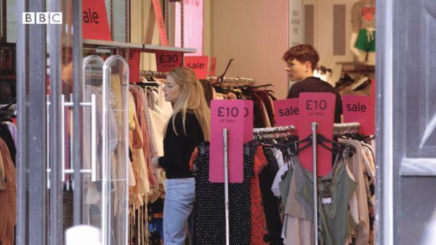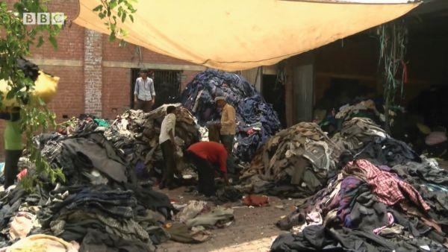

**A B**

1. What can you see in the photos?

2. How can you connect the photos?

3. What problems could the fashion industry and clothes production cause?

**While-viewing**

**Task 1: Watch Part 1 of a TV programme about the fashion industry and check your answers to questions in Pre-viewing.**

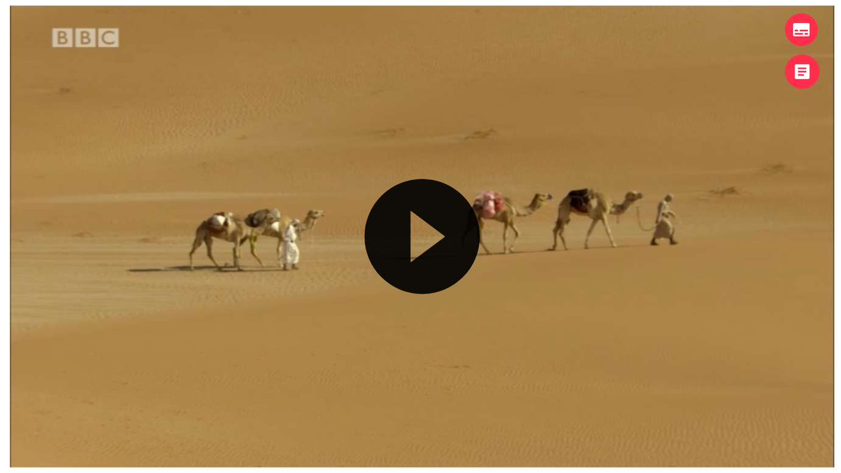

**Task 2: Watch Part 2 of the video and mark the sentences *True* or *False*.**

| 1. People have started producing cotton very recently. | True | False |
| --- | --- | --- |
| 2. People are generally aware how much water is needed to produce clothes. | True | False |
| 3. The Aral Sea is in Asia. | True | False |
| 4. The Aral Sea was important for the fishing and tourist industry. | True | False |

**Post-viewing**

**1. Is fast-fashion popular in Vietnam? Does it cause any problems?**

**2. How does the documentary suggest we should change the way we think about clothes? Do you agree?**

**ANSWER KEY**

**Pre-viewing**

1. In photo A, people are shopping in a sale. In photo B, people are looking at clothes in a place with a lot of old/thrown away/unwanted clothes.

2. People buy a lot of clothes and then throw them away. We can see a lot of old clothes like this in photo B.

3. children working, using animal products

**While-viewing**

**Task 1**

1. In photo A, people are shopping in a sale, in a high street clothes shop. In photo B people are bringing clothes to a place with thrown away/unwanted clothes.

2. People buy a lot of new clothes and then throw many of them away.

3. We’re producing and buying too many new clothes. This creates a lot of waste and has an environmental price. Clothes factories use a lot of chemicals, and they produce a lot of waste. That waste can pollute the air and the water. There are health problems for local people near clothes factories.

**Task 2.**

**1. F 2. F 3. T 4. T**

**Post-viewing**

1. Students’ own answers.

2. We should buy fewer clothes and throw fewer of them away. The clothes industry should use fewer natural resources to make clothes. This will have a less harmful effect on the environment and also reduce the need for factory activities.

***AUDIO SCRIPT***

**The price of fashion, Part 1**

These days the fashion industry is big business. Fashion designers bring out new clothes collections every week. And everybody wants to have the latest styles. That means a lot of shopping. Fashion bloggers on social media and clothes shops on the High street want us to buy, buy, buy. But what is the environmental price of all these clothes?

Stacey Dooley is meeting Lucy Siegle – a journalist who’s been investigating the problem.

‘What we’re doing is we are producing over a hundred billion new garments from new fibres every single year and the planet cannot sustain that.’

The idea of fast fashion means that people throw a lot of clothes away. In fact, six out of ten of all new clothes become rubbish like this in less than a year. The fashion industry causes a lot of pollution. Clothes factories use a lot of chemicals and they produce a lot of waste. That waste can pollute the air and the water, and cause health problems for the local people. But do we actually know about this?

**The price of fashion, Part 2**

Cotton is one of the world’s favourite materials. It feels natural and eco-friendly, but the truth is very different. People have been producing cotton for thousands of years. These days we produce around 25 million tons of it every year. Growing and producing cotton uses a lot of water. It’s difficult to believe how much as this survey in the city centre shows. To make just one pair of jeans you need … how many litres?

‘One thousand, two thousand, three thousand, four thousand, five thousand, fifteen thousand 5 hundred and twenty tree.’

‘No way!’

And for a pair of jeans and a shirt you need …

‘Nineteen, twenty, twenty thousand five hundred litres.’

‘What?’

We all love to shop, but how often do we think of fashion’s effect on the environment?

‘How many pairs of jeans do you have?’

‘Probably about six or eight.’

‘Six or eight. You know, to put it frankly, cotton is responsible for one of the biggest environmental catastrophes that we’ve seen today on planet earth.’

This is the catastrophe that Lucy is talking about. This area was once the Aral Sea on the border of Kazakhstan and Uzbekistan. Sixty-eight thousand square kilometres of water. The Aral Sea had an important fishing industry and was popular with tourists too, but in the 1960s people began growing cotton in this region. They changed the direction of some rivers so that the water went to the cotton farms and not into the sea. Ninety per cent of the Aral Sea gradually disappeared and became desert like this. Cotton farming and the clothes industry have caused the problems of this region.

Perhaps it’s time for all of us to change our shopping habits. We need to stop and think about what fast fashion is doing to the planet.