|  |  |
| --- | --- |
| **Mã đề 9.1.37** | **ĐỀ KIỂM TRA HỌC KỲ I**  **NĂM HỌC 2022 – 2023**  **Môn: Tiếng Anh 9 (Hệ 10 năm)**  ***Thời gian làm bài: 45 phút***  ***( Đề gồm 03 trang )*** |

**A.LISTENING (2.0 POINTS**)

**I. Listen and choose the correct answer. (1.0 point)**

**1.** When is the party? (thông hiểu)

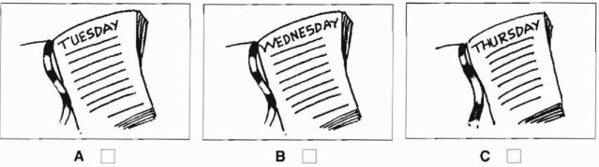

**2.** Where are the glasses? (thông hiểu)

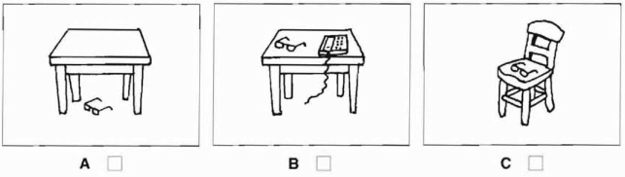

**3.** How much are the shoes? (nhận biết)

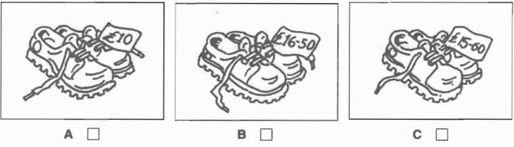

**4.** What will the weather be like in the afternoon? (thông hiểu)

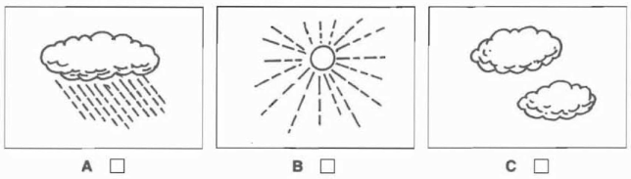

**5.** What time will she take the train? (nhận biết)

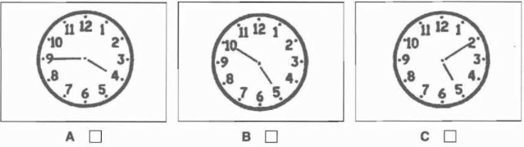

**II. You will hear a man talking on the radio. Listen and complete questions 6-10. You will hear the information twice. (1.0 point)**

|  |  |  |
| --- | --- | --- |
| **Old School Friends** | | |
| *Please contact:* |  | Janet |
| Last name: | **6.** | (nhận biết) |
| Name of school: | **7.** | Green ……………. School (nhận biết) |
| From: | **8.** | (thông hiểu) |
| To: | **9.** | (thông hiểu) |
| Telephone number: | **10.** | (nhận biết) |

**B. GRAMMAR- VOCABULARY AND LANGUAGE FUNCTION( 2.0 POINTS)**

**Choose the best answer to complete the sentence (2.0 points).**

1. He feels ________ after the exam because he did the test very well. (từ vựng – thông hiểu)  
 A. stressful B. delighted C. nervous

2. ________, I’d buy an English – Vietnamese dictionary. (ngữ pháp – thông hiểu)

A. If I have money B. If I had your shoes C. If I were in your shoes

3. It was very dark,_________ we decided to come home. (ngữ pháp – nhận biết)

|  |  |  |
| --- | --- | --- |
| A. because | B. if | C. so |

4. It is _____ that Thang Long Bridge was built in the 20th century. (ngữ pháp – nhận biết)

A. believes B. believe C. believed

5. Bat Trang is famous for its __________products. (từ vựng – nhận biết)

|  |  |  |
| --- | --- | --- |
| A. conical hat pottery | B. pottery | C. silk |

6. Transportation systems in big cities are often _______ those in the countryside.( ngữ pháp – thông hiểu)  
 A. more reliable B. more reliably than C. more reliable

7. My grandparents __________this workshop 30 years ago. (ngữ pháp - thông hiểu)

|  |  |  |
| --- | --- | --- |
| A. set up | B. passed down | C. faced up to |

8. **Vy**: Would you mind lending me your bike? **Ha:** _______. (chức năng NN – nhận biết)

A. Yes, let’s B. No, of course not C. Good idea

9. They have to ________the factory because of the economic problem.( từ vựng – thông hiểu)

A. close down B. turn down C. pass down

10. **An**: “What a nice scarf you have!” – **Hoa**: “………………..”(chức năng NN – thông hiểu)

A. I don’t think so. B. It’s so nice of you to say so. C. Don’t mention it.

**C.READING COMPREHENSION (2.0 POINTS)**

**I. Read and circle the best option A, B or C to complete the paragraph (1.0 point)**

I’m fascinated by (1)_________handicrafts. At weekends, I usually go to Bat Trang where I was born. It’s a (2)________village not far from Ha Noi centre. My uncle and my aunt still live in Bat Trang and they own a big workshop there. In fact, my grandparents started that workshop and some years ago, my uncle and my aunt (3)________the business because my grandparents are very old. My grandfather is a well-known (4)_________in the village. Every time I go there, he teaches me how to make things from clay such as pots, vases and bowls.

There are a lot of tourists coming(5)________ all over the country and the world to Bat Trang craft village. They can make pottery themselves in workshops and they learn how to paint on ceramics.

They can buy the things they like or need for their houses. Many people enjoy their visit to Bat Trang and they feel very interested after their trip.

1. A. tradition B. traditional C. traditionally (nhận biết)

2. A. pottery B. painting C. moulding (nhận biết)

3. A. took after B. took off C. took over (thông hiểu)

4. A. artisan B. painter C. artist (nhận biết)

5. A. around B. in C. from (thông hiểu)

**III. Read the following passage then choose the correct answer to each question. ( 1.0 point)**

With a population of about 2.6 million people, Vancouver is the largest city in Western Canada. Vancouver is in the Southwest of Canada, and it is only a few hours of driving away from the American border. Vancouver is popular because it combines so many things. It is a huge, modern city. On the other hand, it is also one of North America’s most beautiful areas. The natural beauty around Vancouver is famous all over the world.

Vancouver is right next to the Rocky Mountains, so it is a wonderful place for skiing and snowboarding. **Those** aren’t the only winter sports you can do there, if you can name a winter sport, then you can probably do that sport in Vancouver. After all, the 2010 Winter Olympics were there. Vancouver is also great for hiking, jogging and skateboarding. It even has beaches. The beaches aren’t the best in the world, but they are clean and pretty.

Another place that you have to visit in Vancouver is Stanley Park. This is a public park that is a stone’s throw from downtown. However, the park is completely surrounded by Pacific Ocean. The nature in Stanley Park is beautiful. It is close to the downtown, but it feels like it is 100 kilometres away. The park also has playgrounds, garden, beaches, tennis courts and even aquarium.

Vancouver is something for everybody. It is no wonder that people think it is one of the world’s best cities.

1. What does the passage say about Vancouver’s beaches? (thông hiểu)

A. They are the world’s best beaches. B. They are terrible beaches C. They are pretty good beaches.

2. Which of the following is NOT popular in Vancouver? (nhận biết)

A. football B. skateboarding C. winter sports

3. What does the word **Those** refer to? (nhận biết)

A. the Rocky Mountains B. skiing and snowboarding C. hiking, jogging and skateboarding

4. Stanley Park is________________.(thông hiểu)

A. not far from downtown B. 100 kilometres away from the downtown C. a private park

5. Which of the following is TRUE according to the passage? (vận dụng)

A. Vancouver is the biggest city in Eastern Canada.

B. Vancouver is a wonderful place for winter sports.

C. Vancouver is very far from the American border.

**D. WRITING ( 2.0 POINTS)**

**I. Rewrite the sentences in other way with the same meaning (1.0 point)**

1. People know that Son Doong is the biggest cave in Viet Nam. (vận dụng)

⇒It is______________

2. My grandmother often told us fairy stories when we were young. (vận dụng)

⇒ My mother used___________

3. What a pity! we can’t communicate with animals. (vận dụng)

⇒ I wish___________________

4. The tourist asked Mai: “ Do you know how to make a conical hat?” (vận dụng)

⇒ The tourist asked__________

5. No country in the world is as populated as China. (vận dụng)

⇒China__________________

**II. Write a paragraph of about 100 to 120 words about the ways for students to reduce/ get over stress and pressure. (1.0 point)** (vận dụng cao)

***You can follow:***

+ play sports/ take part in outdoor activities.

+ spare a suitable time to relax.

+ make a suitable plan for study.

+ share feelings with parents, teachers, friends

…

---------- The end ---------

|  |  |
| --- | --- |
|  | **HƯỚNG DẪN CHẤM**  **ĐỀ KIỂM TRA HỌC KỲ I**  **NĂM HỌC 2022 – 2023**  **Môn: Tiếng Anh 9 (Hệ 10 năm)** |

**A. LISTENING( 2.0 POINTS)**

**I. Listen and tick (✔) the box. (1.0 point).**

1- C 2-A 3-C 4-A 5. C

**II. Listen and complete the questions 1-5 (1.0 point)**

1. Craig 2. Park 3. 1984 4. 1990 5. 587634

**B. GRAMMAR- VOCABULARY AND LANGUAGE FUNCTION( 2.0 POINTS)**

**Choose the best answer to complete the sentence (2.0 points).**

1. B 2. C 3. C 4. B 5. B

6. C 7. A 8. B 9. A 10. B

**C. READING( 2.0 POINTS)**

**I. (1,0 point): 0.2pt/1**

1.B 2.A 3.C 4.A 5.C

**II. (2.0 point) 0.4pt/1**

1.C 2.A 3.B 4.A 5.B

**D. WRITING ( 2.0 POINTS)**

**I: Rewrite these sentences (1.0 point): 0.2pt/1**

1. People know that Son Doong is the biggest cave in Viet Nam.

⇒It is ***known that Son Doong is the biggest cave in Viet Nam.***

2. My grandmother often told us fairy stories when we were young.

⇒ My mother used ***to tell us fairy stories when we were young.***

3. What a pity! we can’t communicate with animals.

⇒ I wish ***we could communicate with animals.***

4. The tourist asked Mai: “ Do you know how to make a conical hat?”

⇒ The tourist asked ***Mai if/ whether she knew how to make a conical hat.***

5. No country in the world is as populated as China.

⇒ China ***is the most populated country in the world.***

**II. Compete the passage with the words given: (1.0 point)**

**1. Form:**

- Correct form **(**0.1 point)

**2. Task fulfillment:**

- Task completed with relevant information (0.2 point)

- Well-organized (0.2 point)

**3. Language**:

- Accurate grammar (0.2 point)

- Appropriate vocabulary (0.2 point)

- Correct spelling and punctuation (0.1 point)

**The end**