Họ và tên: ....................................................  Lớp: ............................................................. | PHIẾU GHI BÀI HÓA HỌC 11 CÁNH DIỀU  Bài 1: MỞ ĐẦU VỀ CÂN BẰNG HÓA HỌC
MỞ ĐẦU
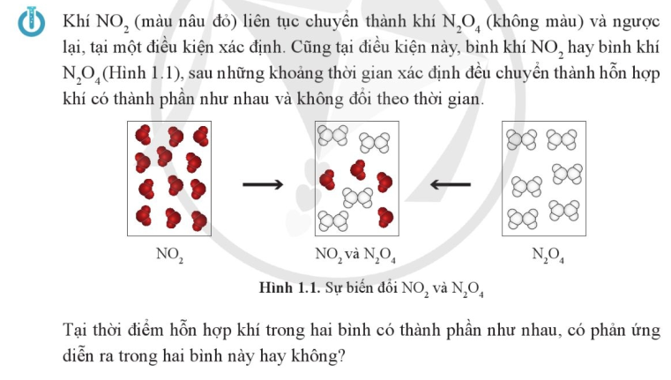
..........................................................................................................................................................................
..........................................................................................................................................................................

I. KHÁI NIỆM PHẢN ỨNG THUẬN NGHỊCH VÀ TRẠNG THÁI CÂN BẰNG
Xét ví dụ 1: N₂(g) + 3H₂(g) 2NH₃(g) (1)
Chiều thuận: ........................................................... Chiều nghịch: ............................................................
Phản ứng thuận nghịch ..................................................................................................................................
..........................................................................................................................................................................
..........................................................................................................................................................................

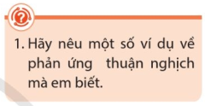 | ..................................................................................................................  ..................................................................................................................  ..................................................................................................................
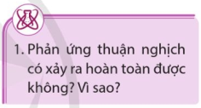 | ..................................................................................................................  ..................................................................................................................  ..................................................................................................................

Xét ví dụ 2: H₂(g) + I₂(g) 2HI(g) (2)
..........................................................................................................................................................................
..........................................................................................................................................................................
..........................................................................................................................................................................
..........................................................................................................................................................................
..........................................................................................................................................................................
..........................................................................................................................................................................
..........................................................................................................................................................................
..........................................................................................................................................................................
..........................................................................................................................................................................
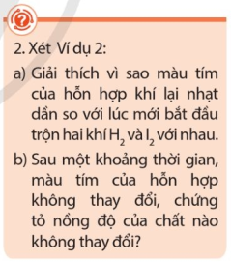 | ..................................................................................................................  ..................................................................................................................  ..................................................................................................................  ..................................................................................................................  ..................................................................................................................  ..................................................................................................................  ..................................................................................................................
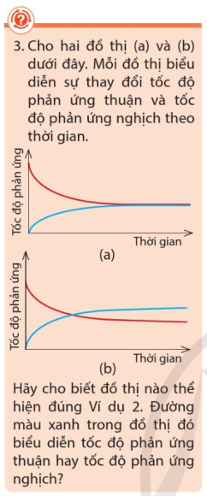 | ..................................................................................................................  ..................................................................................................................  ..................................................................................................................  ..................................................................................................................  ..................................................................................................................  ..................................................................................................................  ..................................................................................................................  ..................................................................................................................  ..................................................................................................................  ..................................................................................................................  ..................................................................................................................  ..................................................................................................................  ..................................................................................................................  ..................................................................................................................  ..................................................................................................................  ..................................................................................................................
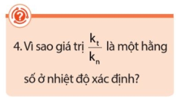 | ..................................................................................................................  .................................................................................................................. ..................................................................................................................  ..................................................................................................................
Trạng thái cân bằng .......................................................................................................................................
..........................................................................................................................................................................
II. BIỂU THỨC HẰNG SỐ CÂN BẰNG VÀ Ý NGHĨA
1) Biểu thức hằng số cân bằng
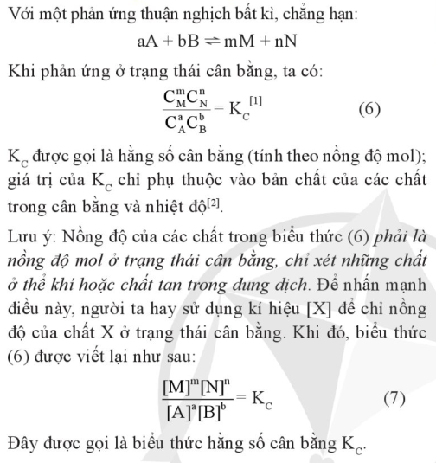 |  | 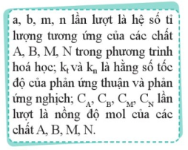
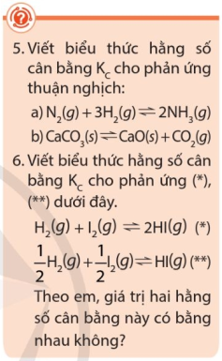 | ..................................................................................................................  ..................................................................................................................  ..................................................................................................................  ..................................................................................................................  ..................................................................................................................  ..................................................................................................................  ..................................................................................................................  ..................................................................................................................  ..................................................................................................................  ..................................................................................................................
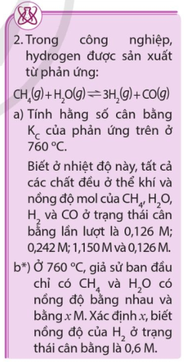 | ..................................................................................................................  ..................................................................................................................  ..................................................................................................................  ..................................................................................................................  ..................................................................................................................  ..................................................................................................................  ..................................................................................................................  ..................................................................................................................  ..................................................................................................................  ..................................................................................................................  ..................................................................................................................  ..................................................................................................................  ..................................................................................................................
2) Ý nghĩa của biểu thức hằng số cân bằng
Xét ví dụ 3: Cho cân bằng: N₂(g) + 3H₂(g) 2NH₃(g)
Tại thời điểm cân bằng ở 472ºC, nồng độ cân bằng của N₂ và H₂ lần lượt là 0,0402M và 0,1200M và có hằng số cân bằng K_{C} = 0,1050. Tính nồng độ mol của NH₃ ở trạng thái cân bằng này.
..........................................................................................................................................................................
..........................................................................................................................................................................
Ý nghĩa 1:.........................................................................................................................................................
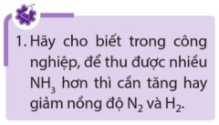 | ...............................................................................................................  ...............................................................................................................  ...............................................................................................................  ...............................................................................................................
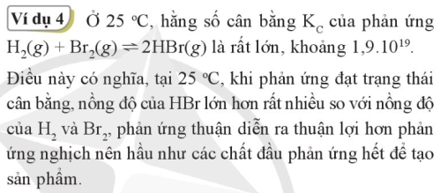
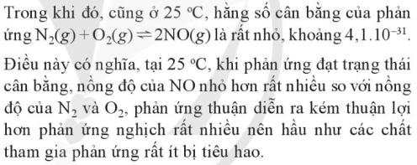
Ý nghĩa 2: ........................................................................................................................................................
..........................................................................................................................................................................
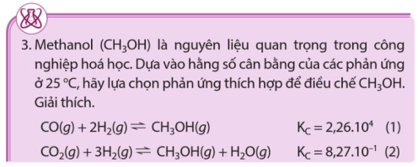 | ...............................................................  ...............................................................  ...............................................................  ...............................................................  ...............................................................
III. ẢNH HƯỞNG CỦA NHIỆT ĐỘ, NỒNG ĐỘ VÀ ÁP SUẤT ĐẾN CÂN BẰNG HÓA HỌC
1) Ảnh hưởng của nhiệt độ tới cân bằng hóa học
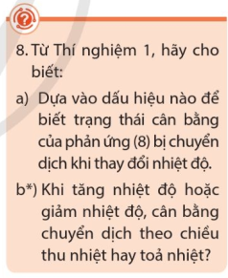 | ..................................................................................................................  ..................................................................................................................  ..................................................................................................................  ..................................................................................................................  ..................................................................................................................  ..................................................................................................................  ..................................................................................................................  ..................................................................................................................
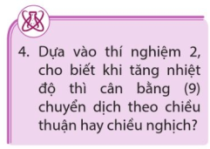 | ..................................................................................................................  ..................................................................................................................  ..................................................................................................................  ..................................................................................................................  ..................................................................................................................

2) Nguyên lý chuyển dịch cân bằng Le Chatelier
                              

