Date of preparing: ………………………………….
Date of teaching: ………………………………….

Period……
UNIT 3: FRIENDS
Lesson 2 - Part 2 (Page 26) - Grammar

I. OBJECTIVES
By the end of the lesson, Ss will be able to…
1. Knowledge
- use the Present Continuous for future use.
2. Ability
- improve speaking skill, writing skill.
- improve the use of English.
3. Quality
- have positive attitude in English language learning so that they actively participate in all classroom activities.
- make a plan for their near future activities.

II. TEACHING AIDS AND LEARNING MATERIALS
Lesson plan, PPT slides, student’s book, workbook, notebook, personal computer (if any), projector/TV, speakers, DCR & DHA on Eduhome, handouts…
III. PROCEDURES
A. Warm up: (5’)
a) Objective: Introduce the new lesson and set the scene for Ss to acquire new language; get students' attention at the beginning of the class by means of enjoyable and short activities as well as to engage them in the steps that follow.
b) Content: Revision of Present Continuous
c) Product: Ss have general ideas about Present Continuous for future plans
d) Competence: Collaboration, communication, analytical skills.
e) Organization of the activity:
Teacher’s Activities | Students’ Activities
- Give greetings  - Check attendance  - Option 1: REARRANGING  - Have Ss rearrange the words / phrases to make a meaningful sentence (format: ioe.vn) (T can use about 4-6 sentences)  - Call Ss to give answers  - Check, correct Ss’ answers if necessary  →Lead to the new lesson.  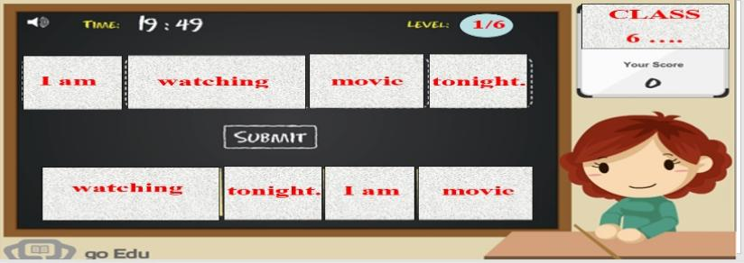  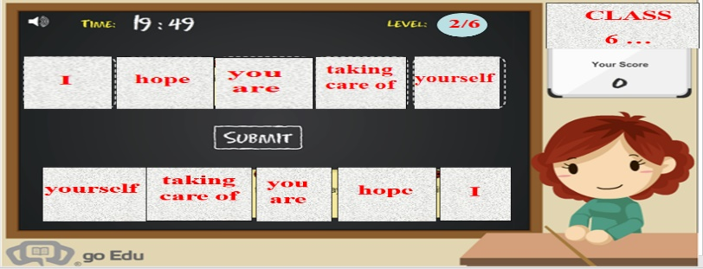  - Option 2: Fill in the blanks  - Give a small exercise. Have Ss use the words given to fill in the blanks  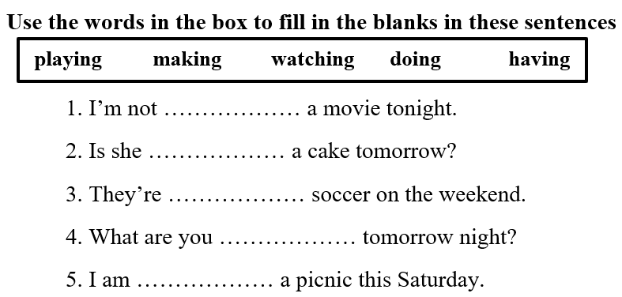  - Have Ss read their answers  - Check, ask Ss to focus on the tense used in these sentences  - Lead to the new lesson | - Greet T  - Work in groups  - Read answers  - Work in pairs, then share answers with the class  Answer keys  1. watching  2. making  3. playing  4. doing  5. having

B. New lesson (35’)
- Activities 1: Grammar: Present Continuous for future use (15’)
a) Objective: Ss know how to use the Present Continuous for future plans.
b) Content:
- Listen and repeat
- Grammar explanation
c) Products: Ss can use the Present Continuous to talk about their plan for future activities.
d) Competence: Communication, collaboration, creativity
e) Organization of the activity:
Teacher’s Activities | Students’ Activities
a. Listen and repeat  - Have Ss look at the picture  - Play the audio (CD1 – Track 35), ask Ss to listen and read the speech bubbles  - Play the audio again and have Ss listen and repeat  *Grammar box:  - Ask Ss to make comments on the black bold verb form in the examples  - Have Ss retell the form and usage of the Present Continuous tense.  - Lead to the grammar table and explain the usage of the Present Continuous for future action  - Ask Ss to pay attention to the future time expressions  - Have some Ss read the sentences aloud  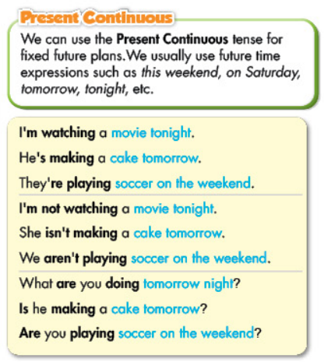  - Have Ss make more sentences, using the Present Continuous for future action  - Give feedback | - Look  - Listen and read  - Listen and repeat  - Comment  - Retell  - Listen and take notes  - Read  - Work in pairs to make sentences  Suggested answers  1. I’m doing exercises tonight.  2. I’m having a cooking class this Saturday.
- Activity 2: Practice (20’)
a) Objective: Ss can get used to using the Present Continuous for future activities
b) Content:
- Filling in the blanks, using the Present Continuous
- Writing full sentences, using the given words and the Present Continuous.
c) Products: Ss can apply the use the Present Continuous in communication.
d) Competence: Collaboration, creativity, communication
e) Organization of the activity:
Teacher’s Activities | Students’ Activities
b. Fill in the blanks, using the Present Continuous  - Option 1:  - Use the example to demonstrate this activity  - Have Ss use the Present Continuous to fill in the blanks, draw attention to the negative and question form  - Have pairs check each other’s work  - Have Ss share their answers with the class by writing down on the board.  - Check Ss’ answers, correct if necessary  - Option 2:  - Use the example to demonstrate this activity  - Have Ss use the Present Continuous to fill in the blanks, draw attention to the negative and question form  - Have pairs check each other’s work  - Call Ss to give answers by answering multiple choice questions (format: game “Who is the millionaire?”)  - Check Ss’ answers, correct if necessary  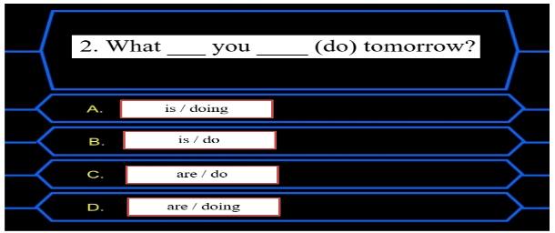  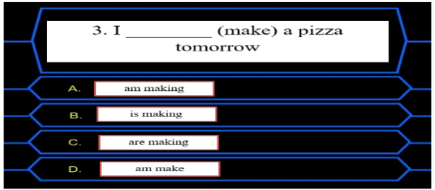  c. Write full sentences, using the given words and the Present Continuous.  - Demonstrate the activity, using the example  - Let Ss write full sentences, using the prompts  - Go round and give help if necessary  - Have Ss work in pairs to check each other’s work  - Call Ss to write answers on the board  - Check and correct Ss’ answers  d. Write true sentences about yourself, then ask your partner  - Have Ss work in pairs to write true sentences about themselves and ask their partner.  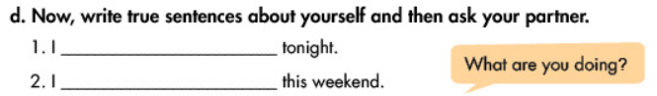  - Have some Ss demonstrate the activity in front of the class  - Give feedback and evaluation | - Look and listen  - Work in pairs  - Write answers  Answer keys  2. are / doing 3. am making  4. Are / having 5. is going  6. are playing 7. Is / watching  - Look and listen  - Work in pairs  - Give answers  Answer keys  2. D 3. A  …  - Look and listen  - Do the task  - Work in pairs  - Write answers  Answer keys  2. I am having a barbecue today.  3. Emma and Jane are not watching a movie on Sunday.  4. We are making a pizza this weekend.  5. Is David playing badminton this evening?  6. Is Maria watching TV with her sister tonight?  - Work in pairs  - Ask and answer

C. Consolidation (3’)
* Present Continuous for future action:
Form: (-) S + am / is / are + V-ing
(-) S + am / is / are + not + V-ing
(?) Am / Is / Are + S + V-ing
Future time expressions: this weekend, on the weekend, on Saturday, tomorrow, tonight, this week, …

D. Homework (2’)
- Make 2 sentences, using the Present Continuous for future use.
- Do exercises in WB: Lesson 2 - Grammar – Part a, b, c (page 17).
- Prepare: Lesson 2 – Pronunciation and Speaking (page 27 – SB).

