**Mã đề 9.1.12**

**ĐỀ KIỂM TRA GIŨA KỲ I NĂM HỌC: 2022-2023**

**MÔN: TIẾNG ANH LỚP 9**

*Thời gian làm bài: 60 phút*

**SECTION A: LISTENING (2.5 points)**

**Task1: Listen, then tick** **the right answer. You will listen twice (1point)**

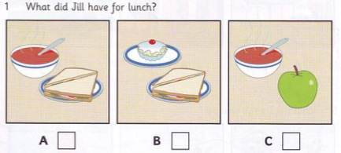**Nhận biết**

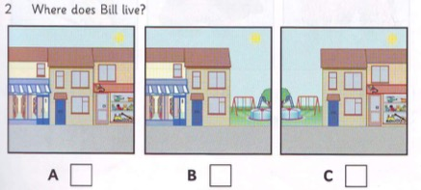**Nhận biết**

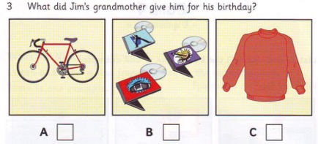**Thông hiểu**

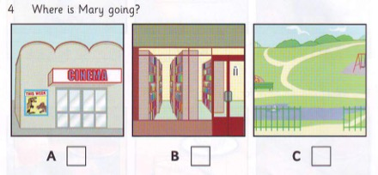**Thông hiểu)**

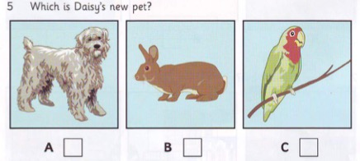**(Thông hiểu)**

**Task 2: Listen and write. You will listen twice (1.5 points)**

1. How old: …………………………. **Nhận biết**

2. Where he works: ………………….. **Nhận biết**

3. How many days he works: ……………………… **Thông hiểu**

4. What he does at weekends: ………………………….. **Thông hiểu**

5. What sport he plays: …………………………………. **Thông hiểu**

**SECTION B: LANGUAGE (2.5 points)**

**I. Choose the word whose underlined part pronounced differently from that of the others by circling A, B, C or D (0.5 point)**

1. A. pottery B. local C. control D. so**Nhận biết**

2. A. artisan B. establish C. attraction D. handicraft **Nhận biết**

**II. Choose the best option (A, B, C or D) to complete these sentences. (2.0 points)**

1. They suggested ……………. more trees in the school yard. **(NP)** **Nhận biết**

A. plant B. planted C. to plant D. planting

2. Her son felt sleepy, ……………... he went to bed. **(NP)** **Thông hiểu**

A. however B. so C. although D. because of

3. Nam isn't going to the concert………..the tickets are too expensive. **(NP) Thông hiểu**

A. though B. in spite of C. because D. even though

4. He asked me_________. **(NP) Thông hiểu**

A. what my phone number B. what my phone number were

C. what my phone number was D. what was my phone number

5. He was sentenced to ten years in prison on charges of drug . **(TV) nhận biết**

A.charging B.stealing C.trafficking D.trading

6. John cannot make a ______ to get married to Mary or stay single until he can afford a house and a car. **(TV)** **Vận dụng**

A. decide               B. decision              C. decisive               D. Decisively

7. Chaul Chnam Thmey is festival of the Khmer people**. (NP) Thông hiểu**

A. the biggest B. as big as C. bigger than D. bigger

8.Studies show that having good conflict skills is associated with various positive outcomes. **(TV) Vận dụng**

A. resolutional B. resolving C. resolve D. resolution

**SECTION 3: READING (2.5 points)**

**I.Read the following passage, then choose the correct answer to questions. (1point)**

Smoking causes lung cancer, which is the number one cancer among men. Ninety percent of the people who get lung cancer die. Smoking is also the leading cause of mouth cancer, tongue cancer, and throat cancer.Many smokers have heart disease and pneumonia. Smoking causes one million early deaths in the world every year.

Smokers not only harm themselves but also harm others. Smokers breathe smoke out into the air. They breathe***it*** out on their children and their wives or husbands. Children whose parents smoke have more breathing and lung problems than other children. Women who are married to smokers are more likely to have lung cancer than those married to non-smokers.

We are all aware that smoking is bad. So why do people smoke?

1. The number one cancer among men is____________. **Nhận biết**

A. tongue cancer B. throat cancer C. lung cancer D. mouth cancer

2. The main cause of mouth cancer, tongue cancer and throat cancer is________. **Nhận biết**

A. drinking B. overeating C. breathing D. smoking

3. Every year, smoking causes about one million____________. **Thông hiểu**

A. cancer patients B. killing diseases C. early deaths D. injured men

4. The word “it” in the passage refers to____________. **Vận dụng**

A. cancer B. smoke C. air D. breath

5. Who are more likely to have lung cancer and lung problems? **Vận dụng**

A. People who live in the city B. People who live with smokers.

C. People who live with non-smokers. D. People who live in the country.

**II. Choose A, B, C or D to complete the following passage (1.5points)**

Christmas is a family celebration and many of the customs center on children. When they go to bed on Christmas (1)…………..…, children hang up a pillow case or a sack for their presents (2)………………, it should be a stocking, but a stocking wouldn’t hold enough to become today’s kids.

While the children are(3)………...., so the custom goes, Father Christmas or Santa Claus, comes (but also to children who have been good). He travels from the North Pole in a sleigh which is (4) ………….by reindeer. After landing on the roof, Santa Claus climbs down the (5) …………….and puts presents in the sacks that the children have left out.

1/ A. Eve B. evening C. morning D. afternoon **Thông hiểu**

2/ A. Actually B. Traditionally C. Fortunately D. Usually  **Nhận biết**

3/ A. sleep B. asleep C. sleeping D. slept **Vận dụng**

4/ A. pull B. to pull C. pulling D. pulled **Vận dụng**

5/ A. tree B. chimney C. roof D reindeer. **Thông hiểu**

**SECTION D: WRITING (2.5 points)**

**I. Find out the mistake in each following sentence. (0.5 point)**

1. I enjoy to read these books, which tell about the ancient cultures in Africa. **Nhận biết**

A B C D

2. My brother hasn’t played football for last year. **Nhận biết**

A B C D

**II. Rewrite these sentences with the same meaning. (1.0 point)**

1. In spite of the bad weather, they had a wonderful holiday. =>Although................................................................................................. **Vận dụng cao**

2. She is too short to play basketball

=>If.............................................................................................................. **Vận dụng cao**

3. They have painted the gate of the building

=>The gate.................................................................................................. **Vận dụng cao**

4. “I must go to Ha Noi tomorrow.” said Nam.

=>Nam said................................................................................................ **Vận dụng cao**

5. Let’s decorate the Christmas tree.

=>She suggested......................................................................................... **Vận dụng cao**

**III. Read this postcard from your friend, Alex and then write a postcard to him to answer his questions. You should write about 30-35 words.(1.0 point) Vận dụng cao**

*I am going to visit your country next month. Can I see you?*

*Please tell me about one of the traditional craft villages in your area. (what it makes?).*

*Can I buy some for souvenirs? And tell me about the weather there, what clothes should I bring? (Alex)*

*Dear Alex,*

**…………………………………………………………………………………………………………………………………………………………………………………………………………**

**ANSWER KEY**

**SECTION A: LISTENING (2.5 points)**

**Task1: Listen to Minh and Lam talking about their teachers. Fill in the gap with no more than a word. (1 point)**

*1.C*

*2.B*

*3.A*

*4.A*

*5.C*

**Task 2: Listen to Mira talking about her neighborhood. Tick T (True) or F (False). You will listen twice (1.5 points)**

1. 17

2. library

3. 4 days

4. cinema

5. table tennis

**SECTION B: LANGUAGE (2.5 points)**

**I. Choose the word whose underlined part pronounced differently from that of the others by circling A, B, C or D (0.5 point)**

1. A.

2. A.

**II. Choose the best option (A, B, C or D) to complete these sentences. (2.0 points)**

|  |  |  |  |
| --- | --- | --- | --- |
| 1. D | 3. C | 5. C | 7. A |
| 2. B | 4. C | 6. B | 8. D |

**SECTION 3: READING (2.5 points)**

**I. Read the following passage, then choose the correct answer to questions. (1point)**

1. C

2. D

3. C

4. B

5. B

**II. Choose A, B, C or D to complete the following passage (1.5points)**

1. A

2. B

3. C

4. D

5. B

**SECTION D: WRITING (2.5 points)**

**I. Find out the mistake in each following sentence. (0.5 point)**

1. A

2. D

**II. Rewrite these sentences with the same meaning. (1.0 point)**

1. Although the weather was bad, they had a wonderful holiday.

2. If she weren’t short, she could play basketball.

3. The gate of the building has been painted

4. Nam said he had to go to Hanoi the next day.

5. She suggested decorating the Christmas tree.

**III. III. Read this postcard from your friend, Alex and then write a postcard to him to answer his questions. You should write about 30-35 words.(1.0 point)**

**Tổng 1.5 điểm. Gợi ý cho điểm như sau**

* Viết đúng mẫu postcard: 0.2 điểm
* Nêu cảm nghĩ khi nghe tin Alex đến thăm: 0.1 điểm
* Trả lời hay mời Alex đến thăm bạn: 0.1điểm
* Kể được tên làng nghề: 0.1 điểm
* Kể được sản phẩm mà làng nghề sản xuất: 0.2 điểm
* Khẳng định Alex mua sản phẩm đó làm quà hay không: 0.2 điểm
* Nói được kiểu thời tiết ở đó: 0.1 điểm
* Gợi ý cho Alex mang loại quần áo phù hợp: 0.1 điểm

Nếu sai ngữ pháp câu nào không cho điểm câu đó.

Nếu sai chính tả 2 lỗi không cho điểm câu đó.