School: ……………………………………….. | Date:……………………………………..
Class: ……………………………..................... | Period: 30

UNIT 2: FIT FOR LIFE
CLIL (Page 40)

1. Objectives
By the end of this lesson, students will be able to…
1.1. Language knowledge/ skills
- learn and use some vocabulary: feel unpleasant, ginger tea, reduce, ingredient, cough syrup.
- practise reading for specific information.
- talk about medicine in the kitchen.
- improve listening skills and pronunciation.
1.2. Competences
- improve Ss’ communication, collaboration, analytical, research and critical thinking skills.
1.3. Attributes
- develop their patriotism, kindness, honesty and accountability.
2. Teaching aids and materials
- Teacher’s aids: Student’s book and Teacher’s book, class CDs, IWB – Phần mềm tương tác trực quan, projector/interactive whiteboard /TV (if any), PowerPoint slides.
- Students’ aids: Student’s book, Workbook, Notebook.
3. Assessment Evidence

Performance Tasks | Performance Products | Assessment Tools
- Look at the picture, listen and repeat.  - Read the title of the article and look at the pictures. Then answer the question.  - Read the article again and complete it with the words in Exercise 1.  - Answer the questions.  - Talk about medicine in the kitchen. | - Ss’ performance.  - Ss’ answers.  - Ss’ answers.  - Ss’ answers.  - Ss’ answers/ presentation. | - Observation.  - Observation.  - Observation.  - Observation.  - Observation.

4. Procedures
A. Warm up: 5 minutes
a. Objectives: to introduce some diseases.
b. Content: Task 1.
c. Expected outcomes: Ss can know and recall some diseases
d. Organization

Teacher’s activities | Students’ activities
Task 1. Look at the pictures. Listen and repeat.  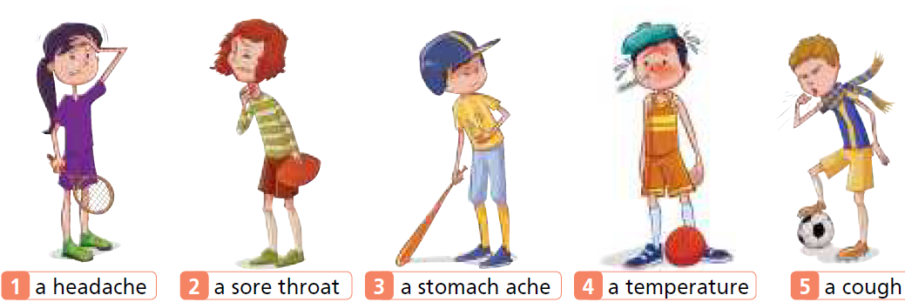  - Ask Ss to look at the pictures.  - Play the recording with pauses for Ss to repeat chorally and/or individually. | - Look at the pictures.  - Listen and repeat chorally and/or individually.
B. Presentation: 10 minutes
a. Objectives: to present some key words of the text.
b. Content: vocabulary.
c. Expected outcomes: Ss can understand and learn some key words of the text.
d. Organization
Teacher’s activities | Students’ activities
Vocabulary:  + feel unpleasant:  + ginger tea:  + reduce (v)  + ingredient (n)  + cough syrup  - Ask Ss to read the text and underline the words above.  - Get Ss to try to guess their meanings in the context first.  - Explain the meanings of the words.  - Ask Ss to listen and repeat chorally and individually.  - Check if Ss remember the words. | - Read the text and underline the words.  - Try to guess their meanings in the context.  - Listen to the teachers and take notes the meanings of those words.  - Listen and repeat chorally and individually  - Answer the teacher.

C. Practice: 15 minutes
a. Objectives: to introduce the topic; read for specific information; consolidate information from a text; develop critical thinking skills.
b. Content: tasks 2, 3, 4.
c. Expected outcomes: Ss can read for cohesion and coherence; understand the text.
d. Organization:
Teacher’s activities | Students’ activities
Task 2: Read the title of the article and look at the pictures. What medicine can someone find in the kitchen?  - Elicit what medicine someone can find in the kitchen.  - Check Ss’ answers (using the IWB). | - Read the title of the article and look at the pictures.  Answer Keys:  lemon, chocolate, honey, ginger, mint
Task 3: Read the article again and complete it with the words in Exercise 1.  Listen and check.  - Give Ss time to complete the task.  - Check Ss’ answers (using the IWB).  - Play the video for Ss and elicit their comments at the end. | - Read the article again and complete it with the words in Exercise 1.  - Listen and check.  Answer keys  1 headache 2 stomach ache  3 sore throat 4 temperature 5 cough  - Watch the video and listen to the teacher.
Task 4. What is the author’s purpose: to answer? to persuade? to inform? Is the information in the text useful to you? Why?  - Give Ss time to complete the task.  - Check Ss’ answers. | - Complete the task individually and then share with their friend.  Answer keys:  The purpose of the text is to inform. It tells people how to use some medicine in the kitchen for some common health problems. It is very useful to me because I know how to feel better if I have got these health problems.

D. Production: 10 minutes
a. Objectives: to help Ss to use the language and information in the real situation.
b. Content: task 5.
c. Expected outcomes: Ss can talk about medicine in the kitchen
d. Organization

Teacher’s activities | Students’ activities
Task 5: Which medicine in the article did you know about? Do you know any other medicine in the kitchen? Tell your partner.  - Give Ss time to complete complete the task and then elicit answers from Ss around the class. | - Complete the task individually and then share with their partner.  - Ss’ own answers.

E. Consolidation and homework assignments: 5 minutes
- Vocabulary: feel unpleasant, ginger tea, reduce, ingredient, cough syrup.
- Do the exercises in workbook on pages 22, 23.
- Prepare the next lesson: Right on (page 41).
5. Reflection

a. What I liked most about this lesson today:
…………………………………………………………………………………………
b. What I learned from this lesson today:
…………………………………………………………………………………………
c. What I should improve for this lesson next time:
…………………………………………………………………………………………

