|  |  |  |
| --- | --- | --- |
| Phòng GD&ĐT TP Hà Tiên  Trường Tiểu học Thuận Yên  Lớp:..................................................................  Họ và tên:……………………………………. | | Bài kiểm tra cuối học kỳ II  Năm học: 2021 – 2022  Môn: Tiếng Anh  Khối: 5- Thời gian: 40 phút  Ngày kiểm tra:…………………… |
| Điểm | Nhận xét của giáo viên | Chữ ký giám thị:……………………  Chữ ký giám khảo: ………….…….. |

**SPEAKING: .......**

**LISTENING**

**Part1: Listen and circle:**

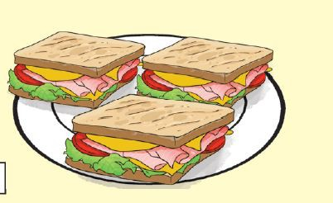**1. a/ 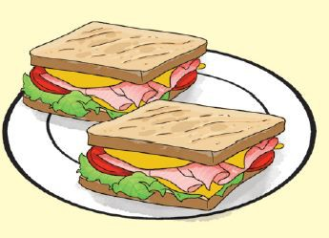 b/ 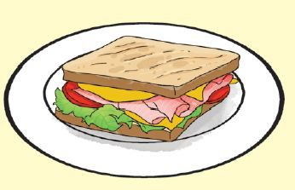 c/**

**2. a/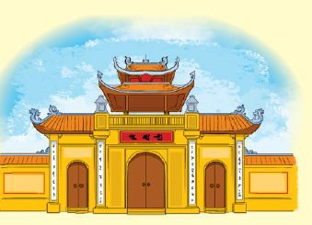 b/**  **c/**

**3. a/**  **b/ 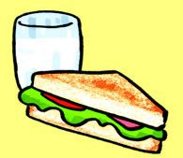 c/**

**4. a/ 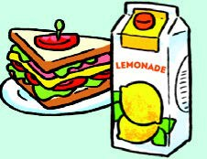 b/ 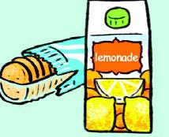 c/**

**Part 2: Listen and circle a, b, c:**

1. Trung would like to be…………….?

**a.** an artist **b.** an engineer **c.** an architect

2. Mai would like to be …………….?

**a.** a singer **b.** a nurse **c.** a teacher

3. Tom thinks Phu Quoc is more ……… than he expected?

**a.** attactive **b.** beautiful **c.** exciting

4. Phong thinks Dam Sen Park is more ………….. than he expected.

**a.** interesting **b.** exciting **c.** beautiful

**READING**

**Part 1: *Read and complete:***

|  |
| --- |
| Watch weather forecast cold go |

Mai: Let’s (1)…… for a picnic tomorrow.

Phong: What will the (2)….. be like tomorrow?

Nam: Well, it will be (3)….. and stormy.

Mai: How do you know that?

Nam: I watched the weather (4) …… on TV.

Phong: We can’t go for a picnic if it’s stormy.

Mai: Ok, let’s stay home, eat popcorn and (5)………..cartoons.

Nam and Phong: Great idea!

1_ ***go*** , 2_................. , 3 _.................. , 4 _....................., 5_....................

**Part 2: Read and tick: (✓) Đọc và đánh dấu :(✓)(True or False)( *Đúng hoặc sai)***

My name’s Tom. Yesterday, I visited Tran Quoc pagoda. It is on an island in the middle of West Lake and not far from the centre of Ha Noi. I went there by bike. Tran Quoc Pagoda is very quiet. It is more beautiful than I expected. There are a lot of statues and trees in the yard. I met some friends there. My friends and I learn more about the history of Ha Noi after the visit.

|  |  |  |
| --- | --- | --- |
| ***Sentences:*** | ***True ( T )*** | ***False ( F )*** |
| ***0) My name is Tom*** | **✓** |  |
| 1) Tran Quoc Pagoda is on an island in the middle of West Lake |  |  |
| 2) He went there by motobike |  |  |
| 3) Tran Quoc Pagoda is very noisy |  |  |
| 4) It is more beautiful than I expected |  |  |

**WRITING**

Part 1: ***Write (viết)- Answer the questions (Trả lời các câu hỏi)***

Example***:* what do you do in your free time?*****I often watch TV***

1. What would you like to be in the future?

🖛 _____________________________________________________

1. What would you like to drink?

🖛 _____________________________________________________

1. What’s spring like in your country?

🖛 _____________________________________________________

1. What do you think of Ha Tien?

🖛 _____________________________________________________

**Part 2: Arrange the following words to make meaningful sentences:**

Example: **Where/ you/ going?/ are/**

***Where are you going?***

1. teacher?/ Why / like / you /be/ to/a/would/

................................................................................................................................

1. would/ Which / Phu Quoc Island? / place/ Da Lat/ or/you/like/ visit/ to/

................................................................................................................................

1. much/water/ How/ drink/you/ do/day?/ every/

................................................................................................................................

1. supermaket? / can / I / to / the/ get / How/

................................................................................................................................

The end