USING AI APPLICATIONS TO ASSIST TEACHERS IN DESIGNING LISTENING TASKS FOR GIFTED STUDENTS

……… – 5th July, 2024

TABLE OF CONTENTS
PART 1. INTRODUCTION 3
1. Rationale of the Study 3
2. Objectives of the Study 3
3. Time and Place of the Study 3
4. Significance of the Study 3
PART 2: CONTENT 4
1.Definition of Listening Comprehension Skills 4
2. What are AI tools? 4
2.1. AI (Artificial Intelligence) tools 4
2.2.Why are AI tools useful for teachers? 4
3 .Teaching listening skills 5
4. How AI tools can assist in designing listening tasks 5
4.1. Finding and adapting authentic audio materials 5
4.2. Generating comprehension questions 9
4.3. Creating Listening Scripts and Dialogues 13
4.4. Speech recognition and pronunciation feedback 15
4.5. Customizing for different levels or themes 15
4.6. Creating themed listening projects 16
5. Listening comprehension exercises bank by topic 18
5.1. Human and the Environment 18
5.2. Theme Music 19
5.3. Theme Gender equality: 21
5.4. Theme Protecting the Environment 22
6. A sample lesson plan 24
7. Outcomes of the study 29
8. Some recommendations 30
PART 3: CONCLUSION 30
REFERENCES 31

PART 1. INTRODUCTION

1. Rationale of the study
Among the four core language skills—listening, speaking, reading, and writing—listening serves as the essential foundation. Early in the language learning process, students often need to hear words multiple times before they can understand and reproduce them effectively. Moreover, listening not only promotes vocabulary acquisition and fluency but also strengthens overall language competence and supports the development of other language skills.
In today’s educational landscape, artificial intelligence (AI) has emerged as a powerful catalyst for personalized, adaptive, and engaging instruction. Research demonstrates that AI-powered language-learning tools significantly enhance listening comprehension, motivation, self-competence, resilience, and learner mindset compared to traditional instruction. These technologies leverage speech recognition, natural language processing, and adaptive feedback mechanisms to provide individualized learning pathways .
Gifted students—those with advanced proficiency (e.g., B2 level and above) and a capacity for deep exploration—require listening materials that are rich, challenging, and authentic. At our school, English-major classes tend to rely on graded or exam-focused recordings, which often lack freshness, diversity, and real-world context. AI tools can fill this gap by generating dynamic audio content with varied accents, topics, and difficulty levels—designed to meet talented learners’ evolving needs
Despite this potential, many language teachers are unaware of or uncertain about how to integrate AI into classroom listening practice. Consequently, they miss the opportunity to capitalize on AI's capabilities for creating motivating, customized, and cognitively stimulating lessons.
This study aims to explore how diverse AI tools can be harnessed to design effective listening tasks and themed exercises specifically for gifted learners.

2. Objectives of the study
- Introduce key AI tools and show how teachers can find and use them effectively.
- Describe practical ways to build listening exercises using these applications to improve students' language skills.
- Recommend reliable applications for designing authentic audio material that matches students’ interests and proficiency.

- Share ready-to-use, themed listening activities for teachers to try or adapt.

3. Time and place of the study
This study is based on my experience teaching at our school during the 2024–2025 academic years. I introduced online listening materials into weekly selective lessons for Grade 10 English majors (B2-C1 level). Additionally, I employed these resources to support a select group of learners preparing for provincial and national excellence competitions.

4. Significance of the study
The study’s primary purpose is to propose to teachers how to exploit AI tools into tailoring the high school curriculum, enabling students to engage with real-life communication scenarios and thus enhance their overall language skills.
Furthermore, it aims to recommend a variety of listening sources, serving as a helpful guide for educators interested in enriching their teaching approaches. It also offers suggestions for creating tailored exercises for high-achieving students preparing for national-level competitions.

PART 2: CONTENT

1.Definition of Listening Comprehension Skills
Below are definitions of listening comprehension skills from reputable scholars: Michael Rost: Rost (2002) defines listening comprehension as "the ability to hear and understand messages conveyed in speech, including recognizing words and context, deducing meaning from language, and grasping main ideas and details in spoken discourse."
Larry Vandergrift: Vandergrift (2007) defines listening comprehension as "the ability to understand the message conveyed in spoken language, including recognizing sounds and vocabulary, understanding context and purpose, and drawing meaning from context."
Richard R. Day: Day (2015) defines listening comprehension as "the ability to understand the meaning of spoken passages through recognizing and analyzing language components, combined with understanding context and purpose."
These definitions provide an in-depth understanding of listening comprehension skills, including the ability to recognize vocabulary and grammatical structures, understand context and purpose, and draw meaning from context.
In the age of globalization today, students need to be exposed not only to varieties (not just one) of English such as British, American, Australian, Japanese or Singaporean English but also to the ‘real language’ in order to be able to cope with different versions and real challenges awaiting them in the outside world.

2. What are AI tools?

2.1. AI (Artificial Intelligence) tools
They are computer programs that use advanced algorithms to mimic human intelligence. They can process language, recognize speech, analyze images, learn from data, and even generate human-like responses. In education, AI tools help automate and improve teaching and learning processes by making them more personalized, efficient, and engaging. In simple words, AI tools are like smart assistants that can help people learn, create, or work faster by using machines that "think" like humans.

2.2.Why are AI tools useful for teachers?
- Save time when designing lessons :AI tools can automate many time-consuming tasks such as generating worksheets, quizzes, transcripts, or summaries. For example, a teacher can input a podcast or article, and an AI tool can instantly create comprehension questions or vocabulary lists. This allows teachers to focus more on teaching and guiding students rather than spending hours on preparation.
- Create interesting, modern, and real-life listening tasks: AI can help teachers design listening activities using real-world materials such as news clips, interviews, or YouTube videos. These tools can transcribe audio, simplify complex content, or add subtitles. This brings the outside world into the classroom, making learning more relevant and engaging.
- Support differentiated instruction for gifted or diverse learners: Gifted students often need more challenging, thought-provoking content. AI tools can personalize listening tasks based on a learner's level or interests. For instance, a student interested in science can listen to TED Talks on space, while another can explore entrepreneurship podcasts — all supported by AI-generated questions and summaries.
- Make learning more interactive and personalized: AI tools can adjust materials in real time based on a student’s responses or performance. Some tools provide instant feedback on pronunciation, listening comprehension, and grammar. Others allow students to repeat, slow down, or translate sections of audio, giving them more control over their learning pace and style.
- Promote independent and autonomous learning: Students can use AI-powered applications outside the classroom to practice on their own. Tools like ChatGPT, ELSA Speak, or YouGlish help them practice listening, ask questions, and learn new vocabulary without always relying on a teacher. This builds confidence and encourages life-long learning habits.
- Encourage creativity and innovation in lesson planning: Teachers can explore creative formats for listening tasks, such as designing role-plays, games, or simulations based on audio content. AI tools can help brainstorm ideas, provide example dialogues, or even generate characters and storylines, making lessons more dynamic.
- Provide access to authentic and up-to-date materials: Instead of using outdated CDs or scripted recordings, AI tools can help teachers tap into current, authentic materials — such as news articles, podcasts, or trending videos. These real-life resources expose students to natural speech patterns, accents, idioms, and cultural references.

3 .Teaching listening skills
Listening is a demanding process, not only due to its inherent complexity, but also because of various factors associated with the listener, the speaker, the content of the message, and any visual aids that accompany it (Brown & Yule, 1983). According to language expert Natasha Walker, teaching listening is particularly challenging as it requires a significant amount of time for students to acquire the skill, often eliciting a range of emotions from frustration to pride. This can be attributed to common problems encountered by learners during listening tasks, such as unfamiliar context, vocabulary, time constraints, lack of focus, anxiety about longer passages, diverse accents, and background noise.
Consequently, mastering listening skills demands considerable time and effort from learners to reach a level of comfort and ease. If teachers can alleviate tension and spark students' interest in listening content, the process should naturally become more manageable and engaging.
Listening serves as the gateway to comprehension and communication, making it indispensable for language learners across all skill levels. Students who struggle with listening may miss out on crucial interactions both inside and outside the classroom. The challenge with listening instruction often lies in the perception that it is dull and passive, with students merely sitting and listening.
In Vietnam, English is the most popular foreign language and a compulsory school subject. However, English teaching and learning have, for a long time, been influenced by traditional methods with a great focus on grammar and vocabulary. The implementation of new English textbooks for high school students since the school-year 2006 – 2007 has created a shift toward communicative teaching and learning. Listening has gained much more attention, and different ways to enhance students’ listening ability have been sought and implemented. However, most listening materials are old with not so natural recordings and may be a hindrance for students when they take national excellent student contest. Moreover, some students, especially excellent ones, are keen on self-study listening activities; they want to explore the online materials themselves but have no clue how to begin and where to find appropriate materials. It is necessary that teachers act as an instructor to guide them through the process of self-study so that their listening skills will be enhanced. Therefore, I would like to give some suggestions as to how online listening materials can be used and how teachers can help students in their self-studying process in this study.

4. How AI tools can assist in designing listening tasks

4.1. Finding and adapting authentic audio materials
AI tools like ChatGPT, QuillBot, or Wordtune can help teachers select, summarize, or simplify authentic audio sources such as podcasts, interviews, TED Talks, or YouTube videos. This allows students to be exposed to real-life spoken English, including natural pronunciation, intonation, and varied accents.
Example: A teacher can use a TED Talk and ask ChatGPT to generate a list of comprehension questions or vocabulary based on the transcript.
Unit 1: Family-Supplementary Practice
Link: The Importance of Family Dinners | Nicole Sanders | TEDxPascoCountySchools
A. Pre-listening
1. How often do you have family dinners?
2. Do you think family dinners help reduce stress in your household?
3. What benefits do you think come from eating meals together as a family?
4. How do you think family dinners can impact the relationships within a family?
5. Have you noticed any differences in your health or well-being when you have family dinners versus when you don't?
B. While-listening
1. Listen and choose the best answer:
1. According to the video, what is the primary benefit of family dinners?
a. Reducing stress b. Improving health
c. Strengthening family relationships d. Increasing financial stability
2. The video suggests that family dinners help children develop what type of relationship with their parents?
a. Excellent b. Strained c. Distant d. Competitive
3. Which of the following factors does the video say can contribute to overeating during meals?
a. Eating while watching TV b. Eating while reading a book
c. Eating without other family members d. Both A and B
4. How does the video recommend starting family dinners if you don't currently have the habit?
a. Begin with family dinners every day of the week
b. Begin with family dinners a few times per month
c. Begin with family dinners once a week
d. Begin with family dinners on weekends only
5.Which of the following benefits of family dinners is NOT mentioned in the video?
a. Improving mental health b. Reducing tension from work
c. Increasing financial stability d. Encouraging healthier eating habits
6. What did the study at Brigham Young University find about the effects of family dinners?
a. They helped reduce stress and strain from long work hours.
b. They encouraged children to eat more fruits and vegetables.
c. They improved relationships between family members.
d. They led to healthier meal planning and preparation.
7. According to the video, what is the most important reason for having regular family dinners?
a. To improve physical health b. To reduce stress and anxiety
c. To strengthen family bonds d. To encourage better communication
2. Listen again and fill in the blanks with the following phrases
Family dinners are important for _______________(1).
Research shows that family dinners can _______________(2).
Children who dine with their parents tend to eat better, consuming _______________(3).
Eating with family helps individuals pay attention to _______________(4).
Family dinners can _______________(5).
Overall, family dinners are crucial for fostering a _______________(6).
Starting with just a few family dinners a week can gradually lead to making it _______________(7).
3. Post- listening: Discuss the importance of family dinners to you and your own family.
Keys:
Part 1: 1c 2a 3d 4c 5c 6a 7c
Part 2:
1.relieving stress, improving health, and bringing families closer together
2.reduce tension and strain from work, leading to a happier and stress-free life
3.more fruits, vegetables, minerals, and vitamins
4.how much they are eating, promoting healthier habits
5.strengthen relationships within the family, with kids having better relationships with their parents and siblings
6.happy, healthy, and close-knit family dynamic
7.a daily tradition

As for summarizing the tapescripts for summary gap- fill, we can use AI Text Summarizer - One-Click Summarization (Ad-Free)(Quill box)
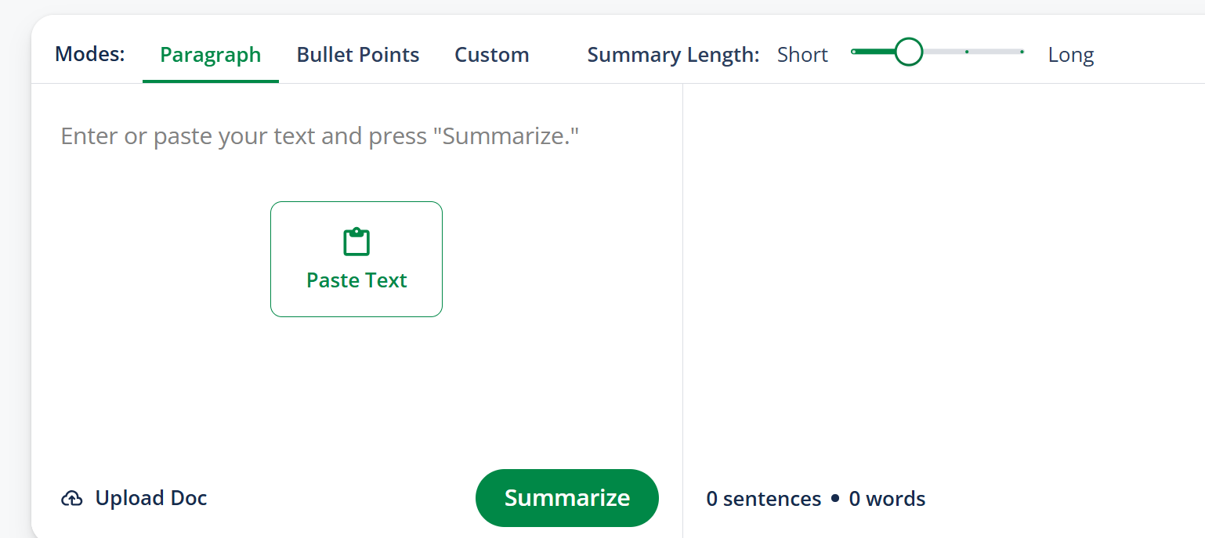
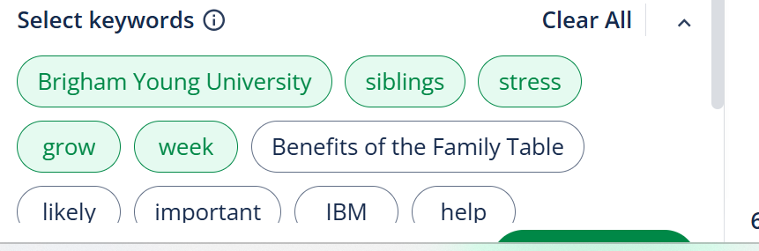
Example:
Tapesripts:
Mom's, dads, and siblings.
They mean so much to us, but unfortunately, we don't get enough time with the whole family.
There is a solution though.
It's called family dinners, taking time each night to sit down and enjoy a meal with the entire family.
Family dinners are important because they relieve stress, help with health, and help
our families grow closer together.
School jobs in housework are all very stressful, but family dinners relieve stress.
According to gonnet.org, in 2008, researchers at Brigham Young University conducted a study of IBM employees and found that sitting down to a family meal helped reduce tension and strain from long hours at the office.
Being happy and stress free is very important, and if having family dinner helps you get that way, that makes family dinners important too.
A second reason that family dinners are important is it helps with health.
Standforchildren.org informs the reader that children who dine with their parents tend to eat better too.
The Academy of Nutrition and Dietetics says that children who join family dinners eat more fruits, vegetables, minerals, and vitamins.
So eating with your family makes you healthier, but it isn't only what you eat, it's how much you eat too.Sitting in front of a TV or even reading a book as you eat means that you're focused on what's happening on TV or in your book and not how much you're eating.
When you're eating with your family, you're alert and can pay attention to what's happening around you and how much you're eating.
This makes family dinners very important, but there is still one more reason.
The third and most important reason that family dinners are important is it helps our families grow closer together.
Family is so important and sadly many families are drifting apart.
In the article, Benefits of the Family Table, it says that when eating family dinners, kids are one and a half times more likely to have an excellent relationship with their mother, twice as likely to have an excellent relationship with their father, and twice as likely to have an excellent relationship with their siblings.
Everyone wants a family that can help them through their good times and bad.
Family dinners can help your family grow closer together so they can love, help, and care for each other.
This makes family dinners extremely important.
In conclusion, family dinners are important.
They help both health, help release stress, and help our families grow closer together. All of these things can help you lead a happier, healthier life, and even if you think you don't have time for family dinners, start small, and only have family dinners maybe two times a week.
Before you know it, you'll be having family dinners every day of the week.
Here is a summary with 5 key words for a gap-fill:
Brigham Young University researchers found that family dinners are crucial for reducing stress, improving health, and fostering closer relationships. They found that sitting down to a family meal reduces tension and strain from long hours at the office, leading to happiness and stress-free living. Children who dine with their parents tend to eat better, consuming more fruits, vegetables, minerals, and vitamins. Additionally, family dinners help families grow closer together, with children being more likely to have excellent relationships with their parents, fathers, and siblings. This fosters a sense of belonging and care for each other, ultimately leading to a happier, healthier life. To start, start small, having family dinners two times a week, gradually increasing to every day of the week.

4.2. Generating comprehension questions
AI can automatically create multiple-choice, true/false, or short answer questions based on any given audio transcript or script. This saves time and ensures tasks are level-appropriate and aligned with learning objectives.
Example: We can use https://twee.com/ to
- convert the videos or audios to text
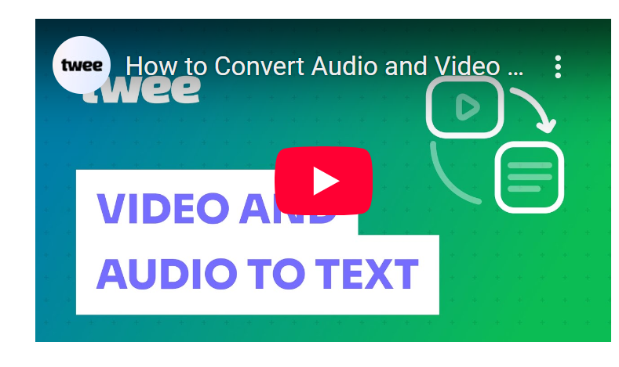
- design warm- up or lead-in questions before listening:
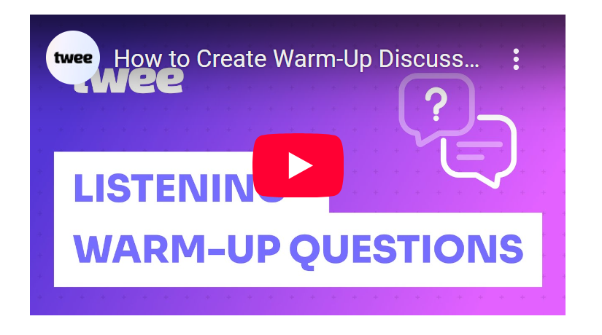
- - create lead-in activities:
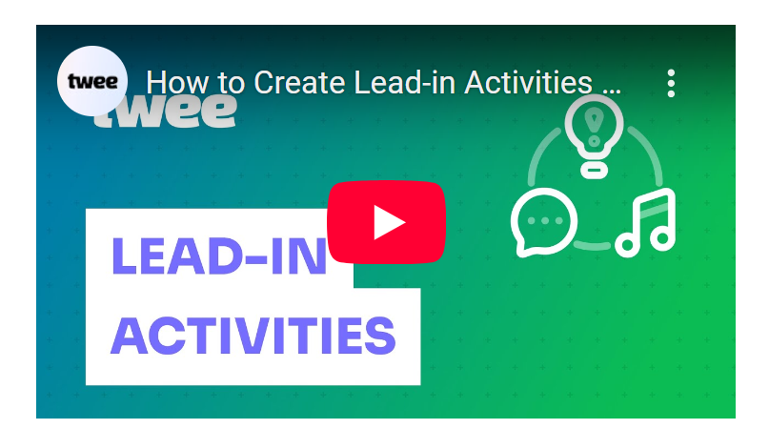
- design while- listening activity tasks like: Summary gap-fill, MCQs, Multiple matching…

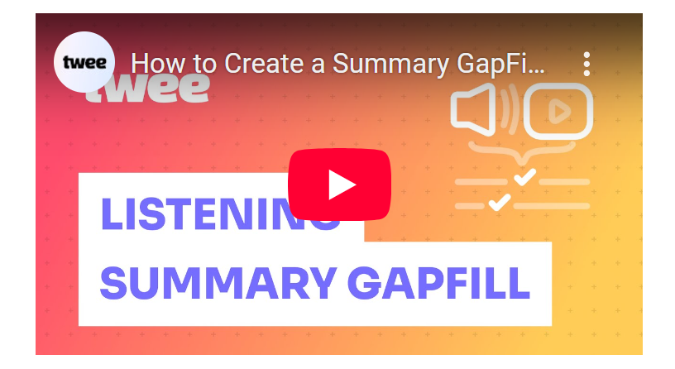

Example: How to Use the Audio & Video Summary GapFill Tool

Step 01 :Add audio or video
To create an "Audio and Video Summary Gapfill" task using Twee, start by uploading an audio or video file from your device, or paste a link directly from YouTube or Vimeo. If you'd like to focus on a specific section of the video, you can trim it to your preferred length.
Step 02: Select a language & level
Next, set the language of the video. You can either manually select it or leave "Detect automatically" and let Twee handle the rest. Then, choose the appropriate student level. You can select from CEFR levels, a grade, or an age group.
Step 03: Generate your gap-fill task
Once everything is set, click "Do the magic!" and Twee will generate a summary gap-fill exercise in seconds.
Step 04: Listen & Learn
This activity is a fantastic way to improve listening comprehension while reinforcing key vocabulary and ideas from the video or audio file.
Sample lesson 1:
UNIT 3 MUSIC
INTENSIVE LISTENING


Music and Creativity in Ancient Greek
Link: Music and creativity in Ancient Greece - Tim Hansen
Lead-in questions:
1. Do you think music can influence our emotions or behavior? How so?
2. Do you agree that certain types of music can be harmful or beneficial?
3. Do you believe that music should be part of education? Why or why not?
1. Vocabulary checking:
1. In Greek ___________, the gods and goddesses controlled different aspects of life and nature.
2. The charity aims to ___________ information about environmental issues to a wide audience.
3. The way these animals are killed is _____________.
4. The company’s ____________ is based on respect, teamwork, and innovation.
5. In many cultures, people believe in _____________ forces that guide and protect them.
6.You would never have guessed his intentions from the ___________expression on his face.
2. Listen to the first part of the recording and fill in the blanks with one suitable word or phrase:
Music is essential in our society, serving various purposes such as worship, storytelling, celebration, work, exercise, and to declare our (1) ________. In (2) ________, creativity was believed to be inspired by divine figures known as the Muses. Each Muse was responsible for different areas of art ranging from song and dance to (3) _________The ancient Greeks considered these subjects vital to civilization, especially in what they perceived as a pretty (4) ________.
Music was the primary medium through which these concepts were taught, studied, and (5) ________, highlighting its significance in ancient Greek culture.
2. Listen to the second part of the recording and choose the best answer for the question:
1. What role did music play in ancient Greek poetry?
A) It was considered unnecessary. B) It served as a form of punishment.
C) It was sung with musical accompaniment. D) It was only used for entertainment.
2.According to the passage, how did the ancient Greeks view the connection between music and education?
A) They believed music was irrelevant to education.
B) Music was integral to understanding various subjects.
C) They thought music distracted from learning.
D) Music was only for religious purposes.
3.What is the concept of "harmonia" as mentioned in the text?
A) A type of musical instrument.
B) The belief in the randomness of the universe.
C) Understanding the interconnectedness of all things.
D) A genre of music.
4.What did Plato believe about the influence of music on a person’s ethos?
A) Music has no impact on a person’s behavior.
B) Certain types of music can promote positive traits.
C) All music is equally beneficial.
D) Music should be avoided entirely.
5. Which genres of music does the passage suggest Plato might have disapproved of?
A) Classical and folk music. B) Jazz, punk, and rap.
C) Religious and instrumental music. D) Country and rock music.
3. Choose the best summary:
A. In the video, the importance of music in Ancient Greek society is explored, highlighting its role in various aspects of life such as education, entertainment, and even medicine. Music was believed to be a divine inspiration from the Muses, with each Muse overseeing different artistic areas. The Greeks saw music as a way to connect with the universe and influence a person's ethos. Plato emphasized the impact of music on a person's behavior and believed that only certain types of music were beneficial for one's ethos.
B. In the video, the focus is on the architectural influence of music in Ancient Greek society. It delves into how music was used to design and construct important structures like temples and theaters. The video also explores the connection between music and mathematics, showcasing how musical harmony was based on mathematical principles. The role of music in shaping the Greek language and literature is also discussed, emphasizing its impact on cultural development.
C. In the video, it's clear that music played a minor role in Ancient Greek society, mainly limited to entertainment purposes. The video suggests that the Muses were not significant figures in Greek mythology. It hints that music had no connection to a person's ethos or behavior. Plato's views on music are presented as outdated and irrelevant in modern times.
Keys:
Task 2
- love and hatred
- Ancient Greek mythology
- history and astronomy
- barbaric world
- disseminated

Task 3:

1C 2B 3C 4B 5B

Task 4: A

Sample lesson 2:
UNIT 4: FOR A BETTER COMMUNITY
Lesson: Intensive Listening
GAP YEAR VOLUNTEERING – WHO GAINS MORE?
Gap year volunteering - Who gains more? | Charlotte Baker Maher | TEDxKingAlfredSchool
I. Before you listen
Vocabulary
• the voluntary/third (noun) – organisations whose purpose is to benefit society rather than to make a profit.
• gap year (noun) – a period of time, often before or after university, when people participate in a personal experience such as travelling or volunteering.
• worthy cause (noun) – a cause that provides a lot of value to society, especially a charitable cause.
• to give (something) back to the community (saying) – to help or volunteer for a worthy cause as a way of repaying or acknowledging the contribution society has given to the volunteer.
• to pay it forward (saying) – to respond to a person's kindness by performing an act of kindness to another person.
Using the vocabulary words above, complete the following sentences (remember to use the correct form of the word)
1. Every Friday night I volunteer to give food to the homeless people in our city; It's just my little way of ________________________.
2. “Thank you so much! That's so kind of you; How can I ever repay you?” “Don't worry! It's no problem whatsoever; just ________________________.”
3. Helping victims of landmines is such a ________________________.
4. During my ________________________ after finishing university, I volunteered to help build a school in Zambia.
5. The government announced that it would abolish taxes for the ________________________.
II. While you listen
You will hear a TEDx Talk by Charlotte Baker Maher called “Gap year volunteering - Who Gains More?”
Part 1. For questions 1-4, choose the answer (A, B, or C) which fits best according to what you hear.
1. How often does the King Alfred School organise trips to Namibia?
A. once per year B. twice per year C. three times per year
2. How did the children in Namibia react when the volunteers left?
A. They were angry B. They were upset C. They were glad
3. What did the Namibian children’s diet mainly consist of?
A. rice B. meat C. porridge
4. Even though the volunteers were supposed to be helping, what existed between them and the Namibian children?
A. animosity B suspicion C. inequality
Part 2. For questions 5-8, Complete the following sentences with NO MORE THAN TWO WORDS from the recording.
5. Helping out in a low-income developing country can be a transformational __________________ for the volunteer.
6. It is an imperialistic view to think volunteers are __________________ by imparting their ideal lifestyle on others.
7. Westerners cause much of the problems faced in the developing world due to their excessive __________________ and causing of __________________.
8. 80% of international volunteers are performing __________________ that locals could do themselves.
Part 3. For questions 9-12, Answer the following questions with NO MORE THAN FOUR WORDS.
9. What is the number one reason for volunteering abroad?
_____________________________________
10. How long do volunteers prefer their trips to last?
_____________________________________
11. Volunteers are unqualified to do what?
_____________________________________
12. What are the students at King Alfred’s raising money for?

Keys:
1A, 2B, 3C, 4C 5.experience, 6. Doing good, 7. Consumerism, climate change, 8. Manual tasks
9. professional development, 10. Two to three, 11 teach, 12. A dining hall

4.3. Creating Listening Scripts and Dialogues
Teachers can request AI to generate custom scripts or dialogues based on any theme or grammar point (e.g., travel, school, health). It gives educators control over language complexity, context, and target vocabulary.
Example: Ask the AI to write a talk about an philanthropist, then use it to create gap-fill or sentence-ordering tasks.
UNIT 4. FOR A BETTER COMMUNITY
(English Specialized Class)
Link: https://docs.google.com/presentation/d/1tEEECpL4AwMNNDcrjUc4RBPwGfAycX9j/edit?usp=sharing&ouid=115721301351968877802&rtpof=true&sd=true
I. VOCABULARY
Checking Vocabulary: Choose the best answer for each of the following questions.
Listen to Mr. Johnson's Philanthropic Journey and do the tasks that followed.
Task 1. Complete the story using the correct forms of the words in the box.
cause | beneficiary | philanthropist | selflessness | deed
commitment | welfare | benevolent | crowdfunding | underprivileged

Mr. Johnson's Philanthropic Journey
Once upon a time in a close-knit neighborhood, there lived a generous (1)_________________, Mr. Johnson. He was known as the pillar of the community due to his unwavering (2)_________________to improving the well-being of the disadvantaged residents.
One day, Mr. Johnson learned about a group of (3)_________________ children who were struggling to access education. He decided to take action and become their benefactor. With his (4)_________________ and desire to share the wealth of knowledge, he initiated a (5)_________________ campaign to sponsor the education of these kids.
He dedicated his time and resources to do good (6)_________________, from organizing educational workshops for local youth to providing food and clothing for families in need. Mr. Johnson's (7)_________________deed ignited a spark in the hearts of others. Community members, inspired by his selfless act, joined the (8)_________________, contributing their efforts tirelessly for the good of these children. They all understood the importance of paying it forward.
As the community rallied together, they witnessed the power of collective action, creating a brighter future for all. The campaign exceeded its target, and soon, the marginalized children had access to quality education. Mr. Johnson's commitment and the community's dedication had transformed the lives of the (9)_________________.
This heartwarming story is a testament to the impact of one individual's selfless commitment, which, when shared with the community, can lead to significant positive change and promote the (10)_________________ of all its members.
Task 2. Locate the words in the story that correspond to the given meanings below.
Meanings | Words/Phrases
1. A verb meaning “to help others as a response to being helped, creating a chain of kindness”. | ……………………………………
2. An adjective with a similar meaning to "underprivileged" or disadvantaged." | ……………………………………
3. A verb meaning "to unite people to provide assistance or support to someone or something." | ……………………………………
​4. An adjective signifying "remaining constant or not weakening in any way." | ……………………………………
5. A noun phrase referring to “a highly respected and influential person who plays a significant role in the well-being and development of a particular community or society.” | ……………………………………
What is the key message in the story?
III. HOMEWORK REPORT
Story writing:
* Work in groups of 7 to create a story of about 180 words about Mr. Johnson's ongoing philanthropic journey to uplift those in need. Conduct a role-play for your story and extract a moral lesson from it. Your story should include:
- Words and phrases related to community development.
- Past simple and past continuous with “when” and “while.”
You can use the following questions as prompts:
- Why did Mr. Johnson start his philanthropic journey?
- Where did Mr. Johnson start helping his community?
- How did Mr. Johnson get money for his projects?
- Who worked with Mr. Johnson on his community projects?
- What problems did Mr. Johnson face and how did he solve them?
- How did the community benefit from Mr. Johnson's work?
Let your imagination run wild and continue the story of hope, compassion, and positive change in the community!
Keys:
Task 1:
1. Philanthropist 2. Commitment 3. Underprivileged 4. Selflessness 5 . crowdfunding
6. Deeds 7. Benevolent 8. Cause 9. Beneficiaries 10. Welfare
Task 2:
1. paying it forward 2. marginalized 3. rallied 4. unwavering 5. the pillar of the community

4.4. Speech recognition and pronunciation feedback
Apps like TikTok Voice Generator allow teachers to transfer text to speech, easily downloadable from browser or mobile phones.
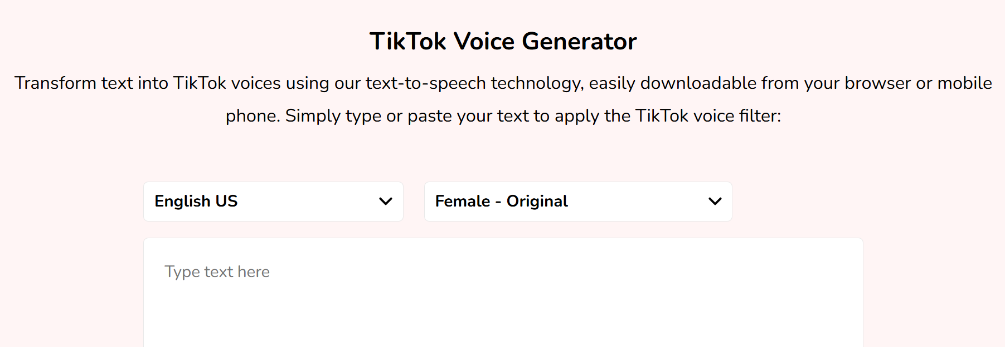

Moreover, Apps like ELSA Speak allows students to listen, repeat, and receive feedback on pronunciation and fluency. Students actively engage with the listening content and improve their speaking at the same time.
Example: After listening to a conversation, students record themselves mimicking the dialogue and receive AI-generated pronunciation feedback.

4.5. Customizing for different levels or themes
AI can adjust content difficulty, provide translations, or rephrase complex audio into simpler forms. This makes it easier to differentiate for students with varied English levels—even within the same gifted group.
Example: Provide the same audio to the whole class but give advanced students open-ended reflection questions, and others multiple-choice ones.
Or we can change the speed of the original audio or video to make it more challenging for students. https://mp3cut.net/change-speed#google_vignette

This listening task is from an advanced test for Halong gifted high school students majoring in English, the audio sped up 1.5 times as much as the original one.

Part 4. For questions 16-25, listen to a recording about Edgar Allan Poe, an American author, and complete the following summary. Write NO MORE THAN THREE WORDS taken from the recording for each blank.
https://www.youtube.com/watch?v=x-387NMCR6w&t=35s
16. Edgar Allan Poe was described with disheveled hair, ________________, reflecting his deep wit and deeper weary in such a fashion that was of high notoriety.
17. Regardless, his ________________style of writing gothic horror was deemed to have an everlasting impact on the literary domain.
18. At his time, Poe had outshone most of his fellows in the field thanks to his own determination of short story form’s ________________.
19. The ________________of the whole gamut of emotions were portrayed by his capitalization of violence and horror, bucking all unambiguity in message delivery and interpretations.
20. The relationship between a ________________and his victim in Poe’s story “The Tell-Tale Heart” had unexpectedly evoked a nagging experience for him to undergo.
21. Another compelling example of his wit in writing was illustrated by a story of an ________________, who might have reckoned that the story “Ligeia” namesake character had reincarnated into her husband’s second wife.
22. Also, Edgar Allan Poe was well-known for his detective series telling the story of C. Auguste Dupin who always outwitted the police with his commanding ________________.
23. From time to time, his works displayed sci-fi elements, exemplified by a balloon voyage to the moon and an account of a patient in ________________.
24. The author also involved himself in different genres, including a ________________ and an adventure novel about the southernmost point of the earth.
25. Accomplished as he might be, Poe was obsessed with his beloved who died of ________________ in their twenties.
Keys:
16. a sickly pallor | 17. macabre and innovative | 18. two cardinal rules | 19. paradoxes and mysteries | 20. ghastly murder
21. opium-addicted narrator | 22. observation and deduction | 23. (a) hypnotic trance | 24. treatise on astrophysics | 25. tuberculosis

4.6. Creating themed listening projects
AI can suggest project ideas or tasks connected to real-world themes (e.g., family, climate change, technology, tourism). Gifted students enjoy meaningful, content-rich learning. Themed tasks make lessons more integrated and interdisciplinary.
Example: AI generates a set of listening tasks around the topic "Protecting the Environment," including listening, discussion, and writing follow-ups.

UNIT 9- PROTECTING THE ENVIRONMENT
LESSON 5: LISTENING AND SPEAKING
Endangered Animal Species - Animals for Kids - Educational Video
- Matching: Match the name of the animals with the pictures and their descriptions:

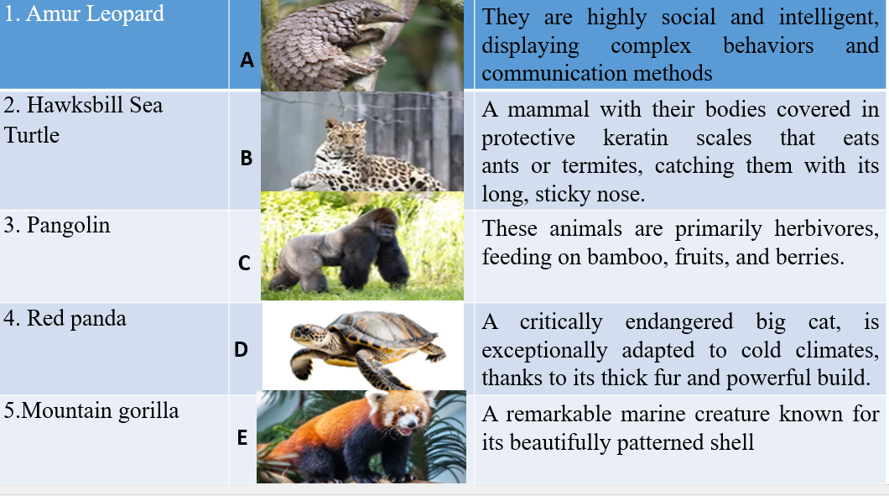
- Listening 2: Listen to a piece of news about some endangered species in the world and do the following tasks:
Task 1: Listen and fill in the gaps with a word or a phrase:
Many animals are endangered due to various threats, including habitat destruction, hunting, and pollution. The Amur Leopard is one of the most beautiful and (1) ______________ big cats, but its population is declining as deforestation and (2) _______________ destroy its habitat. Rhinos are also at risk because their horns are considered a (3) _______________ by hunters and a valuable booty for poachers, despite hunting bans. Similarly, the Hawksbill Turtle is hunted for its (4) _______________, making it a target for illegal trade. Ocean pollution is another major threat, as turtles often mistake plastic waste for (5) _____________, leading to severe harm.
Task 2: Listen and choose the best answer:
6. What is the primary threat to mountain gorillas?
A. hunting B. poaching C. global warming D. pollution
7. Why are pangolins considered endangered?
A. their scales are toxic B. their scales are beautiful
C. their scales have medical properties D. they are rare
8. What challenges do polar bears face due to climate change?
A. decreasing food supply B. constant migration northward
C. loss of hunting grounds D. reduction in population
9. What unique characteristic that makes bamboo problematic for pandas?
A. it grows quickly B. it's not nutritious
C. it blossoms rarely and then dies D. it's hard to find
10. According to the listening, what are the main reasons animals become endangered?
A. natural disasters B. human activities C. animal migrations D. lack of food sources
Keys:
Task 1:
1. (world’s) rarest 2. slash and burn 3. desired trophy 4. shell and meat 5. Jellyfish
Task 2: 5b 6c 7b 8c 9c 10b

5. Listening comprehension exercises bank by topic

5.1. Human and the Environment
UNIT 2: Supplementary listening
Authentic 1
1. Greenhouse, the main cause of climate change, occurs when Sun’s light is allowed to get into but some of the heat gets ……………., which looks like the……………………..
2. It takes ………....... such a long time to reach today’s levels.
3. Consequences of climate change :
- the melting of ………..
- The rise of sea levels and floods in …………., as a direct result of water held in ……………..
- Warmer temperatures lead to ………. weather patterns, such as storms, floods, ………. and droughts
4. Challenges posed by changing weather patterns:
- Growing crops becomes more difficult because possible habitats for animals and plants ……… and water supplies are ……………
- As ..................... are an component of smog, exposure to smog may cause severe health problems.
5. By replacing fossil fuels with renewable energy sources, humans can …….. climate change
https://www.youtube.com/watch?v=G4H1N_yXBiA
Authentic 2
1. The air quality in some developing countries is so bad that city officials have to resort to extreme measures to ………………..
2. Some scientists measure air quality based on the number of particles with diameters ………………………………………., while others concentrate on particles with diameters amounting to as much as ……………………
3. Onitsha is heavily polluted as a result of …………………………
4. Onitsha has the worst traffic in Nigeria, lacks any ………………. and establishes too few regulations.
5. Zabol’s pollution problem is unique because it is not a ……………………
6. In fact, its excess air particles result from …………………………………
7. In the early 2000s, the amount of dust accelerated as ……………………………
8. In 2015, the issue of air pollution in Zabol became so serious that city officials had to ……………………..
9. As a result of serious pollution in Delhi, …………………………… are popular diseases among adults while children suffer from irreversible lung damage.
10. The issue in Delhi exacerbated in 2016, forcing its people into a ………………..
https://www.youtube.com/watch?v=iqH9e58ngAk&t=125s
Authentic 3
1. Climate change is a fact. We can see it in fish migration patterns, in melting Arctic sea ice, ………………… and the damage to corals
2. Climate change, in some ways, is believed to be ……………….
3. More serious floods may arise in the future as ………………….
4. At the……………., the author affirms that future changes to the climate need to be fully adapted
5. One example of adaptation to climate change is ………………. to block drainage channels.
6. Another example is in Cranfield University where ………….are created.
7. Adaptation also has its limits as a ……………. may lead to extinctions and impacts on ecosystem.
8. Extreme warming would also ……………
9. Overall, the report is considered to be ……………..
10. …………… asserts that we have to make certain that the situation is not so bad.
https://www.facebook.com/cunghocthihocsinhgioitienganh/videos/1821939288021318/
Keys:
Task 1:
1. trapped – glass walls of a greenhouse
2. atmospheric carbon dioxide
3. ice sheets – coastal regions – glaciers - more extreme – snowfall
4. shift – diminished – ozone particles
5. combat
Task 2:
1. Protect residents from respiratory diseases
2. Less than or equal to 2.5 micrometers/10 micrometers
3. Rapid growth and industrialization
4. Proper waste incineration plants
5. Population or industrial hub
6. Continuous dust storms
7. The region's primary wetland dried up
8. Distribute free face masks
9. Headaches, sore throats, and reduced lung capacity
10. Full-blown state of emergency
Task 3:
1. (in) shrinking Himalayan glaciers
2. reversible
3. warmer air holds more moisture
4. document launch in Japan
5. building mini-dams
6. artificial mini-fields
7. 4 degree C rise (in temperature)
8. melt the Greenland ice caps
9. alarmist
10. The UN Panel

5.2. Theme Music
PRE LISTENING: VOCABULARY TEACHING
Link: CS 25- UNIT 3.pptx - Google Trang trình bày
Using the vocabulary words above, complete the following sentences (remember to use the correct form of the word, e.g. verb conjugation or plural noun)
1. My colleague claimed to be really ______________ techno, but when I asked what his favorite DJs were, he said David Guetta, Calvin Harris and Tiesto.
2. I’ve got “Cruel Summer” by Taylor Swift ______________. I can’t stop singing it, but it’s fine because I love Taylor Swift!
3. My friend went to one of the first ever Arctic Monkey ______________ in Sheffield and hasn’t stopped mentioning it since.
4. My neighbor has a terrible ______________. He’s spent all morning listening to Justin Bieber’s “greatest” hits.
5. The Rembrandts are a ______________ due to their song “I’ll Be There For You” that became famous as the theme song to the TV show Friends, but the band never achieved success with any other tracks.

6. We ______________ last night, but instead of dancing, everyone just filmed the DJ on their phones.

WHILE- LISTENING
EX1: While you watch the video, answer the following questions:
For questions 1-4, choose the best answer (A, B or C).
1. What was the nickname of The Beatles?
A. the famous four B. the fab four C. the furious four
2. In which year did the Beatles form?
A. 1950 B. 1960 C. 1970
3. How many of the Beatles sang?
A. 2 B 3 C. 4
4. ‘Beatles mania’ was a frenzied reaction by whom?
A. band managers B. fans C. their parents
For questions 5-8, complete the sentences with a word or short phrase.
5. The Beatles’ first number one hit, and their appearance on the Ed Sullivan Show, paved the way
for ________________ the of America.
6. On their ________________in 1964, the band were chased by screaming fans.
7. The Beatle’s number one ________________ from their film Help! featured the song Yesterday.
8. In 1966, John Lennon caused________________ when he made comments about the Beatle’s
popularity.
For questions 10-12, answer the questions with NO MORE THAN THREE WORDS
9. Where did the band go after releasing the song All You Need Is Love?
_____________________________________________________
10. What category of film was Yellow Submarine?
_____________________________________________________
11. What is the Beatle’s self-titled album also known as?
_____________________________________________________

12. By the time of Let It Be, what had Lennon and McCartney started to release?
AFTER- LISTENING: Write a paragraph about the importance of music
Keys:
1 into, 2.stuck in my head 3. gigs 4. taste in music, 5. one-hit wonder, 6. went clubbing
1B, 2B, 3C, 4B
5. British invasion, 6. International tour dates, 7. Soundtrack, 8.controversy
9.A meditation retreat( in Bangor, Wales) 10. Animated, 11.The Whilte Album, 12. Solo material

5.3. Theme Gender equality:
INTENSIVE LISTENING UNIT 6- GENDER INEQUALITY
Authentic 1
http://www.npr.org/2017/04/28/525992223/survery-says-workers-are-leaving-tech-jobs-because-of-mistreatment
The tech industry is getting hit hard by 1)________________ who think they've been treated unfairly.
That's the conclusion of a national study that examines why workers leave their jobs in tech. The problem is most acute among 2________________, meaning women, racial minorities, ethnic minorities.
There are many 3) ____________ about what tech companies are like on the inside - places where women are sexually harassed and blocked from promotion, where blacks and Latinos don't get hired. This new survey is an effort to 4)___________ from anecdotes to patterns.
Researchers found the No. 1 reason for leaving was not a better job offer; it was 5)_______________especially for women and underrepresented minorities. The survey considered four types of unfair practices.
One being unfair 6) ________________, things like job assignments and promotions; two being 7)______________; three, 8)________________; and four, 9)____________.
About 10)________________ said they'd experienced at least one of these. But the type experienced varied by race, gender and sexual orientation. For example, white and Asian men reported being more 11)__________________ than men of other races. LGBTQ respondents reported the highest rate of bullying. And women...
12) _______________women reported unwanted sexual attention or harassment.
In recent years, the largest tech companies have begun to disclose how many women and underrepresented minorities they're hiring. But with the exception of the chip maker Intel, no major company is disclosing how many of these employees are staying versus leaving.
Authentic 2
https://www.npr.org/templates/transcript/transcript.php?storyId=593102978
A contract worker doesn't have the right to sue for (1)_________or gender discrimination.
A few years later, it happened again in a different job - this time with the grandfather of a child Irizarry was tutoring. She considered posting about it online. But Irizarry, now 33 and a (2)_________, says she decided against it.
Over the last century, full-time employment has been the (3)_________
Caitlin Pearce is (4)_________of the Freelancers Union with 350,000 members.
New York City and three states - California, Washington and Pennsylvania - extend other (5)________to contractors.
The same protections, where the (6)_________and the manager control the workplace - control the worker, is not relevant to the independent contractor relationship.
Weil says that many employers are simply labeling more jobs as contract positions in order to (7)______and risk onto workers.
Perhaps employers are confused. Perhaps they're taking advantage of the fact that contract employees aren't so (8)_________in the law.
Natalie Franke says this lack of data (9)_____a big problem.
Franke urges freelancers to do what they can - seek (10)___________and include anti-harassment and discrimination clauses in their future contracts.
Keys:
Authentic 1:
1. turnover among workers
2. underrepresented workers
3. ugly anecdotes
4. pivot
5. mistreatment
6. people management practices
7. stereotyping
8. sexual harassment
9. bullying
10. 80% of respondents
11. unfairly managed
12. One in 10
Authentic 2:
1. sexual harassment
2. freelance writer
3. norm
4. executive director
5. workplace protections
6. supervisor
7. shift the cost
8. well-defined
9. masks
10. emotional support

5.4. Theme Protecting the Environment
AUTHENTIC LISTENING
Link: https://drive.google.com/drive/folders/1BXhyJl66bdh5GWQRd3VqmyHAti8Ng8ow?usp=sharing
I. Fill in each blank with NO MORE THAN THREE WORDS
1. A new study of China's greenhouse gas emissions suggest they could (1) ________________________ within the next 10 years.
The research by the London (2) ________________________ indicates that the fall could happen five years earlier than forecast.
Despite being the world's (3) ________________________, China is also the biggest investor in solar, wind and nuclear power.
2. The head of world (4)________________________ Fifa has held talks with senior officials ahead of a planned meeting on Monday, at which a date is expected to be set for a (5)________________________.
Sepp Blatter announced last month that he would step down weeks after the (6)________________________ in Zurich in early May of (7)________________________ of the organisation.
3. Researchers in the United States have designed an (8)________________________ on how to purify water, with the pages themselves (9) ________________________ as water filters.
Tests show that when (10)________________________, the pages, which are impregnated with copper or silver nanoparticles, killed almost all of the (11)________________________in contaminated water.
II. Choose the correct summary:
1.
a) A new report has shown that greenhouse gas emissions by China will end in 10 years' time.
b) A new report has forecast that China will produce the world's biggest emission of greenhouse gases in five years' time.
c) A new report predicts China is going to reduce its emission of greenhouse gas earlier than expected.
2.
a) Fifa has held an election to choose its new leader.
b) The Fifa president Sepp Blatter has announced his resignation.
c) Fifa will decide a date for the election of their new leader.
3.
a) The new book shows you how to purify water by adding copper and silver nanoparticles.
b) The new book's pages are contaminated with copper and silver nanoparticles.
c) The new book's pages are used as filters which can clean dirty water.
Keys: 1c, 2b, 3c
III. Listen to the recording and fill in each blank with NO MORE THAN THREE WORDS.
As coronavirus cases continue to climb in both the United States and Europe, experts worry it could be the beginning of a fall surge.
"As some countries start to open up, we see cases, and they're (1) ______________________,” said Tedros Adhanom Ghebreyesus, Director General of the World Health Organization.
European leaders are making changes after relaxed rules and expanded reopenings. (2) ______________________ have gone into a new lockdown, the Czech Republic appointed a new minister of health, and the United Kingdom announced pubs and restaurants would now close at 10 p.m. to try to slow the spread.
"A month ago, on average around a thousand people across the U.K. were testing positive for coronavirus every day," said British Prime Minister Boris Johnson. "The latest figure has almost quadrupled to (3) ______________________."
On Tuesday President Trump defended his response, despite the U.S. leading the world in cases and deaths. He spoke in a recorded address to the United Nations (4) ______________________.
“In the United States we launched the most (5) ______________________ since the Second World War,” said President Trump.
(6) ______________________ from the University of Washington predicts the U.S. is nowhere close to being out of the woods yet, suggesting nearly 180,000 more people will die in the United States by January.
“The U.S. has about half the population of Europe, however, we have twice as many cases,” said Dr. Jon Andrus, an adjunct professor of global health at George Washington University.
Dr. Andrus thinks we should learn from Europe’s mistakes. He points out that more Europeans taking non-essential trips may have led tourists to lower their guards, contributing to (7) ______________________ events.
“They're not masking, they're not physically distancing, and then they return home,” he said.
Besides wearing masks and washing hands, he wants Americans to expand (8) ______________________, like in Canada and South Korea.
“We need to be reading from the same sheet of music," Andrus said. "When one community is doing one thing, might have (9) ______________________, and another community is very lax and has no restrictions. at the end of the day, that does not help.”
Keys:
1.starting to spike 2. Chunks of Spain 3 .3,929 4.virtual General Assembly 5.aggressive mobilization
6.An influential model 7.potential superspreader 8.contact tracing 9. tighter restrictions
IV. Listen to a piece of news from Earth Watch radio and fill in the missing information. Write NO MORE THAN THREE WORDS taken from the recording for each answer in the spaces provided.

Withering in Warm Water

When the oceans get warmer, the number of plants in the water goes down.

By Brian Sweeney
(1) __________________________ reveal that tiny marine plants become less common as water temperatures get warmer. The change in temperature apparently slows down a
(2) __________________________ system that feeds the plants at sea, and that slowdown could cause big problems in the future.
Mike Behrenfeld is a plant pathologist at Oregon State University. He worked with the (3) __________________________ NASA on a study of plant growth at sea. The study used satellite imagery to (4) __________________________ over ten years. Behrenfeld says it revealed a connection between plant growth and air temperature.
"There seems to be this very clear relationship that -- on (5) __________________________ -- when you have climate warming periods, production goes down and cooling periods, production goes up."
Periods of cooler air temperatures also cool off the water at the ocean surface. That makes the water more dense, and when it sinks, it forces nutrients up from the depths. The nutrients feed plants at the surface, and that increases the (6) __________________________ of plant life at sea.
Things change when the surface is warmer. The (7) __________________________ of ocean water grows weaker and plants at the surface die off.
Behrenfeld says air temperatures grew warmer over the 10 years of the NASA study. That led to a loss of phytoplankton that could be seen from space. Behrenfeld says that as the climate grows warmer, other marine life might suffer because they won't have phytoplankton to eat.
"It's the same in the ocean as it is on land. If you reduce how much grass is growing in a field, that's obviously going to change how much (8) __________________________ can be supported by that field."
The loss of tiny plants at sea is not a (9) __________________________. Marine plants account for 50 percent of all plant life on Earth.
Keys:
1.Satellite images 2.natural conveyor 3.space agency 4.monitor changes 5.global average
6.overall mass 7. natural flip-flop 8.animal biomass 9.trivial matter

6. A sample lesson plan
UNIT 9: PROTECTING THE ENVIRONMENT
(English 10 textbook Global success)
LESSON 5: LISTENING AND SPEAKING
A. OBJECTIVES: After the lesson students will be able to
1. Knowledge
- Use the lexical items related to the topic Protecting the environment;
- Listen for specific information in a conversation about ways to protect endangered animals.
- Speak about ways to protect the environment
2. Skills
- Develop listening skills and creativity;
- Be collaborative and supportive in pair work and team work;
- Actively join in class activities.
3. Attitude
- Be well aware of saving endangered animals;
- Be encouraged to attend activities organized to protect endangered animals.
B. TEACHING AIDS:
Textbooks, posters, projectors
C. METHODS: Integrated, mainly communicative.
D. CONTENTS:
I. Class organization (1’)
II. New lesson (44’)
Warm-up - Whole class/ (5’)
Aim of the activity | Content and Procedure | Expected outcome
- Check students’ general knowledge about rhinos and tigers - two endangered animals.  - To introduce the topic of listening.  - To set the context for the very listening part | GAME: ANIMAL RESCUE  *T divides class into 2 teams and chooses a team leader for each. 2 team leaders compete by raising his/ her hand to be the first to give answers to the questions.  ** Ss do as instructed.  ***Competitors may discuss with his/ her team members to find out the answers.  ****T gives comments or feedback.  - T draws Ss’ attention to the word ENDANGERED ANIMALS, then lets them know they are going to listen to a talk show related to this word. | Ss will be able to know they are going to listen to the topic related to endangered animals.  Key:  1. D  2. B  3. A  4. C  5. C
PART 1: LISTENING:
LEAD IN - LOOK AT THE PICTURE AND ANSWER THE QUESTIONS. (p.106) (Group work/ 1 min)
Aim of the activity | Content and Procedure | Expected outcome
- To help students brainstorm and have an overview about what they are going to listen to.  - To provide Ss with essential vocabulary | TASK 1:(p.106)  *T asks Ss to look at the picture and answer the questions:  - What threats are these animals facing? | Ss will be able to  - figure out the answer
ACTIVITY 1: LISTEN TO THE CONVERSATION AND DECIDE WHETHER THE STATEMENTS ARE (T) OR FALSE (F). (p.106) 5 mins
Aim of the activity | Content and Procedure | Expected outcome
To help students develop listening skills for specific information. | - TASK 2: NAM AND MAI ARE TALKING ABOUT MAI’S PROJECT ON WAYS TO SAVE ENDANGERED ANIMALS  T asks Ss to read the statements, underline the key words, and reminds them to pay attention to keywords while listening. T plays the recording. T asks Ss to listen and decide whether the statements are true (T) or false (F).  ** Ss do as instructed.  ***T asks Ss to compare their answers with their partner.  ****T calls on some Ss to present their answers, then plays the recording once again and checks with the class.  TASK 3: LISTEN TO THE CONVERSATION AGAIN AND COMPLETE THE NOTES. USE ONE WORD FOR EACH GAP. (p.106)  3.1. Read and identify the part of speech (word class) of the missing word.  *T asks Ss to read the notes and identify the part of speech (word class) of the missing word.  ** Ss read the notes, do as required.  *** Ss compare their answers.  ****T calls on one student to write their answers on the board, then read the notes and check with the class.  3.2. Listen and complete the notes with ONE word from the listening text.  *T plays the recording and asks Ss to listen and complete each blank number with ONE word from the listening text.  ** Ss do as required.  ***T asks Ss to compare their answers with their partner.  ****T calls on some Ss to write their answers on the board, then play the recording once again and check with the class. | - Ss will be able to understand the conversation and decide the correct aswers.  Key:  1. T  2. T  3. F  4. T  - – a noun  - – a noun  - – a noun  - – a noun or an adjective  Ss will be able to complete the notes with one word form the listening  Key:  1. importance  2. laws  3. trade  4. animal
ACTIVITY 2: LISTEN TO A NEWS REPORT AND DO THE TASK. (authentic listening)
Aim of the activity | Content and Procedure | Expected outcome
To check students’ understanding of the listening part. | - Matching: Match the name of the animals with the pictures and their descriptions:  - Listening 2: Listen to a piece of news about some endangered species in the world and do the following tasks:  - Task 1: Listen and fill in the gaps with a word or a phrase:  Many animals are endangered due to various threats, including habitat destruction, hunting, and pollution. The Amur Leopard is one of the most beautiful and (1) ______________ big cats, but its population is declining as deforestation and (2) _______________ destroy its habitat. Rhinos are also at risk because their horns are considered a (3) _______________ by hunters and a valuable trophy for poachers, despite hunting bans. Similarly, the Hawksbill Turtle is hunted for its (4) _______________, making it a target for illegal trade. Ocean pollution is another major threat, as turtles often mistake plastic waste for (5) _____________, leading to severe  Task 2: Listen and choose the best answer:  1. What is the primary threat to mountain gorillas?  A. hunting B. poaching  C. global warming D. pollution  2. Why are pangolins considered endangered?  A. their scales are toxic  B. their scales are valuable  C. their scales have medical properties  D. they are rare  3. What challenges do polar bears face due to climate change?  A. decreasing food supply  B. constant migration northward  C. loss of hunting grounds  D. reduction in population  4. What unique characteristic that makes bamboo problematic for pandas?  A. it grows quickly  B. it's not nutritious  C. it blossoms rarely and then dies  D. it's hard to find  5. According to the listening, what are the main reasons animals become endangered?  A. natural disasters  B. human activities  C. animal migrations  D. lack of food sources | - Answers:  1. (world’s) rarest  2. slash and burn  3. desired trophy  4. shell and meat  5. Jellyfish  6.B  7.C  8.B  9.C  10. B
PART 2: SPEAKING (20 minutes)
Aim of the activity | Contents and procedure | Expected outcome
Students can be able to talk about problems with endangered species and our environment | Drama Performance  Group 1: The Cost of Luxury  Group 2: Miss Nature | - Students work in groups and voice their opinions about problems with endangered species and our environment
C. Consolidation and Homework
Aim of the activity | Content and Procedure | Expected outcome
CONSOLIDATION  - To consolidate what students have learnt in the lesson.  - To prepare for the next lesson. | WRAP-UP  Teacher asks students to talk about what they have learnt in the lesson.  HOMEWORK  Teacher asks students to write a short paragraph about their opinion on how students can help to save endangered animals. | - Ss will be able to recall what students have learnt in the lesson.

Handouts:
UNIT 9- PROTECTING THE ENVIRONMENT
LESSON 5: LISTENING AND SPEAKING
- Matching: Match the name of the animals with the pictures and their descriptions:
- Listening 2: Listen to a piece of news about some endangered species in the world and do the following tasks:
- Task 1: Listen and fill in the gaps with a word or a phrase:
Many animals are endangered due to various threats, including habitat destruction, hunting, and pollution. The Amur Leopard is one of the most beautiful and (1) ______________ big cats, but its population is declining as deforestation and (2) _______________ destroy its habitat. Rhinos are also at risk because their horns are considered a (3) _______________ by hunters and a valuable booty for poachers, despite hunting bans. Similarly, the Hawksbill Turtle is hunted for its (4) _______________, making it a target for illegal trade. Ocean pollution is another major threat, as turtles often mistake plastic waste for (5) _____________, leading to severe harm.
- Task 2: Listen and choose the best answer:
6. What is the primary threat to mountain gorillas?
A. hunting B. poaching C. global warming D. pollution
7. Why are pangolins considered endangered?
A. their scales are toxic B. their scales are beautiful
C. their scales have medical properties D. they are rare
8. What challenges do polar bears face due to climate change?
A. decreasing food supply B. constant migration northward
C. loss of hunting grounds D. reduction in population
9. What unique characteristic that makes bamboo problematic for pandas?
A. it grows quickly B. it's not nutritious
C. it blossoms rarely and then dies D. it's hard to find
10. According to the listening, what are the main reasons animals become endangered?
A. natural disasters B. human activities C. animal migrations D. lack of food sources

7. Outcomes of the study
After a year of incorporating AI tools into my listening instruction, I’ve seen some promising initial results. One of the most noticeable changes is a boost in students’ motivation. The listening content—especially media clips—focuses on themes that are both familiar and personally meaningful to them. Some clips even spark their curiosity and imagination. As a result, many students find listening lessons more enjoyable and are more eager to participate.
In addition, these digital tools expose students to a broader range of world knowledge. They also support vocabulary development, particularly in areas such as technology, social issues, politics, and environmental topics.
Above all, the most outstanding achievement is the improvement in students’ listening proficiency. At first, many felt uncertain about understanding authentic materials like podcasts or video segments. However, as time went on, their confidence grew along with their comprehension skills. These AI-powered tools have effectively connected learners to real-life social contexts. Although there’s still room for growth, their value in enhancing language learning continues to motivate me to explore more resources.
Through my ongoing efforts to discover various educational apps, collaborate with fellow teachers, and gather materials from students’ work, I’ve developed a rich collection of current and useful teaching resources. More importantly, I’ve gained insights into the interests and concerns of today’s youth. This awareness drives me to keep learning and adapting in order to meet the evolving demands of modern language education.

8. Some recommendations
Drawing from my teaching experience, there are several important factors to consider when integrating AI tools into instruction.
First and foremost, teachers should carefully evaluate their students’ language proficiency and select materials that are appropriate to their level. Content that is either too advanced or too basic can hinder learning. While some challenge can be beneficial, the material must remain comprehensible overall, avoiding vocabulary or grammar that may overwhelm learners.
Student engagement also plays a critical role in selecting suitable applications and customizing listening resources. It is important to choose tools that are both appealing to students and manageable for teachers to use. Conducting surveys to understand students’ interests can help guide the selection process. Topics such as music, films, environmental issues, education, career paths, and travel are often popular and can spark curiosity and participation.
Equally important is the need to evaluate the reliability of online platforms and applications. Teachers should ensure they are sourcing materials from trustworthy and reputable websites to maintain accuracy and avoid misinformation. Carefully selecting credible resources protects the quality of the content and contributes to a positive and effective learning environment.
When designing listening activities using online content, a range of approaches can be employed. It is important for teachers to select strategies that align with their teaching goals and classroom context. A well-balanced lesson should include tasks of varying difficulty, from basic comprehension to more complex analysis, providing both support and challenge for students.
Lastly, incorporating diverse multimedia elements such as videos, images, and audio can greatly enhance the learning experience. Compared to traditional textbook-based methods, multimedia makes lessons more dynamic, engaging, and easier to understand. Using a variety of media formats helps students absorb and retain information more effectively.

PART 3: CONCLUSION
The findings of the study highlight that listening is the most commonly used language skill, both in educational settings and in everyday interactions, surpassing speaking, reading, and writing. Aural comprehension plays a crucial role in the process of second-language acquisition, underscoring the importance of placing greater emphasis on developing listening skills. The research also demonstrates that ESL students show significant improvement in their listening comprehension after engaging with authentic listening materials in the classroom. Furthermore, integrating AI tools into the design of listening tasks has been shown to boost students’ interest in learning English while simultaneously expanding both their linguistic and general world knowledge. As a result, the regular inclusion of online materials in classroom instruction is strongly encouraged.
The study recommends the use of modern technology to incorporate authentic listening materials into the curriculum as a strategy to improve listening comprehension among English majors. However, the current use of these materials remains limited and still requires further development to better meet students’ learning needs. In light of this, several directions for future research and practice are proposed:
Future studies should aim to design listening tasks specifically for non-English majors, particularly those with lower proficiency levels, to ensure that online materials are accessible and beneficial to a broader range of learners. Moreover, the adoption of AI in English teaching is still at an early stage in many Vietnamese high schools, presenting challenges for educators. Therefore, it is advisable to organize more professional development workshops, allowing teachers to exchange ideas, share practical experiences, and gain hands-on experience in creating their own listening activities.

REFERENCES
Adams, T. (1995). What Makes Materials Authentic? (ERIC Document Reproduction Service No. ED 391389).
Guariento, W., & Morley, J. (2001). Text and task authenticity in the EFL classroom. ELT Journal, 55 (4), 347 - 353.
Harmer, J. (1991). The Practice of English Language Teaching. London: Longman. Kilickaya. F. (2004). Authentic materials and cultural content in EFL classrooms. The
Internet TESL Journal, 10 (7). Retrieved November 1, 2006 from http://iteslj.org/Techniques/Kilickaya-AutenticMaterial.html
Kim, D. (2000). A qualitative approach to the authenticity in the foreign language classroom: a study of university students learning English in Korea. Texas Papers in Foreign Language Education, 5 (1), 189-205.
Lee, W. (1995). Authenticity revisited: text authenticity and learner authenticity. ELT Journal, 49 (4), 323-328.
Martinez, A. (2002). Authentic materials: An overview. Karen's Linguistic Issues.
RetrievedOctober25,2006from http://www3.telus.net/linguisticsissues/authenticmaterials.html
McNeill, A. (1994). What Makes Authentic Materials Different? The Case of English Language Materials for Educational Television. Papers presented at the Annual International Language in Education Conference, Hong Kong.
Schmidt, T. (1994). Authenticity in ESL: a study of requests. Unpublished master’s thesis, Southern Illinois University, Carbondale.

