

**HƯỚNG DẪN CHẤM**

**ĐỀ THI ĐỀ XUẤT TRẠI HÈ DUYÊN HẢI – ĐBBB NĂM 2023**

**TRƯỜNG THPT CHUYÊN SƠN LA – TỈNH SƠN LA**

**MÔN: TIẾNG ANH 10**

*(HDC gồm có: 08 trang)*

**SECTION I: LISTENING (50pts)**

**Part 1: Questions 1-5. Complete the notes below. Write ONE WORD AND/ OR A NUMBER for each answer. (10pts)**

|  |  |  |  |  |
| --- | --- | --- | --- | --- |
| 1. journalist | 1. return | 1. delay | 1. information | 1. parking |

**Part 2. For questions 6-10, listen to a talk about fear and decide whether these statements are True (T) or False (F). Write your answers in the corresponding numbered boxes provided. (10 points)**

|  |  |  |  |  |
| --- | --- | --- | --- | --- |
| 6. TRUE | 7. TRUE | 8. FALSE | 9. TRUE | 10. FALSE |

**Part 3: You will hear part of an interview in which a career coach called Charles Norris is discussing job-hunting. For questions 11-15, choose the answer (A, B, or C) which fits best according to what you hear. (10pts)**

|  |  |  |  |  |
| --- | --- | --- | --- | --- |
| 11. D | 12. A | 13. A | 14. B | 15. D |

**Part 4. For questions 16-25, listen to Listen to a recording and complete the sentences with NO MORE THAN THREE WORDS AND/OR A NUMBER taken from the recording for each answer in the space provided.**

|  |  |
| --- | --- |
| 1. human pathogens | 21. microbes |
| 1. hypothetical infection | 22. catalogue viruses |
| 1. Metagenomics | 23. bottommost foundation |
| 1. metagenomic sequencing | 24. viral genetic code |
| 1. sequencing machine | 25. pulling the strings |

**SECTION II: LEXICO-GRAMMAR (40pts)**

**Part 1: Choose one word or phrase which best completes each sentence. Circle its corresponding letter A, B, C, or D to indicate your answer. (20pts)**

|  |  |  |  |  |  |  |  |  |  |
| --- | --- | --- | --- | --- | --- | --- | --- | --- | --- |
| 1. A | 2. B | 3. D | 4. C | 5. C | 6. C | 7. C | 8. D | 9. D | 10. C |
| 11. B | 12. D | 13. A | 14. B | 15. B | 16. A | 17. A | 18. B | 19. C | 20. C |

**Part 2: Use the word given in capitals at the end of each line to form a word that fits in the gap in the same line.**

|  |  |
| --- | --- |
| 1. contemporaneous | 6. discretion |
| 2. guardian | 7. disciplinary |
| 3 disapproval | 8. refugees |
| 4. . stunningly | 9. lawful |
| 5. transparency | 10. recover |

***Part 3. Complete each of the following sentences with suitable preposition(s). Write your answer in the boxes provided on the answer sheet. (10 points)***

|  |  |  |  |  |
| --- | --- | --- | --- | --- |
| 1. under | 1. by | 1. up | 1. out | 1. in |
| 1. at | 1. in | 1. for | 1. with | 10. to |

**SECTION C: READING (60 points)**

***Part 1. Read the following passage and decide which option (A, B, C, or D) best fits each gap. Write your answers in corresponding numbered boxes on the answer sheet. (15 points)***

|  |  |  |  |  |
| --- | --- | --- | --- | --- |
| 1. A | 1. C | 1. D | 1. A | 1. B |
| 1. A | 1. C | 1. D | 1. A | 1. B |

***Part 2. Fill each of the following numbered blanks with ONE suitable word and write your answers in the corresponding numbered boxes on the answer sheet. (15 points)***

|  |  |  |  |  |
| --- | --- | --- | --- | --- |
| 1. chosen | 2. few | 3. without | 4. However | 5. especially |
| 6. sustainable | 7. called | 8. radiation | 9. attacked | 10. organically |

***Part 3. Read the following passage and circle the best answer to each of the following questions. Write your answers in corresponding numbered boxes provided on the answer sheet. (15 points)***

|  |  |  |  |  |
| --- | --- | --- | --- | --- |
| 1. A | 1. D | 1. C | 1. A | 1. B |
| 1. A | 1. C | 1. B | 1. A | 10. D |

***Part 4. Read the passage and do the following tasks. Write your answers in the corresponding numbered boxes on the answer sheet. (15 points)***

|  |  |  |  |  |
| --- | --- | --- | --- | --- |
| 1. FALSE | 2. NOT GIVEN | 3. TRUE | 4. TRUE | 5. FALSE |
| 6. rule | 7. river | 8. confidence | 9. statistics | 10. clinics |

**D. WRITING (60 points)**

**Part 1: 20 points**

Contents (10 points)

*The report MUST cover the following points:*

- Introduce the charts (*2 points*) and state the overall trends and striking features (*2 points*)  
- Describe main features with relevant data from the charts and make relevant comparisons (*6 points*)

Language use (10 points)

*The report:*

- should demonstrate a wide variety of lexical and grammatical structures

- should have correct use of words (verb tenses, word forms, voice...) and mechanics (spelling, punctuations,)

**Part 2: *(30 points)***

The mark given to part 3 is based on the following criteria:

1. Organization (5 points)

a. Ideas are well organized and presented with coherence, cohesion and unity.

b. The essay is well-structured:

* Introduction is presented with clear thesis statement.

* Body paragraph are written with unity, coherence and cohesion.

Each body paragraph must have a topic sentence and supporting details and examples when  
necessary.

* Conclusion summarizes the main points and offers personal opinions (prediction,  
recommendation, consideration ...) on the issue.

2. Content (15 points)

a. All requirements of the task are sufficiently addressed.

b. Ideas are adequately supported and elaborated with relevant and reliable explanations,  
examples, evidence....

3. Language use (10 points)

a. Demonstration of a variety of topic-related vocabulary.

b. Excellent use and control of grammatical structures (verb tenses, word forms, voice...) and  
mechanics (spelling, punctuations...)

**TRANSCRIPTS**

**PART 1. IELTS 15. TEST 4. PART 1**

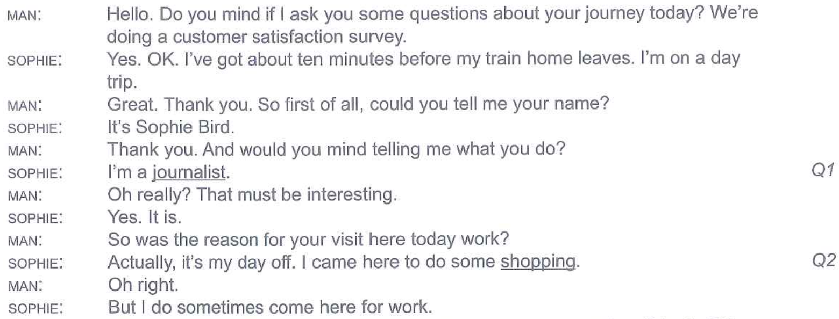

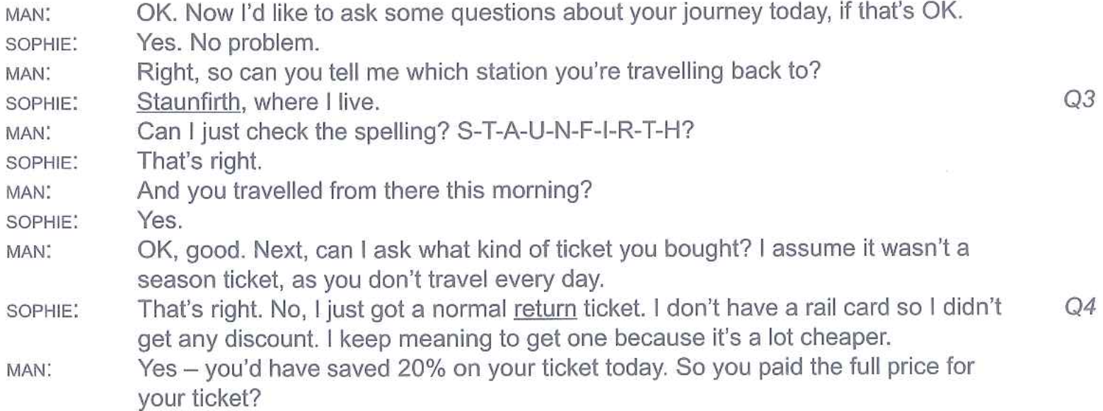

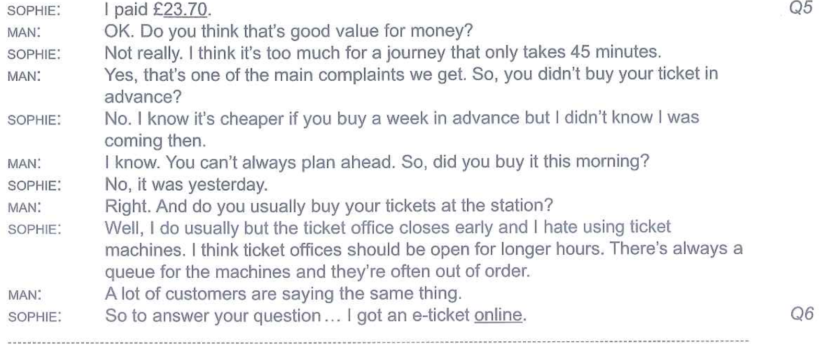 

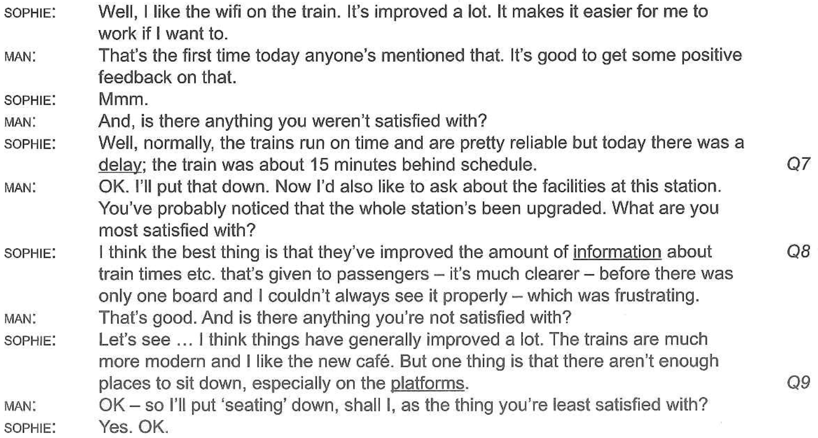

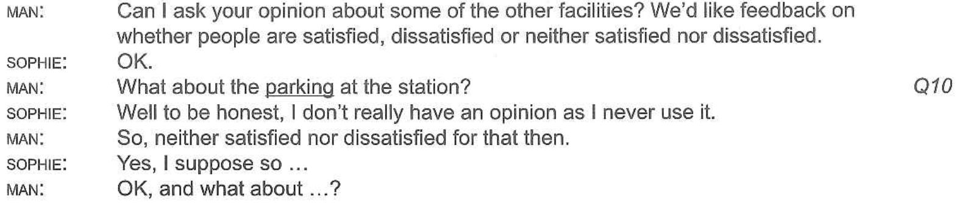

**PART 2.** [**https://www.youtube.com/watch?v=9WicYGH5X4M**](https://www.youtube.com/watch?v=9WicYGH5X4M)

So how do you overcome fear and worry? Right this is something we all experience in different degrees from time to time. This is very easy to overcome once you understand awareness in the mind. Let's look at a simple view of time. Right you have the past, you have the present which is now, and the future. Right this is a very simplified way of looking at time.

Worry and fear only exists in the future. You cannot worry anything about anything in the past. It's already happened, but you can be concerned or fearful of what the consequences that may take place in the future. Fear and worry is future based. Fear and worry is awareness leaving the present moment going into the future, creating a situation that has not happened coming back to the present, and worrying about it. I'll tell you a story that my guru shared with me when he was seven years old. This was in 1934 up in Lake Tahoe. His family was coming back in the car and it was snowing really heavily, and he was really worried that he would miss his favorite radio program called captain midnight. And back then if you miss your favorite radio show there's no internet that you can go and like listen to it again. Right, there's somebody on the phone going captain midnight. Right, and that's all you get to listen you get one shot. So sitting in the car, it was snowing really heavily, the car was driving and he was thinking “my god i'm going to miss my show. We're going to get stuck in the snow.

I'm not going to get home in time, not going to be able to watch my rad, listen to my radio show.” And then he saw what was happening in his mind. He saw his awareness going into

the future, creating a situation in his mind where they were getting stuck in the snow and then he was coming back his awareness, came back to the present and started worrying about this thing that had not happened yet. Then he asked himself “Are we stuck in the snow?” and his answer was “no”. “Are we still moving” “Yes am I still on schedule to get home to watch my show”. “Yes, so what am I worried about?” right and he said to himself I am all right right now. And that's a beautiful affirmation to say every time you're fearful or worry say to yourself. I am all right right now but to understand and overcome fear and worry you have to understand awareness. And the mind fear and worry is based on the fact that awareness is leaving the present moment going into the future in your head, creating a situation that has not happened. coming back to the present and worrying about that or fearing that. So every time awareness goes into the future in an uncontrolled way and creates a situation in your mind. Right that is not wholesome bring it back to the present and say I'm not going to let it do it and that's why you want to develop concentration, and willpower right. So you can keep awareness on what you're doing. It's okay to let awareness go into the future as long as it goes into the future to think out things in a very positive way.

**PART 3. ON SCREEN C1. MODULE 3- 3d. listening**

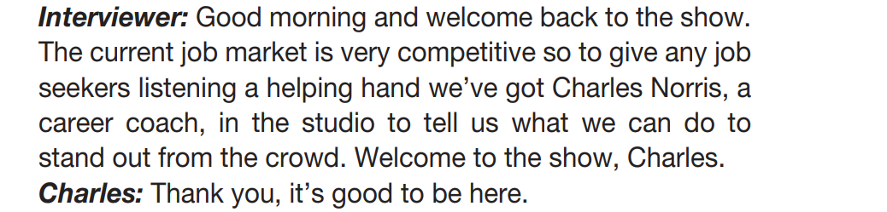

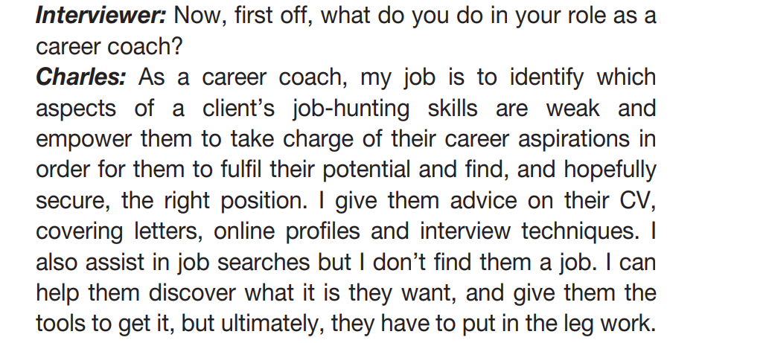

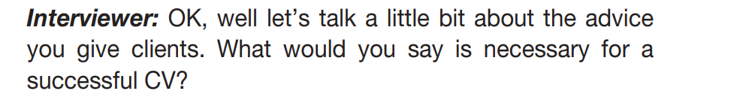

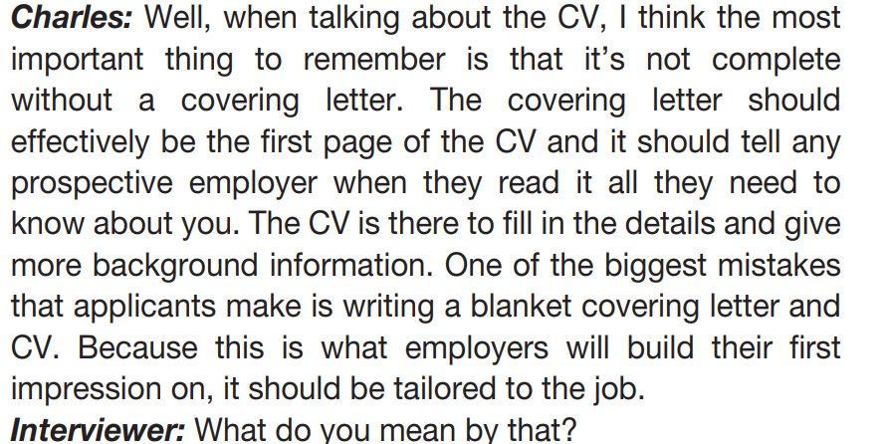

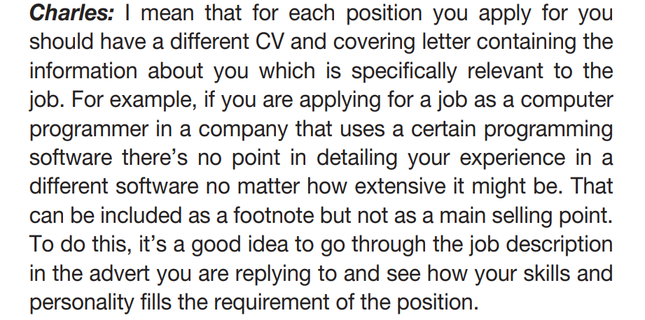

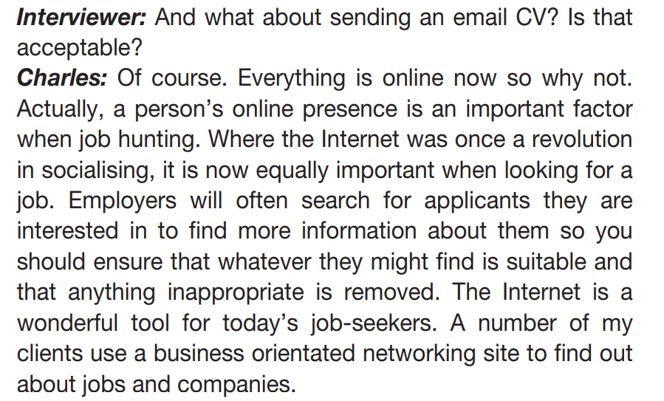

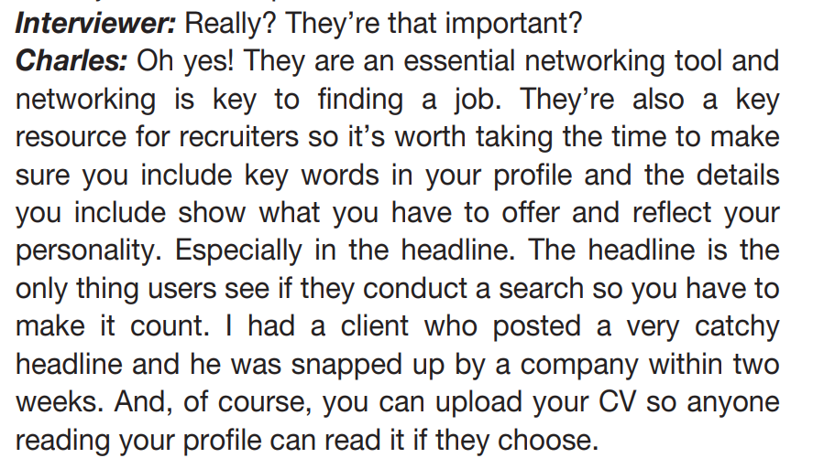

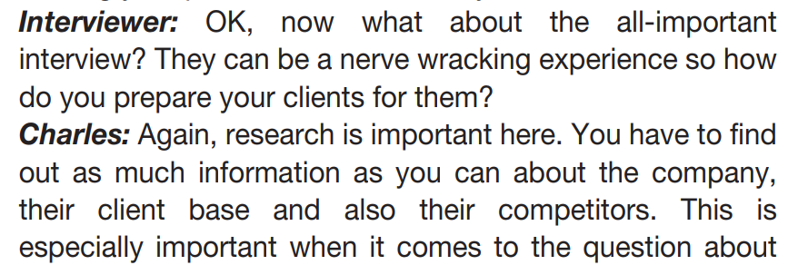

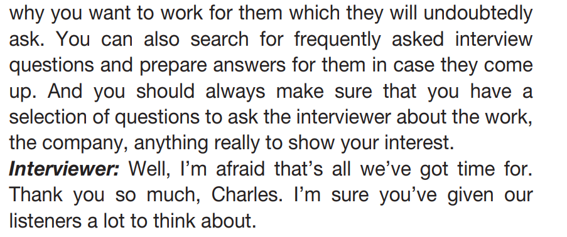

**PART 4.** [**https://youtu.be/uRABqa8wPQw**](https://youtu.be/uRABqa8wPQw)

The current pandemic has highlighted how important it is for us to know what viruses may be **lurking** out there. But while we keep one wary eye out for those potentially harmful ones, we’re also uncovering just how much viruses have actually shaped humans—and the rest of life on Earth—in some really surprising ways. ‘Virus hunters’, as they’re known, are scientists who search the hidden corners of the world for viruses that are **poised** to become human **pathogens**. In many cases, they’re searching for Disease. That’s not the name of an actual illness—it's what we call the **hypothetical infection** that could cause the next big global disease. The idea is to find it before it finds us. But other researchers are delving into what else viruses are doing on our planet besides making people sick. It’s estimated that there are about this many individual viruses on our planet. And we’ve only made the most **miniscule dent** in that number: we’ve found and classified about 9,000 of the viruses on Earth. And of those, only about 200 are known to cause disease in humans. But over the past decade, scientists have been identifying new viruses by the thousands. And the main tool they’re using to do that...is **metagenomics**. This is actually something I’m using in my own research on bacterial communities, so let’s break it down together.! In **metagenomic sequencing**, we take a sample—that can be soil, ocean water, a bodily fluid—and we purify it down to the genetic material of just the stuff we’re looking for. In this case, let’s say it’s viruses. So now we have the genomes of all the viruses in our sample. Lets picture each virus's genome as a piece of paper with sentences on it. Because the next step—and this sounds nuts— is that we rip each piece of paper up into little strips with just sentences on them. We do this because our sequencing machine has to ‘read’ all of these **genomes.** And, if you can picture, it’s much faster for lots of people to each read a sentence. And they can each read their sentence at the same time a sentence than it is for one person to read a whole page, one at a time. That’s what we’re doing when we divide our genome up into little chunks. Now that we’ve read the sentences in a super efficient way, we can put the sentences back together into the full page, or the full genome. Then we compare that to a library full of known genomes. So we can say, ‘this unknown page is the same as this known page that we have on file’. It’s a match! We’ve ID’ed the virus in our sample. And we do this for every virus in our sample. Metagenomic sequencing is an incredibly useful tool that lets us identify huge numbers of **microbes** really fast. And as scientists have turned that powerful lens on our world to catalogue viruses...they’ve been astonished at just how many they’re finding, everywhere. In the ocean, in our wastewater, inside the spiders in our gardens and of course, inside us. Most of them are totally harmless to humans, and many of them are totally new to science! The viruses in the ocean? They’re preying on other **marine microorganisms**, releasing nutrients. This may be the bottommost foundation of the ocean’s food web. The viruses in every ecosystem? They help maintain our planet’s biodiversity by keeping other species in check. If viruses suddenly vanished from the planet, it’s likely that the balance of other organisms would rapidly get **out of whack**. And one other major result of all this sequencing is a new understanding of just how thoroughly viruses have shaped life on Earth as we know it. Because they invade living cells to replicate, they’re equipped to take over a host’s genetic replication machinery—sometimes, viral genetic material gets incorporated into the host’s. It’s estimated that around 8% of human DNA actually came from a virus, including some of our most important skills. Like, the ability of modern humans to give birth probably came from a piece of viral genetic code that jumped over to its mammalian host about 130 million years ago. That gave us our ability to grow a **placenta**. So, yep. We got hacked, and it’s probably the reason we don’t lay eggs. Scientists don’t know how many more viruses are out there, waiting to be discovered. And of those, we have no idea how many of them may be harmful to us. But sequencing at least some of those nonillion viruses out there is the first step. The next step is to identify what they’re living inside...and how exactly these tiny, invisible puppeteers are **pulling the strings** of our natural world. If you want more on just how many viruses are in our oceans and what they’re doing there, you can check out this video, and leave us a comment down below if there’s another viral topic you’d like to see us cover.