|  |  |
| --- | --- |
| *Họ và tên: ....................................................*  *Lớp: .............................................................* | PHIẾU GHI BÀI HÓA HỌC 11 CÁNH DIỀU  **Bài 8: HỢP CHẤT HỮU CƠ**  **VÀ HÓA HỌC HỮU CƠ** |

**MỞ ĐẦU**

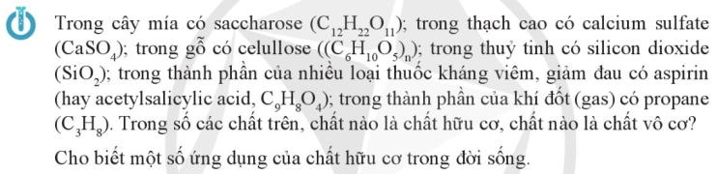

..........................................................................................................................................................................

..........................................................................................................................................................................

..........................................................................................................................................................................

..........................................................................................................................................................................

..........................................................................................................................................................................

..........................................................................................................................................................................

**I. HỢP CHẤT HỮU CƠ VÀ HÓA HỌC HỮU CƠ**

..........................................................................................................................................................................

..........................................................................................................................................................................

..........................................................................................................................................................................

..........................................................................................................................................................................

**II. ĐẶC ĐIỂM CHUNG CỦA HỢP CHẤT HỮU CƠ**

**1) Thành phần nguyên tố**

..........................................................................................................................................................................

..........................................................................................................................................................................

**2) Đặc điểm liên kết**

..........................................................................................................................................................................

..........................................................................................................................................................................

..........................................................................................................................................................................

|  |  |
| --- | --- |
|  | ...................................................................................................................  ...................................................................................................................  ...................................................................................................................  ...................................................................................................................  ................................................................................................................... |
|  | ...................................................................................................................  ...................................................................................................................  ...................................................................................................................  ...................................................................................................................  ...................................................................................................................  ...................................................................................................................  ...................................................................................................................  ...................................................................................................................  ...................................................................................................................  ...................................................................................................................  ...................................................................................................................  ...................................................................................................................  ................................................................................................................... |

**3) Tính chất vật lí**

..........................................................................................................................................................................

..........................................................................................................................................................................

..........................................................................................................................................................................

..........................................................................................................................................................................

|  |  |
| --- | --- |
|  | ...................................................................................................................  ...................................................................................................................  ...................................................................................................................  ...................................................................................................................  ................................................................................................................... |
|  | ...................................................................................................................  ...................................................................................................................  ...................................................................................................................  ...................................................................................................................  ................................................................................................................... |

**4) Tính chất hóa học**

..........................................................................................................................................................................

..........................................................................................................................................................................

..........................................................................................................................................................................

..........................................................................................................................................................................

|  |  |
| --- | --- |
|  | ................................................................  ................................................................  ................................................................  ................................................................ |

**III. PHÂN LOẠI CÁC HỢP CHẤT HỮU CƠ**

..........................................................................................................................................................................

..........................................................................................................................................................................

|  |  |
| --- | --- |
|  | ..................................................................................................................  ..................................................................................................................  ..................................................................................................................  ..................................................................................................................  ..................................................................................................................  .................................................................................................................. |

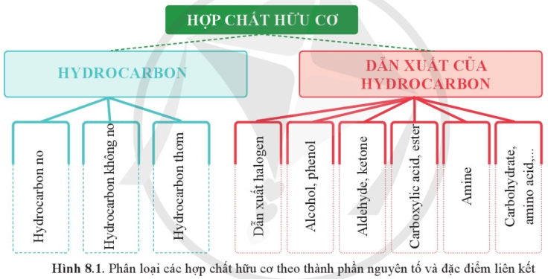

**IV. NHÓM CHỨC**

**1) Khái niệm**

..........................................................................................................................................................................

..........................................................................................................................................................................

|  |  |
| --- | --- |
|  | ................................................................................................................  ................................................................................................................  ................................................................................................................  ................................................................................................................  ................................................................................................................  ................................................................................................................  ................................................................................................................  ................................................................................................................ |
|  |  |
|  | ................................................................................................................  ................................................................................................................  ................................................................................................................  ................................................................................................................  ................................................................................................................  ................................................................................................................  ................................................................................................................  ................................................................................................................  ................................................................................................................  ................................................................................................................  ................................................................................................................ |

**2) Xác định nhóm chức bằng phổ hồng ngoại**

|  |  |
| --- | --- |
|  |  |



    
    
              