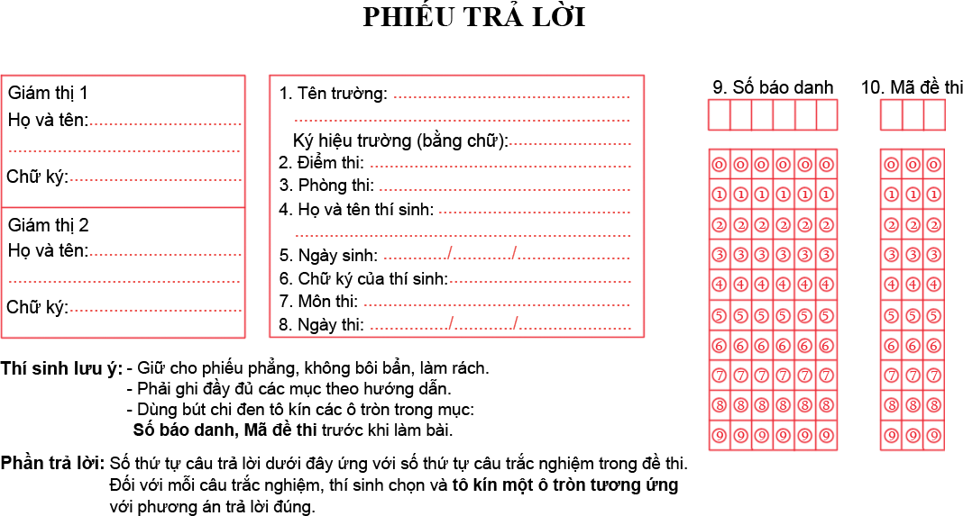

Phần trắc nghiệm khách quan:
01. | 08. | 15. | 22.
02. | 09. | 16. | 23.
03. | 10. | 17. | 24.
04. | 11. | 18. | 25.
05. | 12. | 19. | 26.
06. | 13. | 20. | 27.
07. | 14. | 21. | 28.

Phần tự luận
Bài làm:
………………………………………………………………………………………………………………………………………………………………………………………………………………………………………………………………………………………………………………………………………………………………………………………………………………………………………………………………………………………………………………………………………………………………………………………………………………………………………………………………………………………………………………………………………………………………………………………………………………………………………………………………………………………………………………………………………………………………………………………………………………………………………………………………………………………………………………………………………………………………………………………………………………………………………………………………………………………………………………………………………………………………………………………………………………………………………………………………………………………………………………………………………………………………………………………………………………………………………………………………………………………………………………………………………………………………………………………………………………………………………………………………………………………………………………………………………………………………………………………………………………………………………………………………………………………………………………………………………………………………………………………………………………………………………………………………………………………………………………………………………………………………………………………………………………………………………………………………………………………………………………………………………………………………………………………………………………………………………………………………………………………………………………………………………………………………………………………………………………………………………………………………………………………………………………………………………………………………………………………………………………………………………………………………………………………………………………………………………………………………………………………………………………………………………………………………………………………………………………………………………………………………………………………………………………………………………………………………………………………………………………………………………………………………………………………………………………………………………………………………………………………………………………………………………………………………………………………………………………………………………………………………………………………………………………………………………………………………………………………………………………………………………………………………………………………………………………………………………………………………………………………………………………………………………………………………………………………………………………………………………………………………………………………………………………………………………………………………………………………………………………………………………………………………………………………………………………………………………………………………………………………………………………………………………………

