School:
Teacher’s name:
Class:
LESSON PLAN
(Based on Official Letter No. 5512/BGDĐT-GDTrH dated December 18, 2020 of the MOET)

REVIEW 1
Lesson 1: Language

I. OBJECTIVES
By the end of this lesson, Ss will be able to:
1. Knowledge
- Revise words related to school things and activities, types of house, rooms and furniture, body parts and appearance and personality adjectives.
- Revise the sounds /ɑ:/, /ʌ/, /s/, /z/, /b/ and /p/
- Revise the use of present simple, adverbs of frequency, possessive case, prepositions of place and present continuous.
2. Competences
- Develop communication skills and creativity
- Be collaborative and supportive in pair work and team work
3. Personal qualities
- Develop self-study skills
- Actively join in class activities

II. MATERIALS
- Grade 6 textbook, Review 1, Language
- Computer connected to the Internet
- Projector / TV
- hoclieu.vn

Assumption
Anticipated difficulties | Solutions
Students may find the lesson boring due to a large number of language exercises. | - Encourage students to work in pairs, in groups so that they can help each other.  - Design as many exercises as games as possible.  - Provide feedback and help if necessary.

III. PROCEDURES
1. WARM-UP (5 mins)
a. Objectives:
- To remind students of the knowledge that they have learnt in Units 1 - 2 - 3.
b. Content:
- Memory game
c. Expected outcomes:
- Students recall what they have learnt in Units 1 - 2 - 3.
d. Organisation:

TEACHER’S ACTIVITIES | STUDENTS’ ACTIVITIES | CONTENTS
Memory game  - Teacher divides the class into 4 big groups.  - Teacher gives each group an unfinished chart which summarises the language that students have learnt in Units 1, 2, 3 and asks them to complete the chart.  - The group which finishes correctly and more quickly is the winner. | - Students look and fill in the chart with what they have learnt in Units 1, 2, 3. | Answer key:  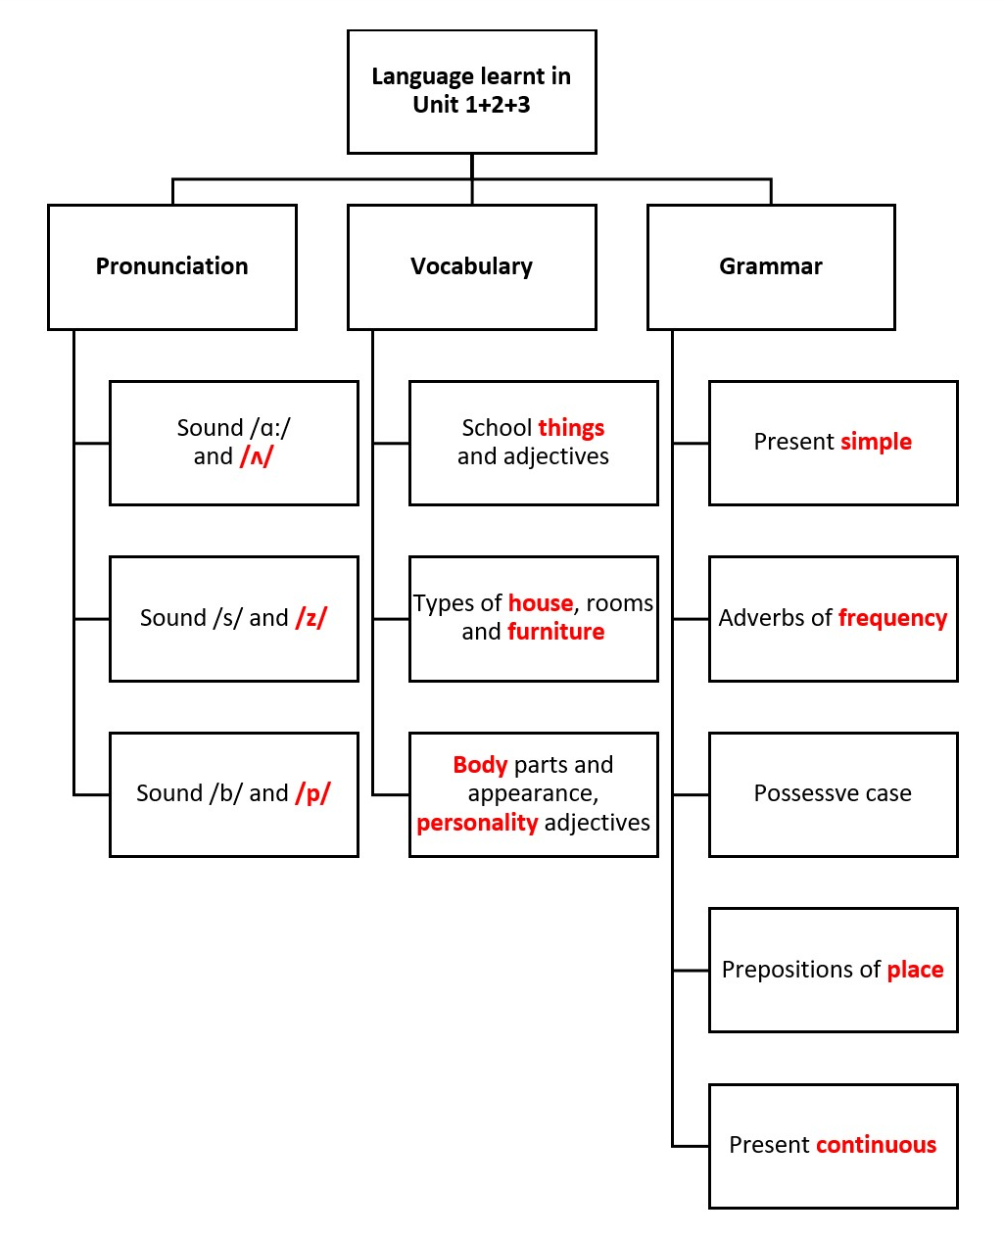
e. Assessment
- Teacher observes and gives feedback.

2. ACTIVITY 1: PRONUNCIATION (7 mins)
a. Objectives:
- To help Ss review the pronunciation of the sounds learnt in Units 1 – 3: /ɑ:/ and /ʌ/, /s/ and /z/, and /b/ and /p/ correctly.
b. Content:
- Task 1: Choose the word whose underlined part is pronounced diﬀerently.
- Task 2: Write the names of school things and furniture in the house which begin with /b/ and /p/.
c. Expected outcomes:
- Students can distinguish the sounds they have learnt.
d. Organisation

TEACHER’S ACTIVITIES | STUDENTS’ ACTIVITIES | CONTENTS
Task 1: Choose the word whose underlined part is pronounced diﬀerently. (3 mins)
- Teacher elicits the rules of pronouncing final -s if needed.  - Students do this exercise individually then share their answers with their partners.  - Teacher gives feedback and confirms the answers. | - Students tell the rule of pronouncing final -s.  - Students do the task individually and then check the answers. | Answer key:  1. C  2. A  3. B  4. A  5. B
Task 2: Write the names of school things and furniture in the house which begin with /b/ and /p/. (4 mins)
- Teacher organises this task as a game.  - Teacher asks students to play the game in pairs. Teacher calls the 3 fastest pairs to go to the board and write their answers.  - Other pairs may want to add more words. Write other words on the board.  - Teacher gives feedback and confirms the answers. | - Students play the game in pairs.  - Other pairs can add more words. | Suggested answer:  /b/: book, bag, bed…  /p/: pen, pencil, picture, poster…
e. Assessment
- Teacher checks students’ pronunciation and gives feedback.

3. ACTIVITY 2: VOCABULARY (10 mins)
a. Objectives:
- To help Ss review the adjectives describing the neighbourhood, the wonders of Viet Nam, and Tet holiday.
- To help Ss identify the words through their definitions.
b. Content:
- Task 3: Complete the words.
- Task 4: Solve the crossword puzzle.
c. Expected outcomes:
- Students recall vocabulary through their opposites and definitions.
d. Organisation

TEACHER’S ACTIVITIES | STUDENTS’ ACTIVITIES | CONTENTS
Task 3: Complete the words. (5 mins)
- Teacher asks students to do this task individually and then share their answers with their partners.  - Teacher calls one or two students to write their answers on the board.  - Teacher checks and confirms the correct ones. | - Students work independently to do the activity.  - Students compare the answers in pairs. | Answer key:  1. English  2. homework  3. lunch  4. sports  5. badminton  play: sports, badminton  have: lunch  do: homework  study: English
Task 4: Choose the correct word / phrase for each definition. (5 mins)
- Teacher has students look at the picture of a classroom and complete the sentences.  - Students compare their answers with a classmate.  - Teacher checks and confirms the correct answers. | - Students work independently to do the activity.  - Students compare the answers in pairs. | Answer key:  Down:  1. friendly  2. kitchen  4. ears  Across:  3. creative  5. cheek
e. Assessment
- Teacher checks students’ exercises individually and gives feedback.

4. ACTIVITY 3: GRAMMAR (15 mins)
a. Objectives:
- To help Ss review grammar elements taught in Units 1 – 3: prepositions of place, possessive
case, present simple and present continuous.
b. Content:
- Task 5: Look at the picture of a classroom. Choose the best answer A, B, or C.
- Task 6: Complete the sentences with the present simple or the present continuous form of the verbs in brackets.
c. Expected outcomes:
- Ss can use what they have just revised to do the exercises well.
d. Organisation

TEACHER’S ACTIVITIES | STUDENTS’ ACTIVITIES | CONTENTS
Task 5: Look at the picture of a classroom. Choose the best answer A, B, or C. (7 mins)
- Teacher has students look at the picture of a classroom and complete the sentences.  - Teacher checks and confirms the correct answers. | - Students work independently to do the activity.  - Students compare the answers in pairs. | Answer key:  1. B  2. A  3. A  4. B  5. C
Task 6: Complete the sentences with the present simple or the present continuous form of the verbs in brackets. (8 mins)
- Teacher elicits form and usage of the present simple and the present continuous.  - Teacher asks students to do the exercise individually before calling one or two students to write their answers on the board.  - Teacher checks students’ answers and asks them for explanations if necessary. | - Students work independently to do the activity.  - 1-2 students come to the board to write the answer.  - Students give explanation | Answer key:  1. is / ’s raining  2. do … have  3. Is … studying  4. likes  5. is not / isn’t cooking; is reading
e. Assessment
- Teacher observes and gives feedback.

5. CONSOLIDATION (5 mins)
a. Wrap-up
- Teacher asks Ss to summarise the main points of the lesson.
b. Homework
- Do exercises in the workbook.
- Prepare for Review 1 – Skills.
Board plan

Date of teaching
Review 1
Lesson 1: Language
* Warm-up

* Pronunciation
Task 1: Choose A, B, or C.
Task 2: Write words begin with /b/ and /p/.
* Vocabulary
Task 3: Complete the words.
Task 4: Solve the crossword puzzle.
* Grammar
Task 5: Choose A, B, or C.
Task 6: Complete the sentences.

*Homework

REVIEW 1
Lesson 2: Skills

I. OBJECTIVES
By the end of this lesson, Ss will be able to:
1. Knowledge
- Practise reading for specific information about a best friend and a school.
- Practise practise asking and answering about what they like and dislike about their school
and their reasons.
- Practise listening for specific information about some activities of a family.
- Practise completing an email to a friend to tell about a family member.
2. Competences
- Develop communication skills.
- Be collaborative and supportive in pair work and team work.
3. Personal qualities
- Develop self-study skills.
- Actively join in class activities.

II. MATERIALS
- Grade 6 textbook, Review 1, Skills
- Computer connected to the Internet
- Projector / TV
- hoclieu.vn

Assumption
Anticipated difficulties | Solutions
Students may find the lesson boring due to a large number of skills exercises. | - Encourage students to work in pairs, in groups so that they can help each other.  - Provide feedback and help if necessary.

III. PROCEDURES
1. WARM-UP (5 mins)
a. Objectives:
- To create an active atmosphere in the class before the lesson.
b. Content:
- Chatting
c. Expected outcomes:
- Students can revise vocabulary related to places
d. Organisation:

TEACHER’S ACTIVITIES | STUDENTS’ ACTIVITIES | CONTENTS
Chatting  - Teacher asks students some questions to lead them into the lesson.  - Teacher calls on some Ss to give their ideas.  - Teacher leads in the reading part of the lesson. | - Students discuss in groups to answer the questions. | Questions:  1. Do you have any pen pals?  2. How do you communicate with your pen pal?  3. Do you often write emails to your pen pal?
e. Assessment
- Teacher observes and gives feedback.

2. ACTIVITY 1: READING (10 mins)
a. Objectives:
- To help Ss practise reading for general and specific information.
b. Content:
- Task 1: Choose A, B, or C for each blank in the email below.
- Task 2: Read the text and answer the questions.
c. Expected outcomes:
- Students can understand the email and the text to do the tasks successfully.
d. Organisation

TEACHER’S ACTIVITIES | STUDENTS’ ACTIVITIES | CONTENTS
Task 1: Choose A, B, or C for each blank in the email below. (5 mins)
- Teacher asks students to do the task individually.  - Teacher asks students to compare their answers in pairs before giving the answers to the teacher.  - Teacher confirms the correct answers. | - Students work independently to complete the task.  - Students check their answers with their partners.  - Students correct their answers. | Answer key:  1. A  2. C  3. C  4. B  5. B
Task 2: Read the text and answer the questions. (7 mins)
- Have Ss read each sentence and look for the key word(s) in it.  - Teacher asks students to do the task individually.  - Teacher asks students to compare their answers in pairs before giving the answers to the teacher.  - Teacher confirms the correct answers. | - Students read the sentences and use the underlined keywords to find the information.  - Students work independently to complete the task.  - Students check their answers with their partners.  - Students correct their answers. | Answer key:  1. It’s in a quiet place not far from the city centre.  2. They are hard-working and kind.  3. They are helpful and friendly.  4. There are five clubs.  5. Because it’s a good school.
e. Assessment
- Teacher observes and gives feedback.

3. ACTIVITY 2: SPEAKING (7 mins)
a. Objectives:
- To help Ss practise asking and answering about what they like and dislike about their school
and their reasons.
b. Content:
- Task 3: Interview two of your classmates about what they like and dislike about your school. Report their answers.
c. Expected outcomes:
- Students can talk about what people like and dislike about their school and the reasons why.
d. Organisation

TEACHER’S ACTIVITIES | STUDENTS’ ACTIVITIES | CONTENTS
Task 3: Interview two of your classmates about what they like and dislike about your school. Report their answers.
- Teacher has students work in groups of three. One interviews the other two about what they like and  dislike about their school and the reasons why.  - Teacher tells students to write their group members’ answers in their notebooks and report them to the class.  - Teacher summarises students’ ideas. | - Students make a list of the places and practise asking and answering in pairs.  - Students present their ideas to the whole class. | Students’ own ideas  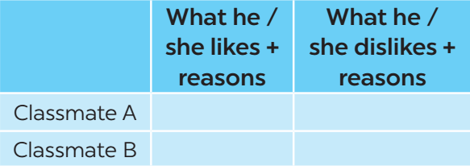
e. Assessment
- Teacher observes and gives feedback.

4. ACTIVITY 3: LISTENING (6 mins)
a. Objectives:
- To help Ss review listening for specific information
b. Content:
- Task 4: Mai’s family is talking to a travel agent about their trip to Singapore. Listen and tick T (True) or F (False). (p. 69)
c. Expected outcomes:
- Ss can listen for specific information and tick T or F.
d. Organisation

TEACHER’S ACTIVITIES | STUDENTS’ ACTIVITIES | CONTENTS
Task 4: Mai’s family is talking to a travel agent about their trip to Singapore. Listen and tick T (True) or F (False).
- Teacher has students read the sentences and find the key words.  - Teacher plays the recording for the first time.  - Teacher asks students to listen and complete the sentences. Ask for their answers and write them on the board.  - Teacher plays the recording for the second time for students to check their answers.  - Teacher checks students’ answers.  - Teacher plays the recording the last time if necessary, stopping at diﬀerent places where students got the wrong answers. | - Students read the statements and find the key words.  - Students do the task individually then listen again to the recording to check the answers. | Answer key:  1. home  2. plants  3. living  4. sleeping  5. TV
e. Assessment
- Teacher corrects the students' answers as a whole class.

5. ACTIVITY 4: WRITING (7 mins)
a. Objectives:
- To help Ss complete an email of about 50 words about a student’s family member.
b. Content:
- Task 5: Write an email of about 50 words to your friend. Tell him / her about a family member. Use these questions as cues.
c. Expected outcomes:
- Ss can complete the email to describe a family member.
d. Organisation

TEACHER’S ACTIVITIES | STUDENTS’ ACTIVITIES | CONTENTS
Task 5: Write an email of about 50 words to your friend. Tell him / her about a family member. Use these questions as cues.
- Teacher elicits the parts of an email.  - Teacher asks students to discuss and answer the questions in pairs.  - Teacher then has them write their emails individually.  - Teacher asks one student to write the email on the board.  - Other students and teacher comment on the email on the board.  - Teacher then collects some emails to give feedback at home. | - Students work in pairs first to discuss and answer the questions, then write their emails individually.  - One student comes to write the email on the board.  - Other students give comments. | 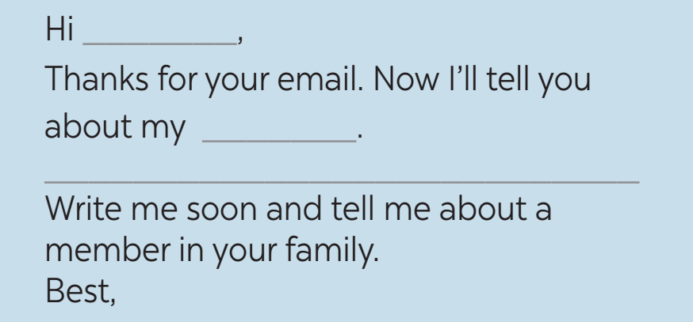
e. Assessment
- Teacher observes and gives feedback.

6. CONSOLIDATION (3 mins)
a. Wrap-up
- Teacher asks students to talk about what they have learnt in the lesson.
b. Homework
- Do exercises in the workbook.
- Prepare for Unit 4 – Getting started

Board plan
Date of teaching
Review 1
Lesson 2: Skills
* Warm-up
Chatting
* Reading
Task 1: Choose A, B, or C.
Task 2: Answer the questions.
* Speaking
Task 3: Interview and report the answer.
* Listening
Task 4: Fill in the blanks.
* Writing
Task 5: Write an email.

* Homework

