UNIT 5. FOOD AND DRINK
PART 1. THEORY
I. VOCABULARY
No. | English | Type | Pronunciation | Vietnamese
1 | anchovy sauce/  fish sauce | n | /'æntʃəvɪ sɔːs/, /fɪʃ sɔːs / | nước mắm
2 | apple | n | /'æpl/ | táo
3 | bamboo shoot | n | /,bæm'bu: ʃu:t/ | măng (tre)
4 | banana | n | /bə'nɑːmə/ | chuối
5 | biscuit | n | /'bɪskɪt/ | bánh quy
6 | bread | n | /bred/ | bánh mì
7 | butter | n | /'bʌtə(r)/ | bơ
8 | cheese | n | /tʃkz/ | phô mai
9 | chicken | n | /tʃɪkɪn/ | gà
10 | chocolate | n | /'tʃɒklət/ | sô cô la
11 | cooking oil | n | /'kʊkɪrη ɔɪl/ | dâu ăn
12 | cream | n | /kri:m/ | kem
13 | cucumber | n | /'kju:kʌmbə(r)/ | dưa chuột
14 | delicious | adj | /dɪ'lɪʃəs/ | ngon
15 | egg | n | /eg/ | trứng
16 | flour | n | /'flaʊə(r)/ | bột mỳ
17 | fried vegetables | n | /fraɪd 'vedʒtəblz/ | rau xào
18 | fry | v | /fraɪ/ | rán, chiên
19 | ginger | n | /'dʒɪndʒə(r)/ | gừng
20 | grapefruit | n | /'greɪpfru:t/ | bưởi
21 | lemon | n | /'lemən/ | chanh
22 | mango | n | /'mæηgəʊ/ | xoài
23 | menu | n | /'menju:/ | thực đơn
24 | milk | n | /mɪlk/ | sữa
25 | mushroom | n | /'mʌʃrʊm/ | nấm
26 | noodles | n | /'nu:dlz/ | mỳ
27 | olive oil | n | /'ɒlɪv ɔɪl/ | dấu ô liu
28 | omelette | n | /'ɑːmlət/ | trứng ốp la
29 | onion | n | /'ʌnjən/ | hành
30 | orange | n | /'ɒrɪndʒ/ | cam
31 | pancake | n | /'pænkeɪk/ | bánh kếp
32 | peach | n | /pi:tʃ/ | đào
33 | pepper | n | /'pepər/ | tiêu
34 | pizza | n | /'pi:tsə/ | bánh pizza
35 | rice | n | /raɪs/ | Cơm
36 | roast chicken | n | /rəʊst 'tʃɪkən/ | gà quay
37 | shrimp | n | /ʃrɪmp/ | tôm
38 | soup | n | /su:p/ | súp, canh
39 | spring rolls | n | /sprɪη rəʊlz/ | nem
40 | tofu | n | /'təʊfu:/ | đậu phụ
41 | yoghurt | n | /'jɒgət/ | sữa chua

II. GRAMMAR
SOME, A LOT OF, LOTS OF
a. Some (vài, một vài, một số)
- Some: được xem là hình thức số nhiều của a, an. Some có thể dùng trước danh từ số nhiều đếm được và không đếm được. Some thường được dùng trong câu khẳng định.
Ex: There s some milk in the fridge.
(Có một ít sữa trong tủ lạnh.)
There are some books on the table.
(Có vài quyển sách trên bàn.)
Chú ý:
- Lượng từ any thường được dùng trong câu phủ định hoặc nghi vấn. Any đứng trước danh từ số nhiều đếm được hoặc không đếm được.
Ex. Are there any oranges? (Có quả cam nào không?)
No, there aren't. (Không, không có.)
Is there any milk in the fridge? (Có sữa trong tủ lạnh không?)
No, there isn’t. (Không, không có.)
b. A lot of/ lots of (nhiều)
A lot of / lots of đều có nghĩa là “nhiều”. Nó đề cập đến số lượng lớn.
- A lot of và lots of được dùng trong câu khẳng định. Chúng có thể dùng với danh từ đếm được số nhiều hoặc không đếm được.
Ex . There are a lot of bananas in the fridge.
(Có nhiều chuối trong tủ lạnh.)
Learning a foreign language needs lots of time.
(Học một ngoại ngữ cẩn nhiều thời gian.)
Chú ý: “many” và “much” cũng có nghĩa là “nhiều”. Chúng thường được sử dụng trong câu phủ định hoặc nghi vấn.
Ex. Did he make many mistakes in his writing yesterday?
(Anh ta có mắc nhiều lỗi sai trong bài viết của anh ta ngày hôm qua không?)
We don’t drink much wine.
(Chúng tôi không uống nhiều rượu.)
iii. PHONETICS

Cách phát âm âm /ɒ/ và /ɔ:/
1. Cách phát âm âm /ɒ/
/ɒ/ là một nguyên âm ngắn. Để phát âm âm này, ta mở rộng miệng và tròn môi. Mặt trước của lưỡi hạ thấp xuống và phát âm /ɒ/. (Nó gần như âm o của người Việt). | 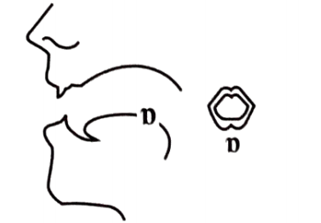
2. Cách phát âm âm /ɔ:/
/ɔ:/ là một nguyên âm dài. Nguyên âm này ở giữa âm nửa mở và âm mở đối với vị trí của lưỡi. Để phát âm âm này, ta tròn môi và hạ thấp đầu lưỡi rồi phát âm /ɔ:/. Đây là âm o dài. Nó được phát âm dài hơn so với âm /ɒ/. | 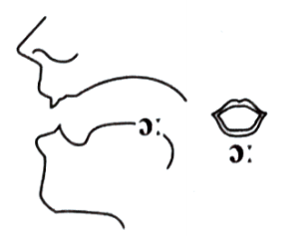
Listen and repeat these words. Track 013
/ɒ/ | mock | dog | shock | drop
 | /mɒk/ | /dɒg/ | /ʃɒk/ | /drɒp/
/ɔ:/ | short | talk | thought | chalk
 | /ʃɔ:t/ | /tɔ:k/ | /θɔ:t/ | /tʃɔ:k/

PART 2. LANGUAGE
I. VOCABULARY
Exercise 1. Find the odd one out among A, B, C or D.
1. A. meal B. breakfast C. lunch D. dinner
2. A. lemonade B. soda C. orange juice D. bread
3. A. meat B. milk C. egg D. fish
4. A. sour B. sweet C. bitter D. cook
5. A. pork B. pancake C. beef D. chicken
Exercise 2. Complete the blank with available names of each kind of food.
Chinese sausage | bamboo shoot | young rice cake
anchovy sauce | mustard green | lemongrass
rice noodles | round sticky rice cake | sweet gruel

1. ____________________  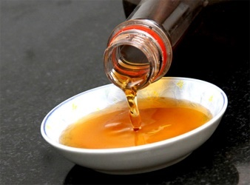 | 2. ____________________  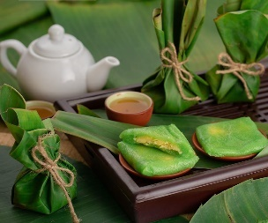 | 3. ____________________  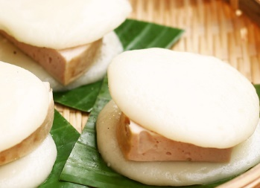
4. ____________________  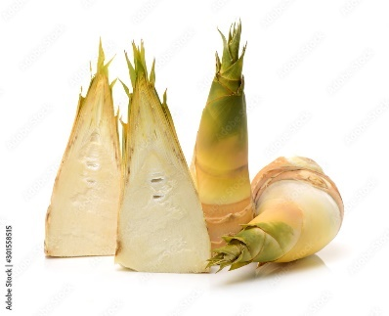 | 5. ____________________  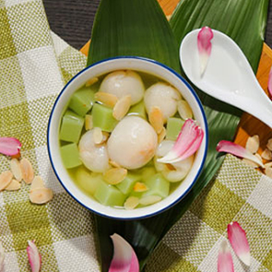 | 6. ____________________  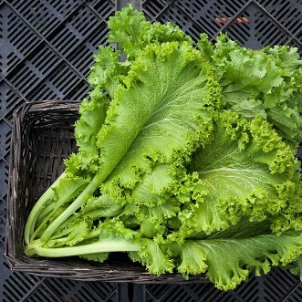
7. ____________________  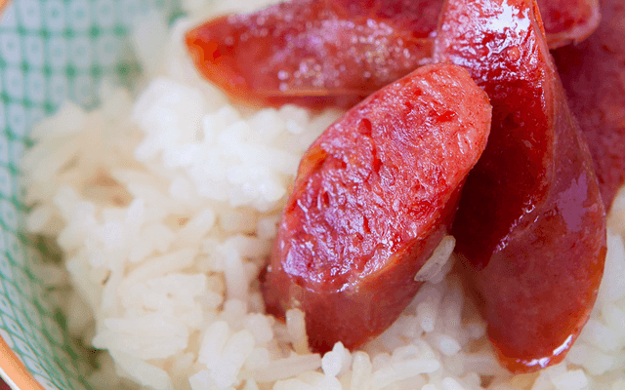 | 8. ____________________  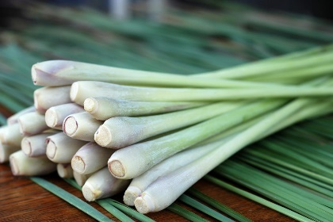 | 9. ____________________  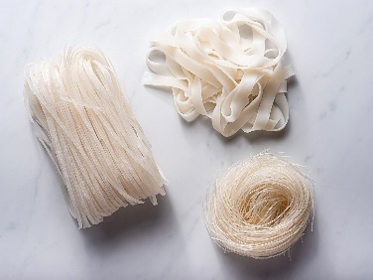
Exercise 3. Complete the blank with suitable name of each kind of food/drink.
1. _______________  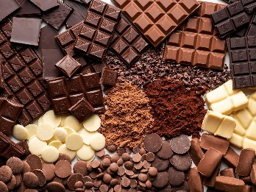 | 2. _______________  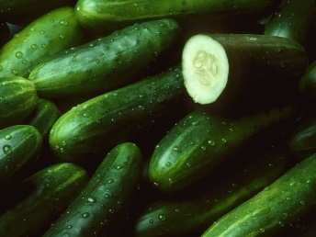 | 3. _______________  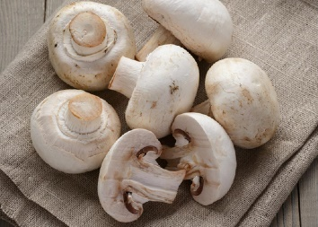 | 4. _______________  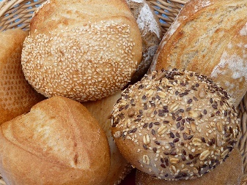
5. _______________  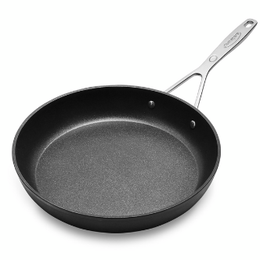 | 6. _______________  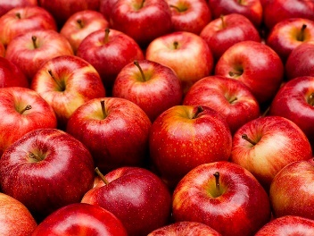 | 7. _______________  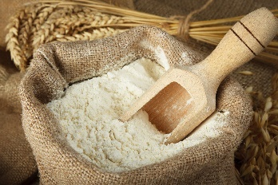 | 8. _______________  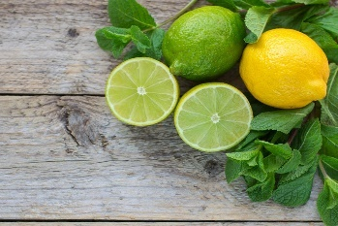
9. _______________  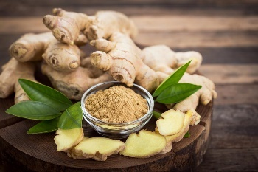 | 10. _______________  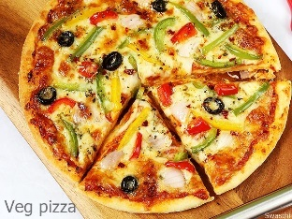 | 11. _______________  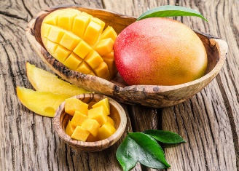 | 12. _______________  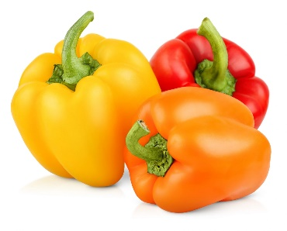
Exercise 4. Choose the correct words.
1. She bought a loaf/ bowl/ bar of bread so we can make sandwiches.
2. We’ve already eaten a tube/ packet/ slice of biscuits!
3. Would you like a bowl/piece/glass of lemonade?
4. There is a piece! carton/ kilo of milk in the fridge.
5. Could you cut me a smaller slice/ spoon/ bunch of ham?
6. You can have a loaf/ piece/pot of cake after you’ve eaten your vegetables!
II. GRAMMAR
Exercise 1. Divide these words into two columns: countable nouns and uncountable nouns.
smoke | car |  | tomato |  | dog |  | tea
apple | class |  | beer |  | soup |  | doctor
butter | cheese |  | house |  | housework |  | cup
bread | happiness |  | bus |  | map |  | help
book | orange |  | window |  | advice |  | hair
boy | news |  | leaf |  | sugar |  | oil
Countable nouns |  |  |  | Uncountable nouns
Exercise 2. Complete the sentence with: a, an, some, any.
1. There is ________ banana in the basket.
2. I need ________ tea.
3. Are there ________ tomatoes in the fridge?
4. There’s ________ orange on the table.
5. I’d like ________ apple juice.
6. Do you have ________ dogs or cats at home?
7. Would you like ________ cup of tea?
8. I would like ________ cakes, please.
9. Can I have ________ glass of milk?
10. Thank you. And ________ box of chocolate would be fine.
Exercise 3. Complete the sentence with: a, an, some, any.
1. There isn’t ________ plum jam.
2. She’d like ________ apple.
3. There are ________ bananas.
4. Is there ________ pork?
5. There aren’t ________ beef noodles.
6. There are ________ sandwiches for lunch.
7. Are there ________ water in fridge ?
8. I have ________ bread for you.
9. He eats ________ banana after his dinner.
10. Would you like ________ orange juice, please?
11. She wants to buy ________ apples for her mother.
12. Would you like ________ eggs for breakfast?
13. Can you bring me ________ water, please?
14. I don’t want ________ sugar in the tea.
15. She has ________ bread for breakfast.
Exercise 4. Complete the sentence with "How much" or "How many".
1. ____________ beer is there in the fridge?
2. ____________ eggs do you want?
3. ____________ languages do you speak?
4. ____________ people are there in the class?
5. ____________ days are there in a week?
6. ____________ milk do you drink every day?
7. ____________ kilos of rice do you want?
8. ____________ soda does she want?
9. ____________ monkeys are there in the forest?
10. ____________ English homework does she have tonight?
Exercise 5. Choose the best option to complete the sentence.
1. She can drink ____________ water, but she cannot drink much coffee.
A. much B. many C. few
2. She does not eat ____________ meat, but she eats a lot of vegetables.
A. much B. many C. a lot
3. She has got a lot of dresses, but she has not got ____________ skirts.
A. much B. many C. a lot
4. She does not buy much perfume, but she buys ____________ clothes.
A. much B. many C. a lot of
5. Every morning she buys a lot of newspapers, but she does not buy ____________ magazines.
A. much B. many C. a lot
6. How ____________ English books have you got?
A. much B. many C. a lot of
7. I have got a lot of English books, but I have not got ____________ Spanish ones.
A. much B. many C. a lot
8. How ____________ money do you need to buy this French dictionary?
A. much B. many C. a lot of
9. Are there ____________ new students in the class?
A. much B. many C. a lot
10. There are not ____________ Italian teachers in that school, but there are a lot of English ones.
A. much B. many C. a lot
Exercise 6. Fill in the gaps with a lot of/ lots of, much or many.
1. Sara hasn’t got ____________ children.
2. I’ve got ____________ nice friends.
3. There aren’t ____________ flats in our street.
4. My little brother has got ____________ toys.
5. Have you got ____________ English books?
6. There isn’t ____________ coffee in my cup.
7. There is ____________ sugar in the bowl.
8. John hasn’t got ____________ CDs.
9. We are early. We have ____________ time.
10. Are there ____________ apples on the tree?
III. PHONETICS
Tick to the correct sounds. TRACK 14
Word | /ɒ/ | /ɔ:/ | Word | /ɒ/ | /ɔ:/
shot |  |  | court
horse |  |  | fault
block |  |  | bottle
stop |  |  | top
pour |  |  | caught
born |  |  | bother
dog |  |  | comma
cord |  |  | tall
awful |  |  | launch
lock |  |  | four
body |  |  | robbery
shock |  |  | lot
wall |  |  | crawl
board |  |  | call
odd |  |  | box

PART 3. COMMUNICATION SKILLS
I. LISTENING
Listen and do the tasks followed. Track 15
Exercise 1. Listen and complete the following sentences.
1. Claras favourites meals are ____________.
2. Clara especially likes ____________ and cupcakes.
3. When Clara eats a sweet, she starts making ____________.
4. When Clara gets a ____________, she always jumps around in the grass.
5. If Clara eats too many sweets, she will get ____________.
6. Clara eats a cake and candy on Sunday, a cupcake on ____________, a doughnut on Thursday, and a pie on ____________.
Exercise 2. Listen again and answer the questions.
1. Where does Clara live?
______________________________________________________________________
2. What does Clara always want to eat?
______________________________________________________________________
3. What does Clara likes besides doughnuts and cupcakes?
______________________________________________________________________
4. What does it mean when Clara looks at the farmer unhappily?
______________________________________________________________________
5. What does Bill feed Clara on Sunday?
______________________________________________________________________
6. When must Clara eat grass?
______________________________________________________________________
II. SPEAKING
Read and complete the conversation. Then practise it with your friends.
Mother: Can you go to the market for me, Mai?
Mai: Yes, Mum. (1) _______________________________________________________?
Mother: I need a bottle of cooking oil and some beef.
Mai: (2) _______________________________________________________?
Mother: Three hundred grams.
Mai: (3) _______________________________________________________?
Mother: Yes, I need a box of milk and some eggs.
Mai: (4) _______________________________________________________?
Mother: A dozen, please. Here is the money.
Mai: (5) _______________________________________________________?
Mother: No, I don't need any vegetables.
Mai: OK, Mum. I'm going now.
III. READING
Exercise 1. Fill in the blank with a word/ phrase in the box.
familiar | rice | features | ingredients
herbs | available | appearance | dessert
The main features of Vietnamese Cuisine
Cuisine in the country with more than 100,000,000 people differs strikingly between the north, south and central regions, but two key (1) _____________ stand out.
Firstly, (2) _____________ plays an essential role in the nations diet as it does throughout Southeast Asia. Humorous speaking Vietnamese is noodle-crazy. You have seen regularly the (3) _____________ of noodle in their breakfast, lunch and dinner, in homes, restaurants and at roadside stands. Noodles are eaten wet and dry, in soup or beside soup, and are made in different shapes and thicknesses of wheat, rice and mung beans such as bun cha, Cao Lau, Hue beef noodle, bun rieu... Rice also a main (4) _____________ for making banh chung, banh bao, banh xeo, banh beo, xoi...Secondly, no meal is complete without fresh vegetables and (5) _____________. Thanks to the tropical climate, fresh vegetables are (6) _____________ all the year round. As the result, dishes with fresh vegetable become (7) _____________ with every family, especially with poor people in the old days. Some popular dishes are canh, goi ngo sen, nom du du, rau muong, caphao... Viet Nam can also be considered as a tropical paradise of (8) _____________ and beverage with che, sugarcane, fruit smoothies, bubble tea...
Exercise 2a. Read and decide if each statement is True (T) or False (F).
THE LAND OF MILK AND HONEY
Have you ever heard about a country in which the chickens fly into your mouth and candy grows on trees? And no one can say where the country exactly is. This beautiful country is called the Land of milk and honey. Houses are covered with pancakes, there are doors and walls made of bread. Each house is surrounded by a fence made of sausages. From all well sweet juice is flowing. Everybody who wants to drink fruit juice just needs to keep his mouth under the well pipe and can drink as much as he likes.
On the trees there are many colourful candies and baked rolls, under the trees there are streams of milk and hot chocolate. Biscuits float in those streams. If you want to eat them, just call their name “biscuits”.
Besides kinds of sweet food, there is lots of other food. For example, geese, ducks, chickens, and turkeys are flying around in the air. All of them are fried. If you want to eat them, just call their names and they will fly into your mouth.
Now you know how life is in the Land of milk and honey. There is a high wall around this country, and if you want to go in or out, please contact Doraemon or Nobita.
1. The land of milk and honey is located in America. ______
2. The wells in the land are full of fresh water. ______
3. Besides candies, there are baked rolls on the trees. ______
4. Food like geese, chickens, turkeys are located on the shelves. ______
5. Geese, chickens, ducks, and turkeys are fried. ______
6. If you want to go to the Land of milk and honey, lets contact Doraemon or Nobita. ______
Exercise 2b. Read the text again and answer the questions.
1. What are houses covered with?
________________________________________________________________________
2. What are the fences made of?
________________________________________________________________________
3. What do you do if you want to drink fruit juice from the wells?
________________________________________________________________________
4. Where can we find colourful candies?
________________________________________________________________________
5. What is there under the trees?
________________________________________________________________________
6. What should we do if we want to eat biscuits?
________________________________________________________________________
IV. WRITING
Exercise 1. Make sentences using the words and phrases given.
1. There /be I meat/ and/ sugar/ your/ diet.
_____________________________________________________________________________
2. I / be/ very/ thirsty/ and/I/ need/ water.
_____________________________________________________________________________
3. school-leavers/ choose/ college/ employment/ immediate
_____________________________________________________________________________
4. Many/ foreigners/ like/ eat/ Vietnamese food/ because / it/very/ unique/ interesting.
_____________________________________________________________________________
5. Banh Chung/ be/ Vietnamese/ traditional/ dish/ that /must/ part I Tet meals.
_____________________________________________________________________________
6. How much/ fruits/ vegetables/ you I eat/ a I day?
_____________________________________________________________________________
7. Can/ you/ tell/ me/ how/ cook/ beef/ noodles?
_____________________________________________________________________________
8. What/ your/ favorite/ dish/ breakfast?
_____________________________________________________________________________
Exercise 2. Reorder the words to have correct sentences.
1. kilos/ how many/ would/ potatoes/ of/ like/ you/ ?
_____________________________________________________________________________
2. but/ went/I/ fish/I/ fishing/ catch/ didn’t/ any/.
_____________________________________________________________________________
3. 15/ cook/ for/ chicken/ you/ over/ the/ low/ minutes/ heat/ it/ before/ serve/.
_____________________________________________________________________________
4. broken/ tell/ you/ can/ how/ me/ to/ rice/ cook/ ?
_____________________________________________________________________________
5. three/ in/ fridge/ are/ there/ milk/ the/ cartons/ of/.
_____________________________________________________________________________
6. has/ but/ egg/ bread/ got/ he/ an/ hasn’t/ he/ any/ got/.
_____________________________________________________________________________
7. electric cooker/ how much/ in/ rice/ left/ the/ is/ ?
_____________________________________________________________________________
8. Viet Nam/ most/ Pho/ of/ the/ popular/ is/ one/ dishes/ in/.
_____________________________________________________________________________

