|  |  |  |
| --- | --- | --- |
| UBND QUẬN  PHÒNG GIÁO DỤC VÀ ĐÀO TẠO ĐỀ CHÍNH THỨC | ĐỀ KIỂM TRA  Năm học: 20 - 20 Tiếng Anh - Lớp 8  Thời gian làm bài: 60 phút | |
| Trường:  Họ tên:  Lớp: | Điểm | Nhận xét của giáo viên |

Tiếng Anh 8 i-Learn Smart World - Kiểm tra cuối kỳ 1 Time allotted: 60 minutes

**PRONUNCIATION (5 questions)**

**PART 1**

# Choose the word that differs from the other three in the position of the main stress in the following question.

1. A. basketball B. competition C. shuttlecock D. badminton

# Choose the word whose primary stress is placed on the first syllable.

1. A. effect B. environment C. tourism D. reduce

# Choose the word whose underlined part differs from the other three in pronunciation in the following question.

1. A. protect B. water C. national D. plastic

# Choose the word whose underlined part differs from the other three in pronunciation in the following question.

1. A. school B. headache C. character D. children

# Choose the word whose underlined part differs from the other three in pronunciation in the following question.

1. A. volcanic B. fire C. disaster D. tsunami

**USE OF ENGLISH (12 questions)**

**PART 2**

# Choose the option that best completes the following sentence.

**Question:**

1. Classes start 7.15 a.m. every day, so students have to get up early.

A. in B. on C. at D. from

# Choose the option that best completes the following sentence.

**Question:**

1. There is a lot homework to do on the weekend.

A. in B. of C. at D. for

# Choose the option that best completes the following sentence.

**Question:**

1. Turning off the air conditioner ten minutes before leaving saves a lot of .

A. water B. electricity C. air D. plastic

# Choose the option that best completes the following sentence.

**Question:**

1. When there is a , move wooden furniture away from windows.

A. wildfire B. drought C. heat wave D. tsunami

# Choose the option that best completes the following sentence.

**Question:**

1. Jack likes dancing but he acting.

A. isn't liking B. doesn't like C. won't like D. didn't like

# Choose the option that best completes the following sentence.

**Question:**

1. We can the environment by making small changes in our daily live.

A. take care of B. take part in C. take place D. take turn

# Choose the option that best completes the following sentence.

**Question:**

1. Children should ride a bike to school they shouldn't litter.

A. or B. nor C. so D. and

# Choose the option that best completes the following sentence.

**Question:**

1. Don't walk flooded areas because the moving water can knock you over and sweep you away.

A. into B. inside C. outside D. under

# Choose the option that best completes the following sentence.

**Question:**

1. is the sport of moving over the ground wearing shoes with wheels.

A. Cycling B. Roller skating C. Skiing D. Karate

# Choose the option that best completes the following sentence.

**Question:**

1. Lisa’s hometown is about 250 kilometers Ho Chi Minh city.

A. for B. from C. to D. away

# Choose the option that best completes the following sentence.

**Question:**

1. Everybody should work together to keep the environment .

A. polluted B. unpolluted C. pollution D. polluting

# Choose the option that best completes the following sentence.

|  |  |  |
| --- | --- | --- |
| **Question:**  17. Air | is often seen as a major environmental result of modern living. |  |
| A. pollution | B. smoke C. fume | D. sewage |

**WORD FORMATION (3 questions) Write the correct form of the given word.**

**PART 3**

1. Those products are not , so don’t put them in the recycling bin.

***(RECYCLE)***

# Write the correct form of the given word.

1. It's important to follow that are given to you by emergency services.

***(INSTRUCT)***

# Write the correct form of the given word.

1. We should use more products to reduce pollution.

***(RECYCLE)***

**ERROR RECOGNITION (2 questions)**

**PART 4**

# Find the underlined part that needs correction in the following question.

**Question:**

1. How many people have to leave their houses because of the earthquake last week?

A. many B. have C. their D. of

# Find the underlined part that needs correction in the following question.

**Question:**

1. My uncle is one of the best environmentalist in my country.

A. My B. the best C. environmentalist D. in

**READING (10 questions)**

**PART 5**

# Read the blog from Alison on an environmental website and choose the best answer for each question. (5 questions) Start your own …

**School Environmental Group!**

Everyone wants to do something to protect the environment. Your school is an excellent place to start. It probably wastes lots of things, including electricity, water, and paper. For example, I found that my school pollutes the local area with dirty water.

# Do your homework!

There are a few questions to answer before you get started.

* + Do at least five of your classmates want to start an environmental group?
  + Is one of your teachers interested in helping you? If not, it will be very difficult to get your school to help you with a room for meetings, for example, and other things, like letting you make photocopies.
  + Are there any environmental groups in other classes? If there are, would **they** like to join your group? Remember: You are stronger together.

# Have a team meeting!

Start by asking two questions:

* + Why are we here?
  + What do we want to do?

People will have different answers to the first question, but unless you have the same answer to the second question, your group will not be successful. Is it the most important thing to you to

* + reduce paper waste in the school?
  + save electricity?
  + find ways to save water?
  + do something else?

Good luck!

**Questions:**

1. What does the writer say about her school?

A. It wastes a lot of things. B. It uses too much electricity. C. It pollutes local water. D. It should use less paper.

1. Alison calls Section 1 **Do your homework!** because she thinks .
   1. students should start a group as a homework project
   2. people should learn about environmental problems first
   3. school environmental groups' activities are like homework
   4. people should find out some basic information first
2. Why do you need a teacher to help you?
   1. Because you will need help with the photocopier
   2. Because every school group needs help from the school
   3. Because teachers understand about environmental groups
   4. Because students cannot run an environmental group on their

own

1. What does **they** mean in Section 1?

A. Other classes B. Other students C. Other environmental groups D. Other teachers

1. You should start with a team meeting .
   1. to decide on the most important project to work on
   2. because you all must have the same reason for joining the group
   3. to choose a number of projects to work on
   4. to agree on the reason for the group

# Read the website article. Write ONE suitable word in each space. (5 questions) What is a disaster?

We can use the word ‘disaster’ in normal conversation. If we say, ‘My project was a disaster’, we (28) that many things went wrong. But when we use the word to talk about natural disasters, (29) earthquakes, tsunamis, and typhoons, it has a very different meaning.

Scientists say that there are over 50 earthquakes every day somewhere in the world, but not all of these earthquakes are disasters. In the same way, most of the 30 typhoons each year are not disasters, (30) they happen far out to sea.

So when does a natural event become a disaster? The most important thing is (31) the height of the waves in a tsunami or the area of land in an earthquake. It is not even the cost of the event in dollars from buildings falling down or roads being damaged.

A disaster is an event in which, unfortunately, a (32) of people die. It is as simple, and sad, as that.

**LISTENING (10 questions)**

**PART 6**

# Listen to a conversation between two friends. Choose the best answer for each question. (5 questions)

**Questions:**

* + 1. What does the girl like about the village?

A. The sound of birds. B. The insects. C. The wildflowers. D. The peace and quiet.

* + 1. The girl .
       1. would like to move to the city B. would like to stay in the

country

1. would like to live in a large town
2. is not sure about the best place to live
   * 1. The girl and the boy agree about .

A. the facilities in the village B. the transport in the village C. the problems of living in a city D. the idea of living in a large

town

* + 1. The boy doesn’t want to move to the city because .

A. he likes his house B. he loves his bedroom C. cities are noisy and dirty D. city people are not friendly

* + 1. How is the girl getting home?

A. By car B. By bus C. On foot D. On her bicycle

# Listen to five short texts. Choose the correct picture for each question. (5 questions)

**Questions:**

* + 1. (1) Which natural disaster was the man in?

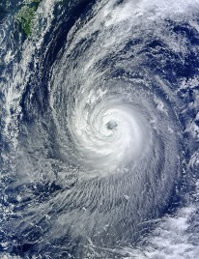

A. ☐

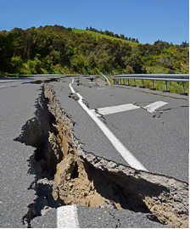

B. ☐

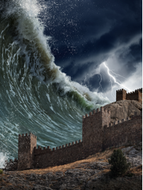

C. ☐

* + 1. (2) What happened to the man?

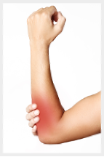

A. ☐

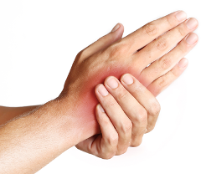

B. ☐

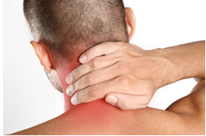

C. ☐

* + 1. (3) Which natural disaster was the woman in?

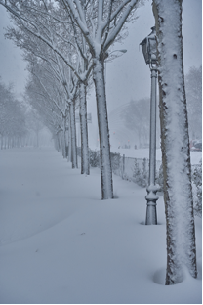

A. ☐

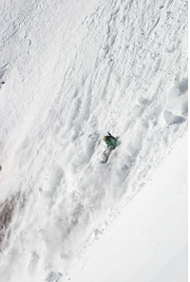

B. ☐

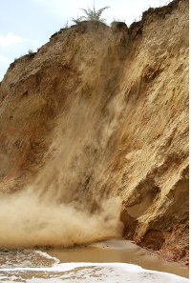

C. ☐

* + 1. (4) What did the woman do?



A. ☐

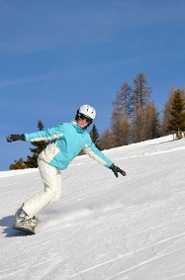

B. ☐

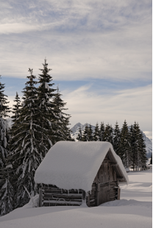

C. ☐

* + 1. (5) What is the warning telling people to do?

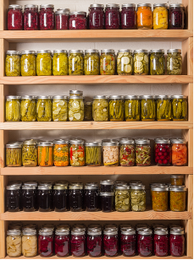

B. ☐

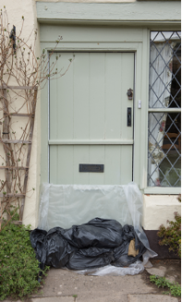

C. ☐

**WRITING (8 questions)**

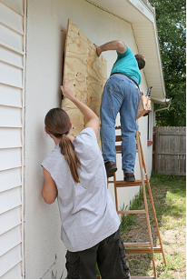

A. ☐

**PART 7**

# Put the words in the correct order to make a correct sentence. Question:

Keywords: meet/Saturday morning/Let's/./6.45 a.m./on/at

→

# Rewrite the following sentence without changing its meaning. Use the given word(s) if any.

* + 1. Minh really likes to chat with his friends.

→ENJOYS

# Use the given words or phrases to make a complete sentence.

* + 1. Single-use plastic / be / main cause / pollution / the ocean.

→

# Rewrite the following sentence without changing its meaning. Use the given word(s) if any.

* + 1. How about coming with me to the table tennis practice on Sunday afternoon?

→Do you want

# Rewrite the following sentence without changing its meaning. Use the given word(s) if any.

* + 1. It is too noisy for me to focus on my work.

→ENOUGH

# Write question for the underlined information in the following sentence.

* + 1. Typhoon Linda was the worst typhoon in Vietnam’s history.

→

# Use the given words or phrases to make a complete sentence.

* + 1. Mr. Thomas / one of / famous / environmentalist / in / world.

→

# Put the words in the correct order to make a complete sentence. Question:

Keywords: Russia/in/was/The/2021./biggest/in/wildfire

→

**---THE END---**