School: ……………………………………….. | Date:…………………………………..
Class: ……………………………..................... | Period: ………………………….........

UNIT 4: COMMUNITY SERVICES
Lesson 3.1 - Listening and Reading (Page 34)

I. OBJECTIVES
By the end of the lesson, Ss will be able to:
1.1. Language knowledge and skills
- talk about how to protect the environment.
- review past simple.
- practice listening and understanding general and specific information about voluntary clean-up project.
- read and understand an email about cleaning up the beach.
1.2. Competences
- improve communication, collaboration, analytical and critical thinking skills.
1.3. Attributes
- be active to take part in social activities.
- help other people.
- raise awareness of protecting the environment.

II. TEACHING AIDS AND LEARNING MATERIALS
1. Teacher’s aids: Student book and Teacher’s book, class CDs, Digital Book (DCR phần mềm tương tác SB, DHA (từ vựng/ cấu trúc) phần mềm trò chơi tương tác), projector/interactive whiteboard / TV (if any), PowerPoint slides.
2. Students’ aids: Student’s book, workbook, notebook.

III. ASSESSMENT EVIDENCE
Performance Tasks | Performance Products | Assessment Tools
- Let’s Talk: Look at the picture. Do you know any beaches that look like this? How does it make you feel? What can we do to stop this from happening? | - Ss’ answers / presentation. | - T’s feedback/Peers’ feedback.
- Listen to Annie talking to Robert. What do you think Annie's job is? | - Ss’ answers. | - T’s feedback/Peers’ feedback.
- Listen again and circle the correct answer. | - Ss’ answers. | - T’s feedback/Peers’ feedback.
- Read Jane's email to Dan. Would Jane like to take part in future clean-ups? | - Ss’ answers. | - T’s feedback/Peers’ feedback.
- Now, read and write True or False. | - Ss’ answers. | - T’s feedback/Peers’ feedback.
-Speaking: Would you like to take part in a beach clean-up? Why (not)? | - Ss’ answers / presentation. | - T’s observation/ DCR and T’s feedback.

IV. PROCEDURES
A. Warm up: (5’)
a) Objective: Introduce the new lesson and set the scene for Ss to acquire new language; get students' attention at the beginning of the class by giving enjoyable and short activities as well as to engage them in the follow-up steps.
b) Content: Introduce the situation: Dirty beaches.
c) Expected outcomes: Ss have general ideas about the topic “cleaning up the beaches”, which they are going to listen and read in the new lesson.
d) Organization of the activity:
TEACHER’S ACTIVITIES | STUDENTS’ ACTIVITIES
- Option 1: Let’s Talk!  - Use the “Let’s talk!” part in the textbook– page 34 for warm-up activity.  - Ask Ss to work in pairs to look at the picture and answer the questions:  1. Do you know any beaches that look like this?  2. How does it make you feel?  3. What can we do to stop this from happening?  - Call Ss to share their answers with the whole class.  - Give feedback and evaluation.  - Lead to the new lesson.  - Option 2:  - Show a video clip about cleaning up the dirty beach.  - Have Ss watch and answer some questions:  1. Do you know any beaches that look like this?  2. How does it make you feel?  3. What can the people in the clip do to make the beach cleaner?  - Call Ss to give answers.  - Check and give comment.  - Lead to the new lesson.  *Link: https://www.youtube.com/watch?v=cV2gBU6hKfY  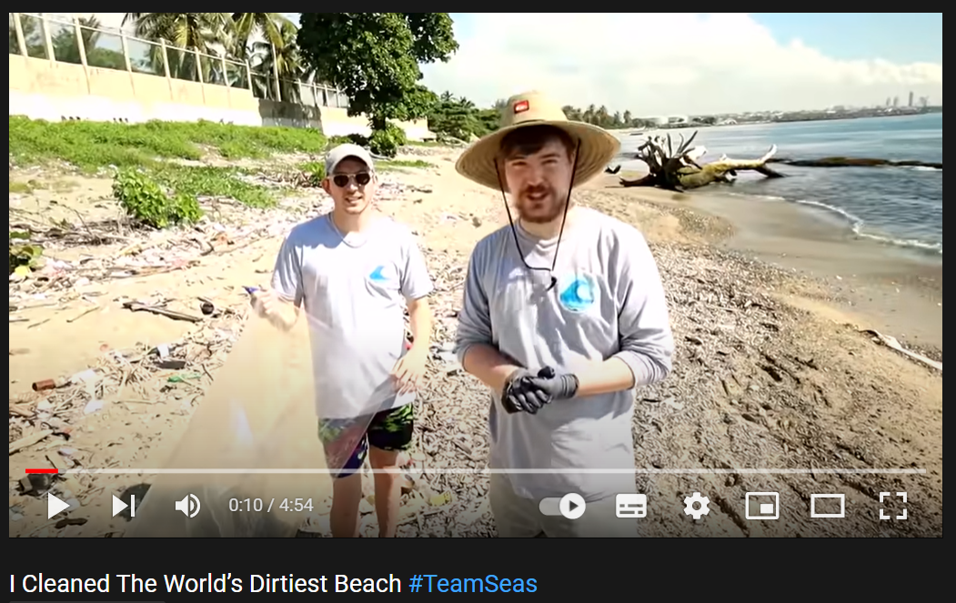 | - Work in pairs to discuss.  - Present.  - Watch the video clip, then answer T’s questions.  - Give answers.  - Listen.

B. New lesson (35’)
- Activity 1: Listening (17’)
a) Objective: Students can develop their listening skill.
b) Content: Listen to a conversation about clean-up activities.
c) Expected outcomes: Students can practice listening and understanding general + specific information about clean-up activities.
d) Organization of the activity:

TEACHER’S ACTIVITIES | STUDENTS’ ACTIVITIES
Task a. Listen to Annie talking to Robert. What do you think Annie's job is?  - Briefly explain the meaning of the three options.  - Have Ss read the question.  - Play audio (CD1 - Track 46).  - Have Ss listen and circle the correct answer.  - Call Ss to give answer, explain  - Play the audio again and check the answer as a whole class using DCR.  Task b. Now, listen and circle the correct answers  - Have Ss read through the content of Task b first.  - Play the audio again (CD1 - Track 46).  - Have Ss listen and circle the correct answers.  - Have Ss check answers with their partners.  - Call Ss to give answers, explain.  - Check answers as a whole class using DCR. | - Listen and take notes.  - Read.  - Listen and circle the correct answer.  - Give answer, explain.  Answer keys  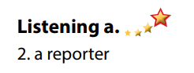  - Read.  - Listen and circle the correct answers.  - Exchange answers.  - Give answers.  Answer keys  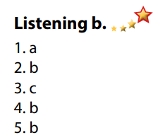

- Activity 3: Reading (18’)
a) Objective: Students can develop their reading skill.
b) Content:
- Read Jane's email to Dan. Would Jane like to take part in future clean-ups?
- Now, read and write True or False.
c) Expected outcomes: Students can read an email about cleaning up the beach for gist and detail, and they can talk about their environmental clean-up activities.
d) Organization of the activity:
TEACHER’S ACTIVITIES | STUDENTS’ ACTIVITIES
Task a. Read Jane's email to Dan. Would Jane like to take part in future clean-ups?  - Have Ss read Task a.  - Ask Ss to read the email quickly and circle the correct answer.  - Call 1 S to give answer.  - Check answers as a whole class using DCR.  Task b. Now, read and write True or False.  - Have Ss read the content in Task b and underline the key words.  - Have Ss read the email again and write True or False.  - Have Ss check their answers with a partner.  - Call Ss to give answers.  - Check answers as a whole class using DCR.  Task c. Speaking: In pairs: Would you like to take part in a beach clean-up? Why (not)?  - Have Ss discuss the questions in pairs.  - Call some Ss to share their answers with the whole class.  - Give feedback and evaluation.  - For class with high level students: Give Ss an extra task: List some activities you can do in a beach clean-up project.  - Call Ss some Ss to share their answers with the whole class.  - Give feedback and evaluation. | - Read and guess.  - Scan the email for general idea.  - Give answer.  Answer keys  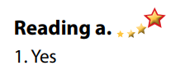  - Read and underline the key words.  - Read the text again for details.  - Exchange answers.  - Give answers.  Answer keys  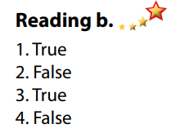  - Discuss in pairs.  - Present.  - Discuss in pairs.  - Present.

C. Consolidation and homework assignments (5’)
*Consolidation:
- Vocabulary: cleaner, volunteer, reporter, clean-up, environment, environmental, take part in, trash, pick up, organize.

*Homework
- Practice talking about your environmental clean-up.
- Do the exercises in WB: Listening and Reading (page 24).
- Do the vocabulary exercise in Tiếng Anh 7 i-Learn Smart World Notebook (page 26).
- Play consolation games in Tiếng Anh 7 i-Learn Smart World DHA App on www.eduhome.com.vn
- Prepare: Lesson 3 – Writing and Speaking (page 35 – SB).

D. Reflection
a. What I liked most about this lesson today:
…………………………………………………………………………………………
- What I learned from this lesson today:
…………………………………………………………………………………………
c. What I should improve for this lesson next time:
…………………………………………………………………………………………

