Chỉ 100k/12 tháng, bạn tải rất nhiều tài liệu tiếng anh file word hay tại: Giaoandethitienganh.info Mong bạn ghé ủng hộ !
ĐỀ VIP 8+ SỐ 6
Read the following review and mark the letter A, B, C or D on your answer sheet to indicate the option that best fits each of the numbered blanks from 1 to 6.

A PREMIUM SMARTPHONE EXPERIENCE!
I recently purchased the Samsung Galaxy Z Ultra and I must say, it's an (1) device. The design is sleek, with a large screen (2) vibrant colours and excellent clarity. What (3) the most is its performance; the phone handles multitasking with ease, even when running demanding apps. The camera quality is (4) highlight, producing sharp and detailed images, even in (5)
. One feature I particularly appreciate is the battery life, which lasts well over a full day with moderate use. Overall, the Samsung Galaxy Z Ultra offers great value for its price, and it truly makes using technology a more enjoyable experience. I highly recommend it (6) anyone looking for a reliable and high-performing phone.
Written by: Alex Thompson
Question 1. | A. impress | B. impression | C. impressive | D. impressively
Question 2. | A. displaying | B. to display | C. displayed | D. display
Question 3. | A. figures out | B. stands out | C. stays up | D. makes out
Question 4. | A. others | B. the other | C. other | D. another
Question 5. | A. conditions  light poor | B. light  conditions poor | C. light poor  conditions | D. poor light  conditions
Question 6. | A. up | B. to | C. with | D. on
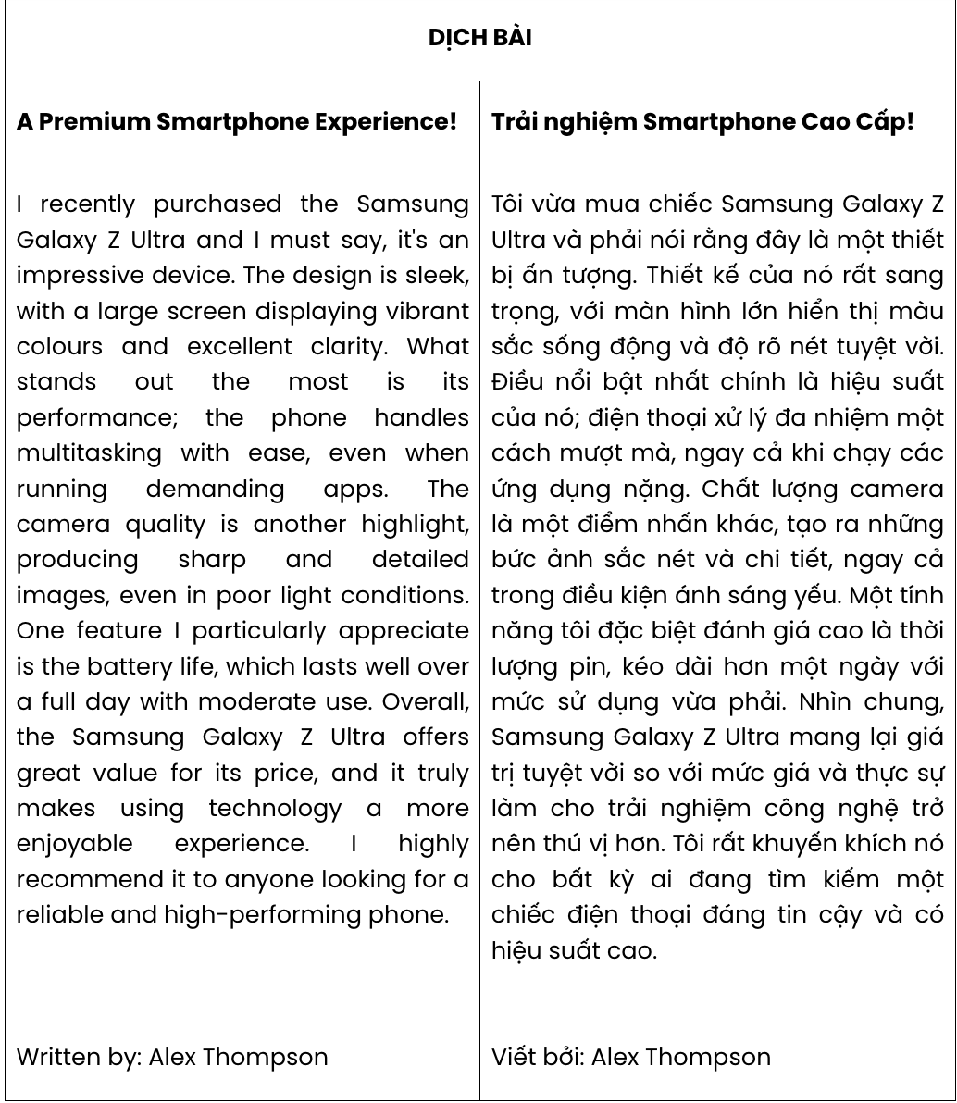
GIẢI CÂU 1:
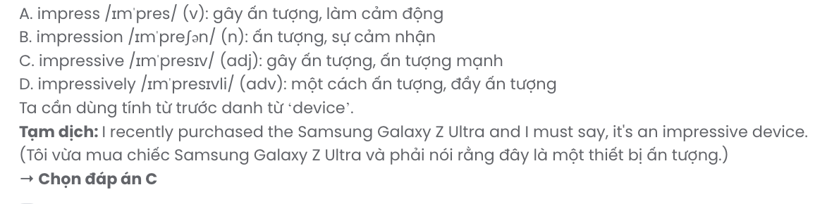

GIẢI CÂU 2:
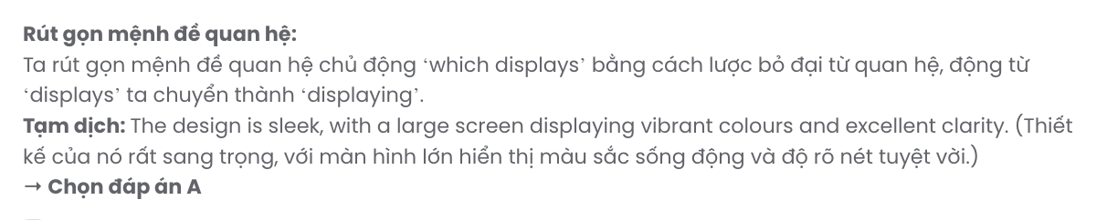
GIẢI CÂU 3:
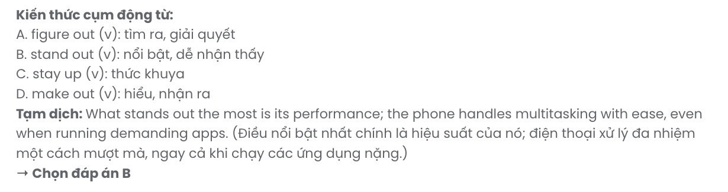

GIẢI CÂU 4:
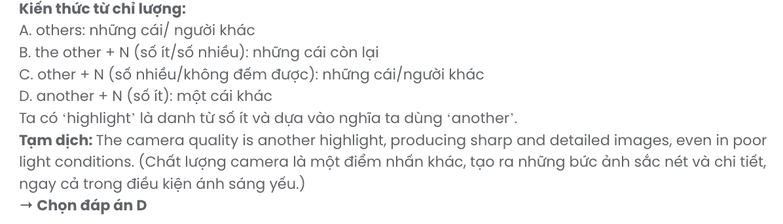
GIẢI CÂU 5:
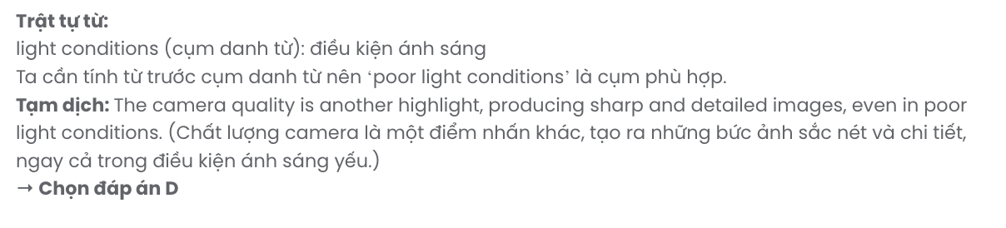
Read the following announcement and mark the letter A, B, C or D on your answer sheet to indicate the option that best fits each of the numbered blanks from 7 to 12.

ANNOUNCEMENT: CHANGE IN OFFICE WORKING HOURS
Dear Team,
We would like (7) you about an important update regarding our office working hours. (8)
recent feedback from several employees, we have decided to implement the following changes starting next Monday:
- New office hours: 9:00 AM - 5:00 PM (Monday to Friday)
- Lunch break: 1:00 PM - 2:00 PM (1-hour break).
- Flexible working days: Employees can work from home on Wednesdays, as long as they (9)
sure they are online during working hours.
This decision was made to improve work-life balance and (10) productivity among employees. We trust that these changes will benefit a(n) (11) of our staff.
If you have any questions or concerns, feel free to reach out to the HR (12) . Thank you for your cooperation!
Best regards.

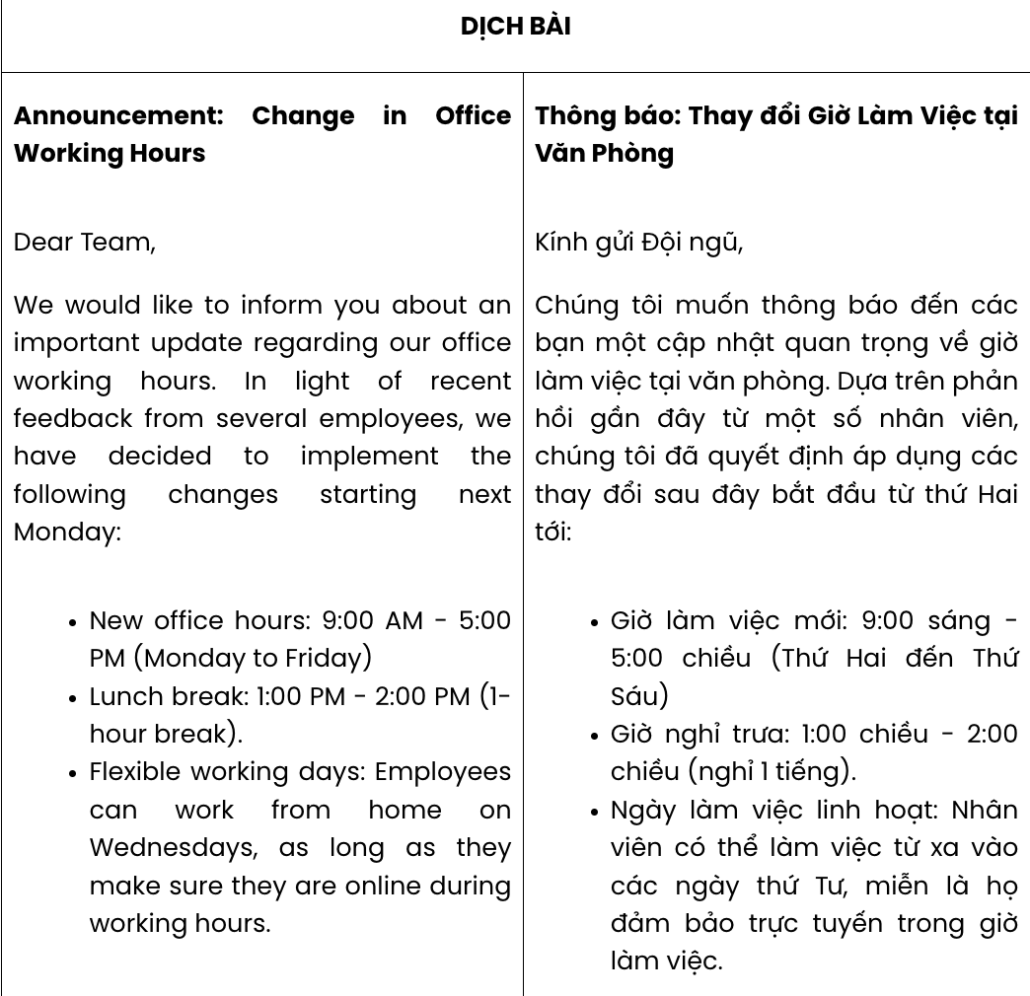

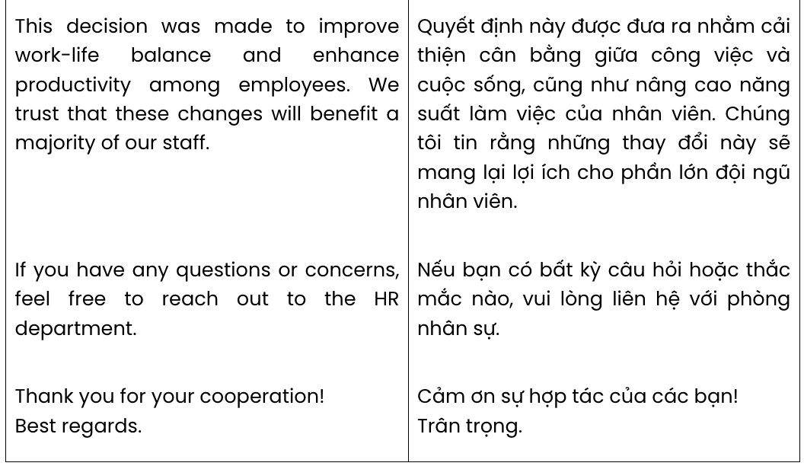

Question 7. | A. to inform | B. informing | C. to informing | D. inform
Question 8. | A. By means of | B. In spite of | C. In light of | D. On behalf of
Question 9. | A. get | B. make | C. take | D. stay
Question 10. | A. control | B. observe | C. adapt | D. enhance
Question 11. | A. amount | B. majority | C. minority | D. great deal
Question 12. | A. vacancy | B. accountant | C. department | D. branch
GIẢI CÂU 7:
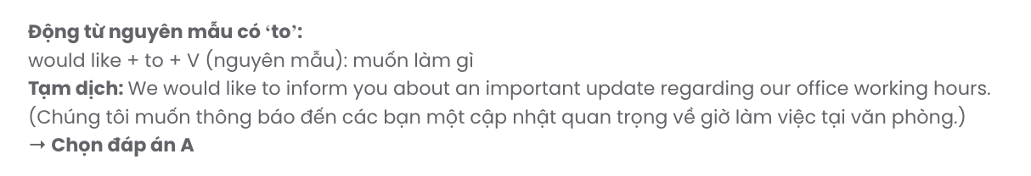
GIẢI CÂU 8:
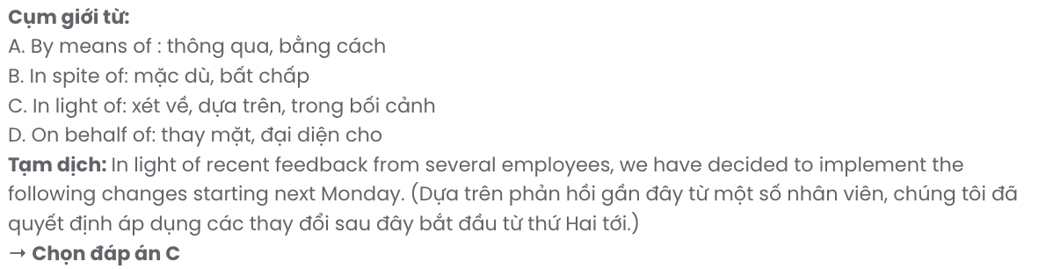
GIẢI CÂU 9:
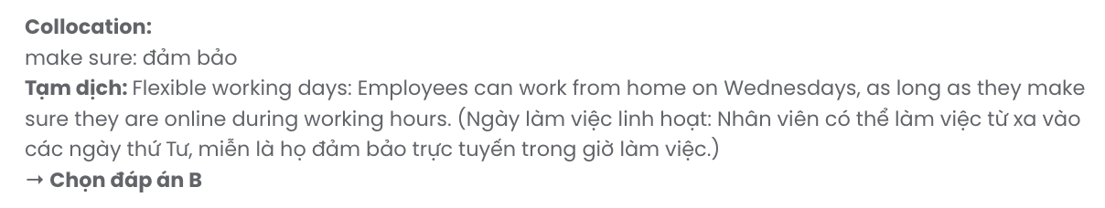
GIẢI CÂU 10:
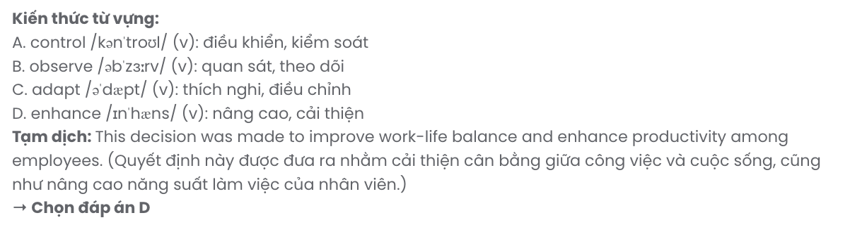
GIẢI CÂU 11:
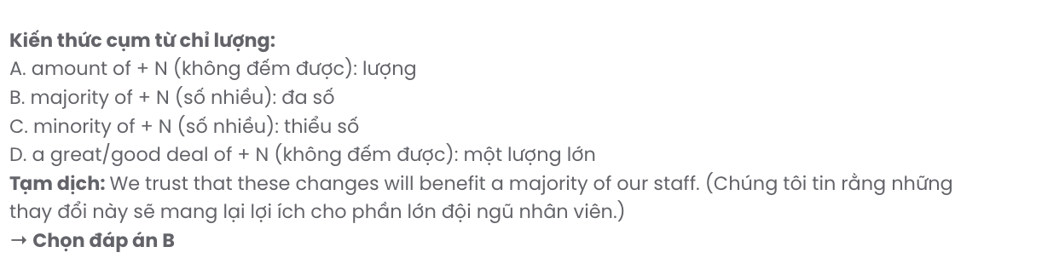
GIẢI CÂU 12:
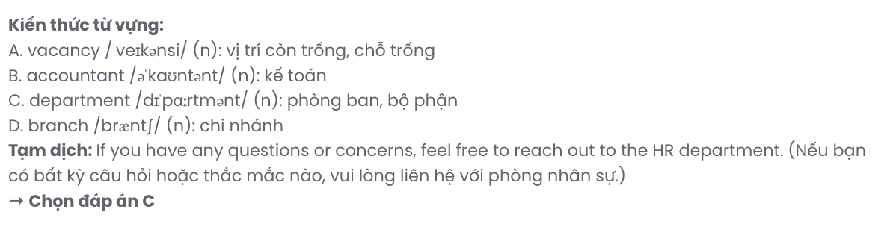
Mark the letter A, B, C or D on your answer sheet to indicate the best arrangement of utterances or sentences to make a meaningful exchange of text in each of the following questions from 13 to 17.

Question 13.
- Tom: I go a few times a week. I’m thinking about trying some new classes.
- Tom: Hey, I saw you at the gym yesterday! Do you go there often?
- Alice: Hi, Tom! Yeah, I try to go every evening after work. It’s my way of unwinding. How about you?
A. b – a – c B. a – c – b C. b – c – a D. c – a – b
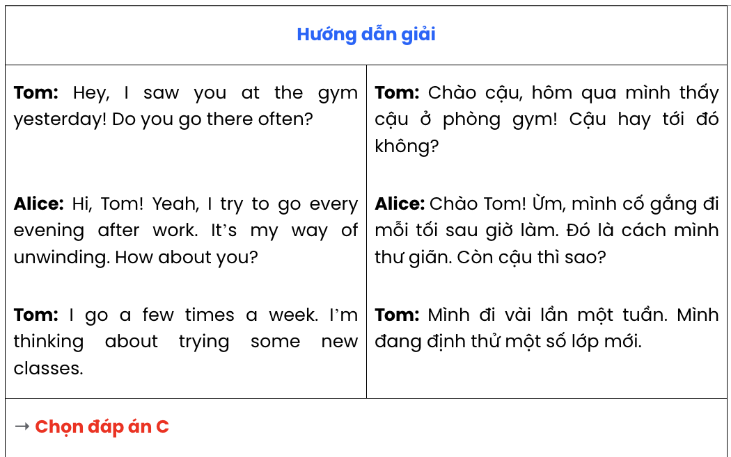

Question 14.
- Julia: I’ve always wanted to experience British culture, and the universities there have strong programs in my field.
- Julia: Yes, I think I’ll apply to a few universities in the UK.
- Andy: Have you decided which university you want to apply to yet?
- Andy: That’s a great choice! It sounds like it would be an exciting adventure. I’m sure you’ll get in!
- Andy: Why do you prefer to study in the UK?
A. e – a – c – b – d B. c – a – d – b – e C. d – b – e – a – c D. c – b – e – a – d
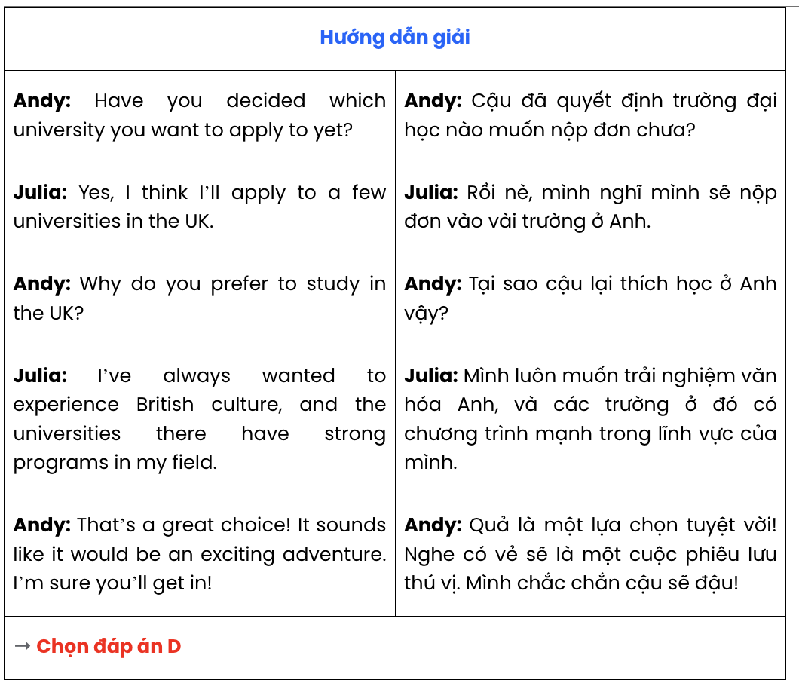

Question 15.
Dear Lucy,
- It feels like it was just yesterday that we were celebrating your last birthday together!
- Also, I hope the year ahead brings you even more happiness and success.
- I’m so proud of everything you’ve accomplished this year.
- How about planning a little celebration soon to mark this special occasion?
- Happy Birthday! I hope you have an amazing day filled with joy and surprises. Best wishes,
Mia
A. e – a – c – b – d B. e – c – b – d – a C. a – e – b – c – d D. e – d – a – c – b
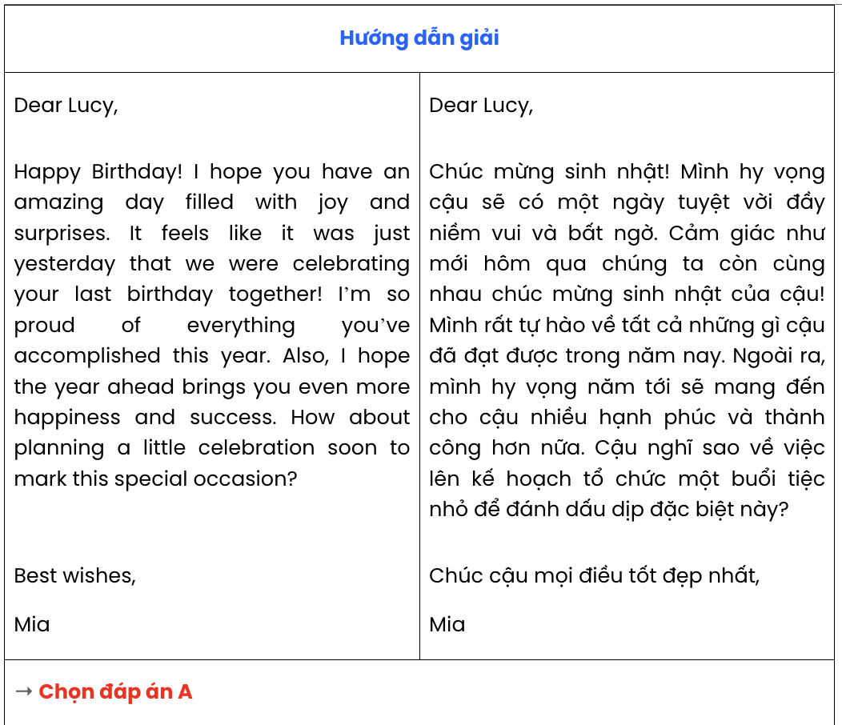

Question 16.
- They often travel long distances, sometimes crossing entire continents, in search of food and better weather conditions.
- For some others, they may rely on landmarks, the sun, and even the stars to navigate accurately.
- During migration, some species follow the same flyways year after year, guided by instinct and environmental cues.
- Every year, millions of birds migrate to warmer climates to escape the cold winter months.
- This incredible journey is not only vital for the survival of many bird species but it also plays a key role in maintaining ecological balance across different regions.
A. d – a – b – e – c B. d – c – b – e – a C. d – a – c – b – e D. c – b – d – a – e

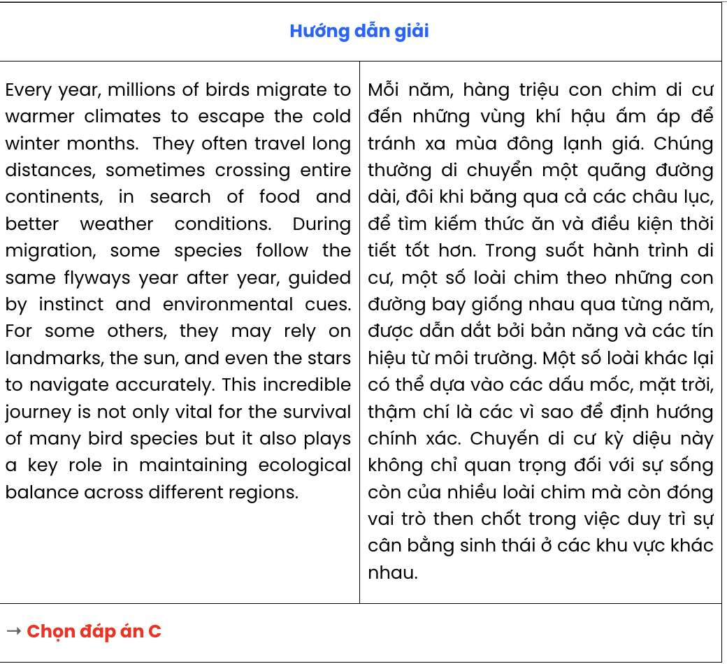

Question 17.
- Many minority languages around the world are slowly disappearing, often due to globalisation and cultural assimilation.
- However, without stronger initiatives, many of these languages may vanish forever, taking with them irreplaceable aspects of human heritage.
- As communities adopt dominant languages like English, their native tongues lose speakers, especially among younger generations.
- Efforts are being made to preserve endangered languages, such as through education and documentation projects.
- This loss of language also leads to the erosion of cultural identities, traditions, and knowledge passed down through generations.
A. a – c – e – d – b B. d – a – c – e – b C. a – d – b – e – c D. a – e – c – b – d
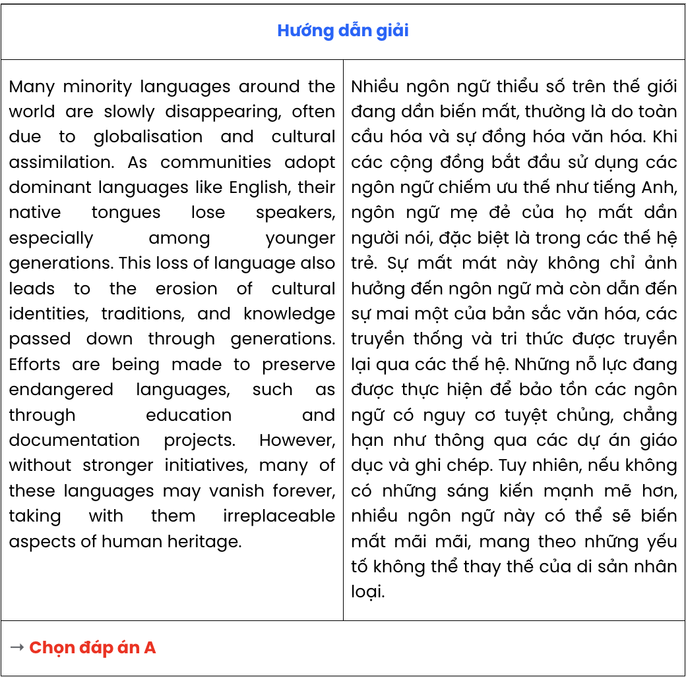

Read the following passage and mark the letter A, B, C, or D on your answer sheet to indicate the correct option that best fits each of the numbered blanks from 18 to 22.

THE SLOW PACE OF RURAL LIFE
Often described as peaceful and unhurried, (18) . In the countryside, people wake up early to the sound of birds singing and the rustling of leaves in the wind. The daily routine revolves around nature, with farming and animal care taking centre stage. Activities are spread throughout the day, (19)
, such as watching the sunset or taking a walk by the river.
(20) . In almost all rural areas, neighbours still help each other with tasks, whether it’s harvesting crops or lending a hand in times of need. Less about rushing from one task to the next, (21)
and appreciating the beauty of nature.
Even though rural life can be challenging due to limited access to resources and infrastructure,
(22) . With fresh air, open spaces, and less noise, rural living offers an escape from the pressures of modern life. It is a lifestyle that prioritises well-being over speed and embraces simplicity in all its forms.
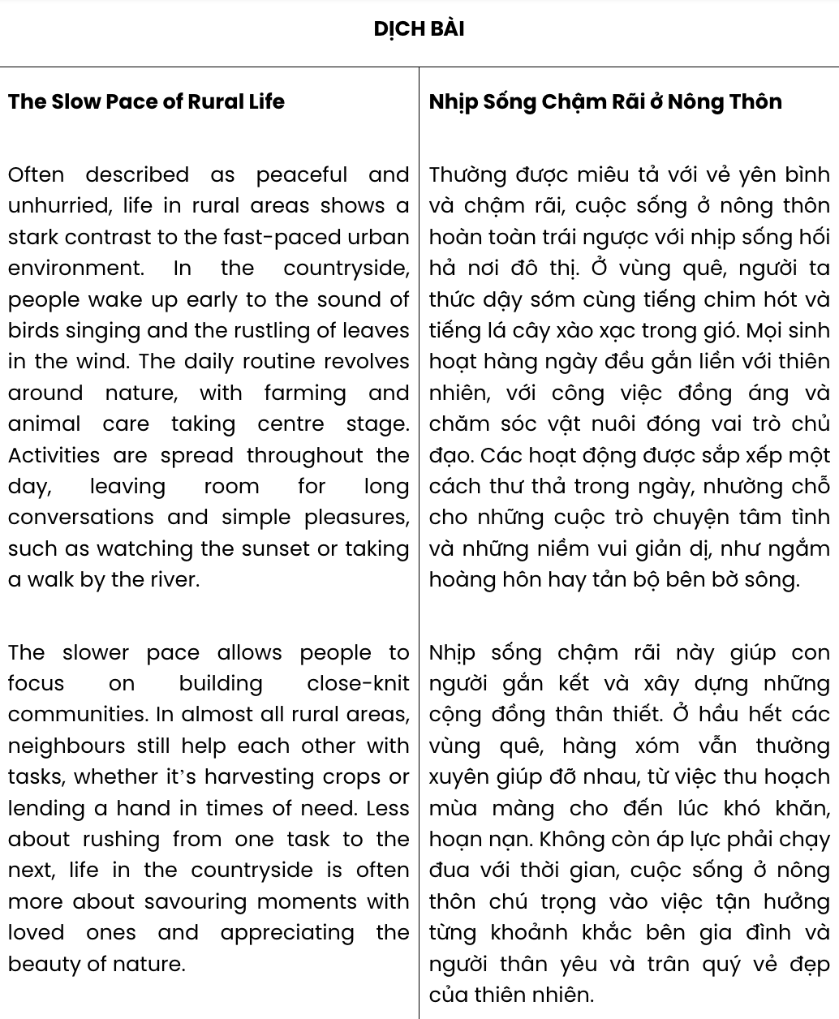
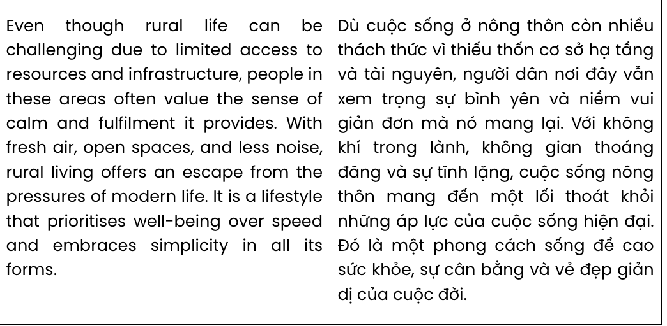

Question 18:
A. the fast pace of urban life is very different from living in the countryside
B. people often prefer living in the countryside to rushing in the fast pace of life in cities
C. life in rural areas shows a stark contrast to the fast-paced urban environment
D. the peace of the countryside often attracts more people than the fast pace of city life does
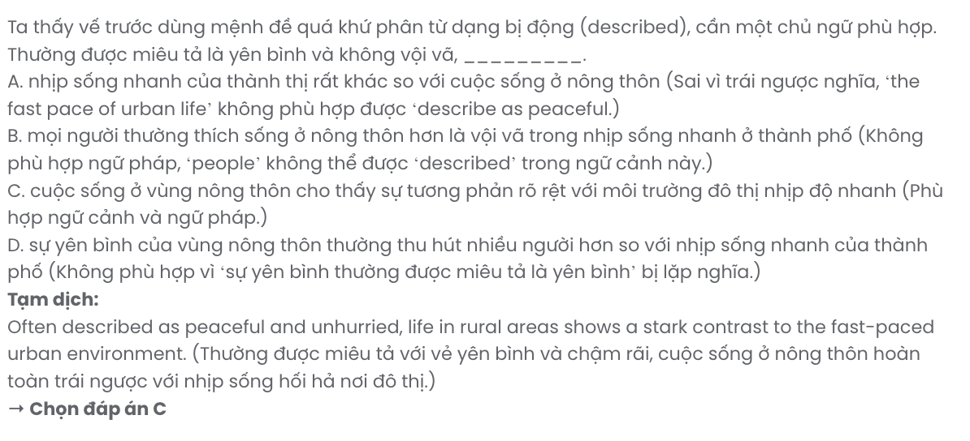

Question 19:
A. leaving room for long conversations and simple pleasures
B. long conversations and simple pleasures occur frequently
C. allow people to have long conversations and simple pleasures
D. when long conversations and simple pleasures often take place
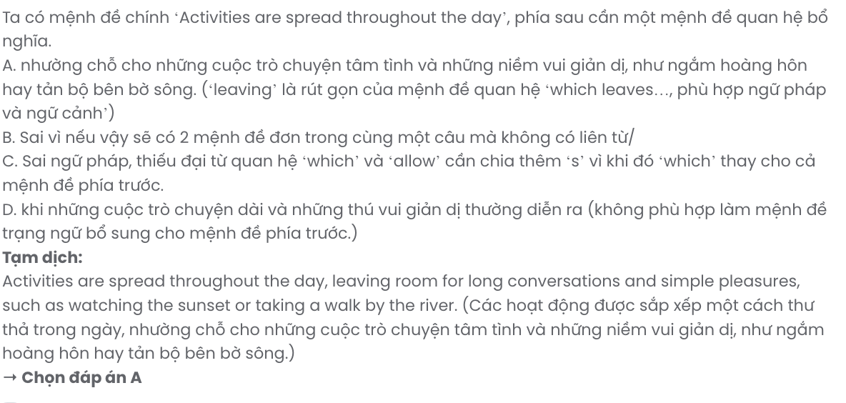

Question 20.
A. The slow pace of life in the countryside does a lot for a person’s health
B. Rural people often feel strange with modern facilities in the city
C. The contrast between these two ways of life is evident in customs
D. The slower pace allows people to focus on building close-knit communities

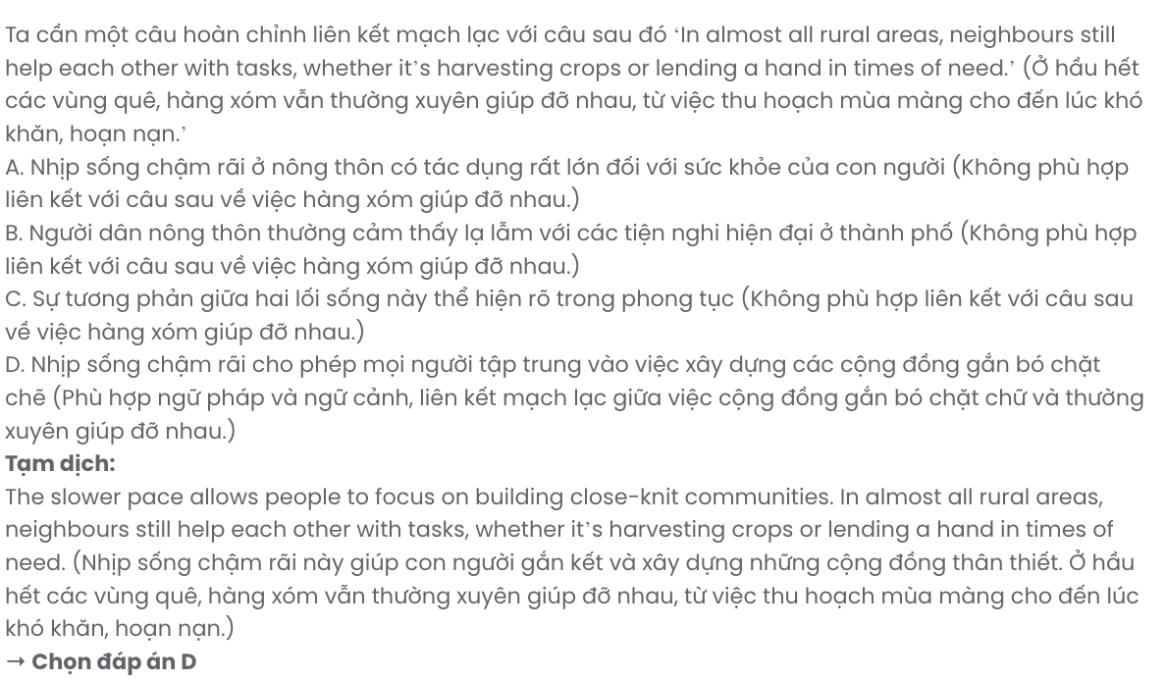

Question 21.
A. the fast city life often prevents us from spending more time with our loved ones
B. the countryside which is considered perfect for spending time with loved ones
C. rural life that often highlights spending the most time with loved ones
D. life in the countryside is often more about savouring moments with loved ones
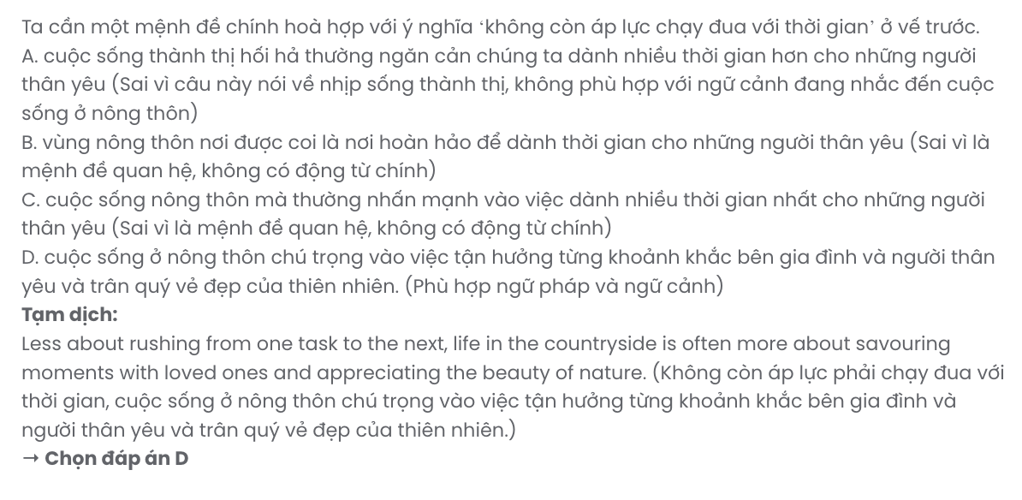

Question 22.
A. most people agree that city life is still far more convenient and comfortable
B. people in these areas often value the sense of calm and fulfilment it provides
C. these limitations also make rural life less rich in experience and information
D. more rural people are tending to migrate to cities for better job opportunities
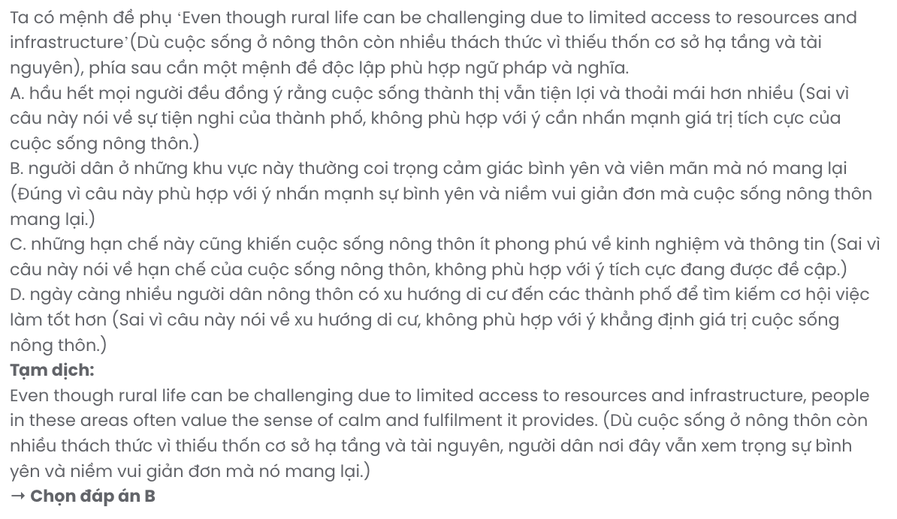
Read the following passage and mark the letter A, B, C, or D on your answer sheet to indicate the best answer to each of the following questions from 23 to 30.
What you eat has a direct impact on the cells in your body, which in turn has an impact on longevity. A healthy diet provides cells with vital sources of energy and keeps them stable and working as they should. Healthy foods support your immune cells, which defend against infections and other health threats, protect other cells from damage, and help the body repair or replace damaged cells.
A diet high in sugar, unhealthy fats, and processed foods, on the other hand, can leave cells throughout the body more vulnerable to damage and poor function. This can lead to an increased risk of infection, cancer, inflammation, and chronic diseases such as diabetes, cardiovascular problems, and obesity.
An excellent diet for promoting longevity is a plant-based diet. A plant-based diet involves eating lots of fruits and vegetables, beans, nuts and seeds, and whole grains instead of processed foods. Foods from plants are high in antioxidants such as beta carotene, lycopene, and vitamins A, C, and E, which protect cells from damage. Following a plant-based diet doesn’t mean you need to become a vegetarian, or never have meat or a dessert. It simply means that most of the foods you eat should be minimally processed and come from plants.
A study published in JAMA Network Open found that women who most closely adhered to the plant-based Mediterranean diet, which emphasises vegetables, fruits, nuts, whole grains, legumes, and fish, and minimises red and processed meats, were 23% less likely to die from any cause than those who did not closely adhere to this dietary pattern.
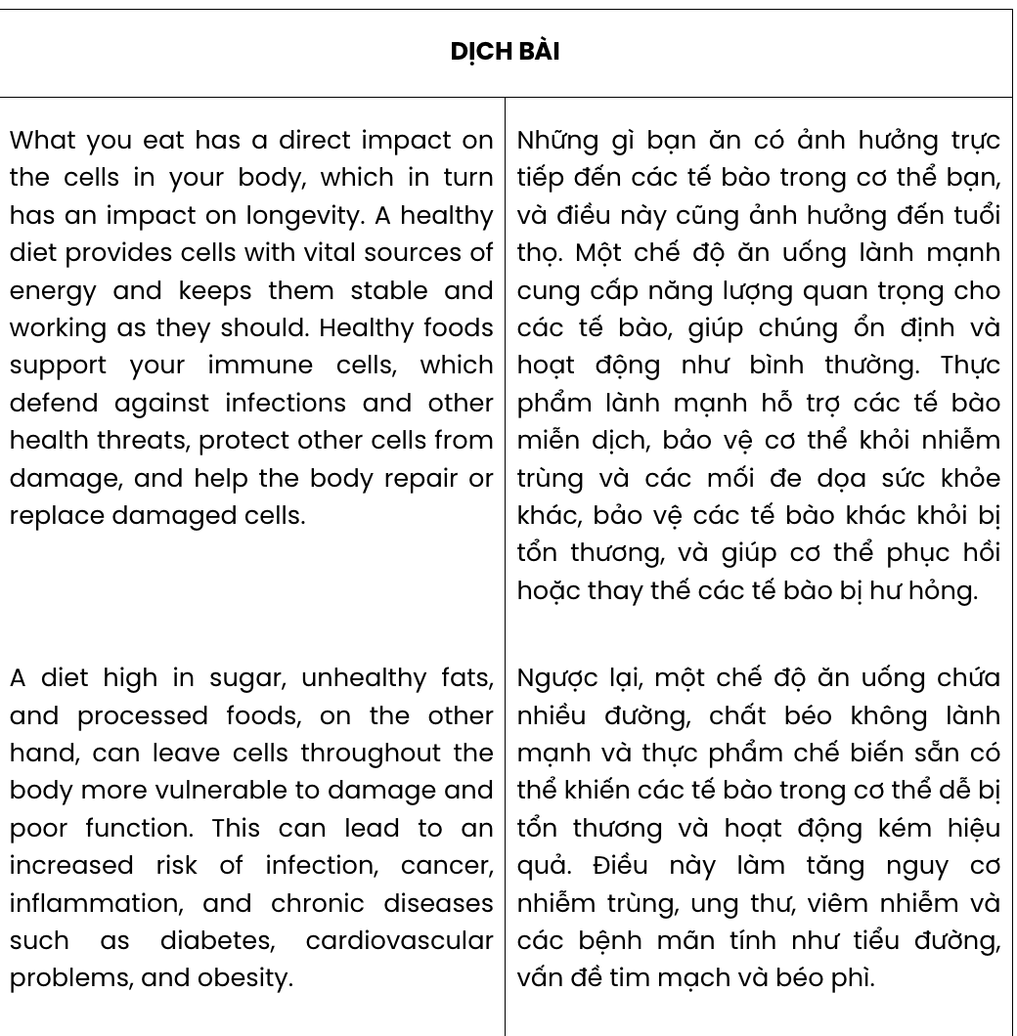(Adapted from https://www.health.harvard.edu)

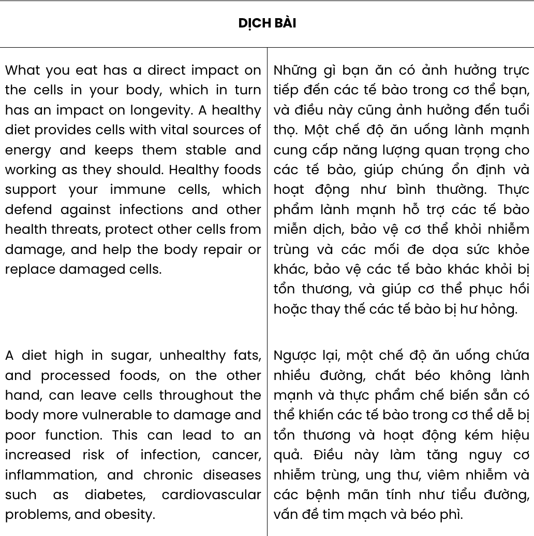
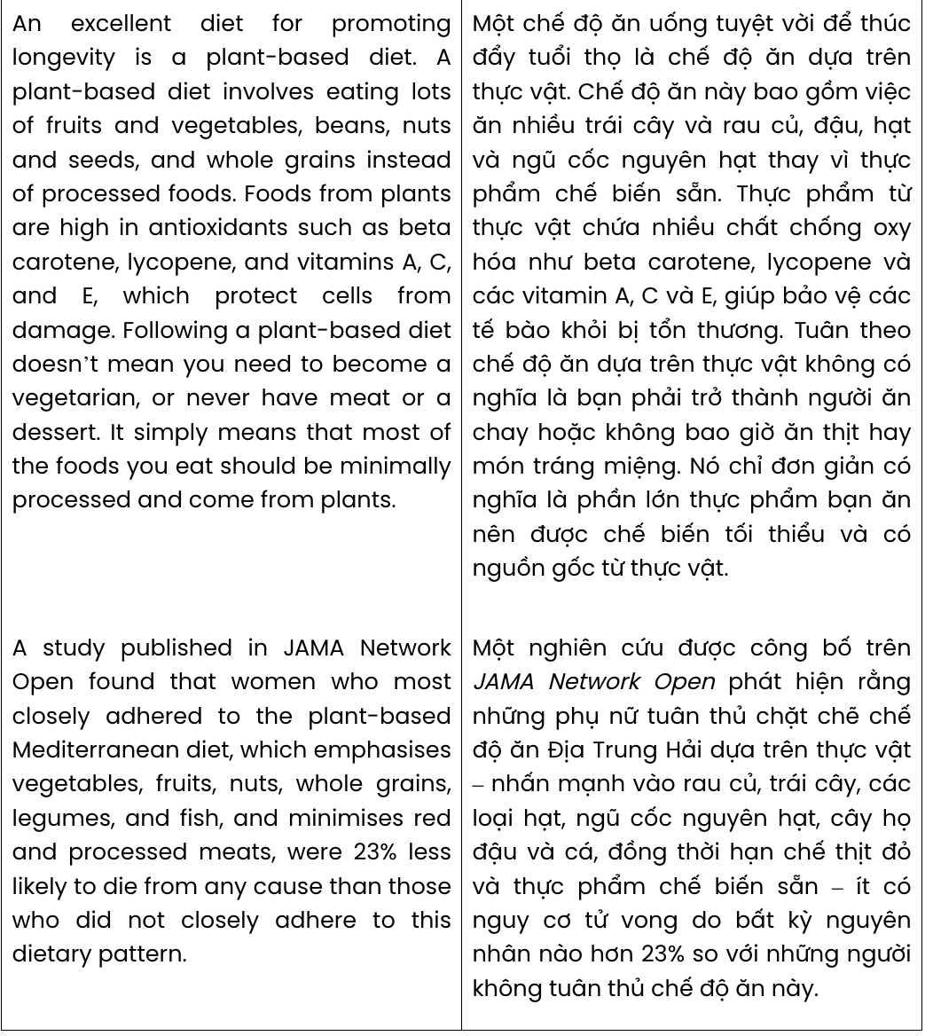
Question 23. Which of the following best paraphrases the underlined sentence in paragraph 1?

What you eat has a direct impact on the cells in your body, which in turn has an impact on longevity.
A. Your diet affects your cells, which can influence how long you live.
B. The foods you consume directly affect your health, leading to a longer life.
C. The health of your cells depends on your diet, which also determines your happiness.
D. What you eat can improve the function of your cells and help you live longer.
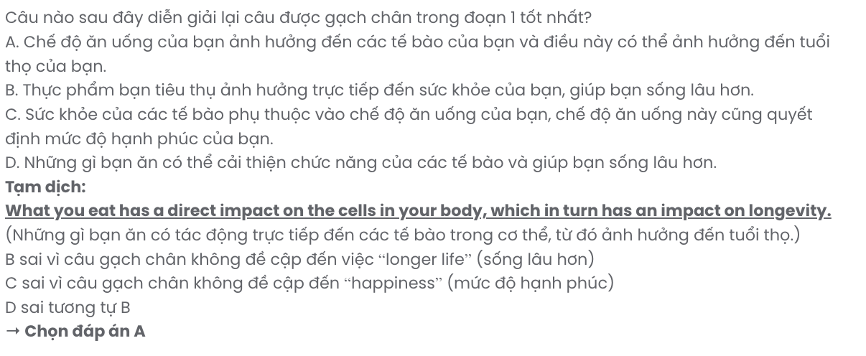
Question 24. Which of the following is NOT mentioned as one of the functions of immune cells?
A. keeping energy stable B. helping heal the body
C. protecting other cells D. preventing infections
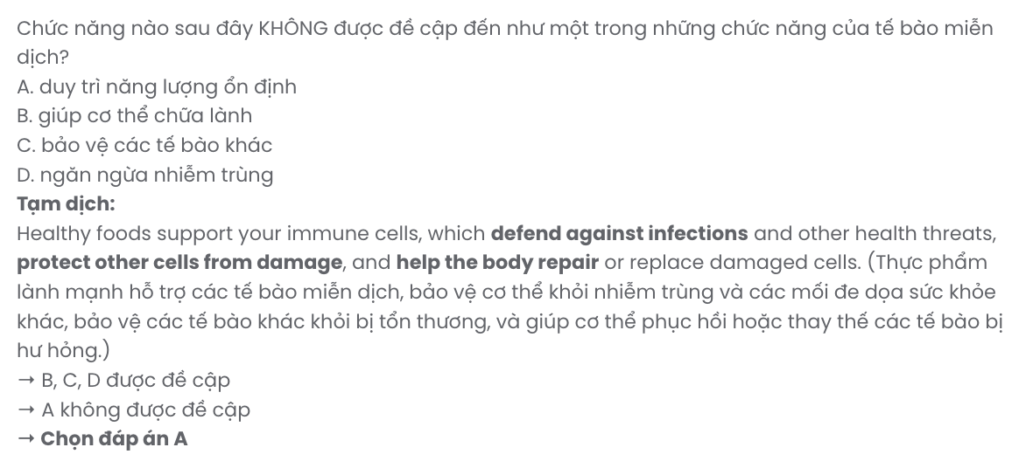
Question 25. The word vulnerable in paragraph 2 can be best replaced by .
A. inevitable B. susceptible C. preventive D. protective

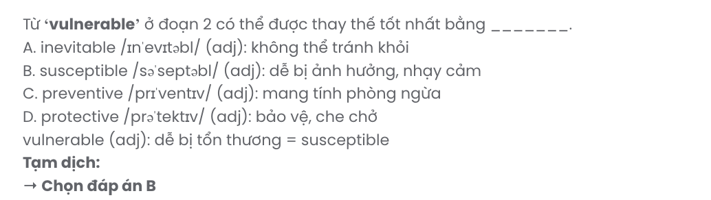
Question 26. The word protect in paragraph 3 is OPPOSITE in meaning to .
A. attempt B. avoid C. neglect D. secure
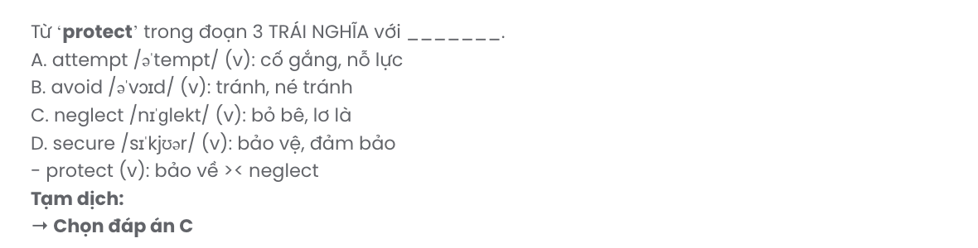
Question 27. The word those in paragraph 4 refers to .
A. whole grains B. processed meats C. vegetables D. women
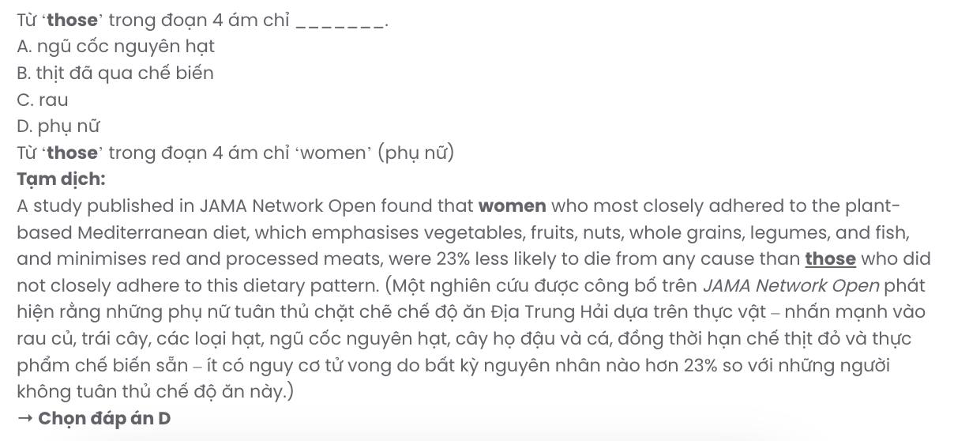
Question 28. Which of the following is TRUE according to the passage?
A. When a person follows a plant-based diet, they have to eliminate animal ingredients.
B. One study found that women who followed a plant-based diet lived 23 per cent longer.
C. Healthy immune cells will help the body work and perform more without getting tired.
D. Taking in too much sugar, unhealthy fats and processed foods raises the risk of disease.
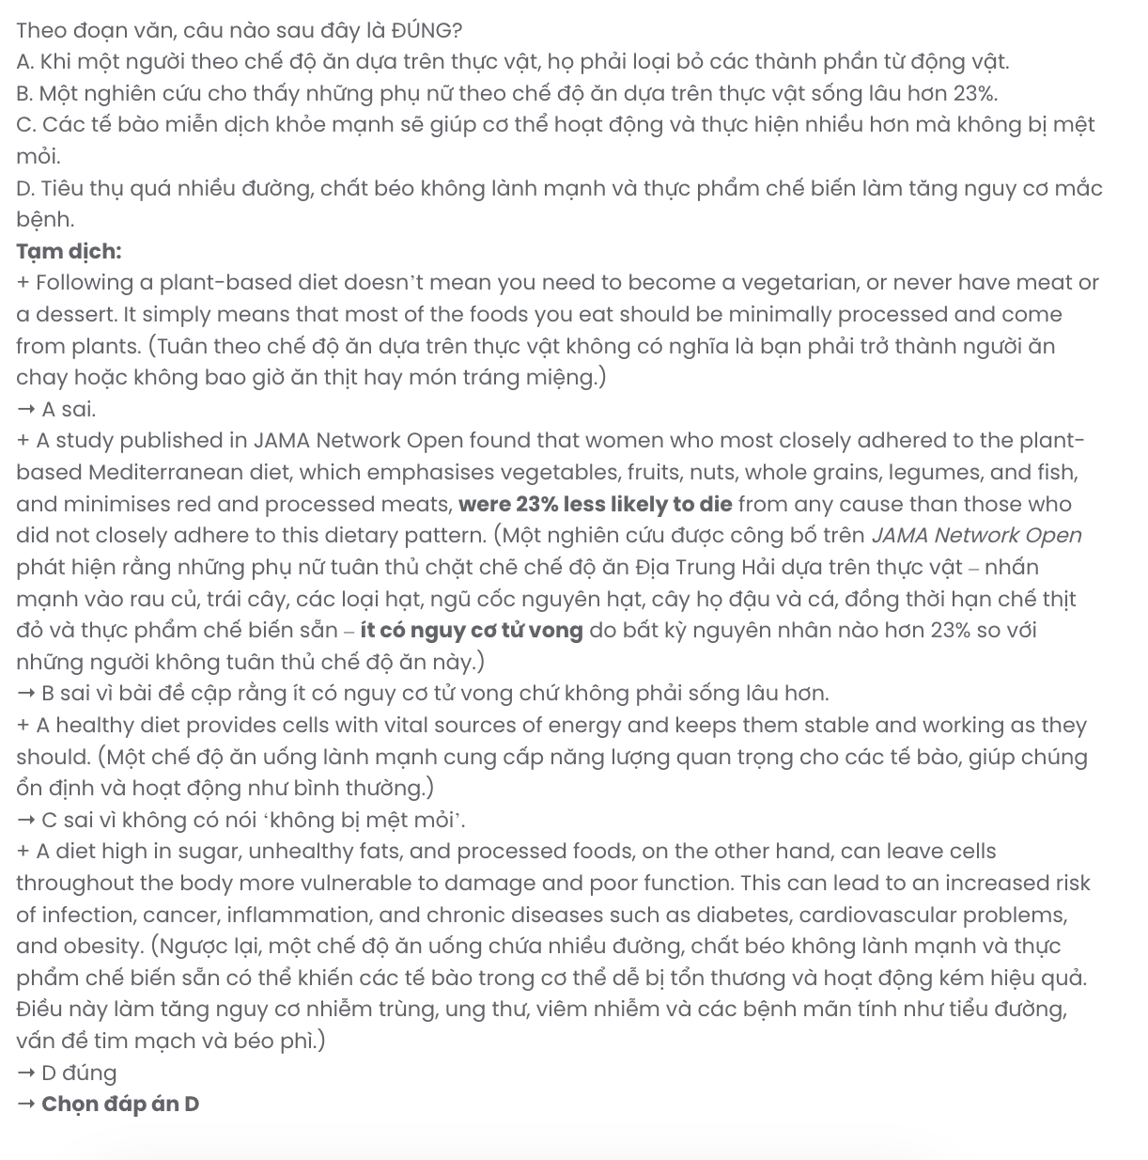
Question 29. In which paragraph does the author give further explanation about a diet?
A. paragraph 1 B. paragraph 2 C. paragraph 3 D. paragraph 4
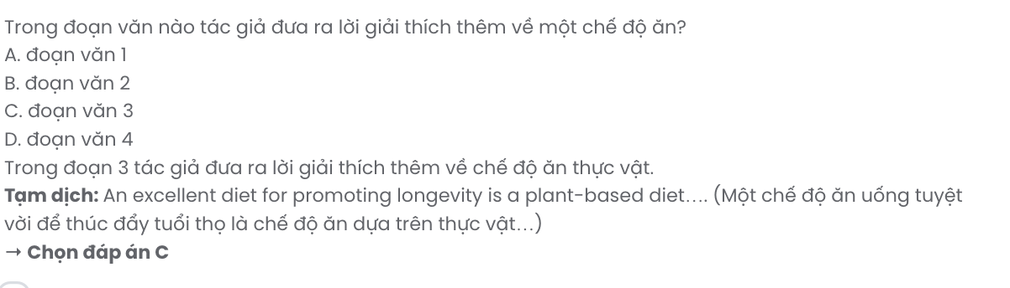
Question 30. In which paragraph does the author list some diseases?
A. paragraph 1 B. paragraph 2 C. paragraph 3 D. paragraph 4
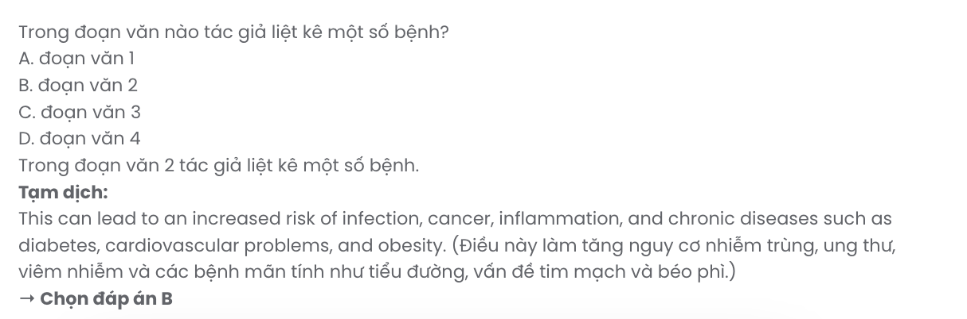

Read the following passage and mark the letter A, B, C, or D on your answer sheet to indicate the best answer to each of the following questions from 31 to 40.
Due to changes in climate, some species will adapt by changing their behaviours, physical characteristics, or how their bodies function. Others will not be able to adapt. Accordingly, climate change could lead to expansions, reductions, or extinctions of some populations. These changes, in turn, can affect the overall biodiversity of a region.
Plants and animals may also change the geographic range they inhabit in response to changing climatic conditions. [I] Changing temperature and water conditions have already altered the ranges of many plants and animals. [II] Many plants and animals rely on cues in nature, including temperature and water conditions, to trigger certain stages of their life cycles. [III] As a result, species that depend on one another at certain times of the year may no longer be in sync. [IV]
For example, plankton are an important food source for young fish, but they tend to react more quickly to changes in temperature than the fish. This means the plankton might not be as available when growing fish need it most. Also, if a bird migrates at the same time each year, it could reach its destination to find that, due to shifting temperatures, its main food source grew too early and is no longer available.
Climate change is also changing the way species and populations interact with the environment and one another. These impacts can be felt throughout an entire ecosystem. For example, climate change is increasing the spread of invasive species in some areas. Invasive species can outcompete native plants and animals, bring in new diseases, and cause other problems. These changes can create significant environmental and economic harm.
(Adapted from https://www.epa.gov/)
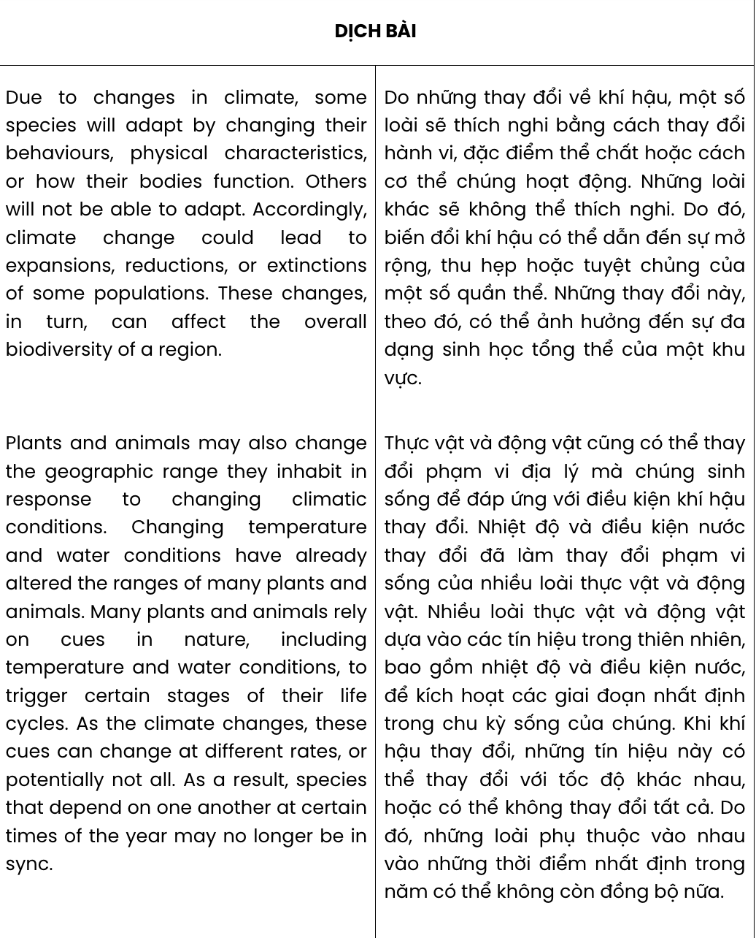
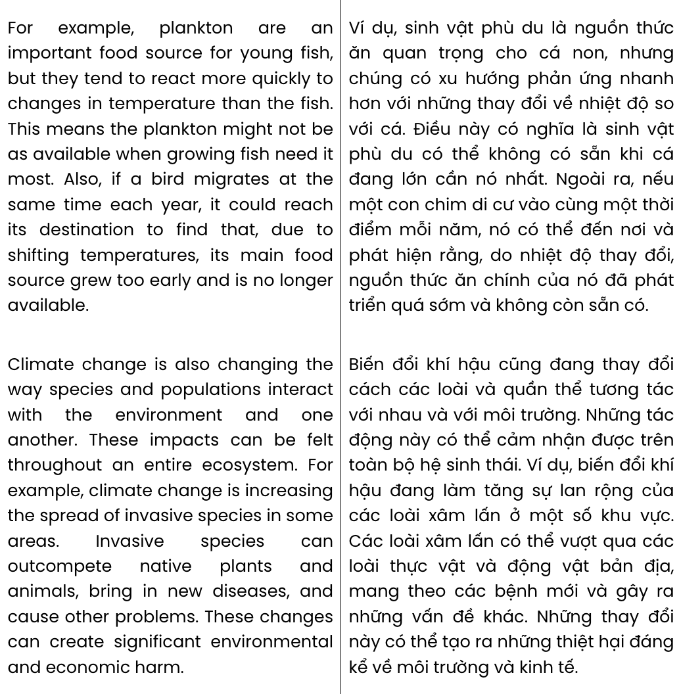
Question 31. The word their in paragraph 1 refers to .
A. species B. behaviours C. characteristics D. changes
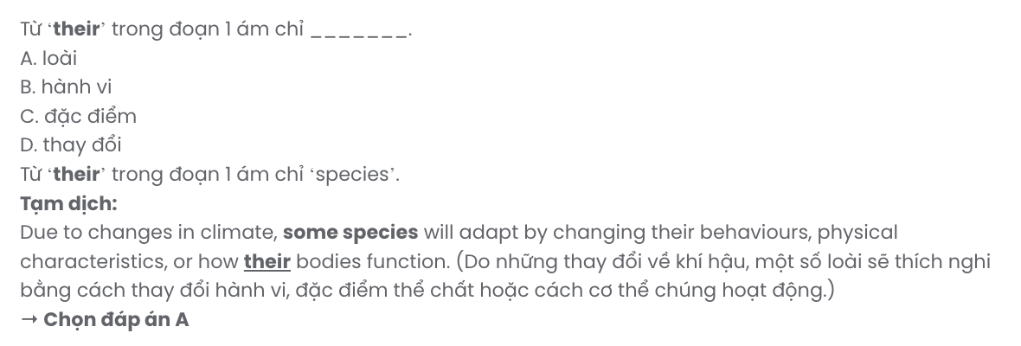
Question 32. Where in paragraph 2 does the following sentence best fit?

As the climate changes, these cues can change at different rates, or potentially not all.
A. [I] B. [II] C. [III] D. [IV]
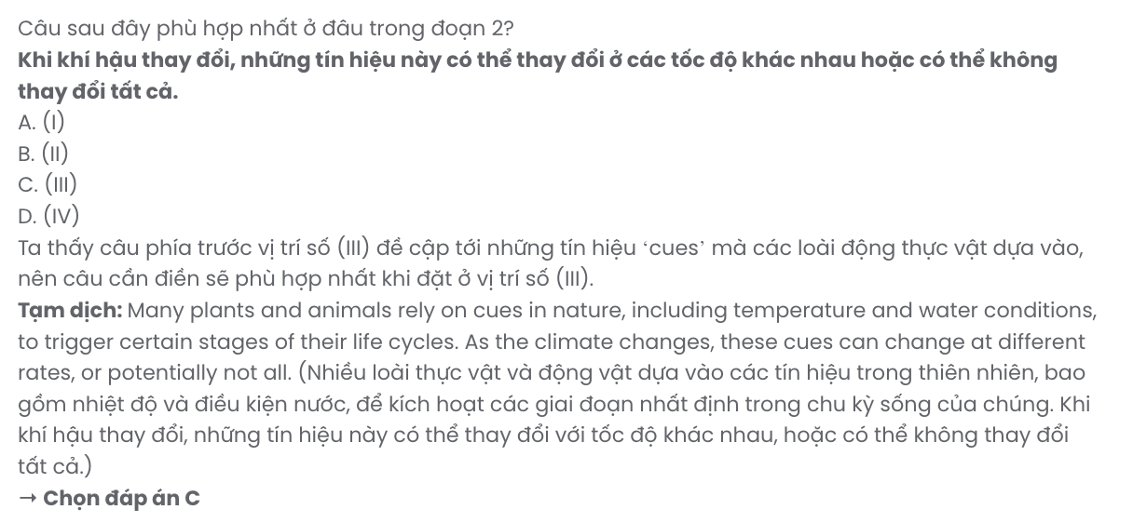
Question 33. The phrase be in sync in paragraph 2 could be best replaced by .
A. communicate with each other B. support each other to survive and develop
C. work together at the same time D. become attached and inseparable

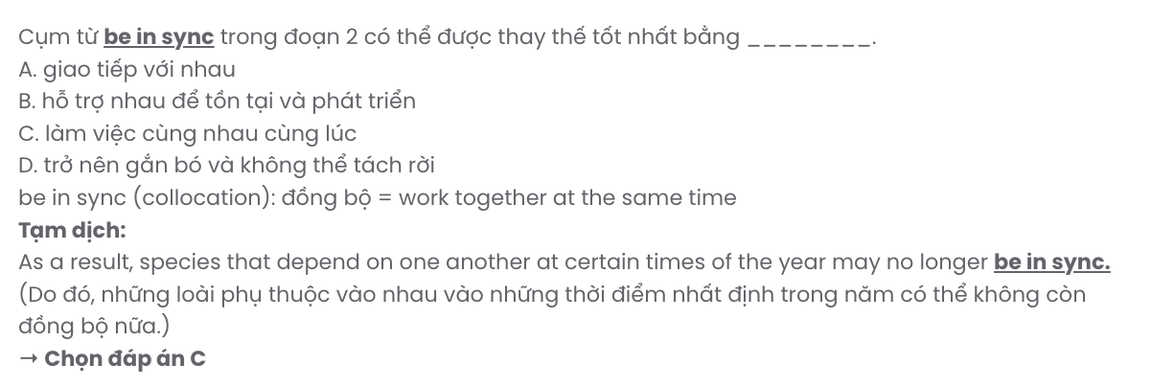
Question 34. Which of the following is NOT mentioned as one of the examples of species affected by changes in temperatures?
A. fish B. shrimps C. birds D. plankton
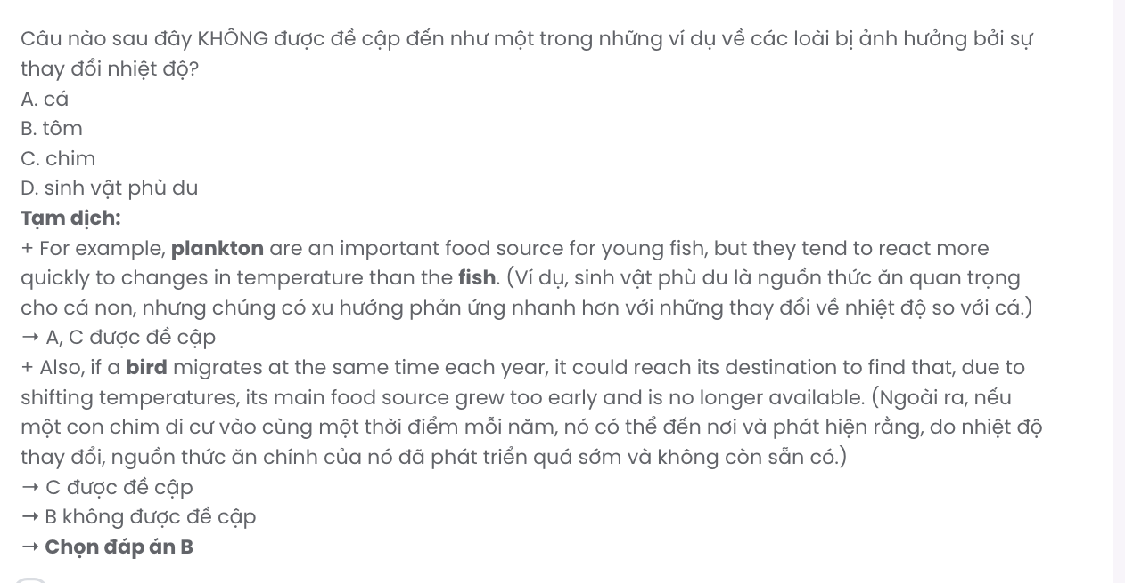
Question 35. The word available in paragraph 3 is OPPOSITE in meaning to .
A. irresponsible B. harmful C. adequate D. limited
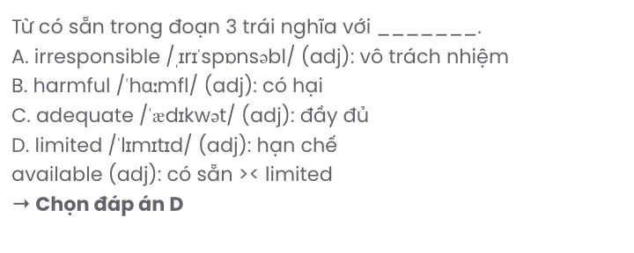
Question 36. Which of the following best summarises paragraph 4?
A. Climate change is causing some species to alter their behaviours and migration patterns.
B. Climate change is leading to food shortages for many species due to higher competition.
C. The interaction between species is becoming increasingly disrupted due to climate change.
D. Climate change is causing species interactions to change, leading to negatives.
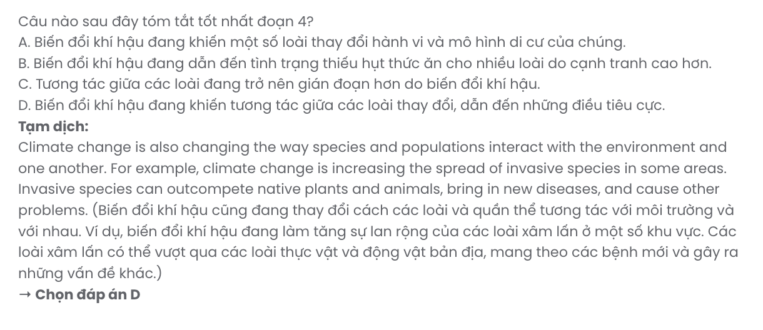
Question 37. Which of the following best paraphrases the underlined sentence in paragraph 4?

These impacts can be felt throughout an entire ecosystem.
A. These consequences affect sensitive parts of an entire ecosystem.
B. The effects are observable across every level of the ecosystem.
C. The ecosystem as a whole has largely benefited from these impacts.
D. The changes are mostly confined to local environments.
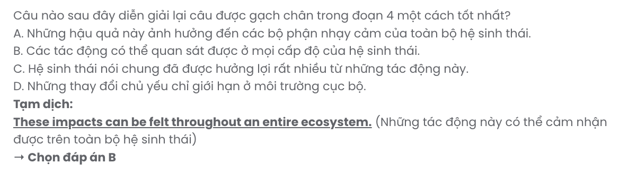
Question 38. Which of the following is TRUE according to the passage?
A. Climate change is leading to significant shifts in species’ geographical ranges.
B. Most species will be able to adapt to climate change through behavioural changes.
C. Invasive species are decreasing as a result of climate change.
D. Plankton are less affected by temperature changes than the fish that rely on them.
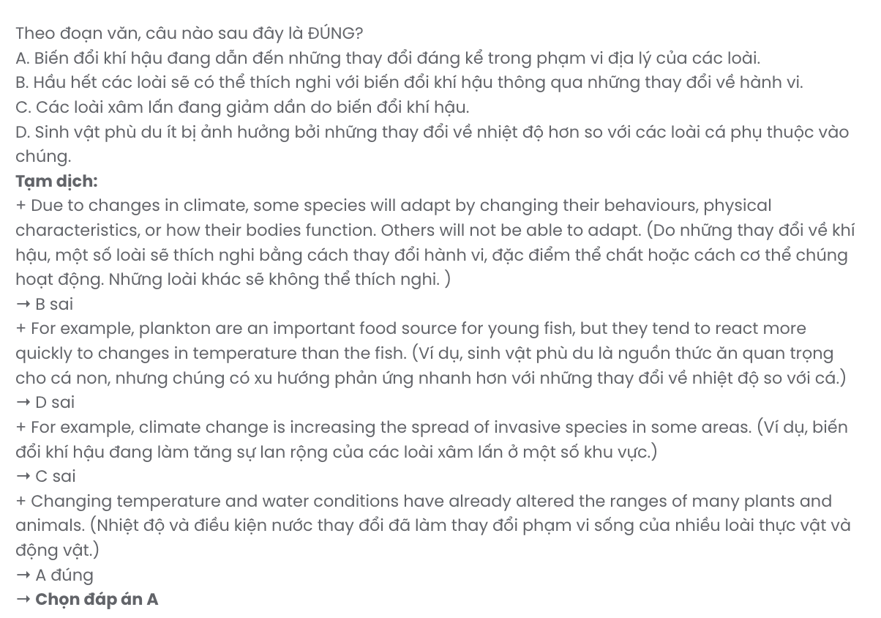
Question 39. Which of the following can be inferred from the passage?
A. Climate change affects species' physical bodies but not their behavioural characteristics.
B. Species that cannot adapt to climate change will likely face reductions or extinctions.
C. Invasive species are directly benefiting from climate change and becoming less harmful.
D. The impact of climate change on species is only temporary and not worth worrying about.
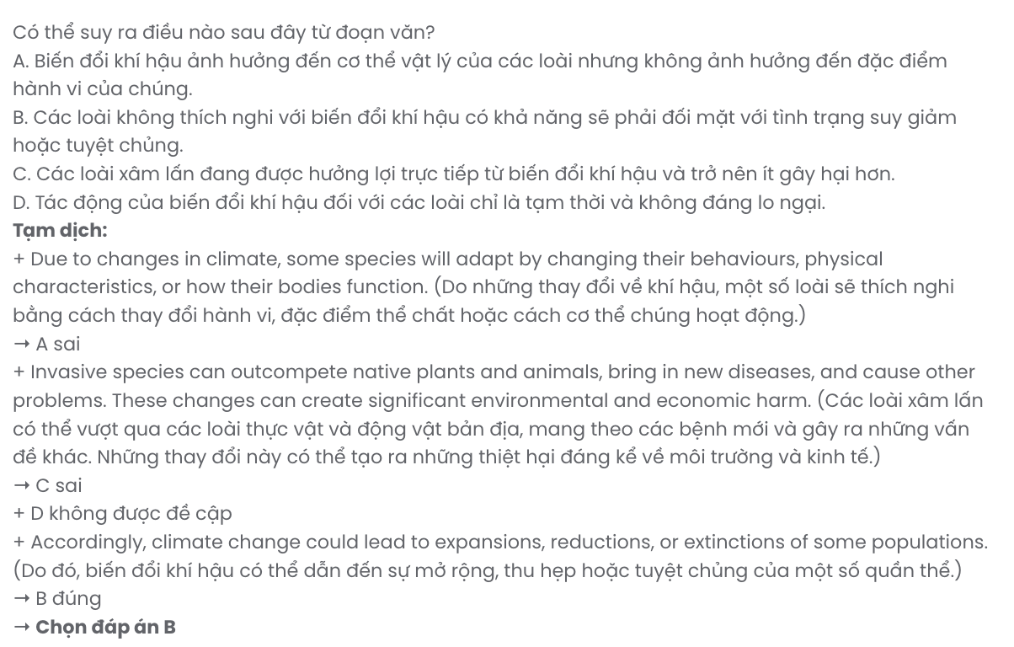
Question 40. Which of the following best summarises the passage?
A. Species’ adaptation to climate change will ensure minimal disruption to ecosystems and biodiversity in the long term.
B. Climate change is causing some species to face insurmountable challenges, altering ecosystems in complex ways.
C. Climate change affects species’ populations, distribution, behaviour, and interactions within ecosystems, leading to significant changes.
D. Climate change primarily impacts species that cannot adapt, while others continue to thrive without any issue.

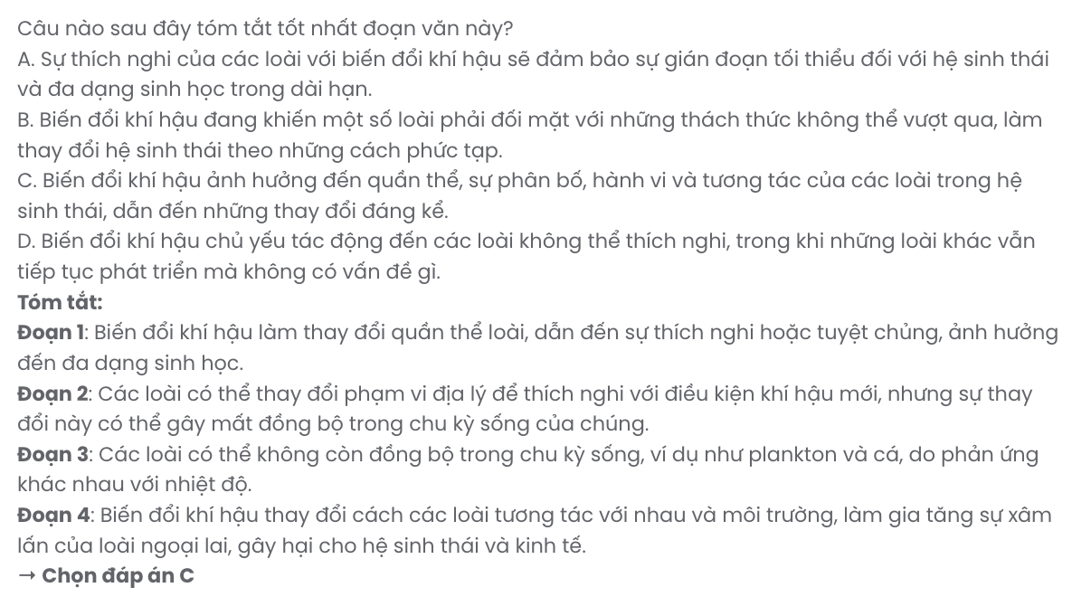
BẢNG TỪ VỰNG
STT | Từ vựng | Phiên âm | Từ loại | Nghĩa
1 | impressive | /ɪmˈpresɪv/ | adj | ấn tượng
2 | sleek | /sliːk/ | adj | bóng bẩy
3 | vibrant | /ˈvaɪbrənt/ | adj | sôi động
4 | excellent | /ˈeksələnt/ | adj | xuất sắc
5 | clarity | /ˈklærɪti/ | n | sự rõ ràng
6 | handle | /ˈhændl/ | v | xử lý
7 | multitasking | /ˈmʌltiˌtæskɪŋ/ | n | đa nhiệm, làm nhiều việc cùng lúc
8 | moderate | /ˈmɒdərɪt/ | adj | vừa phải
9 | reliable | /rɪˈlaɪəbl/ | adj | đáng tin cậy
10 | recently | /ˈriːsəntli/ | adv | gần đây
11 | purchase | /ˈpɜːrtʃəs/ | v | mua
12 | enhance | /ɪnˈhɑːns/ | v | nâng cao
13 | vacancy | /ˈveɪkənsi/ | n | vị trí trống
14 | accountant | /əˈkaʊntənt/ | n | kế toán
15 | branch | /bræntʃ/ | n | chi nhánh
16 | unwind | /ˌʌnˈwaɪnd/ | v | thư giãn
17 | accomplish | /əˈkɒmplɪʃ/ | v | hoàn thành
18 | migrate | /ˈmaɪɡreɪt/ | v | di cư
19 | continent | /ˈkɒntɪnənt/ | n | lục địa
20 | migration | /ˈmaɪɡreɪʃən/ | n | sự di cư
21 | flyway | /ˈflaɪweɪ/ | n | đường bay (di cư của chim)
22 | instinct | /ˈɪnstɪŋkt/ | n | bản năng
23 | environmental | /ˌɪnvɪˈrɒnməntəl/ | adj | thuộc về môi trường
24 | cue | /kjuː/ | n | tín hiệu
25 | navigate | /ˈnævɪɡeɪt/ | v | điều hướng
26 | accurately | /ˈækjʊrətli/ | adv | chính xác
27 | incredible | /ɪnˈkredəbl/ | adj | đáng kinh ngạc
28 | vital | /ˈvaɪtl/ | adj | rất quan trọng
29 | ecological | /ˌiːkəˈlɒdʒɪkl/ | adj | sinh thái
30 | minority | /maɪˈnɒrɪti/ | n | thiểu số
31 | globalisation/ globalization | /ˌɡləʊbəlaɪˈzeɪʃən/ | n | toàn cầu hóa
32 | assimilation | /əˌsɪmɪˈleɪʃən/ | n | sự đồng hóa
33 | dominant | /ˈdɒmɪnənt/ | adj | chiếm ưu thế
34 | erosion | /ɪˈrəʊʒən/ | n | sự xói mòn

35 | identity | /aɪˈdentɪti/ | n | bản sắc
36 | documentation | /ˌdɒkjʊmenˈteɪʃən/ | n | tài liệu
37 | initiative | /ɪˈnɪʃətɪv/ | n | sáng kiến
38 | vanish | /ˈvænɪʃ/ | v | biến mất
39 | irreplaceable | /ˌɪrɪˈpleɪsəbl/ | adj | không thể thay thế
40 | heritage | /ˈherɪtɪdʒ/ | n | di sản
41 | stark | /stɑːrk/ | adj | rõ ràng
42 | rustle | /ˈrʌsl/ | n | tiếng sột soạt
43 | revolve | /rɪˈvɒlv/ | v | xoay quanh
44 | harvest | /ˈhɑːrvɪst/ | v | thu hoạch
45 | savour/savor | /ˈseɪvər/ | v | thưởng thức
46 | infrastructure | /ˈɪnfrəstrʌktʃər/ | n | cơ sở hạ tầng
47 | fulfilment/ fulfillment | /fʊlˈfɪlmənt/ | n | sự hoàn thành, thỏa mãn
48 | prioritise/ prioritize | /praɪˈɒrɪtaɪz/ | v | ưu tiên
49 | simplicity | /sɪmˈplɪsɪti/ | n | sự đơn giản
50 | fast-paced | /ˌfæst ˈpeɪst/ | adj | nhịp độ nhanh
51 | immune | /ɪˈmjuːn/ | adj | miễn dịch
52 | infection | /ɪnˈfekʃən/ | n | sự nhiễm trùng
53 | repair | /rɪˈpeər/ | v | sửa chữa
54 | process | /ˈprəʊses/ | n | quy trình
55 | function | /ˈfʌŋkʃən/ | n/v | chức năng, hoạt động
56 | inflammation | /ˌɪnfləˈmeɪʃən/ | n | viêm
57 | diabetes | /ˌdaɪəˈbiːtiːz/ | n | bệnh tiểu đường
58 | cardiovascular | /ˌkɑːdɪəʊˈvæskjʊlər/ | adj | tim mạch
59 | obesity | /əʊˈbiːsɪti/ | n | bệnh béo phì
60 | longevity | /lɒnˈdʒevɪti/ | n | tuổi thọ
61 | plant-based | /plɑːnt beɪst/ | adj | nguồn gốc thực vật
62 | minimise/minimize | /ˈmɪnɪmaɪz/ | v | giảm thiểu
63 | adhere | /ədˈhɪər/ | v | tuân thủ
64 | dietary | /ˈdaɪətəri/ | adj | thuộc về chế độ ăn uống
65 | pattern | /ˈpætən/ | n | mô hình, khuôn mẫu
66 | inevitable | /ɪnˈevɪtəbl/ | adj | không thể tránh khỏi
67 | susceptible | /səˈseptɪbl/ | adj | dễ bị tổn thương
68 | preventive | /prɪˈventɪv/ | adj | phòng ngừa
69 | close-knit | /ˈkləʊs nɪt/ | adj | khăng khít
70 | protective | /prəˈtektɪv/ | adj | bảo vệ, bảo hộ
71 | vulnerable | /ˈvʌlnərəbl/ | adj | dễ bị tổn thương
72 | attempt | /əˈtempt/ | n/v | nỗ lực

73 | neglect | /nɪˈɡlekt/ | v/n | bỏ bê, sự bỏ bê
74 | characteristic | /ˌkærɪktəˈrɪstɪk/ | n | đặc điểm, đặc trưng
75 | expansion | /ɪkˈspænʃən/ | n | sự mở rộng
76 | reduction | /rɪˈdʌkʃən/ | n | sự giảm
77 | extinction | /ɪkˈstɪŋkʃən/ | n | sự tuyệt chủng
78 | biodiversity | /ˌbaɪəʊdaɪˈvɜːsɪti/ | n | đa dạng sinh học
79 | region | /ˈriːdʒən/ | n | khu vực
80 | range | /reɪndʒ/ | n | phạm vi, dãy
81 | inhabit | /ɪnˈhæbɪt/ | v | cư trú
82 | trigger | /ˈtrɪɡər/ | v | gây ra, kích hoạt
83 | potentially | /pəˈtenʃəli/ | adv | có tiềm năng
84 | plankton | /ˈplæŋktən/ | n | sinh vật phù du
85 | invasive | /ɪnˈveɪsɪv/ | adj | xâm lấn
86 | economic | /ˌiːkəˈnɒmɪk/ | adj | thuộc về kinh tế
87 | adequate | /ˈædɪkwət/ | adj | đầy đủ

STT | Cấu trúc | Nghĩa
1 | stand out | nổi bật
2 | figure out | tìm ra, hiểu ra
3 | stay up | thức khuya
4 | make out | hiểu
5 | recommend something to somebody | gợi ý, đề xuất điều gì cho ai đó
6 | allow somebody to do something | cho phép ai đó làm gì
7 | tend to do something | có xu hướng làm gì
8 | lead to | dẫn đến
Chỉ 100k/12 tháng, bạn tải rất nhiều tài liệu tiếng anh file word hay tại: Giaoandethitienganh.info Mong bạn ghé ủng hộ !

