Đề 1
A. PART 1: USE OF ENGLISH (4,5ms)
I. MULTIPLE CHOICE QUESTIONS: Choose the letter (A, B, C or D) that indicates the best answer to each of the following questions. Write your answers In the box provided. (2,5ms)
- What should we do to cut down ………….. our electricity bill?
A. at B. in C. on D. from
- I use different study methods to ……………. my writing.
A. bring B. improve C. give D. spend
- Huong was not sure …………. to buy souvenirs for her pen pals from Korea.
A. what B. how C. which D. where
- Do you watch movies ……………. English?
A. to learn B. learning C. learned D. to learning
- I need to …………… where the nearest grocery store is.
A. find in B. find out C. come across D. go into
- If you understand English, you can enjoy a lot more………….. on the internet.
A. internation B. career C. content D. overseas
- The …………… person brought my package to the door this morning.
A. operator B. delivery C. communicator D. transportation
- The brave firefighters rushed to the scene to ………… out the fire in the building.
A. stop B. prevent C. bring D. put
- ……………. the job I want in the future, I need to speak English really well
A. Though B. Despite C. Because of D. Because
- Find the mistake.
I am wondering how improving my reading and listening skills in a short time?
A. wondering B. improving C. skills D.short time

II. WORDS FORM: Supply the correct form of the word in bold to complete each of the following sentences. Write your answer in the box provided. (1.0m)
- If you want to study in another country, It is ……………… to learn English. (ESSENCE)
- The garbage ………………. comes every Friday to pick up our trash. ( COLLECT)
- Studying in Singapore will give you a(n) …………… to practice English. (OPPORTUNE)
- The people in this town always try hard to …………………… their traditional crafts like pottery and weaving. ( PRESERVATION)
III. VERBS FORM AND VERBS TENSE: Complete each of the following sentences with the correct tense and voice (active or passive) of the verb in bold. Write your answer in the box provided. (1.0m)
- Last week, I …..…… to join Lan’s family on a trip to her home village. (invite)
- Janet usually ……………… the bus to school every day. (take)
- I ………………………………….…. the washing up when the phone rang. (do)
- Don’t forget …………………… your identity card with you to the interview.(take)
B. PART 2: READING. ( 3ms)
I. MULTIPLE CHOICE GAP – FILL: Read the following flyer and mark the letter A, B, C, or D on your answer sheet to indicate the correct option that best fits each of the numbered blanks from 1 to 4 (1m)

Join Us at the International Cultural Festival in Hanoi!
- Explore (1) ____________ cultures from around the world.
- Enjoy traditional music, dance, and food.
- Engaging (2) ___________ activities for the whole family
- Cultural exhibitions (3) ___________ global heritage
- Date: March 15th, 2024
- Place: Hanoi Cultural Center
Don't (4) __________ this vibrant celebration of diversity!

- A. diversity B. diversify C. diverse D. diversely
- A. x (no article) B. an C. a D. the
- A. showcase B. showcased C. to showcase D. showcasing
- A. miss B. missing C. missed D. misses

II. MULTIPLE CHOICE COMPREHENSION: Read the article about London police and then answer the questions. For questions 1-4, mark A, B or C on the answer sheet. (1m)

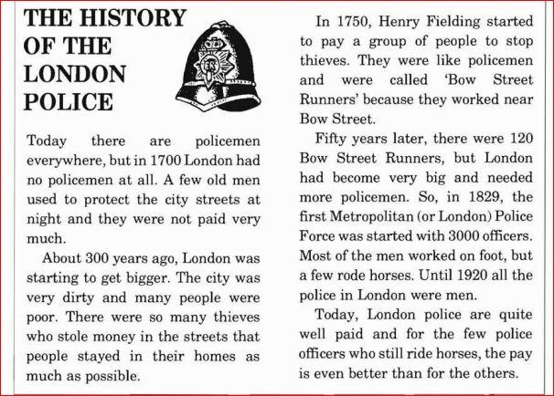

- 300 years ago, many people__________.
A. came to live in London. B. wanted to leave London. C. had big houses in London.
- People did not leave their houses because__________.
A. the city was not clean. B. they had no money. C. they were afraid.
- In 1800, there were__________.
A. enough policemen. B. not enough policemen. C. too many policemen.
- Of the first 3000 Metropolitan policemen, __________.
Chỉ 100k/12 tháng, bạn tải rất nhiều tài liệu tiếng anh file word hay tại: Giaoandethitienganh.info Mong bạn ghé ủng hộ !
A. all of them rode horses. B. some of them rode horses. C. most of them rode horses.

III. MATCHING. Look at the notice (1-5) and choose the letters (A – E). Indicating the sentence that best fits each the notices. The first one has been done as an example. Write your answers in the box provided. (1m)
All flights half price
(weekdays only).

2

Bookshop
Closed afternoons

1

3

OPEN DAILY 10-6 (except Mondays)

4

LEFT LUGGAGE
open 24 hours

SORRY !
CASH ONLY

5

A. You can shop here six days a week.
B. You can leave your suitcase here.
C. We are only open in the morning.
D. For cheaper tickets, travel from Monday to Friday. E. . You can’t pay by cheque.

 | 1. C
 | 2.
Answers | 3.
 | 4.
 | 5.

C. PART 3: COMMUNICATION SKILLS (0,5m)
- The librarian: Will you be quiet, boys? Tim and Jack: ……………………..
A. No, that’s OK. B. You are welcome.
C. It’s very nice of you to say so. D. Yes, of course. We’re sorry.
- Rearrange the sentences to make a dialogue. Choose the best answer.
a. Besides, doing chores together can actually be fun and it makes the work go faster.
b. Dear Mike, I hope you are well! I've been thinking about why it's important for children to help with housework.
c. It's a good way for families to spend time together and learn new skills.
d. Firstly, it teaches us responsibility and how to take care of our own things.
e. Also, when we help our parents, it shows them respect and gratitude for all they do for us.
f. Best wishes.
A. d-b-a-c-f-e B. b-d-e-a-c-f
C. b-d-e-a-c-f D. a-d-c-f-b-e

D. WRITING. (2pts)
1. Complete each of the following sentences so that it is closest in meaning to the original one.
- “What should I do to stop arguing with my sister?” Linh wondered.
Linh wondered …………………………………………………………………………..
- Mr.Brown's team has lost the game. He looks very sad.
Mr. Brown whose ………………………………………………….looks very sad.
2. Complete each of the following sentences so that it Is closest in meaning to the original one. Use the word given in brackets.
- They were late because the traffic was heavy. ( BECAUSE OF)
………………………………………………………………………………………….
- My mum just went to the store, and then she returned home. (BACK)
My mum ………………………………………………………………………………
The end
Chỉ 100k/12 tháng, bạn tải rất nhiều tài liệu tiếng anh file word hay tại: Giaoandethitienganh.info Mong bạn ghé ủng hộ !

