School: ……………………………………….. | Date:……………………………………..
Class: ……………………………..................... | Period: 4

UNIT 1: FREE TIME
Lesson 1.3 – Pronunciation & Speaking, pages 6 & 7
1. Objectives
By the end of this lesson, students will be able to…
1.1. Language knowledge/ skills
- practice the pronunciation of "s" which can sound like /s/ or /z/
- talk about leisure activities, likes / dislikes using verbs expressing preference + gerunds
1.2. Competencies
- improve Ss’ communication, collaboration, analytical, critical thinking skills.
1.3. Attributes
- have healthy lifestyles.
- spend free time in a good way.
2. Teaching aids and materials
- Teacher’s aids: Student’s book and Teacher’s book, class CDs, DCR– Phần mềm tương tác trực quan, DHA – Ứng dụng trò chơi tương tác, projector / interactive whiteboard /TV (if any), PowerPoint slides.
- Students’ aids: Student’s book, Workbook, Notebook.
3. Assessment Evidence
Performance Tasks | Performance Products | Assessment Tools
- Listen and write "/s/" or "/z/" after each word.  - Read the words to your partner.  - Ask and answer using the pictures and prompts.  - Ask your friends about their preferred activities and complete the survey. | - Ss’ answers.  - Ss’ answers.  - Ss’ answers.  - Ss’ answers. | - Observation.  - Observation.  - Observation.  - Observation.
4. Procedures
A. Warm up: 5’
a. Objective: to review lesson 1.2 and lead in the new lesson.
b. Content: speaking activity.
c. Expected outcomes: Ss can ask and answer about hobbies.
d. Organization
Teacher’s activities | Students’ activities
Speaking activity.  -Ask Ss to work in groups of four, taking turns asking to complete the table below:  Student 1 Student 2 Student 3  Like  Love  Prefer  Hate  -Pick some Ss to report the result of their group. | -Ask their friends to complete the table.  Suggested answer:  Student 1 Student 2 Student 3  Like Painting … …  Love Singing … …  Prefer Swimming … …  Hate Cooking … …  -Report the result of their group.
B. New lesson (35’)
1. Pronunciation: 15’
a. Objective: to help Ss know when the final sound /s/ is pronounced /s/ or /z/.
b. Content: tasks a, b, c & d.
c. Expected outcomes: Ss can pronounce the final sound /s/ correctly
d. Organization
Teacher’s activities | Students’ activities
Presentation:  Task a:  - Tell Ss that at the end of words, "s" can sound like /s/ or /z/.  - Give some examples:  /s/ /z/  Likes, hates Loves, prefers  Task b:  - Ask Ss to listen to the words and focus on  the underlined letters (using the DCR/PPT slides).  sports, books, games, friends  -Ask Ss to figure out the rules of pronouncing the final sound /s/.  - Check Ss’ answers.  Practice  Task c: Listen and write "/s/" or "/z/" after each word.  girls __ arts __ prefers __ lots __ enjoys __  - Ask Ss to listen and write "/s/" or "/z/" after each word.  - Pick some Ss to give the answers and explain.  - Check their answers.  - Get Ss to listen again and repeat.  Task d: Read the words to your partner using the sounds noted in "a."  - Ask Ss to work in pairs, reading the words to their partners with the correct pronunciation.  - Pick some students to say the words and correct their pronunciation if necessary. | - Listen and take notes.  -Listen and take notes.  Answer Keys:  /s/ /z/  When the words end with /p/, /k/, /t/. When the words end with other sounds.  - Listen and write "/s/" or "/z/" after each word.  - Give their answer.  Answer Keys:  girls /z/ arts /s/ prefers /z/ lots /s/ enjoys /z/  -Listen again and repeat.  -Work in pairs, reading the words to their partners with the correct pronunciation of final sound /s/.
2. Speaking: 20’
a. Objectives: to help Ss practice talking about hobbies.
b. Content: task a, task b
c. Expected outcomes: Ss can make a survey about popular free time activities.
d. Organization:
Teacher’s activities | Students’ activities
Task a: Your local youth center wants to find out what activities are popular. Complete the survey with your own information. In fours: Ask your friends about their preferred activities and complete the survey.  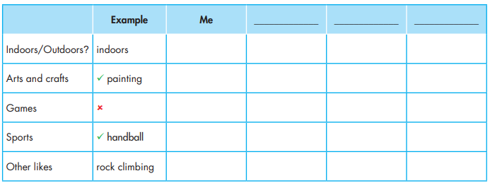  - Introduce the task.  - Give Ss some time to complete the “Me” column with their own information.  - Divide the class in groups of four.  - Ask Ss to ask the friends in their group to get information to complete the survey.  - Go around and help if necessary.  - Pick some Ss to present the result. | - Complete the “Me” column with their own information.  - Ask the friends in their group and complete the survey.  - Share the result of their group.
Task b: Which activities should your youth center have next summer?  - Ask Ss to discuss in their group and decide activities the youth center should have next summer. (based on the survey results of the whole class)  - Pick some Ss to share their ideas.  - Give feedback. | -Discuss in their group and decide activities the youth center should have next summer.  -Share their ideas.

C. Consolidation and homework assignments: 5’
- Pronunciation: the final sound /s/
- Prepare the next lesson: Lesson 2.1 – Vocab & Listening, pages 8 & 9

5. Reflection

a. What I liked most about this lesson today:
…………………………………………………………………………………………
b. What I learned from this lesson today:
…………………………………………………………………………………………
c. What I should improve for this lesson next time:
…………………………………………………………………………………………

