Thời gian làm bài: 40 phút (Không kể thời gian giao đề)
-------------------------
Họ tên thí sinh: .................................................................
Số báo danh: ......................................................................
Mã Đề: 034.
Câu 1. What is the main purpose of Sophie's message to Anna?
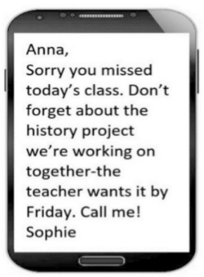
A. To invite Anna to a history class B. To remind Anna about a project deadline
C. To ask Anna to call the teacher D. To scold Anna for missing class
Câu 2. Who should students contact if they have lost their phone?
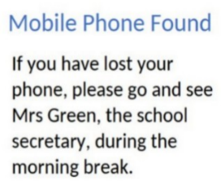
A. Mrs Green B. The janitor C. Their teacher D. The principal
Câu 3. Look at the signs. Choose the best answer for the question.
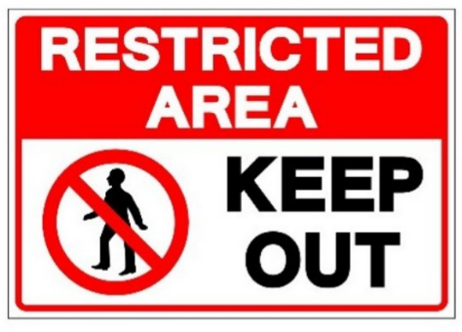
A. People aren’t allowed to enter this area. B. This area is kept open.
C. We should keep this area out. D. This area is open to everyone.
Câu 4. What is true about this notice?
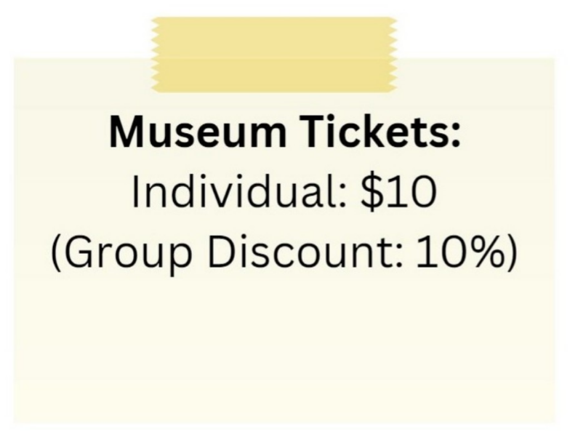
A. There is no group discount available.
B. The group discount is 20%.
C. The individual ticket price is $5.
D. The individual ticket price is $10 and there is a 10% group discount.
Câu 5. Look at the signs. Choose the best answer for the question.
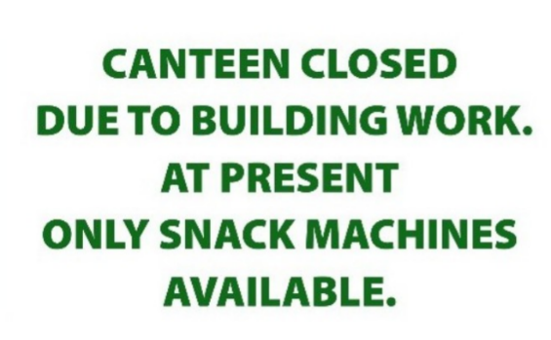
A. Students have to stop buying food till the canteen is opened.
B. Students can only buy food from the snack machines.
C. Students can’t buy snacks because the machines are closed.
D. Students can’t buy food until the snack machines are fixed.
Câu 6. Look at the signs. Choose the best answer for the question.
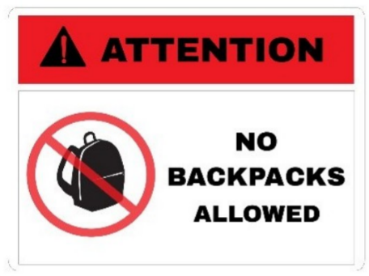
A. You shouldn’t carry a backpack when you’re in this area.
B. You cannot bring your backpacks into this area.
C. You must pay attention when you bring a backpack.
D. Backpacks are not allowed in this area without your attention.
Câu 7. What is true about the Tanzania advertisement?
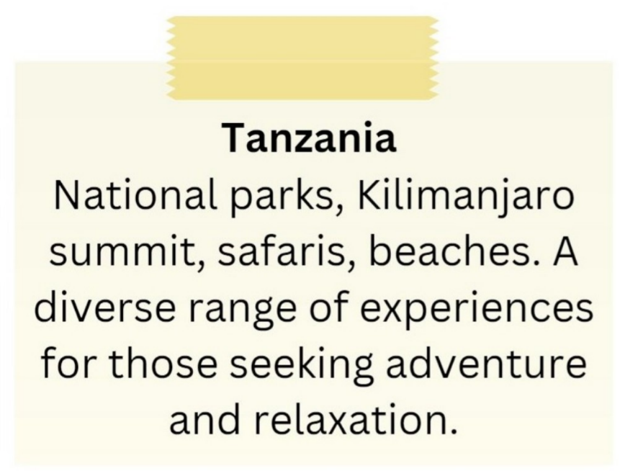
A. It features Kilimanjaro summit and safaris.
B. It promotes a single national park as the main attraction.
C. It is focused solely on relaxation.
D. It excludes beach-related experiences.
Câu 8. What activity is being proposed in the message?
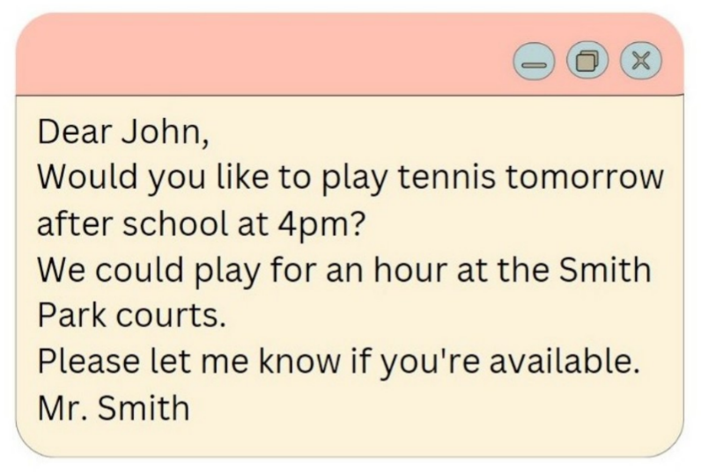
A. Going swimming B. Playing basketball C. Playing tennis D. Going for a run
Câu 9. Which of the following statements is true?
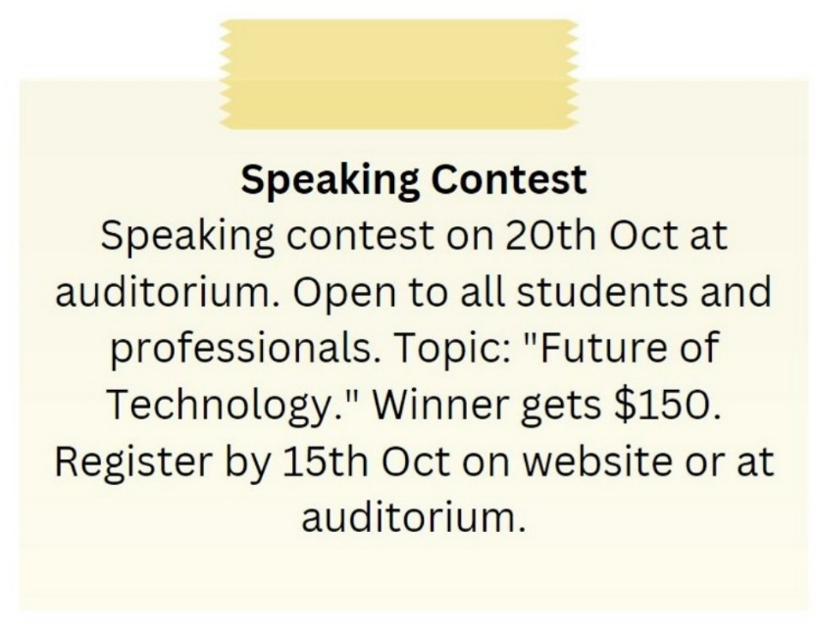
A. The winner of the speaking contest gets $100.
B. The speaking contest is on 15th October.
C. The speaking contest is only open to students.
D. The topic of the speaking contest is "Future of Technology."
Câu 10. What does this sign mean?
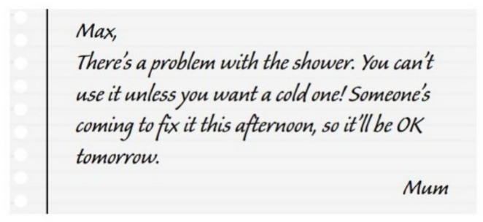
A. Someone helped Max fix the shower. B. Max can only have hot shower tomorrow.
C. Mum needs Max to fix the shower. D. Max can take a hot shower now.
----HẾT---

