|  |  |
| --- | --- |
| **School: ………………………………………..** | **Date: …………………………………..** |
| **Class: …………………………….....................** | **Period: ………………………….........** |

**UNIT 5: FOOD and DRINKS**

**Lesson 3.2 – Speaking and Writing (Page 43)**

**I. OBJECTIVES**

By the end of the lesson, Ss will be able to:

**1.1. Language knowledge and skills**

- know format of writing food blog posts.

- talk about local dishes.

- write a food blog post.

**1.2. Competences**

- improve communication, collaboration, writing and critical thinking skills.

**1.3. Attributes**

- choose healthy food for meals.

- respect the culture and customs of their locals.

**II. TEACHING AIDS AND LEARNING MATERIALS**

**1. Teacher’s aids:** Student book and Teacher’s book, class CDs, Digital Book (DCR phần mềm tương tác SB, DHA (từ vựng/ cấu trúc) phần mềm trò chơi tương tác), projector/interactive whiteboard / TV (if any), PowerPoint slides, handouts.

**2. Students’ aids:** Student’s book, workbook, notebook.

**III. ASSESSMENT EVIDENCE**

|  |  |  |
| --- | --- | --- |
| **Performance Tasks** | **Performance Products** | **Assessment Tools** |
| - **Speaking:** Look at the pictures. Can you buy these dishes in your hometown? Would you like to try them? Why (not)? Is your hometown famous for any other dishes? Which ones? | **-** Ss’ answers / presentation. | - T’s feedback/Peers’ feedback. |
| **-** Choose one of the foods in the pictures or your own idea, then make notes. | - Ss’ answers. | - T’s feedback/Peers’ feedback. |
| - **Writing:** Read about writing food blog posts. Then, read Long's blog and circle the six points listed below. | - Ss’ answers. | - T’s feedback/Peers’ feedback. |
| - Number the sentences (1–6). Use the skill box to help you. | - Ss’ answers. | - T’s feedback/Peers’ feedback. |
| - Now, write a food blog post using the information above or your own ideas. Write 60 to 80 words. | - Ss’ answers. | - T’s observation and feedback. |

**IV. PROCEDURES**

**A. Warm up: (5’)**

**a) Objective:** Introduce the new lesson and set the scene for Ss to acquire new language; get students' attention at the beginning of the class by enjoyable and short activities as well as to engage them in the follow-up steps.

**b) Content:** Review old vocabulary.

**c) Expected outcomes:** Ss know about the topic that they are going to talk and write about in new the lesson.

**d) Organization of the activity:**

|  |  |
| --- | --- |
| **TEACHER’S ACTIVITIES** | **STUDENTS’ ACTIVITIES** |
| **Option 1: Fill in the blanks.**  - Have Ss work in pairs to fill in the blanks, using the words from the box. (T may use handouts or show the exercise on the screen).  - Have Ss give answers.  - Give feedback and evaluation.  - Lead to the new lesson.     * **Option 2: Kim’s Game**   - Have Ss close all books and notebooks.  - Show pictures of unusual dishes and things relating to cooking, have Ss see them in 30 seconds and try to remember all.  - After 30 seconds, call Ss to list what they have seen.  - Check Ss’ answers, give feedback and evaluation.  - Lead to the new lesson. | - Work in pairs: fill in the blanks.  - Give answers.  - Listen.  **Answer keys**  *1 chef*  *2 insects*  *3 fry*  *4 tasty*  *5 crunchy*  - Close all books and notebooks.  - Look and remember.  - Read answers.  - Listen. |

**B. New lesson (35’)**

* **Activity 1: Pre-Writing (Speaking) (8’)**

**a) Objective:** Ss prepare for what they are going to write about.

**b) Content:**

**-** Speaking: Look at the pictures. Can you buy these dishes in your hometown? Would you like to try them? Why (not)? Is your hometown famous for any other dishes? Which ones?

**-** Choose one of the foods in the pictures or your own idea, then make notes.

**c) Expected outcomes:** Ss have more ideas and language for their writing.

**d) Organization of the activity:**

|  |  |
| --- | --- |
| **TEACHER’S ACTIVITIES** | **STUDENTS’ ACTIVITIES** |
| **Task a. In pairs: Look at the pictures. Can you buy these dishes in your hometown? Would you like to try them? Why (not)? Is your hometown famous for any other dishes? Which ones?**  **-** Divide the class into pairs.  - Have students discuss in pairs using the questions.  - Go round and support Ss if necessary.  - Have some students share their ideas with the class.  - Give feedback and evaluation.  **Task b. Choose one of the foods in the pictures or your own idea, then make notes.**  - Have students look at the pictures, choose one of them or use their own dishes to make notes:    - Go round and give help if necessary.  - Have Ss exchange their answers.  - Have some pairs read their answers.  - Give feedback and evaluation. | - Work in pairs.  - Present.  - Look and make notes.  - Exchange.  - Present. |

* **Activity 2: While - Writing (22’)**

**a) Objective:** Students can develop their writing skill.

**b) Content:**  - Read about writing food blog posts. Then, read Long's blog and circle the six points listed below.

- Number the sentences (1–6). Use the skill box to help you.

- Now, write a food blog post using the information above or your own ideas. Write 60 to 80 words.

**c) Expected outcomes:** Students can write a food blog post, using right format and rich vocabularies.

**d) Organization of the activity:**

|  |  |
| --- | --- |
| **TEACHER’S ACTIVITIES** | **STUDENTS’ ACTIVITIES** |
| **Task a. Read about writing food blog posts. Then, read Long's blog and circle the six points listed below.**  -Briefly explain the Writing skill box and have some Ss read it aloud.  - Have Ss read Long’s blog again (page 42) and circle the six points listed in the writing box.  - Have Ss check their answers with a partner.  - Call Ss to give answers.  - Check the answers as a whole class using DCR.  **Task b. Number the sentences (1–6). Use the skill box to help you.**  - Have students read the prompts.  - Have students number the sentences (1–6), using the skill box to help.  - Have students check their answers with a partner.  - Check the answers as a whole class using DCR.  **\*Let’s Write: Now, write a food blog post using the information above or your own ideas. Write 60 to 80 words.**  - Draw Ss’ attention to the feedback form.  - Have Ss use their notes in speaking part and the instruction in the Writing box to write a food blog post.  - Go round, observe and give help if necessary.  - Have some Ss write their email on the board. | - Listen.  -Work in pairs.  - Exchange their answers with a partner.  - Give answers.  **Answer keys**    - Read the prompts and number the sentences (1–6).  - Exchange answers.  - Read answers.  **Answer keys**      - Look and listen.  - Do the writing part.  -Write. |

* **Activity 3: Post - Writing (5’)**

**a) Objective:** Help Ss realize their mistakes in writing and correct them.

**b) Content:**  Correcting Ss’ writings**.**

**c) Expected outcomes:** Students know whether their writings follow the model and use the correct structures and language, whether their writings are interesting and understandable or not.

**d) Organization of the activity:**

|  |  |
| --- | --- |
| **TEACHER’S ACTIVITIES** | **STUDENTS’ ACTIVITIES** |
| - Give feedback, correct Ss’ mistakes.  - Use the feedback form to give evaluation. Focus on:  + the format, the structures  + the understandability  + the coherence and cohesion  + the spelling | - Look, listen and correct mistakes.  **Suggested writing**  *You'll Love Grilled Frog! In Ho Chi Minh City, it's common to see people eat ếch nướng. It's a frog and we usually grill it on a barbecue. We cook the whole frog, and eat it with fried rice. It tastes like a mix of chicken and fish. The meat is soft and it's healthy, too. If you come to Ho Chi Minh City, you have to try it!* |

**C. Consolidation and homework assignments (5’)**

**\* Consolidation:**

**- Writing Skill**:

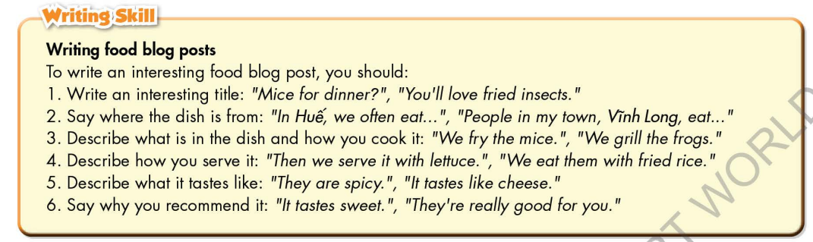

**\* Homework**

- Remember how to write a food blog post.

- Finish the writing part.

- Do the exercises in WB: Writing (page 31).

- Complete the grammar notes in Tiếng Anh 7 i-Learn Smart World Notebook (page 33).

- Play consolation games in Tiếng Anh 7 i-Learn Smart World DHA App on [www.eduhome.com.vn](http://www.eduhome.com.vn)

- Prepare: Unit 5 – Review pages 94, 95.

**D. Reflection**

a. What I liked most about this lesson today:

…………………………………………………………………………………………

1. What I learned from this lesson today:

…………………………………………………………………………………………

c. What I should improve for this lesson next time:

…………………………………………………………………………………………