Tiếng Anh 7 – i-LEARN SMART WORLD

UNIT 10 TEST
Note: Each correct answer earns 0.2 points.

I. PRONUNCIATION (0.8 points)
A. Choose the word whose underlined part is pronounced differently.
1. A. sources B. types C. advantages D. exercises
2. A. turbine B. nuclear C. useful D. future
B. Choose the word that has a different stressed syllable from the rest.
3. A. power B. thirty C. easy D. thirteen
4. A. energy B. dangerous C. expensive D. microwave

II. VOCABULARY AND GRAMMAR (2.4 points)
Choose the best option (A, B, C or D) to complete each of the following questions.
5. __________ uses moving water to produce electricity.
A. Solar power B. Wind power C. Hydropower D. Natural power
6. Solar power seems like a great future source of energy, __________ it has some disadvantages. For example, it doesn’t work at night.
A. and B. but C. so D. because
7. Energy __________ are various in Vietnam, ranging from coal, oil, natural gas, hydropower and renewable energy.
A. power B. uses C. plants D. sources
8. Denmark gets twenty percent of its electricity __________ wind power.
A. from B. with C. in D. by
9. They are building a nuclear __________ near my town.
A. factory B. station C. power plant D. industry
10. In Vietnam, hydropower is one of the largest sources of renewable energy. It _________ about 40% of the total national energy resources.
A. uses B. provides C. has D. creates
11. Vietnam’s largest wind power plant with 45 _________ is in central Ninh Thuận Province.
A. wheels B. engines C. panels D. turbines
12. People are now trying to lead a greener way of life by using __________ coal and oil.
A. less B. more C. most D. fewer
13. On 14th August, a fishing boat sank off the west side of San Juan Island, sending heavy black __________ flowing into the sea and destroying the marine life.
A. coal B. gas C. oil D. energy
14. Person A: What is a disadvantage of wind power?
Person B: _________
A. Wind power is clean to run.
B. Wind turbines are cheaper.
C. Wind power produces more energy.
D. Wind turbines can harm wildlife such as birds and bats.
15. What does this sign mean?
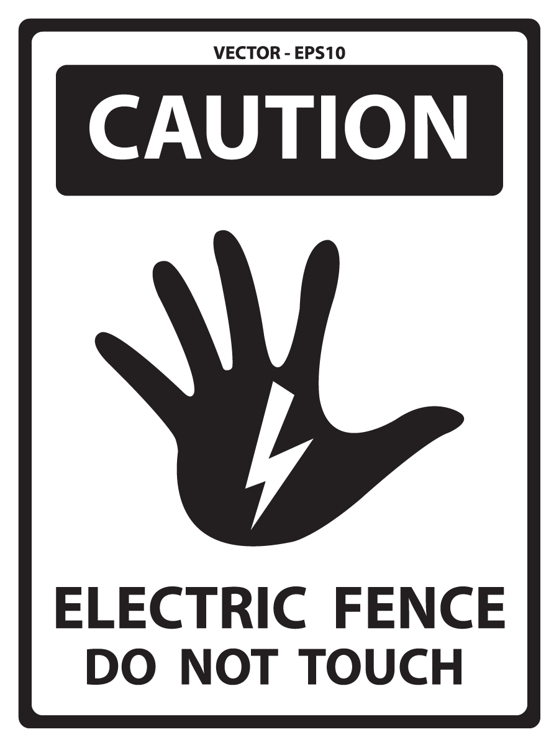 | A. You can’t touch the electricity on the fence.  B. You don’t touch the fence, so it is electric.  C. You mustn’t touch the fence because it has electricity.  D. Touching the fence causes electricity, so don’t do it.

16. What does this sign mean?
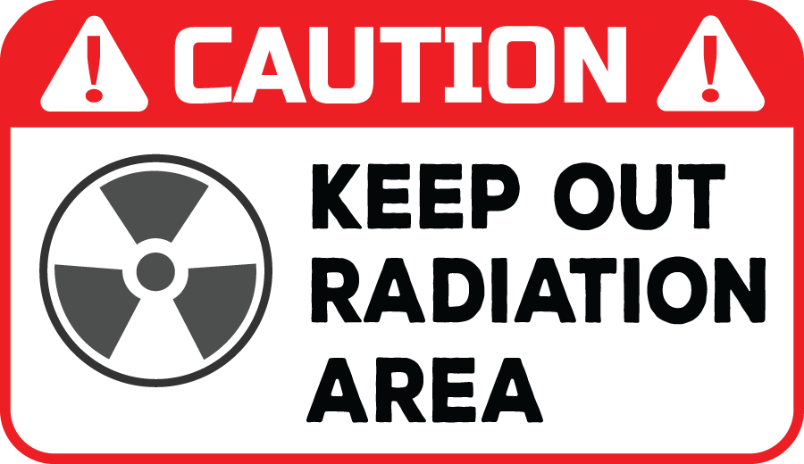 | A. You can’t enter this area because the level of radiation can be dangerous.  B. You can’t keep radiation out of this area because it’s dangerous.  C. This area is dangerous because people keep the radiation out.  D. You should be careful when you keep out of the radiation.

III. WORD FORMATION (1.2 points)
Write the correct form of the words in brackets.

Today, we get a lot of energy from fossil fuels: coal, oil, and (17) __________ gas. But when we burn fossil fuels, they cause air (18) __________, and they are (19) __________. This means they will not last forever. In the long term, we will have to find alternative sources of energy. (20) __________ energy uses panels to catch sunlight and convert it into electricity. However, it doesn’t work at night and needs a lot of space. Wind power is another type of (21) __________ energy source. It’s cheap and produces clean energy, but wind turbines can be (22) __________ and some people think they look ugly. | (NATURE)  (POLLUTE)  (NEW)  (SUN)  (RENEW)  (NOISE)

IV. LISTENING (2 points)
A. You will listen to a conversation. For each question, complete the notes with NO MORE THAN TWO WORDS.

In this interview, Mr. Stark explains the difference between renewable and non-renewable (23)______________. He says renewables can be used again and again like the (24)___________ or the sun, and non-renewables like coal or (25)____________ have limited resources and can be used only once. Because of this, Chris suggests we build more wind turbines and (26)_______________. Mr. Stark agreed and said renewables also cause (27)_________ pollution and are better for the environment.

B. You will listen to a conversation. For each question, circle the correct option A, B, C, or D.

28. What can cause water pollution on the beach?
A. natural gas B. oil C. coal D. smoke

29. How can natural gas make it rain more?
A. by polluting the ocean B. it makes the planet colder
C. it blows through the city C. by warming the planet

30. What causes air pollution that can blow through the city and hurt someone's throat?
A. burning coal B. solar power C. oil spill D. renewable energy

31. Which renewable energy sources pollute less than non-renewable energy sources?
A. coal power, solar power, hydropower B. solar power, oil power, hydropower
C. wind power, oil power, solar power D. wind power, solar power, hydropower

32. What is the topic of the conversation?
A. oil, natural gas, and coal are a renewable energy source
B. natural gas causes the planet to warm
C. oil, natural gas, and coal pollute the community
D. oil pollution can be found on the beach

V. READING (2 points)
A. Read the following passage. For each question, circle the correct option A, B, C, or D that best suits each blank.

Dear Mayor Glenn,
This email is about the advantages of new renewable energy sources. As you may know, 80% of the electricity for the town comes from the coal plant, which is the cause of (33)______in the city. After researching new technologies, I suggest the city develop more renewable sources like (34)_____, wind, and nuclear power. Progress in the last couple of years has made renewables better energy sources than non-renewables like coal and gas. For example, solar panels have become less (35)______ than coal, cheap to build, and cleaner for the environment. (36)______ have gotten larger, make less noise, and produce more energy with less wind. Nuclear power can sometimes be (37)______, but it’s cheap to run.

33. A. expense B. pollution C. weather D. noise
34. A. solar B. oil C. gas D. coal
35. A. advantage B. noise C. expensive D. dangerous
36. A. Nuclear B. Solar panels C. Hydropower D. Wind turbines
37. A. safe B. dangerous C. advantage D. expensive

B. Read the following passage. For each question, write T if the statement is TRUE and F if it is FALSE.

Dear Mayor Khan,
My name is Henry. I recently visited your city, London, England, and I would like you to know how surprised I was at how clean and beautiful the city has become. On my last visit twenty years ago, the pollution was so terrible I had to stay inside the hotel during the day, and I could not exercise in the park. Now, the air is cleaner and easier to breathe. It was also great to see the dirty coal plant replaced with solar panels and wind turbines. I read in the newspaper that the city now gets 60% of its energy from renewable energy sources and will add another 20% by 2030. These changes make London more eco-friendly, and visitors like me notice the difference. My only suggestion to make the city more eco-friendly would be to reduce the use of natural gas for cooking.

38. Henry was surprised at how clean and beautiful London became after 20 years. ____
39. On Henry’s last visit to the city, the pollution was so terrible he could only go outside during the day. ____
40. London replaced the coal plant with solar panels and wind turbines. ____
41. By 2030, the city will get 60% of its energy from renewable energy sources. ____
42. Henry suggested the city should add more renewable energy like natural gas. ____

VI. WRITING (1.6 points)
A. Rewrite the following sentences without changing their meaning.
43. I’m going to buy a hybrid car because it doesn’t use as much gas as other cars.
→ I’m going to buy a hybrid car because it uses .
44. China is the largest producer of wind power in the world.
→ China produces than any other countries in the world.
45. Although solar panels are quite expensive to install, you’ll save money on electricity in the end. (BUT)
→ .
B. Combine the following sentences using “and” or “but”.
46. This backpack has small solar panels on it. You can actually use them to charge your phone.
→ .
47. Nuclear power is a clean and efficient way of producing electricity. It may be dangerous.
→ .
C. Use the information in the table and write sentences with the given words or phrases.

Vietnam Energy Sources

 | 2020 | 2021
Coal | 49.72% | 49.67%
Oil | 23.61% | 21.66%
Hydropower | 16.43% | 16.55%
Natural gas | 7.54% | 5.94%
Solar | 2.43% | 5.62%
Wind | 0.24% | 0.52%

48. In 2020 / Vietnam / get / energy / solar power / 2021.
→
49. Natural gas / produce / energy / in 2020 / 2021.
→
50. Vietnam / get / energy / from / coal / other energy sources.
→

***End – Of – Test***

