UNIT 1: MY NEW SCHOOL

Lesson 1: Getting started – A special day

I. Objectives
By the end of this lesson, students will be able to gain:

1. Knowledge
- An overview about the topic My new school
- Vocabulary to talk about school things

2. Core competence
- Develop communication skills and creativity
- Be collaborative and supportive in pair work and team work
- Actively join in class activities

3. Personal qualities
- Be ready to make new friends at school
- Develop self-study skills

II. Materials
- Grade 6 textbook, Unit 1, Getting started
- Computer connected to the internet
- Projector/ TV/ pictures and cards
- hoclieu.vn

Language analysis
Form | Pronunciation | Meaning | Vietnamese equivalent
1. subject (n) | /ˈsʌbdʒekt/ | the thing that is being studied | môn học
2. uniform (n) | /ˈjuːnɪfɔːm/ | a set of clothes that has to be worn by the members of the same group of people | đồng phục
3. calculator (n) | /ˈkælkjəleɪtər/ | an electronic device used for  mathematical processes | máy tính (cầm tay)

Anticipated difficulties | Solutions
Students may lack experience of group/ team work. | - Encourage students to work in groups so that they can help each other.  - Give short, clear instructions and help if necessary.

Board Plan
Date of teaching
Unit 1: My new school
Lesson 1: Getting started

* Warm-up
Memorising game
I. Vocabulary
- subject (n)
- uniform (n)
- calculator (n)
II. Practice
Task 1: Listen and read.
Task 2: Read the conversation again and tick (✔) T (True) or F (False).
Task 3: Write one word from the box in each gap.
Task 4: Match the words with the school things. Then listen and repeat.
Task 5: Write names of the things you can see around the class in your
notebook.
* Homework

Procedures

Stage | Stage aim | Procedure | Interaction | Time
Warm-up | - To activate  students’ knowledge on the topic of the unit.  - To set the  context for the listening and reading part.  - To enhance students’ skills of cooperating with team mates. | * Memorising game:  - Teacher divides the class into 2 teams.  - Teacher asks students to close the books, shows the picture (pages 6 and 7) and asks them to memorise every detail in the picture in 1 minute.  - Teacher hides the pictures and asks questions about the picture. The team who has more correct answers is the winner.  1. How many people can you see in the picture?  2. Who are they?  3. Where are they?  4. What are the two  students carrying on their backs?  5. Where are they going to go?  Suggested answers:  1. I can see three people.  2. They are students.  3. They are at one of the boys’ homes.  4. They are carrying school bags/  backpacks.  5. They are going to go to school.  - Teacher sets the context for the listening and reading text: Write the title on the board A special day. Explain the meaning of special and ask students to guess what the conversation might be about. | Team work | 5 mins
Presentation  (Vocab –  pre-teach) | - To provide  students with  vocabulary.  - To help students be well-prepared for the listening and reading tasks. | VOCABULARY  Teacher introduces the vocabulary by:  - giving explanations;  - showing the pictures  illustrating the words.  1. subjects (n) [explanations]  2. uniform (n) [picture]  3. calculator (n) [picture] | T-Ss | 5 mins
Practice | - To have  students get to know the topic.  - To have students get specific information about the text.  - To check  students understand the conversation and help students use the words in context.  - To help students get further comprehension of the text.  - To provide students with vocabulary.  - To check students’ vocabulary and improve group work skills. | Task 1: Listen and read.  - Teacher plays the recording twice.  - Students listen and read.  - Teacher checks students’ predictions.  - Teacher calls 3 students to read the conversation aloud.  Task 2: Read the  conversation again and tick (✔) T (True) or F (False).  - Teacher tells students to read the conversation again and work independently to find the answers. Remind students to underline the information and correct the false statements.  - Teacher has a student pair compare before checking with the whole class.  - Teacher calls some students to give the answers.  Answer key:  1. T  2. F  3. T  4. T  5. F  Task 3: Write one word from the box in each gap.  - Teacher has students read the conversation again, and work independently to put a suitable word from the box to fill in the gap.  - Teacher calls one student to share his/ her answer on the board.  - Teacher asks students to look at the board, check their mates’  answers.  Answer key:  1. wear  2. has  3. go  4. uniforms  5. subjects  Task 4: Match the words with the school things. Then listen and repeat.  *Pelmanism  - Teacher divides the class into 2 teams.  - Teacher put two sets of cards, one includes pictures of school things and the other includes their names. Members from two teams take turns and match the names with the correct pictures as fast as possible. The team matched faster and correctly is the winner.  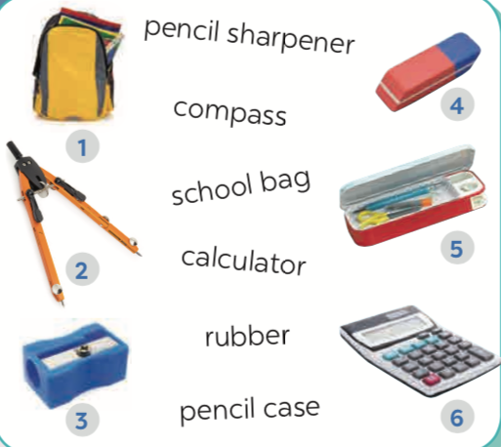  Task 5: Write names of the things you can see around the class in your notebook.  - Students work in groups of four to look around the class and write down things they can see in the class.  - Students may ask the teacher if they don’t know the names of the items.  - Students share with the whole class. | T-Ss  T-Ss  Ss-Ss  T-Ss  S  T-Ss  Ss-Ss  T-Ss  Ss-Ss  Group work | 5 mins  7 mins  5 mins  7  mins  6 mins
Wrap-up | To consolidate what students have learnt in the lesson. | Teacher asks students to talk about what they have learnt in the lesson. | T-Ss | 3 mins
Homework | To review the  lesson and  prepare for the next lesson. | - Do exercises in the workbook.  - Think of activities students can do at school. | T-Ss | 2 mins

UNIT 1: MY NEW SCHOOL

Lesson 2: A closer look 1

I. Objectives
By the end of this lesson, students will be able to:

1. Knowledge
- Use the lexical items related to the topic My new school;
- Use the combinations: to study, to have, to do, to play + N;
- Pronounce correctly the sounds /ɑː/ and /ʌ/.

2. Core competence
- Be collaborative and supportive in pair work and team work
- Access and consolidate information from a variety of sources
- Actively join in class activities

3. Personal qualities
- Be ready to join some school activities.
- Develop self-study skills

II. Materials
- Grade 6 textbook, Unit 1, A closer look 1
- Computer connected to the internet
- Projector/ TV/ pictures and cards
- hoclieu.vn

Language analysis
Form | Pronunciation | Meaning | Vietnamese equivalent
1. science (n) | /ˈsaɪəns/ | a particular subject that is studied using scientific methods. | khoa học
2. exercise (n/v) | /ˈeksəsaɪz/ | physical activity that you do to make your body strong and healthy. | Bài tập/ tập thể dục

Anticipated difficulties | Solutions
- Students may have difficulties in distinguishing two sounds /ɑː/ and /ʌ/. | Provide students some tips by identifying the letters that may include each sound.
- Some students will excessively talk in the class. | - Define expectation in explicit detail. Have excessive talking students practise.  - Continue to define expectations in small chunks (before every activity).

Board Plan

Date of teaching
Unit 1: My new school
Lesson 2: A closer look 1
* Warm-up
Game: Hot seat
I. Vocabulary
1. science (n)
2. exercise (n/v)
Task 1: Listen and repeat the words.
Task 2: Put the words in the correct columns.
Task 3: Put the words in the blanks.
II. Pronunciation
Task 4: Listen and repeat. Pay attention to the sounds /ɑː/ and /ʌ/.
Task 5: Listen and repeat. Underline the words with the sounds /ɑː/ and /ʌ/.
III. Production
Game: Who is faster?
* Homework

Procedures

Stage | Stage aim | Procedure | Interaction | Time
Warm-up | - To activate  students’ prior knowledge and vocabulary related to the topic.  - To enhance students’ skills of cooperating with team mates. | * Game: Hot seat  - Teacher divides students into 2 teams.  Each team has a member standing against the board.  - Teacher shows pictures of some activities one by one and other members use body language to let their team members guess the names of the activities.  - The team with the most correct answers in the fastest time is the winner.  Answer key:  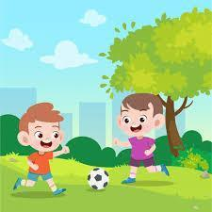  play football    listen to music  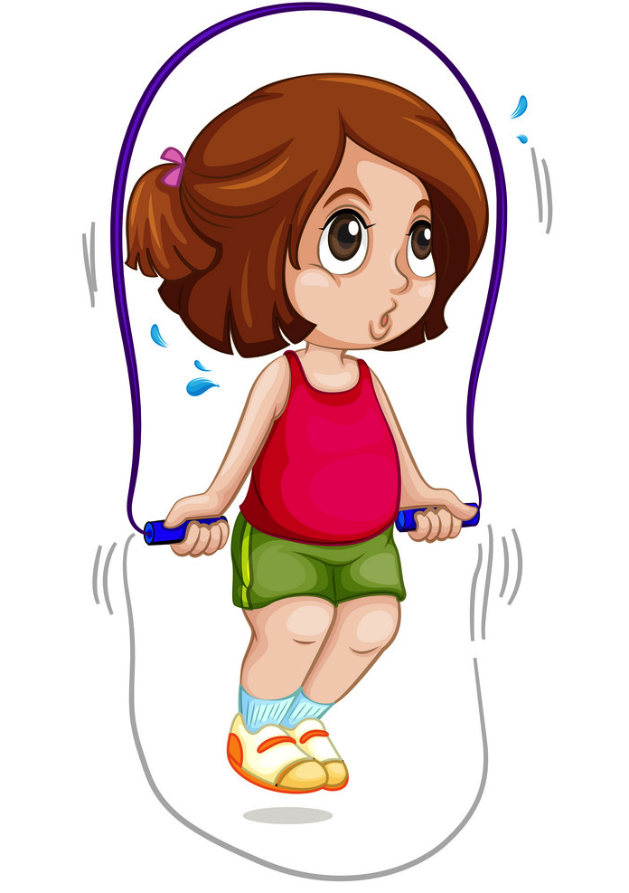  skip rope    drink water  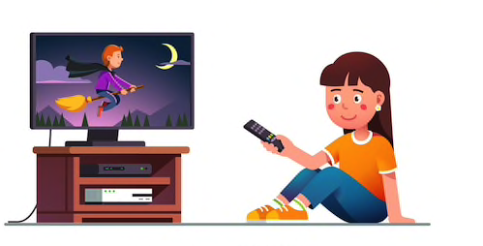  watch TV    play video games | Team work | 5 mins
Presentation  (Vocab –  pre-teach) | To enrich  students’  vocabulary. | VOCABULARY  - Teacher introduces the vocabulary by:  + providing explanations of the words;  + showing picture  illustrating the word.  - science (n) [picture]  2. exercise (n/v)  [explanation] | T-Ss | 3 mins
Practice | To teach  students some activities they can do at school.  To help students identify which nouns go after which verbs to make names of school activities.  To help students use the  vocabulary in context. | Task 1: Listen and repeat the words.  - Teacher asks students to listen and repeat the words.  - Teacher calls some students to read the words aloud.  Task 2: Work in pairs. Put the words in Task 1 in the correct columns.  - Teacher asks students to work in pairs and use the words in Task 1 to put them into the correct columns.  - Students work in pairs and do the task.  - Teacher calls some pairs to share their answers with the whole class.  - Teacher gives feedback and corrections (if  necessary).  Answer key:  play do  football music homework exercise  have study  school lunch lessons English history science  - Teacher explains which nouns go with each verb to make meaningful names of activities.  - Teacher asks students to work in groups of four and add as many words into each column as possible.  Task 3: Put the words in the blanks.  - Teacher asks students to work independently and put a suitable word in each blank.  - Teacher allows students to share their answers before discussing as a class.  - Teacher asks some students to share the answers and gives feedback.  Answer key:  - homework  - football  - lessons  - exercise  - science | T-Ss  Pair work  T-Ss  S  Ss-Ss  T-Ss | 16 mins
Presentation  (Pre-teach the sounds /ɑː/ and /ʌ/) | To help students have concept and identify the sounds /ɑː/ and /ʌ/. | PRONUNCIATION  - Teacher introduces 2 sounds /ɑː/ and /ʌ/ to students and lets them watch a video about how to pronounce these two sounds.  https://www.youtube.com/watch?v=1F47WdIjn5U  https://www.youtube.com/watch?v=zUpF0pYoTZ8  - Teacher asks students to give some words they know containing these sounds.  Suggested answers:  - /ɑː/: car, start, after, party  - /ʌ/: cut, one, country  - Teacher draws students’ attention to the letters containing the sounds and helps them identify the sounds. | T- Ss | 5 mins
Practice | To help students identify and practise the /ɑː/ and /ʌ/ sounds.  To help students practise the sounds /ɑː/ and /ʌ/ in sentences. | Task 4: Listen and repeat. Pay attention to the sounds /ɑː/ and /ʌ/.  - Teacher asks students to listen and repeat.  - Students work independently.  Task 5: Listen and repeat. Underline the words with the sounds /ɑː/ and /ʌ/.  - Before listening, teacher let students  discuss in pairs and find the words with the sounds /ɑː/ and /ʌ/.  - Teacher plays the recording for students to check and repeat the sentences. | T-Ss  Pair work  T- Ss | 6 mins
Production | To give students a chance to  apply what they have learnt. | * Game: Who is faster?  - Teacher divides students into groups of four, gives each group a piece of paper, asks them to write sentences including 2 features: school activities and one of the sounds /ɑː/ or /ʌ/.  (e.g: I usually play basketball with my brother.)  - Teacher asks each group to hand in their paper and checks, the group with more  correcting sentences is the winner.  - Teacher invites the winner to read aloud their sentences. | Group work | 5 mins
Wrap-up | To consolidate what students have learnt in the lesson. | Teacher asks students to talk about what they have learnt in the lesson. | T-Ss | 3 mins
Homework | To revise what they have learnt. | - Rewrite the sentences into notebooks.  - Find 3 more school activities that have the sound /ɑː/ or /ʌ/. | T-Ss | 2 mins

UNIT 1: MY NEW SCHOOL
Lesson 3: A closer look 2

The present simple

I. Objectives
By the end of this lesson, students will be able to:

1. Knowledge
- Use the present simple tense

2. Core competence
- Develop communication skills
- Be collaborative and supportive in pair work and team work
- Actively join in class activities

3. Personal qualities
- Exchange personal information with friends and be friendly at school.
- Develop self-study skills

II. Materials
- Grade 6 textbook, Unit 1, A closer look 2
- Computer connected to the internet
- Projector/ TV/ pictures and cards
- hoclieu.vn

Language analysis
Form | Example
S + Vinf/ V(s/es) + … . | I usually go to school by bike.
S + don’t/ doesn’t + Vinf + … . | She doesn’t like school lunch very much.
Do/ Does + S + Vinf + … ? | Do they live near here?
W/H + do/does + S + Vinf + … ? | What do you often do after school?

Anticipated difficulties | Solutions
1. Students may find it confusing when to use the present simple tense. | Give short and clear explanations with legible examples for each case.
2. Students may have  underdeveloped speaking and co-operating skills. | - Give clear instructions, give examples before letting students work in groups.  - Provide feedback and help if necessary.

Board Plan
Date of teaching
Unit 1: My new school
Lesson 3: A closer look 2
* Warm-up
Game: Sentence puzzling
I. Grammar focus
1. Present simple tense
Task 1: Elicit the present simple tense
Task 2: Choose the correct answer A, B or C. (Ex. 1, p. 9)
Task 3: Write the correct form of verbs (Ex. 2, p. 9)
2. Adverbs of frequency
Task 4: Fill the blanks with usually, sometimes or never. (Ex. 3, p. 10)
II. Practice
Task 5: Choose the correct answer A or B to complete the sentences.
(Ex. 4, p. 10)
III. Production
Task 6: Work in pairs. Make questions then interview your partner. (Ex. 5, p. 10)
* Homework

Procedures

Stage | Stage aim | Procedure | Interaction | Time
Warm-up | - To activate  students’ prior knowledge  related to the targeted  grammar of  present simple tense.  - To increase  students’  interest.  - To enhance students’ skills of cooperating with team mates. | * Game: Sentence puzzling  - Teacher divides the class into 4 groups.  - Teacher delivers a set of word cards which are jumbled sentences in present simple to each group.  - Students will have to work in groups to create as many correct sentences from the word cards as possible.  - The group with the most correct sentences will be the winner.  Suggested sentences:  1. Peter lives near  his school.  2. We go to  the same school.  3. They have new  subjects.  4. We always look  smart in our uniforms. | Group work | 5 mins
Lead in | To introduce the targeted grammar of the present simple tense. | - Teacher draws students’ attention to the form of the sentences created in the game and asks them whether they know the target tense. | T-Ss | 2 mins
Presentation | - To have students get to know about the present simple tense.  To help students understand the use of the present simple tense.  - To check students’ understanding of the present simple tense  To have them use the grammar in context.  To lead in and activate student’s knowledge on adverbs of frequency.  - To provide  students the adverbs of  frequency, and help them  understand the difference in frequency of the adverbs.  - To have the students use the adverbs of frequency in context. | 1. THE PRESENT SIMPLE TENSE  Task 1: Elicit the present simple tense.  - Teacher provides or confirms the answers and leads in the grammar focus of the lesson:  Positive  S + Vinf/ V(s/es) + … .  Negative  S + don’t/ doesn’t + Vinf + … .  Interrogative  Do/ Does + S + Vinf  + … ?  Answer  Yes, S + do/does.  No, S + don’t/ doesn’t.  W/H questions  W/H + do/does + S + Vinf + … ?  Notes  Use do/don’t with: I, you, we, they and singular noun forms.  Use does/ doesn’t with: she, he, it and plural noun forms.  -- Teacher gives students some time to study the grammar box.  Task 2: Choose the correct answer A, B or C.  - Teacher has students work independently, look at the form and do Exercise 1 – page 9.  - Teacher lets students work in pairs and exchange the answers before checking with the whole class (explain each sentence if necessary).  Answer key:  1. A  2. C  3. B  4. A  5. C  Task 3: Write the correct form of the verbs.  - Teacher asks students to work independently.  - Teacher calls 1 or 2 students to write their answers on the board, checks their answers sentence by sentence.  Answer key:  - has  - Do you have  - like  - Does Vy walk  - ride  - go  2. ADVERBS OF FREQUENCY  - Teacher asks students to read the sentences in Exercise 2 - page 9 again and asks them when to use the present simple tense, drawing their attention to the adverbs of frequency.  We often ride our  bicycles to school.  Task 4: Fill the blanks with sometimes, usually or never.  - Teacher shows the graph and lets students fill in the blanks with suitable adverbs of  frequency: sometimes, usually or never  (Exercise 3 – page 10)  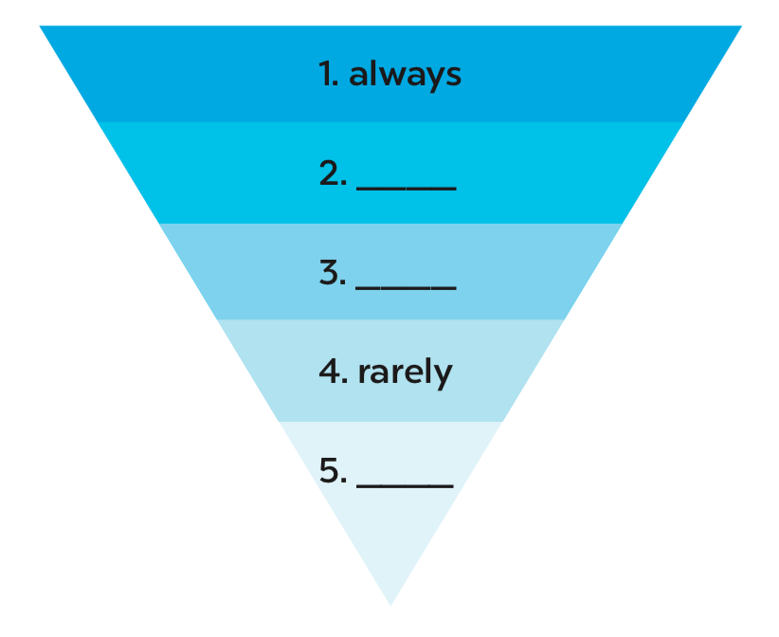  Answer key:  2. usually  3. sometimes  5. never  - Teacher lets students work in groups of four to make 5 sentences using the 5 adverbs of frequency above.  - Teacher calls some groups to read aloud the answers and gives feedback. | T-Ss  S  Pair work  S  T-Ss  T-Ss  T-Ss | 22 mins
Practice | To give students opportunities to use the present simple tense with adverbs of frequency correctly in context. | Task 5: Choose the  correct answer A or B to complete each sentence.  - Teacher has students complete Exercise 4 – page 10 independently.  - Teacher then asks students to exchange their textbooks to check their friends’ answers.  Answer key:  1. B 2. A 3. A 4. B 5. A | S  Ss-Ss | 4 mins
Production | To help  students distinguish and use correctly the present simple tense.  - To improve cooperative skills. | Task 6: Work in pairs. Make questions then interview your partner.  - Teacher has students work on Ex. 5, p. 10 in pairs.  - Teacher checks the answers by playing a game. Teacher divides students into 2 teams, 2 students in each team choose a set of questions (which are the questions 1-5 in Ex. 5, p. 10). T may add more questions if necessary) then interview each other. The team with the higher score is the winner.  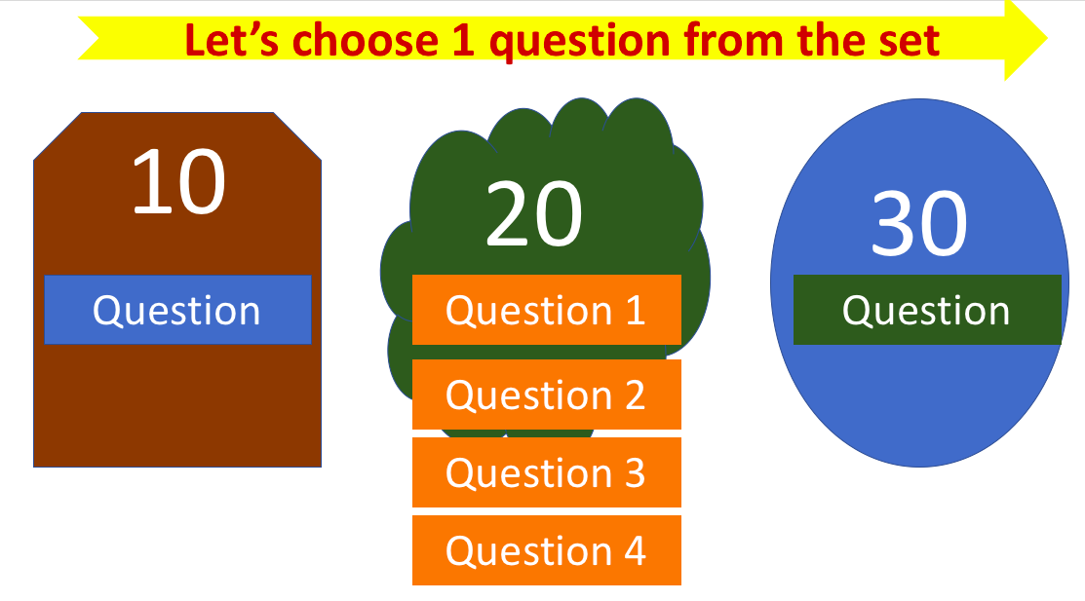  10 points: you/ like/ your new school  20 points:  Question 1: you/ often/ ride your bicycle/ to school  Question 2: you/ sometimes/ study in the school library  Question 3: your friends/ always/ go to school/ with you  Question 4: you/ usually/ do homework/ after school  30 points: How often/ your mother/ pick you up/ school  Answer key:  - Do you like your new school?  - Do you often ride your bicycle to school?  - Do you sometimes study in the school library?  - Do your friends usually go to school with you?  - Do you usually do your homework after school?  - How often does your mother pick you up from school? | Pair work  Team work | 7 mins
Wrap-up | To consolidate what students have learnt in the lesson. | Teacher asks students to talk about what they have learnt in the lesson. | T-Ss | 3 mins
Homework | To review the knowledge that students have gained in this lesson. | Make 5 sentences in the present simple tense,  using adverbs of frequency. | T-Ss | 1 min

UNIT 1: MY NEW SCHOOL

Lesson 4: Communication

I. Objectives
By the end of this lesson, students will be able to:

1. Knowledge
- Use the lexical items related to the topic My new school
- Know how to introduce someone
- Ask appropriate questions when making friends at school, know what good qualities a good friend should have

2. Core competence
- Develop creativity and communication skills
- Be collaborative and supportive in pair work and team work
- Actively join in class activities

3. Personal qualities
- Be ready to introduce someone.
- Understand more about good qualities of a good friend and try to be a good friend.

II. Materials
- Grade 6 textbook, Unit 1, Communication
- Computer connected to the internet
- Projector/ TV/ pictures and cards
- hoclieu.vn

Language analysis
Form | Pronunciation | Meaning | Vietnamese equivalent
1. classmate (n) | /ˈklɑːsmeɪt/ | someone who is in the same class with you at school | bạn cùng lớp
2. share (v) | /ʃeər/ | to divide food, money, goods and give parts of it to someone else | chia sẻ

Anticipated difficulties | Solutions
1. Students may have  underdeveloped speaking and  co-operating skills. | - Encourage students to work in pairs, in groups so that they can help each other.  - Provide feedback and help if necessary.
2. Some students will excessively talk in the class. | - Define expectation in explicit detail.  - Have excessive talking students practise.  - Continue to define expectations in small chunks (before every activity).

Board Plan
Date of teaching
Unit 1: My new school
Lesson 4: Communication
* Warm-up
Game: Who knows more?
I. Everyday English
1. Vocabulary
share (v)
classmate (n)
2. Introducing someone
This is … .
Nice to meet/ see you.
Nice to meet/ see you, too.
Task 1: Listen and read the dialogue.
Task 2: Work in groups. Practice introducing a friend to someone.
II. New friends at school
Task 3: Read and tick the questions you think are suitable to ask a new friend at school.
Task 4: Friendship quiz.
III. Producton
Task 5: Work in groups. Take turns to interview the others, use the questions above.
* Homework

Procedures

Stage | Stage aim | Procedure | Interaction | Time
Warm-up | - To introduce the topic.  - To enhance students’ skills of cooperating with team mates. | * Who knows more?  - Teacher divides the class into 2 teams.  - Teacher shows pictures of some famous pairs of friends around the world, asks students to name them.  - The team that gives more correct names is the winner.    Tom and Jerry    Woody and Buzz    Lisa and Rose    Spongebob and Patrick    Harry Potter and Hermione Granger    Leonardo DiCaprio and Tobey Maguire | Team work | 5 mins
Lead-in | To lead in the targeted  vocabulary and  pronunciation. | Teacher leads students into the lesson by telling about what they are going to learn:  Are people above good friends? Why?  Let’s find out what makes a good friend in our lesson today. | T-Ss | 2 mins
* EVERYDAY ENGLISH
Presentation | To prepare students with vocabulary.  To introduce the structure of introducing someone. | 1. PRE-TEACH VOCABULARY:  - Teacher introduces the vocabulary by:  + giving situation;  + giving an explanation.  1. share (v) [situation]: What action can you say when you give your food to poor children?  2. classmate (n) [explanation]: What word can you use to say about people who are in the same class with you?  2. SENTENCE STRUCTURE:  INTRODUCING SOMEONE  Task 1: Listen and read the dialogue. (Ex. 1, p. 11)  - Teacher lets students listen and read the dialogue, asks them what the characters say when they first meet someone.  - Teacher calls some students to share their opinions.  - Teacher gives more explanations and writes down the structure of introducing someone.  This is … .  Nice to meet/ see you.  Nice to meet/ see you, too. | T-Ss  T-Ss | 3 mins  4 mins
Practice | To practice the structure of  introducing someone. | Task 2: Work in groups. Practice introducing a friend to someone.  - Teacher asks students to work in groups of four, introducing themselves to the group members, using structures above.  - Teacher calls some students to introduce their new friends to the whole class.  - Teacher gives feedback and corrections (if necessary). | Group work  T-Ss | 5 mins
* NEW FRIENDS AT SCHOOL
Practice | To identify questions people should ask when they first meet.  To identify qualities of a good friend. | Task 3: Read and tick the questions you think are suitable to ask a new friend at school.  - Teacher has students discuss in groups of four, then asks them to add 2 more questions to the list.  - Teacher checks with the whole class.  Task 4: Friendship quiz.  Students work independently and do the quiz in Ex. 4, p. 11. | Group work  T-Ss  S | 14 mins
Production | To apply the knowledge they have learnt in this lesson. | Task 5: Work in groups. Take turns to interview the others, use the  questions above.  - Teacher ask students to move to places of classmates they haven’t got acquainted yet, form a new group and  interview the new mates, then give feedback on their mates.  - Teacher calls some groups to make models. | Group work | 8 mins
Wrap-up | To consolidate what students have learnt in the lesson. | Teacher asks students to talk about what they have learnt in the lesson. | T-Ss | 3 mins
Homework | To review what students have learnt in the lesson. | Write down the results and feedback of the previous interviews. | T-Ss | 1 min

UNIT 1: MY NEW SCHOOL

Lesson 5: Skills 1

I. Objectives
By the end of this lesson, students will be able to:

1. Knowledge
- Develop reading skill for general and specific information about schools
- Talk about different types of school
- Talk about things they like and don’t like at school and the reasons for that

2. Core competence
- Develop communication skills and creativity
- Be collaborative and supportive in pair work and team work
- Develop presentation skill
- Actively join in class activities

3. Personal qualities
- Understand more about their preference of different types of schools and show their love for the school.
- Develop self-study skills

II. Materials
- Grade 6 textbook, Unit 1, Skills 1
- Computer connected to the internet
- Projector/ TV/ pictures and cards
- hoclieu.vn

Language analysis
Form | Pronunciation | Meaning | Vietnamese equivalent
- international (adj) | /ˌɪntəˈnæʃən.əl/ | involving more than one country | quốc tế
- boarding school (n) | /ˈbɔːdɪŋ ˌskuːl/ | a school where  students live and study | trường nội trú
- playground (n) | /ˈpleɪɡraʊnd/ | an area designed for children to play outside | sân chơi

Anticipated difficulties | Solutions
1. Students may lack knowledge about some  lexical items. | Provide students with the meaning and  pronunciation of words.
2. Students may have  underdeveloped reading, speaking and co-operating skills. | - Let students read the text again (if needed).  - Create a comfortable and encouraging environment for students to speak.  - Encourage students to work in pairs, in groups so that they can help each other.  - Provide feedback and help if necessary.
3. Some students will excessively talk in the class. | - Define expectation in explicit detail.  - Have excessive talking students practise.  - Continue to define expectations in small chunks (before every activity).

Board Plan
Date of teaching
Unit 1: My new school
Lesson 5: Skills 1
* Warm-up
Game: Lucky number
I. Reading
Task 1: Look at the picture and quickly read the passages. Match 1-3 with A-C.
Vocabulary
- boarding school (n)
- playground (n)
- international (adj)
Task 2: Read the passages again and complete the sentences.
Task 3: Answer the questions.
II. Speaking
Task 4: Which school in Exercise 1 would you like to go to? Why/ Why not? Complete the table.
Task 5: Discuss your choice with your friends.
* Homework

Procedures

Stage | Stage aim | Procedure | Interaction | Time
Warm-up | - To introduce the topic of reading.  - To enhance students’ skills of cooperating with team mates. | * Game: Lucky number  - Class is divided into 2 groups.  - Teacher prepares 7 numbers which includes 5 questions about their school, and 2 lucky numbers.  - Each team takes turns and chooses a number and answers the question behind the number. If the team answers the question correctly, they will get 1 point. If the team chooses the lucky number, they get 1 point without answering the question and may choose another number.  Suggested questions:  1. How many classes are there in our school?  2. Do students have to wear uniforms when they go to school?  3. How many computer rooms does our school have?  4. Name some clubs in our school.  5. When was our school established? | Team work | 5 mins
Pre-Reading | To lead in the reading skills. | Teacher leads students into the lesson by  showing pictures of 3 schools Sunrise, An Son and Dream and asks them some questions:  - What can you see in these pictures?  - Are these schools in the same place?  - Which school do you think is in Viet Nam?  Suggested answers:  - I can see three different schools.  - No, they aren’t.  - The second school. | T-Ss | 4 mins
While-  Reading | To develop  reading skill for general  information.  To provide  students with some lexical items before reading the text.  To develop  reading skill for specific  information.  To identify  different  features of each school. | Task 1: Look at the  picture and quickly read the passages. Match 1-3 with A-C.  - Teacher asks students to open the book, read through the text and do Ex. 1 – p. 12.  - Teacher calls some students to give the answer, explaining which sentence gives them the information.  Answer key:  1. C  2. A  3. B  VOCABULARY  Teacher asks students to get the meaning of the words boarding school, international and playground in  context.  - boarding school (n) [explanation]  - playground (n)  [visual]  - international (adj) [explanation]  Task 2: Read the  passages again and complete the  sentences.  - Teacher asks students to read through the sentences, predict what information/ what types of words they have to fill in the blanks.  - T lets students work independently and find the correct answer.  - Teacher lets students pair up before checking with the whole class.  Answer key:  - boarding  - Sydney  - mountains and green fields  - Dream School  - English-speaking teachers  Task 3: Answer the questions.  - Teacher asks students to read the questions and underline key words, and reminds them to focus on the types of information they have to find (What/ Where/ Which school…).  - Teacher asks students to work in pairs and find the answer.  - Teacher calls a student to write his/her answer on the board, then checks sentence by sentence with the class.  Suggested answers:  - Sunrise is a boarding school.  - An Son School is in Bac Giang.  - Yes, there is.  - They join many interesting clubs. | T- Ss  T- Ss  T-Ss  S  Pair work  T-Ss  Pair work  T-Ss | 15 mins
Pre-Speaking | To help students form the ideas for their speaking. | Task 4: Which school in Exercise 1 would you like to go to? Why/ Why not? Complete the table.  - Teacher asks students to work independently and complete the table.  - Teacher goes around and offers help if needed. | T-S | 5 mins
While-  Speaking | To help students use what they have learnt so far to talk about a school. | Task 5: Discuss your choice with your friends.  - Teacher tells students to work in groups of four and share the answer, reminding them to take note of the information from other members.  - Teacher invites some students to share their preparation and makes sure they speak in full  sentences.  - Students share their ideas with the whole class. | Group work | 8 mins
Post-Reading and Speaking | To help students improve next time.  - Check students’ understanding about the reading passage.  - To help some students enhance their presentation skills. | - T allows students to give comments for their friends and vote for the most interesting and informative presentation.  - Teacher gives feedback and comments. | Ss-Ss  T-Ss | 3 mins
Wrap-up | To consolidate what students have learnt in the lesson. | T asks students to talk about what they have learnt in the  lesson. | T-Ss | 2 mins
Homework | To review the lesson they have learnt and  prepare for the next lesson Skills 2. | - T asks students to write down their opinion about a school in their books.  - Teacher asks students to search for information about their school. | T-Ss | 2 mins

UNIT 1: MY NEW SCHOOL

Lesson 6: Skills 2

I. Objectives
By the end of this lesson, students will be able to:

1. Knowledge
- Use the lexical items related to the topic My new school
- Listen for specific information about school activities
- Write a passage about their new school

2. Core competence
- Develop communication skills and creativity
- Be collaborative and supportive in pair work and team work
- Actively join in class activities

3. Personal qualities
- Grow more feelings about friends and school
- Be encouraged to attend school activities.

II. Materials
- Grade 6 textbook, Unit 1, Skills 2
- Computer connected to the internet
- Projector/ TV/ pictures and cards
- hoclieu.vn

Anticipated difficulties | Solutions
1. Students may have  underdeveloped listening skills. | - Play the recording many times if necessary.  - Encourage students to work in pairs, in groups so that they can help each other.  - Provide feedback and help if necessary.
2. Some students will excessively talk in the class. | - Define expectation in explicit detail.  - Have excessive talking with students.  - Continue to define expectations in small chunks (before every activity).

Board Plan
Date of teaching
Unit 1: My new school
Lesson 6: Skills 2
* Warm-up
Crossword puzzle
I. Listening
Task 1: Guess the answers to the following questions.
Task 2: Listen again and choose the correct answer A or B.
II. Writing
Task 3: Write the answers to the following questions about your school.
Task 4: Use the answer in Task 3 to write a paragraph of 40-50 words about your school. You can refer to the reading passages to help you.
* Homework

Procedures

Stage | Stage aim | Procedure | Interaction | Time
Warm-up | - Check students’ vocabulary from previous lessons.  - To introduce the topic of listening.  - To set the context for the listening part. | *Crossword Puzzle  Teacher divides the class into 2 teams. Each team takes turns to choose a  crossword, reads the clues and solves the puzzle.  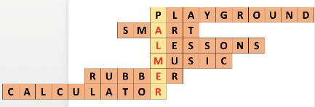  - This is an area designed for children to play outside, especially at school or in a park.  - This is an adjective used to describe people who have a clean, tidy and stylish appearance.  - Complete the following sentence with a suitable word:  Mrs Nguyen teaches all my history _____.  - What is this subject? – [visuals]  - What is this school thing? – [visuals]  - This is a small electronic device that is used for calculations. | Team work | 5 mins
Lead in | To lead in the listening tasks. | Teacher draws students’ attention to the word PALMER – the name of a school in America, letting them know they are going to listen to Janet, a student from Palmer school. | T-Ss | 1 min
Pre-Listening | To help students brainstorm and have an overview about what they are going to listen to. | Task 1: Guess the answer to the following questions.  - Do you think the students there wear uniforms?  - Do they learn Vietnamese as a foreign language?  - Teacher lets students work in pairs and discuss the questions. Encourage them to speak English and feel free to make guesses.  - Teacher plays the recording once. Students listen to check their guesses.  Suggested answers:  - Yes, they do.  - Yes, they do. | T-Ss  Pair work | 4 mins
While-Listening | To help  students  develop  listening skill for specific  information. | Task 2: Listen again and choose the correct answer A or B.  * Read and find the key words  Teacher asks students to read the statements,  underline the key words, reminds them to pay  attention to keywords while listening.  * Listen and choose the correct answer  - Teacher plays the recording.  - Teacher asks students to listen and choose the answers.  - Teacher asks students to compare their  answer with the partner.  - Teacher calls on some students to write their answers on the board, then play the recording once again and check with the class.  Answer key:  - A  - B  - B  - A  - A  Audio script:  Hi. My name’s Janet. I’m eleven years old. I’m now in year 6 at Palmer School. I like it here.  My classmates are friendly. The teachers at my school are nice and very helpful, and my favourite teacher is Mrs. Smith. She teaches us maths. I have two hours to study Vietnamese every week. I usually do my homework in the library. We wear our uniforms every day, but today we aren’t. We’re going to have a biology lesson on a farm. | T-Ss  Ss-Ss  T-Ss | 10 mins
Post-Listening | To check  students’  understanding of the listening part. | * Summarize the  information of the  listening part.  - Students work in groups of four.  - Teacher asks students to summarize the  information in the listening part and talk about it.  - Teacher helps if necessary. | Group work | 5 mins
Pre-Writing | - To help students have information about their school.  - To help  students write simple sentences for the next  writing passage. | Task 3: Write the  answers to the following questions about your school.  - Teacher asks students to work independently to answer the questions.  - Teacher encourages students to write in full sentences and tells them that their  sentences must be grammatically and logically correct with the right choice of words and correct punctuation.  - Teacher allows students to look back at the reading passages.  - Teacher asks students to compare their answers.  - Teacher invites one or two students to write their answers on the board and gives feedback as models. | S  Pair work  T-Ss | 5 mins
While-Writing | To let students learn and help each other write a complete passage about their school. | Task 4: Use the answer in Task 3 to write a paragraph of 40-50 words about your school. You can refer to the reading passages to help you.  - Teacher asks students to work in groups of four, gives them a large piece of paper and asks them to write the full paragraph into the paper in 6 minutes.  - T asks students to pay attention to punctuation, structures, word choice, linking words, etc. | Group work | 8 mins
Post-Writing | To cross check and final check students’  writing. | - Teacher has the groups swap and give feedback on each other’s writing.  - Teacher then gives feedback on one writing as a model. | Group work | 4 mins
Wrap-up | To consolidate what students have learnt in the lesson. | Teacher asks students to talk about what they have learnt in the lesson. | T-Ss | 2 mins
Homework | To allow  students  finalize their versions after being checked by friends and teacher. | - Rewrite the paragraph in the notebooks.  - Prepare for the project. | T-Ss | 1 min

UNIT 1: MY NEW SCHOOL

Lesson 7: Looking back & Project

I. Objectives
By the end of this lesson, students will be able to:

1. Knowledge
- Review the vocabulary and grammar of Unit 1
- Apply what they have learnt (vocabulary and grammar) into practice through a project

2. Core competence
- Develop communication skills and creativity
- Develop presentation skill
- Develop critical thinking skill
- Be collaborative and supportive in pair work and team work
- Actively join in class activities

3. Personal qualities
- Be more creative when doing the project
- Develop self-study skills

II. Materials
- Grade 6 textbook, Unit 1, Looking back & Project
- Computer connected to the internet
- Pictures, A0 paper
- Projector/ TV
- hoclieu.vn

Anticipated difficulties | Solutions
1. Students may have underdeveloped speaking, writing and co-operating skills when doing the project. | - Encourage students to work in pairs, in groups so that they can help each other.  - Provide feedback and help if necessary.
2. Some students will excessively talk in the class. | - Define expectation in explicit detail.  - Have excessive talking with students.  - Continue to define expectations in small chunks (before every activity).

Board Plan
Date of teaching
Unit 1: My new school
Lesson 7: Looking back & Project
* Warm-up
Brainstorming: School things
I. Looking back
Task 1: Look at the pictures. Write the correct words in the gaps.
Task 2: Match the words in A with the words/ phrases in B.
Task 3: Complete the sentences with the present simple.
Task 4: Complete the text with the correct form of the verbs in brackets.
Task 5: Put the adverb in brackets in the correct place in each sentence.
II. Project
School Convention
* Homework

Procedures

Stage | Stage aim | Procedure | Interaction | Time
Warm-up | - To revise the vocabulary related to the topic and lead in the next part of the lesson.  - To enhance students’ skills of cooperating with team mates. | * Brainstorming  - Teacher divides the board, and divides the class into 2 teams.  - Members of each team take turns and write as many school things as possible in 2 minutes.  - The group having more correct answers is the winner. | Team work | 3 mins
Looking back | To help students revise school things.  To help  students  revise the combination: to study, to have, to do, to play + N.  To help  students  revise the present  simple tense.  To help  students  revise the  position of adverbs of frequency in context. | Task 1: Look at the pictures. Write the correct words in the gaps.  - Teacher encourages students to complete the task individually.  - Students exchange their textbooks with their partners.  - Teacher gives feedback as a class discussion.  Answer key:  - uniform  - pencil sharpener  - notebook  - compass  - calculator  - ruler  Task 2: Match the words in A with the words/ phrases in B.  - Teacher encourages students to complete the task individually.  - Students exchange their textbooks with their partners.  - Teacher gives feedback as a class discussion.  Answer key:  - e  - d  - b  - a  - c  - Teacher encourages students to provide more school activities.  Task 3: Complete the sentences with the  present simple.  - Teacher has students complete the task individually.  - Students exchange their textbooks and give feedback to each other.  - Teacher gives feedback as a class discussion.  Answer key:  - comes  - don’t  - walks  - do  - teaches  Task 4: Complete the text with the correct form of the verbs in brackets.  - Students work in pairs.  - Teacher asks students to read the sentences carefully and give the answers.  - Students complete the task and discuss the  answers.  - Teacher gives feedback as a class discussion.  Answer key:  - is  - has  - walks  - study  - likes  Task 5: Put the adverb in brackets in the correct place in each sentence.  - Students work in pairs.  - Students complete the task and discuss the  answers.  - Teacher gives feedback as a class discussion.  Answer key:  - I always remember to do my homework.  - Nick usually gets good marks in exams.  - We do not often see a rabbit in town.  - I rarely read in bed at night.  - Do you sometimes sing in the shower? | S  Ss-Ss  T-Ss  S  Ss-Ss  T-Ss  S  Ss-Ss  T-Ss  Pair work  T-Ss  Pair work  T-Ss | 17 mins
Project | To allow students to apply what they have learnt (vocabulary and grammar) into practice through  a project. | * My dream school  - Teacher sets the context of a School Convention that will occur right now in the classroom.  - Teacher divides students into 4 big groups. Each group will act as a representative of a school, come to the convention to introduce and enroll new students.  - Teacher lets the groups discuss and summarise the information and design A0 size posters about their school.  - Teacher asks the class to listen to the reports and ask questions if they would like to.  - Students will critically evaluate all the posters, then give 1 vote for the most attractive poster.  - Teacher gives comments and feedback to all 4 posters and awards a special prize to the group which has the most votes. | T-Ss  Group work  Ss-Ss  T-Ss | 22 mins
Wrap-up | To consolidate what students have learnt in the lesson. | Teacher asks students to talk about what they have learnt in the lesson. | T-Ss | 2 mins
Homework | To prepare for the next lesson. | Prepare for the next lesson: Unit 2 – Lesson 1. Getting started. | T-Ss | 1 min
* Pictures' source: From Internet

