ĐỀ THAM KHẢO TUYỂN SINH 10 – NGUYỄN HUỆ
I. Choose the word / phrase / sentence (A, B, C or D) that best fits the space or best answers the question given in each sentence. (3.5 pts)
1. Which word has the underlined part pronounced differently from that of the others?
A. walked B. involved C. missed D. jumped
2. Which word has the underlined part pronounced differently from that of the others?
A. decide B. leaflet C. deceive D. remind
3. Which word has a different stress pattern from that of the others?
A. interest B. pleasure C. cousin D. disgust
4. Which word has a different stress pattern from that of the others?
A. mention B. belong C. remind D. reduce
5. David: Should we go hiking this weekend ……….. stay home and relax?
Sylvie: Let’s decide based on the weather.
A. or B. but C. and D. though
6. Sylvie: Did you arrive …………… time for the meeting? David: Yes, I was early.
A. by B. in C. on D. at
FB: Thầy Đình (Dạy Tiếng Anh)
7. Sylvie: Where did you leave the book? David: I left it ………… the table in the living room.
A. under B. on C. in D. by
8. Sylvie: Hey David, do you know who comes early every morning to take away all the trash from our neighborhood?
David: Of course, Sylvie! It's the ………..
A. gardener B. mailman C. garbage collector D. electrician
9. Sylvie: The girl ……… dress is red is my cousin. David: She looks very nice.
A. who B. which C. where D. whose
10. Sylvie: Do you think it’s ……. to study English every day if we want to improve quickly?
David: Of course! Regular practice is essential for progress.
A. impossible B. optional C. necessary D. unimportant
11. Sylvie: David, how do you think this situation might ………. to our previous project?
David: Good question, Sylvie. I believe there are some similarities that we should discuss further.
A. react B. involve C. relate D. explain
12. Sylvie: Hi David, I need some help. Do you know who I should call if I have an issue with the wiring in my house?
David: Sure, you should call a(n) ………….. They’re experts at handling electrical issues.
A. plumber B. mechanic C. electrician D. carpenter
13. Sylvie: Do you want to join me for a coffee after work? David: ………….
A. I don’t drink coffee. B. I’d rather go home.
C. Sure, I’d love to! D. Coffee is not my thing.
14. Sylvie: Should we implement stricter rules about littering? David: ………..
A. Absolutely, it’s important for the environment. B. No, people should do as they please.
C. I’m not sure what littering is. D. Let’s think about it next year.

II. Look at the sign or the notice. Choose the best answer (A, B, C or D) for questions 15 and 16. (0.5 pt)
15. What does the sign say?
A. Do not throw trash into the toilet.
B. Flush the toilet after use.
C. Throw all waste into the toilet.
D. This toilet is for trash disposal only.
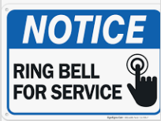
16. What does the sign say?
A. Ring the bell to request assistance.
B. Do not touch the bell.
C. Service is unavailable at the moment.
D. Wait for assistance without ringing the bell.
FB: Thầy Đình (Dạy Tiếng Anh)

III. Choose the word (A, B, C or D) that best fits each space in the following passage. (1.5pts)
Dear Sylvie,
I hope this letter finds you well. These days, electronic devices have become an essential part of our lives. They help us (17) ............... our daily tasks more efficiently. For example, smartphones allow us to connect with friends and family instantly, and laptops are used for studying or working.
However, there are some drawbacks. Spending too (18) ……………….. time on electronic devices can harm our health. For instance, looking at screens for long periods can affect our eyesight.
Another concern is the impact (19) ……………….. the environment. Many old devices are not properly recycled, which leads to electronic waste. People should also consider the quality of the devices they buy. A durable and (20) ……………….. product will last longer and be more useful.
Finally, electronic devices are great for (21) ……………….. . With the right apps and tools, we can improve our knowledge every day.
What do you think about the role of (22) ……………….. devices in our lives? Let me know your thoughts!
Best wishes,
TayDavidlor
17. A. make B. do C. create D. take
18. A. few B. much C. little D. many
19. A. on B. of C. at D. in
20. A. expensive B. reliable C. colorful D. noisy
21. A. learning B. learners C. library D. study
22. A. digital B. mechanic C. automatic D. electronic
IV. Read the following brochure. Decide whether the statements from 23 to 26 are True or False and choose the correct answer (A, B, C or D) to complete the statements in the questions 27 and 28. (1.5 pts)
LIFE IN THE PAST
Introduction:
Have you ever wondered what life was like in the past? The world has changed a lot over the years, and the way people lived many decades ago is very different from today. Let’s take a look back in time and explore how people worked, communicated, and spent their free time.
Life at Work:
In the past, most people worked in farming or small workshops. Machines were rare, so tasks were done by hand. Farmers used simple tools to grow crops, while craftsmen made goods like clothes or furniture without modern technology. Life was harder, but people were often proud of their handmade products.
Communication:
There were no smartphones, emails, or social media. Letters were the main way to stay in touch with others. People wrote letters by hand and sent them through the post. Sometimes, it took weeks for a letter to reach its destination. In emergencies, people used telegraphs, which were faster but expensive.
Free Time:
Without television or the internet, free time was spent differently. Families often gathered to share stories, sing songs, or play traditional games. Reading books or listening to the radio were common forms of entertainment. Outdoor activities like picnics and community festivals also brought people together.
Transport:
Traveling in the past was slower. People mostly walked, rode bicycles, or used horse-drawn carriages. Trains and ships were the fastest forms of transport, but they were not always affordable for everyone. Cars and planes became popular only in the 20th century.
Family and Community Life:
Families were often larger, with many generations living under one roof. Neighbors knew each other well, and communities were very close. People shared resources and helped one another during hard times, creating a strong sense of unity.

23. In the past, people used telegraphs as their main way of communication. …………..
24. Families in the past were usually smaller compared to today. …………..
25. Trains were a faster way to travel than walking or riding a bicycle. …………..
26. Reading books and listening to the radio were common leisure activities. …………..
27. According to this brochure, people in the past …………..
A. Spent most of their free time on social media.
B. Used advanced machines for farming and work.
C. Traveled slower compared to modern times.
D. Often lived in small families with only parents and children.
28. All of the following statements are mentioned in the brochure EXCEPT ……………
A. People in the past sent letters to communicate.
B. Horse-drawn carriages were commonly used for travel.
C. Televisions were a major form of entertainment in the past.
D. Communities in the past were very close and helpful.
V. Use the correct form of the word given in each sentence. (1.5 pts)
29. The hospital staff worked tirelessly to minimize the number of ………….. during the epidemic. (fatal)
30. The artist is known for using ………….. colors in his paintings. (vibrant)
31. Digital piracy continues to pose huge ………….. to the industry. (challenge)
32. The ………….. is the ability to create pictures in your mind; the part of your mind that does this. (imagine)
33. I was a bit ………….. with him. (annoy)
34. I wanted to do well, ………….., but I wasn't nervous because I don't see exams as the be all and end all. (obvious)
FB: Thầy Đình (Dạy Tiếng Anh)
VI. Look at the entry of the word “careful” in a dictionary. Use what you can get from the entry to complete the sentences with two or three words. (0.5 pt)
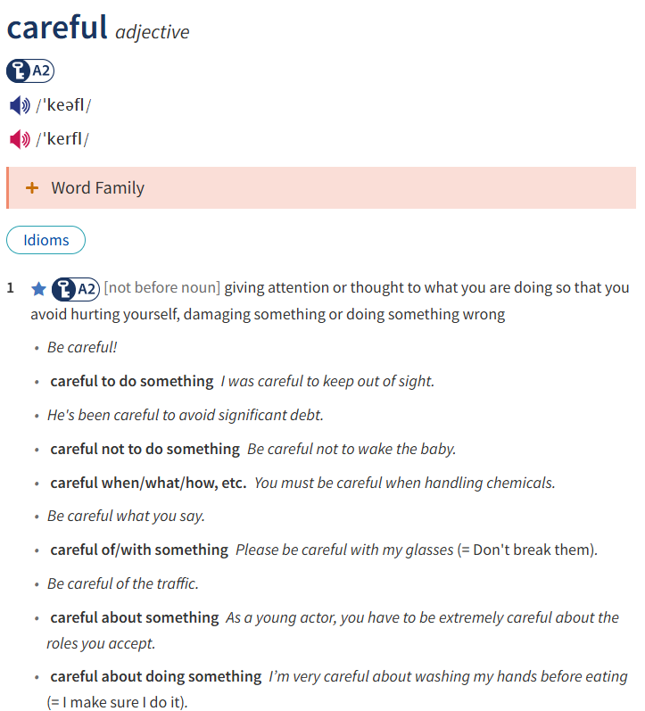
35. He’s been ………….. avoid any significant mistakes during the project.
36. Be ………….. the traffic when crossing the busy street.
VII. Rewrite each of the following sentences in another way so that it means almost the same as the sentence printed before it. (1.0 pt)
37. If you worry less about problems, you’ll feel happier.
=> The less ………………………………………………………………….
38. Many tourists move from one place to another in the city by tram. (“get around”)
=> Many tourists ……………………………………………………………….
39. She doesn’t know how to swim.
=> She wishes …………………………………………………
40. Sylvie started driving 1 month ago.
=> Sylvie has ………………………………………….

