Period
LESSON PLAN
TIẾNG ANH 10 FRIENDS GLOBAL
UNIT 2: ADVENTURE
LESSON 2G: SPEAKING – PHOTO DESCRIPTION
I. OBJECTIVES:
By the end of the lesson, Ss will be able to:
1. Knowledge:
- describe and speculate about a photo
- listen to a candidate in a speaking exam
2. Ability:
- main skills: listening and speaking skills
- sub skills: reading and writing skills
- use a simple structure to describe a photo
3. Quality:
- have positive attitude in English language learning so that they can participate enthusiastically in all classroom activities, especially with the topic conducted by the teacher
- keen on studying English
II. TEACHER AIDS AND LEARNING MATERIALS:
Lesson plan, PPT slides, student’s book, workbook, notebook, personal computer (if any), projector/TV, speakers, IWB software.
III. PROCEDURES:
A. Warm-up (5’)
a) Objective: Introduce the new lesson and set the scene for Ss to acquire new language; get students' attention at the beginning of the class by means of enjoyable and short activities as well as to engage them in the steps that followed.
b) Content: Task 1 page 30.
c) Outcomes: Students can gain more confidence and interest in the lesson.
d) Competence: communication, collaboration, guessing
e) Organisation of the activity:

TEACHER’S ACTIVITIES | STUDENT’S ACTIVITIES | CONTENTS
WARM-UP. T-Ss/ S-S/ Indiv  - Ask students to match two or more of the pieces of equipment below with each photo A-C  - Check answers as a class.  - Make sure students understand what the words mean and how to pronounce them, especially dinghy /ˈdɪŋi/. | - Complete the task.  - Check answers with teacher.  - Understand meanings and pronounce the words properly. | Answers:  A. boots, poles, rucksack  B. helmet, dinghy, life jacket, paddles  C. rope, safety harness  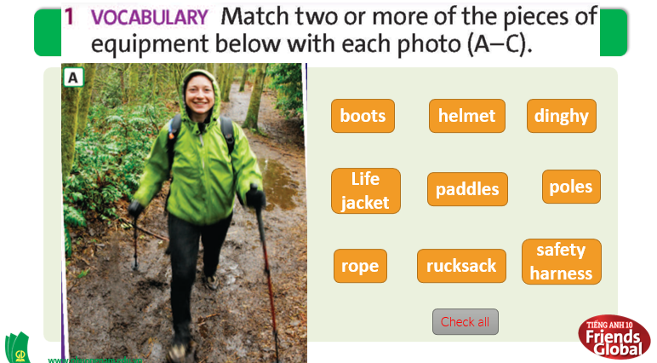

B. New lesson (35’)
- Activity 1: Presentation (10’)
a) Objective: Students listen to 2 candidates in speaking exam describing photo and learn some useful phrases.
b) Content:
Speaking
Listening
c) Outcomes: Students know some key phrases to describe a photo.
d) Competence: communication, presentation, guessing
e) Organisation of the activity:

TEACHER’S ACTIVITIES | STUDENT’S ACTIVITIES | CONTENTS
PRESENTATION. T-Ss/ S-S/ Indiv  Activity 1 (5’): Task 2 page 30.  - Go through the strategy together.  - Tell students they are going to listen to 2 candidates in a speaking exam. In their opinion, who follows the strategy better.  - Play the recording. Ask their opinions.  - Check answer as a class.  Activity 2 (5’): Task 3 page 30.  - Ask students to complete the phrases.  - Play the recording again for students to check their answers.  - Check answers as a class. Point out that looks like and seems to be are used when the speaker is not sure about something. | - Listen to the teacher and take note.  - Listen to the recording and decide who follows the strategy better.  - Complete the phrases.  - Listen to the recording and check answers.  - Check answers with teacher. Highlight what teacher points out. | Answer:  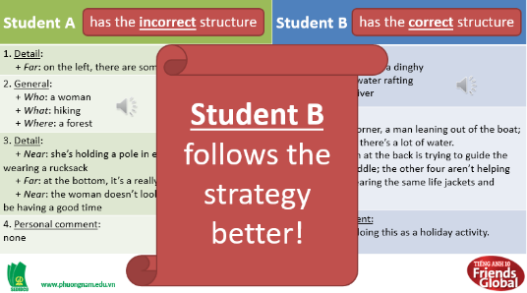  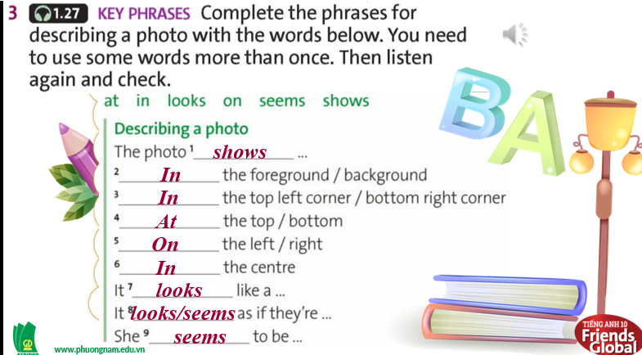
- Activity 2: Practice (15’)
a) Objective: Students can answer the questions to critical thinking, and they can finish the tasks in the textbook. Critical thing skills (guessing/ reasoning) and communication can also be practiced.
b) Content: Students describe how people feel in the photos,
c) Outcomes:
d) Competence: communication, collaboration, presentation
e) Organisation of the activity:
TEACHER’S ACTIVITIES | STUDENT’S ACTIVITIES | CONTENTS
PRACTICE. T-Ss/ S-S/ Indiv  Activity 1 (5’): Task 4 page 30.  - Ask students to work in pairs, take turn to describe how people are feeling in photos A and B. Students can use the words below or other adjectives from lesson 1A page 10.  - Invite some pairs to share their ideas.  - Correct students’ pronunciation if necessary.  Activity 2 (5’): Task 5 page 30.  - Ask students to take note the adjectives the second student uses from exercise 4.  - Play the recording.  - Check answers as a class.  Activity 3 (5’): Task 6 page 30.  - Play the recording and ask students to complete the phrases.  - Check answers as a class. Then elicit translation (optional). | - Work in pairs and describe how people are feeling in two pictures.  - Volunteer to share ideas.  - Understand the task.  - Listen and make a note.  - Check answers with teacher.  - Listen to the recording and complete the phrases.  - Check answers with teacher. | 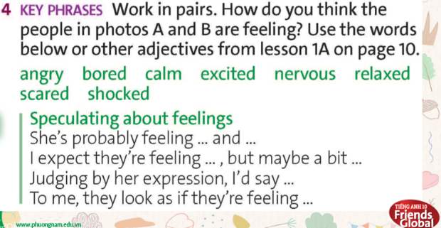  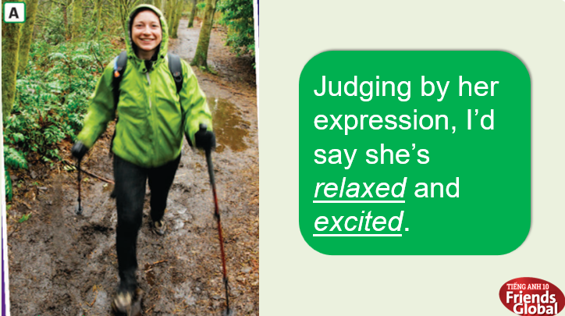  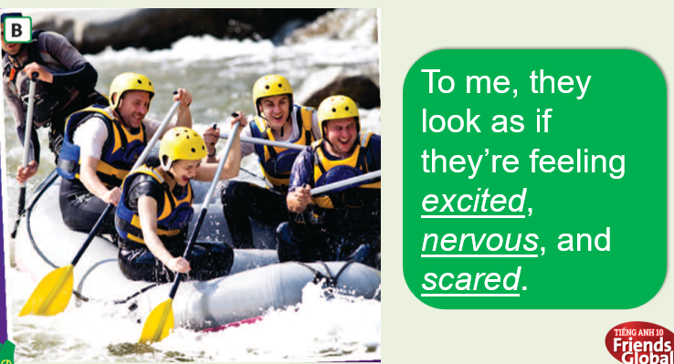  Answers:  Scared, excited, bored  Answers:  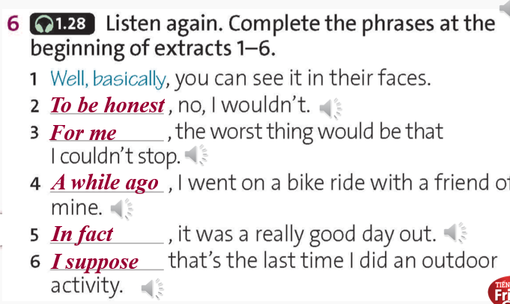

- Activity 3: Outcomes (10’)
a) Objective: Students discuss and describe the photo C.
b) Content: Group Discussion
c) Outcomes: Students can describe photos with useful words and phrases they learnt.
d) Competence: Collaboration, communication, guessing
e) Organisation of the activity:
TEACHER’S ACTIVITIES | STUDENT’S ACTIVITIES | CONTENTS
PRODUCT. T-Ss/ S-S/ Indiv  - Ask students to work in groups to describe photo C using words and phrases from this lesson.  - Give students words and phrases.  - Encourage students to speak up.  - Invite some students to share their ideas.  - Correct them if necessary. | - Work in group and describe the photo C using words and phrases in the lesson.  - Volunteer to answer. | 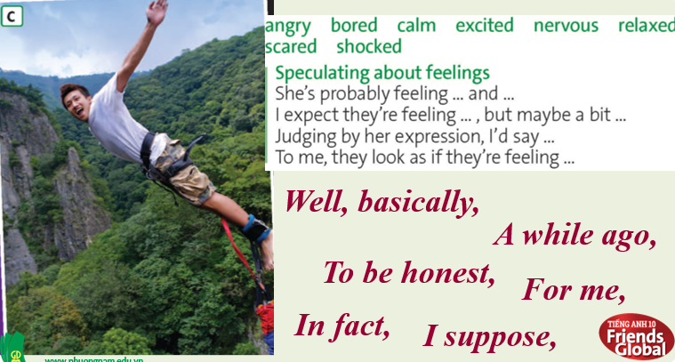
C. Consolidation (3’)
- Students can describe and speculate about a photo.
D. Homework (2’)
- Practice describing photos around you.
- Do exercise
- Prepare: Unit 2 – H- (page 31 – SB)

