THAM KHẢO TS10 – HÙNG VƯƠNG
I. Choose the word / phrase / sentence (A, B, C or D) that best fits the space or best answers the question given in each sentence. (3.5 pts)
1. Which word has the underlined part pronounced differently from that of the others? |  |  |  |  | 1. ________
 | A.  studies | B. describes | C. leaves | D. searches
2. Which word has the underlined part pronounced differently from that of the others? |  |  |  |  | 2. ________
 | A. single | B. dictionary | C. subtitle | D. influence
3. Which word has a different stress pattern from that of the others? |  |  |  |  | 3. ________
 | A. furniture | B. appliance | C. system | D. pharmacy
4. Which word has a different stress pattern from that of the others? |  |  |  |  | 4. ________
 | A. qualification | B. creativity | C. engineering | D. university
5. Roy: What changes in media do you expect to see in the future?  Kate: I expect to see more ______ reality media. |  |  |  |  | 5. ________
 | A. virtual | B. medical | C. limited | D. potential
6. Mary: The population is rising really quickly.  Tom: Yes. It’s ______ a big issue ______ there won’t be enough places for people  to live. |  |  |  |  | 6. ________
 | A. more/ than | B. such/ that | C. so/ that | D. such/ than
7. James: Could you show me where to buy a SIM card?  An: Yeah, you can buy one at the ______. |  |  |  |  | 7. ________
 | A. monument  C. convenience store |  | B. train station  D. art gallery
8. Brian: I am looking ______ some advice on how to improve my English, Susan.  Susan: I can help with that. What are you struggling with? |  |  |  |  | 8. ________
 | A. up | B. after | C. at | D. for
9. Tuan: How did you decide where to eat?  Nam: Before going out to eat, I ______ local restaurants very carefully. |  |  |  |  | 9. ________
 | A. attracted | B. directed | C. researched | D. encouraged
10. Dr. Jones: Although kids love using their phones, too much screen time is bad  for them.  Mrs. Smith: ______ |  |  |  |  | 10. _______
 | A. How far is it?  C. How much is ok? |  | B. How much is it?  D. I don’t believe it.
11. Children: We’re having so much fun!  Parents: I don't want to spoil your fun, ______ it's time to go home. |  |  |  |  | 11. _______
 | A. so | B. but | C. despite | D. however
12. Lara: Why do you think some people prefer being single nowadays?  Croft: In my opinion, they choose to be single because they want to be ______. |  |  |  |  | 12. _______
 | A. impressive | B. thrilling | C. dependent | D. independent
13. A: Why were you so late for your flight?  B: Our coach was caught in a ______ and got to Heathrow forty minutes late. |  |  |  |  | 13. _______
 | A. traffic jam | B. crosswalk | C. sidewalk | D. pedestrian
14. Tam: The hike wasn't ______ I thought it would be, and the view was spectacular.  Sang: Yeah. It wasn't bad at all. |  |  |  |  | 14. _______
 | A. as difficult as | B. far easy | C. a bit longer | D. harder

II. Look at the sign or the notice. Choose the best answer (A, B, C or D) for questions 15 and 16. (0.5 pt)
15. What does the sign say? |  |  | 15. _______
 | 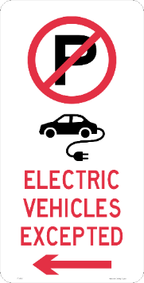 | A. All vehicles are not allowed to park  here.  B. Only electric cars can be parked at  this place.  C. Drivers must not go on this way.  D. There is a shop selling electric  vehicles ahead.
16. What does the notice say? |  |  | 16. _______
 | ARE YOU A FAN OF JAZZ?  JAZZ MUSIC EVENT  Central theme: The 1920s, Jazz Age  Food and drinks: Available at a reasonable price  Gift shop: At the entrance | A. You can buy tickets to the event at the  entrance.  B. Food and drinks are included in the  tickets.  C. Food and drinks will be sold at the gift  shop.  D. You can enjoy music from the Jazz  Age in the 1920s.

III. Choose the word (A, B, C or D) that best fits each space in the following passage. (1.5 pts)
Mông Phụ village gate is the oldest architectural feature of Đường Lâm Ancient Village. This gate was built (17)______ the Lê Dynasty, with laterite pillars and ironwood gate. To the right of the gate is a large lake and to the left is an ancient tree of thousands of years old. (18)______ its peaceful beauty, Mông Phụ village gate is not only an (19)______ sightseeing spot but also an ideal place for tourists to (20)______ pictures when coming to Đường Lâm Ancient Village.
Mông Phụ communal house is a typical (21)______ of the Northern countryside, built nearly 380 years ago in the center of the village. It is about 1800 square meters in size. The communal house has bold ethnic architecture, resembling a house on stilts with wooden floors separated from the ground. Inside the communal house, there are many hanging ancient parallel sentences dating back (22)______ of years ago. It can be said that the communal house is the quintessence of Vietnamese architecture, attracting many tourists to contemplate.
FB: Thầy Đình (Dạy Tiếng Anh)

17. | A. in | B. on | C. for | D. since | 17. _______
18. | A. According to | B. Thanks for | C. Thanks to | D. Next to | 18. _______
19. | A. interest | B. interested | C. interestingly | D. interesting | 19. _______
20. | A. make | B. take | C. do | D. develop | 20. _______
21. | A. villa | B. work | C. cottage | D. apartment | 21. _______
22. | A. thousand | B. thousands | C. hundred | D. hundreds | 22. _______

IV. Read the following passage. Decide whether the statements from 23 to 26 are True or False, and choose the correct answers (A, B, C or D) for questions 27 and 28. (1.5 pts)
These days, many teenagers are creating and sharing their own media online. They enjoy blogging, making websites, and other types of content creation. Some young people have even started their own successful online businesses and websites. For example, a teenager named Catherine Cook created a social media site called MeetMe when she was in high school. Now it has over 1.7 million members! Another teenager, Ashley Qualls, made a website with tutorials for graphics and design, which gets millions of visitors.
Teenagers are also becoming famous on social media platforms like TikTok and YouTube. They gain popularity by making short videos, dancing, and lip-syncing. Some young creators even move from TikTok to YouTube to make longer videos like vlogs and tutorials. These content creators are not only getting popular, but they're also making money through brand partnerships and selling products.
Being a content creator has challenges too. Teenagers have to manage their online presence, deal with criticism, and balance school. They also have a responsibility to their audience, as they can create trends and influence people around them. But overall, by creating content, teenagers can express themselves creatively and share their interests with the world. It's a great way for them to learn and grow through social interaction.
So, if you're a teenager with a talent or passion, consider sharing it online. You might even turn it into a successful career!
23. Blogging and making websites are some types of content creation. |  | 23. _______
24. Catherine started a social media site to teach people graphics and design. |  | 24. _______
25. Ashley’s website, MeetMe, has over 1.7 million members. |  | 25. _______
26. Young creators can earn money on social media platforms. |  | 26. _______
27. The passage is mainly about ______. |  | 27. _______
A. the trend of teenage online creators
B. the popularity of TikTok and Youtube
C. how a teen becomes a content creator
D. the difficulties of creating online content
28. Being a content creator, teenagers ______. |  | 28. _______
A. don’t have to balance their school work
B. cannot influence people around them
C. can express themselves creatively
D. have to create new online trends

V. Use the correct form of the word given in each sentence. (1.5 pts)
29. She is a ________________ student. She often makes mistakes in her tests. (care)
30. My ________________ was spent moving from place to place as my father
was in the army. (child)
31. The computer is ________________ to the internet. (connect)
32. Find books or websites on topics you like. Choose one ________________
above your level to learn new words each time. (slight)
33. ________________ are trying to find the virus that causes the disease. (science)
34. Major airports will need new runways to relieve ________________. (congest)

VI. Look at the entry of the word in a dictionary. Use what you can get from the entry to complete the sentences with two or three words. (0.5 pt)

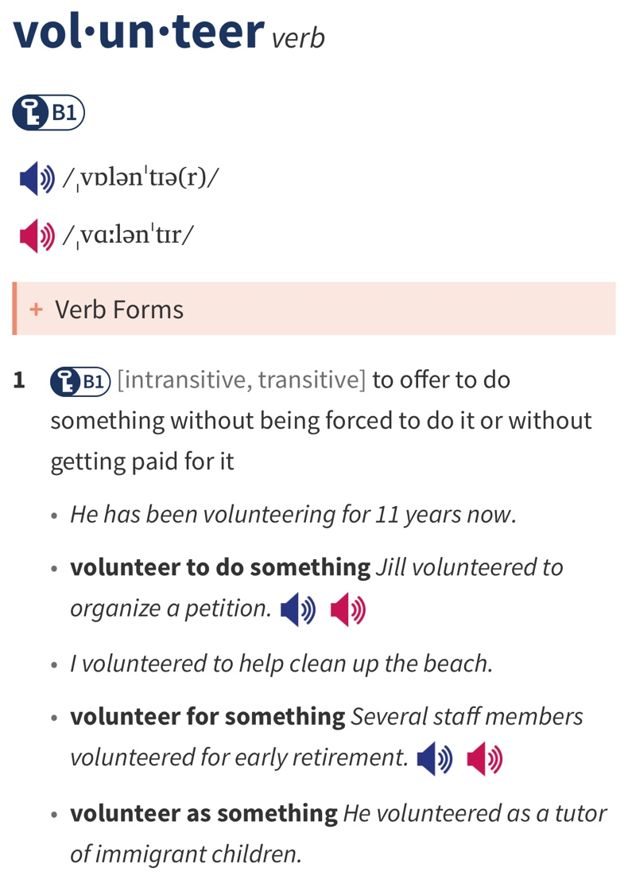 | 35. He __________________ the army.  36. I __________________ clean up the beach.

FB: Thầy Đình (Dạy Tiếng Anh)

VII. Rewrite each of the following sentences in another way so that it means almost the same as the sentence printed before it. (1.0 pt)

37. Although Nam applied for hundreds of jobs, he is still out of work.

Despite

38. Our old car is not as good as this one. (far)

This car is

39. I was so tired that I could sleep in that chair.

I could

40. In the end, we chose to go to the theater. (decided)

