SPEAKING
1. Introduction:
Introduce yourself with basic information (name, class, age, hobby, family, etc.) (0.5 point)
2. Each of you will now receive a card. On the card there is a picture and you can speak about this place. (0.5 point)
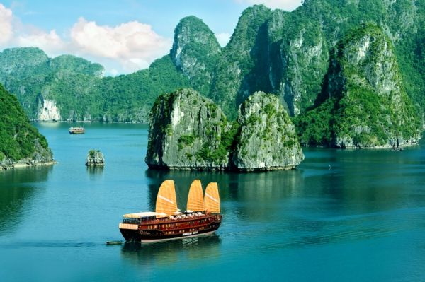
- Ha Long Bay - one of seven new world heritage sites by UNESCO
- located in Quang Ninh province in the northeast of Vietnam
- an area of over 1500 sq km, includes over 1600 islands and islets
- Bo Hon island the home of a variety of flora and fauna, Yen Tu mountain, Surprise Cave or Kissing rocks.
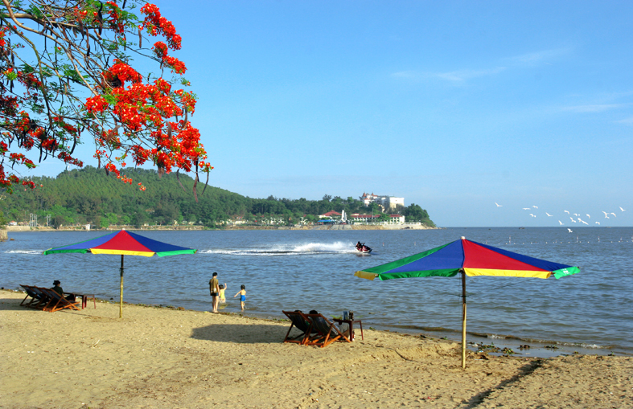
- Do Son beach - 22.5 kilometers in length between the Lạch Tray and Văn Úc Rivers
- Miniature Da Lat
- Hon Dau Island
- Ho Chi Minh road on the sea

3. Answer further questions (1 point)
- How many places have you traveled to?
- Who do you usually go with?
- What is your favourite tourist attraction?
- What language do you use when traveling?
- What do you do during your trip?
- What do you usually bring when you travel?

