LỚP HỌC THẦY (CÔ) ___________________________ ĐỀ ÔN TẬP: READING SIGNS/ NOTICES – A2
Test 19
Thời gian làm bài: [Time]
Họ và tên: ________________________________________________ Lớp: 9/___
Question 1: What does this sign indicate?
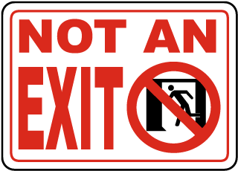
A. This door leads to the exit.
B. You must not go through without permission.
C. You must not go through this door.
D. This is not an exit.

Question 2: What does the message mean?
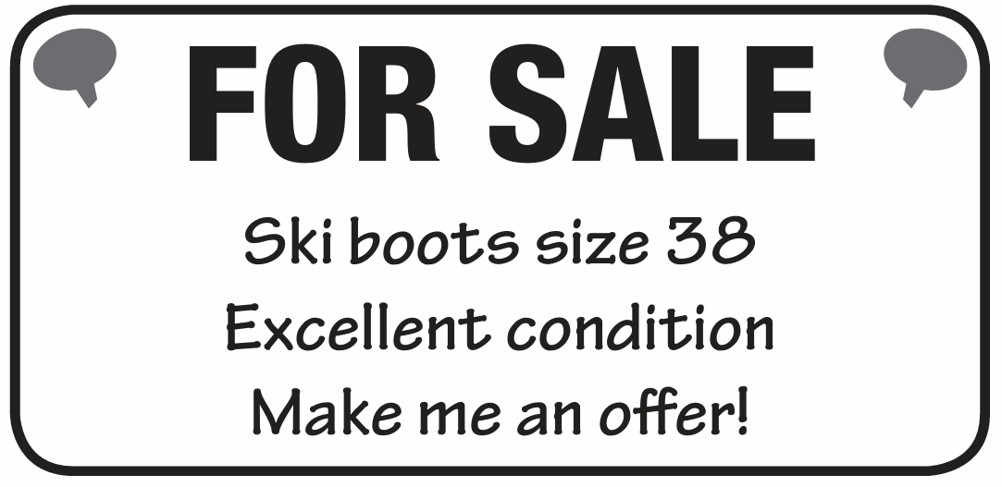
A. The ski boots are for sale; you can suggest a price.
B. The ski boots are free.
C. The ski boots are not for sale.
D. The ski boots are only for kids.
Question 3: What does this sign indicate?
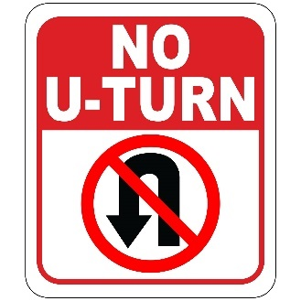
A. U-turns are allowed here.
B. Only straight-ahead driving is allowed here.
C. U-turns are allowed during certain hours.
D. U-turns are allowed with caution.

Question 4: What does the message mean?
New message
From: School secretary
To: All students
Please remember that you have to return all borrowed books to the school library before Friday, the last day of term.

A. You must return all library books before Friday.
B. You can return library books any time after Friday.
C. You do not need to return library books.
D. You must return the books after Friday.
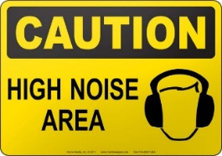
Question 5: What does this sign indicate?
A. This area is quiet.
B. Expect high noise levels in this area.
C. Noise is prohibited in this area.
D. Noise levels are moderate.
Question 6: What does the message mean?
New message
From: Daniel
To: Jake
Jake
Hi Jake Great news! I don't have to go to the shops this afternoon, so shall we see that film? I can meet you outside the cinema at 2.30.
Daniel
A. Daniel is going to the shops and will meet Jake later.
B. Daniel wants to see a film with Jake and can meet at 2:30.
C. Daniel cannot meet Jake this afternoon.
D. Daniel wants to see the film alone and will not meet Jake.
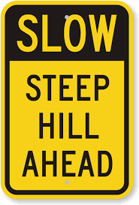
Question 7: What does this sign indicate?

A. No need to be cautious, the hill is not steep.
B. Be cautious, the hill is steep.
C. The hill is flat.
D. The hill is closed to vehicles.

Question 8: What does the message mean?
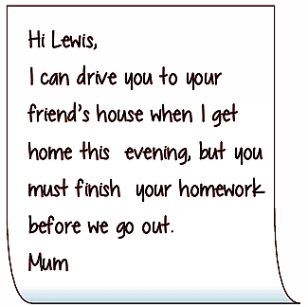
A. Mum will drive you if you finish your homework first.
B. Mum will drive you anytime, no need to do homework.
C. You can go out before doing your homework.
D. Mum cannot drive you to your friend's house.
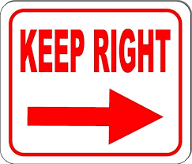
Question 9: What does this sign indicate?
A. Stay on the left side.
B. Keep to the right side.
C. Right side is closed.
D. Both sides are open.

Question 10: What does the message mean?
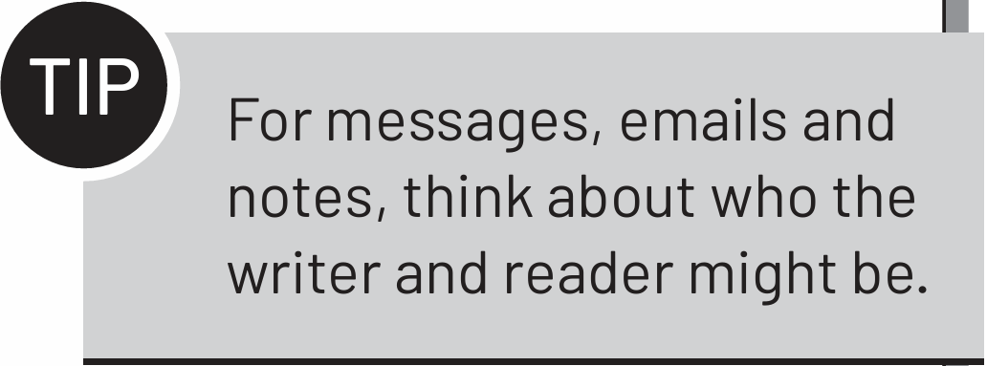
A. Think about who is sending and receiving the message.
B. Only send messages to yourself.
C. Don’t worry about who is reading the message.
D. Write messages only in formal language.
[HẾT]

