Mã đề 9.1.31
ĐỀ KIỂM TRA CUỐI KỲ I NĂM HỌC: 2022-2023
MÔN: TIẾNG ANH LỚP 9
Thời gian làm bài: 60 phút
SECTION A: LISTENING (2 point)
I. Listen and choose the correct picture. (1.0 point)
1. What must the man turn off?( NB)  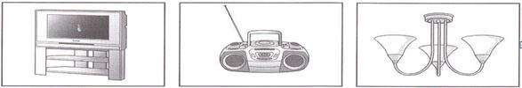 |  |  | 4. What animals did they see on their holiday?(TH)  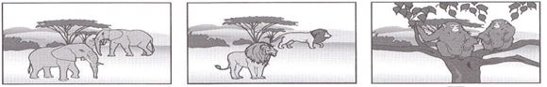
A | B | C | A | B | C
2. Where’s the girl’s pen?(NB)  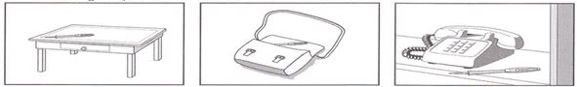 |  |  | 5. What does the man want to buy?(TH)  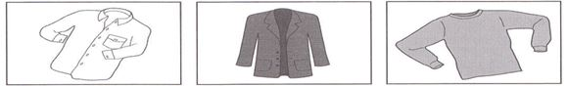
A | B | C | A | B | C
3. What will the boy do this evening?(NB)
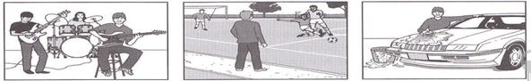
A | B | C
II. Listen and write

André’s tennis lessons
Teacher’s name: Paul
Day: (1) ________________________(NB)
Cost: (2) £____________ per hour(NB)
At tennis courts in: (3) __________________ Street.(TH)
Starting time: (4) __________________ pm(NB)
Wear: (5) _________________ and T-shirt(TH)

SECTION B: LANGUAGE (2 POINTS)
I. Choose the best option A, B, C or D to complete the blank in each sentence.
1. I used ___________ of becoming a singer. NP NHẬN BIẾT
A. dream | B. to dream | C. dreaming
2. He was too poor to pay his debt,............he was imprisoned. NP THÔNG HIỂU
A. so B. because C. if
3. The children were the story of the birth of Jesus. TV THÔNG HIỂU
A. acting out B. putting on C.turning down
4. We need more projects to ___________ cultures of ethnic minority groups TV THÔNG HIỂU
A. achieve |  | B. adjust | C. preserve
5. He becomes very ___________ in French after three years in Paris. TV THÔNG HIỂU
A. smooth | B. fluent | C. easy
6. In the past many people were ___________; they could n’t read and write. TV THÔNG HIỂU
A. responsible B. enthusiastic C. illiterate
6. Mike: - Have you seen John? Laura: - ..................................... CNNN THÔNG HIỂU
a. I don't mind where b. He's happy to do that c. He's just gone out.
7. “ I will go to Vinh tomorrow”. She said. NP THÔNG HIỂU
-> She said..............
a. She would go to Vinh the following day.
b. She would went to Vinh the day after.
c. She would go to Vinh tomorrow.
8. - Why don't we eat out in a restaurant tonight? - ................................. CNNN NHẬN BIẾT
A. That's a good idea B. I hope so C. What a pity
9. It is _____ that Thang Long Bridge was built in the 20th century. NP NHẬN BIẾT
A. believes B. believe C.. believed
10. I wish I ___________ enough money to buy a new computer; this has been so slow NP NHẬN BIẾT
A. have | B. will have | C. had
SECTION 3: READING (2 POINTS)
I. Read the passage and then choose the correct answer to each question. (1 point)
Living in a city has a number of drawbacks. Firstly, there is the problem of traffic(1) and traffic accidents. The increase (2) population and the increasingnumber of vehicles have (3) many accidents to happen every day. Secondly, air pollution (4) affects people’s health, and is also has a bad influence on theenvironment. More and more city dwellers suffer from coughing or breathing problems. Thirdly, the city is noisy, even at night. (5) pollution comes from the traffic andfrom construction sites. Buildings are always being knocked down and rebuilt. These factors contribute to making city life more difficult for its residents.
1. A. calm B. jams C. light D. accidents (NHẬN BIẾT)
2. A. with B. on C. in D. of (NHẬN BIẾT)
3. A. caused B. made C. done D. gave THÔNG HIỂU)
4. A. actively B. negatively C. positively D. completely (THÔNG HIỂU)
5. A. light B. Air C. Water D. noise (THÔNG HIỂU)

II.Read the passage then choose the correct answer A, B, C or D to the questions. (1.0 point).
Last year I went to Nepal for three months to work in a hospital. I think it's important to see as much of a country as you can, but it is difficult to travel around Nepal. The hospital let me have a few days’ holiday, so I decided to go into the jungle and I asked a Nepalese guide, Kamal Rai, to go with me.
We started preparing for the trip at six in the morning, and left camp with two elephants carrying our equipment. It was hot but Kamal made me wear shoes and trousers to protect me from snakes. In the jungle there was a lot of wildlife, but we were trying to find big cats, especially tigers. We climbed onto the elephants' backs to get better view, but it is unusual to find tigers in the afternoon because they sleep in the heat of the day.
Then, in the distance, we saw a tiger, and Kamal told me to be very quiet. We crept nearer and found a dead deer, still bleeding. This was the tiger's lunch! Suddenly I started to feel very frightened.
We heard the tiger a second before we saw it. It jumped out like a flash of lightning, five hundred kilos plus and four meters long. I looked into its eyes and face, and saw right down the animal's throat. It grabbed Kamal's leg between its teeth, but I managed to pull Kamal away. One of our elephants ran at the tiger and made it go back into the grass, so we quickly escaped to let the tiger eat its lunch. That night it was impossible to sleep!
1: The writer went to Nepal ________. (THÔNG HIỂU)
A. for holiday B. for treatment C. for business D. on tour
2: When having a few days off, he decided to go into ________. (THÔNG HIỂU)
A. the remote villages B. the mountains
C. the seaside D. the tropical forest
3: It's difficult to find tigers in the afternoon because ________. (NHẬN BIẾT)
A. they usually sleep at this time of day
B. it's so hot at this time
C. the elephants' back wasn't high enough to get view
D. tigers hardly hunt in the heat of the day
4: The writer started to feel frightened when ________. (THÔNG HIỂU)
A. he saw a tiger B. he saw the tiger's lunch
C. he crept nearer D. he found a deer
5: The tiger ________.(VẬN DỤNG)
A. was like a flash of light
B. saw them a second before they saw it
C. jumped out very fast
D. jumped out of the grass at about four meters
SECTION D: WRITING (2 POINTS)
I. Rewrite the following sentences, using the words given: (1.0 pts)
1. “Have you ever visited Hoi An?” said MrTien. (VẬN DỤNG)
=> Mr Tien asked………………………………………………………………
2. What a pity. My husband doesn’t give up smoking. (THÔNG HIỂU)
=> I wish………………………………
3. People say that he invented the digital camera. (THÔNG HIỂU)
=> It........................................................................................................
4. Let’s collect the waste paper at school. (THÔNG HIỂU)
=> I suggest…........................................................................................
5. Nobody has cleaned the floor since last Sunday. (VẬN DỤNG)
-> The floor ……….
II. Write a short article describing a wonder of Viet Nam: (VẬN DỤNG CAO)
- Name of wonder
- Location:
- Reasons for choosing the place
- Main features of the place
- Comments and feelings about the place.

KEY
SECTION A: LISTENING (2 point)
I.1 point (0.2 point/ 1 correct answer)
1. A | 2.C | 3.B | 4.C | 5.C
II.1 point (0.2 point/ 1 correct answer)
1. Wednesday(s) | 2. 12/twelve | 3. GERALD | 4. 6.15/ six fifteen | 5. shorts
SECTION B: LANGUAGE (2 POINTS)
I. Choose the word whose underlined part pronounced differently from that of the others by circling A, B, or C
1. B 2. A 3. A 4. C 5. B 6. C 7. A 8. A 9. C 10. C
SECTION 3: READING (2 POINTS)
I. Read the passage and then choose the correct answer to each question. (1 point)
1. B 2. C 3. A 4. B 5. D
II. Read the passage and choose the correct answer for each question (1 point)
1. C 2. D 3. A 4. B 5. C
SECTION D: WRITING (2 POINTS)
I. Rewrite the following sentences as directed ( using the suggested words) so that the meanings stay the same. (1.0 pt)
1. “Have you ever visited Hoi An?” said MrTien.
=> Mr Tien asked me if I had ever visited Hoi AN
2. What a pity. My husband doesn’t give up smoking.
=> I wish my husband gave up smoking.
3. People say that he invented the digital camera.
=> It is said that he invented the digital camera.
4. Let’s collect the waste paper at school.
=> I suggest collecting the waste paper at school
5. Nobody has cleaned the floor since last Sunday.
-> The floor hasn’t been cleaned since last Sunday.
II. Write a paragraph about 80 words with the following topic: (1.0 points).
(wrong spelling, without prepositions, articles: -0.1 pt;
wrong verbs, verb tenses: 0 pt)
0.5pt/ 1correct sentence.

