**TIẾNG ANH 8 – FRIENDS PLUS**

**REVIEW (UNITS 7-8) – TEST 1**

**I. PRONUNCIATION**

**Câu 1.** Which word has the underlined part pronounced differently from that of the others?

**A.** music **B.** design **C.** thousand **D.** conserve

**Câu 2.** Which word has the underlined part pronounced differently from that of the others?

**A.** machine **B.** character **C.** Chicago **D.** champagne

**Câu 3.** Which word has a different stress pattern from that of the others?

**A.** access **B.** guitar **C.** graphic **D.** effort

**Câu 4.** Which word has a different stress pattern from that of the others?

**A.** volunteer **B.** signature **C.** sociable **D.** habitat

**II. Choose the answer (A, B, C or D) that best fits the space in each question.**

**Câu 5.** Animal rights activists want to protest ______ the poaching of rhinos for their horn in Asian countries.

**A.** for **B.** with **C.** about **D.** beyond

**Câu 6.** The new project aims to provide the locals with access ______ food and fresh water.

**A.** to **B.** by **C.** at **D.** on

**Câu 7.** The movie comes a close ______ with 78% of the vote.

**A.** second **B.** minute **C.** hour **D.** day

**Câu 8.** Here is a ______ reveals America’s favourite movies in 2022.

**A.** problem **B.** review **C.** reason **D.** survey

**Câu 9.** One day, Mario took a ______ dose of magic mushrooms and climbed to the top of a tall tree, where he was trapped by a lightning storm.

**A.** confident **B.** heroic **C.** sympathetic **D.** generous

**Câu 10.** Louisa May Alcott’s 19th century novel “*Little Women*” has been ______ for the stage and screen multiple times.

**A.** adopted **B.** admitted **C.** adapted **D.** adhered

**Câu 11.** At the end of this special festival, you can eat all the books displayed there. Don’t be surprised! The books are ______.

**A.** uneatable **B.** eatable **C.** edible **D.** inedible

**Câu 12.** ______ is said that supermarkets reject selling “ugly” fruit and vegetables.

**A.** It **B.** There **C.** They **D.** He

**Câu 13.** “Don’t leave David alone when nobody is at home”, my husband said.

**A.** My husband told me not to leave David alone when nobody is at home. **B.** My husband said to me to not leave David alone when nobody was at home. **C.** My husband said me not to leave David alone when nobody is at home. **D.** My husband told me not to leave David alone when nobody was at home.

**Câu 14.** Irene: “There’s a lot of food waste in buffets.” – Jeremy: “______”

**A.** I think people should support it. **B.** We need to find a way to solve it. **C.** Let’s have more parties. **D.** I hope you will tolerate it.

**III. Look at each sign or notice. Choose the best answer (A, B, C or D) that matches its meaning.**

**Câu 15.** What does the sign mean?

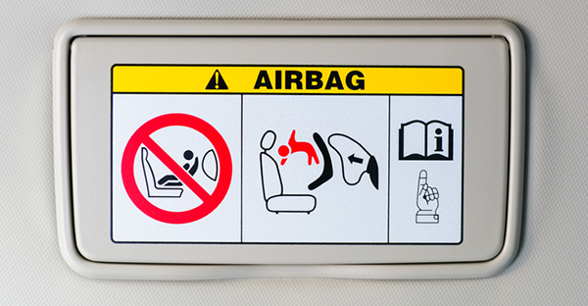

**A.** Always fasten your seat belt. **B.** Do not move out of the car.

**C.** Jump out of the car unless airbag is on. **D.** Never put a rear-facing child in the front.

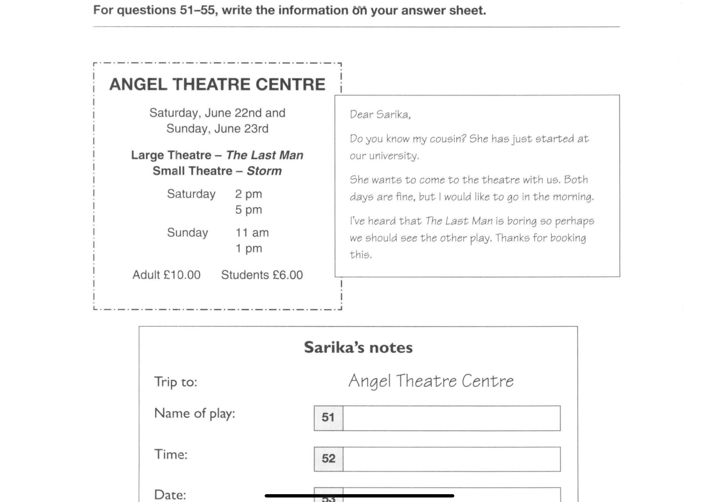**Câu 16.** What does the message say?

**A.** Sarika is going to start work at university. **B.** Sarika and her friend want to watch “The Last Man”.

**C.** Sarika’s friend wants to go at the weekends. **D.** Sarika’s friend suggests changing the play.

**IV. Read the following and do as directed.**

Youth are the driving force of a nation. Known as the most worth-living-and-visiting city in Viet Nam, Da Nang has successfully involved its young and dynamic residents in the development of the city. A students’ group from the University of Da Nang came up with the project of constructing traffic culture in the City of Bridges. Awarded among the Top 10 “Viet Nam’s voluntary projects” by the Central Committee of Ho Chi Minh Communist Youth Union in 2020, the project aims to raise public awareness about traffic rules, change behaviours of young people and the community and create a safe, civilized and friendly traffic environment. The highlight of the project is the companionship of foreign tourists with volunteer students. They guide the tourists in road traffic at major intersections during rush hours and answer their questions of traffic during their stay in Viet Nam. As a result, not only does this activity succeed in raising public awareness of traffic culture, but it also further promotes Viet Nam’s tourism image as well as makes a good impression about the national hospitality on foreign tourists.

Another meaningful community service is “Mom, we are always with you”. In such gratitude movement, the grassroots of the Youth Union units volunteer to pay visits to Vietnamese Heroic Mothers in the city, cleaning their houses, offering incense and fruits on the martyr’s alter. So far, 98 Mothers have been taken care of and treated with respect. This activity has educated the city’s young generations about Viet Nam’s tradition “Gratitude is the sign of noble souls”.

**True/False Questions:**

**Câu 17.** The idea of the “constructing traffic culture” project came from the Central Committee of Ho Chi Minh Communist Youth Union.

**A.** True **B.** False

**Câu 18.** The assistance of volunteers in guiding tourists in road traffic is the most important part of the project.

**A.** True **B.** False

**Câu 19.** The aim of the project of constructing traffic culture is to impress foreigners with the warm hospitality.

**A.** True **B.** False

**Câu 20.** “Mom, we are always with you” has instilled an attitude of gratitude in Da Nang’s youngsters.

**A.** True **B.** False

**Choose the correct answer to each question:**

**Câu 21.** What serves as the best title for the passage?

**A.** Youth Projects. **B.** The City of Bridges. **C.** Traffic Rules. **D.** Tourism in Da Nang.

**Câu 22.** What is NOT mentioned as the activity of the gratitude movement.

**A.** visiting Vietnamese Heroic Mothers. **B.** doing the housework for Mothers.

**C.** preparing offerings on the martyr’s altar. **D.** promoting Viet Nam’s tourism image.

**V. Choose the word (A, B, C or D) that best fits each blank space in the following passage.**

**JAMES CAMERON**

When it comes to 3D filming technology, it would be a mistake if James Cameron went unmentioned. He is best known as an Oscar-winning director with massive (23) ______ hits. He spent his childhood in Canada. It was not (24) ______ he was 17 that he moved to the United States. He (25) ______ his first professional film job as art director, miniature-set builder, and process-projection supervision in 1980. What made him first take (26) ______ Academy Awards was “Titanic” (1997), a romance epic about two young lovers from different social (27) ______ who met on the famous ship. 12 years later, Cameron had a (28) ______ with “Avatar” (2009), featuring 3D cinematography. Now, he is one of the most sought-after directors in Hollywood.

**Câu 23.** Choose the correct answer.

**A.** instant **B.** box-office **C.** best-selling **D.** record-breaking

**Câu 24.** Choose the correct answer.

**A.** only **B.** before **C.** until **D.** when

**Câu 25.** Choose the correct answer.

**A.** performed **B.** offered **C.** paid **D.** landed

**Câu 26.** Choose the correct answer.

**A.** up **B.** back **C.** view **D.** home

**Câu 27.** Choose the correct answer.

**A.** walks **B.** states **C.** classes **D.** grades

**Câu 28.** Choose the correct answer.

**A.** comeback **B.** return **C.** interest **D.** profit

**VI. Supply the correct form of the word given in each sentence.**

**Câu 29.** In India, popcorn was the favorite for ______ with a whopping 863 metric tonnes being consumed in theatres in 2022. **(CINEMA)**

**Câu 30.** “Nha Ba Nu” (The House of No Man) achieved a ______ profit of VND 458 million in revenue one month after its release in January. **(RECORD)**

**Câu 31.** Out-of-the-box thinkers have no tendency to be ______. They set themselves targets and know what they want to do. **(ORGANIZE)**

**Câu 32.** The “Blended” cast was full of ______ gifted performers like Adam Sandler and Drew Barrymore. **(COMEDY)**

**Câu 33.** Love is in the air as the world prepares to celebrate Valentine’s Day and Netflix has a stellar list of ______ flicks to usher in the holiday season. **(ROMANCE)**

**Câu 34.** This heartwarming book inspires readers to ______ obstacles in life. **(COME)**

**VII. Rearrange the groups of words in a correct order to make complete sentences.**

**Câu 35.** encourages young people / sensitive topics openly / to talk about / This project / and honestly.

**Câu 36.** help spread / inspirational stories that / throughout the society. / The book comprises / happiness and

**VIII. Rewrite each of the following sentences in another way so that it means almost the same as the sentence printed before it.**

**Câu 37.** Let’s create an opinion poll.

🡪 Why don’t

**Câu 38.** “You’d better take this offer,” said my parents.

🡪 My parents advised

**Câu 39.** The situation is still under control, so the Red Cross doesn’t send medical aid to the country. **(WORSEN)**

🡪 Were

**Câu 40.** “Leave now or I’ll call the security guards,” the manager said to his employee. **(UNLESS)**

🡪 The manager threatened

**------ HẾT ------**