|  |  |
| --- | --- |
| **Mã đề 6.1.16** | **ĐỀ KIỂM TRA GIỮA HỌC KÌ I**  **NĂM HỌC 2022 - 2023**  **Môn: Tiếng Anh 6**  ***Thời gian làm bài: 60 phút***  ***Đề gồm 4 trang***  ***Kiểm tra, ngày .... tháng ... năm 2022*** |

**A. LISTENING**

**Part I. Listen and choose the correct picture ( 1.0 pt)**

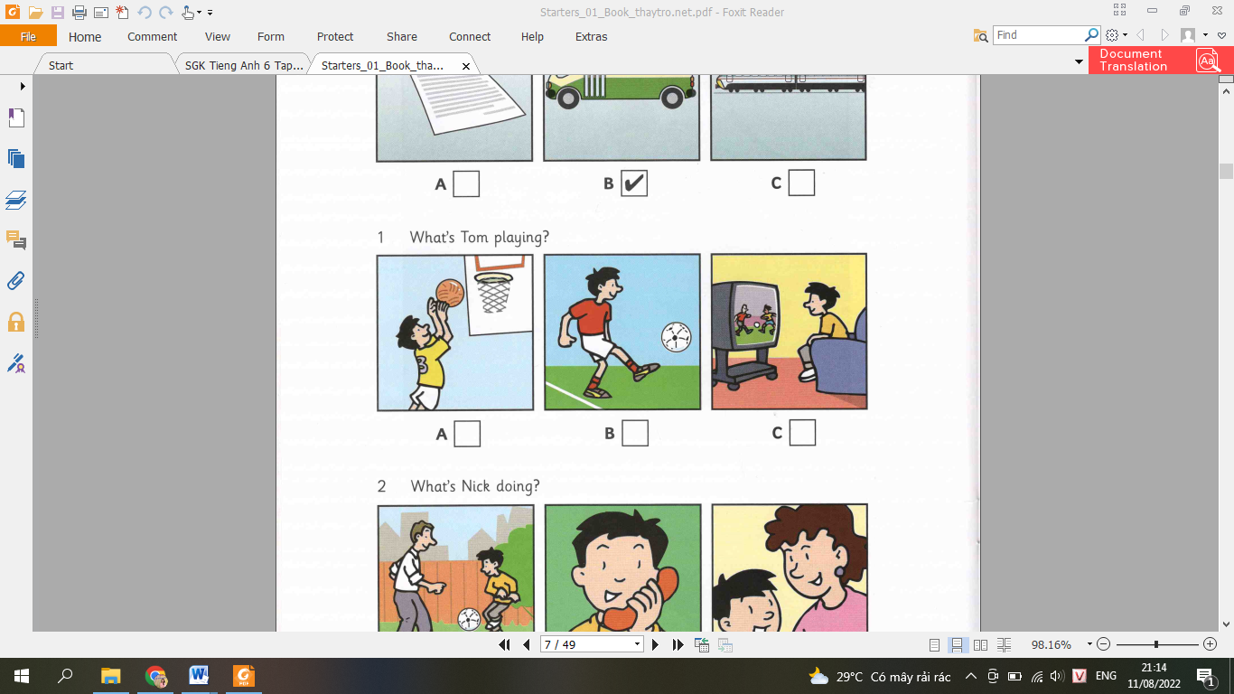 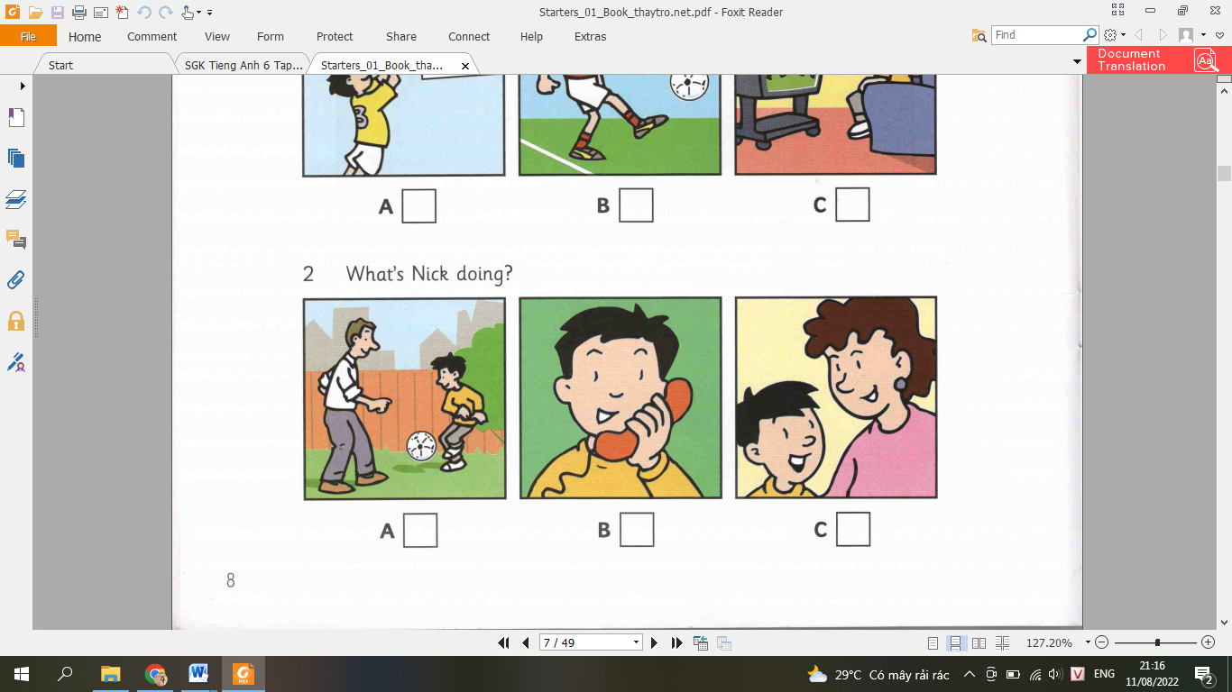

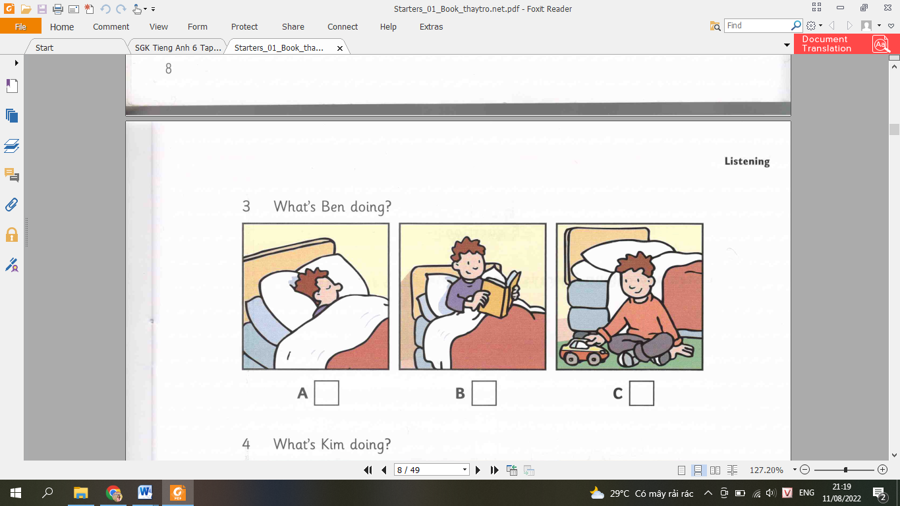 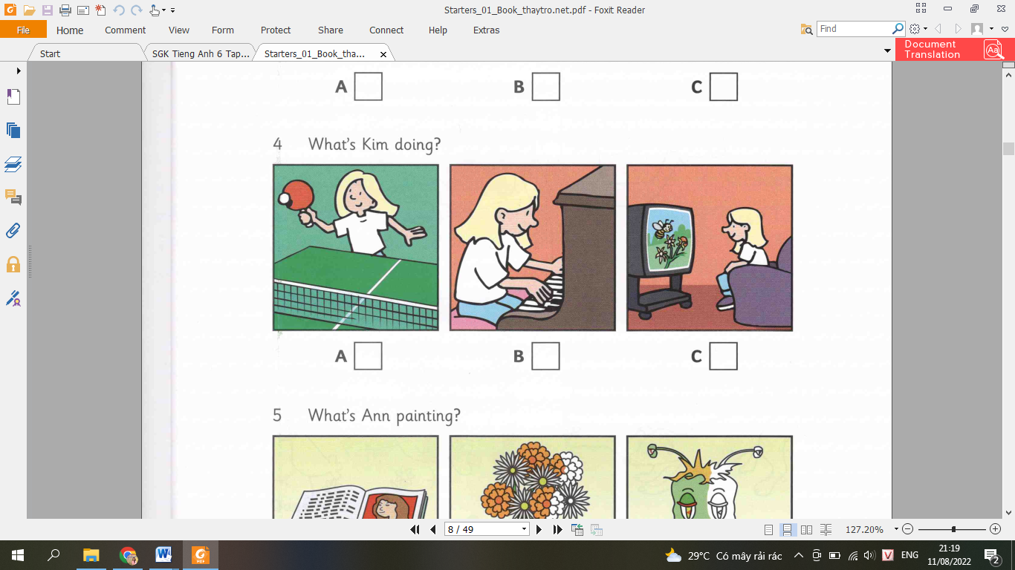

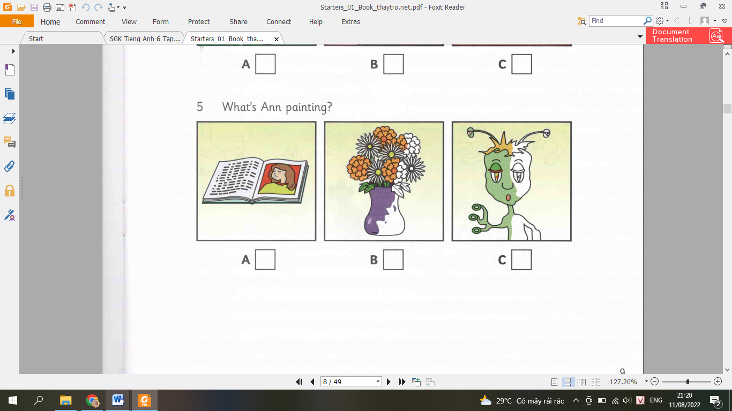

**II. Listen and write a name or a number. There is 2 example. (1.0 pt)**

**Example**:

|  |  |
| --- | --- |
| **What’s the boy’s name?**  **How old is he?** | **Sam**  **10** |

**Question:**

|  |  |
| --- | --- |
| 1. Which class is Sam in? 2. What’s name of Sam’s teacher? 3. Who sits next to Sam in class? 4. How many books are in Sam’s bag? 5. How old is Sam’s sister? | **..............................................**  **Mr.........................................**  **..............................................**  **..............................................**  **..............................................** |

**B- GRAMMAR- VOCABULARY**

1. **Choose A, B or C for each gap in the following sentences (3.0 pts)**

|  |  |  |  |  |  |  |  |  |  |  |  |  |
| --- | --- | --- | --- | --- | --- | --- | --- | --- | --- | --- | --- | --- |
| 1. ***Circle the word with different pronunciation:*** | | | | | | | | | | | | |
| A.sinks | | B.flats | | | C.sofas | | | | D..lamps | | | |
| 1. ***Find a mistake in this sentence:***   **Phong isn’t listen to his teacher now.** | | | | | | | | | | | | |
| A.Isn’t | | B.listen | | | C.his | | | | D.now | | | |
| 1. ***Students have to wear their........... when they are at school.*** | | | | | | | | | | | | |
| A. dresses | | B.T-shirt | | | C.uniforms | | | | D.glasses | | | |
| 1. ***She always.......... to school at 6.45.*** | | | | | | | | | | | | |
| A.goes | | B.going | | | C.go | | | | D.is go | | | |
| 1. ***Mr.Hung ...............English. He teaches Math.*** | | | | | | | | | | | | |
| A.don’t teach | | | B.doesn’t teach | | | |  | |  | | | |
| C.don’t teaches | | | D.doesn’t teaches | | | |  | |  | | | |
| 1. ***Lan: “Hi Hung. Nice to meet you!”***   ***Hung: “..............................”*** | | | | | | | | | | | | |
| A.How old are you? | | | B.Nice to meet you, too | | | | |  | | | |  |
| C.What’s your name? | | | D.You are so nice! | | | | |  | | | |  |
| 1. **My mother is cooking diner in the.......................** | | | | | | | | | | | | |
| A.living room | | B.bathroom | | | C.bedroom | | | | D.kitchen | | | |
| 1. ***You buy a new..........for my living room.*** | | | | | | | | | | | | |
| A.sofa | | B.dishwasher | | | C.fridge | | | | D.sink | | | |
| 1. ***Her ..........................is Lisa!*** | | | | | | | | | | | | |
| A.friend name | | B.friend’s name | | | C.friend’ name | | | | D.friends name | | | |
| 1. ***The table is................the chair and the lamp.*** | | | | | | | | | | | | |
| A.between | | B.next to | | | C.behind | | | | D.in front of | | | |
| 1. ***Rose: “ Let’s put the lamp next to this table !”***   ***Jennie: “................“*** | | | | | | | | | | | | |
| A.I don’t like | | B.I buy a new lamp | | | |  | | |  | | | |
| C.Great idea! | | D.I like this lamp | | | |  | | |  | | | |
| 1. ***Mary is so...................She always makes me laugh.*** | | | | | | | | | | | | |
| A.creative | B.funny | | | | C.confident | | | | D.caring | | | |
| 1. ***We .............English and Math lessons today.*** | | | | | | | | | | | | |
| A.do | | B.have | | | C.play | | | | D.make | | | |
| 1. ***Huy ..................Mr.Bean on Cartoon network at the moment.*** | | | | | | | | | | | | |
| A.is watching | | B.is watch | | | C.be watching | | | | D.waching | | | |
| 1. ***Ana: “.....................................”***   ***Emma: “ She is kind and confident.”*** | | | | | | | | | | | | |
| A.What is Jane look like? | | | | B.What does Jane like? | | | | | |  |  | |
| C.What does Jane look like? | | | | D.What’s Jane like? | | | | | |  |  | |

**C-READING**

**I. Read and choose the best word for each blank (1.5 pts)**

|  |
| --- |
| I live in a house near the sea. It is an old house, about 100 years old and...(1)... very small. There are two bed rooms upstairs but no bathroom. The bathroom is down stairs... (2)... the kitchen and there is a living room where there is a lovely old fire place. There is a garden...(3)... the house. The garden...(4)... down to the beach and in spring and summer. There are flowers every where. I like alone...(5)... my dog, Rack, but we have a lot of visitors. My city friends often stay with me. |

**Questions**:

|  |  |  |  |  |
| --- | --- | --- | --- | --- |
| 1. | A. it’s | B. it | C. there’s | D. they’re |
| 2. | A. between | B. next | C. near to | D. next to |
| 3. | A. in front | B. front of | C. of front in | D. in front of |
| 4. | A. go | B. going | C. goes | D. will go |
| 5. | A. for | B. of | C. on | D. with |

**II. Read the passage. Circle the best answer A, B or C to each of the questions. (1.5 pts )**

At Hill Bilingual School, students learn many subjects. For example, they learn Math in both Vietnamese and English, and **they** also study Science in English. Because of this, students spend their mornings and afternoons studying at school. Here, they only need to wear uniforms on Tuesdays and Thursdays. Besides studying, students also play sports and join many clubs. For sports, there are swimming, basketball, frisbee, football, badminton to choose from. Once a week, students go to their favourite club to have some fun time.

**1. What is the passage about?**

A. Some sports at a school.

B. Some subjects at Hill school.

C. Student life at Hill school**.**

**2. What does the word ‘they’ in line 2 mean?**

A. The subjects.

B. The students.

C. The sports.

**3. Students at Hill Bilingual School have to wear uniforms on………….**

A. Tuesdays and Thursdays

B. Only Mondays

C. All days of the week except Tuesday and Thurday.

**4. What sports do students play at Hill school?**

A. Judo.

B. Frisbee.

C. Baseball.

**5. Why do the students join the clubs?**

A. Because they want to have fun.

B. Because they don’t like studying other subjects.

C. Because they can play sports there.

**D. WRITTING**

**I. Rewrite the sentences without changing their meaning (1.0 pts):**

1. Red is my mother’s favorite color.

->My mother……………………………..

2. My father has a new car.

->This is…………………………………

3. How about going to the cinema this weekend?

-> Let’s……………………………………

4. There are two bedrooms in my house.

-> My house has……………………………

5. My school is in front of a river.

->A river……………………………………

**II. Write a short paragraph (about 40-50 words) describing your best friend, using the cues below** **(1.0 pts)**

This is my best friend. /name/Mary/she/12/yearsold. She/in/the same class/with me. Mary/a beautiful girl/with/ long hair/ black/eye. She/usually/wear/ T-shirt/ and short. She/very nice/because/she/always/help/ me/homework. Now she/play/tennis /in the school yard.

**---The end---**