Điểm  (Bằng số) | Điểm  (Bằng chữ) | Chữ ký Giám khảo |  | Số phách | Số thứ tự

Thí sinh ghi đáp án ở phần làm bài ở mỗi câu
A. PHẦN TRẮC NGHIỆM
I. Choose the word/ phrase (A, B, C or D) that best fits the space in each sentence. (3.5 pts)
Answer
1.

2.

3.

4.

5.

6.

7.

8.

9.

10.

11.

12.

13.

14.

Question 1. Which word has the underlined part pronounced differently from that of the others?
A. played B. climbed C. warned D. needed
Question 2. Which word has the underlined part pronounced differently from that of the others?
A. count B. touch C. down D. sound
Question 3. Which word has a different stress pattern from that of the others?
A. destroy B. receive C. attend D. allergy
Question 4. Which word has a different stress pattern from that of the others?
A. solution B. increasing C. recommend D. abundant
Question 5. Lolita: Do you remember when we went to the festival last year?
Amanda: Yes, I do! That day was the eighteenth ________ October.
A. in B. of C. on D. since
Question 6. Anna: How is the farm doing this season?
Elsa: They didn’t have a good crop this year ________ the weather was good.
A. but B. because C. though D. despite
Question 7. Barbie: I started watching foreign films lately, and it’s been great.
Ken: That’s awesome! Watching a movie with ________ is one of the best ways to naturally learn new vocabulary.
A. method B. language C. subtitles D. aspect
Question 8. Romeo: I’ve been struggling with this math problem for hours. Do you have any idea how to solve it?
Juliet: Honestly, I don’t know the answer. I wish I ________ it.
A. had known B. knew C. know D. would known
Question 9. Anna: I remember you were standing there with tears while I was walking ________ my groom.
Bella: It was hard for me, but I just wanted you to be happy.
A. towards B. to C. in D. on
Question 10. Elio: Can you believe how different traveling was back then?
Oliver: I know! In the 19th century, it ________ two or three months to cross North America by covered wagon.
A. takes B. had taken C. was taking D. took
Question 11. Sebastian: What’s your family dynamic like?
Mia: My father is a ________ because he earns money for my family, and my mother stays at home to take care of the children.
A. house husband B. housewife C. housework D. breadwinner
Question 12. Lila: “I’ve been thinking about tackling that project, but I might wait until next week.
Hannah: You know what they say: “Never ________ till tomorrow what you can do today.”
A. put on B. take care of C. put off D. turn off
FB: Thầy Đình (Dạy Tiếng Anh)

Question 13. – “Could you do me a favor, please?” – “___________________”
A. Let me help you B. Yes, go ahead C. No, thanks. I’m fine D. Sure. What can I do for you?
Question 14. “Would you mind waiting for a few minutes? – “___________________”
A. Not at all B. Never mind C. You’re welcome D. Of course, I wouldn’t
III. Look at the signs and choose the best answer (A, B, C or D) for each sign (0.5 pt)
Question 15. What does the sign mean?  A. There’s wind a head.  B. There’s a corner ahead.  C. There’s a roundabout ahead.  D. There is an intersection ahead. | 
Question 16. What does the sign mean?  A. Ride a bike to throw a car away.  B. Ride a bike and play with a toy car.  C. Take a ride around the bin.  D. Travel by bike instead of by car to save energy. | 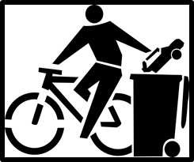
Answer
15.
16.

IV. Choose the best answer to fit each space in the passage. (1.5 pts)
The Importance of Music in Movies
Music is very important in movies ___________ (17) it helps tell the story and makes us feel different emotions. From exciting adventure films to sweet romantic movies, the right music can make us feel happy, sad, or scared. ___________ (18) like Hans Zimmer and John Williams create famous music that many people love.
A well-known example is the music in "Star Wars." The strong music helps us feel the excitement during battles and the bravery of the ___________ (19). In romantic films like "The Notebook," soft piano music can make us feel the love between the main figures.
Music can also help tell the story. Songs in movies can show how a character feels or give hints about what ___________ (20) next. For example, a sad song might mean something ___________ (21) is coming, while a happy song can show a fun moment.
In short, music and movies work together to help us understand and enjoy the stories we see ___________ (22) screen.
Answer
17.
18.
19.
20.
21.
22.
Question 17. A. although B. because C. because of D. so
Question 18. A. Singers B. Directors C. Composers D. Writers
Question 19. A. audiences B. directors C. authors D. characters
Question 20. A. will happen B. has happened C. happens D. had happened
Question 21. A. good B. bad C. exciting D. fun
Question 22. A. in B. at C. on D. from
FB: Thầy Đình (Dạy Tiếng Anh)

B. PHẦN TỰ LUẬN
V. Read the following passage, then do Task A and B (1.5 pts)
The Importance of a Good Living Environment
A good living environment is very important for our health and happiness. It includes clean air, safe water, and places where we can enjoy nature. A clean environment helps us stay healthy by reducing the chances of getting sick. For example, living in areas with low pollution can help us breathe better and avoid health problems.
Having access to nature is also important. Parks and gardens give us a place to relax and have fun. They encourage us to be active, which is good for our bodies. Spending time outside can also help reduce stress and make us feel happier.
Furthermore, a friendly community is part of a good living environment. When people feel safe and connected to their neighbors, it creates a feeling of belonging. Community events and activities can bring people together and strengthen friendships.
In summary, a good living environment is essential for our physical and mental health. By working to make our surroundings better, we can improve our lives and create a happier place for everyone.
Answer
23.
24.
25.
26.
27.
28.
TASK A: WRITE TRUE OR FALSE
Question 23. Parks and gardens do not contribute to our health. _______
Question 24. A friendly community can make people feel isolated. _______
Question 25. Spending time in nature can help reduce stress. _______
Question 26. A clean environment can lead to more health problems. _______
TASK B: CHOOSE THE CORRECT ANSWER
Question 27. What is one benefit of having access to parks and gardens?
A. They make people feel lonely B. They encourage physical activity
C. They create more pollution D. They reduce clean air
Question 28. Why is a friendly community important for a good living environment?
A. It makes people feel safe and connected
B. It keeps people apart
C. It reduces the number of parks
D. It causes stress
VI. Give the correct form of the words in brackets to complete the sentences. (1.5 pt)
Question 29. How much energy ________ does each model have? (efficient)
Question 30. ________ will be very pleased with the new products. (consume)
Question 31. The streets are filled with a ________ atmosphere when Tet comes. (joy)
Question 32. Speech ________ human being from the animals. (distinction)
Question 33. Thousands of people were ________ killed in that morning. (disaster)
Question 34. These accounts are used to sell fake or ________ goods. (exist)
ANSWER | 29. _______________ | 30. _______________ | 31. _______________
ANSWER | 32. _______________ | 33. _______________ | 34. _______________
VII. Look at the entry of the word “ pollution ” in a dictionary. Use what you can get from the entry to complete the sentences with two or three words. (0.5 pt)
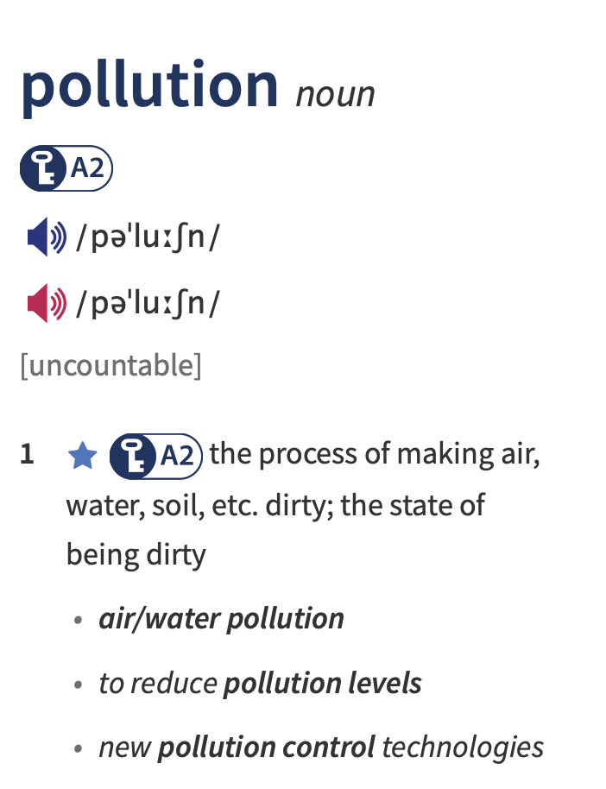
Question 35. Effective ________________ measures are essential to protect the environment and ensure the health of future generations.
Question 36. The ________________ in the city have decreased significantly due to recent environmental policies and community efforts.
 | 35. _______________ | 36. _______________
ANSWER

VIII. Rewrite these sentences so that they mean almost the same as before it. (1.0 pt)
Question 37. It’s a pity. I don’t have more time for my hobby.
I wish _________________________________________________________________________
Question 38. “Why don’t you come over there and help pick up the trash?” Jane said to Rob.
Jane suggested __________________________________________________________________
Question 39. They are living in a lovely house.
The house in __________________________________________________________________
Question 40. Though there are many energy-saving products, people don’t want to use them.
In spite of _____________________________________________________________________
ANSWER
37.
38.
39.
40.
-----THE END OF THE TEST-----

