**KIỂM TRA**

**MÔN: TIẾNG ANH 7**

**HK2 - Lần 3**

**Thời gian: 15 phút**

**PART 1: Write the words next to the pictures: (2.0pts)**



 

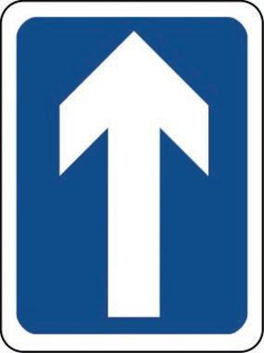 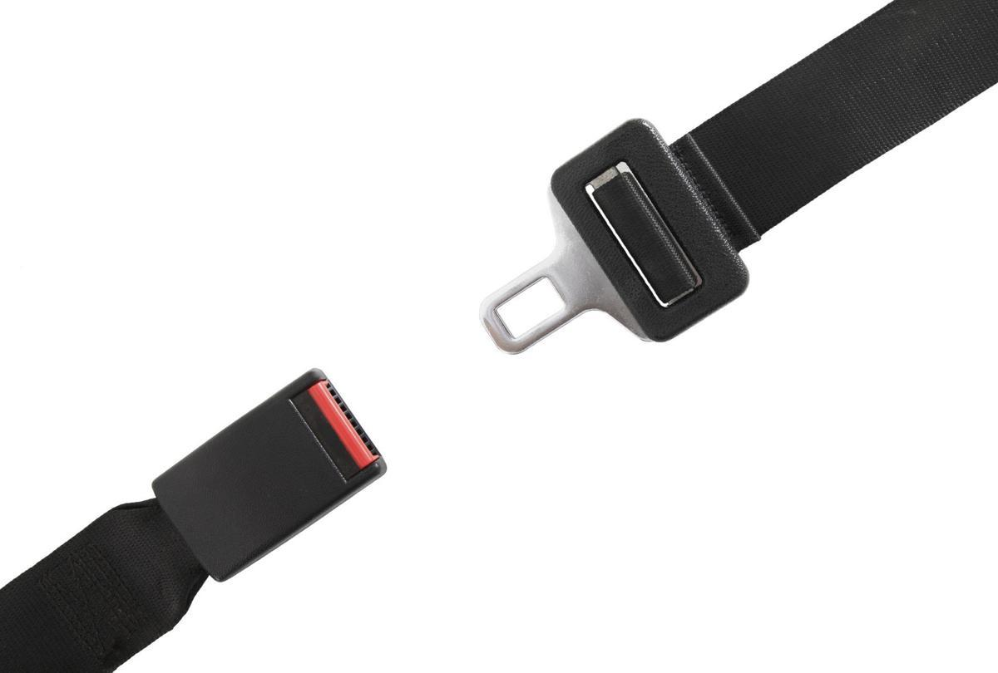

 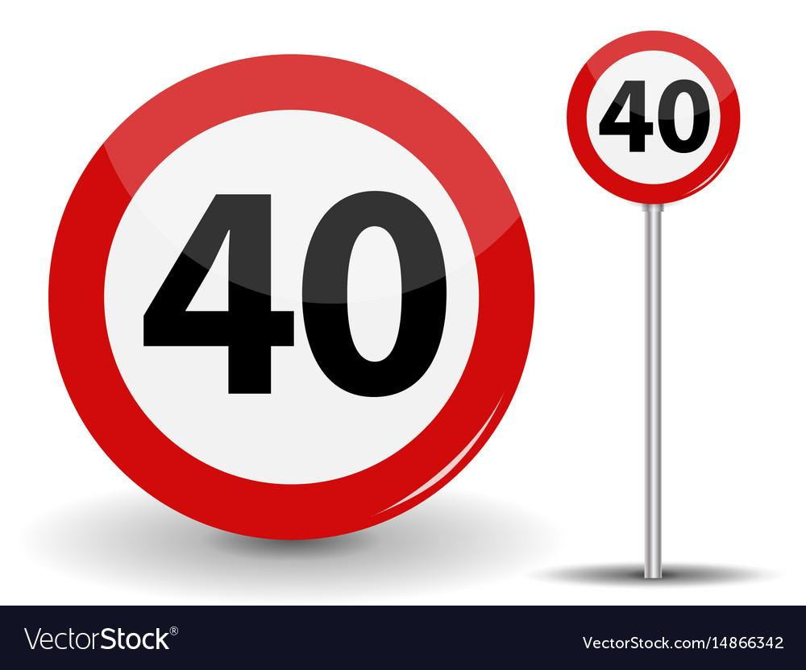

**PART 2: Use the words in the box to make phrases: (2.0pts)**



1. Bus ______________.
2. Subway ______________.
3. Train ______________.
4. Bus ______________.
5. Taxi ______________.

**PART 3:**

**A. Match the parts of the words and write them on the lines: (2.0pts)**

| steam | ship |  | 1. |
| --- | --- | --- | --- |
| air | car |  | 2. |
| horse | and cart |  | 3. |
| street | ship |  | 4. |
| side | car |  | 5. |

**B. Match the words in A with the correct descriptions: (2.0pts)**

1. People put it onto the side of our motorbike, so one more person could ride on it.  
   ___________
2. People used to use it to fly to other countries 100 years ago. ___________
3. People could put many things on this means of transportation, which was pulled by an animal. ___________
4. About 100 years ago, people traveled across the sea on this big boat, which used power from hot gas. ___________
5. It ran on electricity and moved on rails along the streets. ___________

**PART 4: Write the sentences using “used to” and the given information: (2.0pts)**

1. People/ travel/ around the city/ horse and cart.

____________________________________________________________________

1. My grandma/ travel/ airship.

____________________________________________________________________

1. You/ travel/ other countries/ steamship?

____________________________________________________________________

1. They/ not/ travel/ around the city/ streetcar.

____________________________________________________________________

1. People/ ride/ horses/ work.

____________________________________________________________________