Mã đề 9.1.6

ĐỀ KIỂM TRA GIỮA KỲ I
MÔN: TIẾNG ANH 9 – THỜI GIAN LÀM BÀI: 60 PHÚT

SECTION A: LISTENING (2.5 points)
1. What sport does Ben’s brother do?
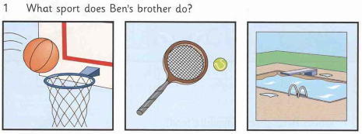
A. basketball B. tennis C. swimming
2. Where does Ben’s brother work?
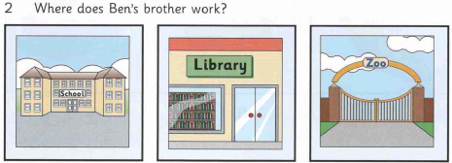
A. in a school B. in the library C. in the zoo
3. How did Ben go to his grandparents’ house?
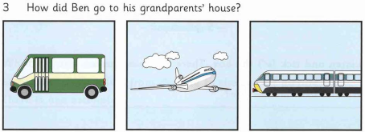
A. by bus B. by plane C. by train
4. What can Ben give his sister for her birthday?
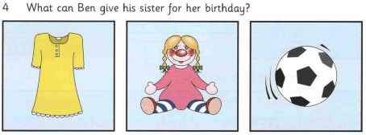
A. a dress B. a doll C. a ball
5. What’s Ben’s sister’s favourite food?
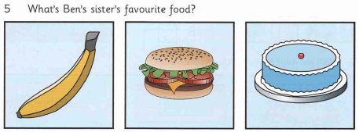
A. banana B. burger C. birthday cake
Part 2
2. Listen to the tape . Decide if the following statements are true (T) or false (F).
1. Time is the only waste caused by congestion.
2. In 2016, Bangkok was the city with the world’s biggest rush hour traffic delays. ……..
3. The traffic situation in Manila has been better than Bangkok.
4. The traffic situation of Bangkok in 2015 was better than in 2016.
5. The traffic situation of Mexico improved between 2015 and 2016.
SECTION B: LANGUAGE (2.5 points )
Choose the best option to complete each sentence . Circle A, B, C or D
1. Which has a different sound in the underlined part?
A. delighted B. continue C. medicine D. situation
2. Which has different stress pattern?
A. exhibition B. disappointed C. entertaining D. interesting
3. Our schools have put various kinds of __________ on us.
- homework B. pressures C. difficulties D. spirit
4.We feel __________to have a long summer holiday after a hard year of work.
A. delighted B. stressful C. embarrassed D. helpless
5. During adolescence, teens experience both emotional and __________ changes.
A. physical B.spiritual C.social D. sociable
6. He at 8 o’clock yesterday evening.
A. worked B. had worked C. was worked D. was working
7. I like living in the countryside. It’s _______ living in a town.
A. peaceful B. as peaceful
C. more peaceful than D. more peacefully than
8. Where __________ before you moved here?
A. did you work B. had you worked
C. were you working D. do you work
9. _____ he had met me twice before, he didn’t recognize me.
A. If B. Although C. However D. But
10. She asked me if I a laptop computer the following day.
- buy B. will buy C. bought D. would buy
SECTION 3: READING (2.5 points )
Part 1. Read the passage below and decide which option A, B, C or D best fits each space. (1.25 pt)
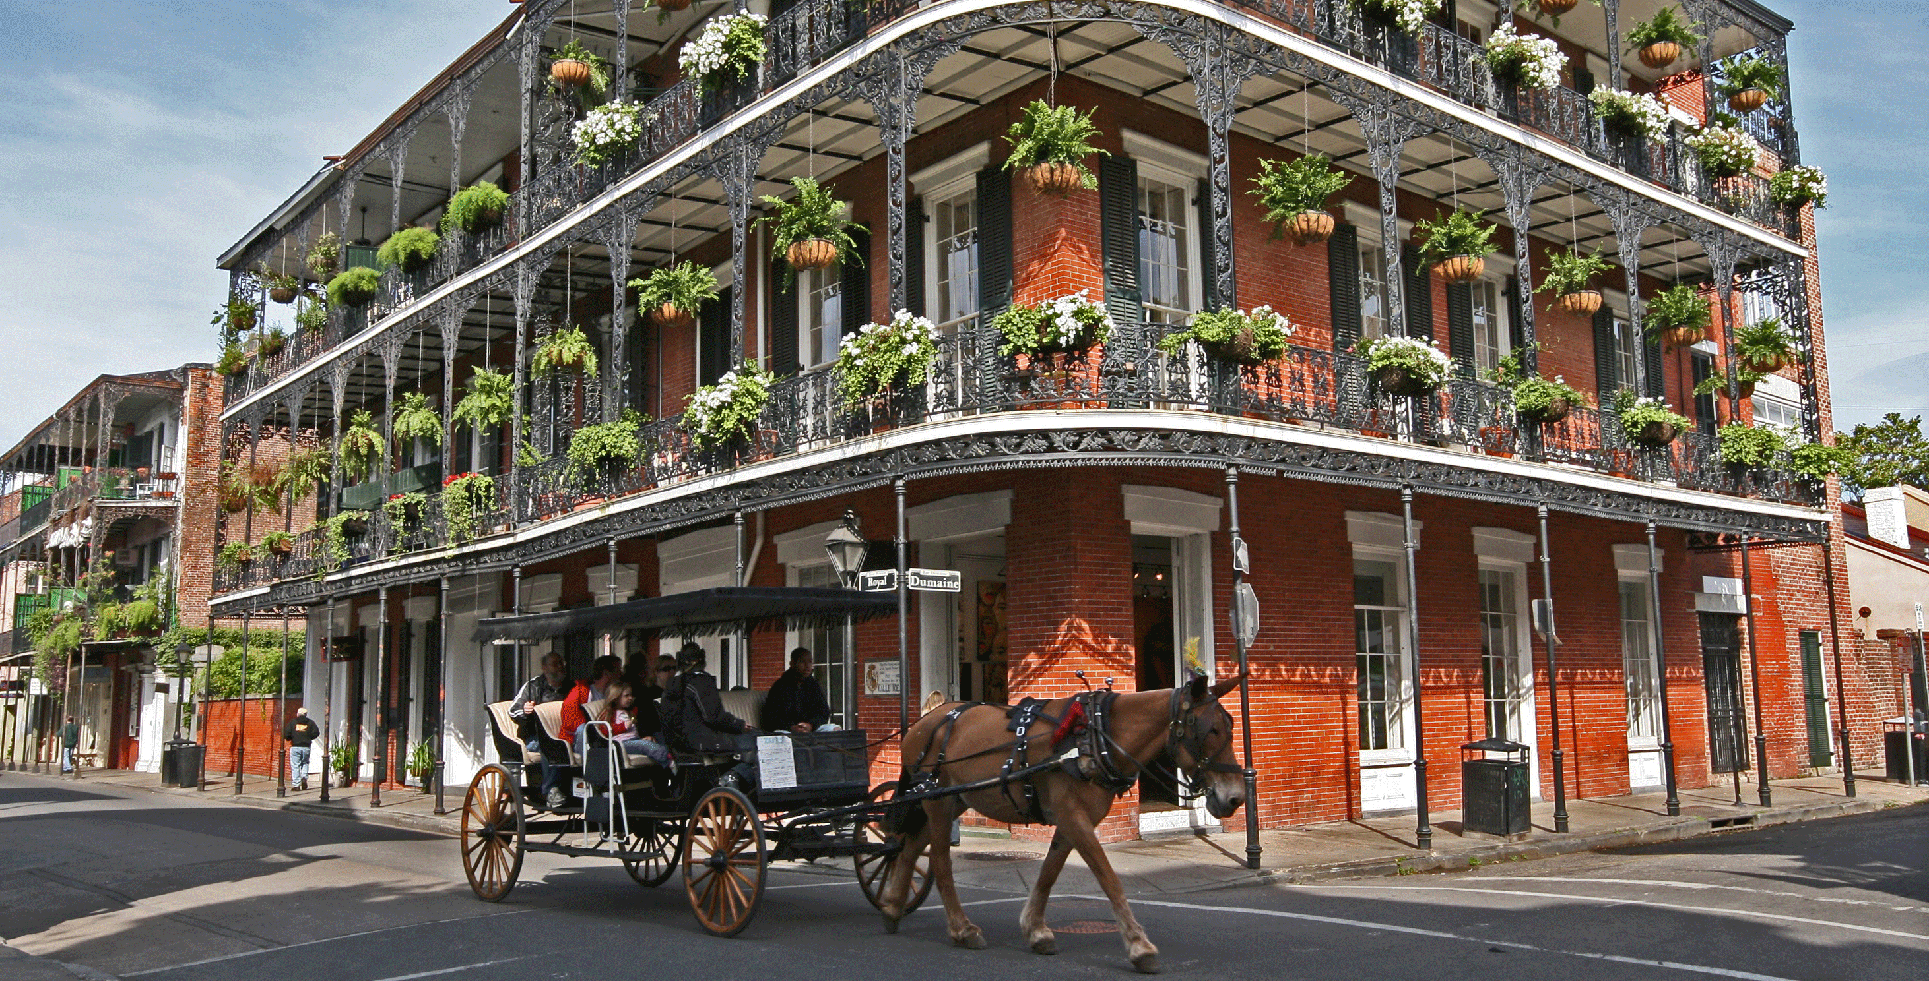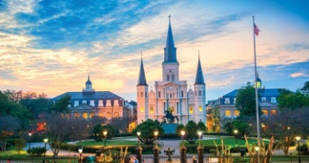
New Orleans is a city in the southern part of the US. It is (1) ……………. for its old-fashioned streets and buildings and jazz music. It used to (2) ……………. millions of tourists every year. But all of this have changed in August of 2005.
A nasty hurricane named Katrina hit the southern part of the US. New Orleans suffered the most damage (3) …………. the storm. New Orleans is a city but built (4) ……………. sea level, so it has levees-walls built to keep sea from flowing into land. However, Katrina destroyed these levees and the city eventually is flooded.
More than 100 people were dead and the city was totally destroyed. Houses were gone, buildings were ruined, and cars were damaged. Experts (5) ……………. that it will cost more than 26 billion dollars to rebuild the city.
1. A. good B. famous C. lovely D. beautiful
2. A. absorb B. keep C. attract D. call
3. A. with B. at C. of D. from
4. A. below B. under C. on D. at
5. A says B. sayed C. say D. said
Part 2. Read the following passage and choose the best answer to each question(1.25pt)
Read the passage. Circle A, B or C to answer each question.
More than 80% of American high school students work at part-time jobs in the evenings, on weekends or in summer. These part-time jobs bring teenagers great advantages.
One of the benefits of the work is the students can learn the skills that will be useful for the rest of their lives. When they work, they have to manage both the job and schoolwork. To be able to do so, they must be very organized and able to keep a sensible schedule. They also learn to cope with the job stress apart from the stress of the schoolwork. Some of the most stressful jobs include teaching, nursing, and police work. These skills help prepare teenagers for their later careers. High school students who work are more likely to succeed as adults than people who enter the job market at a later age with no work experience.
Teenagers want a lot of expensive things: clothes, mp3 players, trips with their friends, etc. Not all parents can afford them. And even if they can, the teens might not really appreciate that money because they did not earn it. When teenagers make money for themselves, they know its true and are less likely to spend it foolishly.
1. Which of the following is a good title for the passage?
A. Why teenagers should work
B. Advantages and disadvantages of part-time jobs
C. Part-time jobs cause stress
D. How teenagers should work
2. According to the passage, what is NOT an effect of part-time jobs?
A.Teenagers become organized.
B. Teenagers become stressed.
C. Teenagers are more likely to have successful careers.
D. Teenagers become strong.
3. The word “cope with” in the passage is closest in meaning to
A. fight against B. deal with
C. suffer from D. take part in
4. According to the passage, when teenagers have jobs, they are more likely to
A. spend foolishly B. want expensive things
C .appreciate money D. Want reasonable things
5. According to the passage, which of the following is TRUE?
A. Only some US students do part-time jobs.
B.US students suffer part-time job stress
C. Part-time jobs are somehow good for teenagers
D.US students suffer full-time job stress
SECTION D: WRITING (2,5 points)
Part 1. Choose the underlined word or phrase (A, B, C or D) that needs correcting.
( 0,5pt)
1. I don't know which to do to finish all these assignments on time.
A B C D
- He wonders why he had to be responsible for others' mistakes.
A B C D
Part 2 . Rewrite the following sentences using the suggested words so that the meanings stay the same. ( 1,0pt)
1. Mr Chapter said “ I am keen on eating apples ”
→ Mr Chapter said that………………………………………………………………
2. Mrs Huong visited Ha Long Bay last week.
→ Ha Long Bay …………………………………………………………………….
3. Although it rained heavily, he went to school with me yesterday.
→In spite ...........................................................................................……………….
4. Mrs Hang teaches English very well.
→Mrs Hang is ....................................................................................................……
5. I think Mrs Thuy is the most beautiful woman in the world.
→ I think no woman ……………………………………………………………….
Part 3. Write an email (100 - 120 words) to a friend of yours telling him/her about one city that you would like to visit the most.
Dear Nick,
1. I / write / tell / you / the city / I would like/ visit / most. Can / guess?
2. It/ Tokyo. I/ want/ go / Tokyo/ because / it / capital / Japan.
3. I / really want / discover / culture/ history. It / especially/ famous / cherry blossom / spring.
4. I / go there/ next February/ after finish / end-of-term examination.
5. Would/ you / go / there? Perhaps/ we / can/ set/ date / meet/ each other/ Tokyo. look forward/ hear/ you.
The end

ANSWER KEY

SECTION A: LISTENING (2.5 points )
Part 1. (5 x 0.25 = 1.25 points)
1. A | 2. C | 3. B | 4. C | 5. A
Part 2 . (5 x 0.25 = 1.25 points)
1. F 2. F 3. F 4. T 5. T
SECTION B: LANGUAGE (2.5 points )
Choose the best option to complete each sentence . Circle A, B, C or D
(10 x 0.25 = 2.5 points)
1.A 2. D 3.B 4. A 5.A 6.D 7.C 8.B 9.B 10. D
SECTION 3: READING (2.5 points )
Part 1. Read the passage below and decide which option A, B, C or D best fits each space.
(5 x 0.25 = 1.25 points)
1. B 2. C 3. D 4. A 5. C
Part 2. Read the following passage and choose the best answer to each question
(5 x 0.25 = 1.25 points)
- A 2. B 3. B 4.C 5. C
SECTION D: WRITING (2,5 points)
Part 1 .Choose the underlined word or phrase (A, B, C or D) that needs correcting.
(2 x 0.25 = 0.5 points)
- B. 2. A
Part 2. Rewrite the following sentences as directed ,so that the meanings stay the same. (5 x 0.2 = 1.0 point)
- Mr Chapter said ( that) he was keen on eating apples.
- Ha Long Bay was visited by Mrs Huong last week.
- In spite of the heavy rain, he went to school with me yesterday.
- Mrs Hang is a good English teacher.
- I think no woman in the world is as beautiful as Mrs Thuy.
Part 3. (5 x 0.2 = 1.0 point)
I am writing to tell you about the city that I would like to visit the most. Can you guess? It’s Tokyo. I want to go to Tokyo because it is the capital of Japan. I really want to discover its culture and history. It is especially famous for cherry blossom in spring. I will go there next February, after finishing end-of-term examination. Would you like to go there? Perhaps we can set the date and meet each other in Tokyo.
Looking forward to hearing from you.

****************THE END***************

