Period
LESSON PLAN
TIẾNG ANH 10 FRIENDS GLOBAL

UNIT 4: OUR PLANET
LESSON 4F: READING- GLIDERS IN THE STORM

I. OBJECTIVES:
By the end of the lesson, students will be able to predict the content
of a text and understand a text about a paraglider and the dangers of extreme weather.

1. Knowledge:
- Reading: An article about a paraglider who was caught in
a storm
- Vocabulary: Verbs of movement
- Grammar: Past Simple and Past Continuous
2. Ability:
- Main skills: reading and writing skills
- Sub skills: listening and speaking skills
* Predicting the content of a text; planning and acting out an interview with a paraglider.
3. Quality:
- Have a positive attitude in English language learning so that they can participate enthusiastically in all classroom activities, especially with the topic conducted by the teacher.
- Know how to make comparisons precisely

II. TEACHER AIDS AND LEARNING MATERIALS:
Lesson plan, PPT slides, student’s book, workbook, notebook, personal computer (if any), projector/TV, speakers, IWB software.

III. PROCEDURES:
A. Warm-up (10’)
a) Objective: Introduce the new lesson and set the scene for students to acquire a new language; get students' attention at the beginning of the class by utilizing enjoyable and short activities as well as engaging them in the steps that followed.
b) Content: Hangman Game
c) Outcomes: Students can gain more confidence and interest in the lesson.
d) Competence: communication, collaboration, prediction.
e) Organization of the activity:

TEACHER’S ACTIVITIES | STUDENT’S ACTIVITIES | CONTENTS
WARM-UP. (T- Ss/ S – S/ Indiv)  - Introduces the game and provides the topic is about Natural Disasters/ Weather.  - Shows the game on the screen and asks them to read the game instruction.  - Asks Ss to give questions if they don’t understand how to play.  - Divides class into teams.  - Has students to play 1 round first to do an example (if necessary)  - Creates a reward chart for the winning team.  - Leads-in to Section 1. | - Pay attention to the screen while listening to the teacher.  - Read the game rules and give questions to have a clearer understanding about the game (if any).  - Play the first round by looking at the picture and thinking of a word related to the picture.  - Open Student’s Book. | 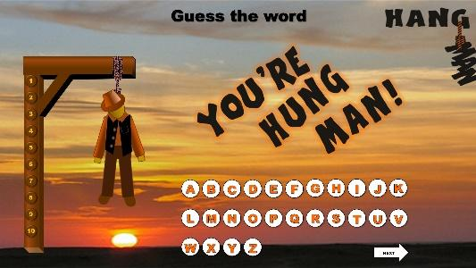  **Answer keys:  1. wind  2. thunderstorm  3. flood  4. lightning  5. temperature  6. hailstones  7. earthquake  8. tsunami

B. New lesson (75’)
- Activity 1: Lead-in (5’)
a) Objective: Have the students to guess about the content of the text through the title and the photo in the book.
b) Content: Students work in pairs and predict what happens in the text.
c) Outcomes: Students can practice speaking and discussing to express their ideas.
d) Competence: communication, presentation, discussion, critical thinking.
e) Organization of the activity:

TEACHER’S ACTIVITIES | STUDENT’S ACTIVITIES | CONTENTS
DISCUSSION (T-Ss/ S-S)  - Asks students to look at the photos and say what the weather is like.  - In pairs, students predict what they think happens in the text.  - Elicits ideas and writes them on the board. Ask them to give reasons for their predictions | - Pay attention and answer the question.  - Discuss with partner.  - Volunteer to answer the question and give the reason. | *Question: What’s the weather like?  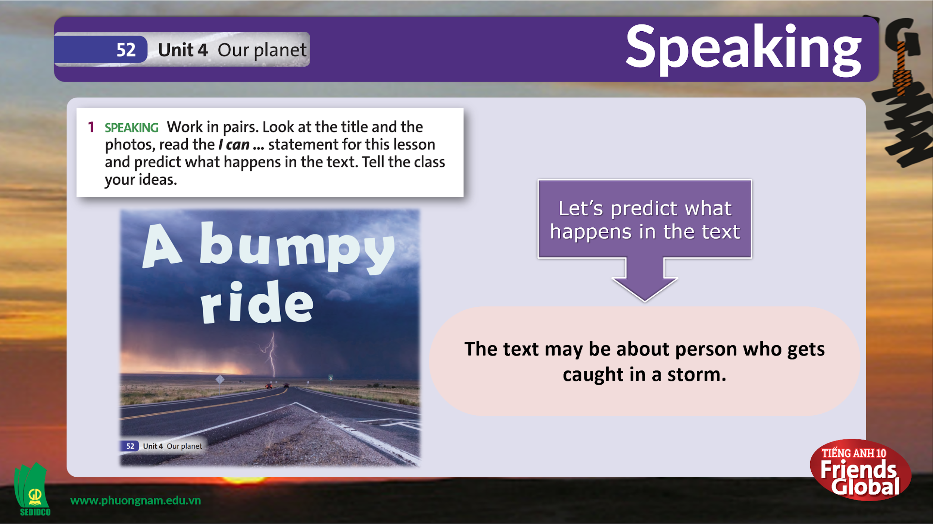  **Answer keys:  - Stormy/ Thunderstorm  - The text may be about the person who gets caught in a storm.

- Activity 2 Vocabulary (7’)
a) Objective: Students gain new words.
b) Content:
- Vocabulary: paraglider, to approach, to reach, to land, frostbite.
c) Outcomes: Ss know how to pronounce the new words precisely and use them in appropriate contexts.
d) Competence: communication, drilling
e) Organization of the activity:

TEACHER’S ACTIVITIES | STUDENT’S ACTIVITIES | CONTENTS
PRESENTATION.  (T-Ss/ S-S/ Indiv)  - Teaches new vocabulary.  - Uses pictures and explanations to present new words.  - Has the students practice their pronunciation drills. | - Pay attention to the slide and listen to the teacher.  - Look, listen and repeat in chorus and individuals.  - Write new words into notebook. | 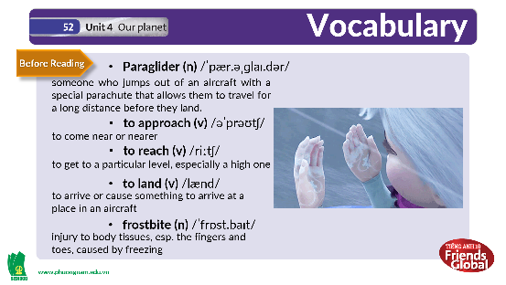  **New words:  paraglider, to approach, to reach, to land, frostbite
- Activity 3: Reading (15’)
a) Objective: Students can skim and scan for the main idea to answer questions and complete tasks. Critical thinking skills and communication can also be practiced.
b) Content: Section 2, 3 and 4.
c) Outcomes: Ss can practice reading skills, including skimming, scanning and predicting suitable answer keys. They can apply the structure of past simple to their conversations.
d) Competence: Collaboration, communication, critical thinking.
e) Organization of the activity:

TEACHER’S ACTIVITIES | STUDENT’S ACTIVITIES | CONTENTS
PRACTICE. (T- Ss/ S-S/ Indiv)  - Activity 2 (4’): Read the text.  - Has the Ss to read the text in silence and skim for the main idea.  - T can invite some Ss to read aloud the text.  - Asks Ss if they have an accurate prediction and decides which prediction was the most accurate.  - Activity 3 (4’): Reading strategy and Scanning.  - Has the Ss to read the Reading Strategy.  - T can invite some Ss to read aloud the Reading Strategy (optional).  - Goes through the strategy together.  - Tells students it is a good idea to read the words before after a gap, and then think about what type of word is needed in the gap.  - Has the students look at the sentences with gaps in the text and decide which ones contain a past simple verb.  - Checks answers as a class.  - Activity 4 (7’): Matching and filling in the gaps.  - Asks Ss to read the text again and guess what kind of information is missing.  - Has them to read through the phrases from A-H with gaps 1-8 in the text.  - Asks Ss to match the sentences with the gaps.  - Checks answers as a class. | - Read the text in silence and skim for the main idea.  - Volunteer to read the text aloud.  - Check their prediction.  - Read the Reading Strategy individually.  - Some Ss volunteer to read the Reading Strategy aloud.  - Pay attention and listen carefully when teacher elicits the ideas and meaning in the Strategy box.  - Ss can highlight key phrases in the strategy box based on the slide.  - Scanning for sentences with gaps begin with a verb in the Past Simple.  - Correct answer with teacher.  - Read the text carefully again and guess the missing information.  - Read through the phrases and the gaps in the text then match the sentences with the suitable gaps.  - Correct answers with teacher. | 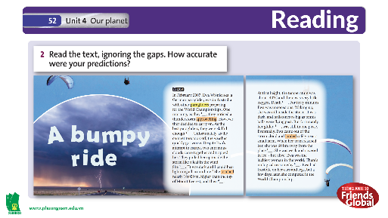  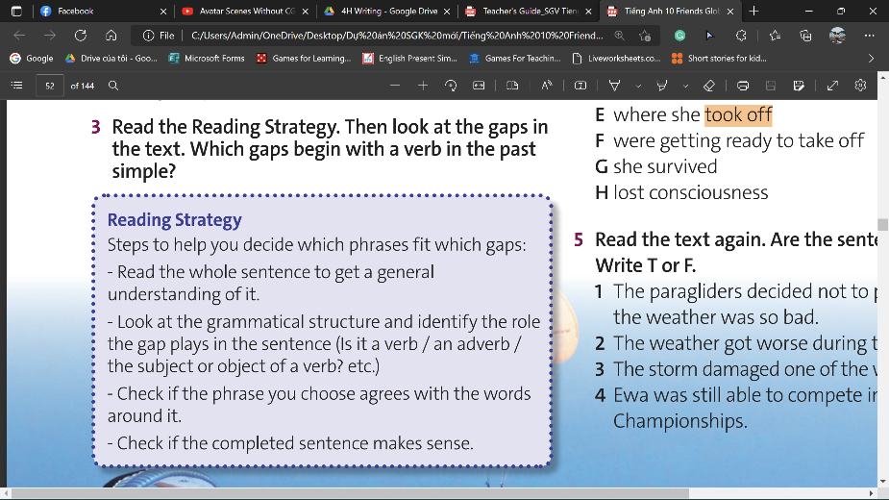  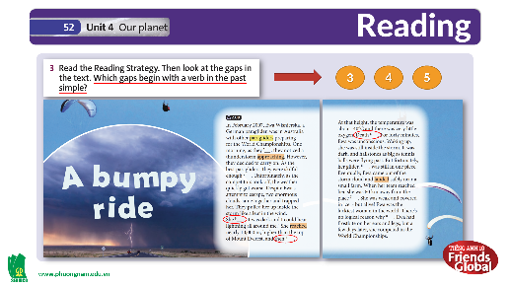  **Answer keys:  Gap 3,4 and 5  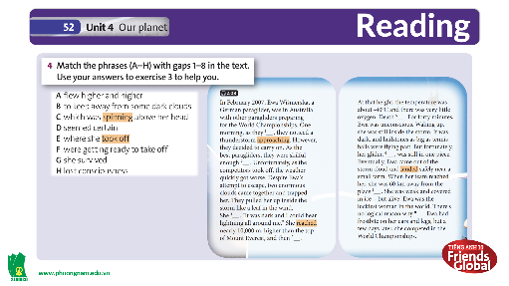  **Answer keys:  1.F 2.B 3.A 4.H  5.D 6.C 7.E 8.G

- Extra Activity: Tom & Jerry game (8’)
a) Objective: To sum up all the important information contained in the Reading text with a competitive game.
b) Content: Tom & Jerry Game – Each team answers the questions in order
c) Outcomes: Students can gain more confidence and remember the main ideas in the reading text.
d) Competence: communication, collaboration.
e) Organization of the activity:

TEACHER’S ACTIVITIES | STUDENT’S ACTIVITIES | CONTENTS
EXTRA ACTIVITY.  (T- Ss/ S – S/ Individual)  - Introduces the game and goes through the game rules.  - Asks Ss to give questions if they don’t understand how to play.  - Creates a reward chart for the winning team.  - Divides class into 2 teams.  - Leads into Section 5. | - Pay attention to the screen while listening to the teacher.  - Read the game rules and give questions to have a clearer understanding about the game (if any).  - Each team takes turns choosing the question and answer.  - Open Student’s Book – page 52. | 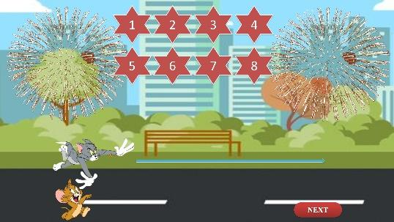  **Answer keys:  1. Australia.  2. two clouds.  3. about 10.000 metres.  4. about 40 minutes.  5. near a small farm.  6. She was too weak and confused.  7. She had frostbite on her ears and legs.  8. She competed in the World Championship.

- Activity 4: Practice (20’)
a) Objective: Students can answer the questions to critical thinking, and they can finish the tasks in the textbook. Critical thing skills (guessing/ reasoning) and communication can also be practiced.
b) Content: Section 5, 6 and 7.
c) Outcomes: Students can read and use the strategy in exams.
d) Competence: Collaboration, communication, critical thinking & presentation.
e) Organization of the activity:

TEACHER’S ACTIVITIES | STUDENT’S ACTIVITIES | CONTENTS
PRACTICE. (T- Ss/ S-S/ Indiv)  - Activity 5 (7’): True or False  - Asks Ss to read all the sentences from 1-4 and look for keywords.  - T can invite some Ss to read aloud the text. (optional)  - Asks Ss to read the text again and complete the task by writing True or False.  - Check answers as a class.  - Activity 6 (8’): Vocabulary.  - Asks students to look at the highlighted verbs in the text and try to work out their meaning from the context.  - Has the students to match the verbs to their meanings.  - Checks answers as a class and invites Ss to correct the task.  - Move on to the Extra exercise  - Asks Ss to complete the exercises with all the previous verbs.  - Checks answers as a class and invites Ss to correct the task.  - Activity 7 (5’): Past Continuous & Past Simple.  - Goes through the instructions together and makes sure students understand what they have to do.  - 1st rewrite all the questions in a complete form.  - Remind them to use the past continuous to describe background events, and the past simple to describe a sequence of events.  - In pairs, students write their questions and answers.  - Monitor and check that students are forming their questions and answers correctly. | - Read the sentences in silence and identify the keywords.  - Volunteer to read the sentences loudly.  - Read the text again and complete the task.  - Correct the task with class.  - Read through the highlight verbs in the text and figure out their meanings from the context.  - Complete the task.  - Ss volunteer to correct the task.  - Ss open their notebook to write down the exercises and complete them.  - Ss volunteer to correct the task.  - Read the instructions carefully and listen for teacher's guidance.  - Rewrite all the questions into the notebook.  - Review the Past continuous and Past simple to apply in the task.  - Work in pairs and complete the task.  - Correct answers with teacher. | 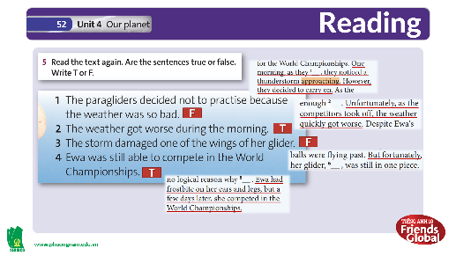  **Answer keys:  - False  - True  - False  - True  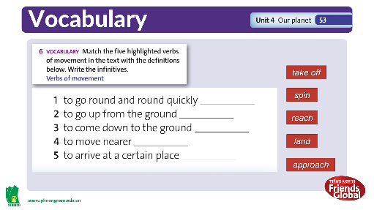  **Answer keys:  - spin  - take off  - land  - approach  - reach  **Answer keys:  1. spin 2. take off  3. spin 4. reach  5. land 6. approach  7. take off 8. Reach  9. approach 10. land  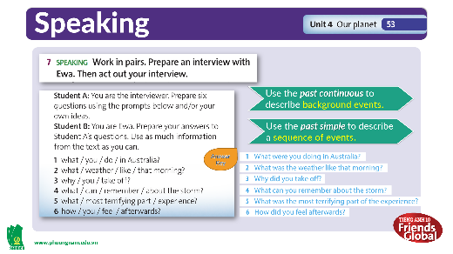  **Answer keys:  - What were you doing in Australia?  - What was the weather like that morning?  - Why did you take off?  - What can you remember about the storm?  - What was the most terrifying part of the experience?  - How did you feel afterwards?

- Activity 5: Outcomes (20’)
a) Objective: Students make an interview and act out for the class.
b) Content: Section 7 – Students work in pairs to act out as an interviewer and Ewa, to ask and answer some questions about the experiences of a paraglider.
c) Outcomes: Students can practice having a dialogue and gain more confidence in daily communication.
d) Competence: communication, collaboration.
e) Organization of the activity:

TEACHER’S ACTIVITIES | STUDENT’S ACTIVITIES | CONTENTS
INTERVIEW. (S – S/ T- S)  - (2’) Introduces the activity and asks Ss to choose their role (Interviewer or Ewa)  - (6’) Asks Ss to practice before volunteering to come front and present.  - (6’) Invites some pairs to come front and act out.  - (6’) Listens and provides the completed answers. | - Pay attention to the teacher's instruction.  - Each pair decides who will be the interviewer or Ewa.  - Practice the dialogue with partner for 2-3 mins.  - Volunteer to come front and act out.  - Rest of the class listens to other pairs and corrects their work. | 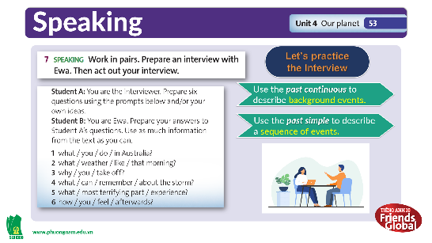  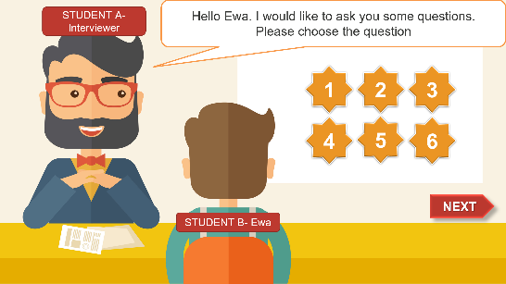  **Answer keys:  1. I was preparing for the World Championships.  2. A thunderstorm approached when we were getting ready to take off.  3. I think I was skillful enough to keep away from the dark clouds.  4. It was dark and I could hear  lightning all around me.  5. I was terrified when I reached nearly 10,000 m, higher than the top of Mount Everest, and then lost consciousness.  6. I felt that I was the  luckiest woman in the world.

C. Consolidation (3’)
a) Vocabulary: Verb of actions and movements
b) Grammar: Past Continuous and Past Simple

D. Homework (2’)
- Learn by heart all the new words.
- Review past continuous and past simple.
- Do exercises in Workbook.
- Prepare: Unit 4G – Speaking (P.54).

