**APPENDIX**

|  |  |  |
| --- | --- | --- |
| **No.** |  | **Page** |
| **1** | **I. Title and scope** | 2 |
| **2** | **II. Content**  **II.1 Problem**  **II.1.1 Description of traditional teaching method**  **II.1.2 Advantages**  **II.1.3 Disadvantages**  **II.2 Solutions**  **II.2.1 Solutions**  **II.2.1.1 Group common irregular verbs with the same pattern together**  **II.2.1.2 Learn with songs**  **II.2.1.3 Turn memorizing into games**  **II.2.1.4 Leave the list where students can see them**  **II.2.2 Advantages of applied solutions** | 2  2  2  2  2  3  3  3  5  5  7  8 |
| **3** | **III. Effectiveness** | 8 |
| **4** | **IV. Conditions and application** | 10 |
| **5** | **V. Commitment** | 10 |

**A REPORT ON SOLUTIONS**

**TO IMPROVE QUALITY OF TEACHING**

**AND LEARNING ENGLISH AS A FOREIGN LANGUAGE**

**AT DONG GIAO LOWER SECONDARY SCHOOL**

**I. Title and scope**

Title: **How to learn the most 75 commonly used irregular verbs quickly, easily and effectively.**

Scope: **English**

**II. Content**

**II.1. Problem**

**II.1.1. Description of traditional teaching method.**

A lot of language learners ask: “why do we need all these irregular verbs?” They only make things more complicated. However, irregular verbs are inherent parts of English language, and whether you like learning them or not you have to learn these verbs. Because you will not be able to write a proper essay or have a conversation without them. In fact, most of common verbs in English language are irregular and even the most 10 often used verbs are irregular, such as “*to be*” and *“to have”*. The question that troubles minds of not only most of the English learners but also teachers and students at Dong Giao Lower Secondary school is how to learn irregular verbs effectively.

Traditionally, we used to provide students with a list of selected irregular verbs in alphabetical order at the beginning of a new school year, then we helped them read the words and asked them to learn by heart at home.

**II.1.2. Advantages**

With this list, students can focus on a smaller number of verbs so they can learn more easily.

**II.1.3. Disadvantages**

Only about 40% of students can remember the verbs with difficulty and the rest are able to remember some of the verbs only. This is due to a combination of reasons:

First, the number of verb is still large, which prevents students from remembering all of them.

Second, each word has its own rule to form past and participle and that confuses students. As a result, they cannot remember 3 forms of these verbs. This prevents students from learning language well, especially when they meet problems related to tenses of the verbs.

Finally, teachers also do not pay enough attention to irregular verbs.

After realizing these problems and to meet the demand for teaching renovation process of the 2018 General Education Program, paying attention to students’ work and skill development, we have found out solutions to address these issues, named: “How to learn the most 75 commonly used irregular verbs quickly, easily and effectively.”

**II.2. Solutions**

**II.2.1. Solutions**

**II.2.1.1 Group common irregular verbs with the same pattern together**

Irregular verbs don’t have common rules for all. However, some of the verbs follow a similar pattern. That is the reason why instead of teaching the verbs in alphabetical order, we select the most 75 commonly used irregular verbs and put them in 9 groups as follow:

(see **APPENDIX 1)**

Group 1: Verbs are the same in 3 forms

Group 2 : Verbs need to add “t” when we change in to past and past participle form

Group 3: Verbs remove “d” and add “t” when we change into past and past participle form

Group 4: Verbs contain “I-A-U”

Group 5: Verbs contain “ew - own”

Group 6: Verbs have the same infinitive and past participle form

Group 7: Verbs change in to past participle by adding “en” or “n

Group 8: Verbs have similar past and participle form

Group 9: Verbs are different in 3 forms (without any rule)

We teach these groups in 7 periods. Each period lasts around 10 minutes and these periods are performed at the beginning of afternoon lessons. These groups of irregular verbs are taught from low to higher level of difficulty.

Period 1: Group 1+2

Period 2: Group 3+4

Period 3: Group 5+6

Period 4: Group 7

Period 5+6: Group 8

Period 7: Group 9

To teach these verbs effectively, we provide students with selected commonly used irregular verbs, then we help them read the verbs in chorus then individually. It is significant to teach students the pronunciation of the words before their spelling because when students remember how to pronounce the verbs, they can write them much more easily. For example, in group 8 the verbs have the same past and participle form and pronunciation, which is also the common pattern of most irregular verbs, so if they remember the past pronunciation and spelling of the verbs, they can write past participle without difficulty.

Furthermore, we use some interesting ways like clips, actions, contexts, explanations, games and some other techniques to teach and check the meanings of verbs.

Then we ask them to write down the verbs in their note books. While they are writing, we ask them to recognize the rule to change the form of the verbs. The fact that teachers group the verbs having the same rule and ask students to find out the rules themselves makes students be enthusiastic in learning. And they see that irregular verbs also have their own rules to form. It is not as difficult as its name.

Here is demo of teaching group 4 **(watch clip no.1)**

**II.2.1.2. Learn with songs**

Another great way to teach the words more effectively is through using music. Music is helpful for learning these verbs because students can hear, see and sing the words in context. You can find many songs to remember irregular verbs on YouTube, and here are some:

- <https://www.youtube.com/watch?v=xO5Lu4Skzcg>

- <https://www.youtube.com/watch?v=jMPgMH-7-jU&t=48s>

- <https://www.youtube.com/watch?v=Ov2v50af7bo>

We often encourage student to create their own songs, and they tend to prefer rap music and make some beautiful ones. **(watch clip no.2** **and clip no.3)**

**II.2.1.3. Turn memorizing into a game**

We also create the environment that students can learn the verbs via playing games. Here are some games that we often use:

1. **Flashcards**

An interesting game is using Flashcards. It is very easy to prepare but has a lot of benefits. Students can make flashcards with irregular verbs, put all the flashcards with their backs up, in a pile, then teacher asks students to work in groups and take turn to pick up one flashcard and say the 3 forms and the meaning of the verb aloud. The number of verbs for each game is 10 or more if they want more challenge. Time for each game is 1 minute. The students having the most cards will receive a present.



1. **Online games**

In addition to that, we also use some games online to make remembering the verbs fun and easy. For example, the MacMillan Dictionary has a verb wheel, and Quia has challenge board. We use these games to check if students remember the forms of the verbs

https://www.macmillandictionary.com/us/verb_wheel

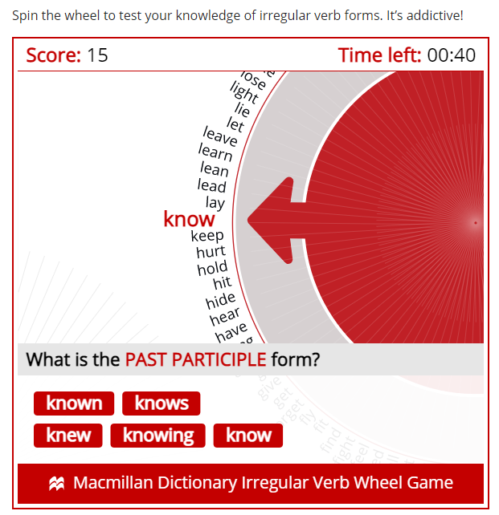

<https://www.quia.com/cb/8111.html>

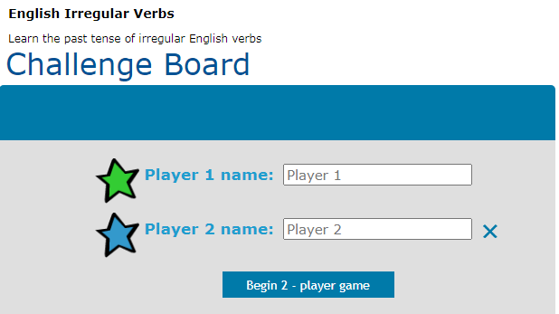

1. **Chain game.**

It might be easier to remember the words when they are a part of a sentence or a phrase. Learning words by putting them into sentences, students will also learn how to use them correctly. To learn the word “learn”, for example, we can use sentences like this: “Every day I learn English, yesterday I learnt English, I have learnt English for 5 years.” We ask students to be creative to make short sentences or they can create an entire story, using as many irregular verbs as they can. For these activities, we let students work in groups of 5 and ask them to play “chain game” to compete among groups. Each student from each group will use an irregular verb with 3 forms in 3 sentences. Time for each group is 1 minute. In groups, students take turn to say their sentences. The group having the most suitable sentences will win the game.

**II.2.1.4. Leave the list where students can see them**

We ask students to make a mind map of the most 75 commonly used irregular verbs and stick it at the study corner so that they can see them whenever they study there. This creates opportunity for students to be exposed to irregular verbs, making these verbs familiar to students. Here are some products:

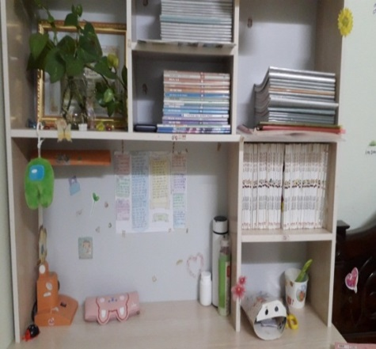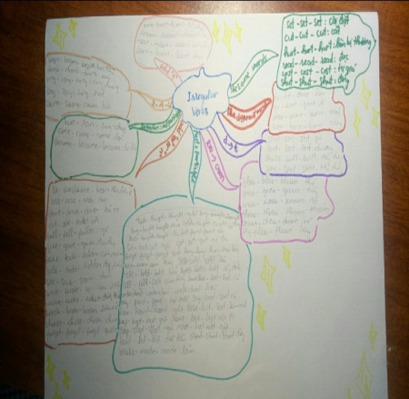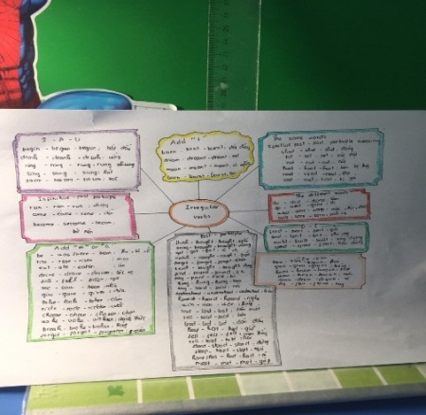

**II.2.2. Advantages of applied solutions**

Learning irregular verbs in these ways helps students memorize words not only more easily and quickly but also effectively. Because they have chances to practise and use these verbs again and again through various, interesting activities.

Teaching irregular verbs in these ways is not difficult to carry out because teaching materials which include handouts and video clips are not costly and time consuming at all. These techniques help teachers not waste a lot of time and money on preparation. Moreover, it is suitable for teaching innovation process.

**III. Effectiveness**

The following outcomes were attained by teachers and students at Dong Giao Lower Secondary School as a result of the implementation of the theme: How to learn the most 75 commonly used irregular verbs quickly, easily and effectively.

**-More students can memorize and use common irregular verbs correctly.**

Students have different ways to learn common irregular verbs. Therefore, most of students no longer make mistakes when they use common irregular verbs. They can speak and write these verbs correctly. As the result, their grades have been getting better and better.

The number of student can remember and use irregular verbs before and after applying the solutions in school year 2021 - 2022:

|  |  |  |  |  |
| --- | --- | --- | --- | --- |
| **No** | **Class** | **Number of students** | **Before applying the solutions** | **After applying the solutions** |
| 1 | 7D | 45 | 17 (37% ) | 39 (85%) |
| 2 | 7E | 45 | 18 (40 %) | 41 (90%) |
| 3 | 7G | 45 | 19 (39%) | 1. (85%) |

**-Students actively participate in learning activities and enjoy learning English**

Students can have fun while they are learning through songs and games with their friends. They also feel satisfied when they can design and create their own mind map to learn words at home. In other words, excitement stimulates students' activities and makes them interested. They become the center, the subject of learning activities. High productivity is the end result of all of these efforts. These activities have encouraged the students’ self-study, creativity and love for learning English, which are considered as indispensable competences and attributes of the era of technology.

-**Students’ speaking and writing skills have been improved remarkably**

When students can use irregular verbs correctly, they feel more confident when speaking and writing in English. Mastering irregular verbs, they can understand, learn and use different tenses, voices, conditional sentences, reported speech and other grammatical points. It is one of the reason why Dong Giao Lower Secondary school remains stable as one of the best schools with high average English marks at high school entrance exams.

**IV. Conditions and application**

These methods can be applied in terms of facilities at Dong Giao Lower Secondary school and other secondary in Tam Diep city, according to the survey. School should set aside a suitable amount of time each week for pupils to review English at the beginning of the academic year. Regarding to the human resource, the majority of English teacher are young, vibrant individuals who are constantly seeking out and learning new approaches.

These activities are designed to suit all students’ levels and abilities. However; the teacher needs to consider the level of difficulty of the tasks in each activity. In this school year, I apply these strategies in classes 8I, 8K, 9B, 9C, 6A.

The above ideas are my points of view which hopefully contribute to improving the students’ ability to remember and use irregular verbs in particular and learn English well in general. Although the use of these techniques have some effects on my teaching process, there are some disadvantages. I hope to have advice from education administrators as well as colleagues to make the techniques more effectively.

**V. Statement of original authorship**

I make a commitment that this measure is firstly used to participate in a competition and has never been considered any individual award before.

*Tam Diep, 20thSeptember, 2022*

|  |  |
| --- | --- |
| **Certified by the head of organization** | **Teacher** |
|  |  |

**APPENDIX 1**

**Group 1: Verbs are the same in 3 forms**

|  |  |  |  |
| --- | --- | --- | --- |
| **Infinitive** | **past** | **Past participle** | **Meaning** |
| let | let | let | để cho |
| cut | cut | cut | cắt |
| hurt | hurt | hurt | làm bị thương |
| read | read | read | đọc |
| cost | cost | cost | trị giá |
| shut | shut | shut | đóng |

**Group 2 : Verbs need to add “t” when we change into past and past participle form**

|  |  |  |  |
| --- | --- | --- | --- |
| **Infinitive** | **Past** | **Past participle** | **Meaning** |
| burn | burnt | burnt | đốt cháy |
| dream | dreamt | dreamt | mơ |
| mean | meant | meant | có nghĩa |
| learn | learnt | learnt | học |

**Group 3 : Verbs remove “d” and add “t” when we change into past and past participle form**

|  |  |  |  |
| --- | --- | --- | --- |
| **Infinitive** | **Past** | **Past participle** | **Meaning** |
| send | sent | sent | gửi |
| lend | lent | lent | cho vay, cho mượn |
| build | built | built | xây dựng |
| spend | spent | spent | tiêu,dành |

**Group 4 : Verbs contain “I-A-U”**

|  |  |  |  |
| --- | --- | --- | --- |
| **Infinitive** | **Past** | **Past participle** | **Meaning** |
| begin | began | begun | bắt đầu |
| drink | drank | drunk | uống |
| ring | rang | rung | rung, reo |
| sing | sang | sung | hát |
| swim | swam | swum | bơi |

**Group 5: Verbs change from “ew” to “own” in past and past participle form**

|  |  |  |  |
| --- | --- | --- | --- |
| **Infinitive** | **Past** | **Past participle** | **Meaning** |
| blow | blew | blown | thổi |
| grow | grew | grown | trồng, mọc, lớn lên |
| know | knew | known | nói |
| throw | threw | thrown | ném |
| draw | drew | drawn | vẽ |
| fly | flew | flown | bay |

**Group 6 : Verbs have the same infinitive and past participle form**

|  |  |  |  |
| --- | --- | --- | --- |
| **Infinitive** | **Past** | **Past participle** | **Meaning** |
| run | ran | run | chạy |
| come | came | come | đến |
| become | became | become | trở nên |

**Group 7 : Verbs change into past participle by adding “en” or “n**

|  |  |  |  |
| --- | --- | --- | --- |
| **Infinitive** | **Past** | **Past participle** | **Meaning** |
| be | was/were | been | là, thì,ở |
| rise | rose | risen | mọc |
| drive | drove | driven | lái xe |
| eat | ate | eaten | ăn |
| fall | fell | fallen | ngã |
| give | gave | given | đưa cho, tặng |
| take | took | taken | cầm, nắm |
| ride | rode | ridden | đạp,cưỡi |
| See | saw | seen | nhìn |
| write | wrote | written | viết |
| wake | woke | woken | đánh thức |
| break | broke | broken | làm vỡ |
| choose | chose | chosen | chọn |
| forget | forgot | forgot/forgotten | quên |

**Group 8 : Verbs have similar past and participle form**

|  |  |  |  |
| --- | --- | --- | --- |
| **Infinitive** | **Past** | **Past participle** | **Meaning** |
| think | thought | thought | nghĩ |
| bring | brought | brought | mang |
| buy | bought | bought | mua |
| catch | caught | caught | bắt |
| teach | taught | taught | dạy |
| find | found | found | tìm |
| Sit | sat | sat | ngồi |
| get | got | got | có được, đến được |
| forget | forgot | forgot | quên |
| hang | hung | hung | treo lên |
| win | won | won | thắng cuộc |
| sell | sold | sold | bán |
| tell | told | told | bảo |
| hold | held | held | cầm, nắm, tổ chức |
| feel | felt | felt | cảm thấy |
| have/has | had | had | có |
| understand | understood | understood | hiểu |
| pay | paid | paid | trả tiền |
| Say | said | said | nói |
| hear | heard | heard | nghe |
| lose | lost | lost | làm mất |
| keep | kept | kept | giữ |
| leave | left | left | rời đi |
| sleep | slept | slept | ngủ |
| meet | met | met | gặp |
| lead | led | led | dẫn đầu |
| stand | stood | stood | đứng |
| understand | understood | understood | hiểu |
| make | made | made | làm |

**Group 9 : Verbs are different in 3 forms**

|  |  |  |  |
| --- | --- | --- | --- |
| **Infinitive** | **Past** | **Past participle** | **Meaning** |
| do | did | done | làm |
| go | went | gone | đi |
| wear | wore | worn | mặc |
| bear | bore | born | sinh ra |