Thời gian làm bài: 40 phút (Không kể thời gian giao đề)
-------------------------
Họ tên thí sinh: .................................................................
Số báo danh: ......................................................................
Mã Đề: 033.
Câu 1. Look at the signs. Choose the best answer for the question.
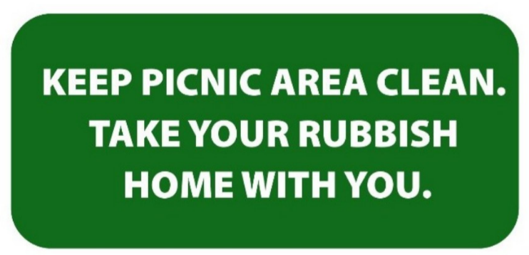
A. You should not leave any rubbish in the picnic area.
B. You can go home with all of the rubbish from the picnic area.
C. You must clean the picnic area before you go home.
D. If you find rubbish in the picnic area, you should clean it.
Câu 2. We're hiring!
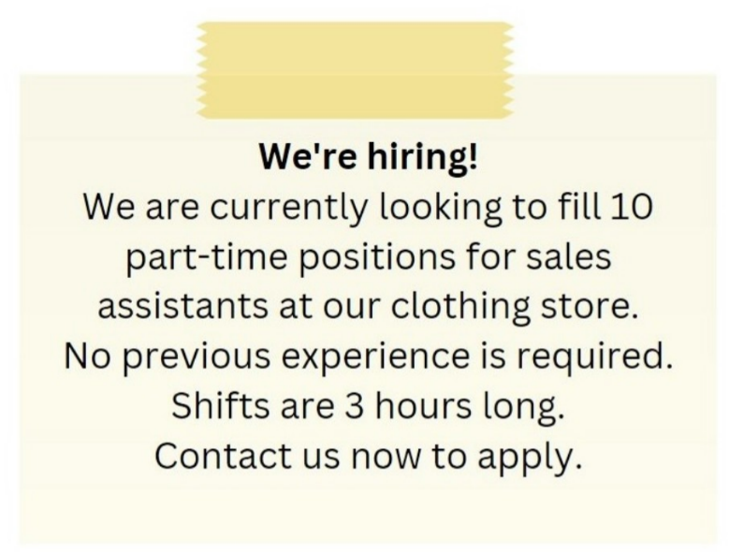
A. No previous experience is required, and the shifts are 3 hours long.
B. The shifts are 8 hours long.
C. Previous experience is required for the sales assistant positions.
D. There are 5 part-time positions available.
Câu 3. What is the main reason Emma cannot attend Dorothy's birthday party?
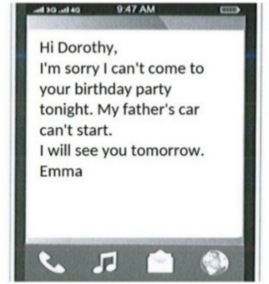
A. She forgot about the party B. She is sick
C. She has another commitment D. Her father's car won't start
Câu 4. Look at the signs. Choose the best answer for the question.
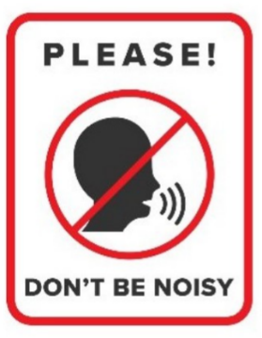
A. You shouldn’t speak to anyone in this area. B. You don’t have to raise your voice in this area.
C. You mustn’t talk in this area. D. You must be quiet in this area.
Câu 5. What activities will be allowed when the pool reopens?
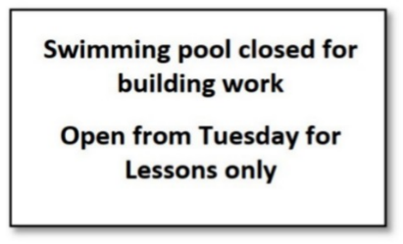
A. Only swimming lessons B. The notice doesn't specify allowed activities
C. All regular activities D. Building work and swimming lessons
Câu 6. What is Peter asking Helen to bring to the barbecue?
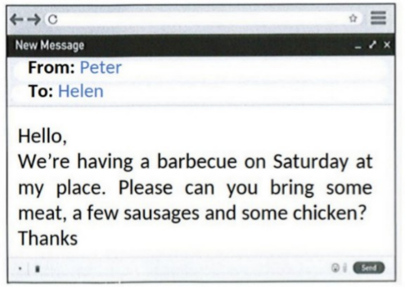
A. Drinks and salad B. Bread and condiments
C. Dessert and side dishes D. Meat, sausages, and chicken
Câu 7. Look at the signs. Choose the best answer for the question.
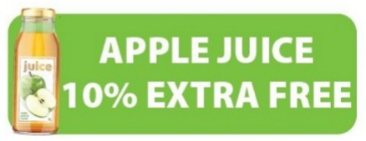
A. People can have more apple juice at the same price.
B. There is 10% of extra apple in this juice.
C. People can have free apple juice.
D. The apple juice is 10% free.
Câu 8. Why has Jenna left a note for Marcus?
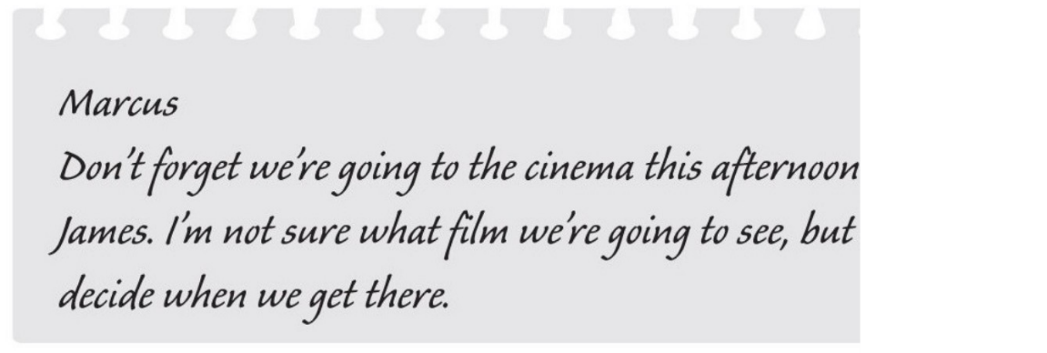
A. to remind him about an arrangement B. to choose the cinema
C. to suggest a film which they could see D. to invite him to the cinema
Câu 9. Look at the signs. Choose the best answer for the question.
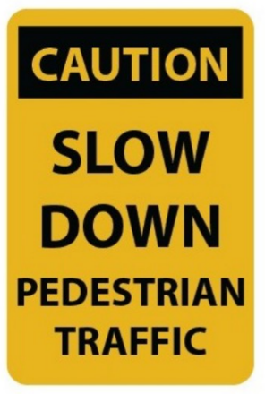
A. You should slow your speed and pay attention to pedestrians.
B. You should drive carefully because of slow pedestrians.
C. Pedestrians will slow down the traffic.
D. Pedestrians should walk slowly.
Câu 10. What does this sign mean?
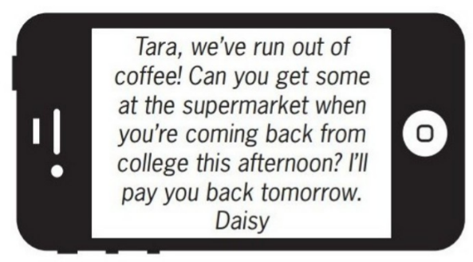
A. Tara will go to the supermarket tomorrow.
B. Daisy wants Tara to buy some coffee this afternoon.
C. Daisy will buy coffee tomorrow when she returns home.
D. Tara should give Daisy some money to buy coffee.
----HẾT---

