UNIT 1: FAMILY LIFE
Lesson 1: Getting started – Household chores

I. OBJECTIVES
By the end of this lesson, Ss will be able to gain:
1. Knowledge
- an overview about the topic Family life;
- vocabulary to talk about household chores.
2. Core competence
- develop communication skills;
- be collaborative and supportive in pair work and teamwork;
- actively join in class activities.
3. Personal qualities
- be aware of responsibilities towards family

II. MATERIALS
- Grade 10 textbook, Unit 1, Getting started
- Computer connected to the Internet
- Projector/ TV/ pictures and cards
- hoclieu.vn

Language analysis
Form | Pronunciation | Meaning | Vietnamese equivalent
1. household (a) | /ˈhaʊshəʊld/ | relating to a house or flat and the people who live there | trong gia đình, dùng trong gia đình
2. chore (n) | /tʃɔːr/ | a job or piece of work that needs to be done regularly | việc vặt

Assumptions
Anticipated difficulties | Solutions
- Students may not know the household chores.  - Students may not know how to work in teams. | - Use pictures/ photos or videos of some household chores to show them in the class.  - Give short, clear instructions and help if necessary.

Board Plan
Date of teaching
Unit 1: FAMILY LIFE
Lesson 1: Getting started – Household chores
* WARM-UP
Game: Let’s race!
I. Vocabulary
1. household (adj) /ˈhaʊs.həʊld/: trong gia đình, dùng trong gia đình
2. chore (n) /tʃɔːr/: việc vặt (thường được dùng ở số nhiều: chores)
II. Practice
Task 1: Listen and read.
Task 2: True or false.
Task 3: Fill in the table.
Task 4: Complete the sentences.
III. Production:
Make a poster

III. PROCEDURES
Notes:
In each activity, each step will be represented as following:
* Deliver the task
** Implement the task
*** Discuss
 Give comments or feedback

Stage | Stage aim | Procedure | Interaction | Time
WARM-UP | - To introduce the unit topic (Family life);  - To introduce some vocabulary and the grammar points to be learnt in the unit. | GAME: LET’S RACE!  * T divides Ss into 4 groups and gives instructions: Watch the video clip and try to remember all the household chores Mr. Bean did in the video. One person from each group then goes to the board and writes the names of the chores.  ** Ss do as instructed.  *** Ss work in pairs to discuss the answer after watching the clip, then one representative from each group writes the answer on the board.   T confirms the correct answers.  Suggested answer:  - Mop the floor  - Clean the toilet  - Wash the clothes / Do the laundry  - Clean the house  - Vacuum the carpet | T-S  S-S  S-S  T-S | 5 mins
PRESENTATION | To help students use key language more appropriately before they read and listen. | VOCABULARY  * T asks Ss to look at the photos to guess the meaning of new words.  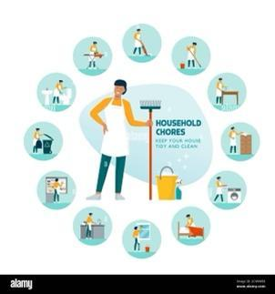  ** Ss say the Vietnamese meaning of the word.  1. household (n) /ˈhaʊs.həʊld/  2. chore (n) /tʃɔːr/  *** Other Ss correct if the previous answers are incorrect.   T shows the Vietnamese meaning, says the words aloud and asks Ss to repeat them. | T-S | 4 mins
PRACTICE | - To get students interested in the topic.  - To get students to learn some vocabulary in the unit.  To practise reading for specific information  - To practise scanning  - To develop students' knowledge of vocabulary for household chores  - To help students revive some collocations for the household chores so that they can use them in the following lessons.  - To help students practise scanning.  To help students identify present simple and present continuous and how they are used in sentences | TASK 1. LISTEN AND READ (p.8)  * T asks Ss to look at the picture (p.8 - 9) and answer the questions:  - Who are they?  - Where are they?  - What are they doing?  ** Ss do the task individually  *** Ss share their answers with a partner.   T checks their answers with the whole class.  Suggested answers: Nam and Minh are two friends. They are at Nam’s home. Nam is cooking.  * T has the Ss read the conversation in pairs.  ** Ss read the conversation  *** One pair reads aloud.   T collects common mistakes and gives comments.  TASK 2: TRUE OR FALSE  Read the conversation again and decide whether the following statements are true (T) or false (F). (p.9)  * T asks Ss to work individually to read the statements and underline the key words, then share their ideas with a partner who sits next to them.  ** Ss do Task 2 individually first.  *** Ss share and discuss with their partners about the key words   T corrects their answers as a class.  - Nam’s mother is cooking now.  - Everybody in Nam’s family does some of the housework.  - The children in Minh’s family don’t have to do any housework.  * T asks Ss to scan the conversation, locate the key words to find the answer for each the question with the partner who sits behind them  ** Ss do the task in pairs.   T has Ss share their answers with the class. T confirms the correct answers and have Ss correct the false statement. T writes the correct sentence on the board.  Key:  - F → Nam is cooking now.  - T  - T  TASK 3: FILL IN THE TABLE  Write the verbs/verb phrases that are used with the words or phrases in the conversation in 1. (p.9)  * T has Ss locate the verbs or phrasal verbs in the conversation, find the nouns or noun phrases after each verb/ phrasal verb to do the matching.  ** Ss work individually  *** Ss share their answers with a partner   T checks and gives the correct answers with the whole class, and has them say the meaning of each collocation.  Answers:  - put out the rubbish  - do the laundry  - shop for groceries  - do the heavy lifting  - do the washing-up  TASK 4: COMPLETE THE SENTENCES.  Complete the sentences from the conversation with the correct forms of the verbs in brackets. (p.9)  * T has Ss read each sentences, try to think of a verb or an auxiliary verb that will complete the gap.  ** Ss do the task individually  *** Ss share the answers with a peer.   T asks the whole class to call out the verb forms first, then calls on individual students to read the complete sentences.  Answers:  - ‘m preparing  - does – ‘s working | T-S  S  S-S  T-S  T-S  S-S  S-S  T-S  T-S  S  S-S  T-S  T-S  S-S  T-S  T-S  S  S-S  T-S  T-S  S  S-S  T-S | 6 mins  10 mins  4 mins  4 mins
PRODUCTION | - To help students practise talking about activities which raise students’ awareness of their responsibilities.  - To practise teamworking.  - To give students authentic practice in using target language. | TASK 5: MAKE A POSTER!  Think about activities which you can do to raise other students' awareness of their responsibilities towards their family.  * T gives Ss clear instructions in order to make sure Ss can do effectively.  - Divide Ss into 4 main groups .  - Ask Ss to work in groups to discuss and make a poster of activities to raise Ss' awareness of their responsibilities towards their family.  - Observer Ss while they are discussing, note their language errors  ** Ss do as instructed   T gives Ss feedback.  - Choose some useful or excellent words/ phrases/ expressions/ word choices Ss have used to give suggestions to other students.  - Choose some typical errors and correct as a whole class without nominating the Ss’ names. | T-S  S-S  T-S | 8 mins
CONSOLIDATION | - To help students memorise the target language and skills that they have learned  - To inform students what the final product of the project should be and how students can prepare for it. | WRAP-UP  * T asks Ss: What have you learnt today?  - Some lexical items about household chores  - Reading for specific information  - Scanning  HOMEWORK  1. Exercises in the workbook  2. Project preparation  - Have Ss look at the last page of Unit 1, the Project lesson and ask them what topic of the project is.  - Tell them the project requirements: Do research on Family Day in Viet Nam or other countries in the world  + suggest activities, provide the reasons and expected results of the activities;  + present their plans in the last lesson of the unit.  - Remind Ss that besides brainstorming activities, they:  + can search for ideas on the Internet, in the newspaper, etc. for reference.  + should use photos/pictures to illustrate their ideas.  - Put Ss into groups and have them choose their group leader. Ask them to assign tasks for each member, making sure that all group members contribute to the project work.  - Help Ss set deadlines for each task. | T-S | 4mins

UNIT 1: FAMILY LIFE
Lesson 2: Language
I. OBJECTIVES
By the end of this lesson, Ss will be able to:
1. Knowledge
- Pronounce the consonant blends /br/, /kr/, and /tr/ correctly in individual words and in sentences;
- Understand and use some lexical items about family life;
- Distinguish and use present simple and present continuous.
2. Core competence
- Be collaborative and supportive in pair work and team work
- Access and consolidate information from a variety of sources
- Actively join in class activities
3. Personal qualities
- Be aware of responsibilities towards family

II. MATERIALS
- Grade 10 textbook, Unit 1, Language
- Computer connected to the Internet
- Projector/ TV/ pictures and cards
- hoclieu.vn

Language analysis
 | Present simple | Present continuous
1. Form | (+) S + V(s/es).  (-) S + do not/ does not (don't / doesn't) + V.  (?) Do/Does + S + V? | (+) S + am/is/are + Ving.  (-) S + am/is/ are + not (‘m not/ isn’t/ aren’t) + Ving.  (?) Am/ Is/ Are + S + Ving?
2. Uses | We use present simple to talk about habits or things we do regularly.  Example: My mother cooks every day. | We use present continuous to talk about things which are happening at the moment of speaking.  Example: My mother isn’t cooking now. She’s working in her office.
3. Time expressions | usually, always, every day, often, never, seldom…  🡪 adverbs of frequency | now, at the moment, at present, presently, …

Assumptions
Anticipated difficulties | Solutions
Students may be confused when to use present simple or present continuous. | - Give short and clear explanations with legible examples for each case.  - Remind them and give some legible examples

Board Plan
Date of teaching
Unit 1: FAMILY LIFE
Lesson 2: Language
* WARM-UP: Guessing game
I. Pronunciation
Task 1: Listen and repeat.
Task 2: Listen to the sentences and circle the words you hear.
II. Vocabulary
Task 1: Match the words with their meanings.
Task 2: Complete the sentences using the words in Task 1.
III. Grammar: Present simple and Present continuous
Task 1: Choose the correct form of the verb in each sentence.
Task 2: Read the text and put the verbs in brackets in the present simple or present continuous.
Game: 20 questions
* CONSOLIDATION

III. PROCEDURES
Notes:
In each activity, each step will be represented as following:
* Deliver the task
** Implement the task
*** Discuss
 Give comments or feedback

Stage | Stage aim | Procedure | Interaction | Time
WARM-UP | - To arouse the classroom atmosphere.  - To lead in the lesson | GAME: Guess the words  * T gives instructions:  - There are 8 pictures related to the topic “Family life”.  - Ss have 5 seconds to think, then guess the word corresponding to the picture.  + Correct answer 🡪 +1  + Wrong answer 🡪 -1   T counts the points, decides the winner, asks some more questions and leads in the lesson. | T-S  S-S  T-S | 5 mins
PRONUNCIATION | To help students recognise and practise the consonant blends /br/, /kr/, and /tr/ in words | TASK 1. LISTEN AND REPEAT.  Pay attention to the consonant blends /br/, /kr/, and /tr/ (p.9)  * Teacher:  - plays the recording and asks Ss to listen to the words and repeat; tell them to pay attention to the consonant blends. (T can play the recording as many times as necessary)  - makes sure Ss know the meaning of each word.  ** Ss do as instructed.   Teacher checks whether Ss have improved their pronunciation by randomly calling on individual Ss to read the words aloud.  (Teacher can also play the pronunciation video lesson of this Unit for students to watch before they do the task.) | T-S  S-S  T-S  T-S | 5 mins
 | To help students practise identifying the consonant blends /br/, /kr/, and /tr/ in sentences. | TASK 2: LISTEN TO THE SENTENCES AND CIRCLE THE WORDS YOU HEAR. (p.9)  * Teacher:  - asks Ss to read all the words once, paying attention to the different consonant blends in the words in each group; checks that Ss understand what the words mean.  - plays the recording for Ss to listen and circle the words with the consonant blends they hear.  - has Ss work in pairs to compare their answers; checks answers by asking individual Ss to read out the words they have circled.  - plays the recording again, pausing after each sentence, for Ss to repeat.  ** Ss do as instructed.  *** Ss practise reading the sentences in pairs   T goes round to offer help and collect common mistakes to correct as a class.  Key:  1. b  2. c  3. a | T-S  S-S  S-S  T-S | 5 mins
VOCABULARY | To make sure that students understand the meaning of some lexical items about household chores. | TASK 1: MATCH THE WORDS WITH THEIR MEANINGS. (p.10)  * T gives clear instructions  ** Ss work in pairs to discuss and do the matching  *** Ss share the answers with the whole class.   T confirms the correct answer  Key:  1. b  2. d  3. e  4. a  5. c | T-S  S-S  S-S  T-S | 4 mins
 | To give students practice in using the words/phrases in meaningful contexts. | TASK 2: COMPLETE THE SENTENCES USING THE WORDS IN TASK 1. (p.10)  * Teacher:  - has Ss work in pairs; tells them to read the sentences carefully and decides which word in task 1 can be used to complete each of the sentences. T explains that they should use the context clues to decide on the word / phrase, e.g. ‘my mother’ in sentence 1 refers to a person.  - checks answers as a class, then has Ss call out the word they have used in each sentence first.  - confirms the correct answers. T asks Ss to give reasons why they have chosen the word for each sentence, e.g. what context clues they have used.  - asks some Ss to read the complete sentences.  ** Ss work in pairs to discuss and find the answers  *** Ss share the answers with the whole class   T confirms the correct answers and asks Ss to give the reasons why they have chosen the word/phrase for each sentence.  Key:  1. homemaker  2. groceries  3. heavy lifting  4. housework  5. breadwinner | T-S  S-S  S-S  T-S | 5mins
GRAMMAR | To give students an opportunity to revise the use of present simple and present continuous  To give students a further opportunity to revise the use of present simple and present continuous. | TASK 1: CHOOSE THE CORRECT FORM OF THE VERB IN EACH SENTENCE. (p.10)  * Teacher:  - tells Ss to read the sentences in 4 in Getting Started. T asks them what tense(s) is / are used in each of them.  For example, What does Nam say? Why is he using that tense? (Nam says, ‘I’m preparing dinner’. He uses the present continuous tense because he is talking about what he is doing at the moment of speaking.)  - in weaker classes, has Ss read through the Remember! box and checks understanding of the grammar points. T asks some questions to elicit more examples from Ss, e.g. What are you doing now? (I’m sitting at my desk. I’m learning about … I’m taking notes.) What do you do every day? (I watch TV. I play computer games. I have breakfast, lunch, and dinner.) - in stronger classes, ask Ss when we use each tense and elicit answers without having Ss read the Remember! box. Then T puts them into  groups to go through the explanations and checks if their answers are correct.  - asks Ss to work in pairs or individually to choose the correct form of the verb in each sentence. T explains that they can use some clues in the sentence to decide on the correct tense form such as adverbs of frequency or phrases of time, e.g. 1: usually; 2: now; 3: every day; 4: today; 5: twice a week.  - checks answers and asks Ss to explain their choices (using the clues above).  ** Ss do as instructed  *** Ss share their answers with a partner   Teacher check Ss’ answers and asks them to explain their choices (using the clues above).  Key:  1. does  2. is putting out  3. cleans  4. is studying  5. does  TASK 2: COMPLETE THE PARAGRAPH.  Read the text and put the verbs in brackets in the present simple or present continuous.  * Teacher:  - T asks Ss to look at Remember! box again to master the differences between Present simple and Present continuous.  - T asks Ss to work individually.  ** Ss do as instructed.  *** Ss share their answers with a partner.   T check Ss’ answers and asks them to explain their choices (using the clues above).  Key:  1. does 2. is not/isn’t doing  3. is watching 4. are doing  5. is tidying up 6. is trying | T-S  S-S  S-S  T-S  T-S  S-S  S-S  T-S | 15 mins
EXTRA ACTIVITY | To help students further practise the present tenses forms. | GAME: 20 questions  * T explains the rules of the game.  * Ss do as instructed   T praises Ss for interesting ideas and having a good memory and decides the winner.  Rules:  - Ss are given a list of words related to the topic: Family life.  - Ss ask each other using Present Simple and Present Continuous Yes/No questions until they guess which of the words their partner chose.  *Possible questions include “Are you doing this now?”, “Is anyone in this class doing this now?”, “Are many people in this city doing this now?”, “Do you do this every day?” and “Do you do this more than twice a week?” | T-S  S-S  T-S | 4 mins
CONSOLIDATION | To help students memorise the target language and skills that they have learnt | WRAP-UP  * T asks: What have you learnt today?  - consonant blends /br/, /kr/, and /tr/  - some lexical items about household chores;  - present simple vs. present continuous  HOMEWORK  - Exercises in the workbook  - Prepare for lesson 3 Unit 1. | T-S | 2 mins

UNIT 1: FAMILY LIFE
Lesson 3: Reading
I. OBJECTIVES
By the end of this lesson, Ss will be able to:
1. Knowledge
- Read for specific information in a text about the benefits of doing housework for children;
- Understand the topic-related words introduced in previous lessons;
- Use the topic-related words in meaningful contexts
2. Core competence
- Be collaborative and supportive in pair work and team work;
- Access and consolidate information from a variety of sources;
- Develop presentation skill;
- Actively join in class activities.
3. Personal qualities
- Recognise the benefits of doing housework for children
- Sharing housework with their families

II. MATERIALS
- Grade 10 textbook, Unit 1, Reading
- Computer connected to the Internet
- Projector
- PowerPoint

Language analysis
Form | Pronunciation | Meaning | Vietnamese equivalent
responsibility (n) | /rɪˌspɒnsəˈbɪləti/ | a duty to deal with or take care of somebody/something, so that you may be blamed if something goes wrong | trách nhiệm
gratitude (n) | /ˈɡrætɪtʃuːd/ | a strong feeling of appreciation to someone or something for what the person has done to help you | lòng biết ơn
strengthen (v) | /ˈstreŋθn/ | to make something stronger or more effective, or to become stronger or more effective | củng cố, làm mạnh
bond (n) | /bɒnd/ | a close connection joining two or more people | mối liên kết
character (n) | /ˈkærəktər/ | the particular combination of qualities in a person or place that makes them different from others | tính cách

Assumptions
Anticipated difficulties | Solutions
- Ss may lack knowledge about some lexical items.  - Ss may lack skills to find specific information | - Provide them with the meaning and pronunciation of words.  - Provide them with techniques to read for specific information.

Board Plan
Date of teaching
Unit 1: FAMILY LIFE
Lesson 3: Reading
* WARM-UP: Who’s in charge?
Task 1: Work in pairs. Look at the picture and answer the questions.
Task 2: Read the text and tick (  ) the appropriate meanings of the highlighted words.
Vocabulary

Task 3: Read the text again and answer the questions.
Task 4: Work in pairs. Discuss the question.
*CONSOLIDATION

III. PROCEDURES
Notes:
In each activity, each step will be represented as following:
* Deliver the task
** Implement the task
*** Discuss
 Give comments or feedback

Stage | Stage aim | Procedure | Interaction | Time
WARM-UP | - To arouse the classroom’s atmosphere  - To lead in the lesson | GAME: Who’s in charge?  * T divides the class into groups of four, has Ss discuss in groups and list down (as much as possible) the housework that they think mom, dad and kids usually do in 3 minutes. T explains that after Ss finish their discussion, one representative from each group comes and writes their lists on the board. T reminds Ss that the 1st group to finish will say “STOP THE BUS” and the others have to stop writing.  ** Ss discuss in their teams and list down the housework. One representative from each group comes and writes on the board.   T confirms, checks the answers on the board, decides the winner and leads in the lesson.  Suggested answers:  Mom: cook, do laundry, wash dishes, clean the house, …  Dad: do heavy lifting, fix the roof, cook, wash dishes, …  Kids: take out trash, tidy their room, fold the clothes, … | T - S  S - T - S  T - S | 7 mins
PRE-READING | To introduce the topic of the reading and get students involved in the lesson | 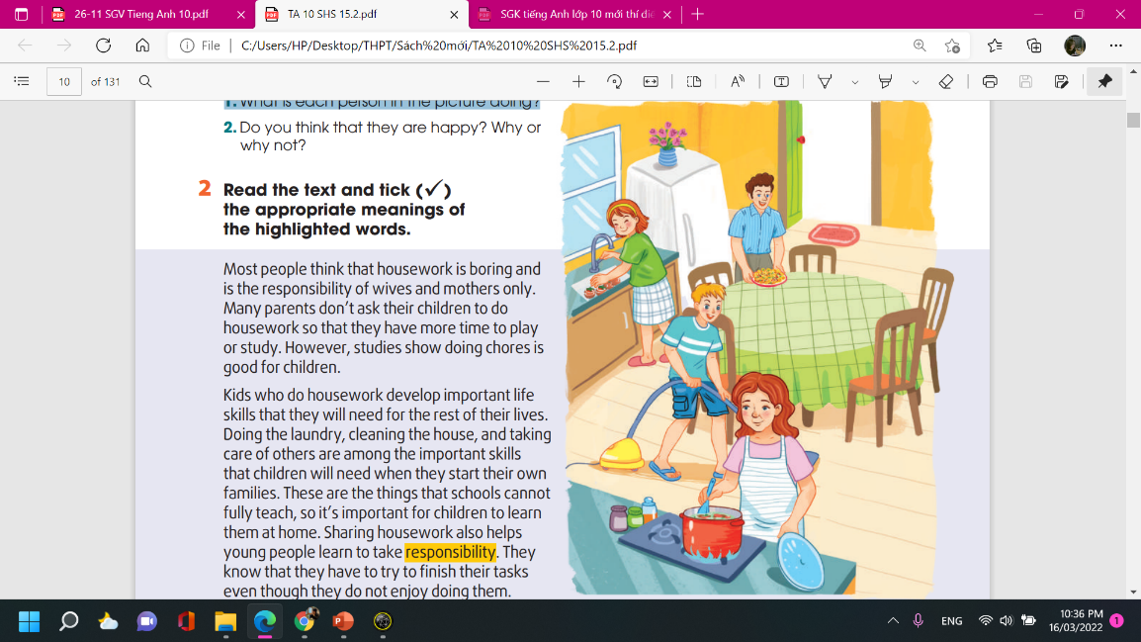  Task 1. LOOK AT THE PICTURE AND ANSWER THE QUESTIONS. (p.11)  * T sets the context for the reading tasks, asks some questions about the picture and has Ss call out the answers as a class.  Suggested questions:  Is this a family?  Who do you think they are?  Where do you think they are?  T asks Ss to work in pairs, look at the picture and answer the questions.  T tells Ss that there are no right or wrong answers and they should feel free to make any guesses.  ** Ss answer the questions.   Teacher confirms, shows the answers on the screen.  Suggested answers:  1. The mother is cooking; the father is laying the table; the son is (vacuuming) cleaning the floor; the daughter is washing vegetables.  2. The people are happy because they are doing housework together, and all the family members are sharing the household chores. | T - S  S  T | 5 mins
WHILE- READING | To help students practise guessing the meanings of words in context | TASK 2: READ THE TEXT AND TICK () THE APPROPRIATE MEANINGS OF THE HIGHLIGHTED WORDS. (p.11)  * Teacher:  - asks Ss to read the whole text once to get an overall idea; asks Ss to go through the two options for each word and check understanding; has Ss read the text again; tells them to pay attention to the context of each highlighted word, and look for context clues conveying the meaning of the word.  - asks Ss to work in groups to discuss the clues for each correct option and compare their answers.  ** Ss discuss in groups to find out the answers and raise their hands to give the answers.  *** T confirms, shows the answers on the screen and asks Ss to make corrections if they choose the wrong answers.  Key:  1. a 2. b 3. a 4. a 5. b | T - S  S - S  T - S | 6 mins
 | To help students understand the lexical items in the text | VOCABULARY  * T has Ss read the text again, and pay attention to the highlighted words. T asks Ss to define the word based on the context and give the Vietnamese meaning of each word.  ** Ss read the text again and try to define the highlighted words. (Ss can do this activity in pairs)  ** Ss explain the words in front of the class. T asks other Ss to give comments.  *** T confirms, shows the items and their meanings on the screen; asks Ss to note down the vocabulary. | T - S  S - S  S - T - S  T - S | 5 mins
 | To help students practise reading for specific information | TASK 3: READ THE TEXT AGAIN AND ANSWER THE QUESTIONS. (p.11)  * T asks Ss to read the questions and underline the key words in each of them.  ** Ss underline the key words in each question. T checks which words Ss have underlined.  * T tells Ss to go through the text to find the answers and has Ss work in pairs to compare their answers.  ** Ss discuss in pairs to find out the answer. T checks answers by asking pairs or groups to give their answers and provide reason for their opinions.  *** T confirms, shows the answers on the screen and asks Ss to make corrections if they are wrong.  Key:  1. Most people think that housework is boring and is the responsibility of wives and mothers only.  2. They want to give their children more time to play or study.  3. These are doing the laundry, cleaning the house, and taking care of others.  4. They learn that they have to try to finish their tasks even though they do not enjoy doing them.  5. Because children learn to appreciate all the hard work their parents do around the house for them.  They also start treating doing household chores as special moments shared with their parents. | T - S  S - T - S  T  S - T - S  T - S | 10 mins
POST-READING | To help students use the ideas and language in the reading to talk about themselves | TASK 4: WORK IN PAIRS. DISCUSS THE QUESTION. (p.12)  What benefits do you think you can get from sharing housework?  * Teacher:  - asks Ss to read the text again and underline the benefits of doing housework.  - has Ss work in pairs to make a mind map of the benefits and use it to talk about which of the benefits of doing housework they can get.  ** Ss discuss in pairs and prepare for their presentation. T invites Ss from different pairs to present a summary of their discussion to the whole class.   T gives feedback | T - S  S - T - S  T - S | 10 mins
CONSOLIDATION | - To consolidate what students have learnt in the lesson  - To prepare for the next lesson | WRAP-UP  T asks: What have you learnt today?  - The benefits of doing housework for children  - Review the vocabulary by asking their meanings  HOMEWORK  - Do the reading exercises in the Workbook  - Prepare for the Speaking lesson | T - S | 2 mins

UNIT 1: FAMILY LIFE
Lesson 4: Speaking
I. OBJECTIVES
By the end of this lesson, Ss will be able to:
1. Knowledge
- Explain why children should or shouldn’t do housework;
- Discuss and express their opinions about why children should or shouldn’t do the housework.
2. Core competence
- Be collaborative and supportive in pair work and team work;
- Develop presentation skills;
- Actively join in class activities;
- Be critical thinking.
3. Personal qualities
- Recognise the benefits of doing housework for children;
- Understand why children should or shouldn’t do housework;
- Sharing housework with their families.

II. MATERIALS
- Grade 10 textbook, Unit 1, Speaking
- Computer connected to the Internet
- Projector
- PowerPoint
- Sticky balls

Language analysis
Form | Pronunciation | Meaning | Vietnamese equivalent
take responsibility | /teɪk/ /rɪˌspɒnsɪˈbɪləti/ | to be in a position of authority over someone and to have a duty to make certain that particular things are done | chịu trách nhiệm
necessary (adj) | /ˈnesəseri/ | needed in order to achieve a particular result | thiết yếu
life skills (n) | /ˈlaɪf ˌskɪls/ | a skill that is useful or important in everyone's life | kỹ năng sống

Assumptions
Anticipated difficulties | Solutions
- Ss may lack knowledge about some lexical items.  - Ss may lack the skills to give a presentation. | - Provide them with the meaning and pronunciation of words.  - Provide them with techniques to present in front of the whole class.

Board Plan
Date of teaching
Unit 1: FAMILY LIFE
Lesson 4: Speaking
*WARM-UP: Matching time

Task 1: Below are reasons why children should or shouldn't do housework.
Put them in the correct column. Add some more if you can.

Task 2: Listen and complete the conversation.

Task 3: Work in groups. Have similar conversations exchanging opinions about whether children should or shouldn’t do housework.

*CONSOLIDATION

III. PROCEDURES
Notes:
In each activity, each step will be represented as following:
* Deliver the task
** Implement the task
*** Discuss
 Give comments or feedback

Stage | Stage aim | Procedure | Interaction | Time
WARM-UP | - To arouse the classroom atmosphere.  - To lead in the lesson | WARM-UP: Matching time  * T divides the class into groups of four. There are ten pictures of household chores on the slides. T asks Ss to match the pictures with the corresponding names of chores. T throws the ball to the team which raise hands the fastest. If the answers are correct, the round ends. If not, the round continues until there is a winner.  ** Ss discuss in their teams and match the pictures with the name of chores. Ss raise their hands when they finish.   Teacher:  - confirms, checks the answers from the fastest team.  - recaps the vocabulary and leads in the lesson.  Key:  1 e. cook  2 c. do the laundry  3 a. do the washing-up  4 d. do the heavy lifting  5 b. shop for groceries  6 g. feed pets  7 h. water the plants  8 j. clean the bathroom  9 i. clean the house  10 f. put out the rubbish | T - S  S - S  T - S | 8 mins
PRE-SPEAKING | To help students recall reasons from the reading text why people think children should or shouldn’t do housework and provide them with some more ideas. | TASK 1: BELOW ARE REASONS WHY CHILDREN SHOULD OR SHOULDN'T DO HOUSEWORK. PUT THEM IN THE CORRECT COLUMN. ADD SOME MORE IF YOU CAN. (p.12)  *Teacher:  - recalls lexical items from previous lessons by asking Ss to call out the meaning of some words  - has Ss work in pairs / groups  - asks Ss if they can think of any reasons why children shouldn’t do housework.  ** Ss brainstorm in group and raise their ideas  * T asks Ss to read the task carefully and discuss in which column each sentence from task 1 should go.  ** Ss do the task in groups and then write their answers on the board. Others Ss check their friends’ answer  *** Teacher:  - check Ss’ answers with the whole class  - encourages Ss to add their own reasons  Key:  SHOULD SHOULDN’T  1. Doing housework helps them develop life skills. 3. Kids should be given plenty of playtime when they are young.  2. Doing housework teaches them to take responsibility. 4. They may break or damage things when doing housework.  5. Doing housework helps strengthen family bonds. 6. They need more time to study and do homework. | T - S  S - T  T  S - T – S  T - S | 10 mins
 | To provide students with an example conversation in which people express their opinions about whether children should or shouldn't do housework. | TASK 2: LISTEN AND COMPLETE THE CONVERSATION. (p.12)  *Teacher:  - has Ss read through the conversation once to get some general ideas about it  Suggested questions:  How many people are talking?  What are they talking about?  - divides Ss into pairs; has Ss read the conversation again, this time more carefully and think of a suitable phrase / sentence to fill in each gap in the conversation.  ** Ss do the task in pairs and discuss the answers together.  * T plays the recording for Ss to listen  *** T plays the recording again and checks Ss’ answers; confirms the correct answers.  Key:  - Doing housework helps them develop life skills.  - They should be given plenty of playtime when they are young.  * T asks Ss to read the conversation in groups of three, each taking turns to be Anna, Nam, and Minh.  ** Ss practise the conversation in groups and present in front of the class.  Audio script – Track 5:  Anna: Nam, why do you think children should do housework?  Nam: Because doing housework helps them develop life skills.  Anna: It’s true. Life skills such as cooking, cleaning or taking care of others are really necessary  for kids when they grow up.  Nam: Yes, we should all have these basic life skills to be adults.  Anna: Now Minh, why do you think children shouldn’t do housework?  Minh: I think kids are kids. They should be given plenty of playtime when they are young.  Nam: I don’t agree with you. I’m afraid too much playtime is not good for children.  Anna: Well, thank you both for sharing your ideas. They are very useful for my project. | T - S  T - S  S - S  T - S  T - S  T - S | 10 mins
WHILE-SPEAKING | To help students practise having conversations in which they can express their opinions about why children should or shouldn’t do housework. | TASK 3: HAVE CONVERSATIONS SIMILAR TO THE ONE IN TASK 2. (p.12)  * Teacher:  - has students work in groups of three.  - reminds Ss to swap roles and role-play their conversations two more times to make sure each student has the opportunity to play the three roles.  - asks some groups to act them out in front of the class after 6-7 minutes of preparation  *** Ss practise making their own conversation in groups of three.  T goes round the class to offer help when necessary while noting down Ss’ participation in the activity and any difficulties they may have.  Some groups act out their conversation in front of the whole class.   T asks other Ss to give comments and then give feedback to Ss’ performance. | T - S  S - T - S  T - S | 15 mins
CONSOLIDATION | - To consolidate what students have learnt in the lesson.  - To prepare for the next lesson. | WRAP-UP  Teacher asks: What have you learnt today?  - How to explain why children should or shouldn’t do housework  HOMEWORK  - Practice discussing the topic with your friends  - Prepare for the Listening lesson | T - S | 2 mins

UNIT 1: FAMILY LIFE
Lesson 5: Listening
I. OBJECTIVES
By the end of this lesson, Ss will be able to:
1. Knowledge
- Listen for details and specific information in a talk show about family life;
- Apply the language they have learnt in the listening in a speaking task about their own experiences.
2. Core competence
- Be collaborative and supportive in pair work and team work;
- Access and consolidate information from a variety of sources;
- Actively join in class activities.
3. Personal qualities
- Recognise how our families have helped us achieve success in our lives;
- Show gratitude towards our families.

II. MATERIALS
- Grade 10 textbook, Unit 1, Listening
- Computer connected to the Internet
- Projector
- PowerPoint

Language analysis
Form | Pronunciation | Meaning | Vietnamese equivalent
achieve (v) | /əˈtʃiːv/ | to succeed in finishing something or reaching an aim, especially after a lot of work or effort | đạt được
achievement (n) | /əˈtʃiːvmənt/ | something that you did or got after planning and working to make it happen, and that therefore gives you a feeling of satisfaction, or the act of working to make this happen | thành tựu
success (n) | /səkˈses/ | the achieving of the results wanted or hoped for | sự thành công
encourage (v) | /ɪnˈkʌrɪdʒ/ | to make someone more likely to do something, or to make something more likely to happen | khuyến khích
routine (n) | /ruːˈtiːn/ | an usual or fixed way of doing things | thói quen hằng ngày

Assumptions
Anticipated difficulties | Solutions
- Ss may lack knowledge about some lexical items.  - Ss may not catch the ideas to decide the statements are true or false. | - Provide them with the meaning and pronunciation of words.  - Remind them to pay attention to the key words in each sentence.

Board Plan
Date of teaching
Unit 1: FAMILY LIFE
Lesson 5: Listening

* WARM-UP: Web completion

Task 1: Look at the picture and answer the questions.
Task 2: Listen to the introduction to the talk show and check whether your answer to Question 2 above is correct or not.
Task 3: True or False
Task 4: Listen again and complete the sentences.
Task 5: Discussion

* CONSOLIDATION

III. PROCEDURES
Notes:
In each activity, each step will be represented as following:
* Deliver the task
** Implement the task
*** Discuss
 Give comments or feedback

Stage | Stage aim | Procedure | Interaction | Time
WARM-UP | - To arouse the classroom atmosphere  - To lead in the lesson | GAME: Web completion  * T divides the class into groups of four, has Ss discuss in groups and match the housework with the roles of women or men. The fastest group will raise their hands and write the answer on the board.  ** Ss discuss in their teams and list down the housework. One representative from each group comes and writes on board.   T confirms, checks the answers on the board, decides the winner and leads in the lesson.  Suggested answers:  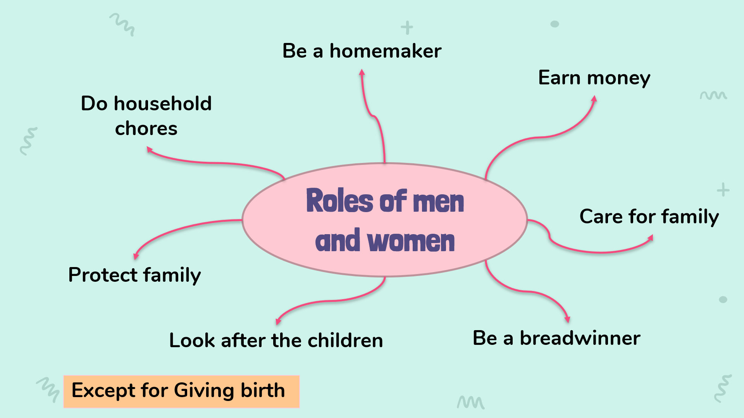 | T - S  S - T  T - S | 7 mins
PRE-LISTENING | To introduce the topic of the listening extract and activate students’ prior knowledge. | 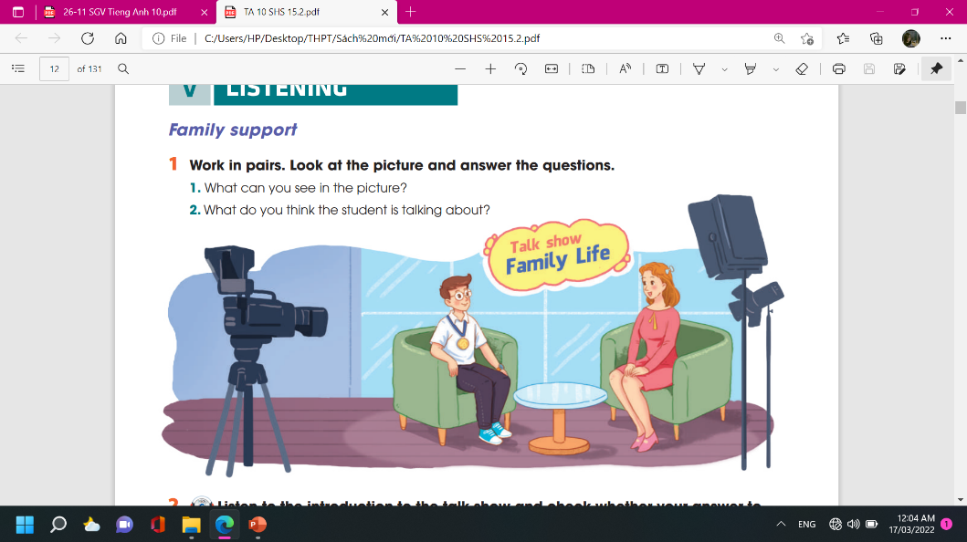  TASK 1: LOOK AT THE PICTURE AND ANSWER THE QUESTIONS.  (p. 13)  * Teacher:  - has Ss look at the picture and describe it.  Suggested questions:  Who are the people?  Where are they?  What is in the background?  What are they doing?  What’s the boy wearing around his neck?  Key:  A student and the host of a talk show  In a studio  Name of the show: Family Life  Talking; The host is interviewing the student.  A gold medal  - asks Ss to work in pairs, look at the picture and answer the questions.  - tells Ss that there are no right or wrong answers and they should feel free to make any guesses.  ** Ss answer the questions.  *** T confirms, shows the answers on the screen. | T - S  T - S  S  T | 5 mins
WHILE- LISTENING | To help students practise listening for specific information in an extract of a talk show and comparing their predictions with what they hear | TASK 2: LISTEN TO THE INTRODUCTION TO THE TALK SHOW AND CHECK WHETHER YOUR ANSWER TO QUESTION 2 ABOVE IS CORRECT OR NOT. (p.13)  * Teachers:  - tells Ss that they are going to listen to part of the talk show and decide whether their guesses are correct.  ** T plays the recording. Ss listen and check their answer.  *** T confirms, shows the answers on the screen and asks Ss to make correction if they made a wrong answer.  Key:  He’s talking about his family life and how his family have helped him achieve success in his studies.  Audio script – Track 6:  Welcome to our talk show. Tonight, our topic is Family Life and our guest speaker is Le Minh Hieu. Hieu is a twelfth-grader. He’s just won a gold medal at the International Physics Olympiad. He’ll tell us about his family life and how his family have helped him achieve success in his studies. | T - S  T - S  T - S | 5 mins
 | To help students practise listening for details. | TASK 3: TRUE OR FALSE. (p.13)  * Teacher  - asks Ss to read through the statements once and underline the key words in them.  - checks Ss’ understanding.  - asks Ss to listen and then compare their answers in pairs before listen to the recording the second time.  - asks Ss to correct the false statements.  ** T plays the recording twice. Ss do the task and correct the false statements.  *** T checks answers.  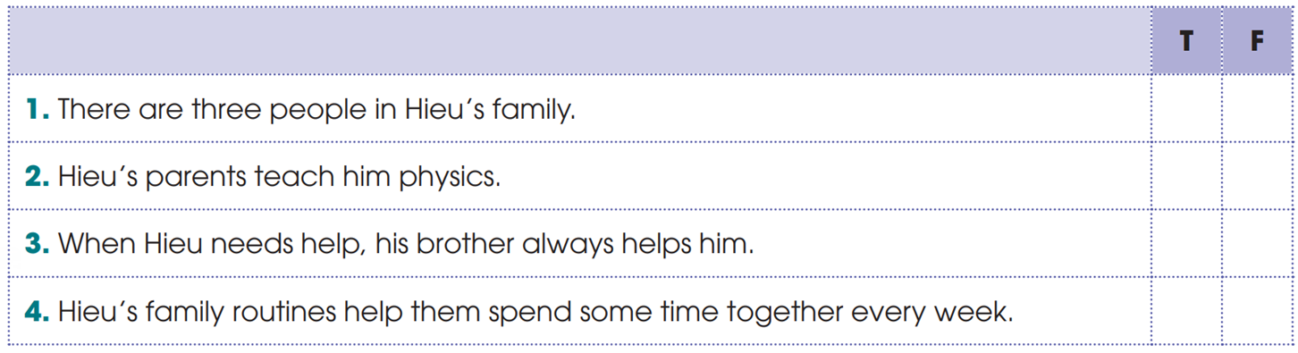  Key: 1. F 2. F 3. T 4. T | T - S  S - T - S  T - S | 6 mins
 | To help students practise listening for keywords. | TASK 4: LISTEN AND COMPLETE THE SENTENCES. (p.13)  * Teacher  - explains the task and asks Ss to read the sentences before they listen to the recording again.  - checks comprehension of words / phrases that may be new to them  - tells Ss to underline the key words while they read the sentences  ** T plays the recording twice.  Ss do the task. Ss can compare their answers in pairs before listening to the recording the second time.  *** T checks answers as a class.  Key: 1. difficulties 2. love 3. sad  Audio script – Tracks 7:  Hieu: Good evening. Well, I live with my parents and my brother. And I must say that all my achievements are the result of their support.  Host: Do your parents help you with your studies?  Hieu: My parents are farmers. They know little about physics. But they believe in me.  They always listen to me and cheer me up whenever I have difficulties.  Host: So they encourage you to try harder?  Hieu: That’s right. Their love and trust give me strength to carry on.  Host: How about your brother?  Hieu: My brother is my best friend. He shares his happy and sad moments with me, and is always there for me when I need help.  Host: You’re so lucky to have a supportive family. Do you spend a lot of time together?  Hieu: Yes. My parents have created some family routines so that every week we can spend some time together although we’re all very busy.  Host: Family routines? Can you tell us more about that?  Hieu: Well, family routines are ... | T - S  T - S  S  T | 10 mins
POST-LISTENING | To help students apply the language they have learnt in the listening in a speaking task about their own experiences. | TASK 5: DISCUSSION (p.13)  Work in groups. Discuss the following question.  “How can parents help their children achieve success in their studies?”  * Teacher:  - has Ss work in groups of three and tells them to think about their own family to answer the question.  ** Ss prepare their presentation in groups. Each group chooses a representative to share the group’s ideas with the class.  *** T gives feedback. | T - S  S - T - S  T - S | 10 mins
CONSOLIDATION | - To consolidate what students have learnt in the lesson  - To prepare for the next lessons | WRAP-UP  Teacher asks: What have you learnt today?  - How can parents help their children achieve success in their studies  HOMEWORK  - Do the Listening exercises in the Workbook  - Prepare for the Writing lesson | T - S | 2 mins

UNIT 1: FAMILY LIFE
Lesson 6: Writing
I. OBJECTIVES
By the end of this lesson, Ss will be able to:
1. Knowledge
- Use lexical items related to the topic “Family life”;
- Write about family routines.
2. Core competence
- Be collaborative and supportive in pair work and team work;
- Actively join in class activities;
- Develop presentation skills.
3. Personal qualities
- Be able and willing to sharing housework in the family.

II. MATERIALS
- Grade 10 textbook, Unit 1, writing
- Computer connected to the Internet
- Projector/ TV/ pictures and cards
- hoclieu.vn

Assumptions
Anticipated difficulties | Solutions
- Ss may want to use their own suggestions but they may not know how to express their ideas in English.  - Ss in weaker classes may not know how to use connectors correctly to link sentences.  - Ss may not know the structure of a paragraph. | - Be ready to provide them with words/ phrases which they can use to express their ideas in English.  - Provide them with some connectors and some examples.  - Give them some basic information about the structure of a paragraph.

Board Plan

Date of teaching
UNIT 1: FAMILY LIFE
Lesson 6: Writing
* WARM-UP

Task 1: Which of the following activities in the pictures do you think can be family routines?

Task 2: Read and complete the table.

Task 3: Complete the email using the information in the box.

Peer correction / Class correction

* CONSOLIDATION

III. PROCEDURES
Notes:
In each activity, each step will be represented as following:
* Deliver the task
** Implement the task
*** Discuss
 Give comments or feedback

Stage | Stage aim | Procedure | Interaction | Time
WARM-UP | - To arouse the classroom atmosphere.  - To get students be actively involved in the lesson  - To introduce the concept of family routines and activities that can become part of them. | TASK 1: WHICH OF THE FOLLOWING ACTIVITIES IN THE PICTURES DO YOU THINK CAN BE FAMILY ROUTINES? (p.14)  * Teacher:  - Takes the 6 pictures in Task 1, prints them out and puts each picture on different tables.  - Asks Ss to stand around the table with the activity they do most with their family.  Ss go to the table with the activity they do most with their family.  ** Ss do as instructed.  *** Ss in each group share with the group how often they do that activity   T asks randomly some Ss to share with the class how often they do the activity and leads in the lesson of “Family routines”: Each of the activities can become a family routine if a family decides to do together and regularly.  The six pictures with six activities:  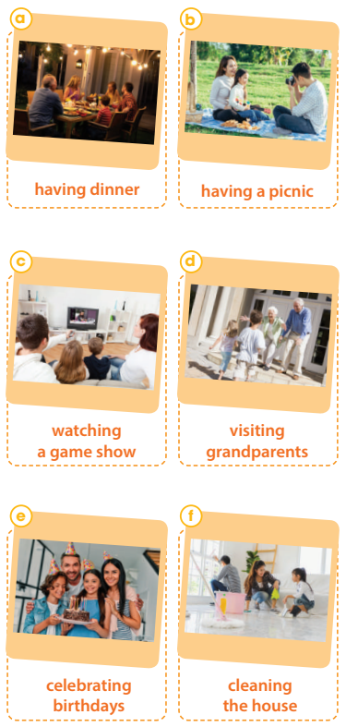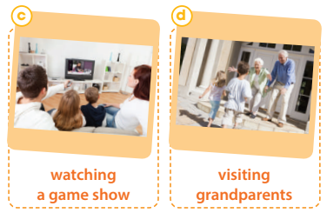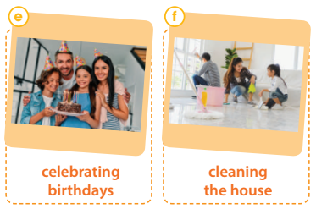 | T-S  S-S  S-S  T-S | 7 mins
PRE-WRITING | To provide an example email about family routines, which students’ can use as a model for their writing. | TASK 2: READ JOEY’S EMAIL ABOUT HIS FAMILY ROUTINES AND COMPLETE THE TABLE WITH THE INFORMATION FROM IT. (p.14)  * Teacher:  - Asks Ss to read the table headings to find out what information they need to focus on when they read the email. (routines, when / how often things to do to strengthen family bonds).  - Ask Ss to read the email and underline the relevant information.  - Has Ss compare their answers with a partner before they complete the table.  ** Ss do as instructed.   T asks individual Ss to call out their answers and confirms the correct ones.  Key:  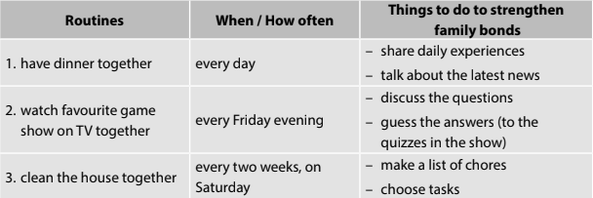 | T-S  S-S  T-S | 10 mins
WHILE-WRITING | - To help students practise writing part of an email about family routines using given ideas.  - To help students practise developing ideas and writing a paragraph. | TASK 3: COMPLETE THE EMAIL ABOUT DONG’S FAMILY ROUTINES USING THE INFORMATION IN THE BOX. (p.15)  - * Teacher:  - Tells Ss that they are going to write a paragraph about family routines. They don’t have to write a whole email, and the opening and ending have been provided.  - Gives Ss some basic information about the structure of a paragraph:  + A paragraph is a group of sentences that develop ONE main idea.  + A paragraph usually consists of three parts: a topic sentence, supporting sentences and a concluding sentence.  + Two important qualities of a good paragraph are unity (i.e. one main idea is developed) and coherence (i.e. all the sentences and ideas flows smoothly to make clear and logical points about the topic)    - Asks Ss read the information in the table and check comprehension.  - Asks Ss to write the middle paragraph of the email individually, sets a limited time for this task and walks round the class to give further support if needed.  - Before they write, reminds them to use some connectors to link the ideas:  + To list ideas: First, Second, In addition, Additionally, Moreover, Furthermore, Another idea worth noting is that, Finally,  + To give an example: For example/ For instance, To illustrate.  + To conclude: In conclusion, In brief, In short.  ** Ss do as instructed.  *** Ss share their answers with their group members.   T walks round the class to monitor, makes a note of some common mistakes. | T-S  S  S-S  T-S | 17 mins
POST-WRITING | To give students an opportunity to recognise the common mistakes so that they can avoid in writing | PEER CORRECTION  * Teacher:  - Explains the marking symbols in the following table.  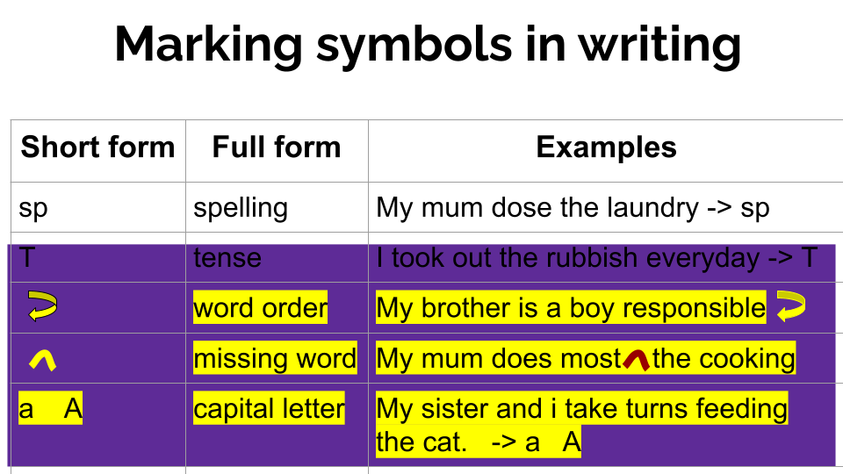  - Asks two Ss sitting next to each other to exchange their writing, read their partner’s writing and write the symbols next to their partner’s mistakes like the ones in the table above.  - Asks Ss to return their partner’s writing and lets them correct themselves.  - Reminds them that they can ask for their partner’s help.  ** Ss do as instructed.  *** Ss share their ideas with a partner.   T goes round to offer help.  CLASS CORRECTION  * Teacher:  - Writes Ss’ common mistakes on the board, asks Ss to check whether they make the same mistakes in their writing.  - Calls on some Ss to correct those mistakes as a class.  ** Ss do as instructed.   Teacher:  - Further explains the paragraph structure if Ss are not able to develop the three elements in their writing.  - Collects Ss’ writing and provides written feedback in the next lesson. In weaker classes, T provides some suggested answers if necessary.  Sample answer:  First, my family always have breakfast together. Breakfast is a quick meal with just bread or noodles because both my parents work and we, kids, have morning classes. But the most important thing is that we can sit down together, eat healthy food, and share our plans for the day. Second, we spend Saturday evenings as a family. We often watch a film, share snacks, and then exchange our opinions after the film. I can even argue and defend my ideas about the film with my parents or brother. Third, on the second Sunday of the month, we visit our grandparents. We come to my grandparents’ home quite early in the morning to help them do some housework such as cleaning the house or washing clothes. Then, we have a big lunch with them. My parents are very happy when we come to see them. The visits make me feel closer to my grandparents. | T-S  S-S  S-S  T-S | 9 mins
CONSOLIDATION | To help students memorise the content of the lesson | WRAP-UP  T asks: What have you learnt today?  - We have practised writing a paragraph about family routines.  HOMEWORK  - Exercises in the workbook  - Prepare for Communication and Culture lesson | T-S | 2 mins

UNIT 1: FAMILY LIFE
Lesson 7: Communication and Culture / CLIL

I. OBJECTIVES
By the end of this lesson, students will be able to:
1. Knowledge
- express their opinions in a conversation about whether family members should spend time together;
- understand British family values.
2. Core competence
- be collaborative and supportive in pair work and team work;
- access and consolidate information from a variety of sources;
- actively join in class activities.
3. Personal qualities
- be more respectful of Vietnamese and British family values;
- be able and willing to embrace those family values.

II. MATERIALS
- Grade 10 textbook, Unit 1, Communication and Culture/ CLIL
- Computer connected to the Internet
- Projector/ TV/ pictures and cards
- hoclieu.vn

Language analysis
Form | Pronunciation | Meaning | Vietnamese equivalent
pass on (sth) (phr.v) | /pæs ɒn/ | give something to someone who lives after you die, usually a person in your family | để lại, truyền lại
truthful (a) | /ˈtruːθfəl/ | honest and not containing or telling any lies | trung thực
respectively (adv) | /rɪˈspektɪvli/ | with each relating to something previously mentioned, in the same order as first mentioned | tương ứng

Assumptions
Anticipated difficulties | Solutions
- Students may have underdeveloped speaking and  co-operating skills.  - Students may lack knowledge about some lexical items | - Encourage students to work in pairs and in groups so that they can help each other.  - Remind them to make use of the ideas and vocabulary items they have learnt in the previous lessons.  - Provide them with the meaning and pronunciation of words/ phrases.

Board Plan
Date of teaching
UNIT 1: FAMILY LIFE
Lesson 7: Communication and Culture / CLIL
* WARM-UP

I. Everyday English
Task 1: Listen and complete the conversation.
Task 2: Have similar conversations exchanging opinions about whether family members should spend time together.

II. Culture
Vocabulary
Task 1: Read the text and complete the table.
Task 2: Discussion.

* CONSOLIDATION

III. PROCEDURES
Notes:
In each activity, each step will be represented as following:
* Deliver the task
** Implement the task
*** Discuss
 Give comments or feedback

Stage | Stage aim | Procedure | Interaction | Time
WARM-UP | - To arouse the classroom atmosphere.  - To help students revise words/ phrases related to the topic | * T divides the class into two teams, has Ss in each team take turns to run to the board and write a word/ phrase about the advantages or disadvantages of sharing housework.  ** Ss do as instructed.   T confirms the correct word/ phrase and decides the winner (the team with most correct words/ phrases). | T-S  S-S  T-S | 5 mins
EVERYDAY ENGLISH | To provide students with an example conversation in which people exchange opinions about  teenagers doing housework.  To help Ss practise expressing their opinions in a conversation about whether family members should spend time together. | TASK 1: LISTEN AND COMPLETE THE CONVERSATION. (p.15)  * Teacher:  - Asks Ss to read through the expressions in the box and the incomplete conversation, checks comprehension and encourages them to complete the gaps based on the clues in the conversation.  - Plays the recording once or twice.  ** Ss do as instructed.   Teacher:  - Checks the answers by asking individual Ss to read out the complete conversation.  - Asks Ss to practise the conversation in groups of three.  - In stronger classes, writes some prompts on the board and asks Ss to role-play the conversation based on the prompts only.  Key:  1.A  2. C  3. B  TASK 2: HAVE SIMILAR CONVERSATIONS EXCHANGING OPINIONS ABOUT WHETHER FAMILY MEMBERS SHOULD SPEND TIME TOGETHER. (p.15)  * Teacher:  - Asks Ss to brainstorm some advantages and disadvantages of spending time together as a family. Give some suggestions, if necessary.  (e.g. Advantages: It strengthens family bonds; It makes children happy, develops their self-confidence; Children can learn life skills and how to behave from their parents.  Disadvantages: Children may become too dependent on their parents, do not have enough time for friends or other relationships, etc.)  - Revises common expressions used to express opinions.  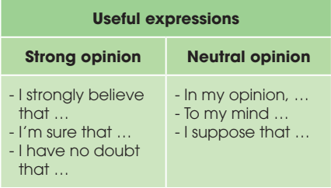  - Has Ss work in groups of three exchanging their opinions using the conversation in Task 1 as a model. Go round to monitor and offer help when necessary.  ** Ss work in groups of 3 to practise their conversations.  *** Some groups act out their conversations to the class.   T praises Ss for good effort, clean pronunciation, fluent delivery and interesting ideas. | T-S  S-S  T-S  T-S  T-S  S-S  T-S | 7 mins  8 mins
CULTURE | To pre-teach the meaning and pronunciation of some words/ phrases, so that students can use them in their presentation later and can understand the reading passage. | Vocabulary  * Teacher:  - Shows the words one by one and has Ss repeat the sound of the words  - Has Ss guess the meaning of the words based on pictures, explanations and examples.  1. pass on sth (phr.v): give something to someone who lives after you die, usually a person in your family    2. truthful (a): honest and not containing or telling any lies    3. respectively (adv): with each relating to something previously mentioned, in the same order as first mentioned  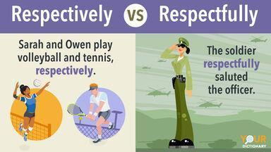   T confirms the meaning, calls on some individual Ss to make sentences with each word. | T-S  S-S  T-S | 6 mins
 | To help students learn about British family values and practise reading for specific information. | TASK 1: READ THE TEXT AND COMPLETE THE TABLE. (p.16)  Read the text and list the five family values of British people in the 21st century in the table below.  * Teacher:  - Asks Ss read the text about British family values and complete the table.  - Walks round the class to offer help, explaining unfamiliar words and answering questions.  ** Ss do as instructed.  *** Ss share their answers with a partner.   T checks the answers as a class by calling on pairs to write their missing words on the board.  Keys:  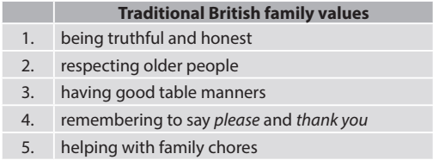 | T-S  S-S  S-S  T-S | 9 mins
 | To help students relate what they have learnt in the reading text to their own culture. | TASK 2: DISCUSSION (p.16)  * Teacher:  - Has Ss draw the completed table in 1 in the notebooks and add one more column to the right which is Traditional Vietnamese family values.  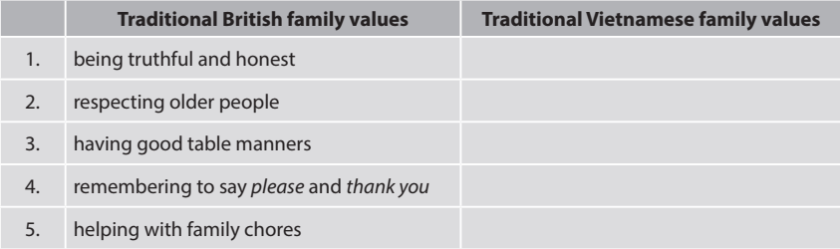  - Ask Ss to work in pairs to discuss each of the British family values in the table and decide whether Vietnamese people follow those values too.  - Tells Ss to write YES in the Vietnamese column if the value is also followed in Viet Nam, NO if it is not, NOT SURE if Ss are not sure whether it is YES or NO.  - Asks Ss to think of more family values observed in Viet Nam (e.g. family unity and harmony, respect for the elders, etc.)  ** Ss work in pairs to discuss and take notes.   T calls on some Ss to report back their answers to the class. | T-S  S-S  T-S | 8 mins
CONSOLIDATION | To help students memorise the content of the lesson that they have learned | WRAP-UP  T asks: What have you learnt today?  - The ways to express opinions  - British and Vietnamese family values  HOMEWORK  - Do exercises in the part Looking back  - Exercises in the workbook  - Prepare for Looking back and Project lesson | T-S | 2 mins

UNIT 1: FAMILY LIFE
Lesson 8: Looking back & Project
I. OBJECTIVES
By the end of this lesson, Ss will be able to :
1. Knowledge
- review pronouncing consonant blends /br/, /kr/, /tr/
- review the vocabulary and grammar of Unit 1
- do research on Family Day in Viet Nam or other countries in the world and give a group presentation about it.
2. Core competence
- develop communication skills and creativity;
- develop presentation skills;
- develop critical thinking skills;
- be collaborative and supportive in pair work and team work;
- actively join in class activities.
3. Personal qualities
- be more creative when doing the project;
- develop self-study skills.

II. MATERIALS
- Grade 10 textbook, Unit 1, Looking back & Project
- Computer connected to the Internet
- Projector/ TV/ pictures and cards
- Pictures, A0 paper
- Hoclieu.vn

Assumptions
Anticipated difficulties | Solutions
Students may have underdeveloped presentation skills. | Give them a suggested checklist for peer assessment and ask them to read carefully and try to practise in advance and apply those techniques in their presentation.

Board Plan
Date of teaching
UNIT 1: FAMILY LIFE
Lesson 8: Looking back & Project
* WARM-UP
I. Looking back
Pronunciation: Listen and write /br/, /kr/ or /tr/.
Vocabulary: Complete the text. Use the correct forms of the word and phrases in the box.
Grammar: There is a mistake in each sentence below. Find the mistake and correct it.
II. Project
Happy Family Day
* CONSOLIDATION

III. PROCEDURES
Notes:
In each activity, each step will be represented as following:
* Deliver the task
** Implement the task
*** Discuss
 Give comments or feedback

Stage | Stage aim | Procedure | Interaction | Time
WARM-UP | - To arouse the classroom atmosphere.  - To help students revise words/ phrases related to the topic | * Teacher:  - Divides Ss into 4 groups.  - Asks each group to write down as many words as they can think of about the topic “Household chores”.  ** Ss do as instructed.   T praises the Ss with the most words and the most interesting words/ phrases. | T-S  S-S  T-S | 5 mins
LOOKING BACK | To help students revise the consonant blends /br/, /kr/, and /tr/.  To help students revise words and phrases related to the topic of household chores, which they have learnt in the unit.  To help students revise the Present simple and Present continuous. | PRONUNCIATION: LISTEN AND WRITE /BR/, /KR/ OR /TR/. (p.16)  Listen and write /br/, /kr/, or /tr/ above the word that has the corresponding consonant blends. Then practise reading the sentences.  * Teacher:  - Asks Ss to listen to the recording and underline the words that have the consonant blends /br/, /kr/, and /tr/.  - Asks individual Ss to write the words with the consonant blends on the board and has them read those words several times.  - Plays the recording again, pausing after each sentence for Ss to repeat.  - Puts Ss in pairs and has them practise reading the sentences together.  ** Ss do as instructed.   T goes round to offer help and collect common mistakes if Ss have to correct as a class.  Key:  /kr/ /br/ /br/  1. I like ice cream, but my brother likes bread pudding.  /tr/ /kr/ /tr/ /br/  2. Tracy crashed her car into a tree and broke her leg.  /kr/ /br/  3. They often have crab soup for breakfast.  VOCABULARY: COMPLETE THE TEXT. (p.16)  Complete the text. Use the correct form of the word and phrases in the box.  * T asks Ss to complete the text by using the correct form of the word and phrases in the box individually.  ** Ss do as instructed.  *** Ss compare their answers with a partner.   T checks the answers by asking individual Ss to write the missing words/ phrases on the board  Key:  1. does the cooking  2. does the heavy lifting  3. laundry  4. cleaning the house  5. does the washing-up  GRAMMAR: THERE IS A MISTAKE IN EACH SENTENCE BELOW. FIND THE MISTAKE AND CORRECT IT. (p.16)  * T asks Ss to find the mistake in each sentence and correct it individually.  ** Ss do as instructed.  *** Ss compare their answers with a partner.   T checks the answers by asking individual Ss to write the answers on the board and has them explain why.  Key:  1. I’m writing to you to tell you how much I’m wanting to see you. → want  2. Jack is away on business, so now I look after his dog. → ’m / am looking  3. Nam’s often looking untidy. → (often) looks  4. She can’t answer the phone now. She cooks dinner. → ’s / is cooking  5. Excuse me, do you read the newspaper? Could I borrow it? → are you reading  6. What are your family doing in the evenings? → do / does ... do | T-S  S-S  T-S  T-S  S  S-S  T-S  T-S  S  S-S  T-S | 6 mins  5 mins  6 mins
PROJECT | To provide an opportunity for students to develop their research and collaboration skills and to practise giving an oral presentation. | * Teacher:  - Gives Ss a checklist for peer and self-assessment and explains that they will have to tick the appropriate items while listening to their classmates’ presentations and write comments if they have any. (The presenters should complete their self-assessment checklist after completing their presentation).  - Goes through the criteria for assessing their talk to make sure Ss are familiar with them.  - Invites two or three groups to give their presentations and encourages the rest of the class to ask questions at the end.  ** Ss do as instructed.  *** Ss make questions after each presentation.   Teacher:  - Gives praise and feedback after each presentation and gives marks for their presentation as part of their continuous assessment.  - Asks Ss to complete the self-assessment table, identifies any difficulties and weak areas and suggests further practice for individual Ss. | T-S  S-S  S-S  T-S | 21 mins
CONSOLIDATION | - To consolidate what students have learnt in the lesson.  - To prepare for the next lesson. | WRAP-UP  T asks: What have you learnt today?  - Revise the consonant blends /br/, /kr/, and /tr/.  - Revise words/ phrases related to the topic Household chores.  - Revise Present simple and Present continuous.  HOMEWORK  - Exercises in the workbook  - Prepare for Unit 2 lesson 1 | T-S | 2 mins

APPENDIXES
Suggested checklist for peer assessment:
 | Tick where appropriate | Comments (in English or Vietnamese)
DELIVERY
- The presenters greeted the audience.
- The presenters spoke clearly and naturally.
- The presenters cooperated when delivering their talk.
- The presenters interacted with the audience.
- The presenters used some photos /pictures to illustrate their ideas.
- The presenters concluded their talk appropriately
CONTENT: The presentation includes the following information about Family Day in Viet Nam or other countries.
- where it is celebrated
- when it is celebrated
- when it was first celebrated
- why it is celebrated
- what people often do to celebrate the day

Suggested checklist for self-assessment:
 | Tick where appropriate | Comments (in English or Vietnamese)
DELIVERY
- I greeted the audience.
- I spoke clearly and naturally.
- I cooperated with my group members when delivering the talk.
- I interacted with the audience.
- I used some photos / pictures to illustrate my ideas.
- I concluded my part of the talk appropriately.
CONTENT: The presentation includes the following information about Family Day in Viet Nam or other countries.
- where it is celebrated
- when it is celebrated
- when it was first celebrated
- why it is celebrated
- what people often do to celebrate the day

