|  |  |
| --- | --- |
|  | *Thời gian làm bài: 40 phút (Không kể thời gian giao đề)*  *-------------------------* |

**Họ tên thí sinh: .................................................................**

**Số báo danh: ......................................................................**

**Mã Đề: 014.**

**Câu 1.** What has Tim booked for himself and Ben?

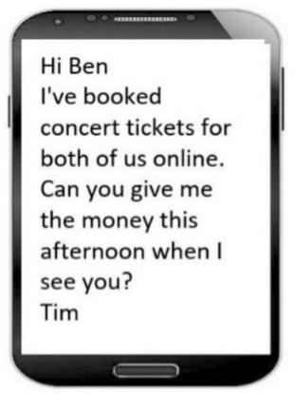

**A.** Concert tickets  **B.** Sports game tickets  **C.** Movie tickets  **D.** Theater tickets

**Câu 2.** **Look at the signs. Choose the best answer for the question.**



**A.** Leaning against the wall is possible.  **B.** This is not a leaning wall.

**C.** Do not lean against the wall.  **D.** Don’t stand near the wall because it’s leaning.

**Câu 3.** What are the things that Mom asked her kid to pick up?

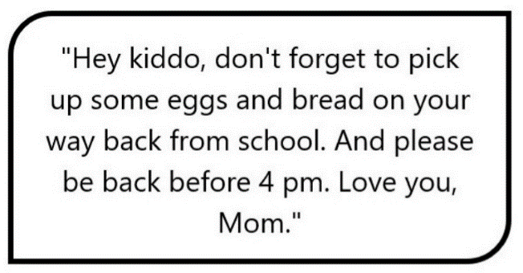

**A.** Eggs, bread, and milk  **B.** Eggs and milk

**C.** Bread and milk  **D.** Eggs and bread

**Câu 4.** **Look at the signs. Choose the best answer for the question.**

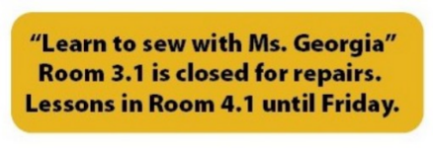

**A.** Ms. Georgia will repair her room on Friday.  **B.** There is a new location for Ms. Georgia’s class.

**C.** Ms. Georgia’s class will be on a different day.  **D.** Ms. Georgia isn’t coming to school until Friday.

**Câu 5.** **Look at the signs. Choose the best answer for the question.**

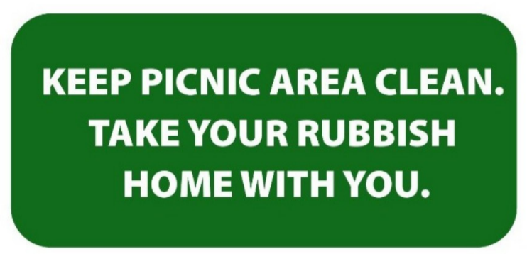

**A.** You should not leave any rubbish in the picnic area.

**B.** You must clean the picnic area before you go home.

**C.** You can go home with all of the rubbish from the picnic area.

**D.** If you find rubbish in the picnic area, you should clean it.

**Câu 6.** What are students asked to do after using the kitchen?

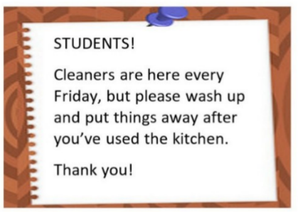

**A.** Leave everything as it is  **B.** Wash up and put things away

**C.** Deep clean the entire kitchen  **D.** Call the cleaners

**Câu 7.** **Look at the signs. Choose the best answer for the question.**



**A.** You cannot set off fireworks here.

**B.** It’s dangerous to set off fireworks here.

**C.** You should be careful when playing with fireworks.

**D.** Fireworks aren’t produced here.

**Câu 8.** **Look at the signs. Choose the best answer for question.**

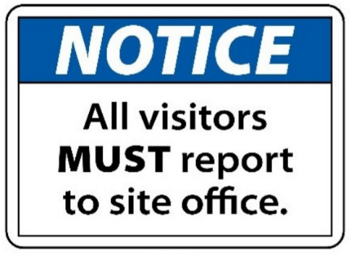

**A.** All visitors can enter the place through the site office.

**B.** Guests are reported to visit the site office.

**C.** Anyone who visits must go to the site office and check in.

**D.** The site office is for everyone to make a report.

**Câu 9.** What is the unique feature of the sports smartwatch?

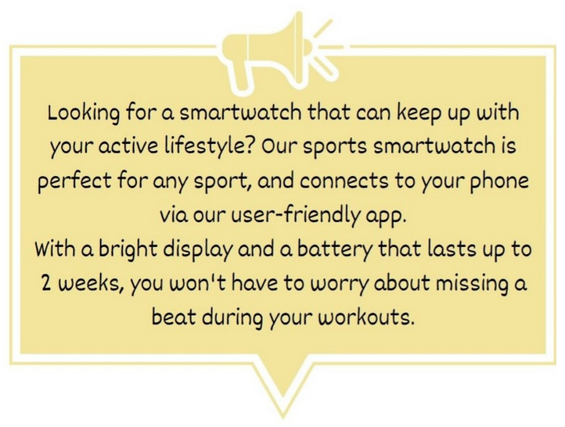

**A.** It can connect to your laptop  **B.** It can last up to 2 years without charging

**C.** It has a built-in camera  **D.** It is perfect for any sport

**Câu 10.** What alternative does Missie suggest if Tess can't lend her laptop?

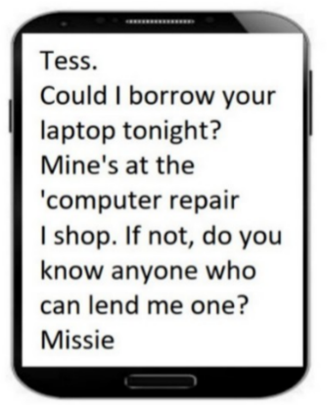

**A.** Going to an internet cafe  **B.** Using a desktop computer

**C.** Finding someone else who can lend a laptop  **D.** Asking Tess to help with her work

**----HẾT---**