Cambridge Young Learners English
MOVERS
TEST 12

Listening
There are 25 questions
You will need coloured pens and pencils.

My name is…………………………….

PART 1
5 questions

This is an example. Now you listen and draw lines.
Fred | Adam |  | Mike
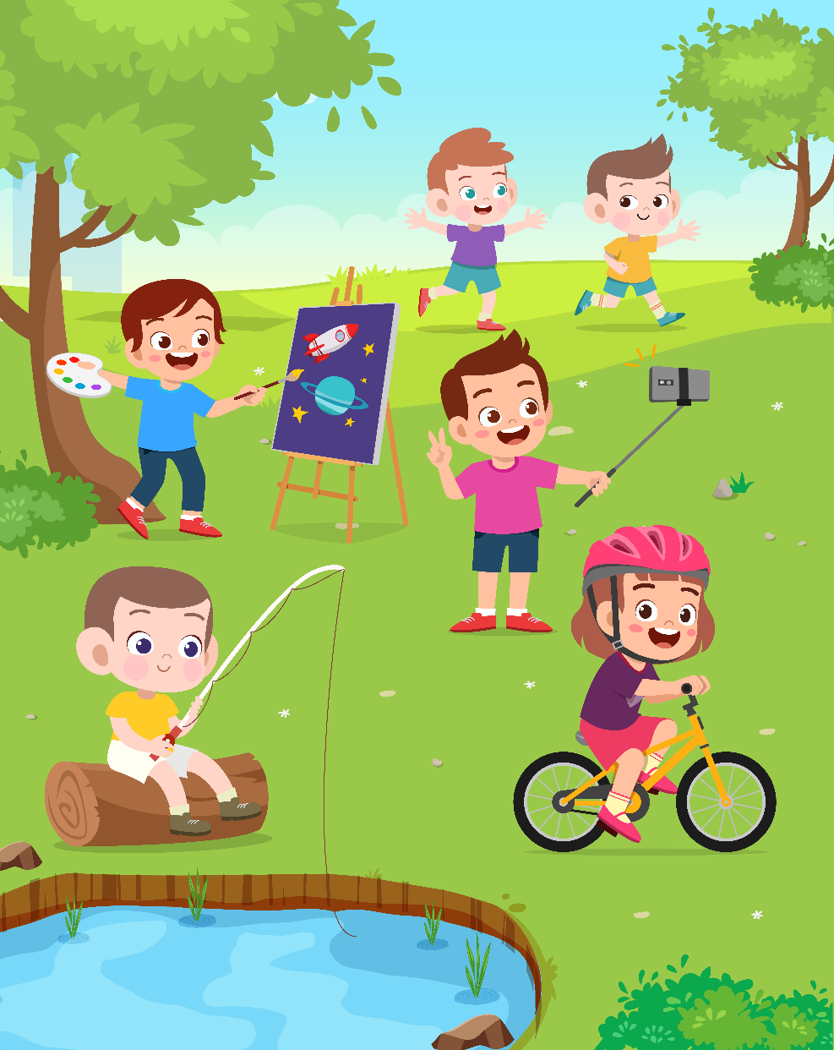
Alex |  | Dave |  | Tom

PART 2
5 questions

Listen and write. There is one example.
 | 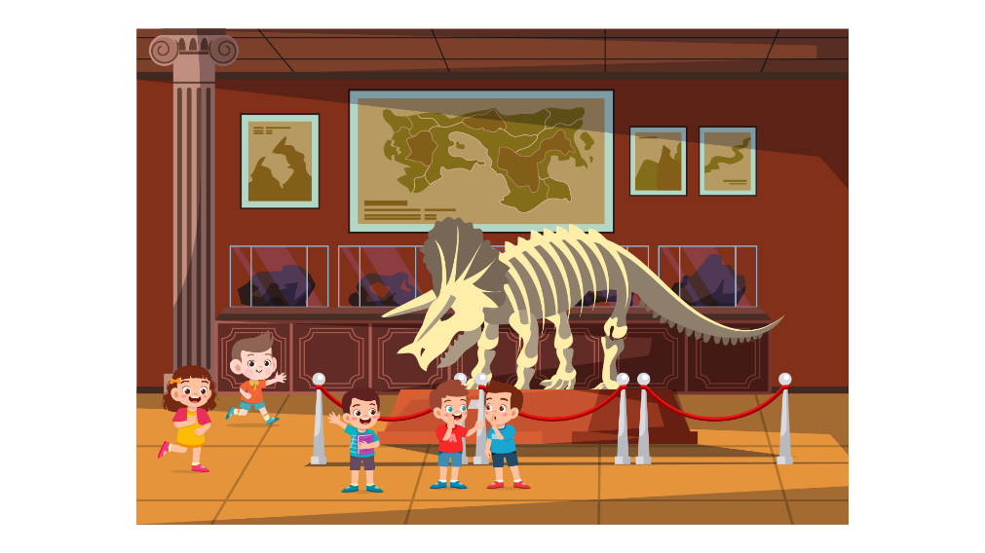
 | A MUSEUM TRIP
0 | Lana will go with her | …friend…
1 | When: | ……
2 | Museums’ name: | …….
3 | Time: | …minutes…
4 | Activity: | ……
5 | Need to bring: | ……

PART 3
5 questions

What did John do at school?
Listen and draw a line from the floor to the correct picture.
There is one example

 | Jamie  Michael  Megan  Brian  Rose  Evan | 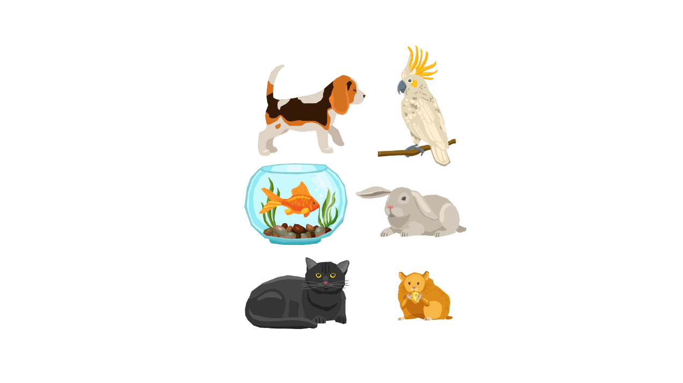
 |  | 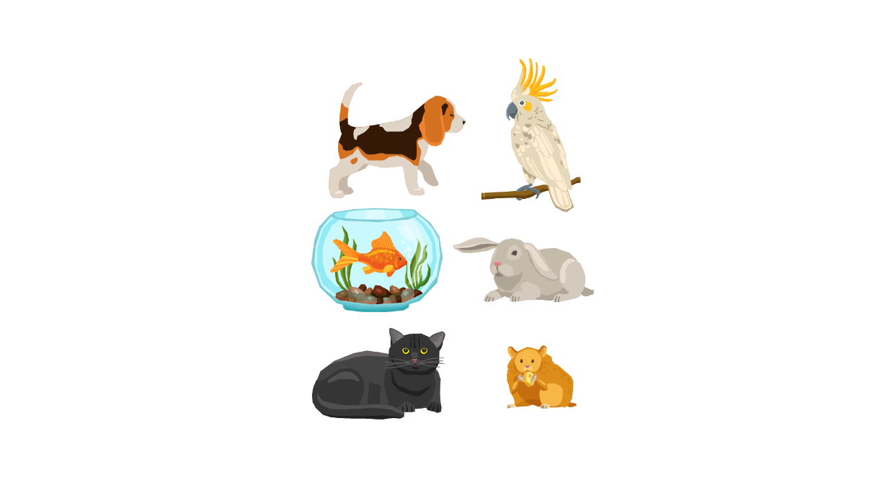
 |  | 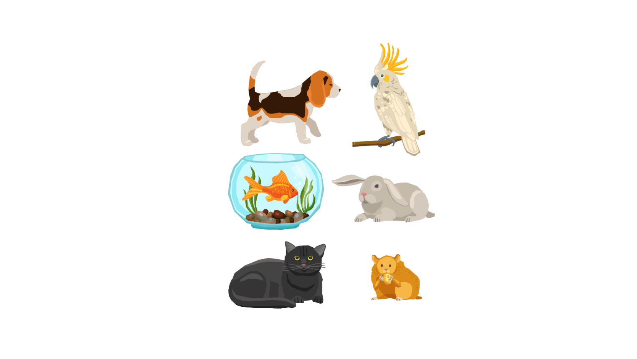
 |  | 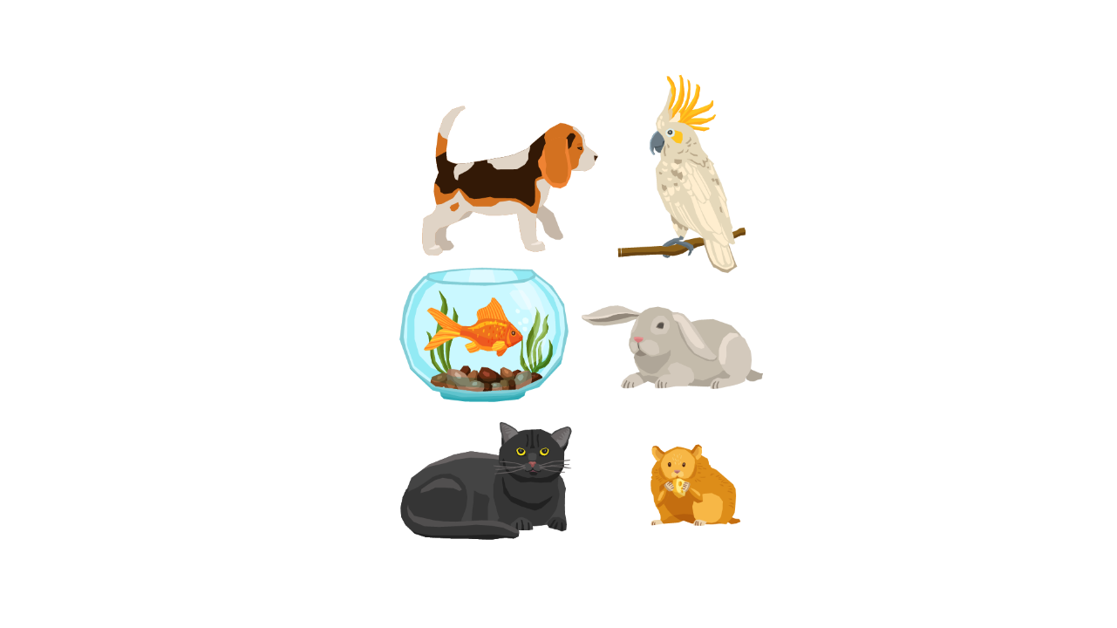
 |  | 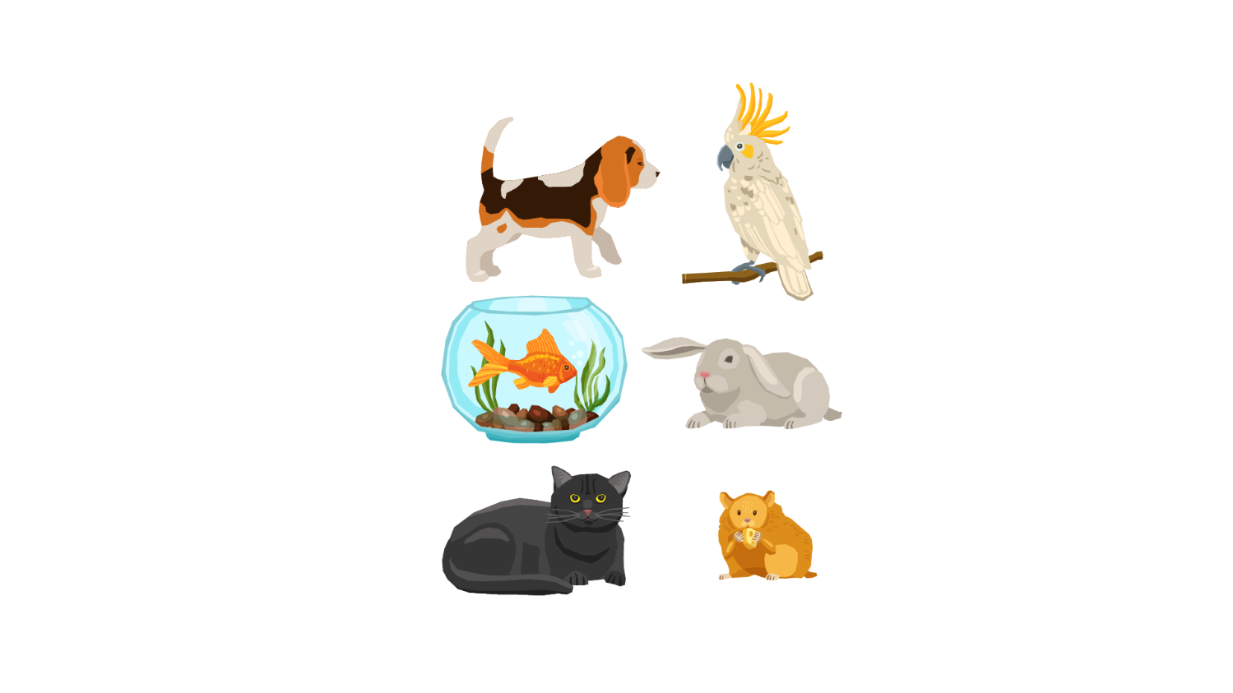
 |  | 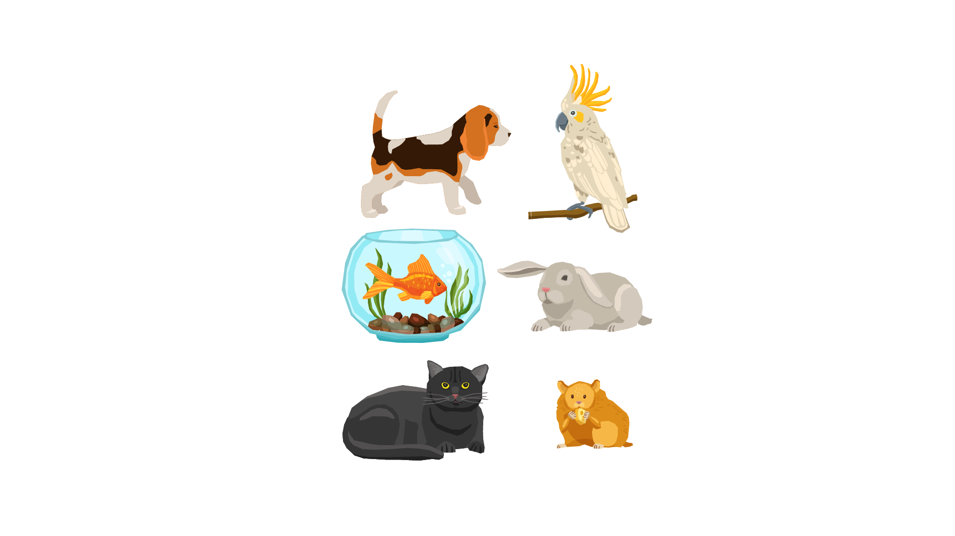

PART 4
5 questions

Listen and tick (✓) the box. There is one example.
What time did Laura go to school?
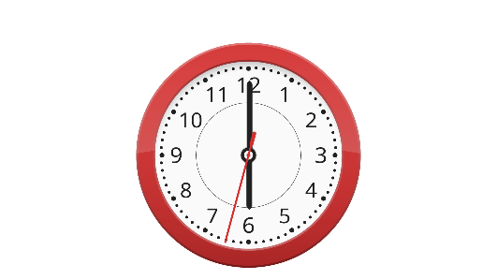 |  | 
A ⬜ | B ⬜ | C ⬜
- What did grandma bake?
 | 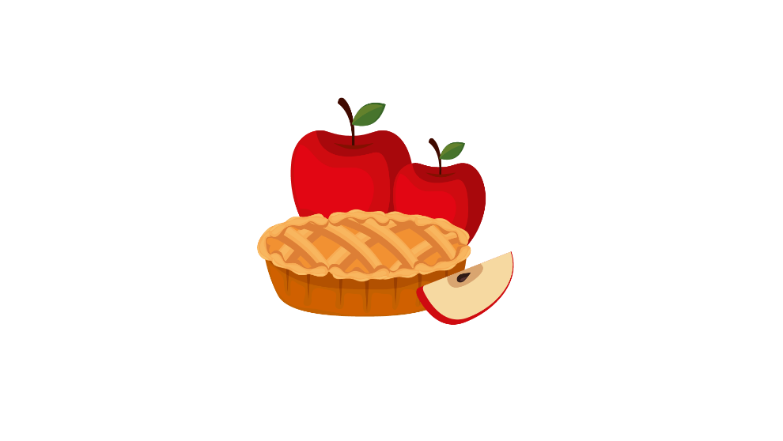 | 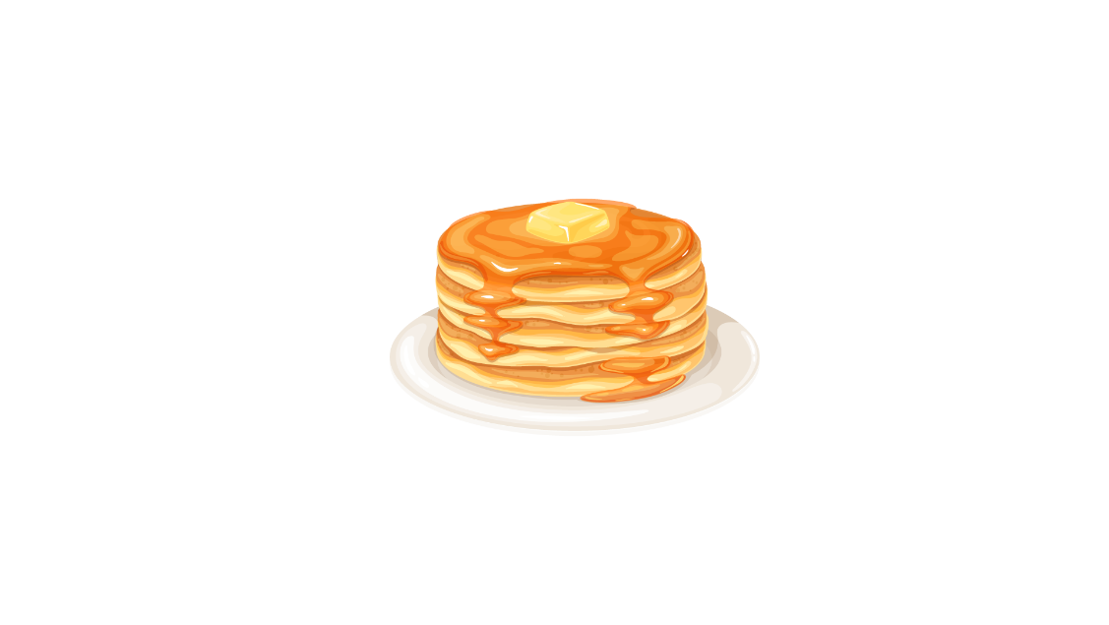
A ⬜ | B ⬜ | C ⬜
- What time does the store close?
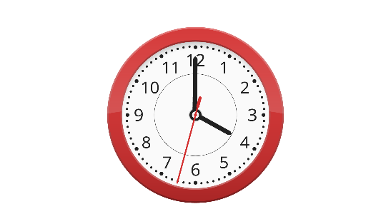 | 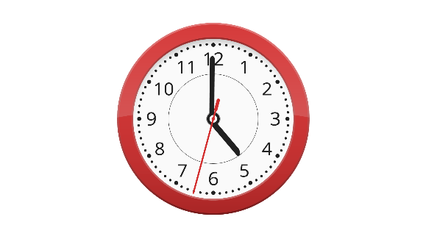 | 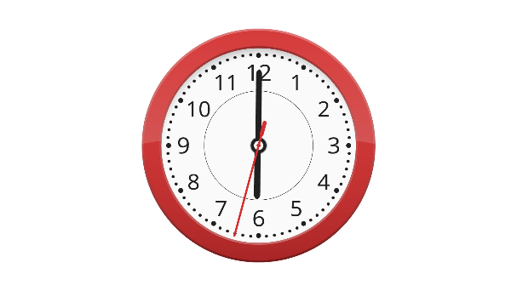
A ⬜ | B ⬜ | C ⬜
- How did she go to work?
 | 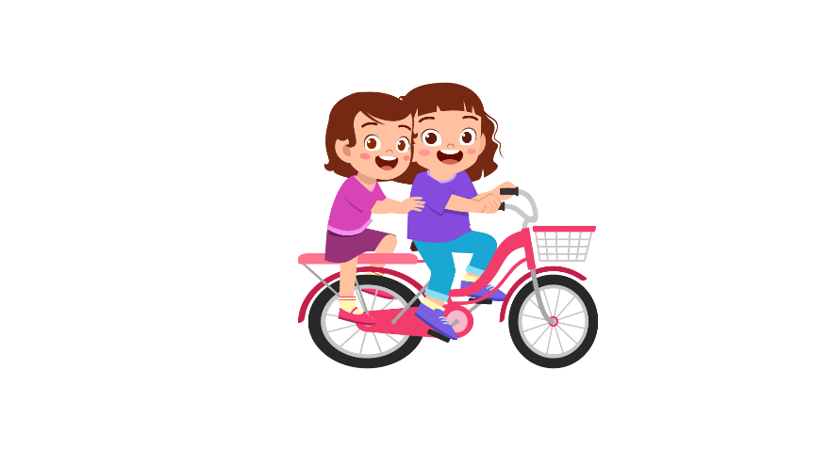 | 
A ⬜ | B ⬜ | C ⬜
- What did Kyle have for breakfast?
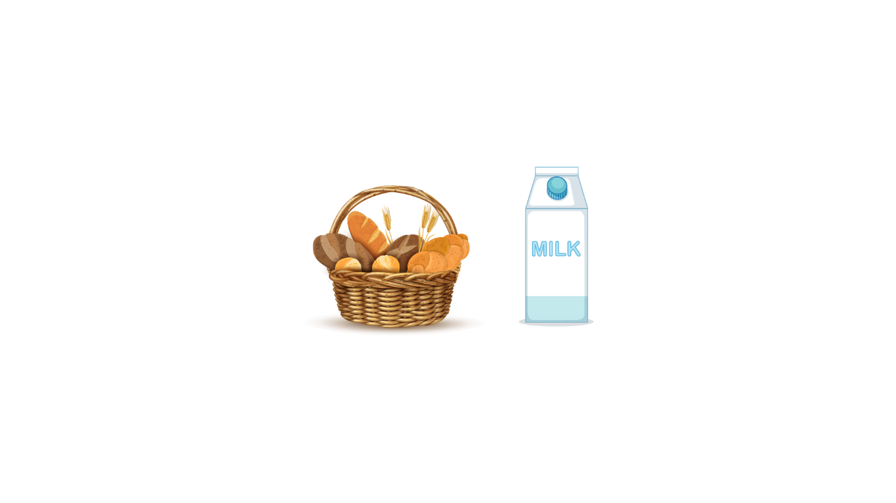 | 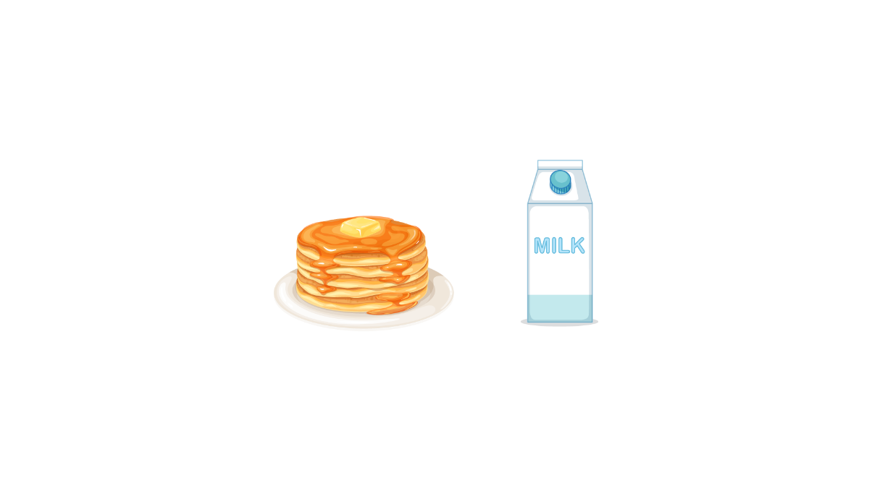 | 
A ⬜ | B ⬜ | C ⬜

- Who will stay at Mary’s house?
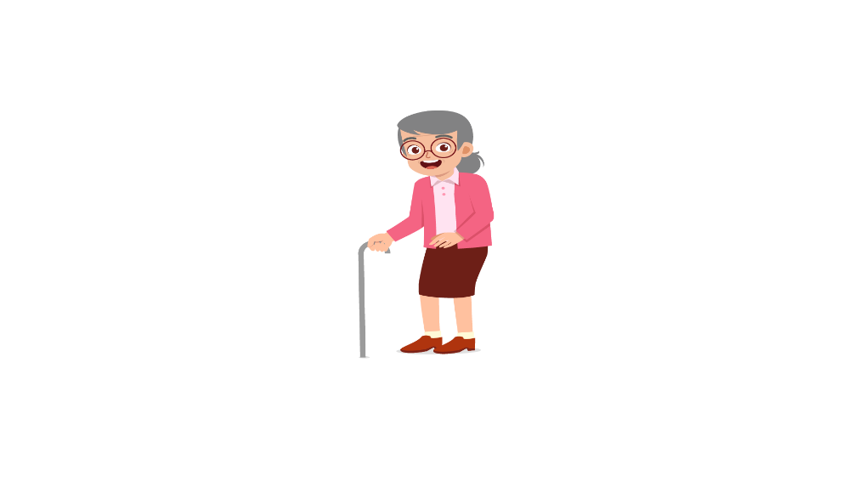 |  | 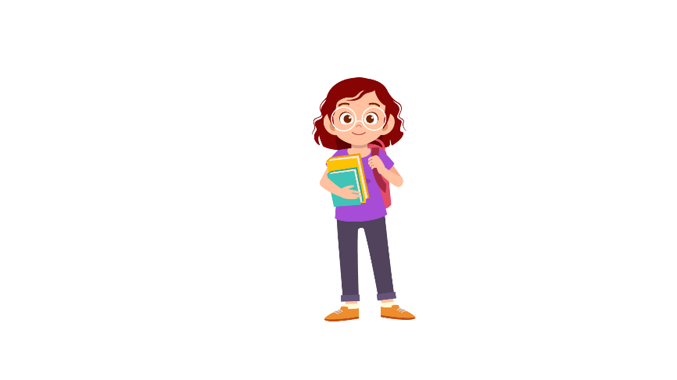
A ⬜ | B ⬜ | C ⬜

Part 5
5 questions

Listen and colour and draw.

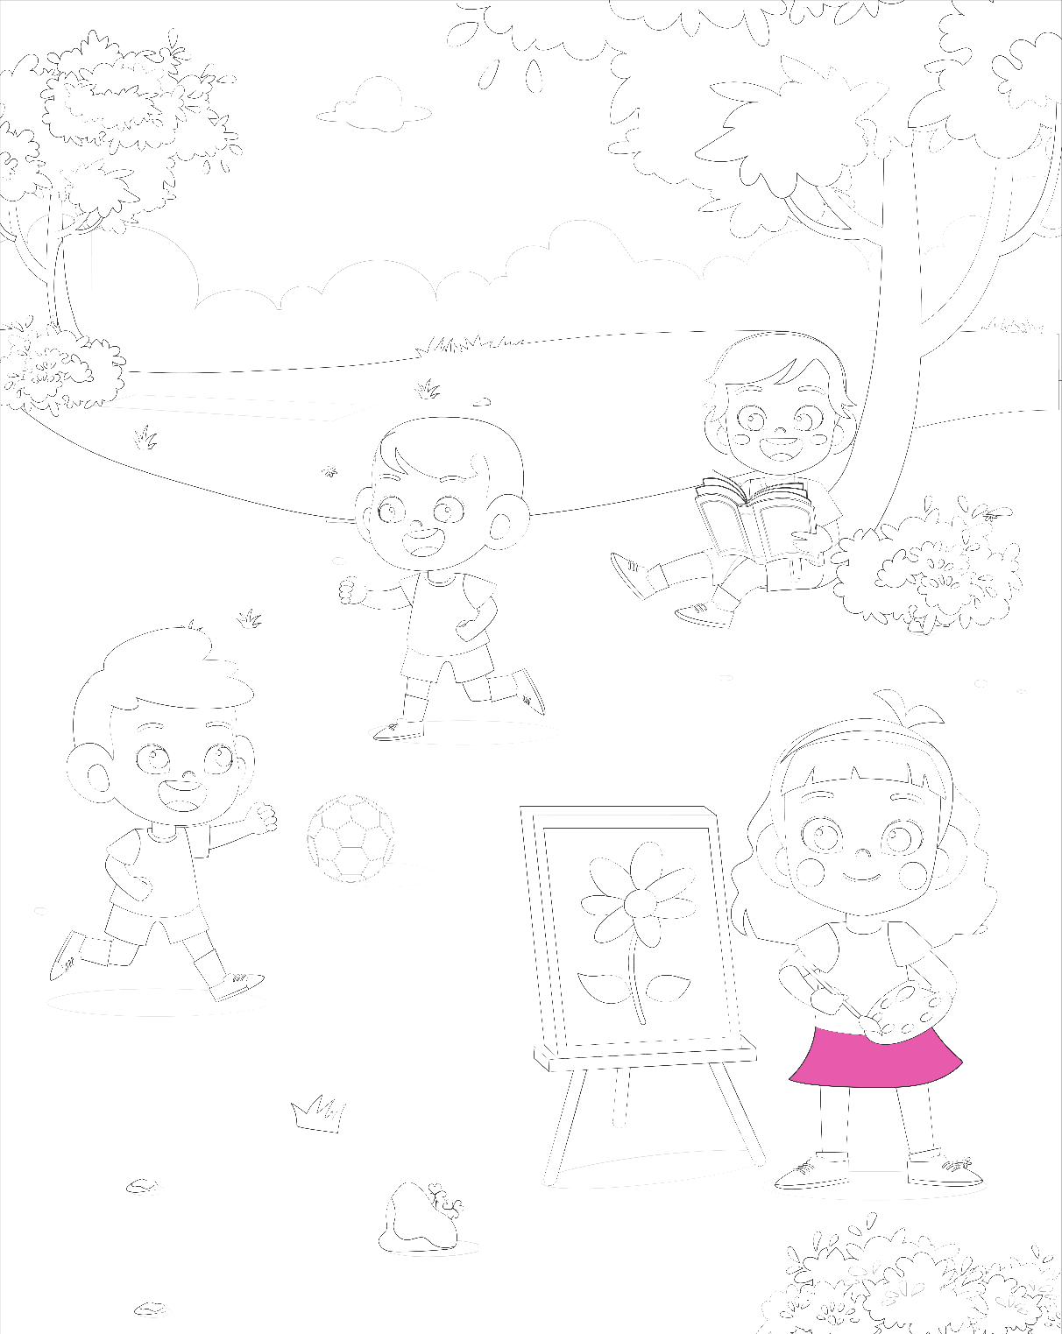

Reading and Writing
There are 35 questions
You have 30 minutes.
You will need a pen or pencil.
My name is…………………………….

PART 1
5 questions

Look and read. Choose the correct word and write them on the lines.

 | 
A hospital | A blackboard
 | 
The moon | A pen
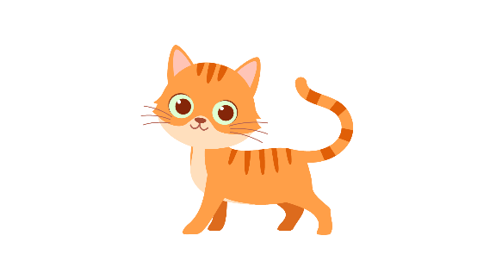 | 
A cat | A chair

An ice-cream
Example
(0) | It is a place. A doctor works there. | A hospital
Questions
1 | Every classroom has it. It’s big and teacher can write on it. | ___________
2 | When you are tired, you can sit on it. | ___________
3 | It uses ink to create letters | ___________
4 | It’s a kind of food. Children love it because it’s sweet and cold. | ___________
5 | It is an animal. You can keep it as a pet

PART 2
6 questions

Read the text and choose the best answer.
Hoa is talking to her friend, Lan, on her first day at school.
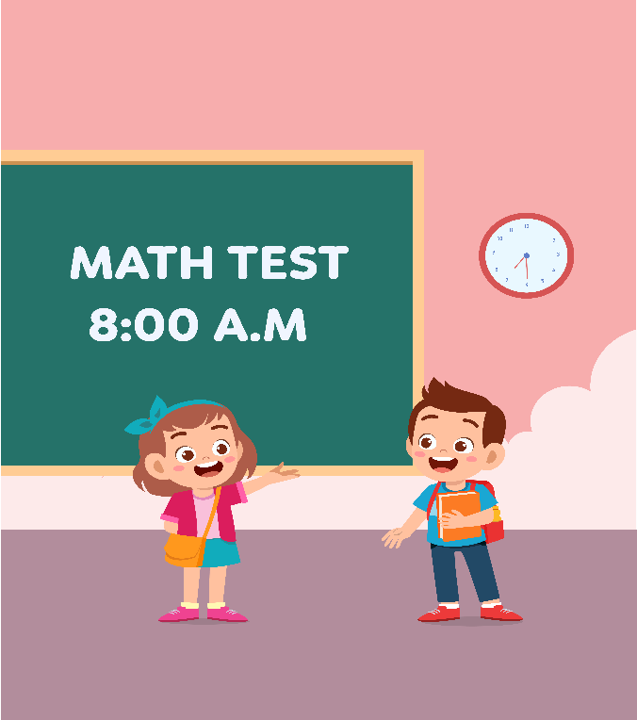

Example:
 | Maya: | Hello! How are you?
 | Dave: | A. I be good.
 |  | B. I am good.
 |  | C. I do good
Questions:
1 | Maya: | Do you worry about the Math exam?
 | Dave: | A. Yes, I am
 |  | B. No, I am
 |  | C. Yes, I do

2 | Maya: | What did you study last night?
 | Dave: | A. I study lessons 1 and 2.
 |  | B. I studies lessons 1 and 2
 |  | C. I studied lessons 1 and 2.

3 | Maya: | Who taught you Math?
 | Dave: | A. My mother
 |  | B. My cat.
 |  | C. My head.

4 | Maya: | How long did you study?
 | Dave: | A. yesterday.
 |  | B. 5 P.M.
 |  | C. 2 hours.

5 | Maya: | When did you go to sleep?
 | Dave: | A. In an hour.
 |  | B. 9 PM.
 |  | C. never

6 | Maya: | Can you say something to me before my test?
 | Dave: | A. Thank you!
 |  | B. Good luck!
 |  | C. You’re welcome!

PART 3
6 questions

Read the story. Choose a word from the box. Write the correct word next to the numbers 1-5. There is one example.
We like to go to the (0) …beach… in Florida.
My favorite beach is Emerson Beach. It is very long, with (1) ………. sand and palm trees. It is very beautiful. I like to make sandcastles and (2) ………. the sailboats go by. Sometimes there are dolphins and whales in the (3) ……….!
We get up early in the (4) ………. and look for shells in the sand. I found fifteen big shells last year. I put them in a special place in my room. This year I want to learn to (5) ………. It is hard to surf, but so much fun! My sister is a good surfer. She says that she can teach me. I hope I can do it!
Nguồn: https://lingua.com/english/reading/my-family/

Example
surf | morning | water
soft | beach | winter
watch | airplane | rocky

(6) Choose the best name for the story.
Tick one box.
Family time | ⬜
Our vacation | ⬜
Winter holiday | ⬜

PART 4
5 questions

Choose the right words and write them on the line.
 | A message to a new friend
Example  1  2  3  4  5 | Hi Lucia,  How are you? It was so (0) nice to meet you last week in Sydney. How was your trip? Did you see any kangaroos?  Anyway, I am back to London. There is a new theme park, and the (1) ………. is sunny. There are lots of restaurants and cafés in the area. Maybe you can (2) ………. and see them one day? I would love to show you London, especially in the summer.  Here's a photo of you and (3) ………. at the restaurant in Sydney. That was a very (4) ………. night! Please send me any other photos you have of that night. Good (5) ……….  Please give me your email address and we can talk more.  Bye for now,  Mikel
Nguồn: https://learnenglish.britishcouncil.org/skills/reading/pre-intermediate-a2

Example: | sad | nice | normal
1. | weather | cloud | sky
2. | go | come | fly
3. | us | I | me
4. | fun | funny | funs
5. | morning | memories | luck

PART 5
7 questions

Look at the picture and read the story. Write some words to complete the sentences about the story. You can use 1, 2 or 3 words.
The House


Examples:
Mr. and Mrs. Smith have one son and one daughter. The son's name is John. The daughter's name is Sarah.

The Smiths has …four…. people.
Sarah is their …daughter….

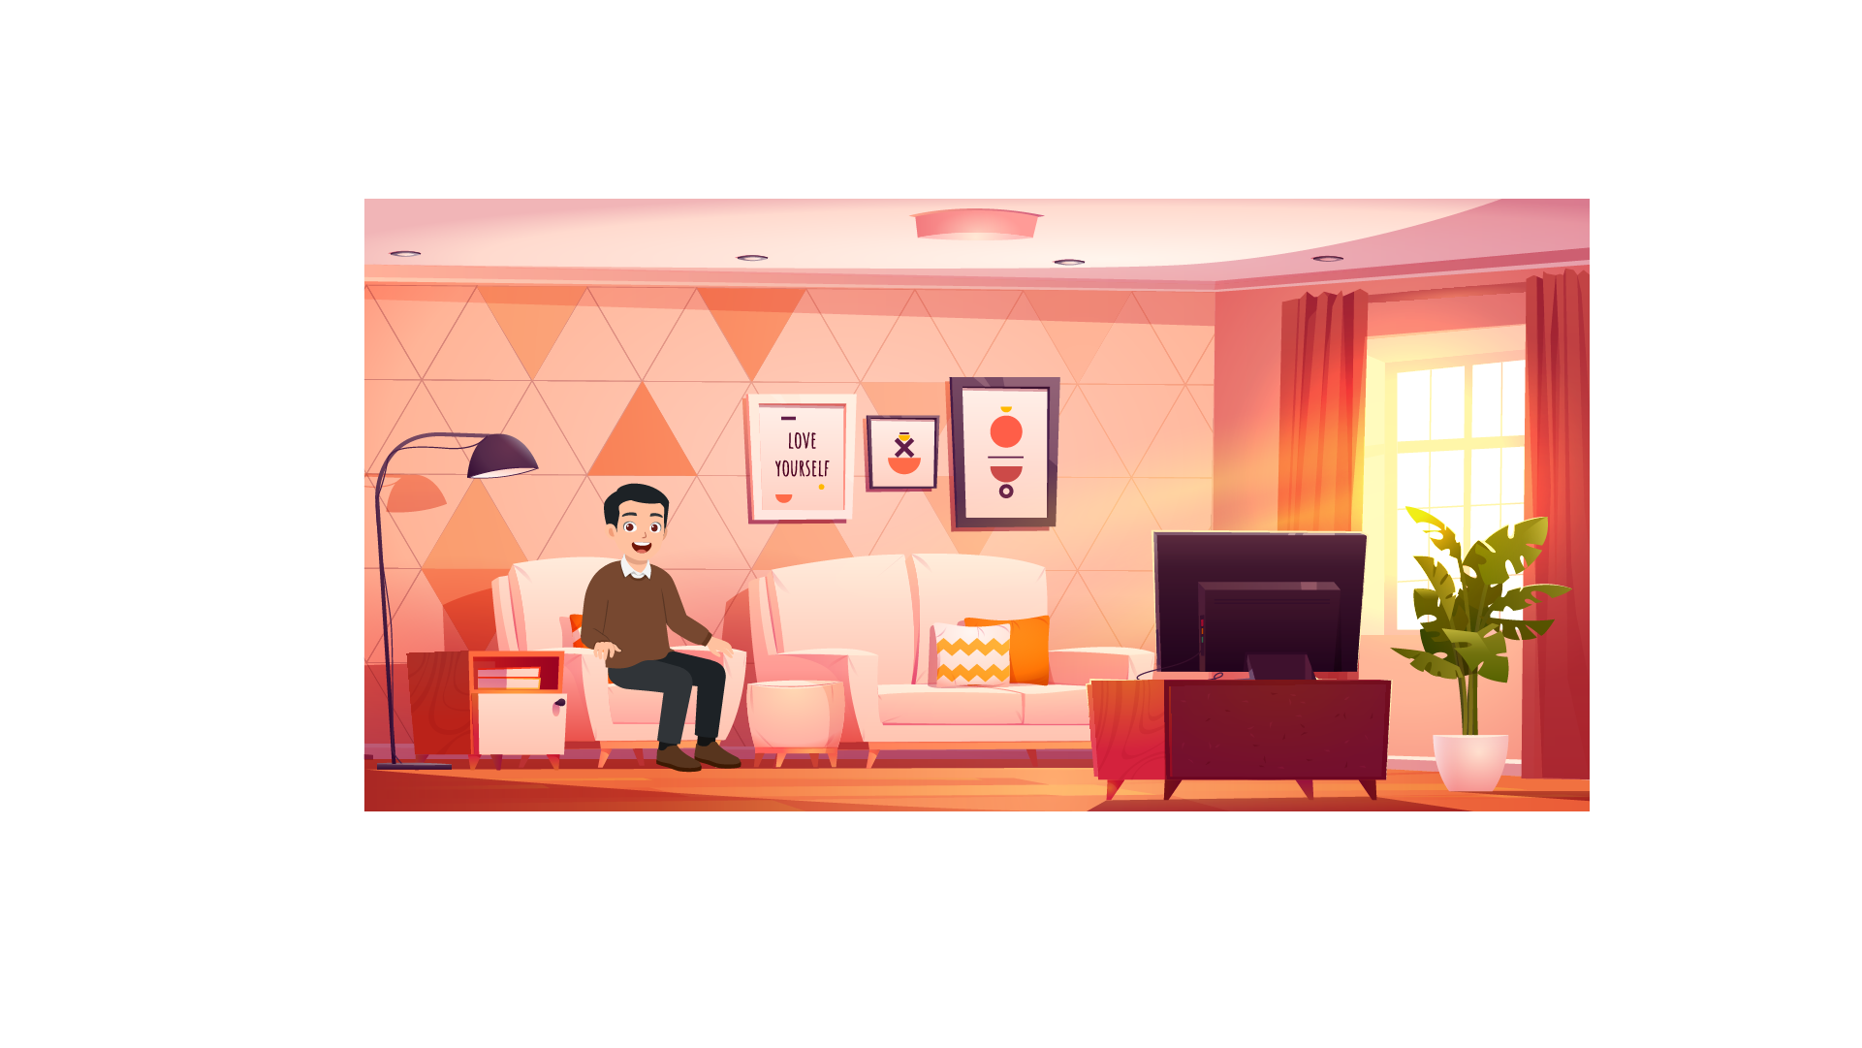
The Smiths live in a lovely and quiet neighborhood. Their home has a large living room with many furnishings. They always gather in the living room. The father watches TV as the children play chess. Mrs. Smith enjoys cleaning the decorations in the living room.

Questions:
1. There is a ……. in the living room.
2. Mrs. Smith likes to clean the decorations in the ……..

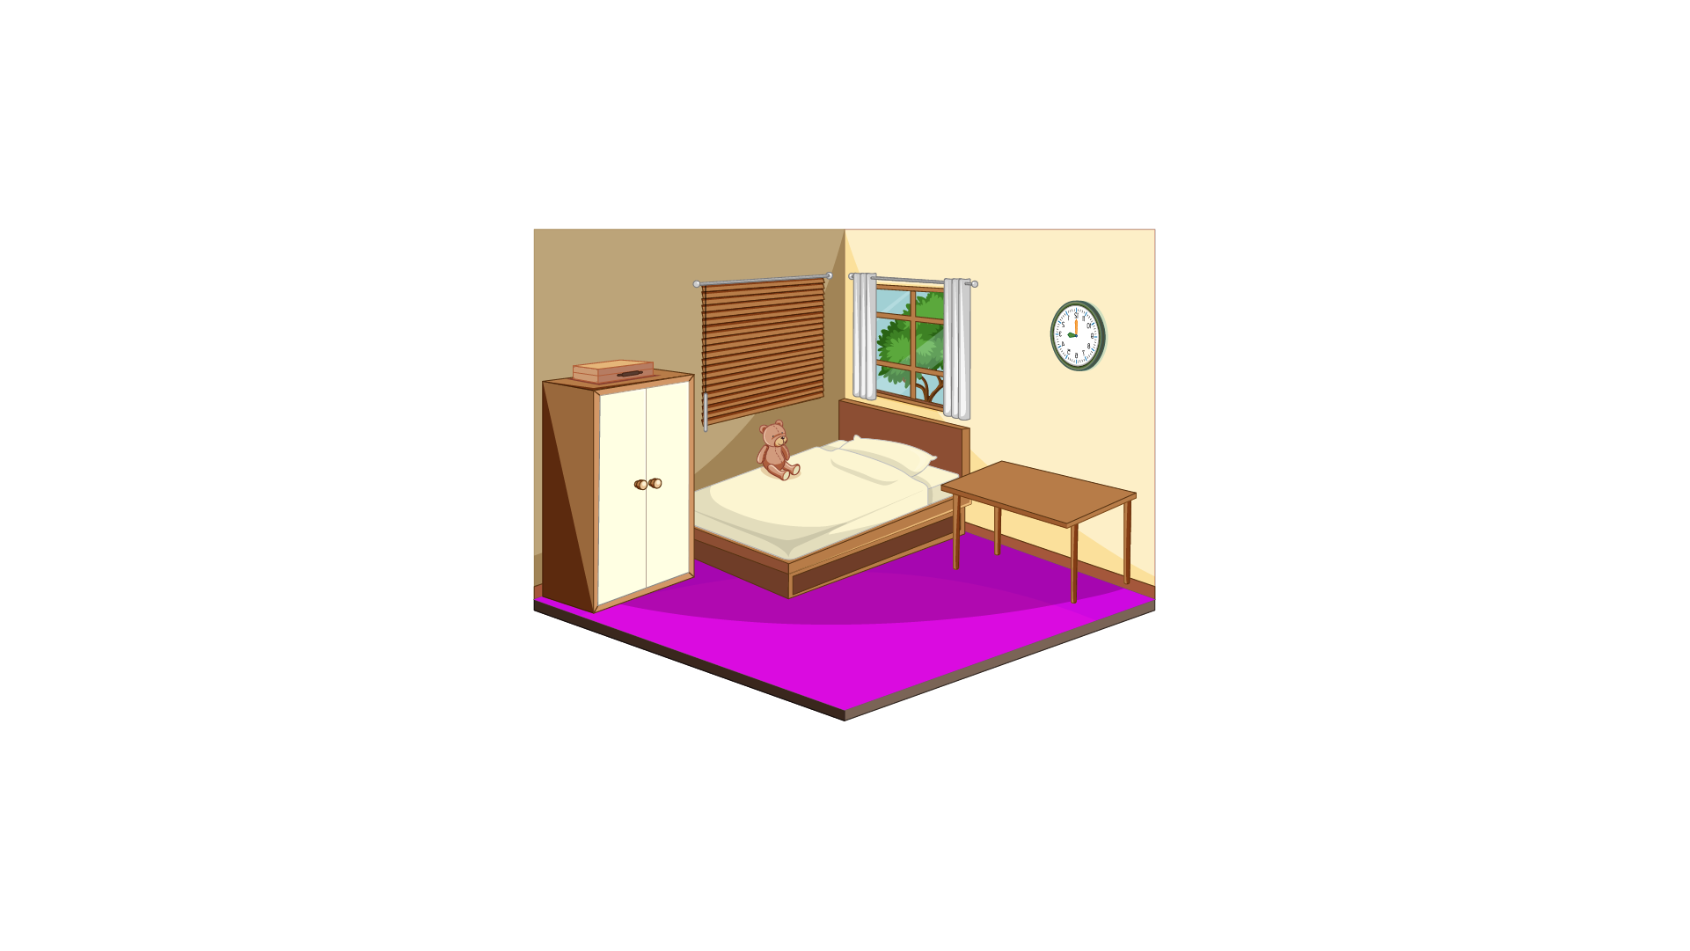
Upstairs, there are two bedrooms. Mr. and Mrs. Smith's room is large and comfortable. In the room, they keep their clothes in an old closet. Sarah and John share a bedroom. The floor is filled with books and toys. Mrs. Smith always reminds children to keep their rooms clean. There is only one bathroom in the hall. In the bathroom, the Smiths clean their teeth.

Questions:
3. The Smiths’ house has ……. bedrooms.
4. The clothes are in the ………
5. When they want to ……… their teeth, they go to the bathroom.


The house has a garden. John and Sarah play in the garden. They have a dog. John and Sarah like to play with the dog.

Questions:
6. The Smiths’ children play in the ………
7. They keep a ……… as a pet.

PART 6
6 questions

Look, read and write.
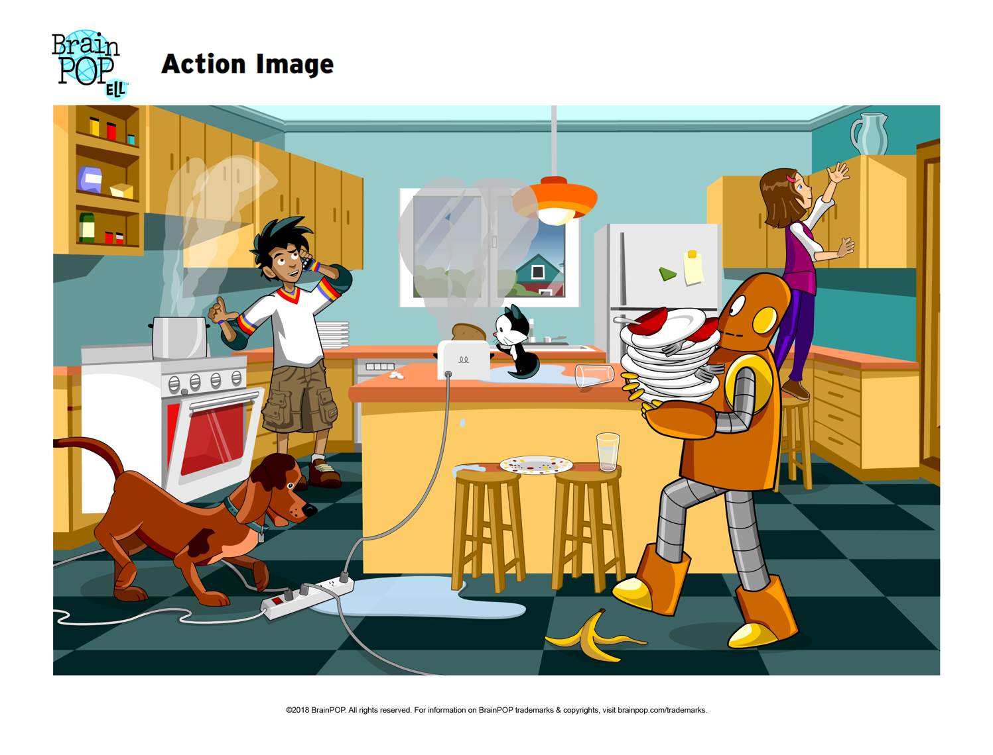

Examples:
Where is the cat? ...on the table…
The banana peel is on the …floor…

Complete the sentences.
- A robot is holding _____________.
- There is __________ everywhere on the floor.
Answer the questions.
- What is the boy doing?
- How is the plate on the chairs?
Now write two sentences about the pictures.
- ____________________________
- ____________________________
Speaking
My name is…………………………….

Summary of Procedures
The usher introduces the child to the examiner. The examiner asks how old the child is.

- The examiner asks the child to describe several differences between the two Find the Differences pictures, e.g. ‘This cat is black but this cat is yellow’.
- The examiner tells the child the name of the story and describes the first picture, e.g. “Linda gets up at 7:00 a.m. She thinks she is late for school”. The examiner then asks the child to continue to tell the story.
- The examiner shows how to do the task with the first odd-one-out set of pictures. For example: ‘These are all places. But this is a room in a house’. Then the examiner asks the child to choose one picture in the other three sets and say which is different and why.
- The examiner asks questions about the child, e.g. ‘Where do you live?’

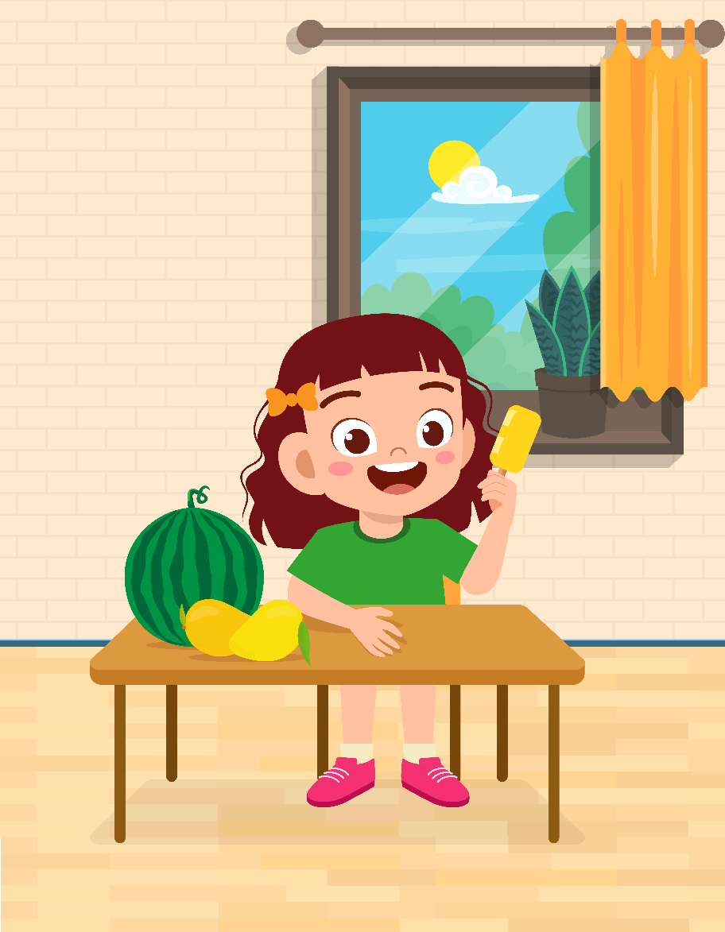 |  | 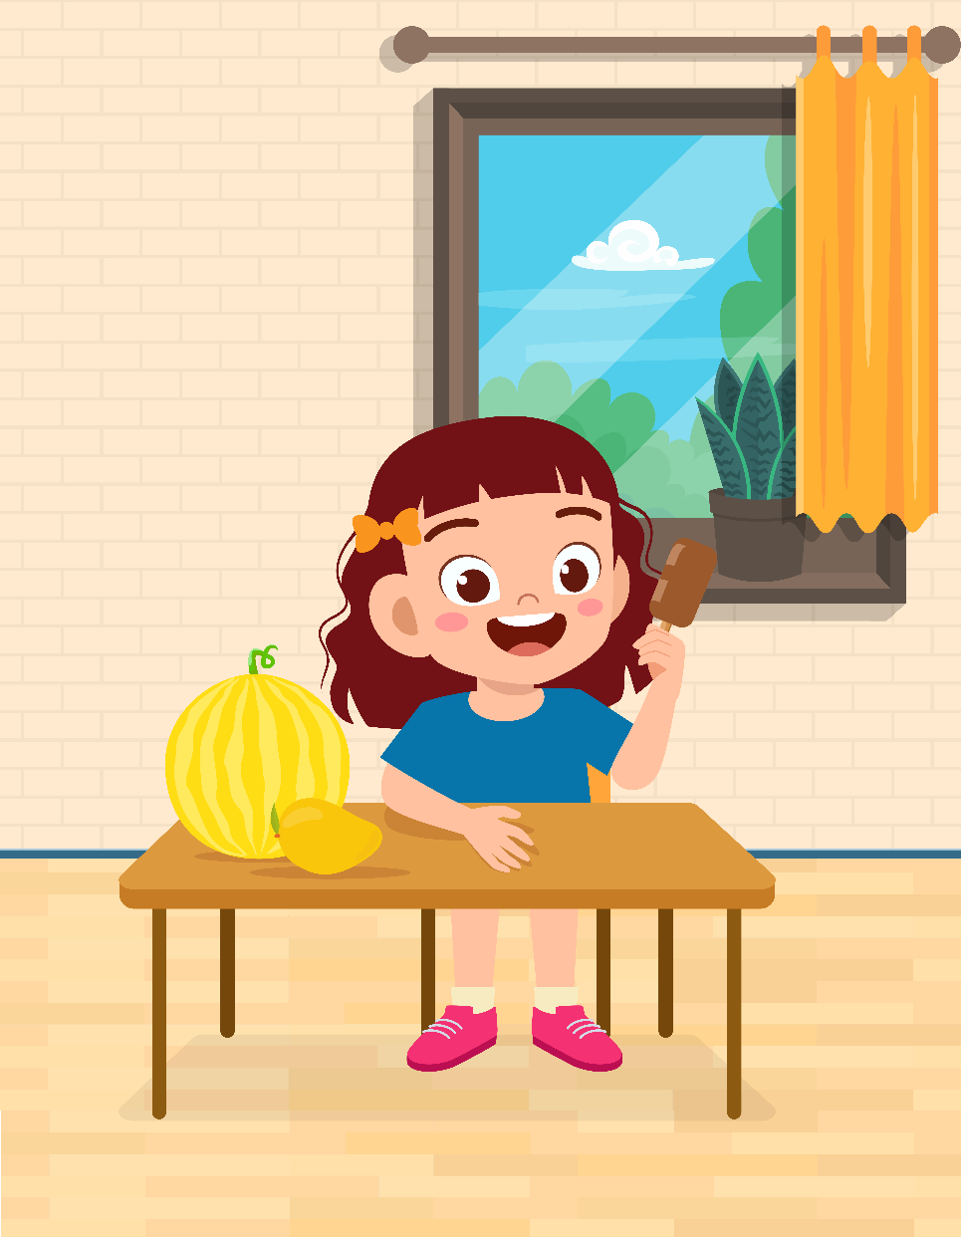

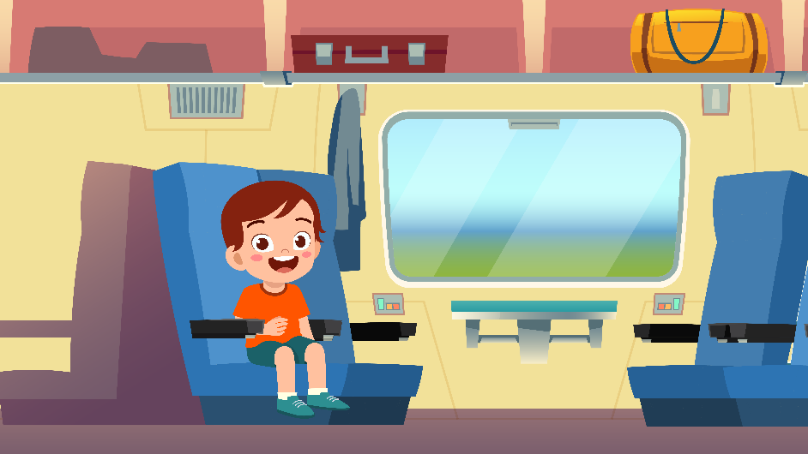 | 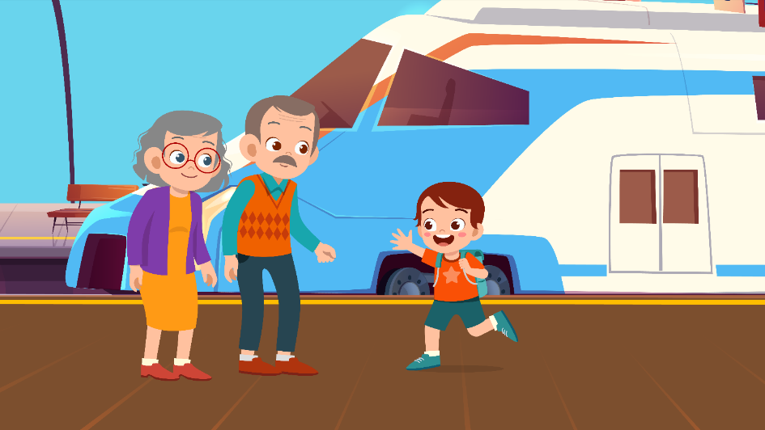
 | 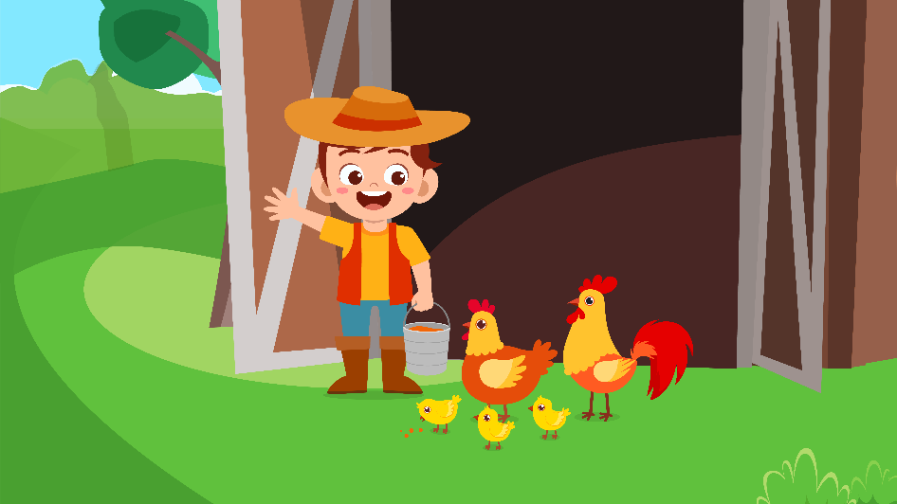

 |  | 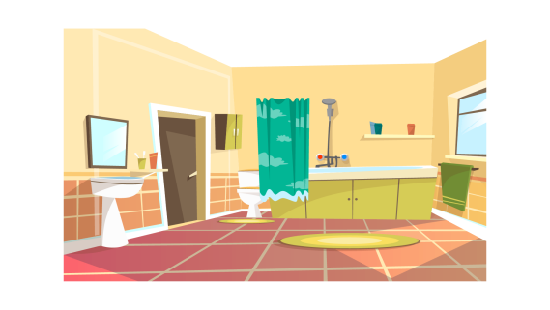 | 
 |  |  | 

 | 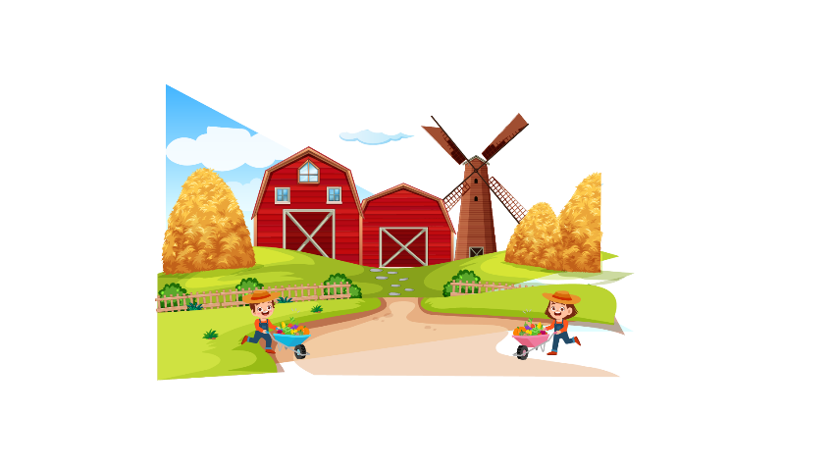 |  | 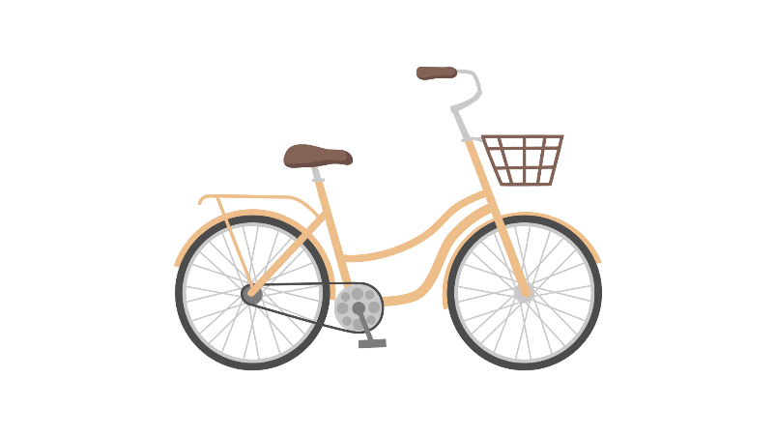
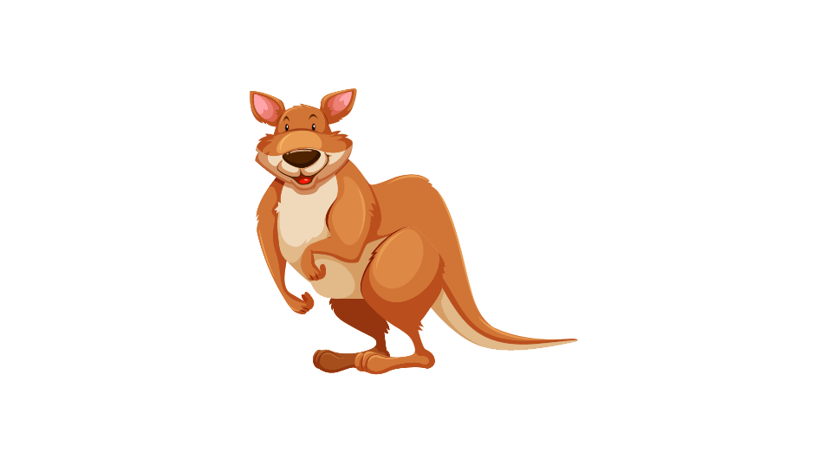 |  |  | 