**LỚP HỌC THẦY (CÔ) ___________________________** **ĐỀ ÔN TẬP: READING SIGNS/ NOTICES – A2**

**Test 9**

*Thời gian làm bài: [Time]*

Họ và tên: ________________________________________________ Lớp: 9/___

**Nội dung:**

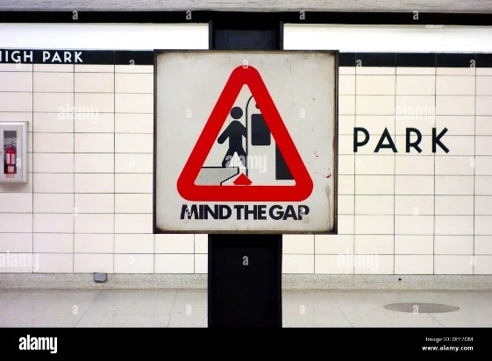**Question 1:** What does the sign mean?

**A.** The gap is unsafe, but you don't need to be careful when entering.

**B.** Be careful! There is a gap below, it is unsafe.

**C.** You should fill the gap with your luggage to make it safer.

**D.** The gap is safe to enter, so you don't need to be careful.

**Question 2:** Amanda wants her grandmother _____________________.



**A.** to lend her a photo. **B.** to lend her some clothes.

**C.** to describe her old uniform. **D.** to take her to school

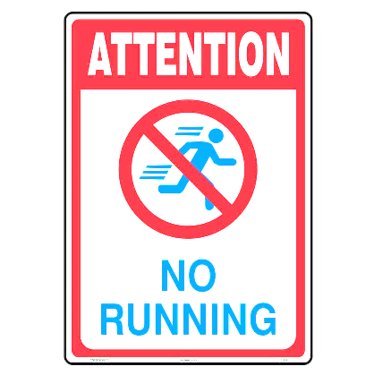**Question 3:** What does the sign mean?

**A.** Running is not encouraged here, so you should run as much as you can.

**B.** Running is allowed in some specific places, but not here.

**C.** Only children are allowed to run here; adults should walk.

**D.** Running is not allowed in this area, so you need to walk instead of running.

**Question 4:** Which of the following information is correct?

Hounslow Cinema: Special Offer

Buy tickets to four films and you don’t need to pay for the next one!

Every day until 5:30 p.m.

**A.** You can watch up to four films for free.

**B.** You must buy 5 tickets to get it free.

**C.**Cheap tickets are available for groups of four in the evenings.

**D.** The fifth film you see during the daytime is free.

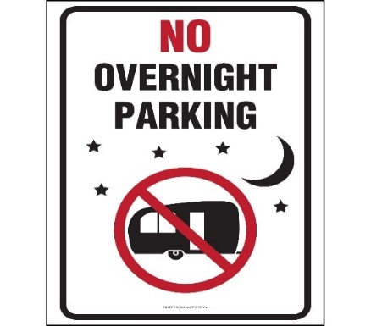**Question 5:** What does the sign mean?

**A.** Overnight parking is not allowed, you have to pay extra**.**

**B.** You have to leave before dark.

**C.** Only employees are allowed to park here overnight.

**D.** Overnight parking here is free, so you can leave your car there all night.

**Question 6:** This is a great way to stay fit?

PLEASE NOTE EVERYONE

There is a lift if you need it. BUT use the stairs if you can.

**A.** Use the lift if you are in a hurry. **B.** Use the stairs if the lift is broken.

**C.** Walking up and down the stairs is better for you. **D.** Use the lift to get there faster.

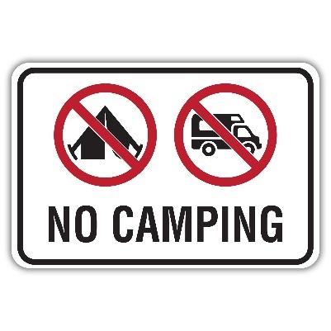**Question 7:** What does the sign mean?

**A.** Camping is allowed here and you may pitch a tent and stay overnight.

**B.** Camping is not allowed here, but you can pay to rent a campsite.

**C.** Certain areas in this area are designated for camping, but not this area**.**

**D.** Do not set up tents or stay overnight in this area; camping is not allowed**.**

**Question 8:** What time do students need to arrive at school tomorrow?

TOMORROW'S TRIP

Bus leaves school: 8:50.

Please arrive no later than 8:40.

The school gates will open at approximately 8:30.

Thank you.

**A.** around 8:30 **B.** before 8:40 **C.** at 8:50 **D.** at 8:40

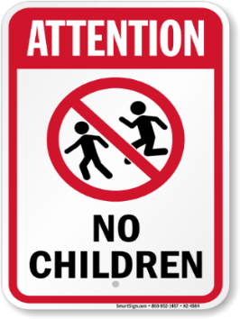**Question 9:** What does the sign mean?

**A.** Children are welcome in this area**.**

**B.** The area is for people over 16 only.

**C.** Children are not allowed to run in this area**.**

**D.** Children can enter but must be accompanied by an adult.

**Question 10:** What should you do according to the notice?

Please turn off your phone during the movie. This helps everyone enjoy the show.

**A.** Keep your phone on **B.** Use your phone during the movie  
**C.** Turn off your phone while the movie is playing. **D.** Leave your phone at home

**[HẾT]**