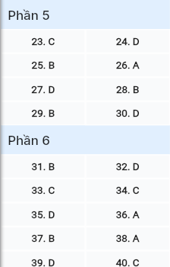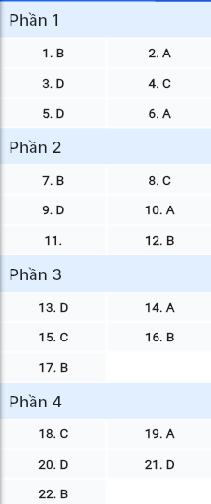**ĐỀ MINH HỌA SỐ 01**  
**KỲ THI TỐT NGHIỆP TRUNG HỌC PHỔ THÔNG NĂM 2025**  
(Đề thi có 08 trang)  
**Môn thi: TIẾNG ANH**  
**Thời gian làm bài: 50 phút, không kể thời gian phát đề**

**Read the following advertisement and mark the letter A, B, C or D on your answer sheet to indicate the option that best fits each of the numbered blanks from 1 to 6.**



**🏫 DISCOVER GREEN VALLEY SCHOOL 🏫**

At Green Valley School, we foster a vibrant and (1) _______ environment where students can excel. Our engaging curriculum (2) _______ to inspire creativity and critical thinking includes hands-on projects and exciting activities. Each year, students enjoy a (3) _______ that turns learning into an adventure. With caring teachers who promise (4) _______ individualized support and small class sizes, every child receives the attention they need to thrive. We also teach valuable life skills and help students learn (5) _______ experience. We ensure each student feels confident and motivated whether they are preparing to (6) _______ for an exam or exploring new interests. Join us at Green Valley, where education is an exciting journey!

**Question 1 [695545]:** A. support B. supportive C. supported D. supporter

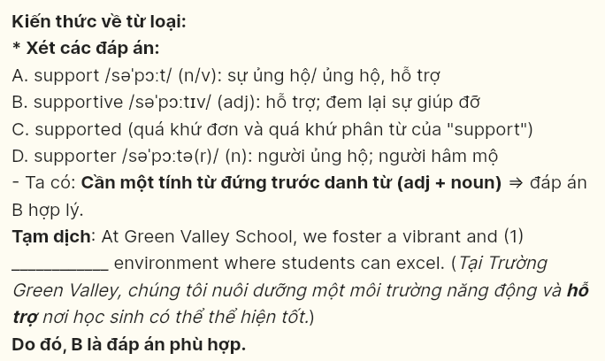

**Question 2 [695546]:** A. designed B. which designs C. is designed D. designing

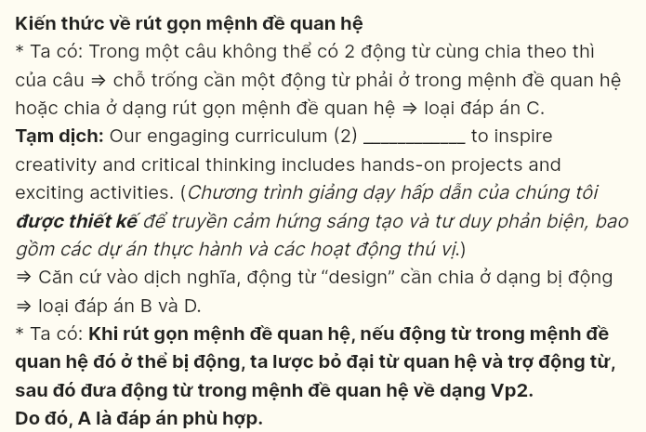

**Question 3 [695547]:** A. trip school wonderful B. school trip wonderful

C. wonderful trip school D. wonderful school trip

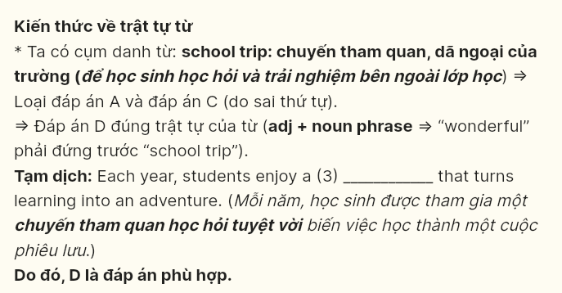

**Question 4 [695548]:** A. provide B. providing C. to provide D. to providing

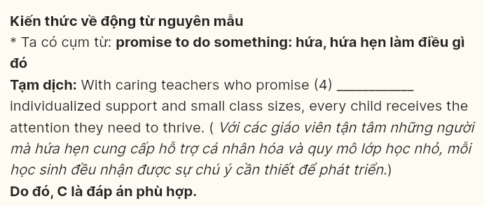

**Question 5 [695549]:** A. about B. on C. in D. from

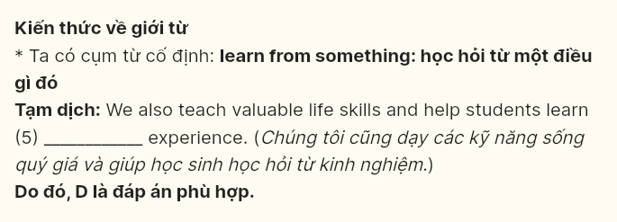

**Question 6 [695550]:** A. sit B. take C. do D. make

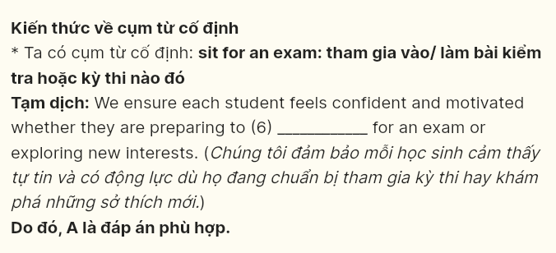

**Read the following leaflet and mark the letter A, B, C or D on your answer sheet to indicate the option that best fits each of the numbered blanks from 7 to 12.**

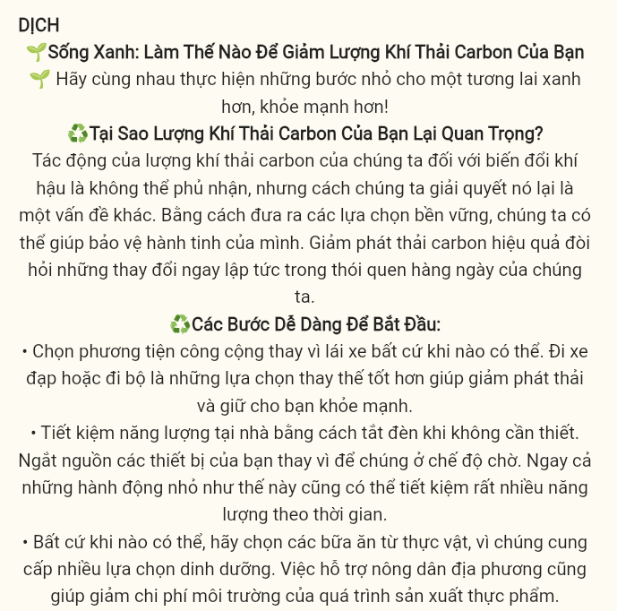

**🌱 Green Living: How to Reduce Your Carbon Footprint 🌱**

*Let’s take small steps together for a greener, healthier future!*

**♻ Why Does Your Carbon Footprint Matter?**

The impact of our carbon footprint on climate change is undeniable, but how we address it is (7) _______ matter. By making sustainable choices, we can help protect our planet. Reducing carbon emissions effectively (8) _______ immediate changes in our daily habits.

**🌟 Easy Steps to Get Started:**

• Choose public (9) _______ over driving whenever possible. Cycling or walking are even better alternatives that reduce emissions and keep you healthy.

• Conserve energy at home by turning off lights when they aren’t needed. Unplug your devices (10) _______ leaving them on standby. Even small actions like these can save a lot of power over time.

• Whenever possible, (11) _______ for plant-based meals, as they offer a wide variety of nutritious options. Supporting local farmers also helps lower the environmental cost of food (12) _______.

**Question 7 [695554]:** A. other B. another C. the others D. others

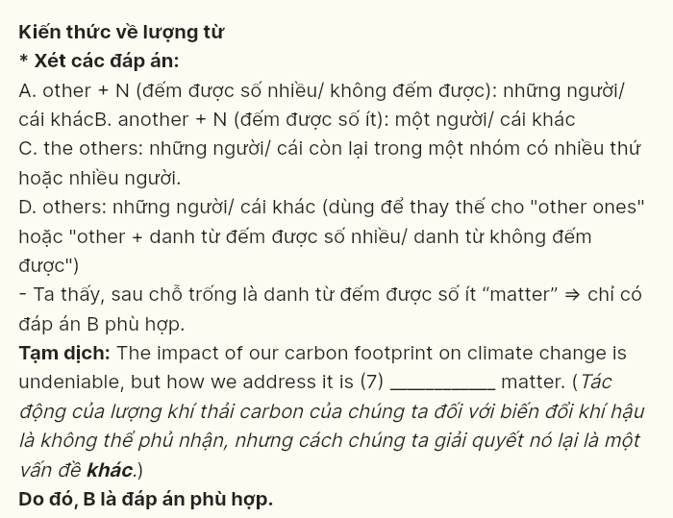

**Question 8 [695555]:** A. comes off B. holds on C. calls for D. takes after

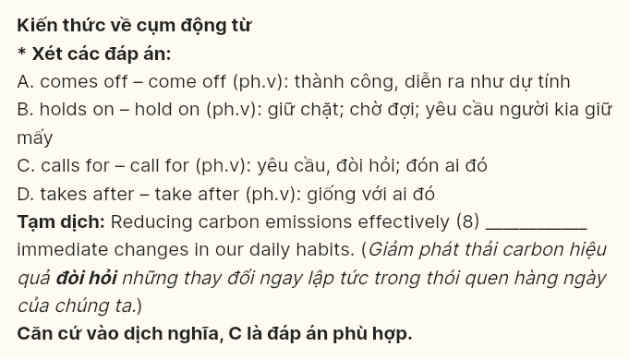

**Question 9 [695556]:** A. awareness B. interest C. internet D. transport

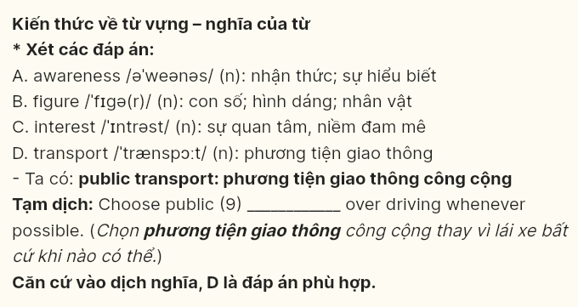

**Question 10 [695551]:** A. instead of B. on account of C. regardless of D. in contrast to

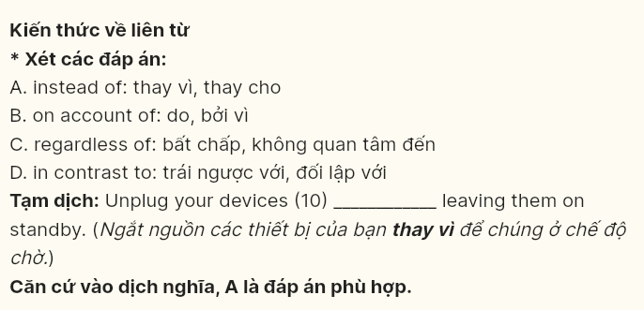

**Question 11 [695552]:** A. decide B. select C. opt D. choose

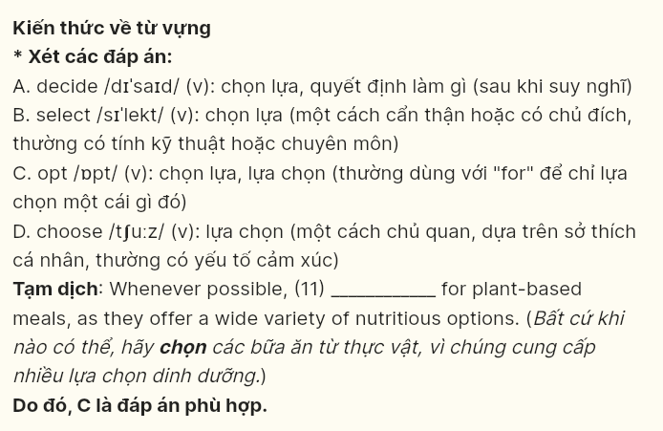

**Question 12 [695553]:** A. creation B. production C. preservation D. consumption

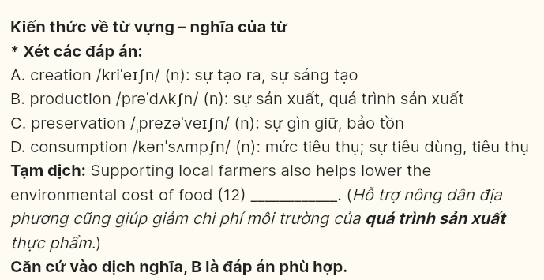

***Mark the letter A, B, C or D on your answer sheet to indicate the best arrangement of utterances or sentences to make a meaningful exchange or text in each of the following questions from 13 to 17.***

**Question 13 [695557]:**  
a. Lisa: Hi, Tom! It looks like it might rain soon. The sky is getting darker.  
b. Lisa: Yes, I have. I checked the weather forecast, and it’s supposed to rain later.  
c. Tom: Oh no, I didn’t bring my raincoat. Did you bring yours, Lisa?

A. c-a-b B. b-c-a C. c-b-a D. a-c-b



**Question 14 [695558]:**  
a. Anna: That makes sense. I hope everyone adapts quickly.  
b. Anna: How do you feel about the new policy at work?  
c. Paul: Change can be difficult, but I believe it will improve our efficiency.  
d. Anna: Really? I’ve heard some people are not happy about it.  
e. Paul: I think it could be beneficial for everyone.

A. b-e-d-c-a B. b-c-a-d-e C. a-c-d-e-b D. a-e-b-c-d

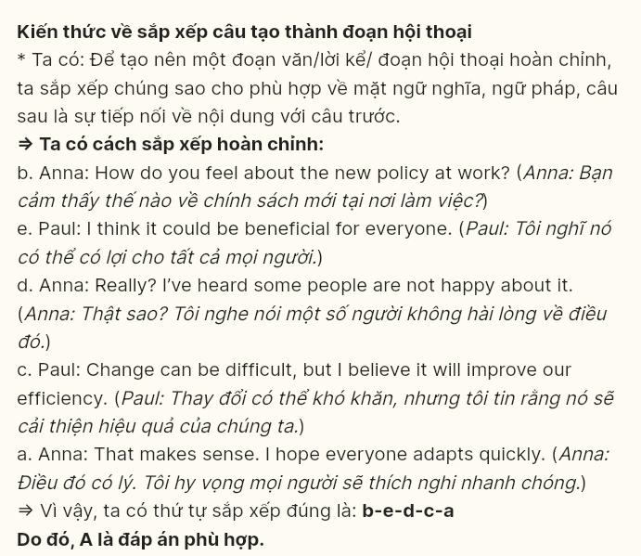

**Question 15 [695559]:**  
Hi David,

a. It’s fascinating to learn about different styles and get inspired by other artists.  
b. I look forward to hearing about any new hobbies you’ve taken up as well!  
c. It’s such a relaxing way to express myself, and I love experimenting with colors and techniques.  
d. I wanted to share that I recently picked up painting as a new hobby, and I’m really enjoying it.  
e. I’ve even signed up for a local art class to improve my skills.

Cheers,  
Sarah

A. b-a-e-d-c B. c-d-e-a-b C. d-c-e-a-b D. e-d-c-a-b

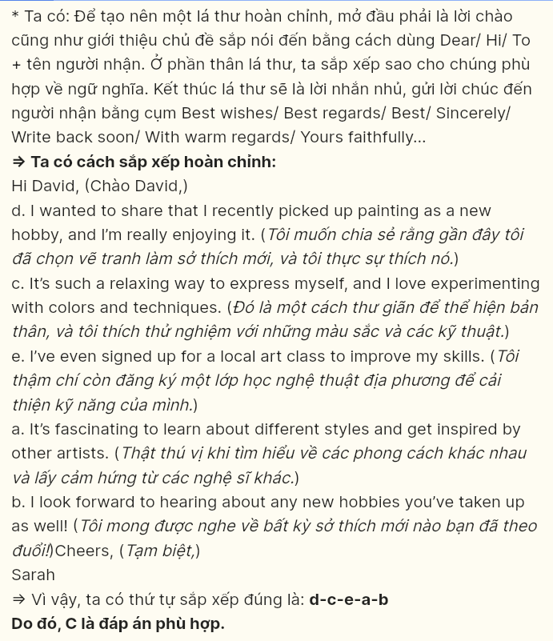

**Question 16 [695560]:**  
a. Over the past year, I volunteered at an orphanage where I helped organize educational activities for the children.  
b. While this work is not always easy, I find immense happiness in knowing that I am making a positive impact on the community.  
c. Participating in charity work has been a profoundly rewarding experience for me.  
d. In fact, seeing their smiles and joy motivated me to continue my efforts in this field.  
e. In conclusion, engaging in charity not only helps those in need but also teaches me valuable lessons about compassion and gratitude.

A. b-c-a-d-e B. c-a-d-b-e C. d-c-a-b-e D. a-c-b-d-e

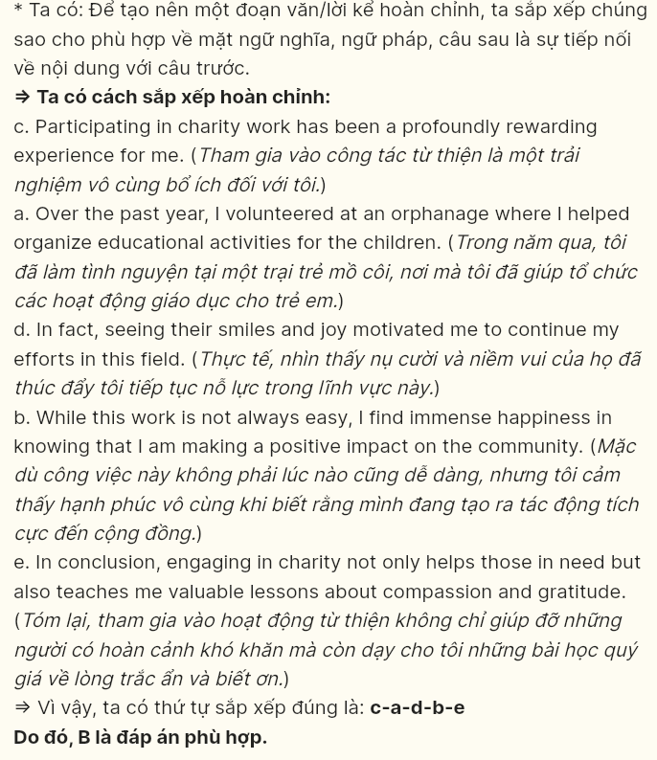

**Question 17 [695561]:**  
a. It was formerly a quiet area with only a few shops and restaurants, but now it is bustling with activity.  
b. In addition to the new shops, several parks have been developed, providing green spaces for relaxation and recreation.  
c. New businesses have opened, attracting both locals and tourists, which has greatly enhanced the vibrancy of the neighborhood.  
d. The city center has undergone significant changes over the past decade.  
e. As a result of these improvements, the city center has become a popular destination for events and gatherings, fostering a strong sense of community.

A. d-e-a-c-b B. d-a-c-b-e C. d-b-e-c-a D. d-c-e-a-b

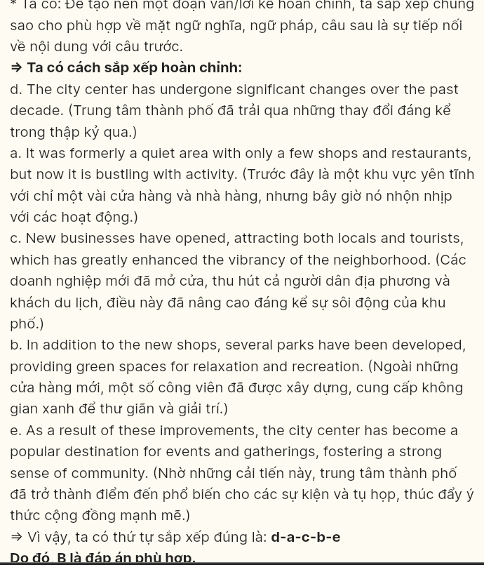

**Read the following passage and mark the letter A, B, C or D on your answer sheet to indicate the option that best fits each of the numbered blanks from 18 to 22.**

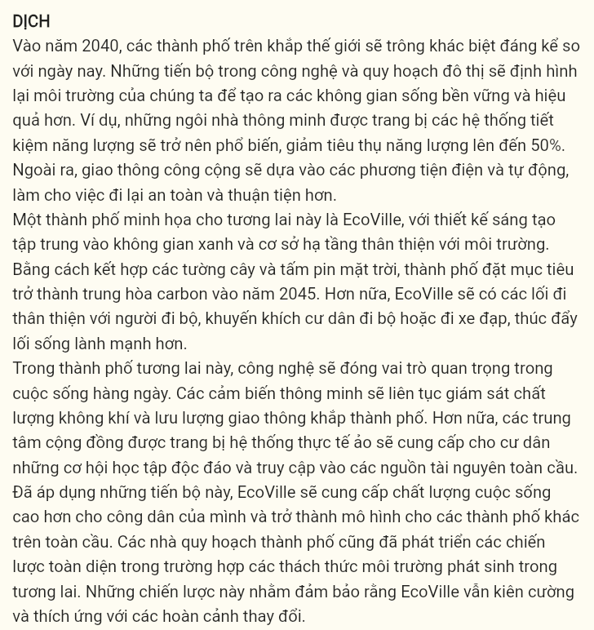

In the year 2040, cities around the world will look drastically different from today. Advances in technology and urban planning (18) ______. For instance, smart homes equipped with energy-efficient systems will be commonplace, reducing energy consumption by up to 50%. Additionally, public transportation will rely on electric and autonomous vehicles, making commuting safer and more convenient.

One city that exemplifies this future is EcoVille (19) ______. By incorporating vertical gardens and solar panels, the city aims to become carbon neutral by 2045. Moreover, EcoVille will feature pedestrian-friendly walkways that encourage residents to walk or cycle, promoting a healthier lifestyle.

In this future city, technology will play a crucial role in everyday life. (20) ______. Furthermore, community centers equipped with virtual reality systems will offer residents unique learning opportunities and access to global resources.

Having embraced these advancements, (21) ______ and serve as a model for other cities around the globe. (22) ______. These strategies aim to ensure that EcoVille remains resilient and adaptable to changing circumstances.

**Question 18 [695562]:**  
A. which will reshape our environments to create more sustainable and efficient living spaces  
B. in which our environments will be reshaped to create more sustainable and efficient living spaces  
C. will reshape our environments to create more sustainable and efficient living spaces  
D. reshaping our environments to create more sustainable and efficient living spaces

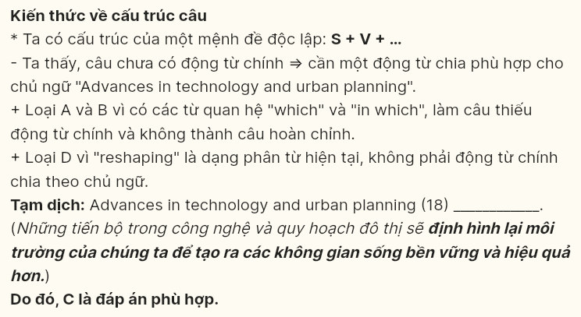

**Question 19 [695563]:**  
A. whose innovative design focuses on green spaces and eco-friendly infrastructure  
B. of which the focus on green spaces and eco-friendly infrastructure in its innovative design  
C. focuses on green spaces and eco-friendly infrastructure for its innovative design  
D. shows innovation in its design for green spaces and eco-friendly infrastructure

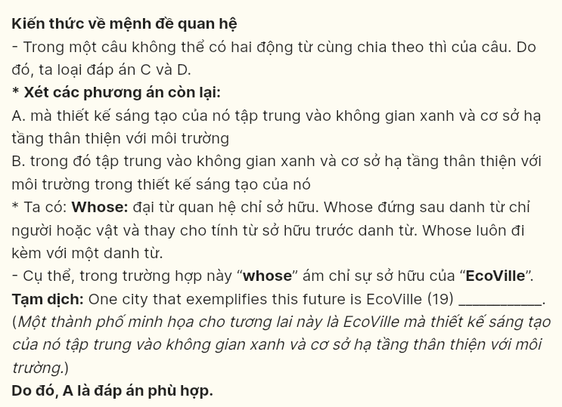

**Question 20 [695564]:**  
A. Continuously monitoring air quality and traffic patterns, the government will place smart sensors throughout the city  
B. Monitoring air quality and traffic patterns throughout the city is the reason for continuous smart sensors  
C. People working on air quality and traffic patterns continuously will create smart sensors throughout the city  
D. Smart sensors will continuously monitor air quality and traffic patterns throughout the city

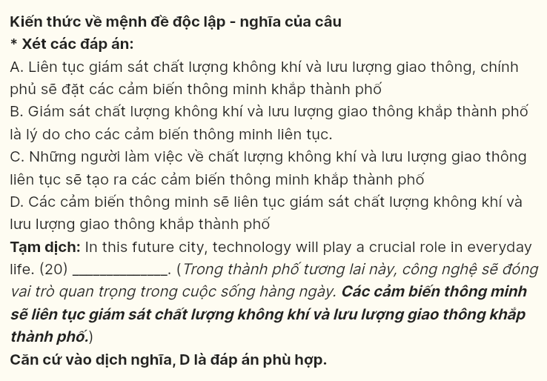

**Question 21 [695565]:**  
A. its citizens will be provided a higher quality of life  
B. residents living in EcoVille will receive a higher quality of life  
C. the quality of life will be improved for EcoVille’s residents  
D. EcoVille will provide a higher quality of life for its citizens

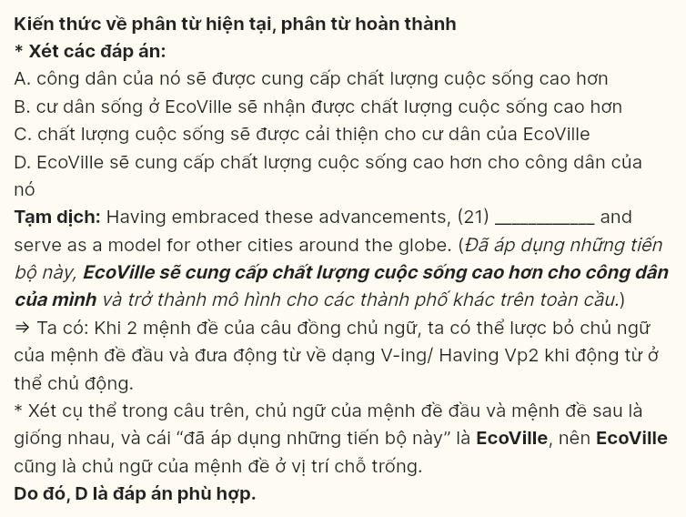

**Question 22 [695566]:**  
A. Environmental challenges also emerge in the future so that city planners will develop comprehensive strategies  
B. City planners have also developed comprehensive strategies in case environmental challenges arise in the future  
C. Developing comprehensive strategies in the future, environmental challenges can also be resolved by city planners  
D. As long as environmental challenges become worse in the future, city planners will also develop comprehensive strategies

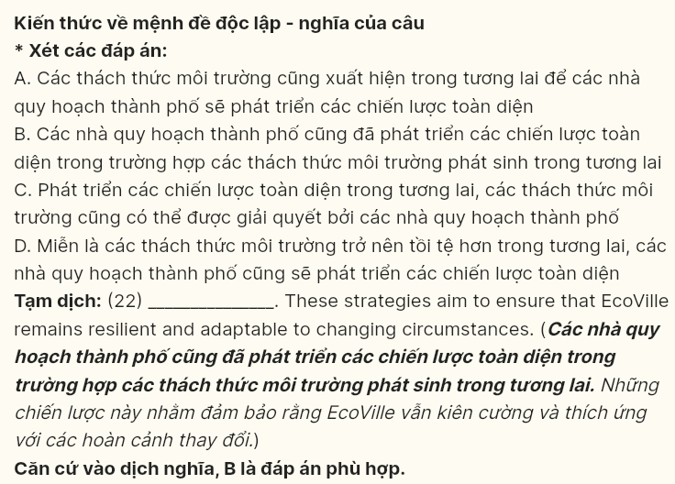

**Read the following passage and mark the letter A, B, C or D on your answer sheet to indicate the best answer to each of the following questions from 23 to 30.**

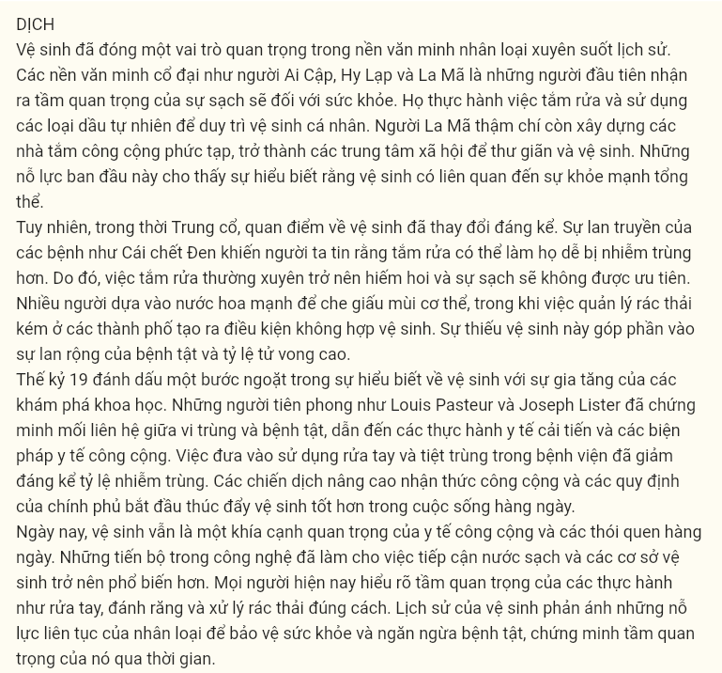

Hygiene has played a vital role in human civilization throughout history. Ancient civilizations, such as the Egyptians, Greeks, and Romans, were among the first to recognize the importance of cleanliness for health. They practiced bathing and used natural oils to maintain personal hygiene. The Romans even built **elaborate** public bathhouses, which became social centers for relaxation and sanitation. These early efforts showed an understanding that hygiene was linked to overall well-being.

During the Middle Ages, however, attitudes towards hygiene changed significantly. The spread of diseases like the Black Death led people to believe that bathing could make **them** more vulnerable to infections. As a result, frequent bathing became rare, and cleanliness was not prioritized. Many people relied on strong perfumes to cover body odor, while poor waste management in cities created **unsanitary** conditions. This lack of hygiene contributed to widespread illness and high mortality rates.

The 19th century marked a turning point in the understanding of hygiene with the rise of scientific discoveries. Pioneers like Louis Pasteur and Joseph Lister demonstrated the link between germs and diseases, leading to improved medical practices and public health measures. **The introduction of handwashing and sterilization in hospitals greatly reduced infection rates.** Public awareness campaigns and government regulations began to promote better hygiene in everyday life.

Today, hygiene remains a crucial aspect of public health and daily routines. Advancements in technology have made access to clean water and sanitation facilities more widespread. People now understand the importance of practices like handwashing, brushing teeth, and proper waste disposal. The history of hygiene reflects humanity's ongoing efforts to protect health and prevent disease, proving its significance across time.

**Question 23 (695567): Which of the following is NOT mentioned as an ancient civilization that practiced hygiene?**

A. Egyptians B. Greeks C. Indians D. Romans

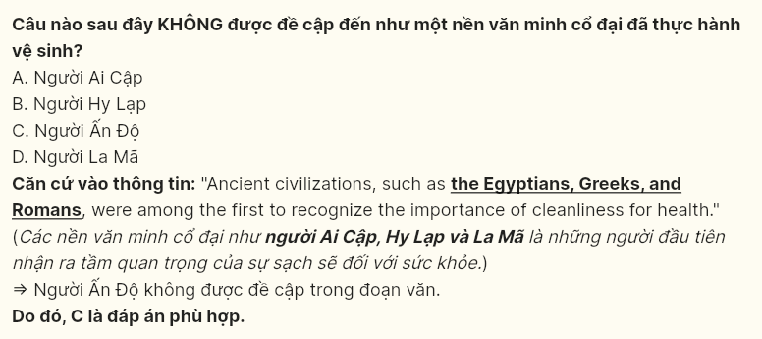

**Question 24 (695568): The word elaborate in paragraph 1 is OPPOSITE in meaning to ______**  
A. complex B. sophisticated C. modern D. simple

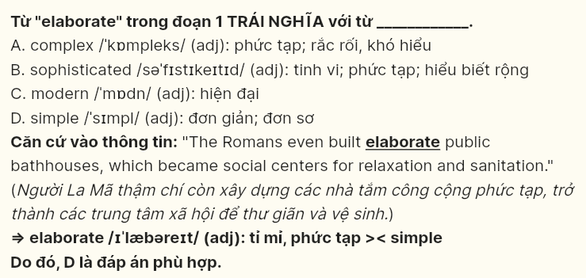

**Question 25 (695569): The word them in paragraph 2 refers to ______**  
A. infections B. people C. diseases D. perfumes

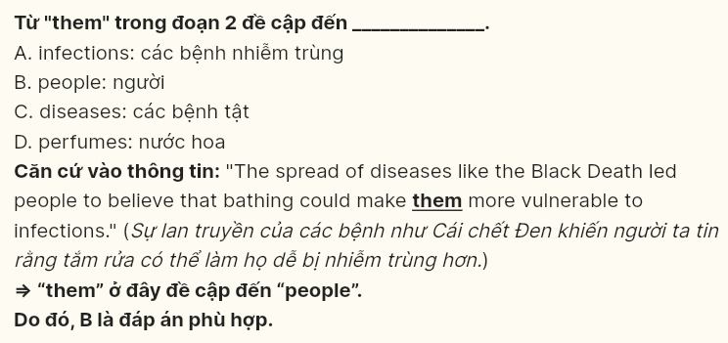

**Question 26 (695570): The word unsanitary in paragraph 2 could be best replaced with ______**  
A. unhealthy B. unsuitable C. unusual D. unlikely

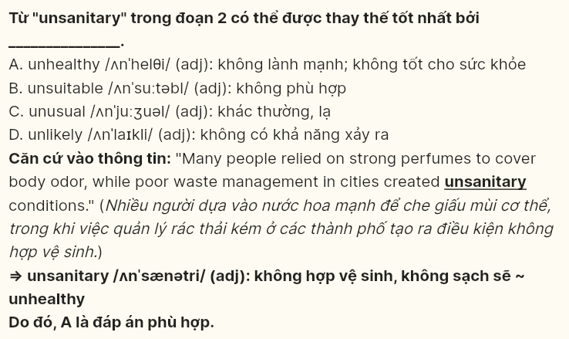

**Question 27 (695571): Which of the following best paraphrases the underlined sentence in paragraph 3?**  
A. Promoting handwashing and sterilization in hospitals gradually decreased infection rates.  
B. Imposing a ban on handwashing and sterilization in hospitals dramatically increased infection rates.  
C. Discouraging the use of handwashing and sterilization in hospitals slightly increased infection rates.  
D. Implementing handwashing and sterilization in hospitals significantly lowered infection rates.

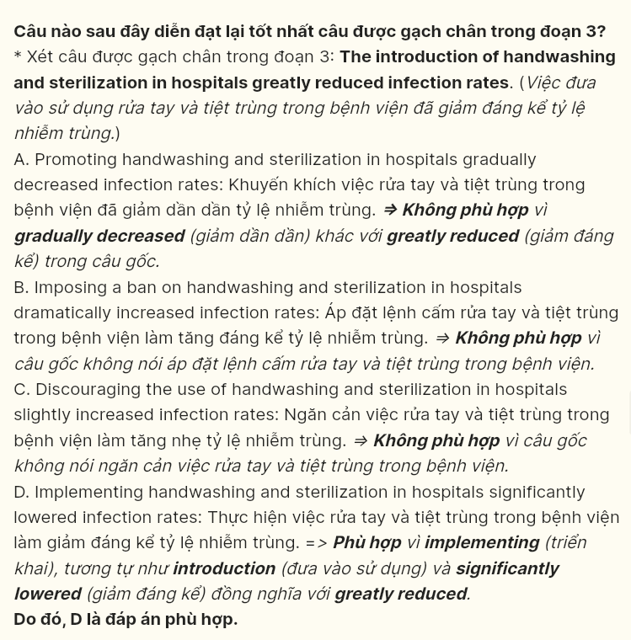

**Question 28 (695572): Which of the following is TRUE according to the passage?**  
A. People in the Middle Ages believed bathing caused infections.  
B. Louis Pasteur and Joseph Lister linked germs to diseases.  
C. Hygiene in ancient times was mainly about using perfumes.  
D. The 19th century brought no changes to hygiene practices.

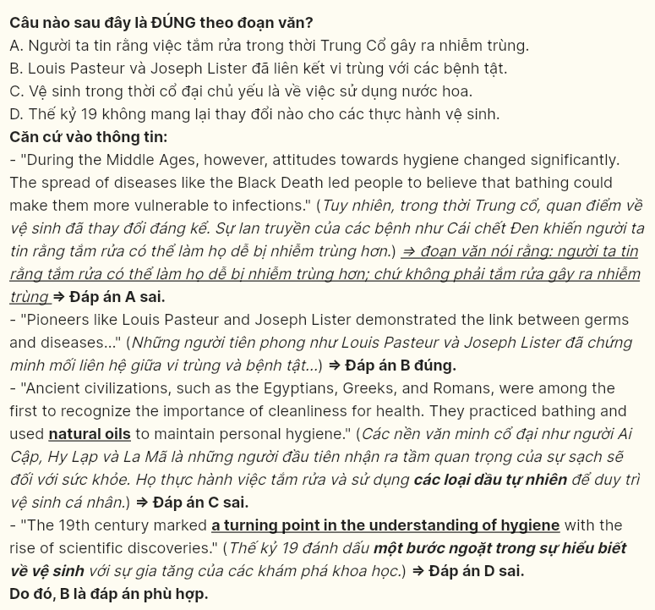

**Question 29 (695573): In which paragraph does the writer mention a causal relationship that resulted in a decline in personal care habits?**  
A. Paragraph 1 B. Paragraph 2 C. Paragraph 3 D. Paragraph 4

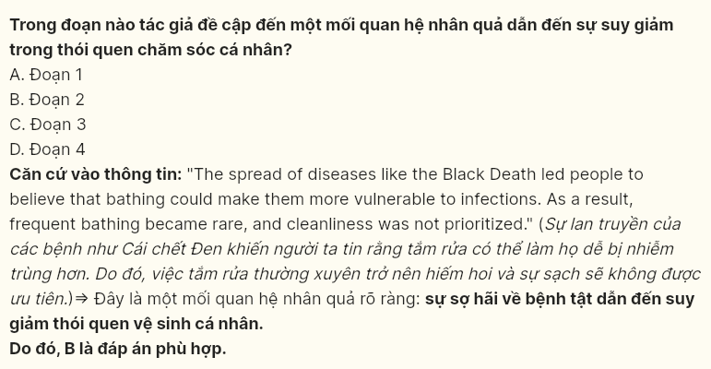

**Question 30 (695574): In which paragraph does the writer emphasize how improved living conditions have become more common in recent times?**  
A. Paragraph 1 B. Paragraph 2 C. Paragraph 3 D. Paragraph 4

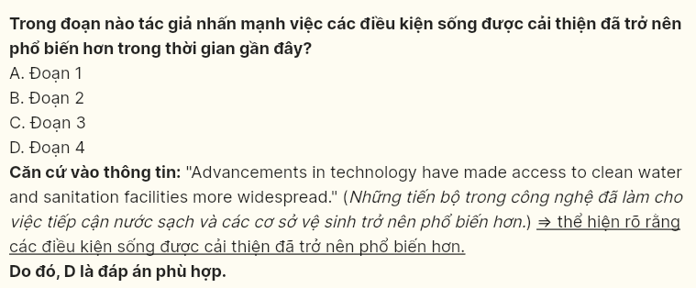

**Read the following passage and mark the letter A, B, C or D on your answer sheet to indicate the best answer to each of the following questions from 31 to 40.**

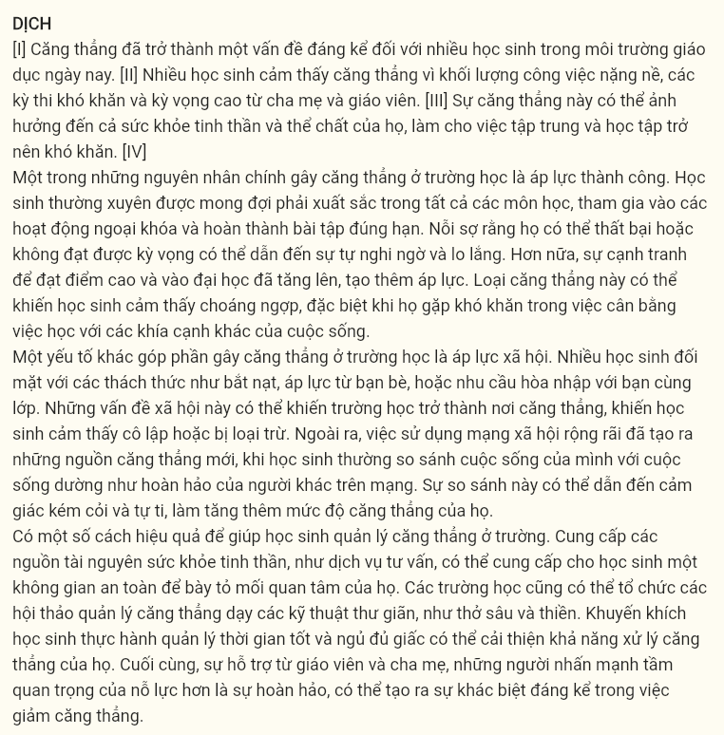

[I] Stress has become a significant problem for many students in today’s educational environment. [II] Many students feel stressed because of heavy workloads, tough exams, and the high expectations set by parents and teachers. [III] This stress can impact both their mental and physical health, making it challenging to concentrate and perform well academically. [IV]

One of the primary causes of stress at school is the intense pressure to succeed. Students are frequently expected to **excel in** all subjects, participate in extracurricular activities, and complete assignments on time. The fear that **they** might fail or not meet expectations can lead to self-doubt and anxiety. Moreover, the competition for top grades and college admissions has increased, adding even more pressure. This kind of stress can cause students to feel overwhelmed, especially when they struggle to balance their studies with other aspects of their lives.

Another contributing factor to school stress is social pressure. Many students face challenges such as bullying, peer pressure, or the need to fit in with their classmates. These social issues can make school a stressful place, causing students to feel isolated or excluded. Additionally, the widespread use of social media has created new sources of stress, as students often compare their lives to the seemingly perfect lives of others online. This comparison can lead to feelings of **inadequacy** and low self-esteem, further increasing their stress levels.

There are several effective ways to help students manage stress at school. **Providing access to mental health resources, such as counseling services, can offer students a safe space to express their concerns.** Schools can also organize stress management workshops that teach relaxation techniques, such as deep breathing and meditation. Encouraging students to practice good time management and get enough sleep can improve their ability to handle stress. Finally, support from teachers and parents, who emphasize the importance of effort over perfection, can make a significant difference in reducing stress.

**Question 31 (695575): Where in paragraph 1 does the following sentence best fit?**  
***“School is meant to be a place for growth and learning, yet it often becomes a major source of anxiety.”***A. [I] B. [II] C. [III] D. [IV]

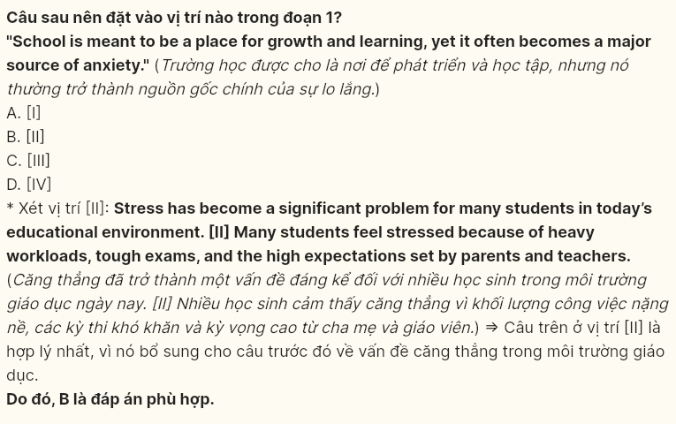

**Question 32 (695576): The phrase excel in paragraph 2 could be best replaced by ______**  
A. control B. struggle C. manage D. master

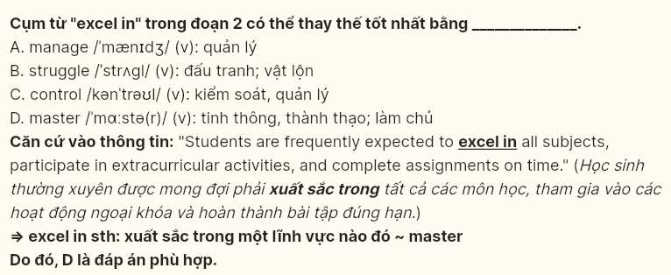

**Question 33 (695577): The word they in paragraph 2 refers to ______**  
A. subjects B. activities C. students D. assignments

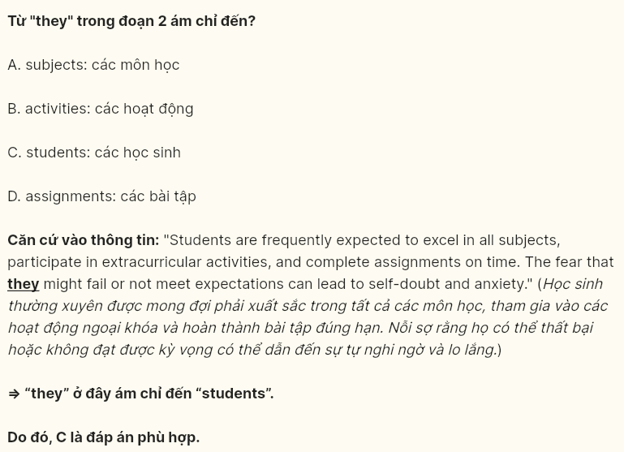

**Question 34 (695578): According to paragraph 3, which of the following is NOT mentioned as a cause of social stress at school?**  
A. peer pressure B. bullying C. romantic relationships D. social media comparisons

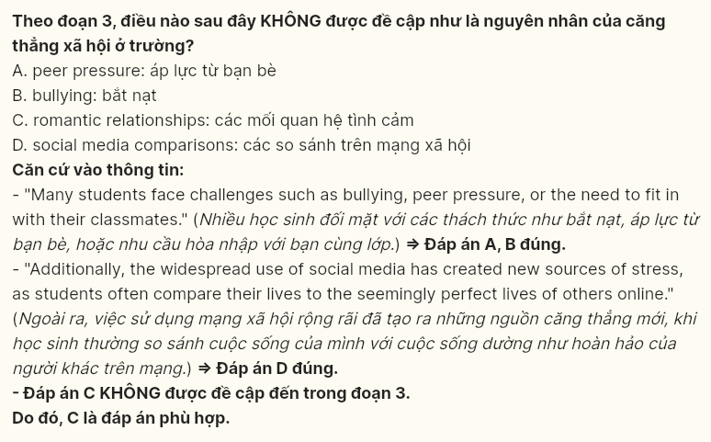

**Question 35 (695579): Which of the following best summarises paragraph 3?**  
A. Social challenges, including bullying and online exposure, heighten student stress.  
B. Peer conflicts and the desire to fit in are the primary sources of school-related anxiety.  
C. The main cause of stress for students is dealing with pressure from classmates.  
D. Social factors like bullying, peer pressure, and digital comparisons intensify stress at school.

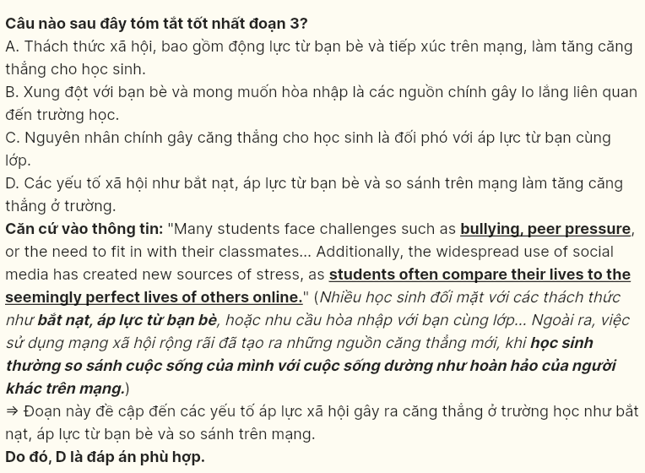

**Question 36 (695580): The word inadequacy in paragraph 3 is OPPOSITE in meaning to**  
A. confidence B. abundance C. shortage D. shortcoming

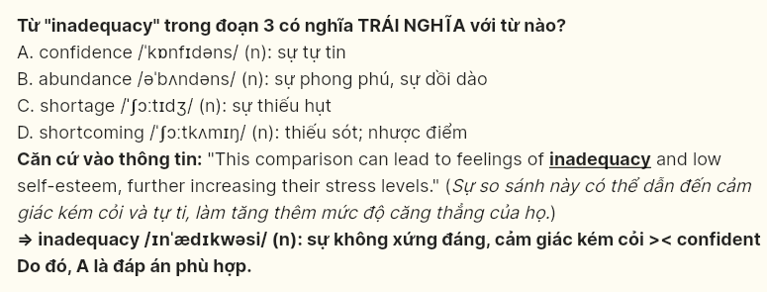

**Question 37 (695581): Which of the following is TRUE according to the passage?**  
A. Students often experience stress solely from high parental expectations.  
B. Balancing schoolwork and personal life can be a major source of stress.  
C. The primary solution to school stress is reducing academic requirements.  
D. Most students find social media helpful for managing school-related stress.

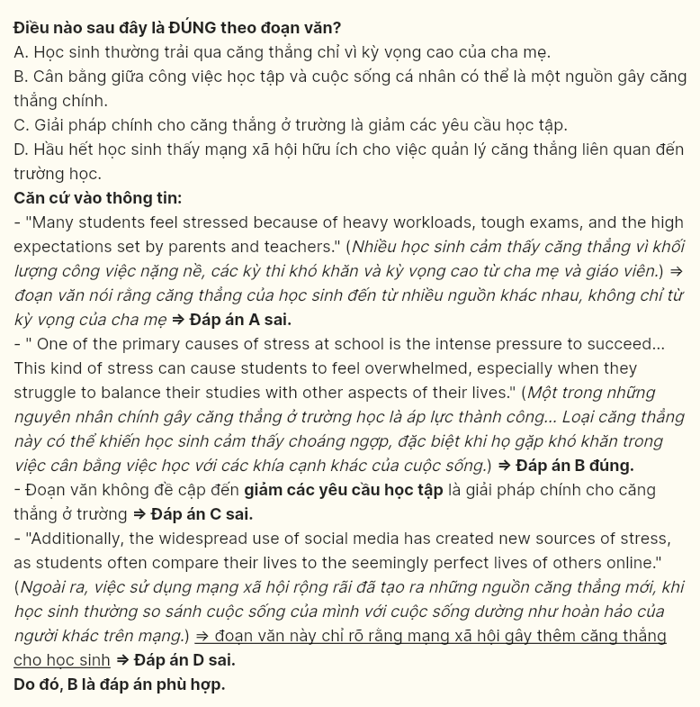

**Question 38 (695582): Which of the following best paraphrases the underlined sentence in paragraph 4?**  
A. Giving students access to mental health resources like counseling services provides them with a secure space to share their worries.  
B. Not until students have access to mental health resources like counseling services are they able to completely eliminate their stress.  
C. Offering students mental health resources, such as therapy, ensures they never experience stress again.  
D. Allowing students to access mental health resources like counseling services guarantees that they will overcome all their stress.

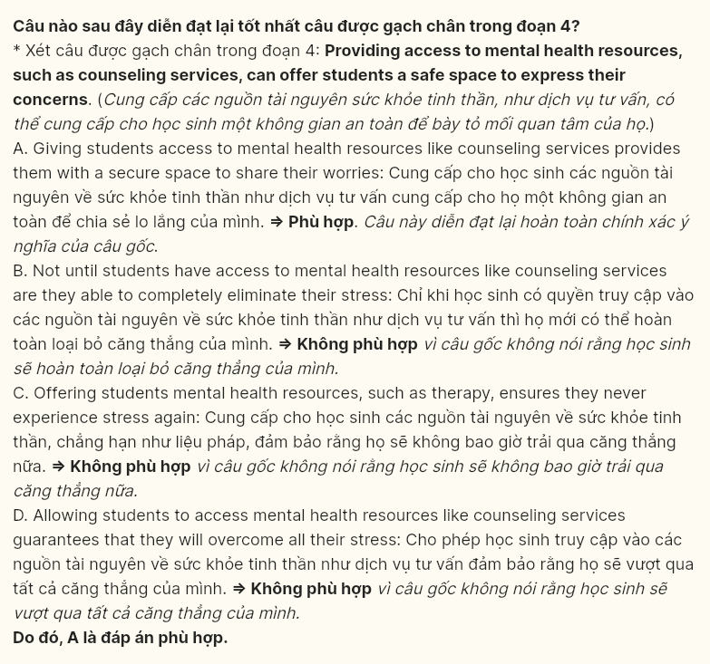

**Question 39 (695583): Which of the following can be inferred from the passage?**  
A. Teachers often overlook the importance of supporting students in managing their stress.  
B. The majority of student stress comes from unrealistic expectations set by schools.  
C. Focusing only on relaxation techniques is the best way to reduce student stress.  
D. Students are likely to feel less stressed when effort is valued over achieving perfect results.

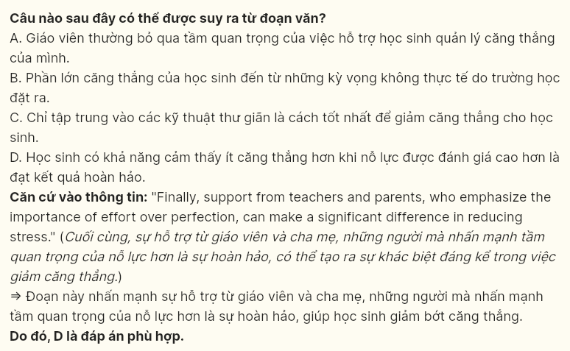

**Question 40 (695584): Which of the following best summarises the passage?**  
A. Academic challenges and social expectations cause significant stress, urging schools to offer time management and mental health support.  
B. High academic pressure and intense competition create stress for students, highlighting the need for effective stress management programs.  
C. Academic demands and social issues both contribute to student stress, with solutions like counseling, time management, and supportive guidance suggested.  
D. Social pressures, including peer influences and digital comparisons, escalate stress levels among students, leading schools to prioritize relaxation techniques and meditation practices.

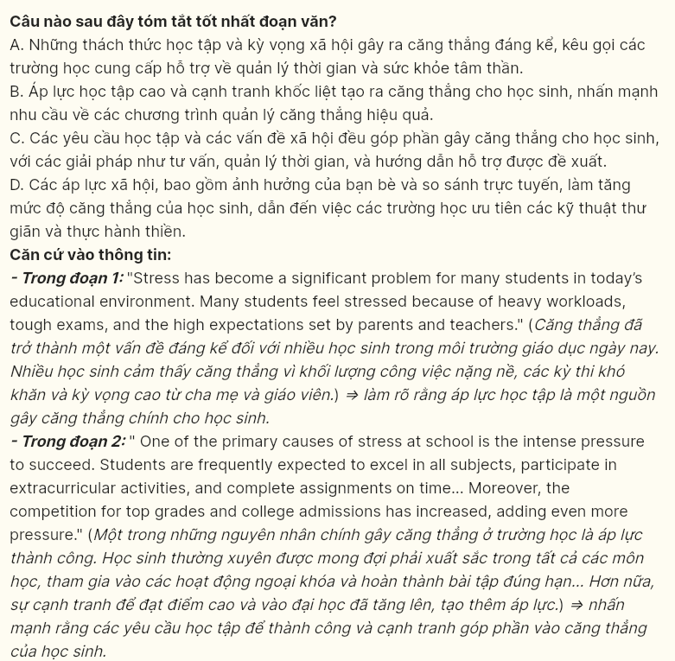

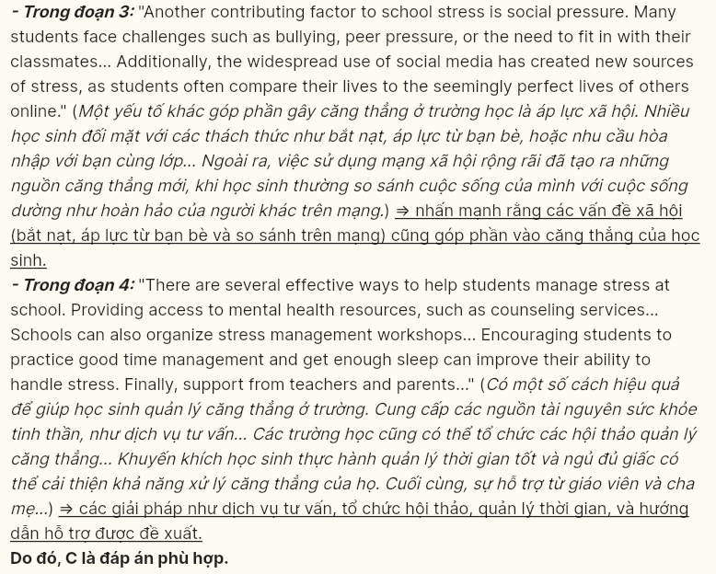

**----- THE END -----**