Thời gian làm bài: 40 phút (Không kể thời gian giao đề)
-------------------------
Họ tên thí sinh: .................................................................
Số báo danh: ......................................................................
Mã Đề: 014.
Câu 1. What has Tim booked for himself and Ben?
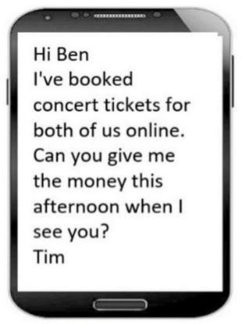
A. Concert tickets B. Sports game tickets C. Movie tickets D. Theater tickets
Câu 2. Look at the signs. Choose the best answer for the question.

A. Leaning against the wall is possible. B. This is not a leaning wall.
C. Do not lean against the wall. D. Don’t stand near the wall because it’s leaning.
Câu 3. What are the things that Mom asked her kid to pick up?
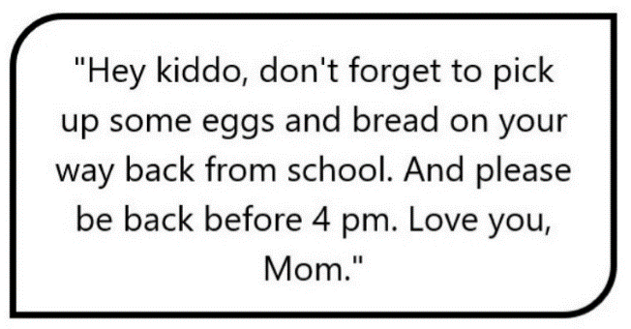
A. Eggs, bread, and milk B. Eggs and milk
C. Bread and milk D. Eggs and bread
Câu 4. Look at the signs. Choose the best answer for the question.
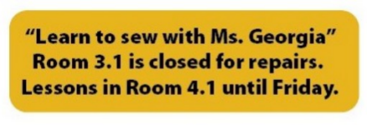
A. Ms. Georgia will repair her room on Friday. B. There is a new location for Ms. Georgia’s class.
C. Ms. Georgia’s class will be on a different day. D. Ms. Georgia isn’t coming to school until Friday.
Câu 5. Look at the signs. Choose the best answer for the question.

A. You should not leave any rubbish in the picnic area.
B. You must clean the picnic area before you go home.
C. You can go home with all of the rubbish from the picnic area.
D. If you find rubbish in the picnic area, you should clean it.
Câu 6. What are students asked to do after using the kitchen?
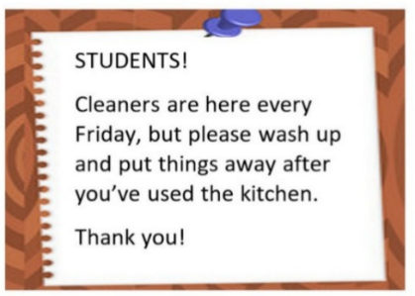
A. Leave everything as it is B. Wash up and put things away
C. Deep clean the entire kitchen D. Call the cleaners
Câu 7. Look at the signs. Choose the best answer for the question.

A. You cannot set off fireworks here.
B. It’s dangerous to set off fireworks here.
C. You should be careful when playing with fireworks.
D. Fireworks aren’t produced here.
Câu 8. Look at the signs. Choose the best answer for question.

A. All visitors can enter the place through the site office.
B. Guests are reported to visit the site office.
C. Anyone who visits must go to the site office and check in.
D. The site office is for everyone to make a report.
Câu 9. What is the unique feature of the sports smartwatch?
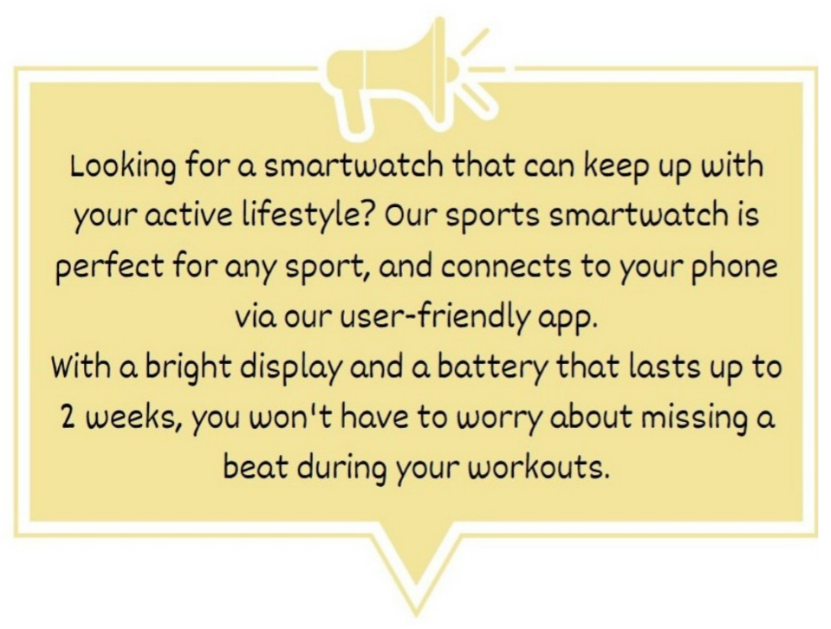
A. It can connect to your laptop B. It can last up to 2 years without charging
C. It has a built-in camera D. It is perfect for any sport
Câu 10. What alternative does Missie suggest if Tess can't lend her laptop?
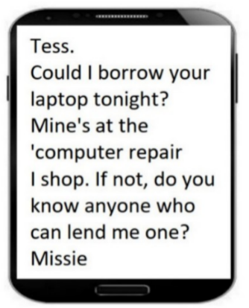
A. Going to an internet cafe B. Using a desktop computer
C. Finding someone else who can lend a laptop D. Asking Tess to help with her work
----HẾT---

