|  |  |
| --- | --- |
|  |  |

**Họ tên thí sinh: .................................................................**

**Số báo danh: ......................................................................**

**Mã Đề: 026.**

**Câu 1.** **Look at the signs. Choose the best answer for the question.**

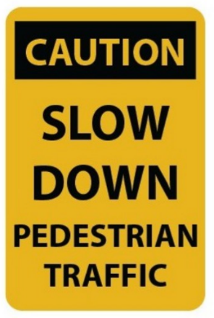

**A.** You should drive carefully because of slow pedestrians.

**B.** You should slow your speed and pay attention to pedestrians.

**C.** Pedestrians should walk slowly.

**D.** Pedestrians will slow down the traffic.

**Câu 2.** What is the main reason James cannot attend the concert?

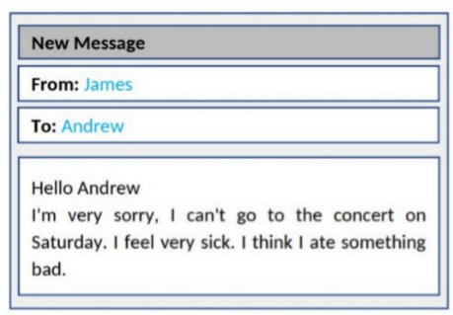

**A.** He doesn't like the music  **B.** He has another commitment

**C.** He is feeling unwell  **D.** He lost his ticket

**Câu 3.** Why has Jenna left a note for Marcus?

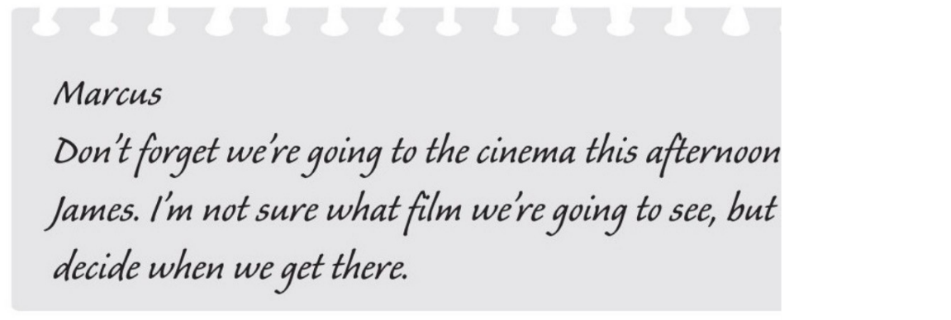

**A.** to suggest a film which they could see  **B.** to invite him to the cinema

**C.** to choose the cinema  **D.** to remind him about an arrangement

**Câu 4.** When is the grand opening of the new department store?



**A.** July 3rd  **B.** June 4th  **C.** July 4th  **D.** July 5th

**Câu 5.** **Look at the signs. Choose the best answer for the question.**

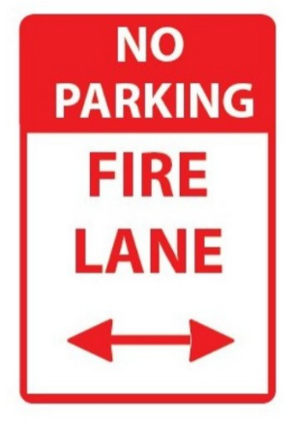

**A.** If there is a fire, park your vehicle in this area.

**B.** This area prevents your cars from fire.

**C.** You can’t park your car here because this area is for fire trucks.

**D.** You can’t park your car here when it is on fire.

**Câu 6.** Who can participate in this cycle ride?

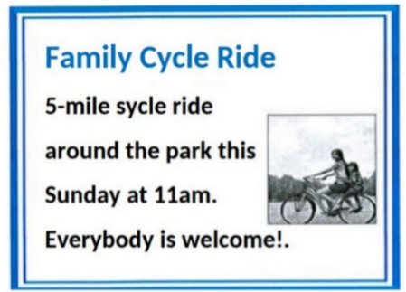

**A.** Anyone who wants to join  **B.** Only families with children

**C.** Only experienced cyclists  **D.** Only park members

**Câu 7.** Who can get free tickets to the football match?

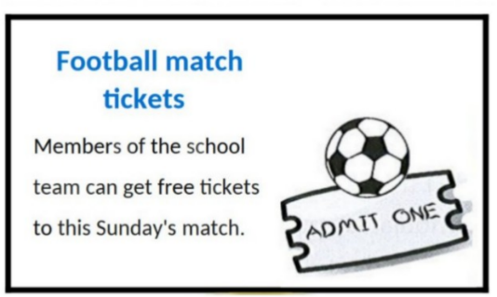

**A.** Members of the school team  **B.** Parents

**C.** All students  **D.** Teachers

**Câu 8.** Which of the following services is NOT offered by the Village Shop?

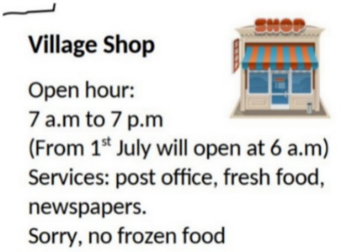

**A.** Fresh food  **B.** Newspapers  **C.** Post office  **D.** Frozen food

**Câu 9.** **Look at the signs. Choose the best answer for the question.**

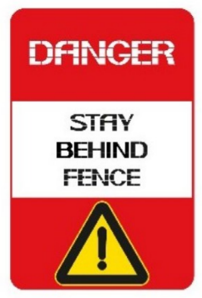

**A.** You shouldn’t stand close to the fence.  **B.** The fence is dangerous.

**C.** You mustn’t cross the fence.  **D.** It is dangerous to stay behind the fence.

**Câu 10.** What time was the theatre originally scheduled to open?

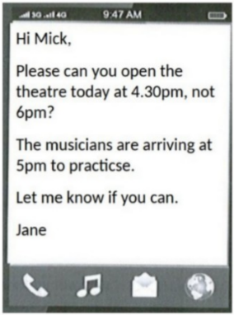

**A.** 5:00pm  **B.** 5:30pm  **C.** 4:30pm  **D.** 6:00pm

**----HẾT---**