**TIẾNG ANH 8 – FRIENDS PLUS**

**UNIT 4 – TEST 1**

**I. PRONUNCIATION**

**Câu 1.** Which word has the underlined part pronounced differently from that of the others?

**A.** function **B.** future **C.** question **D.** nature

**Câu 2.** Which word has the underlined part pronounced differently from that of the others?

**A.** stop **B.** profit **C.** solar **D.** product

**Câu 3.** Which word has a different stress pattern from that of the others?

**A.** protein **B.** insect **C.** minute **D.** resource

**Câu 4.** Which word has a different stress pattern from that of the others?

**A.** premium **B.** condition **C.** develop **D.** banana

**II. Choose the answer (A, B, C or D) that best fits the space in each question.**

**Câu 5.** The table shows the ______ of waste production in 6 different countries over a 20-year period.

**A.** majority **B.** number **C.** amount **D.** quality

**Câu 6.** ______ average, an American resident produces about 4.5 pounds per day and most of it is comprised of recyclable items.

**A.** In **B.** On **C.** At **D.** With

**Câu 7.** Most of South Africans are skipping meals because they simply cannot ______ to buy food.

**A.** save **B.** help **C.** spend **D.** afford

**Câu 8.** I have just ______ a small bite out of the slice of pizza. It’s quite savoury.

**A.** taken **B.** gotten **C.** driven **D.** written

**Câu 9.** Plastic bags do not biodegrade so they can ______ the environment.

**A.** damage **B.** kill **C.** waste **D.** save

**Câu 10.** Could I have ______ of butter, please?

**A.** a few **B.** a bit **C.** a more **D.** a lots

**Câu 11.** We didn’t spend ______ money on Christmas presents.

**A.** few **B.** little **C.** many **D.** much

**Câu 12.** I am OK, ______?

**A.** am not I **B.** am I **C.** aren't I **D.** are I

**Câu 13.** People are not protecting Mother Earth, ______?

**A.** are they **B.** aren't they **C.** is it **D.** isn't it

**Câu 14.** Scott: “What do you think of these pearl earrings?” - Nina: “______.”

**A.** They are rings **B.** It’s real gold **C.** Get these ones then **D.** Nice, they are mom’s style

**III. Look at each sign or notice. Choose the best answer (A, B, C or D) that matches its meaning.**

**Câu 15.** What does the notice say?

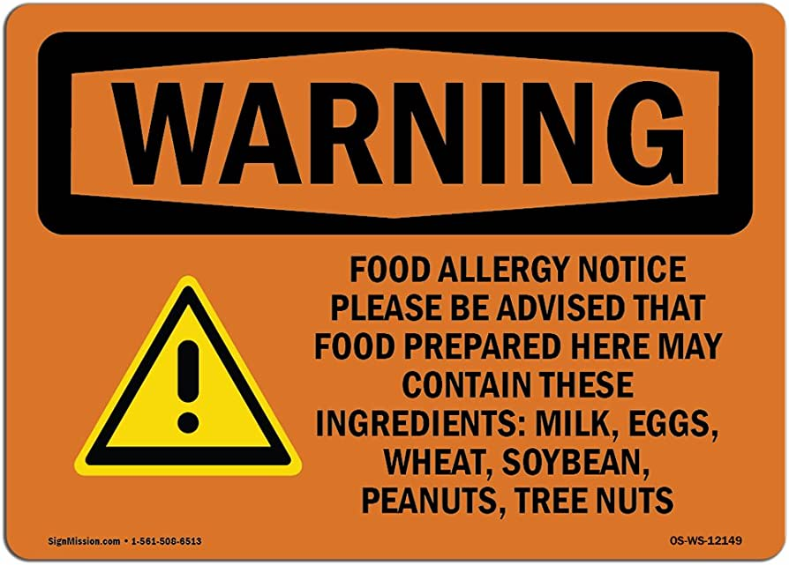

**A.** Please do not bring outside food or beverage.

**B.** The food is served only at your tables.

**C.** Those who are allergic to milk should not eat the food.

**D.** You can buy milk, eggs, wheat, soybean and nuts here.

**Câu 16.** What does the symbol mean?



**A.** The product can be recycled. **B.** The product has no wheat extracts.

**C.** The product must be put into a bin. **D.** The product is suitable for vegetarians.

**IV. Read the following and do as directed.**

In recent years, environmentalists have raised concerns about the future of food. Every year, 1.3 billion tons of food are consciously thrown away by consumers while over one-tenth of the population still go hungry. Many governments have started to take remedial action to reduce food waste. Since 2013, for example, the US government has launched the Food Waste Challenge, encouraging restaurants, schools and universities to make contact with hunger relief organizations like food banks and pantries. It also forces food manufacturers and stores to improve their product storage systems through which food can be kept longer. In addition, food suppliers are required to recycle their discarded but unexpired products to feed animals or create compost, bioenergy and natural fertilizers. In Viet Nam, diners at some buffet restaurants have to make a heavy charge for extra amounts of leftovers whereas some food retailers offer a big discount on near-expired products.

**True/False Questions:**

**Câu 17.** Food waste has recently caused concern among environmentalists.

**A.** True **B.** False

**Câu 18.** Not many countries want to address the problem of food waste.

**A.** True **B.** False

**Câu 19.** According to the US Food Waste Challenge, leftovers should not be given to food banks.

**A.** True **B.** False

**Câu 20.** Vietnamese buffet diners have to pay more than normal if they leave food behind.

**A.** True **B.** False

**Choose the correct answer to each question:**

**Câu 21.** What serves as the best title for the passage?

**A.** Food Suppliers **B.** Home-made Food

**C.** Conserving Natural Resources **D.** Solutions to Food Waste

**Câu 22.** What is NOT mentioned as a measure in the US Food Waste Challenge?

**A.** Improving product storage systems. **B.** Connecting food banks and pantries.

**C.** Using leftovers to feed animals. **D.** Recycling natural resources.

**V. Choose the word (A, B, C or D) that best fits each blank space in the following passage.**

**CUSTOMER REVIEWS**

**Wind-up radio:** I bought it last week. As a green consumer, I love this idea because there is (23) ______ need for batteries. All you need is wind this radio up for one minute and you will listen for twenty minutes. Also, I find it easy to tune to the station I want to hear. However, the biggest (24) ______ is that its rubber cover easily wears (25) ______. The company should deal with it soon or customers will choose a better brand.

**Water-powered clock:** If you like durable goods, this clock is a must-have item. I bought it eight years ago, but it still works. It just stopped (26) ______ last week. I emptied it, filled it with some tap water and shook it around a little. Then, it worked just like a new one. What impresses me is that the clock is made (27) ______ recycled materials, so it’s a bit more expensive than a normal one. In my (28) ______, the price is acceptable and it’s a great gift for your best friends!

**Câu 23.** Choose the correct answer.

**A.** no **B.** not **C.** any **D.** none

**Câu 24.** Choose the correct answer.

**A.** destruction **B.** advantage **C.** solution **D.** disadvantage

**Câu 25.** Choose the correct answer.

**A.** on **B.** off **C.** out **D.** away

**Câu 26.** Choose the correct answer.

**A.** doing **B.** taking **C.** working **D.** bringing

**Câu 27.** Choose the correct answer.

**A.** of **B.** into **C.** from **D.** up

**Câu 28.** Choose the correct answer.

**A.** thought **B.** view **C.** thinking **D.** vision

**VI. Supply the correct form of the word given in each sentence.**

**Câu 29.** Environmentalists believe that the expansion of industrial logging in central Africa has been an ______ disaster. **(ECOLOGY)**

**Câu 30.** Traffic congestion in large cities seems to be an ______ problem. It’s getting worse and worse. **(SOLVE)**

**Câu 31.** It is thought that the very first placental mammals were tiny ______, but no fossil evidence of them remains. **(INSECT)**

**Câu 32.** The human brain is an ______ complicated organ. **(CREDIT)**

**Câu 33.** A scientist has ______ a new species that belongs to a group of rare insects whose closest relative was last seen in 1969. **(DISCOVERY)**

**Câu 34.** According to the UN, 46 million people in Africa experienced ______ in the aftermath of the COVID-19 pandemic. **(HUNGRY)**

**VII. Rearrange the groups of words in a correct order to make complete sentences.**

**Câu 35.** made from recycled material. / ideal platforms / home-made products / Social media provides / to sell

**Câu 36.** The production of / won’t pollute / will it? / the air, / high-tech devices

**VIII. Rewrite each of the following sentences in another way so that it means almost the same as the sentence printed before it.**

**Câu 37.** You should use coconut oil so that you will have smoother hair. **(IDEA)**

🡪 In order

**Câu 38.** Air pollution makes me worried.

🡪 I am

**Câu 39.** The silver bracelet is cheaper than the golden one. **(AS)**

🡪 The silver bracelet

**Câu 40.** They are too poor to buy food. **(ENOUGH)**

🡪 They are

**------ HẾT ------**