UNIT 1: LEISURE ACTIVITIES
I.Vocabulary:
Word | Meaning | Picture | Examples
Addicted(a)  /ə’diktid/ | Nghiện (thích cái gì)    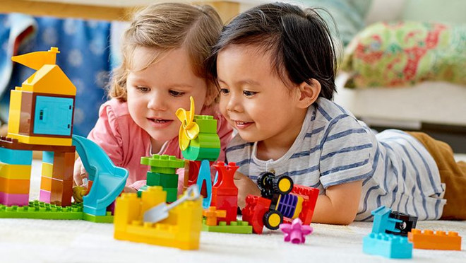 |  | Many teenagers are addicted to computer games nowadays
Adore(v)  /ə’d :r/ | Yêu thích, mê thích  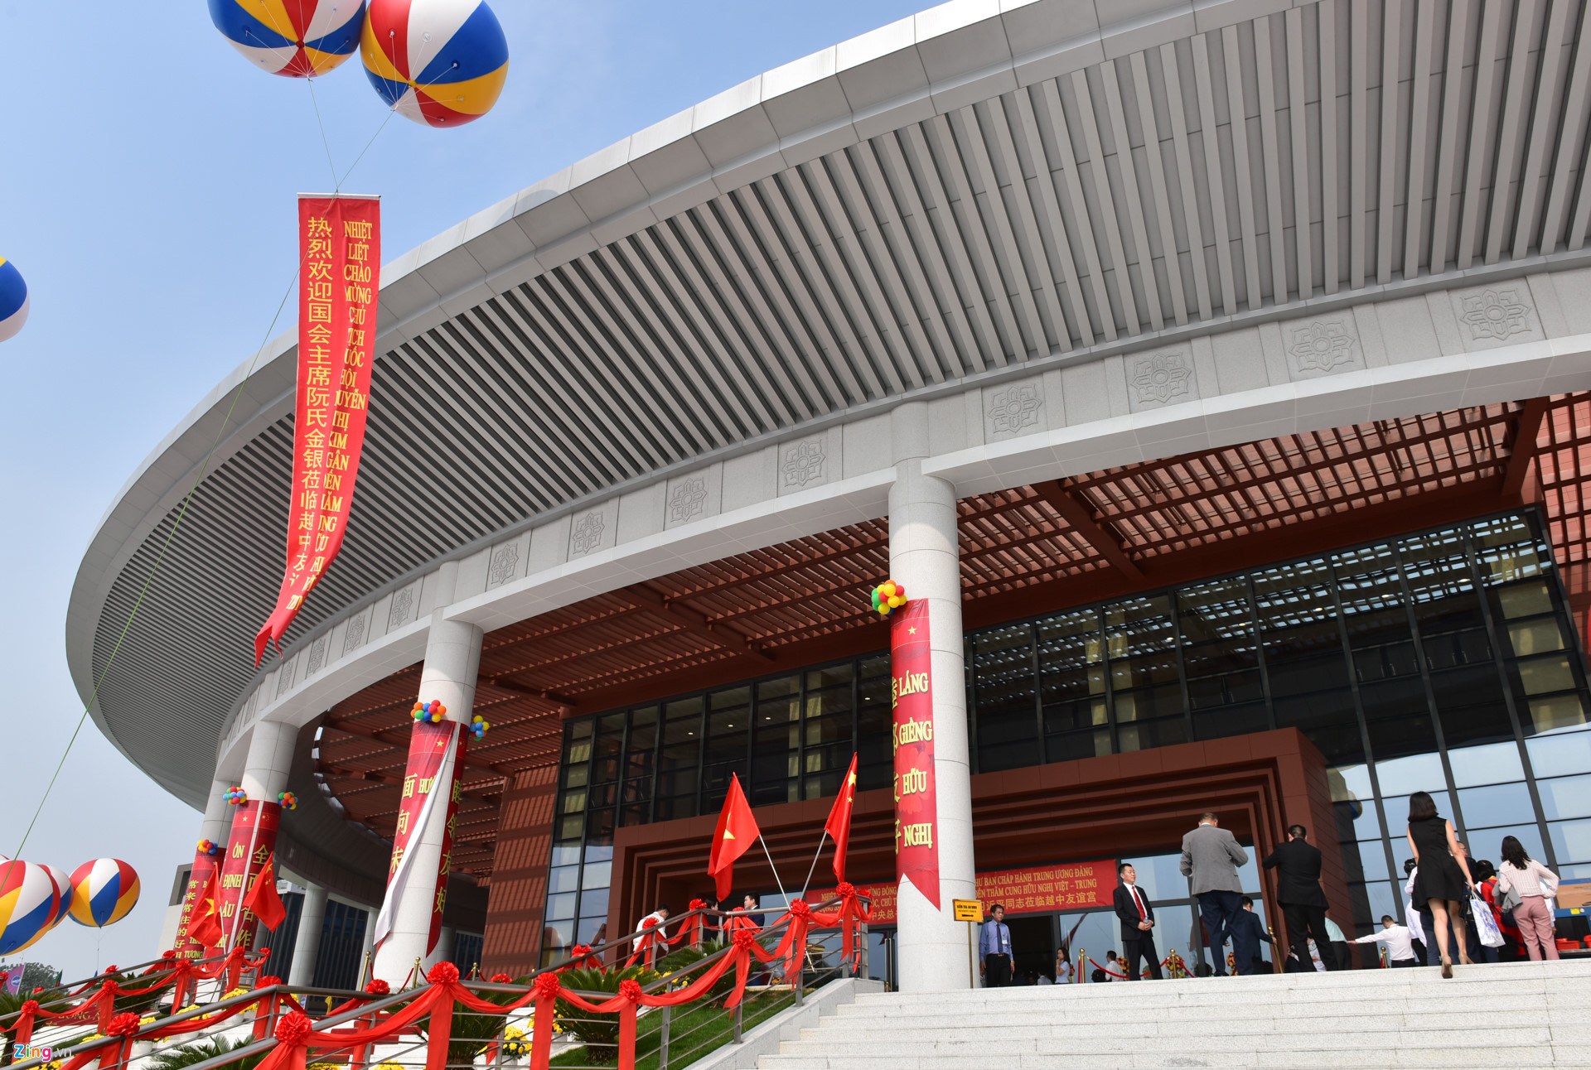 |  | Jane adores working with children
Community centre  /kəˈmjuːnəti ‘sentər/ | Trung tâm văn hóa cộng đồng |  | The locals go to the community centre every weekend
Craft(n)  /kra:ft/ | Đồ thủ công  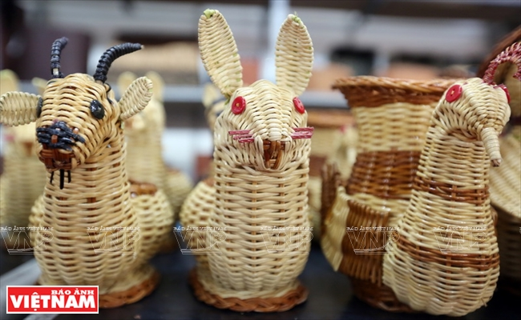  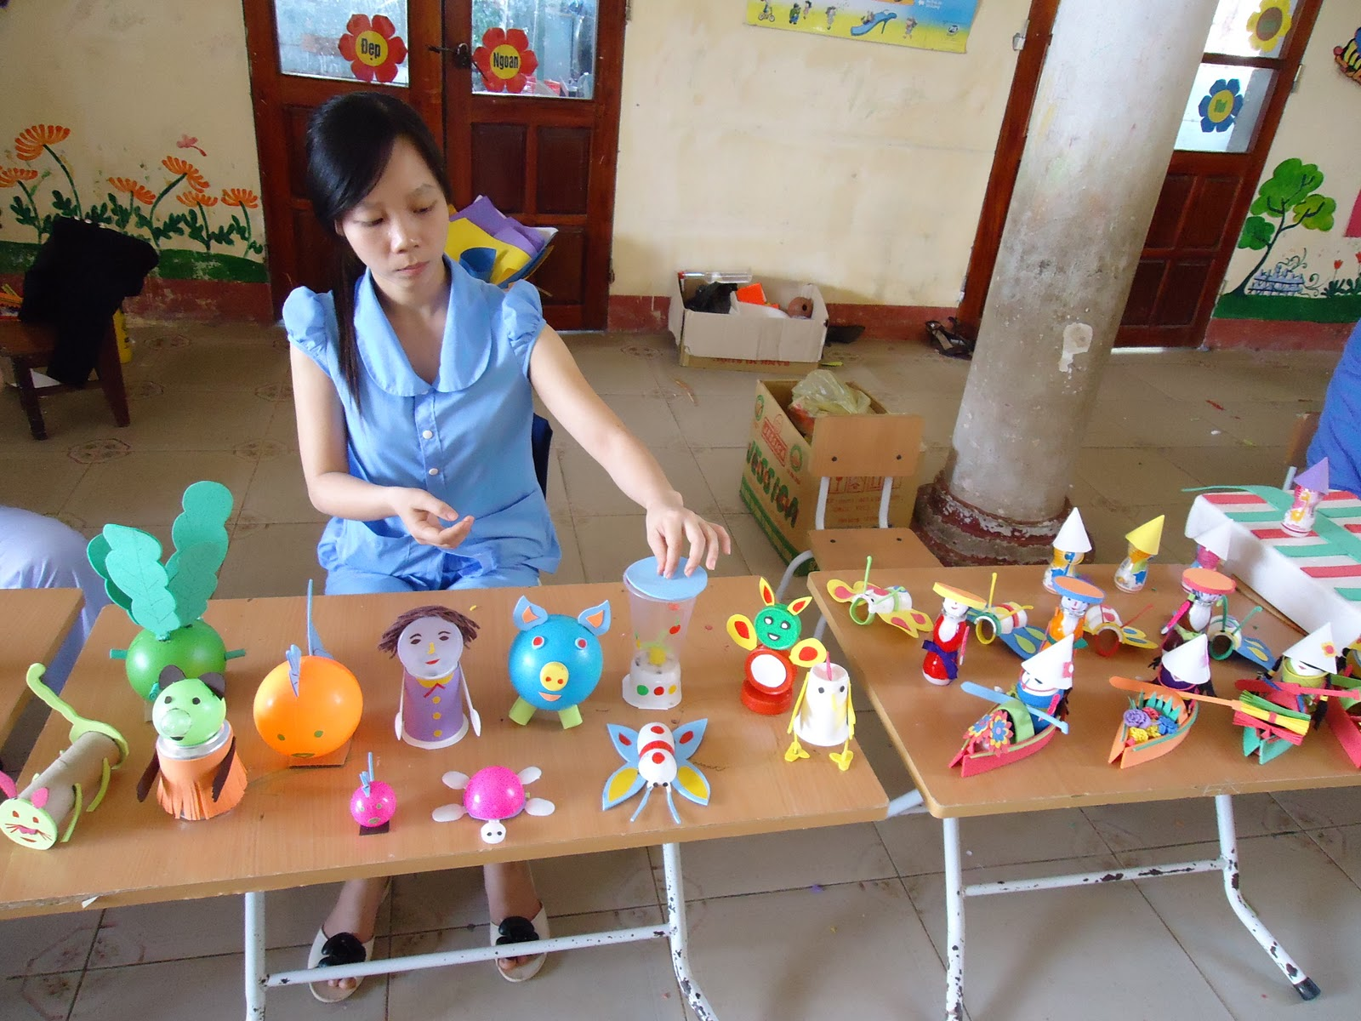 |  | He invited me to a craft work  shop lastweek
DIY  /di: ai wai/ | Đồ tự làm, tự sửa |  | My brother is a real DIY enthusiast
Hang out  /hæŋ aut/ | Đi chơi với bạn bè  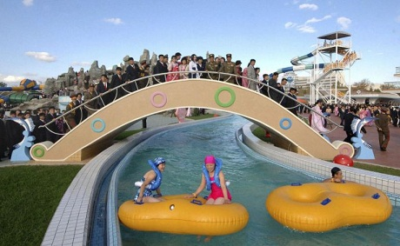 |  | I often hang out with friends in my freetime
Leisure (n)  /ˈleʒə(r)/ | Giải trí |  | These days we have more leisure activities than in the past
Mind(v) /maind/ | Chú ý, để ý  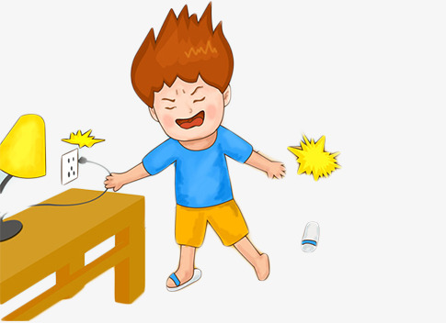   |  | I hope you don’t mind the noise
Rely on  /ri’lai on/ | Tin tưởng, tin cậy   |  | You can rely on his judgement
Savings(n)  /seivi ŋ z/ | Tiền tiết kiệm |  | He spent all his saving on buying a new car
Socialise(v)  /’s əuʃəlaɪz/ | Giao tiếp để  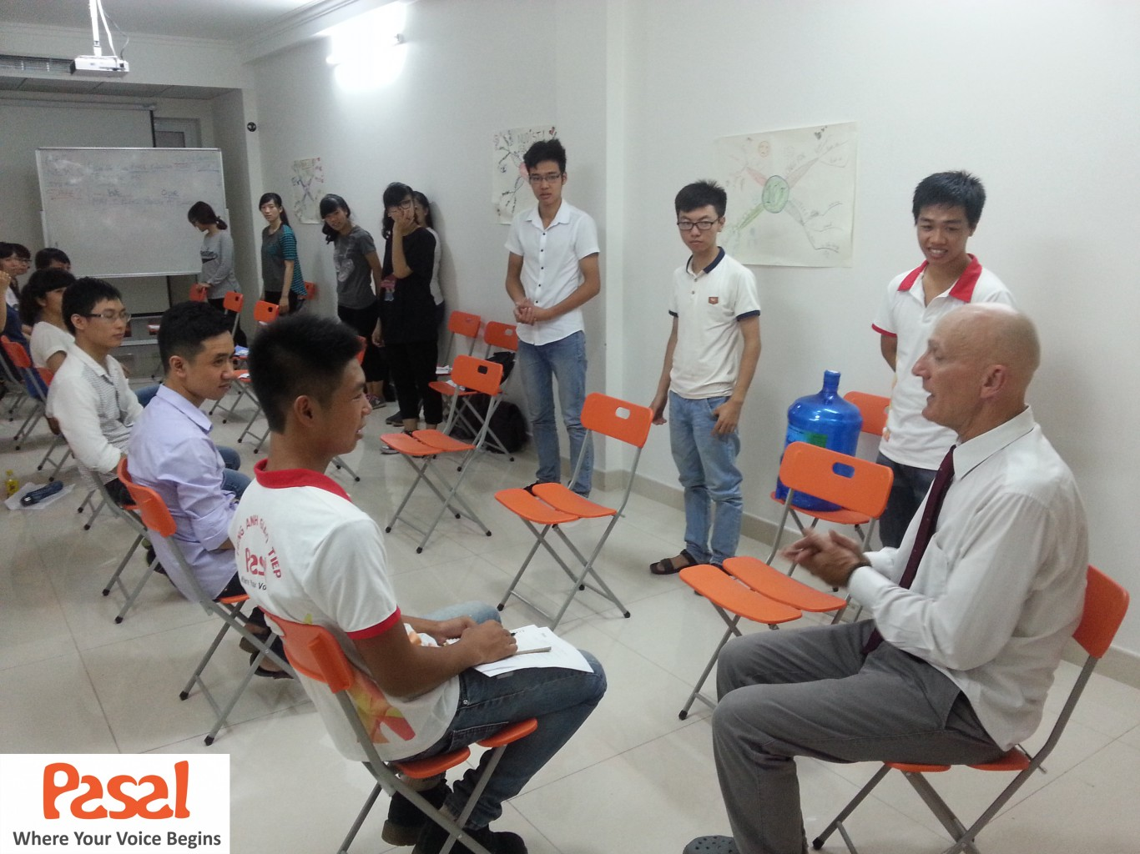  tạo mối quan  hệ  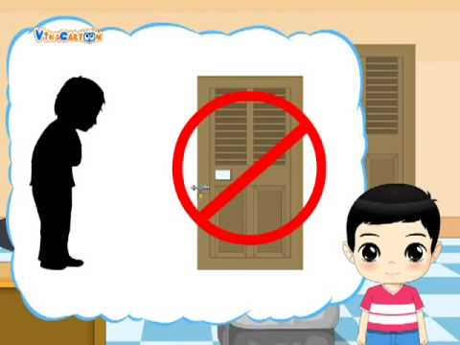 |  | He enjoys socialising with other students
Stranger(n) /ˈstreɪndʒə(r)/ | Người lạ |  | You shouldn’t reveal your personal information to strangers
Surf(v) /sɜːf/ | Lướt    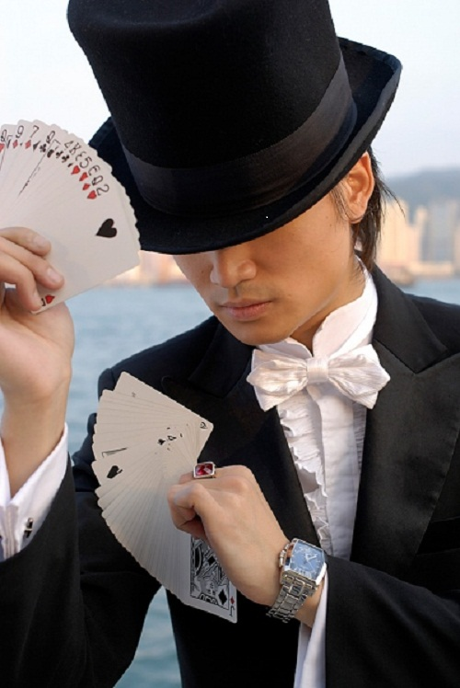 |  | I spent two hours a day surfing the web
Trick(n) /trik/ | Mẹo  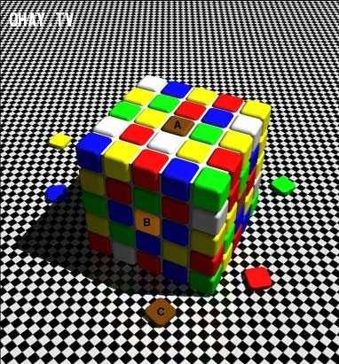 |  | He amazed everyone by a card trick
Virtual(a) /ˈvɜːtʃuəl/ | ảo (chỉ có ở  trên mạng) |  | The Internet has created a virtual world for its users

III. Grammar: CÁC ĐỘNG TỪ DIỄN ĐẠT SỰ YÊU THÍCH (VERBS OF LIKING)
1. VERBS OF LIKING:
Động từ | Nghĩa
adore | Yêu thích, mê mẩn
Love | Yêu
Like/ enjoy/ fancy | Thích
Don’t mind | Không phiền
Dislike/ don’t like | Không thích
Hate | Ghét
Detest | Căm ghét

2.VERBS OF LIKING + V_ING / TO V:
-Khi muốn dùng một động từ chỉ một hàng động khác ở sau động từ chỉ sự thích, ta phải sử dụng danh động từ (V_ing) hoặc động từ nguyên thể co “to” (toV)
1.Verbs + V-ing/ to V
Những động từ đi với cả danh động từ và động từ nguyên thể có “to” mà không đổi về nghĩa
Verbs | Verbs + V-ing | Verbs +to V
Like | I like skateboarding in my free time | I like to skateboard in my free time
Love | She loves training her dog | She loves to train her dog
Hate | He hates eating out | He hates to eat out
Prefer | My mother prefers going jogging | My mother prefers to go jogging
2. Verbs + V-ing
Những động từ chỉ đi với danh động từ
Verbs | Verbs + V-ing
Adore | They adore eating ice-cream
Enjoy | We enjoy playing basketball
Fancy | Do you fancy making crafts?
Don’t mind | I don’t mind cooking
Dislike | Does he dislike swimming?
Detest | I detest doing housework

BÀI TẬP VẬN DỤNG CƠ BẢN:
Bài 1: Hoàn thành những câu sau, sử dụng dạng nguyên thể có (to)(toV) của động từ trong ngoặc:
1.Everyone likes (eat)__TO EAT_______ice cream.
2.Do you prefer (read)____TO READ____books in your freetime?
3.I hate(watch)____TO WATCH____horror movies?
4.Many people prefer(go)__TO GO____travelling on holidays.
5.My father loves(play)____TO PLAY______golf with his friends.
6.I prefer (not stay)____NOT TO STAY______up too late.
7. What does your sister love(do)__TO DO_______in her spare time?
8.I used to prefer(hang out)___TO HANG OUT______with my friends at weekend.
9. I think not many people like(listen)__TO LISTEN______to her music.
10. Teenagers love (surf)___TO SURF______the web to while away their freetime.
Bài 2: Hoàn thành những câu sau, sử dụng dạng danh động từ (V-ing) của động từ trong ngoặc:
1.My mother dislikes(prepare)__PREPARING_____the meals.
2.Do you enjoy(do)__DOING______DIY in your freetime?
3. I detest (have) _____HAVING_____a conversation with John.
4.Do you think Jane prefers(not socialise)__NOT SOCIALISING_________with other students?
5.I don’t mind(explain)__EXPLAINING_____the problem again.
6.Ann fancies(listen)____LISTENING_______to songs of her favourite singer.
7.My friend adores(spend)___SPENDING____time with her cats.
8.I always love(try)___TRYING_____new things when I go travelling.
9.Mr.Smith hates(drive)___DRIVING______his old car.
10.Anne prefers(not go)___NOT GOING______out too late.
Bài 3:Điền dạng thích hợp của động từ trong ngoặc để hoàn thành các câu sau:
1.Did you enjoy(watch)__WATCHING____the comedy last night?
2.Many people prefer(do)_DOING/TO DO_____gardening after their retirement.
3.My cat dislikes(sleep)___SLEEPING_____on the floor.
4.My father doesn’t mind(work)___WORKING___hard.
5.My cousin doesn’t like(study)___STUDYING/ TO STUDY______Math and Chemistry.
6.They dislike(talk)____TALKING______with each other.
7.Jim and Jane don’t fancy(go)___GOING_______out tomorrow.
8.Did you hate(eat)__EATING/TO EAT____vegetables when you was small?
9.she didn’t prefer(tell)___TELLING/ TO TELL_____him about her plan.
10.James enjoys(have)_HAVING______dinner in a luxury restaurant.
11.I hope my mother will enjoy(spend)___SPENDING____time with her grandchildren.
12.Some people enjoy(take)___TAKING___a shower in the morning.
13.I think your brother won’t mind(lend)_LENDING_______you a helping hand.
14.My boyfriend dislike(wait)_____WAITING______.
15.What do you detest(do)___DOING_______the most?
Giaỉ thích:
Bài 4: Dựa vào các từ cho sẵn, viết thành câu hoàn chỉnh:
1.Peter / prefer/ play/ computer games/ in his free time.
PETER PREFERS PLAYING / TO PLAY COMPUTER GAMES IN HIS FREE TIME.
2.You/ hate/ do/ the washing?
DO YOU HATE DOING/ TO DO THE WASHING?
3.My father/ enjoy/ play/ sports/ and/ read/ books.
MY FATHER ENJOYS PLAYING SPORTS AND READING BOOKS
4.The teacher/ not mind/ help/ you/ with difficult exercises.
THE TEACHER DOESN’T MIND HELPING YOU WITH DIFFICULT EXERCISES.
5.Jane/ not fancy/ read/ science books.
JANE DOESN’T FANCY READING SCIENCE BOOKS.
6.Which kind of juice/ you/ dislike/ drink/ the most?
7. Ann/ fancy/ do /DIY/ in her free time.
WHICH KIND OF JUICE DO YOU DISLIKE DRINKING THE MOST?
8. My father/ prefer/ not eat/ out.
MY FATEHR PREFERS NOT EATING / NOT TO EAT OUT
9.Mr.Smith/ love/ go/ shopping/ at weekend.
MS.SMITH LOVES GOING/TO GO SHOPPING AT WEEKENDS
10.Everyone/ adore/ receive/ presents/ on their birthday.
EVERYONE ADORES RECEIVING PRESENTS ON THEIR BIRTHDAYS.
Giải thích: Viết câu ở thì hiện tại đơn để diễn tả sự yên thích, dung danh động từ(V-ing)sau những động từ chỉ sự yêu thích như: adore, enjoy, fancy, don’t mind, dislike, detest” dùng danh động từ(hoặc động từ nguyên thể có “to: sau các động từ :like, love, hate, prefer”
BÀI TẬP VẬN DỤNG NÂNG CAO
Bài 5: Đánh dấu(V) trước câu đúng, đánh dấu(X) trước câu sai và sửa lại cho đúng:
1. X My sister doesn’t mind to look after my cat.--> LOOKING(MIND-V-ING)
2. X Jim dislikes going to the library because he likes reading books. ->LIKES(SAI VỀ LOGIC)
3.X I prefer to not go out today.→NOT TO GO(PHỦ ĐỊNH NOT ĐỨNG TRƯỚC TO)
4.I used to like watching cartoons on TV.
5X.Does Mrs.Smith enjoy to cook?→ COOKING( ENJOY-V-ING)
6.XMary hates doing the housework and take after her baby sister.--> TAKING(SAU HATE LÀ DOING RỒI NÊN PHẢI ĐỂ DOING SONG SONG CẤU TRÚC
7. In my freetime, I love to do DIY with my sister.
8.XJosh detests to socialise with his co-workers.→SOCIALISING(DETEST+VING)
9.XWhich movie does he fancy to watch?→WATCHING (FANCY+V-ING)
10.I prefer hanging out with friends to playing computer games.
Bài 6: Điền dạng đúng của các động từ chcho sẵn vào chỗ trống sao cho hợp lý:
socialize | detest | surf | write
rely | read | adore | Hang out
1.My brother likes____TO SURF/ SURFING______the Internet looking for new music.
2.I dislike____RELYING_____too much on other people. I want to be independent.
3.Josh enjoys____HANING OUT______with his classmates after school.
4.My sister and I fancy___READING____novels when we have free time.
5.He’s very artitic. He enjoys____WRITTING____poems in his free time.
6.James____DETESTS_____talking with his neighbors because he finds them annoying.
7.My uncles loves____TO SOCIALIZE/SOCIALIZING______with other people . he has many friends.
8.Ann______ADORES____working with children. She’s a teacher.
Bài 7: Khoanh tròn vào đáp án đúng:
Nowadays, leisure activities are totally different from the past. Many people no longer enjoy(1) in outdoor activities after school. In stead, they(2)playing computer games or (3) the web in their free time. Some people (4)too much on computer and the Internet. For example, they prefer(5) messages to having a face-to-face conversation with friends. Even when people (6)out with their friends, they rarely talk but they use their phones to surf web. However, many people dislike the Internet and the(7)world. They hate to waste time on the computer and(8)other activities such as reading, shopping or sporting.
1.A.participate B.to participate C. participating D. participates
2.A.fancy B.don’t mind C.dislike D.hate
3.A.sailing B. surfing C.swimming D.diving
4.A.play B.rely C.addict D.use
5.A.send B.to send C.to sending D. sends
6.A.play B.rely C.meet D.hang
7.A.virtual B.real C.fake D.new
8.A.dislike B.detest C.enjoy D.mind
Bài 8: Đọc doạn văn sau và điền (T-true)trước câu đúng với nội dung bài đọc , điền (F-false) trước câu không đúng với nội dung bài đọc:
LEISURE ACTIVITIES IN BRITAIN
The weekends area a time for many leisure activities in Britain. British people often have to work five days a week from Monday to Friday is the precious time for family and friends. People enjoy various indoor and outdoor activities in Britain. According to the EU’s statistical office, British people spend abot 45% of their free time watching television, 24% of their free time socialising , 22-23% on sport and hobbies, and 10% on other activities. Other popular leisure activities are listening to the radio, listening to pre-recorded music, reading, DIY, garedning, eating out and going to the cinema.
The most common leisure activity in the UK is watching television. The average viewing time is 25 hours per person per week. Almost all households have at least one television set. The second most popular activity in Britain is visiting or entertaining friends or relations. Another popular leisure activity is gardening. The British are known as a nation of gardeners. Most people have a garden on their property. Every town in Britain has one or more DIY centers and garden centres. These are like supermarkets for the home and garden. These places are very popular with British home-owners at the weekends.
___T____1.People enjoy various indoor activities Britain.
____F___2.British people spend more than half of their free time watching television.
_______3.The most common leisure activity in the UK is visiting or entertaining friends or relations.
___F____4. All house holds have at least one television set.
___F____5.British people are all gardeners.
____T___6. All towns in Britain have one or more DIY centers and garden centres.

